Task: File Creation Task

1. Created a directory my_folder
2. Created a file named my_file.txt and another_file.txt inside my_folder directory.
3. Concatenated and stored the content into my_file.txt.
4. Listed all the files and folder inside the my_folder directory.

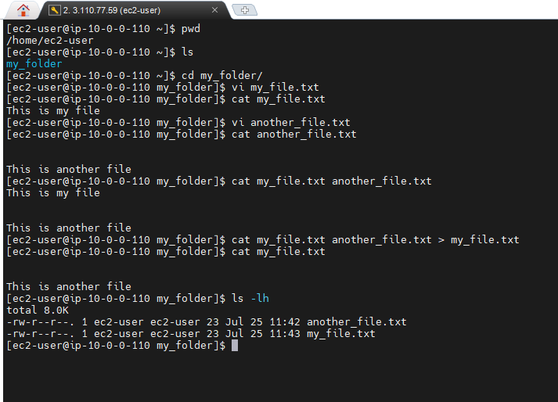

Task 2:

1. Created 20 files with .txt extension
2. Renamed the first 5 files into .yml extension
3. Printing the files created.

