Flight Delay Prediction Around the World
COMP4381 Data Science and Analytics
Final Report - Phase 4
Spring 2026

Role | Name
Student 1 | Mahdi Al Shaikh
Student 2 | Mohammad Humidan
Student 3 | Mais Dar Al Deek
Instructor | Ahmed Sabbah

Project Summary
This final phase uses the cleaned Phase 3 dataset to build a simple delay prediction model. The model predicts whether an airport-day record is delayed or not delayed. We selected the input features carefully to avoid data leakage, so the reported scores reflect genuine prediction, and then we explain the result using normal evaluation scores and a short discussion.

1. Project Overview
This report is the Phase 4 part of the flight delay project. In the earlier phases, the data was collected, cleaned, summarized, and visualized. In this phase, the cleaned data is used to build a simple machine learning model. The goal is not to make a perfect real-world airport system, but to show that the data can be used for a delay-related prediction and that the result can be explained clearly and honestly.
2. Dataset Used
The cleaned dataset has 18,935 rows and 28 columns. It covers five countries: France, Germany, Italy, Spain, and Sweden. The data is based on airport punctuality records and airport metadata. Each row represents an airport-day record after preprocessing. The dataset includes date features, airport information, geographical features, punctuality percentages, and delay values.
3. Modeling Preparation
The target used for modeling is target_delayed. This target has two values: 0 for not delayed and 1 for delayed. The input features used in the final model were year, month, quarter, weekday, season, country, airport, latitude, longitude, elevation, and operated schedules percentage. The text columns, such as country and airport, were converted into numeric dummy columns before training the model.
3.1 Avoiding Data Leakage
When choosing the input features, we were careful not to include any feature that is almost a copy of the target. The target is built from the average arrival delay. In this airport-day dataset, the average departure delay is almost identical to the average arrival delay (in Phase 3 the difference between them was close to zero), and departure punctuality is built from the same delay information. If we used these as inputs, the model would simply be reading a near-copy of the answer. This is called data leakage, and it produces a misleadingly high score that does not reflect real prediction skill.
For this reason we excluded average departure delay and departure punctuality from the feature set. The model predicts using only time, location, airport, and operated-schedules information. The score is therefore more modest, but it reflects genuine prediction from features that are not a copy of the target.
4. Model Method
The model selected for this phase is a Decision Tree classifier. We chose this model because it is simple and easier to explain than many advanced models. The data was split into training and testing parts, with 80% used for training and 20% used for testing, using stratified sampling so the class balance stayed similar in both parts.
A majority baseline model was also used. This baseline always predicts the most common class. It gives a simple comparison point, so we can tell if the Decision Tree is actually learning something useful from the features.
5. Model Results
The table below compares the majority baseline with the Decision Tree model. The Decision Tree performed clearly better than the baseline, especially in F1-score. This means the selected non-leaking features helped the model predict delayed records better than a simple guess.
Model | Accuracy | Precision | Recall | F1-score
Majority baseline | 0.683 | 0.000 | 0.000 | 0.000
Decision Tree | 0.760 | 0.678 | 0.462 | 0.550

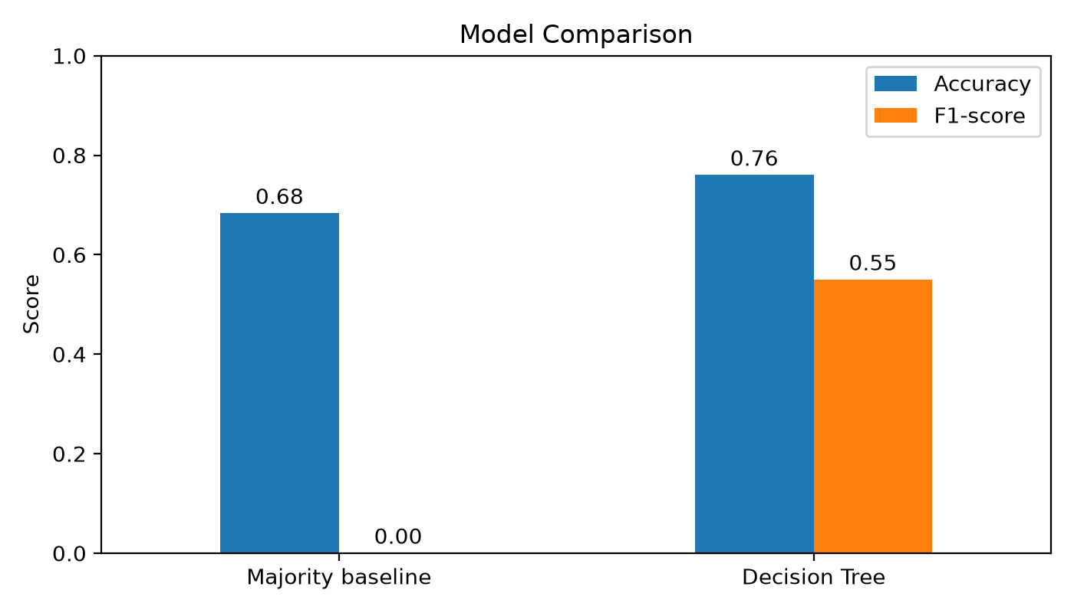
Figure 1. Baseline and Decision Tree model comparison.
6. Confusion Matrix
The confusion matrix gives more detail about the Decision Tree predictions. The model correctly predicted most not-delayed records and many delayed records, but it still missed a fair number of delayed cases (lower recall on the delayed class). This is normal because the dataset is aggregated and does not include every possible reason for a delay.
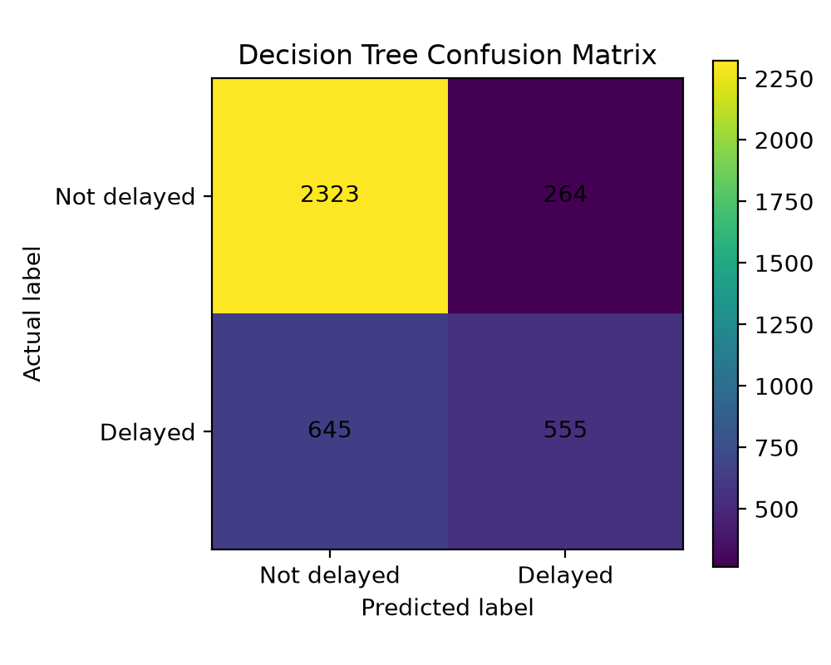
Figure 2. Confusion matrix for the Decision Tree model.
7. Important Features
Because we avoided the leaky departure-delay features, the importance is spread across several meaningful features instead of being dominated by one. The most important features were the season (especially summer), the operated schedules percentage, and the month. This makes sense in the aviation domain, because summer and busy travel months usually bring more traffic and congestion, which can increase delays. Some specific airports and countries also appeared, which suggests that certain locations are more delay-prone than others.
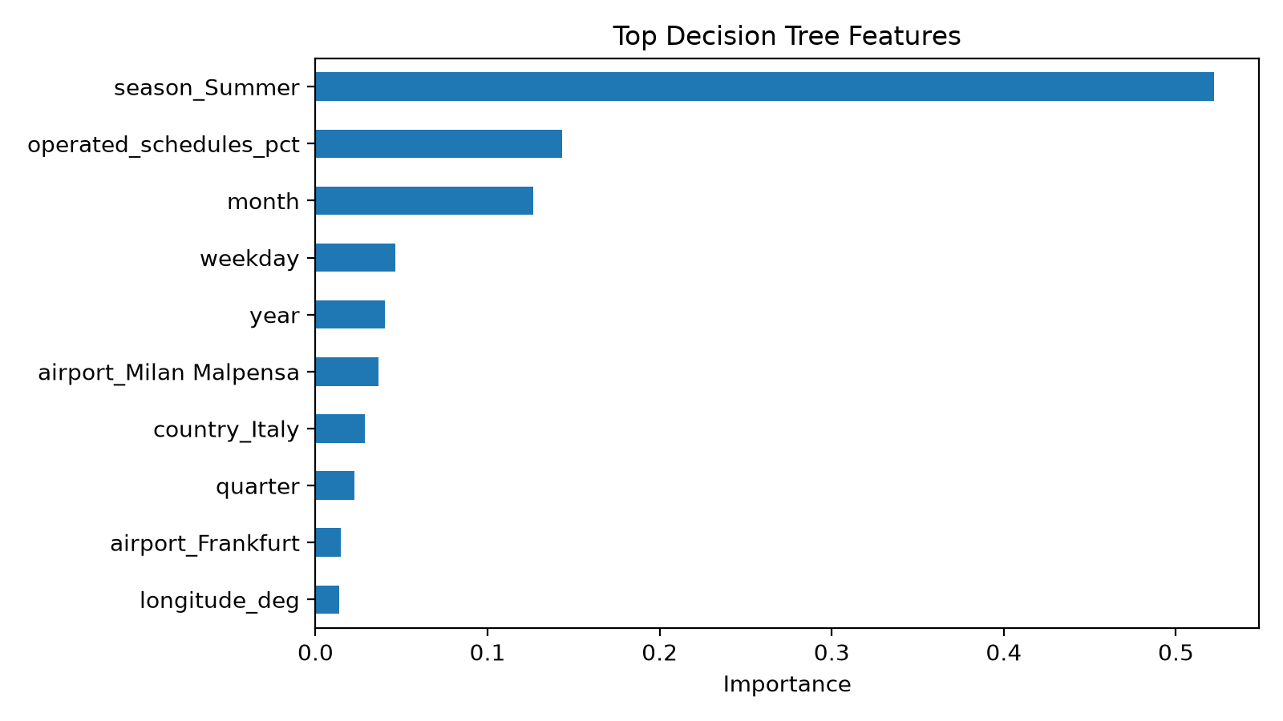
Figure 3. Top features used by the Decision Tree model.
8. Discussion
The model reached about 0.76 accuracy and an F1-score of about 0.55, compared with 0.68 accuracy and 0.00 F1-score for the baseline. Because we avoided data leakage, these scores reflect genuine prediction skill: the model predicts delay from time, season, airport, and schedule information, not from a near-copy of the answer.
The model should still be interpreted carefully. The dataset is not individual flight data; it is an airport-day style dataset. This means each row summarizes airport behavior for a day, so some details are missing, such as individual aircraft, crew issues, passenger issues, or the exact weather condition for every flight.
Another limitation is weather. The project description encourages weather features because they can affect flight delays, but this version of the dataset did not include weather columns. Adding weather could make the model more realistic and could help explain delays that are not caused by traffic or season.
9. Conclusion
In this final phase, a simple Decision Tree classifier was trained to predict delayed versus not delayed records. By selecting features carefully and avoiding data leakage, the model improved clearly over the majority baseline, which shows that time, season, airport, and schedule features carry real (if limited) information about delay.
The strongest signals were season and operated-schedules percentage, which fits the idea that traffic and busy periods drive delays. The project also showed a full basic machine learning pipeline, starting from cleaning and analysis in Phase 3 and ending with an honest prediction model in Phase 4. A future improvement would be to add weather data, use individual-flight records, include more countries, and compare more course-level models such as logistic regression.

