Flight Delay Prediction Around the World
COMP4381 Data Science and Analytics
Phase 3 Data Analysis Report Section
Spring 2026

Role | Name
Student 1 | Mahdi Al Shaikh
Student 2 | Mohammad Humidan
Student 3 | Mais Dar Al Deek
Instructor | Ahmed Sabbah

What this phase contains
- dataset description and source explanation
- data cleaning and preprocessing steps
- simple summaries and charts
- short interpretation for the results
Note: The predictive model is not included in this phase. That part will be handled in Phase 4 once the data preparation is complete.

1. Dataset Description
Our cleaned dataset ended up with 18,935 rows and 28 columns. Each row represents a single airport on a single day, so this is daily punctuality data rather than records for individual flights.
We focused on five European countries: France, Germany, Italy, Spain, and Sweden. The time range runs from January 1, 2022 through April 27, 2026, covering 12 airports in total, which is more than enough to draw some meaningful patterns from.
Column-wise, the data mixes delay figures, airport info, and time breakdowns. On the delay side you’ve got arrival delay, departure delay, and punctuality percentage. Airport info covers things like IATA code, country, coordinates, elevation, and airport type. Then there are date columns like year, month, weekday, and season, plus the two label columns target_delayed and arrival_delay_category.
2. Data Source Explanation
The delay and punctuality numbers come from EUROCONTROL. They publish separate Excel files by country, so we downloaded five of them — one each for France, Germany, Italy, Spain, and Sweden — and they all live in data/raw.
For the airport side of things, we relied on airports.csv to fill in details that EUROCONTROL doesn’t provide, stuff like region, municipality, airport type, lat/long, elevation, and whether the airport runs scheduled commercial service.
To combine the two sources, we matched EUROCONTROL airport names to their IATA codes and used those codes to join in the airport metadata. The 12 airports we ended up with are: Frankfurt, Dusseldorf, Munich, Stockholm Arlanda, Barcelona, Madrid Barajas, Palma de Mallorca, Nice, Paris Charles de Gaulle, Paris Orly, Milan Malpensa, and Rome Fiumicino.
3. Data Cleaning and Preprocessing
First thing we did was load the five Excel files and stack them into one dataframe. After that we hunted down any duplicate rows and dropped them — leaving duplicates in would mess with any averages we calculate later.
The airport names in the EUROCONTROL files aren’t always in a clean format, so we had to standardize them and match each one to its IATA code before the join with airports.csv would work properly. We also trimmed some of the longer column names down so the notebook doesn’t get too cluttered.
The date column came in as plain text so we parsed it into a real datetime object. From there we broke it apart into year, month, month name, quarter, weekday, weekday name, and season. Delays obviously shift depending on the time of year and day of the week, so having those as their own columns will make the analysis — and eventually the model — a lot cleaner.
We also created two target columns that will come in handy for Phase 4. The first, target_delayed, flags any day where the average arrival delay hits 15 minutes or more. The second one, arrival_delay_category, just splits delays into three rough bands: Low, Medium, and High. Neither column is a model prediction — we just made them now so Phase 4 has something concrete to classify against.
4. Data Summarization
Once cleaning was done, we had 5 countries and 12 airports to work with. Looking at the numbers overall, the mean arrival delay came out to 13.59 minutes, with a median of 11.97 minutes. For departures, the mean was 17.71 minutes and the median was 15.85 minutes.
Table 1 breaks this down by country. It’s worth noting that the figures aren’t directly comparable across countries, since each one has a different number of airports represented in our sample.

Table 1. Summary by country
Country | Rows | Airports | Mean Arr. Delay | Median Arr. Delay | Mean Dep. Delay
Italy | 3156 | 2 | 14.85 | 13.37 | 19.94
France | 4734 | 3 | 13.89 | 12.31 | 19.35
Germany | 4733 | 3 | 13.50 | 12.01 | 17.91
Spain | 4734 | 3 | 13.06 | 11.25 | 16.50
Sweden | 1578 | 1 | 11.99 | 10.39 | 11.33
5. Visualizations and Interpretation
We generated all the figures below in our Jupyter Notebook and saved them to the figures folder. We kept the visualizations fairly straightforward for now, since the main goal at this stage is just to get a feel for the data before moving into modeling.
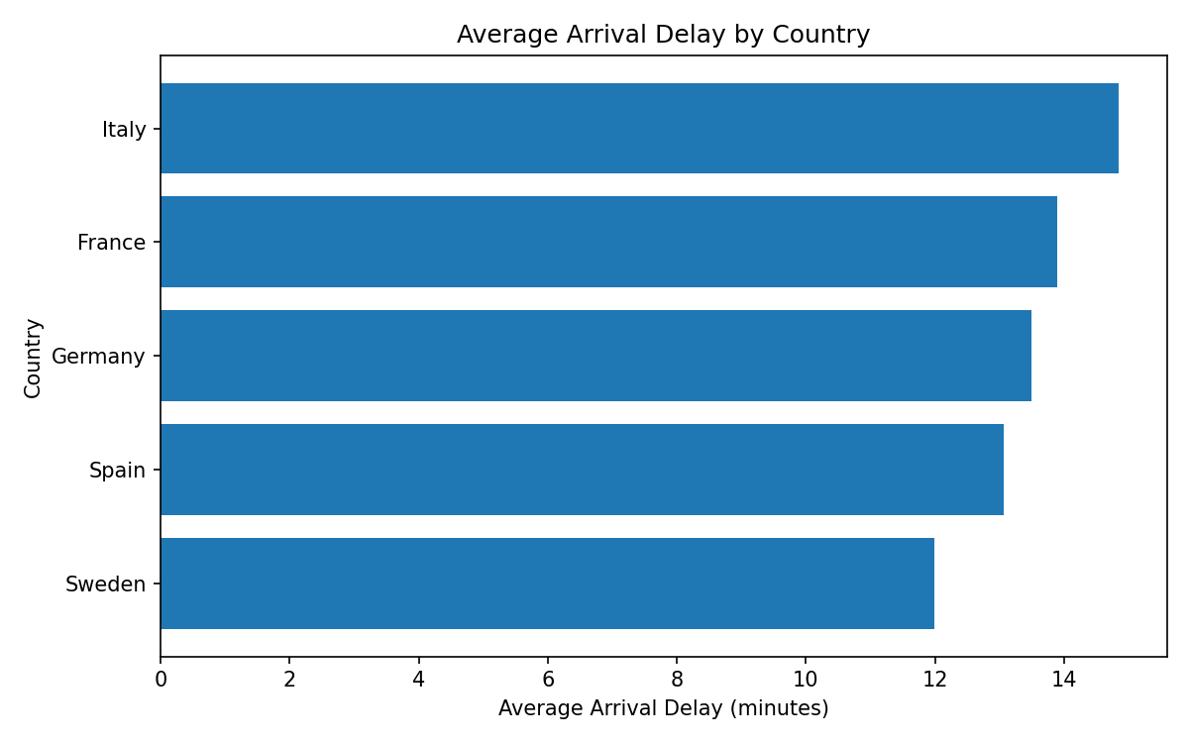
Figure 1. Average arrival delay by country
Among the five countries, Italy shows the highest average arrival delay, while Sweden is noticeably lower. Keep in mind this only reflects the specific airports we selected, not the full picture for each country.
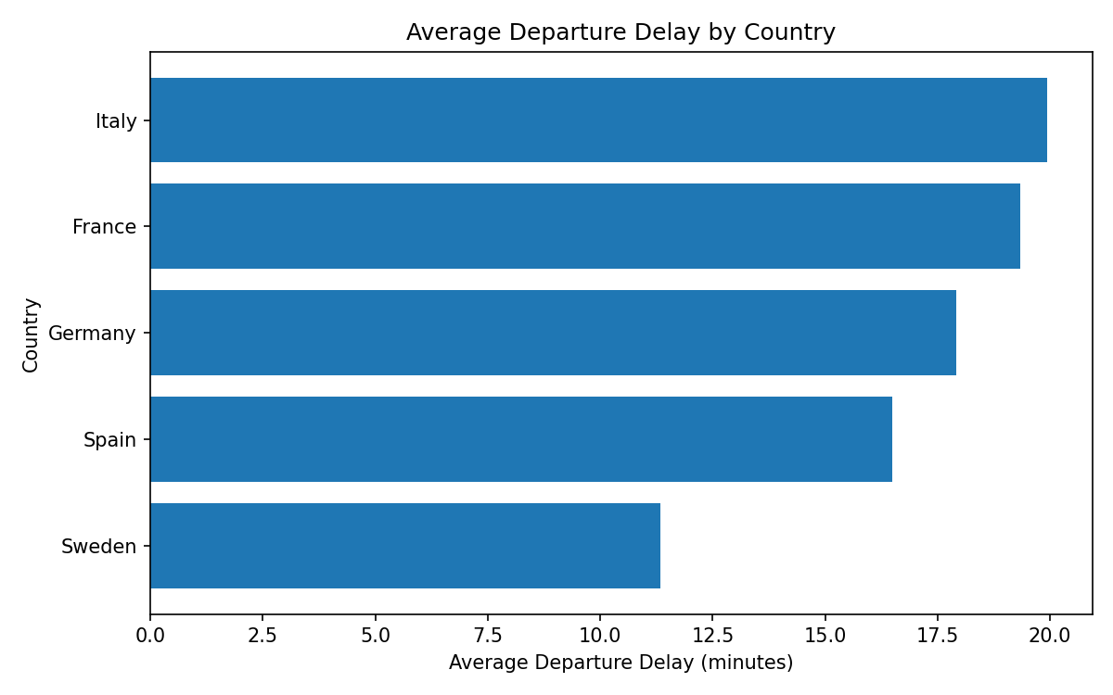
Figure 2. Average departure delay by country
We looked at departure delays separately because a late takeoff often cascades into further disruptions. Italy and France both show considerably higher departure delays compared to Sweden in our data.
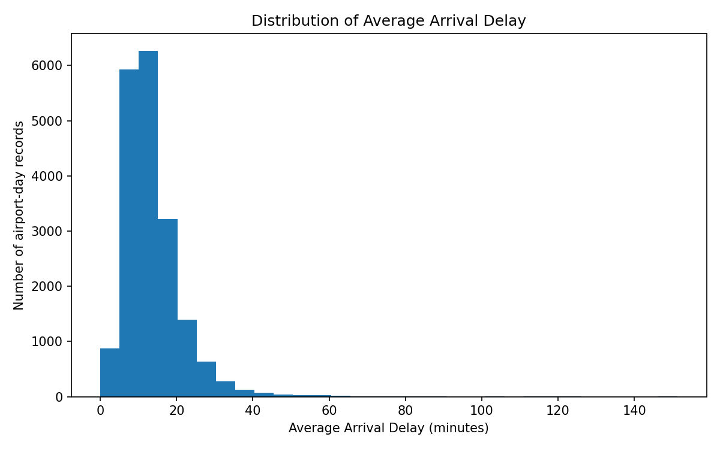
Figure 3. Distribution of average arrival delay
The distribution is right-skewed — the bulk of records cluster around moderate delays, but a tail of unusually long delays pulls the mean upward. That’s why we reported the median alongside the mean; it gives a more stable picture of typical delay times.
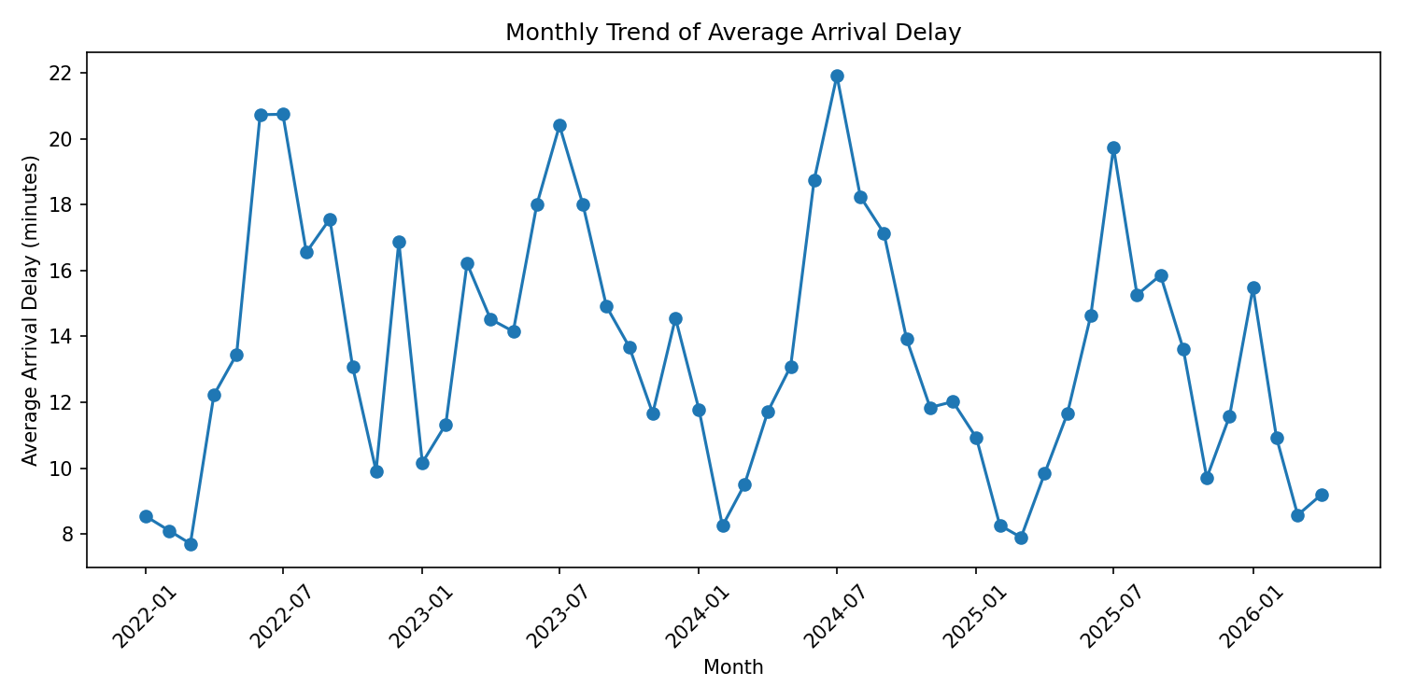
Figure 4. Monthly trend of average arrival delay
Delays clearly vary across months rather than staying flat throughout the year, which confirms that month and season are worth keeping as features when we get to the model.
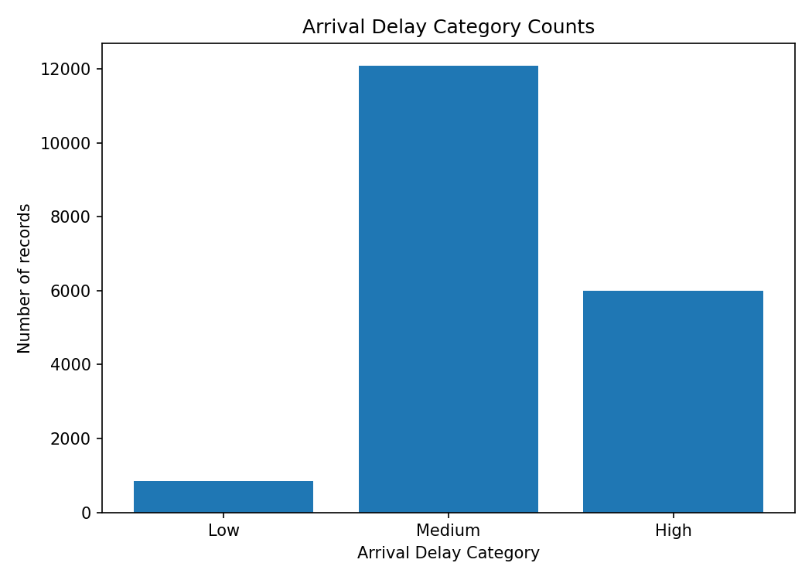
Figure 5. Arrival delay category counts
Medium delay is by far the most common category, but there are still a reasonable number of High delay records in the mix. That balance means a classification model in Phase 4 should have enough examples in each class to work with.
6. Short Notes
Overall the dataset works well for what we need in Phase 3, though there are a few things worth flagging. Since each record is an airport-day aggregate rather than a single flight, we can’t trace the exact cause of any particular delay. Weather information is also missing from the dataset at this point, even though conditions like storms are one of the biggest drivers of delays in practice. Despite these gaps, the cleaned file is ready to be used as input for the Phase 4 model.

