Braxton Worsley

November 20, 2023

CSCI 1010

Professor Xiaoli

Student Information Management System

The Student Information Management System allows a user to (1) add a student, (2) view a student’s entry, (3) view statistics of all entries, (4) remove a student, and (5) view all students’ entries.

There is only one custom function used within the program; that is `getValidID`. This function is used for when the user enters an ID after choosing the view a student or remove a student option. It checks if the ID is within the range of applicable IDs. If it isn’t, the user will be asked for a new, valid, ID until one is entered. It then returns the valid ID.

Now, onto the main function of the project. Most of the code is nested within a `while(true)` loop to loop continuously. Output as a welcomer offers choices; those listed above in the first paragraph. An if statement checks if the choice is 6 and breaks if true. Another if statement checks if the choice is less than 1 or greater than 5 which would be invalid. The last guard clause checks if there are not any students in the system and if the choice is 2, 3, 4, or 5; to which students would need to be present to have adequate output, so the choice is set to 1 so the user can add a student. A switch takes it from there directing which case to run based on the user’s choice.

Moving on to the actual code of each choice, we have a switch with a case for each choice.

Case 1 is to add a student. First, the program checks if there are more than 100 students, and asks the user to remove a student if so. If not, the program asks the user to enter a name for the student, and then their grade. A while loop checks if the grade is within the boundaries of 0 and 100; if not, a new, valid, grade is requested until one is. If these checks are passed, the student’s ID, name, and grade are added into the respective arrays with the same index. Output confirms the additions, and the index is incremented to keep up with the current length of the arrays.

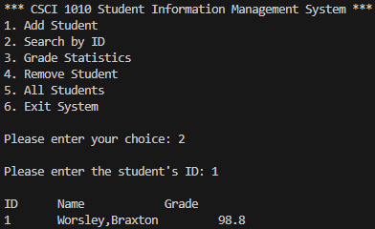

Case 2 is to search a student’s information by their ID. The program asks the user for the ID of a student, the getValidID function is then called to get a valid ID. Then, the student’s information is output.

Case 3 is to view the statistics of all students’ grades. The program sets the high, low, and average grade variables to the first value of the grade array. It then runs a for loop through the grade array. The first if checks if the current value is greater than the high grade variable value, and sets it to the variable if so. The second if checks if the current value is less than the low grade variable value, and sets it to the variable if so. The current value is then added to the average grade variable. The statistics are output; note that in the output of the average grade, it is divided by the index value which is the number of students in the system.

Case 4 is to remove a student. The program asks the user for the ID of a student to remove, the getValidID function is then called to get a valid ID. The given student’s name is saved to a variable to preserve it for later output. Their information is then overwritten as well as all further student data by the value after them. Confirmation is output including removed student’s name. The index variable is decremented as a student was removed.

Case 5 is to view all students’ information. The program outputs the header for the “chart”. Then loops from 0 to index outputting each indexed value from ID, name, and grade arrays.