FL. VEGETII RENATI VIRI ILLUSTRIS DE RE MILITARI LIBRI QUATUOR
Flavius Vegetius Renatus, Aelianus : Modesti ad Tacticus, ...
Digitized by Google XX

FL. VEGETII RENATI VIRI ILLVSTRIS DE RE MILITARI
LIBRI QVATVOR,

SEXTI IVLII FRONTINI viri consularis de Strategematis libri totidem.

AELIANI de instruendis Aciebus liber vnus.
MODESTI de vocabulis rei militaris liber vnus.

Item picturae bellicae cxx. passim VEGETIO
adiectae. Collata sunt omnia ad antiquos
codices, maxime B V D AE I, quod
testabitur Aelianus.

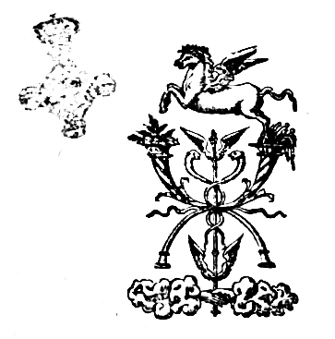

PARISIIS,
Apud Christianum wechelum, sub Pegaso,
in vico Pellouacensi. Anno
M. D. LIII.

Edidit Digitale B. Rodriguez (12/12/2017)
Cum litteris XX saeculi et diversis correctionibus

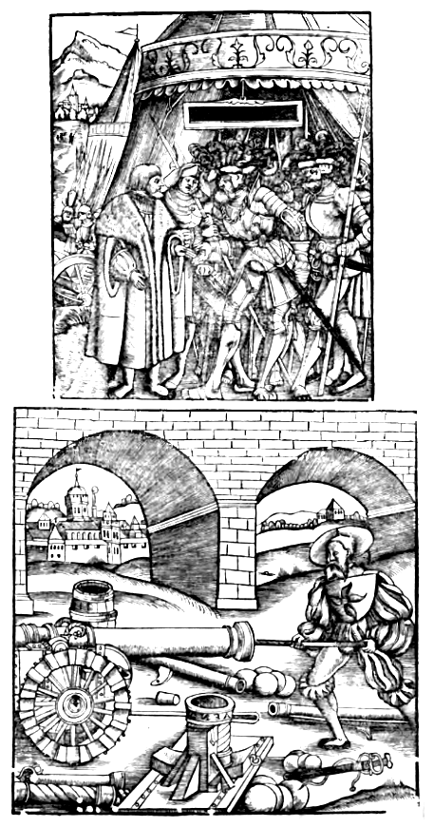

Rerum & verborum in Vegetio contentorum index, in quo prior numerus capita, alter libros supputat.

Acies, capite xiiii, libro, iii.
Accensi xix, ii, & xiiii, iii.
Alae equitum i, ii.
Annibal rei militaris peritus in procemio lib. iii.
Anser xxvi, iiii.
Aphricani iaculatores xv, i.
Aquila xiii, ii.
Aquiliferi vii, iii.
Armaturae ibidem.
Asser xlvi, iiii.
Augustales vii, ii.
Auxiliares ii, ii.
Balearibus fundae primo repertae xvi, i.
Barrhitus xviii, iii.
Bebrae xx, i.
Beneficiarii vii, ii.
Bipennis xlvi, iiii.
Buccina v, iii.
Buccinatores vii, ii.
Burgus x, iiii.
Calones vi, iii.
Campigeni vii, ii.
Campus martius x, i.
Candidati vii, ii.
Capaneus xxi, iiii.
Caput contubernii viii, iii.
Caput porcinum xix, iii.
Castella viii, iii.
Cateruae ii, ii.
Catorei militaris seriptor iii, ii.
Catonis sententia xiii, i.
Centenarii viii, ii.
Centurio primipili ibidem.
Circitores viii, iii.
Classium duo genera i, ii.
Claudii iaculatores xv, i.
Cohortes xxiii, i.
Colligere campum xxv, iii.
Colores lunae xli, iiii.
Cornu v, iii.
Cornicines vii, ii.
Cuneus xix, iii.
Decumana porta xxiii, i.
Decani viii, ii. & xiii, ii.
Decurio xiiii, ii.
Digmata xviii, ii.
Dracones xiiii, ii. & xiii, i.
Drumi xv, iii.
Ducenarius viii, ii.
Equitis legionarii i, ii.
Exercitus i, ii & i, iii.
Falarica xviii, iiii.
Falx xlvi, iiiii
Ferentarii xx, i & xiiiii, iii.
Flauiales vii, ii.
Forfex xix, iii.
Frons xv, iii.
Fundibulatores ibidem.
Funditores xv, ii & xiiii, iii.
Fustibalus xiiii, iii.
Galearii x, i.
Globus xix, iii.
Harpagones xxv, ii.
Hastatus xiiii, iii.
Hastatus primus viii, iii.
Hastatus secundus ibidem.
Imaginarii vii, ii.
Lacedaemoniorum circa bellum cura in procemio, iii.
Legio i, & ii, ii.
Leuis armatura xiiii, iii.
Liberarii vii, ii.
Loricula xviii, iiii.
Malleoli xviii, iiii.
Manipulus xiii, ii.
Marii diligentia v, i & x, iii.
Martiobarbuli xvii, i.
Mensores vii, ii.
Metatores ibidem.
Metelli diligentia x, iii.
Militiae sacramentum v, ii.
Minotauri signum vi, iii.
Mulierum Ro. [Romanum] crines ix, iiii.
Munifices vii, ii & xix, ii.
Murus pedestris exercitus xx, i.
Nauarchi xxxii, iiii.
Ordinarii vii, ii.
Optiones vii, ii.
Pannonici xx, iii.
Papilones xxiii, i.
Peditum duo genera i, ii.
Persarum mos in fossis ducendis x, iii.
Phalanges ii, ii.
Phalarica xviii, iiii.
Pherentarii xv, ii.
Pila xx, i.
Pilum xv, ii.
Pompeii exercitium ix, i.
Praetoria porta xxiii, i.
Principes xxv, ii.
Principes primae cohortis viii, ii.
Principia vii, ii.
Primae centuriae xxiii, i.
Primus hastatus viii, ii.
Promuscis xxvi, iii.
Pyrrhus elephantos primus in Italiam duxit ibidem.
Quibus dux moueat exercitum ad pugnam xii, iii.
Quintius Cincinnatus iiii, i.
Remedium in formidine militum xii, iii.
Rhodiorum astutia xx, iiii.
Sarissae xxiiii, iii.
Scipionis Aphrica in exercendo milite cura x, iii.
Scipionis sententia xxi, iii.
Scriptores rei militaris viii, i.
Scutati xv, ii.
Serra xix, iii.
Semispathae xv, ii.
Signa vocalia v, iii.
Signa semiuocalia ibid.
Signa muta ibidem
Signiferi vii, ii.
Spatha xv, ii.
Spiculum ibidem.
Taleae viii, iiii.
Tessera qui & tesserarii vii, ii.
Torquati ibid.
Tragularii xv, ii.
Tribulus xxiiii, iii.
Tribunus vii, ii.
Triarii xx, i & xiiii, iii.
Triarius Prior viii, ii.
Tubicines vii, ii.
Turma xiiii, ii.
Turmales ibidem.
Tydeus v, i.
Valli quid viii, iii.
Velites expediti xvi, iii & xxvi, iii.
Verriculum xv, ii.
Veterum consuetudo xiii, i.
Vexillationes i, ii.
Xantippus rei militaris peritus in prooemio iii.
FINIS

Index in Sextvm Ivlivm Frontinum complectens illustrium virorum nomina cum exemplis
eorum a Frontino adductis.

Abydeni capite vii (liber ii).
Acilius Glabrio iiii(ii).
Adathantes v(ii).
Aegytii iii(ii). v(ii).
Aemilius Paul. ii(i); xvii(iii).
Aetoli iiii(ii).
Afranius xiii(ii).
Afri iii(ii).
Agathocles xii(i).
Agrigentini x(iii), iiii(iii).
Agesilaus iv(i) x(i) xi(i) vi(ii). xi(iii).
Alexander Mace. iii(i) iiii(i) vi(i) xi(i) iii(ii) v(ii) xi(ii) iv(ii) vi(iii) ii(iiii) iii(iv) vi(iiii)
Alcetas vii(iiii)
Alcibiades v(ii) vii(ii) ii(iii) vi(iii)
Alicius xi(ii).
Amilcar xvi(iii).
Ambiorix xvii(iii)
Amphipolis xvi(iii).
Annibal i(i) ii(i) iii(i) v(i) vii(i) viii(i) ii(ii) iii(ii) v(ii) vi(ii) ix(ii) xi(ii) ii(iii) iii(iii) vi(iii) ix(iii) x(iii) xiv(iii) xv(iii) xvi(iii) xviii(iii) i(iv) v(iv) vii(iv)
Anaxibius iiii(i)
Antigonus vi(ii)
Antiochus viii(i) iiii(ii) xiii(ii)
Antipater iiii(i).
Antonius vii(i) iii(ii) v(ii) xiii(iii) xiv(iii) i(iv)
Appius Claudius i(iv)
Ap(p)ollonides iii(iii)
Aquirius i(iv).
Arabes v(ii).
Arcades ii(iii).
Archelaus v(i)
Archidamus xi(i)
Ategua xiiii(iii)
Ariouistus v(iv).
Aristippus ii(iiii)
Aristides iii(iv)
Armenii iiii(i)
Arpi ix(iii)
Aristomus v(iv)
Arminus dux German. ix(ii)
Artaxerxes iii(ii) ii(iv).
Asdrubal v(i) i(ii) iii(ii). ix(ii)
Asculani xvii(iii).
Atheas rex Scyth. iv(ii)
Athenienses iii(i) iv(i) i(ii) ii(iii).
Attalus xiii(ii)
Attilius v(i)
Attilius Regul. iii(ii) i(iii)
Augustus Germanicus i(i)
Autofraudates Perses iv(i)
Aurelius Cotta i(iiii)
Barca x(iii)
Bateus Nolanus xvi(iii)
Boii vi(i).
Brasidas v(i).
Brutus ii(iiii).
Byzantii iii(i) iv(i)
Caducei vii(iii).
Caeditius v(i)
Caesar i(i) iii(i) v(i) viii(i) xii(i) i(ii) ii(ii) iii(ii) v(ii) xi(ii) xiii(ii) vii(iii) xiv(iii) xvii(iii). iii(iv) v(iv) vii(iv)
C. Cassius v(ii).
C. Laelius v(ii), v(iv)
Calphurnius v(iv)
Camillus xv(iii) iv(iv)
Campani xiii(iii) vii(iv)
Cato x(iii)
Cato Porcius iv(ii).
M. Cato i(i) ii(i) vii(ii) i(iii) i(iiii).
Carthaginenses ii(i)
eorum duces i(ii)
Caelius Primipi. v(iv)
Catii iii(ii).
Catinenses xi(ii)
Casilinum xvi(iii). v(iv)
Causenses ix(ii)
Cassius v(ii) vii(iv)
Castronius iii(ii)
Celtiberi v(ii)
Cimon ii(iii)
Cizycum [Cyzicum] ix(iii) v(iiii)
Chabrias iv(i)
Chares x(iii)
Chalcid. xi(iii)
Ciminia sylva ii(i)
Claudius iv(i) ix(ii).
Clearchus v(iii) i(iv).
Cleandridas iii(ii)
Cleomenes ii(ii)
Cleonymus vi(iii)
Clisthenes Sycio. vii(iii).
Comminius Atrabas xiii(ii)
Conon vii(iiii)
Corneli. Nasica i(iv)
Cornelius Cossus viii(ii)
Cornelius Ruffin. vi(iii)
Coriolanus viii(i)
L. Cornelius cos. ix(iii)
Corinthus xii(iii).
Cotta cos. i(iv)
Crassus i(iv)
P. Crassus v(iv) vii(iv)
Craterus vi(iii)
Crispinus vii(iv)
Crisei vii(iii)
Croesus iiii(ii) vii(iii).
Crotona oppid. vi(iii)
Curius vii(i). ii(ii) i(iv)
Curio cos. vii(i)
Q. Curtius ---
Cyaneae angustiae iv(i).
Cyrrestes i(i)
Cymbri i(i)
Cyrus rex Persarum xi(i) iii(iii) ii(iv)
Dareius v(i)
Daci iv(ii)
Datames vii(ii)
Delminum oppid. vi(iii).
Decius v(i) viii(i) v(iv).
Decimus Iunius i(iv).
Didius viii(i) x(ii).
Dyonisius [Dionysius] viii(i) iv(iii)
Diodorus xvi(iii)
Domitius Corbulo ix(ii) ii(iii) i(iv). vii(iv)
Domitius Caluinus ii(iii)
Domitianus Augustus i(i). ii(iv). iii(iv).
Duillus v(i) iii(ii) ii(iii).
Eginem v(iv)
Eoneus Tarentin. iii(iii).
Epaminundas Thebanus xi(i) ii(ii) v(ii) ii(iii) xii(iii) ii(iv) iii(iv)
Ephesii iii(iii).
Ephialtes Trachinius ii(ii).
Epidaurii xi(ii)
Epirotae iii(iii)
Equi populi viii(ii) [Equos]
Erythrei v(ii).
Ennienes [Eumenes] vii(iiii)
Entidas [Eutidas] ix(i)
Eufrates fluuius vii(iii)
Fabius Max. viii(i). i(ii) v(i)
M. Fabius xi(i).
Fabius Caeso ii(i).
Q. Fab. ii(i). iii(i). v(ii)
Fabius Rutilius Maximus v(i) viii(i). iv(ii)
Fabritius iii(iv) iv(iv)
Fidenates iv(ii).
Flaminius v(ii)
Flamma v(iv)
Flauius Fimbria xvii(iii)
Fonteuius v(i) v(iv).
Fuluius nobil. xi(i)
Fuluius cos. v(ii)
Fuluius Imperator v(ii).
Fuluius Flaccus i(iv) vii(iv).
Furius Agrippa viii(ii).
Furius Camillus viii(ii).
Q. Furius viii(ii).
L. Furius i(i) v(i)
Gabii iii(iii)
Galli xvi(iii)
Gelo tyrannus xi(i)
Germani vi(ii).
Graeci ii(ii)
Halliatis xv(iii).
Halys fluuius v(i).
Hamilcar i(i).
Hanno Carthaginensis v(i) xvi(iii).
Harridas rex Molossorum v(ii).
Hetrusci vi(ii).
Hernici viii(iii).
Herculeius iii(i).
Hermocrates Siracusan. vii(iv).
Himeraei iv(iii).
Himera ciuit. iv(iii)
Himilco carthag. x(iii).
Hircius xiii(iii).
Hispani xiii(ii). i(iii).
Hispaniae ciuitates vii(iii)
Horatius Cocles xiii(ii)
Iberi ii(ii).
Illyrii iii(ii)
Indas vel In(n)ides aruspex xi(i)
Iphicrates iiii(i). v(i). vi(i) i(ii) v(ii) xii(ii) xii(iii) vii(iv)
Iuba rex v(ii).
Iugurtha viii(i) i(ii).
Laberius v(i).
Labienus v(ii).
Lacedaemonii i(i) ii(iv) v(iv) vii(iv).
Lacetani x(iii).
Laelius v(ii) v(iv).
Lartha dux Poen. x(iii)
Leonidas v(iv).
Leptenes Syracusa. v(ii).
Leucadia iv(iii).
Liburni v(ii).
Licinius i(i) iv(i) v(ii).
Lilybaei x(iii)
Lysimachus v(i).
Litana sylva vi(i)
Liuius dux v(ii).
Liuius Salinator iii(ii).
Locri vii(iv).
Luca oppidum ii(iii).
Luceius xii(ii).
Luctatius Catul. v(i)
Lucullus i(ii) ii(ii) v(ii)
Lusitani v(ii).
Lysander v(i) i(ii) v(ii).
Mago dux Carth. v(ii). v(iii). vii(iv).
Magnetes viii(iii).
Maharbal v(ii).
Mandron v(ii).
Marcus Liuius vii(iv).
Marcus Porcius i(i) vii(iv).
Marcellus iv(ii) iii(iii) vi(iii) v(iv).
Marius C. ii(i) xi(i) ii(ii) iv(ii) vii(ii) ix(ii) ix(iii) i(iv)
I. Martius v(ii).
Martius T. eques x(ii).
Mantinia xi(iii).
Manlius A. Cos. i(iv).
Manlius Imperiosus i(iv).
Cn. Manilius vii(ii). i(iv).
Masinissa ii(iii) vi(iii).
Maurus interrex xiv(iii).
Megarenses vii(iv).
Melanthus v(ii).
Memnon Rhodius v(ii).
Messenii i(ii).
Metellus Pius i(i) xiii(ii) i(iv).
Q. Metellus i(i). ii(iiii).
Milites quando primo iureiurando facti. i(iv).
Minutius Cos. v(i).
Milciades vii(iv)
Minutius Ruffus iv(ii).
Mithridates v(ii).
Mummius iii(iv).
Myronides Atheniensis iv(ii) vii(iv).
Nasica i(iv).
Necii xi(ii).
Nero ii(i).
Cl. Nero i(i).
Neuius Centurio vii(iv).
Nicostratus iv(i).
Nolani xvi(iii).
Numantini xvii(iii).
Numidae v(i).
Octauius C. iii(iv)
Otacilius xvi(iii) i(iv).
Pachorus rex i(i).
Pansa Cos. v(ii).
Papyrius Cursor iv(ii) iii(iii) i(iv).
Parthi ii(iv).
Parmenes Thebi. ii(ii).
Paulus xvii(iii).
Peleponenses iii(i).
Pelopidas Theb. iv(i) viii(iii) vii(iv).
Pericles Athen. iii(i). xi(i) xii(i) ix(iii) vii(iv).
Petilius i(iv).
Petreius vii(i).
Petilini iii(iv).
Persae vii(iv).
Phalisci iv(ii). viii(ii). iv(iv).
Phalaris iv(iii).
Phares dux Athen. xii(iii).
Prusias vii(iv).
Pharnastanis parthi v(ii).
Philippus iii(i). iv(i). i(ii). viii(ii). xiii(ii). iii(iii). viii(iii). i(iv). vii(iv).
Philipus Macedon. rex iv(i) ii(ii)
Pinarius vii(iv).
L. Piso i(iv).
Pyrrhus ii(ii) iii(ii) iv(ii) vi(ii) vi(iii) i(iv).
Pythia vii(iv)
Pysistratus [Pisistratus] vii(iv).
Phormio xi(iii).
Poeni iv(i) xi(i).
Pompeius i(i). iv(i) ix(i) i(ii) ii(ii) iii(ii) v(ii) vi(ii) xi(ii) xvi(iii).
Popilius Lenas xvii(iii).
Porsenna xiii(ii).
Posthumius viii(i) xi(i) i(ii).
Pontius Commius xiii(iii).
Praeneste occisorum capita ix(ii).
Ptolemaeus ii(iii)
Quintinus Capitolinus vii(ii). viii(ii).
Quinti(n)us cos. xii(ii) i(iii).
Quintus Max. v(ii)
Rhegini iiii(i)
Rhodii vii(i)
Romulus v(ii)
Romani ii(i) iii(i) viii(i) ix(i) ii(ii) vi(ii) eorum legati viii(i).
Rutilius i(iv).
Sabini xvii(iii).
Sabora v(ii).
Saguntini x(iii).
Salinator i(iv).
Saluius Pelignus viii(ii).
Scaurus i(iv) ii(iv)
Scipio iii(i) xii(i) iii(ii) iv(ii) vi(ii) vii(ii) x(ii) xi(ii) iv(iii) ix(iii)
Scipio Aemilia iii(iv)
Scipio Africanus ii(i) iii(i) ix(i) xii(i) v(ii) xi(ii) i(iv).
P. Scipio iii(i) i(ii) i(iv).
L. Scipio x(iii).
C. Scip. iii(ii)
Scythae v(i).
Scorylo x(i).
Scordisci iv(ii) x(iii).
Segobrienses xi(iii).
Sempronius v(ii).
Sempronius Tuditanus xii(i). v(iv)
Sempronius Gracchus v(ii) v(iv)
Sempronius Longus v(ii).
Semyramis vii(iii).
Sertorius v(i) x(i) xi(i) i(ii) iii(ii) v(ii) vii(ii) xii(ii) xiii(ii) vii(iv).
Seruius Tullius viii(ii).
P. Seruilius vii(iii).
Sextus Tarquin. iii(iii).
Sicyonii ii(iii) vii(iii).
Sinilius Priscus vii(ii).
Sosistratus iii(iii).
Sorobrigenses x(iii).
Spartacus v(i).
Statorius i(i)
Statilius vii(iv).
Sutrini v(ii).
Sulpitius Petreius iv(ii).
Sylla v(i) ix(i) xi(i) iii(ii) vii(ii) viii(ii) i(iv)
Syphax i(i)
Syphacis legati ii(i)
Syracusani v(i).
Tarentini iii(ii).
Tarquinius rex viii(ii)
Tarquin. Super. iii(iii).
Tarquinienses iv(ii)
Tamiris aut Tomiris v(ii)
Tegea ii(iii)
Teutoni ix(ii).
Thebani xi(i). vi(ii)
Thermopylae iv(i) ii(ii)
Themistocles i(i) iii(i) ii(ii) vi(ii)
Thraces xii(ii) v(iii) xv(iii).
Tiberius Caesar i(ii)
Tiberius Gracchus v(iii)
Tigracus vii(iiii).
Timotheus Atheniensis xii(i).
Tisaphernes vii(i).
Titurius Sabin. xvii(iii).
Torquatus v(iii).
Trasybulus ix(iii) xv(iii)
Triballi v(ii)
Triphon ccxix.
Trinasson castel. vii(iii)
Troezenti vi(iii).
Tullus Hostilius vii(ii)
Tymarch.aetolus ii(iii).
Tygranes ii(ii).
Tygranocerta ix(ii)
Valerius Leuinus iiii(ii) vii(iiii)
P. Valer. xi(ii) i(iv)
Varro v(iv).
Veientes iv(ii).
Velius xvii(ii).
Ventidius i(i). ii(ii).
Verginius i(ii).
Vespasianus i(ii). vi(iv).
Viriatus v(ii) xiii(ii) x(iii) xi(iii).
Vmbri i(i).
Volsci iv(ii). vii(ii)
Volturnus flu. ii(ii).
Xenophon iii(iii) iv(iii).
Xanthippus ii(ii)
Zopyrus iii(iii).

FINIS

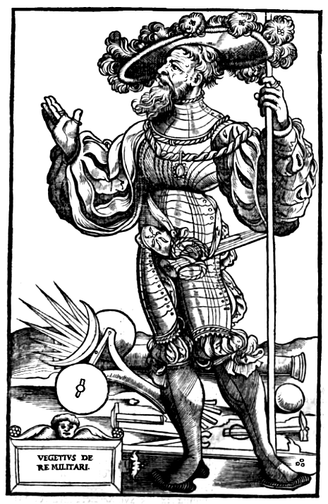

FLAVII VEGETII

Viri illvstris, ad Valentinianum Augustum Epitoma institutorum rei militaris, ex Commentariis Catonis, Celsi, Traiani, Hadriani, & Frontini.

Libri primi

PROLOGVS.

Antiquis temporibus mos fuit, bonarum artium studia mandare literis, atque in libros redacta offerre principibus. Quia neque recte aliquid inchoatur, nisi post deum fauerit Imperator: neque quemquam magis decet vel meliora scire, vel plura quam principem, cuius doctrina omnibus potest prodesse subiectis. Quod Octauium Augustum, ac bonos dehinc principes libenter habuisse, frequentibus declaratur exemplis. Sic regnantium testimoniis creuit eloquentia, dum non culpatur audacia. Hac ego imitatione compulsus, dum considero clementiam vestram, ausibus literarum magis ignoscere posse quam caeteros, tanto inferiorem me antiquis scriptoribus esse vix sensi, licet in hoc opusculo nec verborum concinnitas sit necessaria, nec acumen ingenii, sed labor diligens ac fidelis: ut ea quae ad diuersos historicos, vel armorum disciplinam docentes, dispersa & inuoluta celantur, pro vtilitate Romana proferantur in medium. De delectu igitur atque exercitatione tyronum, per quosdam gradus & titulos antiquam consuetudinem conamur ostendere. Non quo tibi, Imperator inuicte, ista videantur incognita, sed vt quae sponte pro reip. [reipublicae] salute disponis, agnoscas olim custodisse Romani imperii conditores: & in hoc paruo libello, quicquid de maximis rebus, semperque necessariis requiremdum credis, inuenias.

ROMANOS, omnes GENTES SOLA
Armorum exercitatione vicisse.

CAPVT PRIMVM.
In omni autem praelio non tam multitudo & virtus indocta, quam ars & exercitium solent prestare victoriam. Nulla enim aliare videremus populum Romanii sibi orbem subegisse terrarum, nisi armorum exercitio, disciplina castrorum, vsuque militiae. Quid enim aduersus Gallorum multitudinem paucitas Romana valuisset? Quid aduersus Germanorum proceritatem, breuitas potuisset audere? Hispanos quidem non tantum numero sed etiam viribus corporum nostris prestitisse, manifestum est. Aphrorum dolis atque diuitiis semper impares fuimus. Graecorum artibus prudentiaque nos vinci nemo vnquam dubitauit. Sed aduersus omnia profuit tyronem solertem eligere, ius (vt ita dixerim) armorum docere, disciplinam quotidiano exercitio roborare, quaecunque euenire in acie atque in praeliis possent, omnia in campestri meditatione praenoscere, seuere in desides vindicare. Scientia enim rei bellicae, dimicandi nutrit audaciam. Nemo facere metuit, quod se bene didicisse confidit. Etenim in certamine bellorum, exercitata paucitas ad victoriam promptior est: rudis & indocta multitudo, exposita semper ad caedem.

Ex quibus regionibus tyro eligendus • Cap. ii.
Rerum ordo deposcit, vt ex quibus prouinciis vel regionibus tyrones legendi sint prima parte tractetur. Constat enim, in omnibus locis & ignauos & strenuos nasci. Sed tamen, quia gens gentem praecedit in bello, & plaga coeli non ad robur corporum tantum, sed etiam animorum plurimum valet, quo loco ea quae a doctissimis hominibus comprobata sunt, non omittam. Omnes nationes, quae vicinae sunt soli, nimio calore siccatas, amplius quidem sapere, sed minus habere sanguinis dicunt: ea propterea constantiam ac fiduciam cominus non habere pugnandi, quia metuunt vulnera, qui se exiguum sanguinem habere nouerint. Contra Septentrionales populi, remoti a solis ardoribus, inconsultiores quidem, sed tamen largo sanguine redundantes, sunt ad bella promptissimi. Tyrones igitur de temperatioribus legendi sunt plagis, quibus & copia sanguinis suppetat ad vulnerum mortisque contemptum, & non possit deesse prudentia quae ad modestiam seruat in castris, & non parum prodest in dimicatione, consiliis.

Vtrum ex agris an ex vrbibus vtiliores sint tyrones. Cap. iii.
Sequitur, vtrum ex agris, an de vrbibus vtilior tyro sit, requiramus. De qua parte nunquam credo potuisse dubitari, aptiorem armis rusticam plebem, quae sub diuo & in labore nutritur, solis patiens, vmbrae negligens, balnearum nescia, deliciarum ignara, simplicis animi, paruo contenta, duratis ad omnem laborum tolerantiam membris: cui gestare ferrum, fossam ducere, onus ferre consuetudo de rure est. Interdum tamen necessitas exigit, etiam vrbanos ad arma compelli: qui vbi nomen dedere militie primum laborare, decurrere, portare pondus, & solem pulueremque ferre condiscant: parco victu vtantur & rustico, interdum sub diuo, interdum sub papilionibus, commorentur. Tunc demum ad vsum erudiantur armorum: & si longior expeditio emergit, in angariis plurimum detinendi sunt, proculque habendi a ciuitatis illecebris: vt eo modo, & corporibus eorum robur accedat, & animis. Nec inficiandum est, post vrbem conditam, Romanos ex ciuitate profectos ad bellum semper: sed tunc nullis voluptatibus, nullis delitiis frangebantur. Sudorem cursu & campestri exercitio collectum natans iuuentus abluebat in Tyberi. Idem bellator, idem agricola, genera tantum mutabat armorum. Quod vsque adeo verum est, vt aranti Qiuntio Cincinnato viro optimo dictaturam constet oblatam. Ex agris ergo supplendum robur praecipue videtur exercitus. Nescio enim quomodo minus timet mortem, qui minus deliciarum nouit in vita.

Cuius aetatis tyrones probandi sint. Cap. iiii.
Nvnc, qua aetate milites legi conueniat, exploremus. Et quidem, si antiqua consuetudo seruanda est, incipientem pubertatem ad delectum cogendam nullus ignorat. Non enim tantum celerius, sed etiam perfectius imbibuntur, quae discuntur a pueris. Deinde militaris alacritatis saltus & cursus ante tentandus est, quam corpus aetate pigrescat. Velocitas enim est, quae percepto exercitio strenuum efficit bellatorem. Adolescentes legendi sunt, sicur ait Salustius. Nam primum iuuentus, simul ac belli patiens erat, in castris per laboris vsum militiam discebat. Melius enim est vt exercitatus iuuenis causetur aetatem nondum aduenisse pugnandi, quam doleat praeteriisse. Habeat etiam spacium vniuersa discendi. Neque enim parua aut leuis ars videtur armorum, siue equitem, siue peditem sagittarium velis imbuere, siue scutatum armaturae, numeros omnesque gestus docere, ne locum deserat, ne ordines turbet, vt missile & destinato ictu & magnis viribus iaciat, vt fossam ducere, sudes scienter figere norit, tractare scutum & obliquis ictibus venientia tela deflectere, plagam prudenter vitare, audacter inferre. Huic taliter instituto tyroni, pugnare aduersum quoslibet hostes in acie formido non erit sed voluptas.

Qua statura tyrones sint probandi. Cap. V.
Proceritatem tyronum, a Mario consule ad victoriam scio semper exactam, ita vt senos pedes, vel certe, quinos & denas vncias habentes inter alares equites, vel in primis legionum cohortibus probarentur. Sed tunc erat amplior multitudo: & plures militiam sequebantur armatam. Necdum enim ciuilis pars florentiorem adduxerat iuuentutem. Si ergo necessitas exegerit, non tam staturae rationem conuenit habere, quam virium. Et ipso Homero teste non fallimur, qui Tydeum minorem quidem corpore, sed fortiorem animis suisse significat.

Ex vultu & corporis positione agnosci in eligendo, qui meliores possint esse tyrones. Cap. VI.
Sed qui delectum acturus est, vehementer intendat, vt ex vultu, ex oculis, ex omni conformatione membrorum eos eligat, qui implere valeant officium bellatoris. Namque non tantum in hominibus, sed etiam in equis & canibus virtus multis declaratur indiciis, sicut doctissimorum hominum disciplina compraehenditur: quod etiam in apibus Mantuanus autor dicit esse seruandum.
Nam duo sunt genera: hic melior, insignis & ore
Et rutulis clarus squamis: ille horridus, alter
Desidia, latamque trahens inglorius aluum.
Sit ergo adolescens Martio operi deputandus, vigilantibus oculis, erecta ceruice, lato pectore, humeris musculosis, valentibus digitis, longioribus brachiis, ventre modicus, exilior cruribus, suris & pedibus non superflua carne distentis, sed neruorum duritia collectis. Cum haec signa in tyrone depraehenderis, proceritatem non magnopere desideres. Vtilius est enim fortes milites esse, quam grandes.

Cuius artis tyrones vel elegendi sint vel respuendi. Cap. VII.
Sequitur, vt cuius artis tyrones vel eligendi vel penitus respuendi sint, indagemus. Piscatores, aucupes, dulciarios, linteones, omnesque qui aliquid tractasse videntur ad geneacea [gynacea] pertinens, longe arbitror pellendos a castris. Fabros ferrarios, carpentarios, macellarios, & ceruorum aprorumque venatores, conuenit societate militiae. Et hoc est in quo totius reipublicae salus vertitur, vt tyrones non tantum corporibus, sed etiam animis praestantissimi deligantur. Vires regni & Romani nominis fundamentum in prima delectorum examinatione consistunt. Nec leue putetur hoc officium, aut passim quibus cunque mandandum, quod apud veteres inter tam varia genera virtutum, in Sertorio praecipue constat esse laudatum. Iuuentus enim, cui defensio prouinciarum, cui committenda bellorum fortuna, & genere, si copia suppetat, & moribus debet excellere. Honestas enim idoneum militem reddit. Verecundiadum prohibet fugere, facit esse victorem. Quid enim prodest si exerceatur ignauus? Si pluribus stipendiis moretur in castris? Nunquam exercitus profecit tempore belli, cuius in probandis tyronibus claudicarit elector. Et quantum vsu experimentisque cognouimus, hinc tot vbique ab hostibus illatae sunt clades, dum longa pax militem negligentius incuriosiusque legit, dum honestiores quique ciuilia sectantur officia, dum possessoribus addicti tyrones, per gratiam aut dissimulationem probantur, talesque sociantur armis, quales domini habere fastidiunt. A magnis ergo viris magna diligentia idoneos eligi conuenit iuniores.

Quando tyrones signandi sint. Cap. VIII.
Sed non statim punctis signorum inscribendus est tyro delectus: verum ante exercitio praetentandus, vt verum verem tanto operi aptus sit, possit cognosci. Et velocitas in illo requirenda videtur & robur, & vtrum armorum disciplinam ediscere valeat, vtrum habeat confidentiam militarem. Plerique enim quamuis in specie non improbabiles videantur, tamen experimentis comprobantur indigni, Repudiandi ergo minus vtiles, & in locum corum strenuissimi subrogandi sunt. In omni enim conflictu non tam prodest multitudo, quam virtus. Signatis itaque tyronibus per quotidiana excercitia, armorum est demostranda doctrina. Sed huius rei vsum dissimulatio longae securitatis aboleuit. Quem inuenias qui docere possit quod ipse non didicit? De historiis ergo vel libris nobis antiqua consuetudo repetenda est. Sed illi res gestas & euentus tantum scripsere bellorum, ista, quae nunc quaerimus, tanquam nota linquentes. Lacedaemonii quietem, & Athenienses. Aliique Graecorum in libros retulere complura, quae taktik¦ vocantur. Sed nos disciplinam militarem populi Romani debemus inquirere, qui ex paruis finibus imperium suum penem solis regionibus, & mundi ipsius sine distendit. Haec necessitas compulit euolutis autoribus, ea me in hoc opusculo fidelissimem dicere, quae Cato ille Censorius de disciplina militari scripsit, quae Cornelius Celsus, quae Frontinus perstrigenda duxerunt, quae Paternus diligentissimus iuris militaris in libros redegit, quae Augusti & Traiani Adrianique constitutionibus cauta sunt. Nihil enim mihi autoritatis assumo sed horum, quos supra retuli, ea quae dispersa sunt, velut in ordinem & abbreuiationes, quae epitomata dicuntur, conscribo.

Ad gradum militarem & cursum & saltum exercendos tyrones. Cap. IX.
Primis ergo meditationum auspiciis, tyrones militarem edocendi sunt gradum. Nihil enim magis in itinere vel in acie custodiendum est, quam vt omnes milites incedendi ordinem seruent. Quod aliter fieri non potest, nisi vt assiduo exercitio ambulare celeriter & aequaliter discant. Periculum enim saepe ab hostibus grauissimum sustinet diuisus & inordinatus exercitus. Militari ergo gradu, viginti millia passuum, horis quinque duntaxat aestiuis conficienda sunt. Pleno autem gradu, qui citatior est, totidem horis viginti quatuor millia peragenda sunt. Quicquid addideris, iam cursus est, cuius spacium non potest diffiniri. Sed ad cursum praecipue assuefaciendi sunt iuniores, vt maiore impetu in hostes procurrant, vt loca opportuna celeriter, cum vsus aduenerit, occupent: vel aduersariis idem facere volentibus, praeoccupent: vt ad explorandum alacriter pergant, alacrius redeant, vt fugientium terga facilius comprehendant. Ad saltum etiam quo vel fossae transiliuntur, vel impediens aliqua altitudo superartur, exercendus est miles: vt cum eiusmodi difficultates euenerint, possint sine labore transire. Praeterea in ipso conflictu ac dimicatione telorum bellator cum cursu saltumque veniens, aduersarii perstringit oculos, mentemque deterret, priusque plagam infligit, quam ille ad cauendum vel ad resistedum se praeparet. De exercitio Pompei magni Salustius hoc memorat: Cum alacribus saltu, cum velocibus cursu, cum validis vecte certabat. Neque enim ille aliter potuisset par esse Sertorio, nisi se & milites frequentibus exercitiis praeparasset ad praelia.

Ad vsum natandi exercendos tyrones. Cap. X.
Natandi vsum aestiuis mensibus omni aequaliter debet tyro condiscere, non enim semper flumina pontibus transeuntur, sed & cedens & inseques natare cogitur frequenter exercitus. Saepe repentinis imbribus vel niuibus solent exundare torrentes. Et ignorantia non solum ab hoste, sed etiam ab ipsis aquis discrimen incurrit: ideoque Romani veteres, quos tot bella & continua pericula, ad omnem rei militans erudierant artem, campum Martium vicinum Tyberi delegerunt: in quo iuuentus post exercitium armorum, sudorem pulueremque dilueret, ac lassitudinem cursusque laborem natando deponeret. Non solum autem pedites, sed & equites ipsosque equos vel lixas (quos galerios vocant) ad natandum exercere percommodum est, nequid imperitis, cum necessitas imminebit, eueniat.

Quemadmodum ad scuta viminea vel ad palos antiqui exercebant tyrones. Cap. XI.
Antiqui (sicut inuenitur in libris) hoc genere exercuere tyrones. Scuta de vimine in modum cratium corrotundata texebant: ita vt duplum pondus cratis haberet, quam scutum publicum habere consucuit. Iidemque clauas ligneas, duplicis aeque ponderis, pro gladiis tyronibus dabant. Eoque modo non tantum mane, sed etiam post meridiem exercebantur ad palos. Palorum enim vsus non solum militibus, sed etiam gladiatoribus plurimum prodest. Nec vnquam aut arena, aut campus inuictum armis virum probauit, nisi qui diligenter exercitatus docebatur ad palum. A singulis autem tyronibus singuli pali defigebantur in terram, ita vt nutare non possent, & sex pedibus eminerent. Contra illum palum, tanquam contra aduersarium, tyro cum crate illa & claua, velut cum gladio se exercebat & scuto: vt nunc quasi caput aut faciem peteret, nunc a lateribus minaretur, interdum contenderet poplites & crura succidere, recederet, assultaret, insiliret, & quasi praesentem aduersarium, sic palum omni impetu, omni bellandi arte tentaret. In qua meditatione seruabatur illa cautela, vt ita tyro ad inferendum vulnus insurgeret, ne qua ex parte pateret ipse ad plagam.

Non caesim sed punctim ferire docendos tyrones. Cap. XII.
Praeterea non caesim, sed punctim ferire discebant. Nam caesim pugnantes non solum facile vicere, sed etiam derisere Romani. Caesa enim quouis impetu veniat, non frequenter interficit: cum & armis vitalia defendatur, & ossibus. At contra puncta, duas vncias adacta, mortalis est. Necesse estenim vt vitalia penetret, quicquid immergitur. Deinde dum caesa infertur, brachium dextrum latusque nudatur. Puncta autem tecto corpore infertur, & aduersarium sauciat ante quam vidcatur. Ideoque ad dimicandum hoc praecipue genere vsus esse constat Romanos: duplicis autem ponderis illa cratis & claua ideo dabantur, vt cum vera & leuiora arma tyro sumpsisset, velut grauiore pondere liberatus, securior alacriorque pugnaret.

Armaturam docendos tyrones. Cap. XIII.
Praeterea illo exercitii genere, quod armaturam vocant, & a campi doctoribus traditur, imbuendus est tyro. Qui vsus vel ex parte seruatur. Constat enim & nunc in omnibus praeliis armaturam melius pugnare, quam caeteros. Ex quo intelligi debet, quantum exercitatus miles inexercitato sit melior: cum armatura vt cunque eruditi, reliquos contubernales suos bellandi arte praecedant. Ita autem seuere apud maiores exercitii disciplina seruata est, vt & doctores armorum duplicibus remunerentur annonis: & milites, qui parum in illa praelusione profecerant, pro frumento hordeum cogerentur accipere: nec ante eis in tritico redderetur annona, quam sub praesentia praefecti, tribunorum vel principum experimentis datis, ostendissent se omnia, quae erant in militari are, complesse. Nihil enim necque firmius, neque felicius, neque laudabilius est repub. [republica] in qua abundant milites eruditi. Non enim vestium nitor, vel auri vel argenti gemmarumque copiae, hostes aut ad reuerentiam nostram, aut ad gratiam inclinant, sed solo terrore subiguntur armorum. Deinde in aliis rebus (sicut ait Cato) si quid erratum est, potest postmodum corrigi: Praeliorum delicta emendationem non recipiunt, cum statim poena sequatur errorem. Aut enim confestim pereunt, qui ignaue imperiteque pugnauerunt: aut in fugam versi, victoribus vltra pares esse non audent.

Ad missilia iacienda tyro exercendus. Cap. XIIII.
Sed ad inceptum reuertor. Tyro, qui cum claua exercetur ad palum, hastilia quoque ponderis grauioris, quam vera futura sunt iacula, aduersus illum palum, tanquam aduersus hominem iactare compellitur. In qua re armorum doctor attendit, vt magnis viribus hastile contorqueat, vt destinato ictu vel in palum vel iuxta dirigat missile. Eo enim exercitio & lacertis robur accrescit, & iaculandi vsus atque peritia acquiritur.

Sagittis tyronem imbuendum diligenter. Cap. XV.
Sed prope tertia, vel quarta pars iuniorum, quae aptior potuerit reperire, arcubus ligneis, sagittisque lusoriis, ad illos ipsos semper exercenda palos. At doctores ad hanc rem & artifices eligendi: & maior adhibenda solertia, vt arcum diligenter ac scienter teneant, vt fortiter impleant, vt sinistra fixa sit, vt dextera cum ratione ducatur, vt ad illud quod feriendum est, oculus pariter ac animus consentiant, vt siue in equo siue in terra, recte sagittare doceant. Quam artem & disci opus est diligenter, & quotidiano vsu exercitioque seruari. Quantum autem vtilitatis boni sagittarii in praeliis habeant, & Cato in libris de disciplina militari euidenter ostendit, & Claudius pluribus iaculatoribus ante institutis atque perdoctis, hostem, cui prius impar fuerat, superauit. Aphricanus quidem Scipio, cum aduersum Numantinos, qui exercitum populi Romani sub iugum miserant, esset acie certaturus, aliter superiorem futurum esse non credidit, nisi in omnibus centuriis lectos sagittarios miscuisset.

Ad iactandos lapides fundis vel manu exercendos tyrones. Cap. XVI.
Ad lapides vero, vel manibus vel fundis iaciendos, exerceri diligenter conuenit iuniores. Fundarum autem vsum primi Baleanum insularum habitatores & inuenisse, & ita perite exercuisse dicuntur, vt matres paruos filios nullum cibum contingere sinerent, nisi quem ex funda destinato lapide percussissent. Saepe enim aduersum bellatores cassidibus, cataphractis, loricisque munitos, teretes lapides de funda vel fustibalo destinati, sagittis sunt omnibus grauiores: cum membris integris, letale tamen vulnus importent: & sine inuidia sanguinis, hostis lapidis ictu intereat. In omnibus autem veterum praeliis funditores militasse nullus ignorat. Quae res ideo ab vniuersis tyronibus frequenti exercitio discenda est, quia fundam portare nullus est labor. Et interdum euenit, vt in lapidosis locis conflictus habeatur, vt aut mons sit aliquis defendendus aut collis, & ab oppugnatione castellorum siue ciuitatum, lapidibus barbari fundisque sint pellendi.

De exercitio plumbatarum. Cap. XVII.
Plumbatarum quoque exercitatio (quas Martiobarbulos vocant) est tradenda iunioribus. Nam in Illyrico dudum duae legiones fuerunt, quae sena millia militum habuerunt: quae, quod his telis scienter vtebantur & fortiter, Martiobarbuli vocabantur. Per hos longo tempore strenuissime constat omnia bella confecta: vsque eo, vt dum Diocletianus & Maximianus ad imperium venissent, pro merito virtutis hos Martiobarbulos, Iouiarios, atque Herculianos censuerint appellandos, eosque cunctis legionibus praetulisse doceantur. Quinos autem Martiobarbulos insertos scutis portare consueuerunt: quos si opportune milites iacerent, prope sagittariorum scutati imitari videntur officium. Nam hostes equosque consauciant, priusquam non modo manu ad manum, sed ad ictum missilium potuerit perueniri.

Quemadmodum ad ascendendos equos tyrones exercendi sint. Cap. XVIII.
On tantum autem a tyronibus, sed etiam a stipendiariis militibus salitio equorum districte est semper exacta. Quem vsum vsque ad hanc aetatem, licet iam cum dissimulatione, peruenisse manifestum est. Equi lignei hyeme sub tecto, aestate ponebantur in campo: super hos iuniores primo inermes, dum consuetudine proficerent, deinde armati cogebantur ascendere. Tantaque cura erat, vt non solum a dextris, sed etiam a sinistris partibus & insilire & desilire condiscerent, euaginatos etiam gladios vel contos tenentes. Hoc enim continua meditatione faciebant, scilicet vt in tumultu praelii sine mora ascenderent, qui tam studiose exercebantur in pace.

Ad portandum pondus exercendos tyrones. Cap. XIX.
Pondus quoque baiulare vsque ad LX. libras, & iter facere gradu militari, frequentissme cogendi sunt iuniores, quibus in arduis expeditionibus necessitas imminet annonam pariter ac arma portandi. Nec hoc credatur esse difficile, si vsus accesserit: nihil enim est quod non assidua meditatio facillimum reddat. Quam rem antiquos milites factitauisse, Vergil. ipso teste potest cognosci, qui ait,
Non secus ac patriis acer Romanis in armis
Iniusto sub fasce viam cum carpit, & hosti
ante expectatum positis stat in agmine castris.

Quo armorum genere vsi sint antiqui. Cap. XX.
Locus exigit, vt quo armorum genere, vel instruendi, vel muniendi sint tyrones, referre tentemus. Sed in hac parte antiqua penitus consuetudo deleta est: nam licet exemplo Gotthorum & Alanorum Hunnorumque equitum arma profecerint, pedites tamen constat esse nudatos. Ab vrbe enim condita vsque ad tempus diui Gratiani, & cataphractis & galeis muniebatur pedestris exercitus. Sed cum campestris exercitatio, interueniente negligentia desidiaque cessaret, grauia videri arma coeperunt, quae raro milites induebant. Itaque ab Imperatore postulabant primo cataphractas, deinde cassides deponere: sic detectis pectoribus & capitibus, congressi contra Gotthos milites nostri, multitudine sagittariorum saepe deleti sunt: nec post tot clades, quae vsque ad tantarum vrbium excidia peruenerunt, cuiquam curae fuit, vel cataphractas vel galeas pedestribus reddere. Ita sit vt non de pugna, sed de fuga cogitent qui nudi in acie exponuntur ad vulnera. Quid enim pedes sagittarius sine cataphracta, sinc galea, qui cum arcu scutum tenere non potest faciet? Quid ipsi draconarii atque signiferi, qui sinistra manu hastas gubernant, in praelio facient, quorum & capita nuda esse constat & pectora? Sed grauis pediti lorica videtur, &: galea fortasse raro meditanti, & arma tractanti. Caeterum quotidianus vsus non laborat, etiam si onerosa gestauerit. Sed illi qui laborem in portandis veteribus munimentis armorum ferre non possunt, detectis corporibus & vulnera sustinere coguntur & mortes: & (quod est grauius & turpius) aut capi, aut certe fuga rempublicam perdere. Sic dum exercitium laboremque declinant, cum maximo dedecore trucidantur, vt pecudes. Vnde apud antiquos, Murus non dicebatur pedestris exercitus: nisi quod pilatae legiones praeter scuta etiam cataphractis galeisque fulgebant: vsque eo, vt sagittarii sinistra brachia manicis munirentur. Pedites autem scutati, praeter cataphractas & galeas, etiam ferreas ocreas in dextris cruribus cogerentur accipere. Sic erant armati illi qui in prima acie pugnantes principes, in fecunda hastati, in tertia Triarii vocabantur. Sed Triarii genibus flexis solebant intra scuta subsidere, ne stantes vulnerarentur, venientibus telis: & cum necessitas postulasset, tanquam requieti vehementius inuaderent hostes a quibus constat saepe factam esse victoriam, cum hastati illi & qui priores steterant, interiissent. Erant autem apud veteres inter pedites, qui dicebantur leuis armaturae funditores, & ferentarii: qui praecipue in cornibus locabantur, & a quibus pugnandi sumebatur exordium: sed hi & velocissimi & exercitatissimi legebantur. Nec erant admodum multi, quia cedentes (si praelii necessitas compulisset) inter principia legionum recipi solebant, ita vt acies immota consisteret. Vsque ad praesentem prope aetatem consuetudo permansit, vt omnes milites pileis, quos pannonicos vocabant, ex pellibus vterentur, quod propterea seruabatur, ne grauis galea videretur homini in praelio, qui gestabat aliquid semper in capite. Missilia autem quibus vtebatur pedestris exercitus, pila vocabantur , ferro subtili trigono praefixa, vnciarum nouem siue pedali, quae in scuto fixa non possent abscindi: & loricam scienter ac fortiter directa, facile perrumpunt, cuius generis apud nos iam rara sunt tela. Barbari autem scutati pedites, his praecipue vtuntur, quas bebras vocant , & binas etiam ac ternas in praeliis portant. Sciendum praeterea quod cum missilibus agitur, sinistros pedes in ante milites habere debere: ita enim vibrandis spiculis vehementior ictus est. Sed cum ad pilam (vt appellant) venitur & manu ad manum gladiis pugnatur, tunc dextros pedes in ante milites habere debent: vt & latera eorum subducantur ab hostibus, ne possit vulnus accipere, & proximior dextra sit, quae plagam possit inferre. Instruendos igitur ac protegendos omni arte pugnandi, & quocunque genere armorum constat esse tyrones. Necesse est enim, vt dimicandi acriorem sumat audaciam, qui munito capite vel pectore non timet vulnus.

De munitione castrorum. Cap. XXI.
Castrorum quoque munitionem debet tyro condiscere: nihil enim tam salutare, neque tam necessarium inuenitur in bello: quippe si recte constituta sunt castra, ita intra vallum securi milites dies noctesque peragunt, etiam si hostis obsideat, quasi muratam ciuitatem videantur secum vbique portare. Sed huius rei scientia prorsus intercidit: nemo enim iam diu deductis fossis, praefixisque sudibus castra constituit. Sic diurno vel nocturno superuentu equitum barbarorum, multos exercitus scimus frequenter afflictos. Non solum autem confidentes sine castris ista patiuntur, sed cum in acie casu aliquo coeperint cedere, munimenta castrorum, quo se recipiant, non habent, & more animalium multi cadunt. Nec prius moriendi finis fit, quam hostibus defuerit voluntas persequendi.

In quibus locis constituenda sint castra. Cap. XXII.
Castra autem praesertim hoste vicino, tuto semper facienda sunt loco: vbi lignorum & pabuli & aquae suppetat copia. Et si diutius commorandum sit, loci salubritas eligetur. Cauendum etiam ne mons sit vicinus altior, qui ab aduersariis captus, possit officere. Considerandum etiam ne torrentibus inundari consueuerit campus, & hoc casu vim patiatur exercitus. Pro numero autem militum vel impedimentorum munienda sunt castra, ne maior multitudo constipetur in paruis, neue paucitas in latioribus vltra quam oportet cogatur extendi.

Quali specie delinianda sint castra. Cap. XXIII.
Interdum autem quadrata, interdum trigona, interdum semirotunda, prout loci qualitas aut necessitas postulauerit, castra facienda sunt. Porta autem quae appellatur praetoria, aut orientem spectare debet, aut illum locum qui ad hostem respicit: aut si iter agitur, illam partem debet attendere, ad quam est profecturus exercitus, intra quam primae centuriae, hoc est, cohortes, papiliones tendunt, & dracones & signa constituunt, Decumana autem porta, quae appellatur, post praetoriam est, per quam delinquentes milites educuntur ad poenam.

Quo genere munienda sint castra. Cap. XXIIII.
Castrorum autem diuersa triplexque munitio est. Nam si nimia necessitas non premit, cespites circunciduntur e terra, & ex illis velut murus instruitur, altus tribus pedibus super terram, ita vt ante sit fossa, de qua leuati sint cespites: deinde tumultuaria fossa sit lata pedes nouem, & alta pedes septem. Sed vbi vis acrior imminet hostium, tunc latissima fossa ambitum conuenit munire castrorum, ita vt xii. pedes lata sit, & alta sub linea (sicut appellant) pedes nouem Supra aurem sepibus hinc inde factis, quae de fossa leuata fuerit terra congeritur, & crescit in altum quatuor pedes. Sic fit vt sit alta tredecim pedes, duodecim lata: supra quam sudes de lignis fortissimis, quas milites portare consueuerant, praesiguntur. Ad quod opus ligones, rastra, qualos, aliaque vtensilium genera habere conuenit semper in promptu.

Quemadmodum munienda sint castra cum hostis immineat Cap. XXV.
Sed facile est absentibus hostibus castra munire, verum si aduersarius incumbat, tunc omnes equites, & media pars peditum, ad propulsandum hostium impetum ordinantur in acie reliqui post ipsos ductis fossis muniunt castra: & per praeconem indicatur, quae centuria prima, quae secunda, quae tertia, quae quarta donec opus omne compleuerit. Post haec a centurionibus fossa inspicitur, ac mensuratur, & vindicatur in eos, qui negligentius fuerint operati. Ad hunc ergo vsum instituendus est tyro, vt cum necessitas postulauerit, sine perturbatione celeriter possit castra munire.

Quemadmodum exerceantur tyrones, vt in acie ordinem & interualla custodiant. Cap. xxvi.
Nihil magis prodesse constat in pugna, quam vt assiduo exercitio milites in acie dispositos ordines indesinenter obseruerit, nec vltra magisquam expedit, aut conglobent agmen, aut laxent. Nam etiam constipati perdunt spacia pugnandi, & sibi inuicem impedimento sunt: & rariores atque interlucentes, aditus perrumpendi hostibus praestant. Necesse est autem statim metu vniuersa confundi, si intercisa acie ad dimicantium terga hostis accesserit. Producendi ergo tyrones sunt semper ad campum, & secundum matriculae ordinem in aciem dirigendi, ita vt primo simplex extensa sit acies, ne quos sinus, ne quas habeat curuaturas: vtae quali ligitimoque spacio miles distet a milite. Tunc praecipiendum, vt subito duplicent aciem, ita vt in ipso impetu, ad quem ipsi respondere solent, ordo seruetur. Tertio praecipiendum est, vt quadratam aciem repente constituant; quo facto in trigonum (quem cuneum vocat) acies ipsa mutanda est. Quae ordinatio plurimum prodesse consueuit in bello. Iubetur etiam vt instruant orbes, quo genere cum vis hostium interrupit aciem, resisti ab exercitatis militibus consueuit, ne omnis multitudo fundatur in fugam, & graue discrimen immineat. Haec si iuniores assidua meditatione perceperint, facilius in ipsa dimicatione seruabunt.

Quantum spacium ire vel redire debeant, vel quoties in mense exerceri, cum educuntur milites ambulatum. Cap. xxvii.
Praeterea & vetus consuetudo permansit, & diui Augusti atque Hadriani constitutionibus praecauetur, vt ter in mense, tam equites quam pedites educantur ambulatum: hoc enim verbo, hoc exercendi genus nominant. Decem millia passuum armati instructique omnibus telis pedites, militari gradu ire ac redire iubebantur in castra, ita vt aliquam itineris partem cursu alacriore conficerent. Equites quoque diuisi per turmas armatique, similiter tantum itineris peragebant, ita vt ad equestrem meditationem interdum sequerentur, interdum cederent, & recursu quodam impetus repararent. Non solum autem in campis, sed etiam in cliuosis & arduis locis & ascendere & descendere vtraque acies cogebatur, vt nulla res vel casus prorsus pugnantibus posset accidere, quam non ante boni milites assidua exercitatione didicissent.

De adhortatione rei militaris Romanaeque virtutis. Cap.xxviii.
Haec fidei ac deuotionis intuitu, Imperator inuicte, de vniuersis autoribus qui rei militaris disciplinam literis mandauerunt, in hunc libellum enucleata congessi, vt in delectu atque exercitatione tyronum, si quis diligens velit existere, ad antiquae, virtutis imitationem facile corroborare possit exercitum. Neque enim degenerauit in hominibus Martius calor, nec effoetae sunt terrae, quae Lacedaemonios, quae Athenienses, quae Marsos, quae Sannites, quae Pelignos, quae ipsos progenuere Romanos. Nonne Epirotae armis plurimum aliquando valuerunt? Nonne Macedones ac Thessali, superatis Persis vsque ad Indiam bellando penetrarunt? Dacos autem & Moedos ac Thraces, in tantum bellicosos semper fuisse manifestum est, vt ipsum Martem fabulae apud eos natum esse confirment. Longum est, si vniuersarum prouinciarum vires enumerare contendam, cum omnes in Romani Imperii ditione consistant. Sed longae securitas pacis, homines partim ad delectatione ocii, partim ad ciuilia traduxit officia. Ita cura exercitii militaris primo negligentius agi, postea dissimulari, ad postremum olim in obliuionem perducta cognoscitur: nec aliquis hoc superiore aetate accidisse miretur, cum post primum Punicum bellum vigintiquatuor circulis excursis annorum, pax ita Romanos illos vbique victores ocio & armorum desuetudine eneruauerit, vt secundo bello Punico Hannibali pares esse non possent. Tot itaque Consulibus, tot Ducibus, tot exercitibus amissis, tunc demum ad victoriam peruenerunt, cum vsum exercitiumque militare condiscere potuerunt. Semper ergo legendi & exercendi sunt iuniores. Vilius enim constat erudire armis suos, quam alienos mercede conducere.

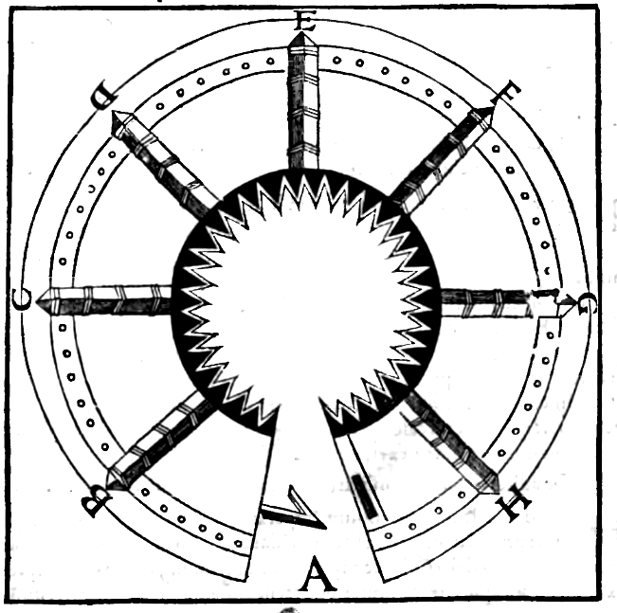
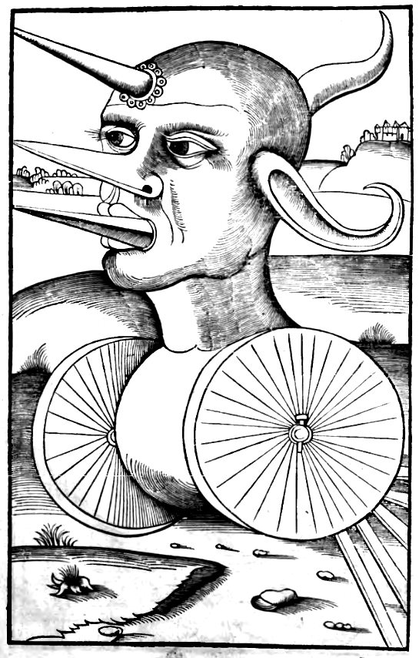
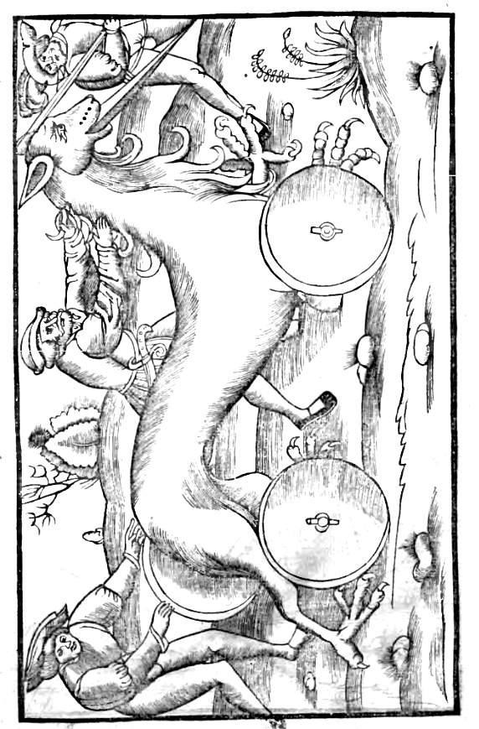
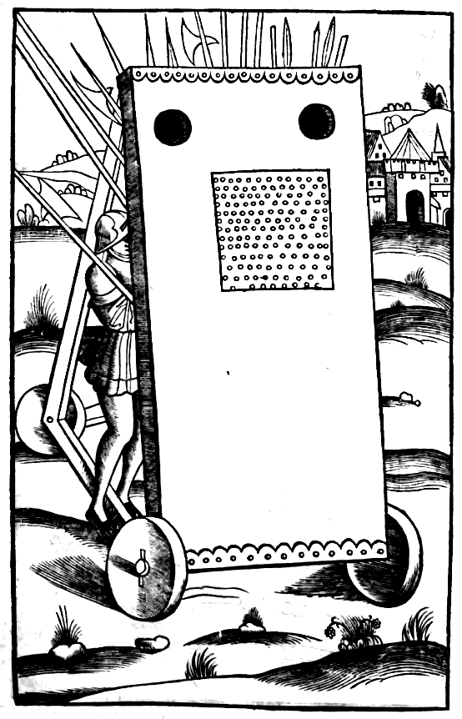
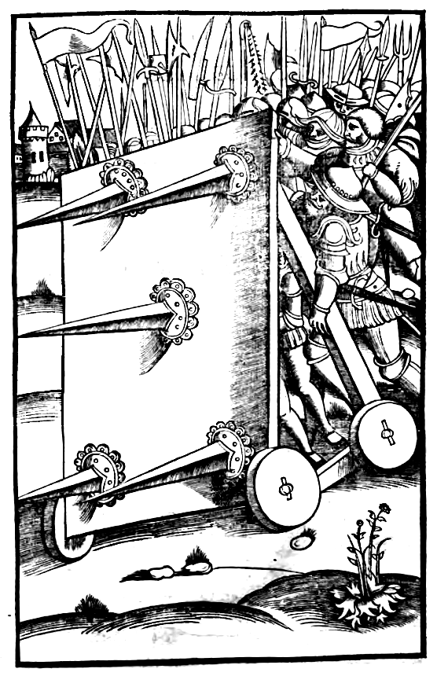
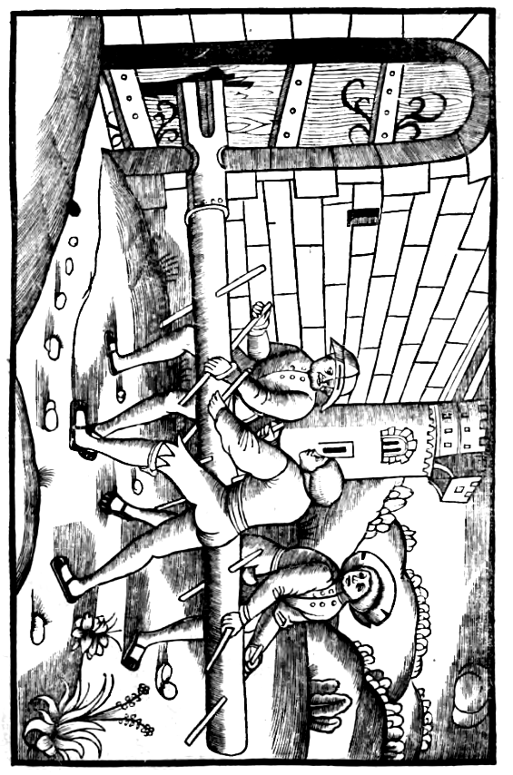
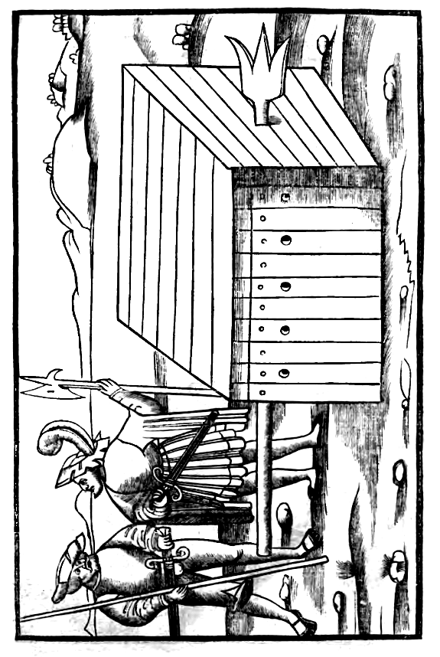
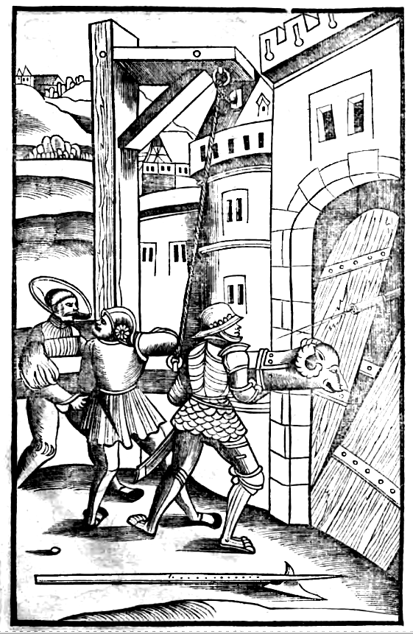
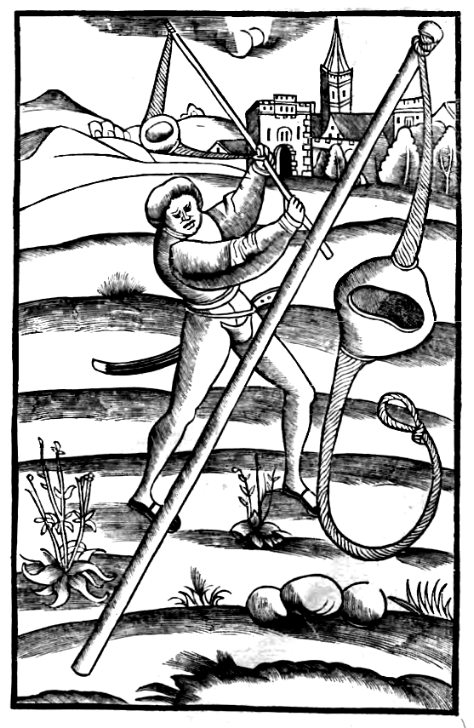
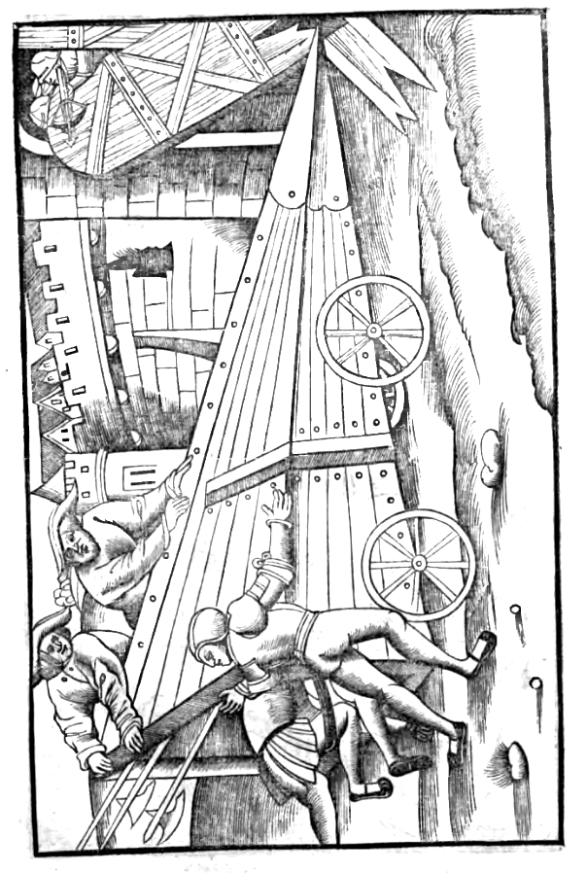
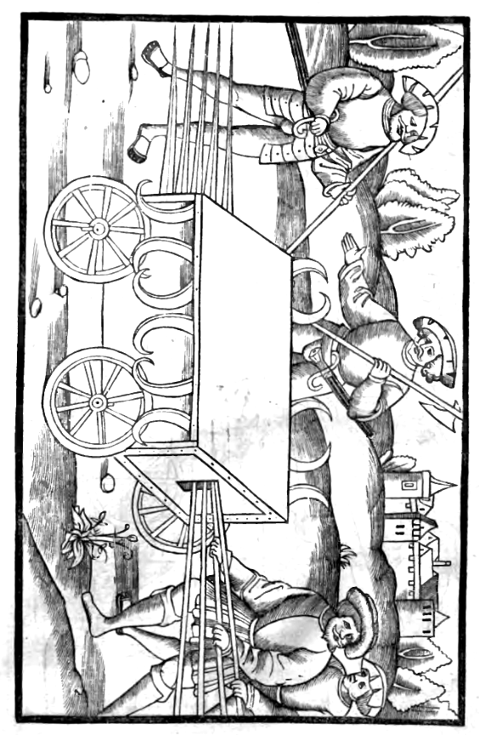
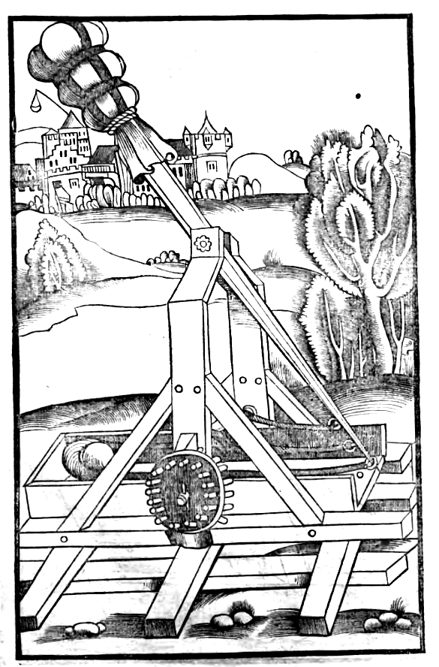
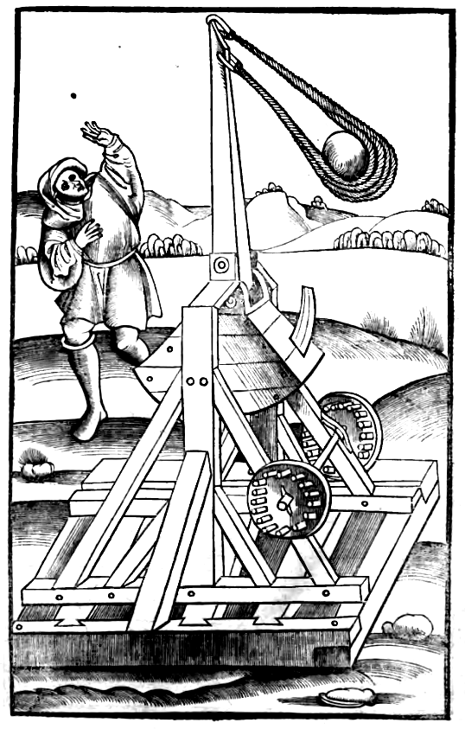
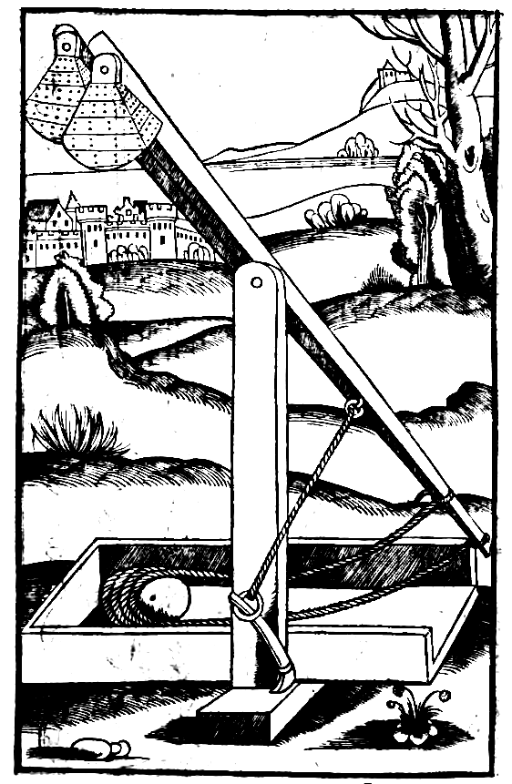
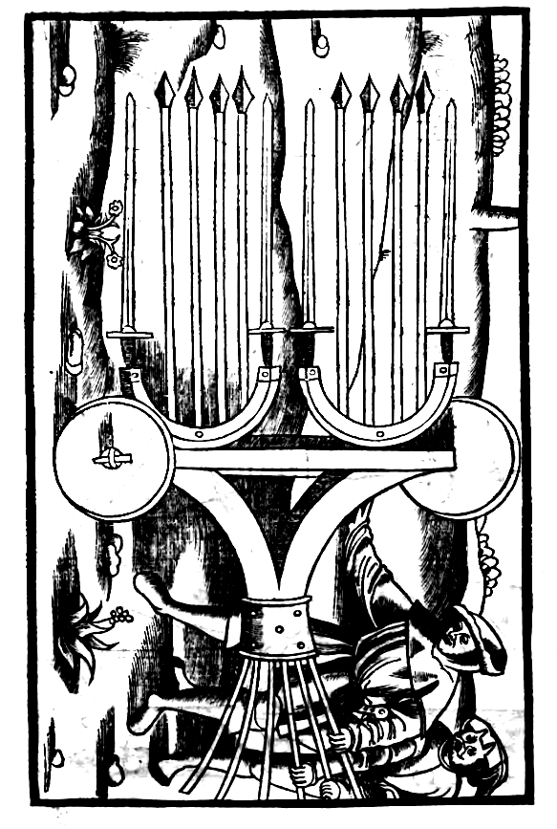
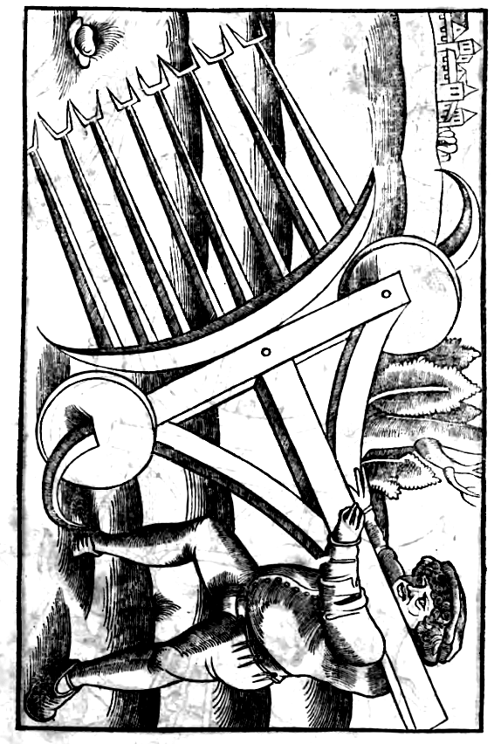
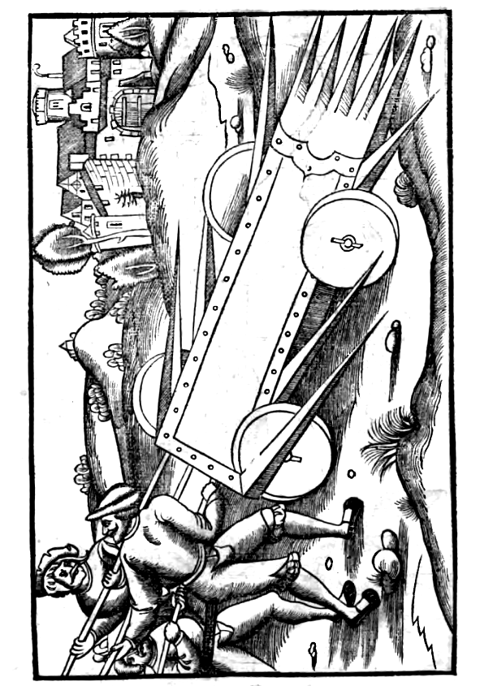
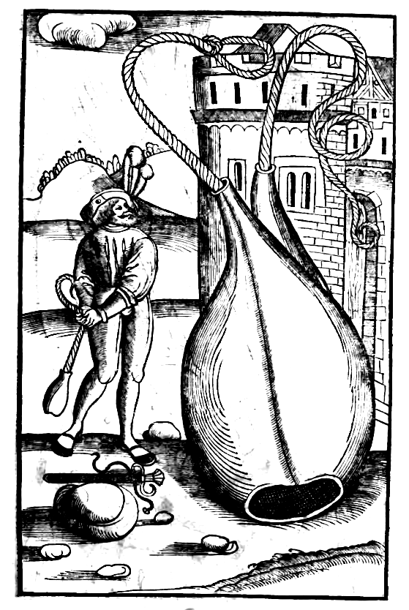
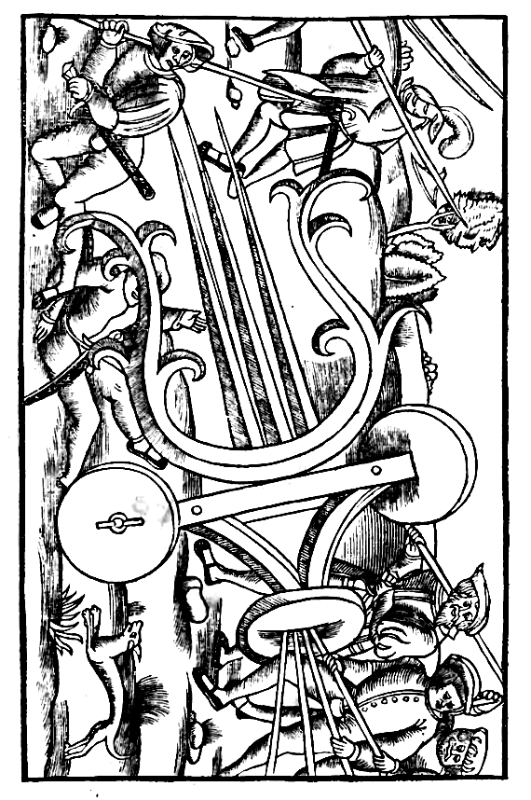
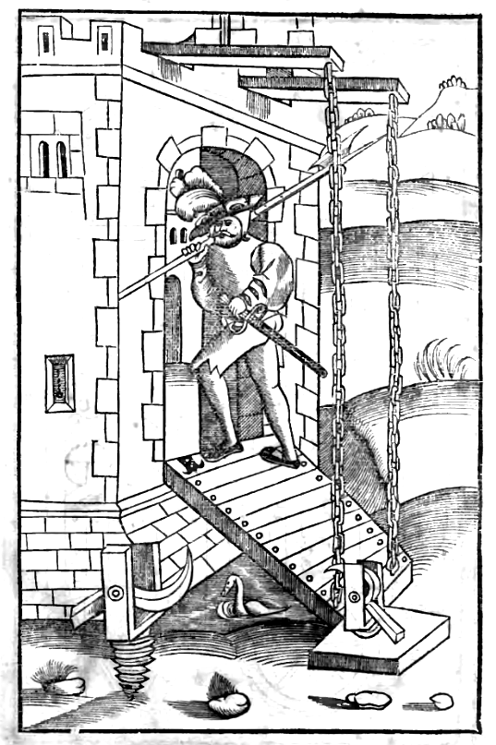
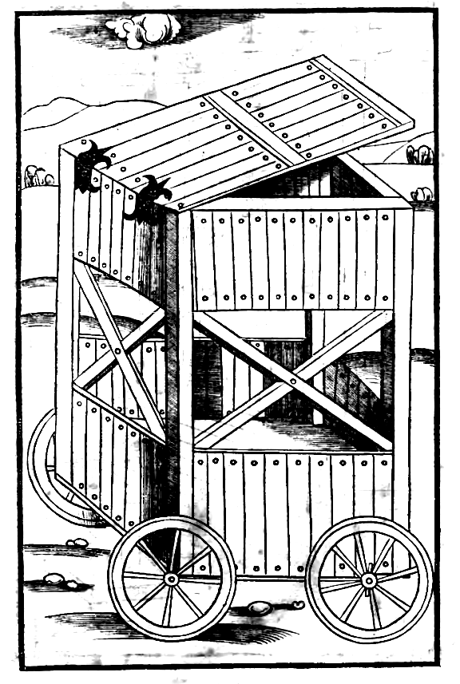
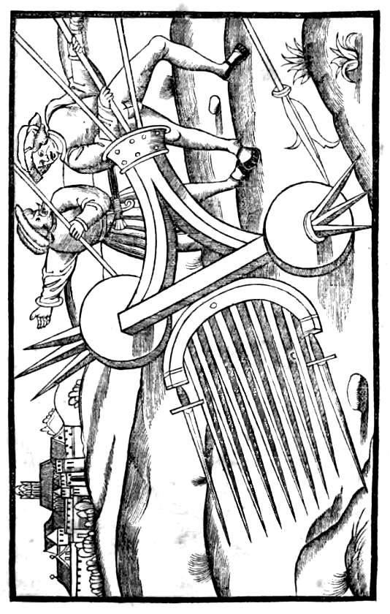
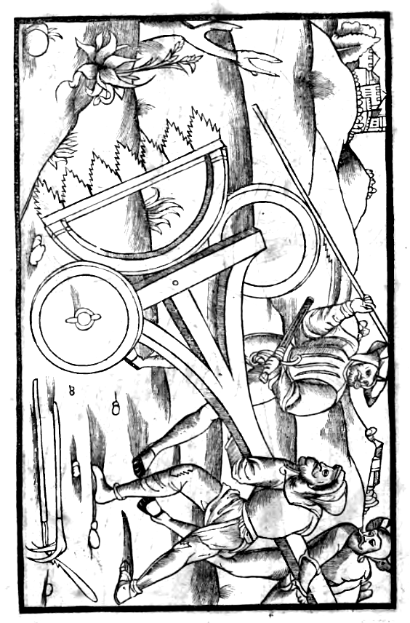
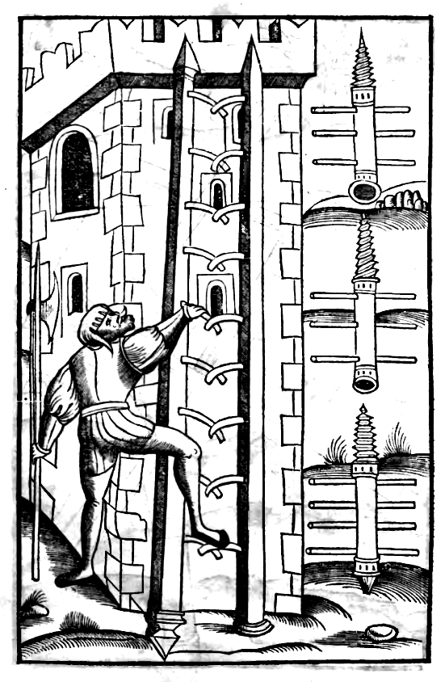
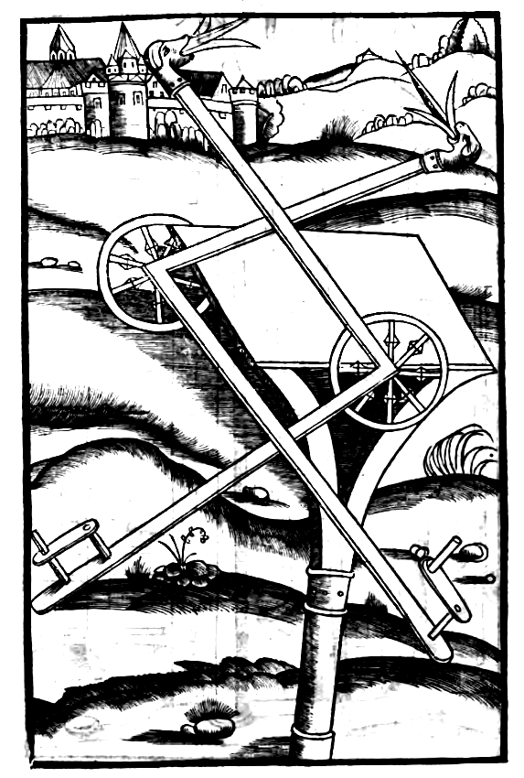
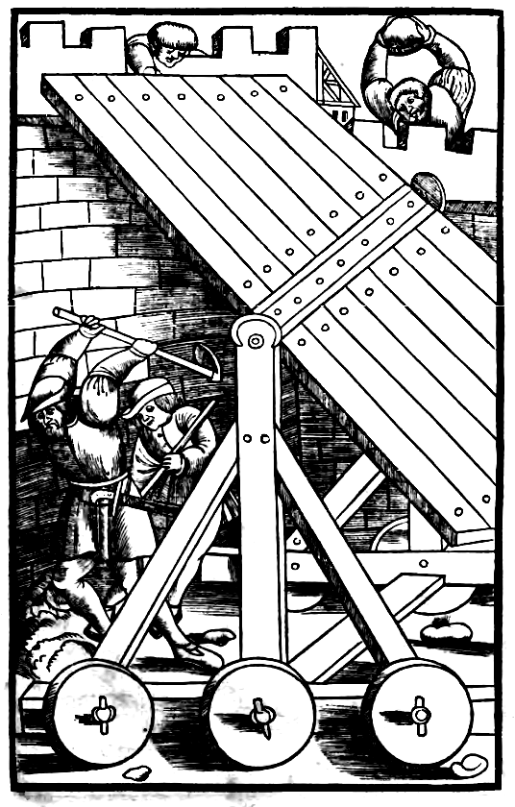
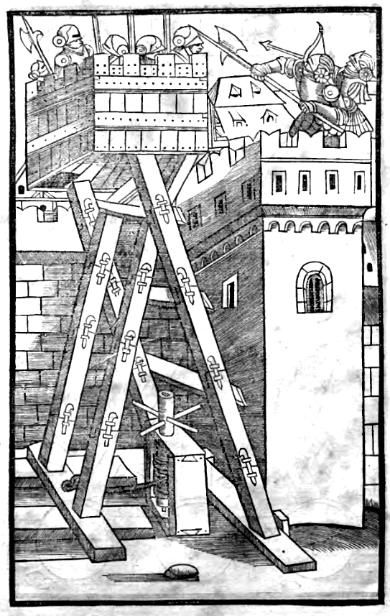
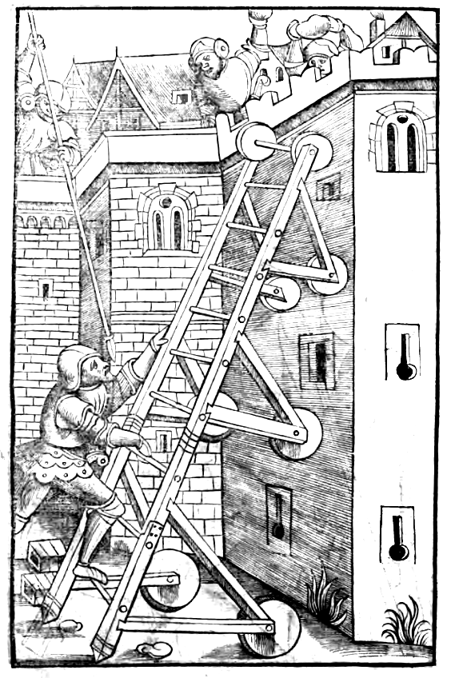
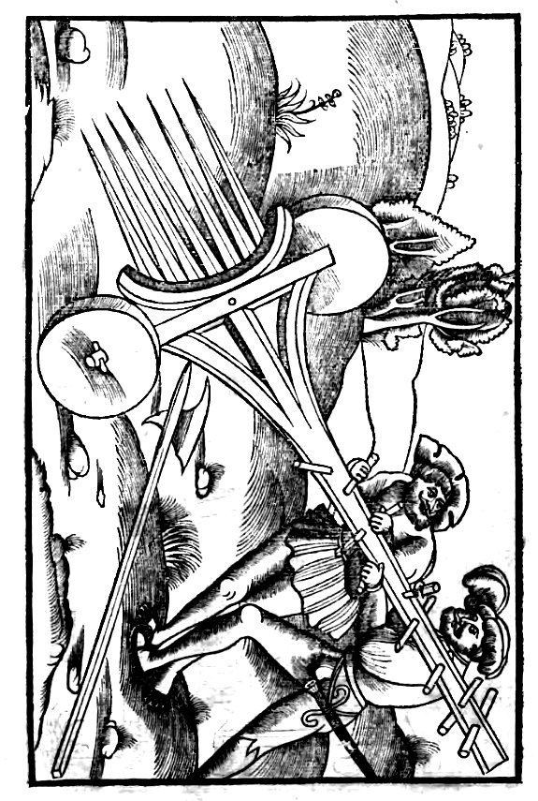
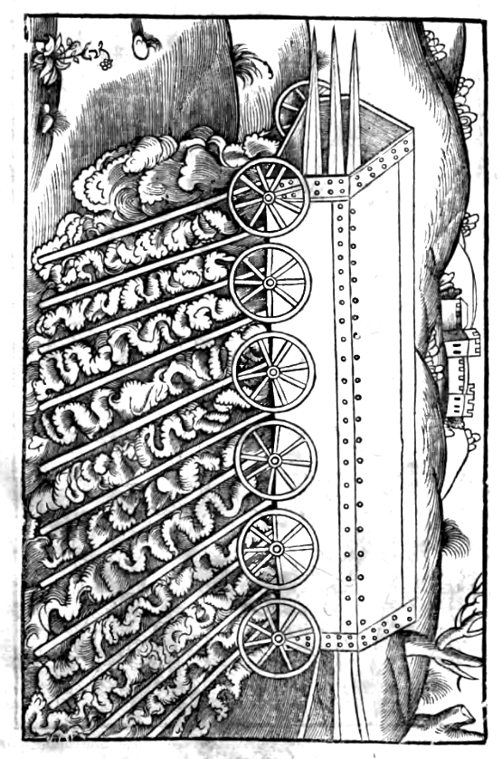
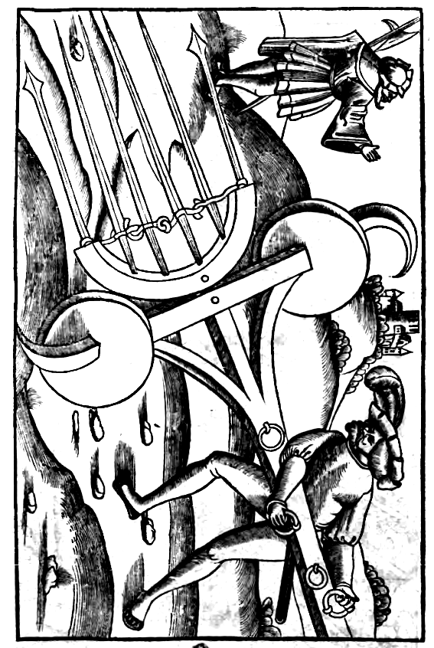
FLAVII VEGETII RENATI DE RE MILITARI

Libri secundi prologus.

Instituta maiorum artis armaturae, praecipue clementiam vestram peritissimeque retinere, continuis declaratur victoriis ac triumphis. Siquidem indubitata approbatio artis est, rerum semper effectus. Verum tranquillitas tua, Imperator inuicte, altiori consilio, quam mens poterat terrena concipere, ex libris antiqua desiderat, cum ipsam antiquitatem factis recentibus antecedat. Cum igitur haec literis breuiter comprehendere, maiestati vestrae non tam discenda quam recognoscenda praeciperer, certauit saepius deuotio cum pudore. Quid enim audacius, quam domino ac principi generis humani, domitori omnium gentium barbararum, de vsu ac disciplina insinuare bellorum? Nisi forte iussisses fieri quod ipse gessisses. Et rursum tanti Imperatoris non obedire mandatis, plenum sacrilegii videbatur atque periculi. Miro itaque modo in parendo audax factus sum, dum metuo videri audacior, si negassem. Ad quam temeritatem, praecedens me indulgentiae vestrae perennitas animauit. Nam libellum de delectu atque exercitatione tyronum, dudum tanquam famulus obtuli: nec tamen culpatus abscessi. Nec formido iussus aggredi opus, quod spontaneum cessit impune.

In quot genera dividatur res Militaris. Cap. I.
Res igitur militaris (sicut Latinorum egregius autor, carminis sui testatur exordio) armis constat & viris. Haec in tres diuiditur partes, Equites, Pedites, Classes. Equitum alae dicuntur, ab eo quod ad similitudinem alarum ab vtraque parte protegant acies: quae nunc vexillationes vocantur a velo, quia velis, hoc est, flammulis vtuntur. Est aliud genus equitum, qui legionarii vocantur, propterea quod connexi sunt legioni: ad quorum exemplum ocreati equites sunt instituti. Classium item duo genera sunt . Vnum liburnarum, aliud lusoriarum. Equitibus campi, classibus maria & flumina, peditibus colles, vrbes, plana & abrupta, seruantur. Ex quo intelligitur magis reip. [reipublicae] necessarios pedites: qui possunt vbique prodesse. Et maior numerus peditum, sumptu & expensa minore nutritur. Exercitus ex re ipsa atque opere exercitii, nomen accepit, vt ei nunquam liceret obliuisci, quod vocabatur. Verum ipsi pedites, in duas diuisi sunt partes , hoc est, in auxilia & legiones. [Sed] Auxilia a sociis, vel foederatis gentibus mittebantur. Romana autem virtus, praecipue in legionum ordinatione praepollet. Legio autem ab eligendo appellata est: quod vocabulum eorum desiderat fidem atque diligentiam, quibus milites probantur. In auxiliis minor, in legionibus longe amplior consueuit numerus militum asscribi [adscribi]

Quid inter legiones & auxilia intersit. Cap. II.
Denique Macedones, Graeci, Dardani, phalanges habuerunt, vt in vna Phalange armatorum octo milia censerentur. Galli atque Celtiberi, pluresque barbaricae nationes, cateruis vtebantur in praelio, in quibus erant sena milia armatorum. Romani legiones habent , in quibus singulis sena milia, interdum amplius, militare consueuerunt. Quid autem inter legiones & auxilia interesse videatur, expediam. Auxiliares conducuntur ad praelium, ex diuersis locis, ex diuersis muneribus venientes: nec disciplina inter se, nec noticia, nec affectione consentiunt. Alia instituta, alius inter eos est vsus armorum. Necesse est autem tardius ad victoriam perueniri, qui discrepant antequam dimicent. Denique cum in expeditionibus plurimum prosit, omnes milites vnius praecepti significatione conuerti, non posiunt aequaliter iussa complere, qui ante pariter non fuerunt. Tamen haec ipsa si solemnibus diuersisque exercitiis prope quotidie roborentur, non mediocriter iuuant. Nam legionibus semper auxilia, tanquam leuis armatura in acie iungebantur, vt in his praeliandi magis adminiculum esset quam principale subsidium. Legio autem propriis cohortibus plena, cum grauem armaturam, hoc est, principes hastarios, triarios, antesignanos: item leuem armaturam, hoc est, ferentarios [ferrentarios], sagittarios, funditores, balistarios, cum proprios & sibi impositos equites legionarios, iisdem matriculis teneat: cum vno animo parique consensu castra muniat, aciem instruat, praelium gerat, ex omni parte perfecta nulloque extrinsecus indigens adiumento, quamtam libet hostium multitudinem superare consueuerat. Documentum est magnitudo Romana, quae semper cum legionibus dimicans, tantum hostium, vicit, quantum vel ipsa voluit, vel rerum natura permisit.

Quae causa exhauriri fecerit legiones. Cap. III.
Legionum nomem in exercitu permanet hodie, sed per negligentiam superiorum temporum, robur infractum est cum virtutis praemia occuparet ambitio, & per gratiam promouerentur milites, qui promoueri consueuerant per laborem. Deinde contubernalibus, completis stipendiis, per testimoniales ex more dimissis, non sunt alii substituti. Praeterea necesse est, morbo aliquantos debilitari atque dimitti: aliquantos militiam deserere, vel diuersis casibus interire: vt nisi annis singulis, imo singulis pene mensibus in recedentium locum iuniorum turba succedat, quamuis copiosus exhauriatur exercitus. Est & alia causa, cur attenuatae sint legiones. Magnus in illis labor est militandi, grauiora arma, sera munera, seuerior disciplina. Quod vitantes plerique in auxiliis saepe festinant militiae sacramenta percipere, vbi & minor sudor & maturiora sunt praemia. Cato ille maior, cum & armis inuictus esset, & consul exercitum saepe duxisset, plus se reip. [reipublicae] credidit profuturum, si disciplinam militarem conferret in literas. Nam vnius aetatis sunt res quae fortiter fiunt, quae vero pro vtilitate reip. [reipublicae] scribunturae, terna sunt. Idem fecerunt alii complures, sed praecipue Frontinus scribes diuo Traiano ob eiusmodi comprobatur industriam. Horum instituta, horum praecepta, inquantum valeo strictim fideliterque signabo. Nam cum easdem expensas faciat & diligenter & negligenter exercitus ordinatus, non solum praesentibus, sed etiam futuris seculis proficiet: si prouisione maiestatis tuae, imperator Auguste, & fortissima dispositio reparetur armorum, emendetur dissimulatio praecedentium.

Quotenas legiones antiqui ad bellum duxerunt. Cap. IIII.
In omnibus autoribus inuenitur, singulos consules aduersus hostes copiosissimos, non amplius quam binas duxisse legiones, additis auxiliis sociorum. Tanta in illis erat exercitatio, tanta fiducia, vt cuiuis bello dux legiones crederentur posse sufficere. Quapropter ordinationem legionis antiqua: secundum normam militaris iuris exponam. Quae descriptio si obscurior aut impolitior videbitur, non mihi, sed difficultati ipsius rei conuenit imputari. Attento itaque animo saepius relegenda sunt vt memoria intelligentiaque valeant comprehendi. Necesse est enim inuictam esse rempub. [rempublicam] cuius Imperator militari arte percepta, quantos voluerit faciat exercitus bellicosos.

Quemadmodum legio constituatur. Cap. V.
Diligenter igitur lectis iunioribus, animis corporibusque, praestantibus, additis etiam exercitiis quotidianis, quatuor vel eo amplius mensium, iussu auspiciisque inuictissimi principis legio formant. Nam puncturis in cute punctis milites scripti & matriculis inferti iurare solent. Et ideo militiae sacramenta dicuntur. Iurant autem per deum Christum & spiritum sanctum, & per maiestatem imperatoris, quae secundum deum generi humano diligenda est & colenda. Nam imperatori, cum Augusti nomen accepit, tanquam praesenti & corporali deo fidelis est praestanda deuotio, & impendendus peruigil famulatus. Deo enim vel priuatus, vel militans seruit, cum fideliter eum diligit, qui deo regnat autore. Iurant autem milites omnia se strenue facturos, quae praceperit Imperator, nunquam deserturos militiam, nec mortem recusaturos pro Romana rep. [republica]

Quot cohortes in vna sint legione, item quot milites in vna cohorte. Cap. VI.
Sciendum est autem in vna legione decem cohortes esse debere. Sed prima cohors reliquas, & numero militum, & dignitate praecedit. Nam genere & institutione literarum viros electissimos quaerit. Haec enim suscipit aquilam, quod praecipuum signum in Romano est semper exercitu, & totius legionis insigne. Haec imagines imperatorum, hoc est diuina & praesentia signa venerant. Habet pedites mille centum quinque. Equites loricatos centum triginta duos: & appellatur cohors miliaria. Haec caput est totius legionis, ab hac, cum pugnandum est, prima acies incipit ordinari. Secunda cohors habet pedites .555. Equites loricatos .66. & appellat cohors quingentaria. Tertia cohors similiter habet pedites .555. Equites .66. sed in hac cohorte tertia, validiores probari moris est, qua in media acie consistit. Cohors quarta habet pedites quingentos quinquaginta quinque. Equites 66. Cohors quinta habet totidem. Sed & ipsa strenuos desiderat milites: quia sicut prima in dextro, ita quinta in sinistro ponitur cornu. Hae quinque cohortes in prima acie ordinantur. Sexta cohors habet pedites .555. Equites 66. In ipsa quoque enucleati asscribendi sunt iuniores: quia in secunda acie post Aquilam & Imagines cohors sexta consistit. Cohors septima habet pedites .555. Equites 66. Cohors octaua habet pedites .555. Equites 66. Sed & ipsa animosos desiderat viros: quia in secunda acie consistit media. Cohors nona habet pedites .555. Equites 66. Cohors decima habet pedites .555. Equites .66. & ipsa bonos accipere consueuit bellatores: qua in secunda acie sinistrum possidet cornu. His decem cohortibus legio plena fundatur, quae habet pedites sex milia centum, equites septingentos viginti sex. Minor itaque numerus armatorum in vna legione esse non debet. Maior autem interdum esse consueuit, si non tantum vnam cohortem, sed etiam alias miliarias fuerit iussa suscipere.

Nomina & gradus principiorum legionum. Cap. VII.
Antiqua ordinatione legionis exposita, principalium militum , & (vt proprio vtar vocabulo) principiorum nomina & dignitates secundum praesentes matriculas indicabo. Tribunus maior per epistolam sacram imperatoris iudicio destinatur. Minor tribunus prouenit ex labore. Tribunus autem vocatur a tribu, tribuendoque iure: quia praeest militibus, quos ex tribu primus Romulus legit. Ordinarii dicuntur qui in praelio praesunt, & primos ordines ducunt. Augustales appellantur, qui ab Augusto ordinariis iuncti sunt. Flauiales item tanquam secundi augustales, a diuo Vespasiano sunt legionibus additi. Aquiliferi qui aquilam portant. Imaginarii , vel imaginiferi qui imperatorum imagines portant. Optiones ab optando appellati, quod antecedentibus aegritudine praepeditis, hi tanquam adoptati eorum, atque vicarii solent vniuersa curare. Signiferi qui signa portant: quos nunc draconarios vocant. Tesserarii qui tesseram per contubernia militum nunciant. Tessera autem dicitur praeceptum ducis, quo vel ad aliquod opus, vel ad bellum mouetur exercitus. Campigeni, hoc est, antesignani, ideo sic nominati, quia eorum opera atque virtute exercitii genus crescit in campo. Metatores qui praecedentes, locum eligunt castris. Beneficiarii , ab eo appellati quod promouentur beneficio tribunorum. Librarii , ab eo quod in libros referant rationes ad milites pertinentes. Tubicines, Cornicines, & Buccinatores qui tuba vel aereo cornu, vel buccina committere praelium solent. Armaturae duplares, quae binas consequuntur annonas. Simplares, quae singulas. Mensores , qui in castris ad podismum dimetiuntur loca, in quibus milites tentoria figant, vel hospitia in ciuitatibus praestant. Torquati duplares, Torquati simplares, quibus torques aureus solidus virtutis praemium fuit, quem qui meruisset, praeter laudem interdum duplas consequebatur annonas: duplares duas, simplares vnam. Erant & secundum annonam candidati duplares, candidati simplares. Hi sunt milites principales, qui priuilegiis muniuntur. Reliqui munifices appellantur, quia munia facere coguntur.

Nomina eorum qui antiquos ordines ducebant. Cap. VIII
Vetus autem consuetudo tenuit, vt ex primo principe legionis promoueretur Centurio primipili: qui non solum aquilae praeerat, verum etiam quatuor centurias hoc est, quadringentos milites, in prima acie gubernabat. Hic tanquam caput totius legionis merita consequebatur & commoda. Item primus hastatus duas centurias, id est, ducentos homines ducebat in acie secunda, quem nunc ducenarium vocant. Princeps autem primae cohortis centuriam & semis, hoc est, centum quinquaginta homines gubernabat. Ad quem prope omnia, quae in legione ordinanda sunt, pertinent. Item secundus hastatus centuriam & semis, id est, centum quinquaginta milites gubernabat. Triarius prior, centum homines regebat: sic decem centuriae cohortis primae, a quinque ordinariis regebantur: quibus magnae vtilitates & magnus honor est a veteribus constitutus: vt caeteri milites ex tota legione omni labore ac deuotione contenderent ad tanta praemia, peruenire. Erant etiam centuriones qui singulas centurias curabant: qui nunc centenarii nominantur. Erant decani, denis militibus praepositi: qui nunc caput contubernii vocantur. Secunda cohors habebat centuriones quinque. Similiter tertia, quarta, quinta, vsque ad decimam cohortem in tota autem legione erant centuriones quinquagintaquinque.

De officio praefecti legionis. Cap. IX.
Sed legati Imperatoris ex consularibus ad exercitus mittebantur, quibus legiones & auxilia vniuersa obtemperabant in ordinatione pacis vel necessitate bellorum, in quorum locum nunc illustres viros constat magistros militum substitutos a quibus non tantum binae legiones, sed etiam plures numero gubernantur. Proprius autem iudex erat praefectus legionis, habens communem primi ordinis dignitatem, qui absente legato, tanquam vicarius ipsius potestatem maximam retinebat. Tribuni vel centuriones, caeterique milites, eius praecepta seruabant. Vigiliarum siue profectionis tessera petebatur ab eodem. Si miles crimen aliquod admisisset, autoritate praefecti legionis deputabatur a tribuno ad poenam. Arma omnium militum, item equi, vestes, annona, ad curam ipsius pertinebant. Disciplinae ius & seueritas & exercitatio, non solum peditum sed etiam equitum legionariorum, praecepto eius quotidie curabatur. Ipse autem custos diligens & sobrius, legionem sibi creditam assiduis operibus ad omnem deuotionem, ad omnem afformabat industriam: sciens ad praefecti laudem subiectorum redundare virtutem.

De officio praefecti castrorum. Cap. X.
Erat etiam castrorum praefectus, licet inferior dignitate, occupatus tarmen non mediocribus causis, ad quem castrorum positio, valli & fossae destinatio pertinebat. Tabernacula vel casae militum, cum impedimentis omnibus, nutu ipsius curabantur. Praeterea aegri contubernales & medici a quibus curabantur, expensae, etiam ad eius industriam pertinebant. Vehicula, sagittarii, necnon etiam ferramenta, quibus materies secatur vel caeditur, quibusque aperiuntur fossae circa situm valli & aquae ductus. Item ligna vel stramina, arietes, onagri, balistae, caeteraque genera tormentorum, ne deessent aliquando procurabat. Is post longam probatamque militiam peritissimus omnium legebatur: vt recte doceret alios quod ipse cum laude fecisset.

De officio praefecti fabrorum Cap. XI.
Habet praeterea legio fabros lignarios, instructores, carpentarios, ferrarios, pictores, reliquosque artifices ad hybernorum aedificia fabricanda, ad machinas, turres ligneas, caeteraque quibus vel expugnantur aduersariorum ciuitates, vel defenduntur propiae, praeparatos: qui arma, qui vehicula caeteraque genera tormentorum vel noua facerent, vel quassata repararent. Habebant etiam fabricas scutarias, loricarias, arcuarias, quibus sagittae, missilia, cassides, omniaque armorum genera formabantur. Haec enim erat cura praecipua, vt quicquid exercitui necessarium videbatur, nunquam deesset in castris: vsque eo, vt etiam cunicularios haberent, qui ad morem Bessorum, ducto sub terris cuniculo, murisque intra fundamenta perfossis, improuisi emergerent ad vrbes hostium capiendas. Horum iudex erat proprius praefectus fabrorum.

De officio tribuni militum Cap. XII.
Decem cohortes habere legionem diximus: sed prima erat miliaria, in qua censu, genere, literis, forma, virtute, pollentes milites mittebantur. Huic tribunus praeerat, armorum scientia, virtute corporis, morum honestate praecipuus. Reliquae cohortes, prout principi placuisset, a tribunis vel a praepositis regebantur. Tanta autem seruabatur exercendi milites cura, vt non solum tribuni vel praepositi contubernales sibi creditos, sub oculis suis iuberent quotidie meditari, sed etiam ipsi armorum arte perfecti, caeteros ad imitationem proprio cohortarentur exemplo. Tribuni autem solicitudo per hanc laudatur industriam: cum miles veste nitidus, armis bene munitus ac fulgens, exercitii vsu & disciplina eruditus incedit.

De centuriis atque vexillis peditum Cap. XIII.
Primum signum totius legionis est Aquila, quam aquilifer portat. Dracones etiam per singulas cohortes a draconariis feruntur ad praelium. Sed antiqui, quia sciebant in acie commisso bello celeriter ordines aciesque turbari atque confundi, ne hoc posset accidere, cohortes in centurias diuiserunt, & singulis centuriis singula vexilla, constituerunt: ita vt ex qua cohorte vel quota esset centuria in illo vexillo literis esset ascriptum, quod intuentes vel legentes milites, in quantouis tumultu, a contubernalibus suis aberrare non possent. Centuriones insuper, qui nunc centenarii vocantur, nimium bellicosos loricatos, transumptis cassidum cristis, vt facilius noscerentur, singulas iusserunt gubernare centurias: qua tenus nullus error existeret, cum centeni milites sequerentur, non solum vexillum suum, sed etiam centurionem qui signum habebat in galea. Rursus ipsae centuriae in contubernia diuisae sunt: vt decem militibus sub vno papilione degentibus vnus quasi praeesset decanus, qui caput contubernii nominatur. Contubernium autem manipulus vocabatur, ab eo quod coniunctis manibus pariter dimicabant.

De turmis equitum legionariorum. Cap. XIIII.
Qvemadmodum inter pedites centuria vel manipulus appellatur, ita inter equites turma dicitur. Et habet vna turma equites 32. Huic qui praeest, Decurio nominatur. Centum enim pedites ab vno centurione, sub vno vexillo gubernantur: similiter 32. equites ab vno decurione, sub vno vexillo reguntur. Praeterea sicut centurio eligendus est magnis viribus, procera statura, qui hastas vel missilia perite iaculetur & fortiter, qui dimicare gladio, qui scutum rotare doctissime nouerit, qui omnem artem didicerit armaturae, vigilans, sobrius, agilis, magis ad facienda quae ei imperantur, quam ad loquendum paratus: contubernales suos ad disciplinam retineat, & ad armorum exercitium cogat, vt bene vestiti & calciati sint, vt arma omnium defricentur ac splendeant: similiter eligendus est decurio qui turmae equitum praeponatur, imprimis habili corpore, vt loricatus & armis circundatus omnibus, cum summa admiratione equum possit ascendere, equitate fortissime, conto scienter vti, sagittas doctissime mittere, turmales suos, id est, sub cura sua equites positos erudire ad omnia quae equestris pugna deposcit: eosdem cogere loricas suas vel cataphractas, contos suos & cassides frequenter tergere & curare. Plurimum enim terroris hostibus armorum splendor importat. Quis credat militem bellicosum, cuius dissimulatione situ ac rubigine arma foedantur? Non solum autem equites, sed etiam ipsos equos assiduo labore conuenit edomari. Itaque ad decurionem & sanitatis & exercitationis tam hominum quam equorum pertinet cura.

Qvuemadmodum legionum acies instruantur. Cap. XV.
Nvnc qualiter instruenda sit acies, si pugna immineat, declaretur vnius legionis exemplo: quod, si vsus exegerit, transferri possit ad plures legiones. Equites locantur in cornibus. Acies peditum a prima cohorte incipit ordinari in cornu dextro. Huic cohors secunda coniungitur. Tertia cohors in media acie collocatur. Huic annectitur quarta. Quinta vero cohors sinistrum suscipit cornu. Sed ante signa, & citra signa, nec non in prima acie dimicantes, principes vocabantur, hoc est, ordinarii, caeterique principales. Haec erit grauis armatura, qui habebant cassides, cataphractas, ocreas, scuta, gladios maiores, quos spathas vocant, & alios minores, quos semispathas nominant, plumbatas quinas positas in scutis, quas primo impetu iaciunt. Item bina missilia, vnum maius, ferro triangulo, vnciarum nouem, hastili pedum quinque & semis, quod pilum vocabant, nunc spiculum dicitur, ad cuius ictum praecipue exercebantur milites, quod arte & virtute directum, & scutatos pedites, & loricatos equites saepe transuerberat: aliud minus, ferro triangulo vnciarum quinque, hastili trium pedum & semis, quod tunc verriculum, nunc verutum dicitur. Prima acies principum. Secunda hastatorum, armis talibus docetur instructa. Post hos erant ferentarii & leuis armatura quos nunc auxiliatores & armaturas dicimus. Scutati qui plumbatis vel gladiis & missilibus accincti, sicut nunc omnes prope milites videntur, armati erant. Item sagittarii cum cassidibus, cataphractis & gladiis, sagittis & arcubus. Erant Funditores, qui ad fundas vel fastibalos [fustibalos] lapides laciebant. Erant tragularii, qui ad manubalistas vel arcubalistas dirigebant sagittas. Secunda acies similiter armabatur: in qua consistentes milites, hastati vocabantur. Sed in secunda acie, dextro cornu, cohors sexta ponebatur: cui iungebatur septima. Octaua cohors mediam aciem tenebat, nona comitante. Decima cohors in secunda acie sinistrum semper obtinebat cornu.

Quemadmodum triarii vel centuriones armentur. Cap. XVI.
Post omnes autem acies, Triarii cum scutis, cataphractis & galeis ocreati cum gladiis, semispathis, plumbatis & binis missilibus locabantur, qui genu posito subsidebant, vt, si prima acies vinceretur, ab his quasi de integro reparata pugna posset reparare victoriam. Omnes autem signarii vel signiferi, quamuis pedites, loricas minores accipiebant, & galeas ad terrorem hostium vrsinis pellibus tectas. Centuriones vero habebant cataphractas, scuta, & galeas ferreas: sed transuersis & argentatis cristis, vt facilius agnoscerentur a suis.

Commissa pugna grauem armaturam stare pro muro. Cap. XVII.
Illud autem sciendum est, & modis omnibus retinendum: commisso bello, prima ac secunda acies stabat immota. Triarii quoque residebant. Ferentarii autem armaturae & scutatores, sagittarii, funditores, hoc est, leuis armatura aduersarios prouocabant ante aciem procedentes: si hostes fugare poterant, sequebantur: si eorum virtute ac multitudine premebantur, reuertebantur ad suos & post eos stabant. Excipiebat autem praelium grauis armatura, & tanquam murus (vt ita dicam) ferreus stabat: & non solum missilibus, sed etiam gladiis cominus dimicabant. Et si hostes fugassent, non sequebatur grauis armatura, ne aciem suam ordinationemque perturbaret, & ad dispersos recurrentes hostes, incompositos opprimerent: sed leuis armatura cum funditoribus, sagittariis, & equitibus, fugientes sequebatur inimicos. Hac dispositione atque cautela sine periculo legio vincebat, aut superata seruabatur incolumis: quia ius legionis est, facile nec fugere nec sequi.

Nomina militum & gradus in scutis corum aduersis scribenda. Cap. XVIII.
Sed ne milites aliquando in tumultu praelii a suis contubernalibus aberrarent, diuersis cohortibus diuersa in scutis signa pingebant: quae ipsi nominant dogmata, sicut etiam nunc moris est fieri. Praeterea in aduerso scuto vniuscuiusque militis, literis erat nomem ascriptum, addito ex qua esset cohorte, quave centuria. Ex his ergo apparet legionem bene institutam, quasi munitissimam esse ciuitatem, quae omnia praelio necessaria secum vbique portaret, nec metueret repentinum hostium superuentum, quae etiam in mediis campis subito fossa se valloque muniret, quae omne genus militum contineret & armorum. Siquis igitur pugna publica superare Barbaros cupit, vt diuinitatis nutu, dispositione Imperatoris inuicti reparentur, ex tyronibus legiones votis omnibus petat. Intra breue autem temporis spacium, iuniores diligenter electi & exercitati, quotidie, non solum mane, sed etiam post meridiem, omni armorum disciplina vel arte bellandi, veteres illos milites, qui orbem terrarum integrum subegerunt, facile coaequabunt. Nec moueatur, Caesar, tua maiestas, quod olim consuetudo est mutata, quae viguit: sed huuis prouisionis ac foelicitatis est perennitas tua, vt pro salute reip. [reipublicae] & noua excogitet, & antiqua restituat. Omne opus difficile videtur antequam tentes [temptes], caeterum si exercitati & prudentes viri delectui praeponantur, celeriter manus bellis apta poterit aggregari & diligenter institui. Quiduis enim efficit solertia, si competentes non denegentur expensae.

Praeter corporis robur, notarum & computandi artem in tyronibus eligendam. Cap. XIX.
Sed quoniam in legionibus plures scholae sunt, quae literatos milites quaerunt ab his qui tyrones probant in omnibus quidem staturae magnitudinem, corporis robur, alacritatem animi, conuenit explorari. Sed in quibusdam notarum peritia, calculandi computandique vsus exigitur. Totius enim legionis ratio, siue obsequiorum, siue militarium numerorum, siue pecuniae quotidie asscribitur actis maiore prope diligentia, quam res annonaria, vel ciuilis, politicis libris annotatur. Quotidianas etiam in pace vigilias. Item excubitum siue angarias, de omnibus centuriis & contuberniis, quae vicissim milites faciunt, vt ne quis contra iusticiam [iustitiam] praegrauetur, aut alicui praestetur immunitas. Nomina eorum qui vices suas fecerunt, breuibus inferuntur. Quando quis commeatum acceperit, vel quot dierum annotatur in breuibus. Tunc enim difficile commeatus dabatur, nisi causis iustissimis approbatis. Nec aliquibus milites instituti deputabantur obsequiis, nec priuata iisdem negocia mandabantur. Siquidem incongruum videbatur, imperatoris militem, qui veste & annona publica pascebatur, vtilitatibus vacare priuatis. Ad obsequia tamen iudicum vel tribunorum, nec non etiam principalium deputabantur milites, qui vocabantur accensi, hoc est, postea additi quam fuisset legio completa, quos nunc Supernumerarios vocant. Fascicularia tamen, id est, lignum, foenum, aquam, stramen, etiam legitimi milites in castra portabant. Munifices enim ab eo appellantur, quod haec omnia munia faciant.

Donatiui partem dimidiam debent apud signa sequestrare milites seruandam. Cap. XX.
Illud vero ab antiquis diuinitus institutum est, vt ex donatiuo quod milites consequuntur, dimidia pars sequestraretur apud signa, & ibidem ipsis militibus seruaretur, ne per luxum aut inanium rerum comparationem, ad contubernalibus possit absumi. Plerique enim homines & praecipue pauperes tantum erogant quantum habere potuerit. Sepositio autem ista pecuniae, primum ipsis contubernalibus docetur accommoda. (Nam cum publica sustententur annona, ex omnibus donatiuis augetur eorum pro medietate castrense peculium) Miles deinde qui sumptus suos scit apud signa depositos, de deserendo nihil cogitat, magis diligit signa. Pro illis in acie fortius dimicat, more humani ingenii, vt pro illis habeat maximam curam, in quibus suam videt positam esse substantiam. Denique decem folles, hoc est, decem sacci, per cohortes singulas exponebantur, in quibus haec ratio condebatur. Addebatur etiam saccus vndecimus, in quem tota legio particulam aliquam conferebat, sepulturae scilicet causa, vt si quis ex contubernalibus defecisset, de illo vndecimo sacco ad sepulturam ipsius promeretur expensa. Haec ratio apud signiferos (vt nunc dicunt) in cophino seruabatur. Et ideo signiferi non solum fideles, sed etiam literati homines eligebantur, qui & seruarent deposita, & scirent singulis reddere rationem.

In legione ita fieri promotiones, vt per omnes cohortes transeant qui promouentur. Cap. XXI
Non tantum humano consilio, sed etiam diuinitatis instinctu, legiones arbitror a Romanis constitutas. In quibus decem cohortes ita sunt ordinatae, vt omnium vnum corpus, vna videatur esse coniunctio. Nam quasi in orbem quemdam per diuersas cohortes & diuersas scholas milites promouentur, ita vt ex prima cohorte ad gradum quempiam promotus vadat ad decimam cohortem: & rursus ab ea, crescentibus stipendiis, cum maiore gradu per alias recurrat ad primam. Ideo primipili centurio, postquam in orbem omnes cohortes per diuersas admistrauerit scholas, in prima cohorte ad hanc peruenit palmam, in qua ex omni legione infinita commoda consequitur. Sicut primicerius in officio praefectorum praetorio ad honestum quaestuosumque militiae peruenit gradum, ita legionarii equites cohortes suas contubernii affectione venerantur, cum naturaliter equites a peditibus soleant discrepare. Per hanc ergo contextionem in legionibus, & omnium cohortium equitum peditumque seruabatur vna concordia.

Quid inter tubicines & cornicines & classicum intersit. Cap. XXII.
Habet praeterea legio tubicines, cornicines, & buccinatores. Tubicines ad bellum vocant milites, & rursum receptui canentes reuocant. Cornicines & biccinatores erant ornamentum totius legionibus in ingressu conflictus & eius reditu. Hi quotiens canunt, non milites, sed signa ad eorum obtemperant nutum. Ergo quotiens ad aliquod opus exituri sunt soli milites, tubicines canunt, & soli milites ad signa eorum obtemperant. Quotiens mouenda sunt signa, cornicines canunt. Quotiens autem pugnatur, & tubicines & cornicines pariter canunt. Classicum item appellatur, quod buccinatores per cornu dicunt. Hoc insigne videtur imperii, quia classicum canitur imperatore praesente, vel cum in militem capitaliter animaduertitur: quia hoc ex imperatoris legibus fieri necesse est. Si vero ad vigilias vel angarias faciendas, siue ad opus aliquod vel ad decursionem campi exeunt milites, tubicine vocante operantur, & rursus tubicine admonente cessant. Cum autem mouentur signa, aut iam mota figenda sunt, cornicines canunt. Quod ideo in omnibus exercitiis & processionibus custoditur, vt in ipsa pugna facilius obtemperent milites, siue eos pugnare, siue stare, siue sequi, vel redire praeceperint duces. Siquidem ratio manifesta sit, semper in ocio debere fieri, quod necessario faciendum videtur in praelio.

De exercitatione militum. Cap. XXIII.
Legionis ordinatione digesta, ad exercitium reuertamur: vnde (sicut iam dictum est) exercitus nomen accepit. Iuniores quidem &: noui milites, mane & post meridiem ad omne genus exercebantur armorum. Veteres autem & eruditi sine intermissione semel in die exercebantur in armis. Necque enim longitudo aetatis, aut annorum numerus artem bellicam tradit, sed continua exercitationis meditatio: post quanta volueris stipendia, inexercitatus miles semper est tyro cum armatura quae festis diebus exhibetur in exercitio. Idcirco non tantum armaturam, qui sub campi doctore sunt, sed omnes aequaliter contubernales quotidiani meditatione discebant, & corporis velocitatem. Nam & velocitas vsu ipso acquiritur corporis, & scientia feriendi hostem seque protegendi, praesertim si gladiis cominus dimicetur. Illud vero maius est, vt seruare ordines discant, & vexillum suum in tantis permixtionibus in ipsa prolusione comitentur, nec inter doctos aliquis error existat, quamuis in multitudine sit tanta confusio. Ad palum quoque vel sudes iuniores exerceri percommodum est, cum latera vel pedes aut caput petere punctim caesimque condiscant. Saltus quoque & ictus facere pariter assuescant, insurgere tripudiantes in clypeum, rursusque subsidere, nunc gestiendo prouolare cum saltu, nunc cedentes in terga resilire. Missilibus etiam palos ipsos procul ferire meditentur, vt & ars dirigendi, & dextrae virtus possit accrescere. Sagittarii vero vel funditores, scopas , hoc est, fruticum vel straminum fasces, pro signo ponebant: ita vt sexcentis pedibus remouerentur a signo, vt sagittis vel certe lapidibus ex fustibalo destinatis, signum saepius tangerent. Propterea sine trepidatione in acie faciebant, quod ludentes in campo fecerant. Semper assuescendum est etiam, vt semel tantum funda circa caput rotetur, cum ex ea emittitur saxum. Sed & manu sola omnes milites meditabantur libralia saxa iactare: qui vsus paratior creditur, quia non desyderat [desiderat] fundam. Missilia quoque vel plumbatas iugiter perpetuoque exercitio dirigere cogebantur vsque adeo, vt tempore hyemis [hiemis] de tegulis vel scandulis, quae si deessent, certe de cannis, vlua vel culmo & porticus tegerentur ad equites, & quaedam velut basilicae ad pedites: in quibus tempestate vel ventis aëre turbato, sub tecto armis erudiebatur exercitus. Caeteris autem etiam hybernis [hibernis] diebus, si niues pluuiaeque cessarent, exerceri cogebantur in campo: ne intermissa consuetudine, animi militum debilitarentur & corpora, syluam caedere, portare onera, transilire fossas, natare in mari siue fluminibus, gradu pleno ambulare, vel currere etiam armatos cum sarcinis suis frequenquentissime [frequentissime] conuenit, vt quotidiani laboris vsus in pace, difficilis non videatur in bello. Siue ergo legio fuerit, siue auxilia, exerceantur assidue. Nam quemadmodum bene exercitatus miles praelium cupit, ita formidat indoctus. Postremo sciendum est, in pugna vsum amplius prodesse quam vires. Nam si doctrina cesset armorum, nihil paganus distat a milite.

Exempla adhortationum & exercitii militaris, de aliis artibus tracta. Cap. XXIIII.
Athleta, venator, auriga, propter exiguam mercedem, vel certe plebis fauorem, cotidiana meditatione artes suas aut seruare, aut augere consuescunt. Militem (cuius est manibus seruanda respub. [respublica]) studiosius oportet scientiam dimicandi vsumque rei bellicae iugibus exercitiis custodire: cui contingit non tantum gloriosa victoria, sed etiam amplior praeda: quemque ad opes ac dignitates ordo militiae & Imperatoris iudicium consueuit euehere. Artifices scaenici ab exercitiis pro laude vulgi non recedunt. Miles sacramento lectus, ab exercitiis armorum, vel nouellus vel iam vetustus cessare non debet, cui pugnandum est pro salute propria & libertate communi: praesertim cum antiqua sit prudensque sententia, omnes artes in meditatione consistere.

Enumeratio ferramentorum vel machinarum legionis. Cap. XXV.
Legio autem non tantum militum numero, sed etiam genere ferramentorum vincere consueuit. Primum omnium instruitur iaculis, quae nullae loricae, nulla possunt scuta sufferre. Nam per singulas centurias singulas carrobalistas habere consueuit, quibus muli ad trahendum, & singula contubernia ad armandum vel dirigendum, hoc est, vndecim homines, deputantur. Nam hae quanto maiores fuerint, tanto longius tela iaculantur. Non solum autem castra defendunt, verum etiam in campo post aciem grauis armaturae ponuntur. Ad quarum impetum, nec equites loricati, nec pedites scutati possunt obstare. In vna autem legione quinquaginta quinque carrobalistae esse solent. Item decem onagri, hoc est, singuli per singulas cohortes in carpentis bobus duobus portantur armatis: vt si forte hostes ad oppugnandum venerint vallum, sagittis & saxis possint castra defendi. Scaphas quoque de singulis trabibus excauatas, cum longissimis funibus, interdum etiam ferreis cathenis, secum legio portat: quatenus contextis eisdem (sicut dicunt) monoxylis, supertextis iniectisque tabulatis flumina quae sine pontibus vadari nequeunt, tam a peditibus quam ab equitatu sine periculo transeantur. Habet ferreos harpagones, quos lupos vocant, & falces ferreas confixas longissimis contis. Item ad fossarum opera facienda bidentes, ligones, palas, rastra, alueos, cophinos quibus portetur terra. Habet quoque dolabras, secures, ascias, ferras, quibus materia ac pali dolantur atque secantur. Habet praeterea artifices cum omnibus ferramentis, qui ad oppugnandas hostium ciuitates, testudines, musculos, arietes, vineas (vt appellant) turres etiam ambulatorias faciant. Verum ne singula enumerando plura dicantur, vniuersa quae in quoque belli genere necessaria esse creduntur, secum legio debet vbique portare, vt in quouis loco fixerit castra, armatam faciat ciuitatem.

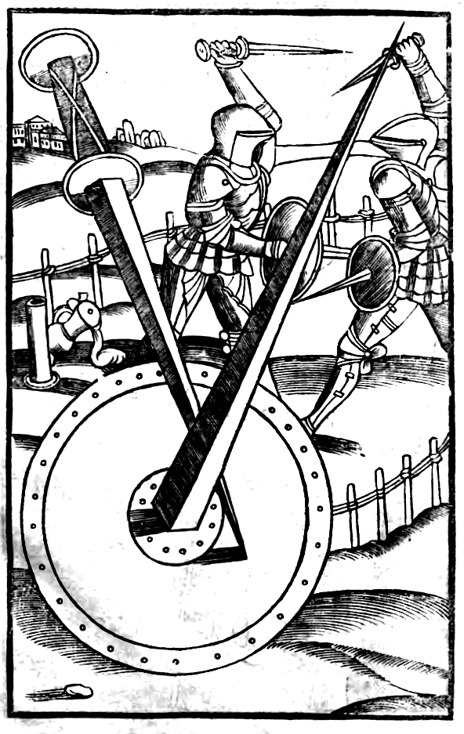
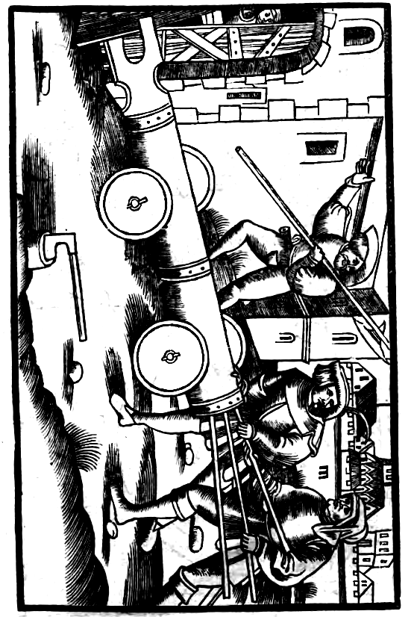

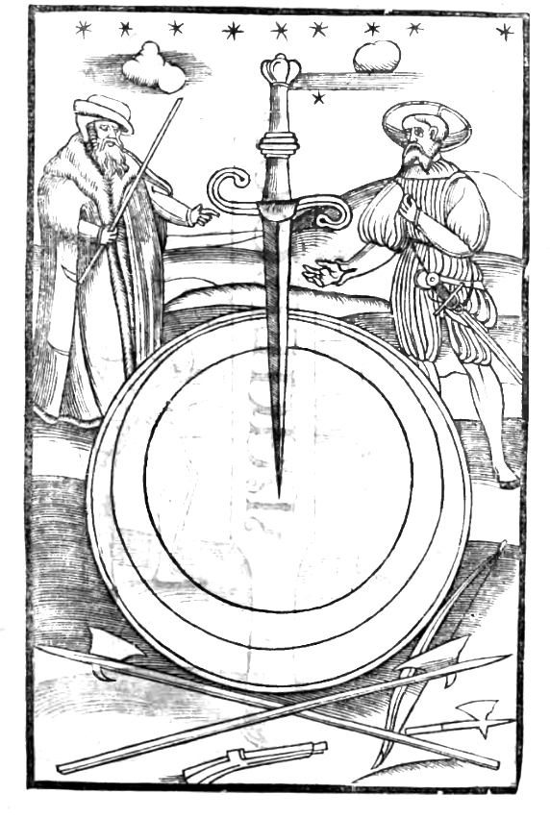
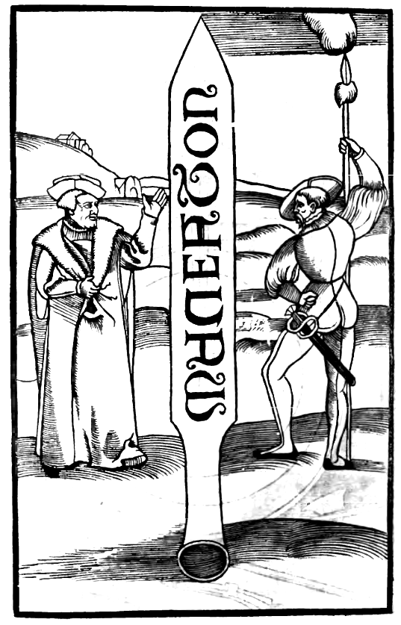
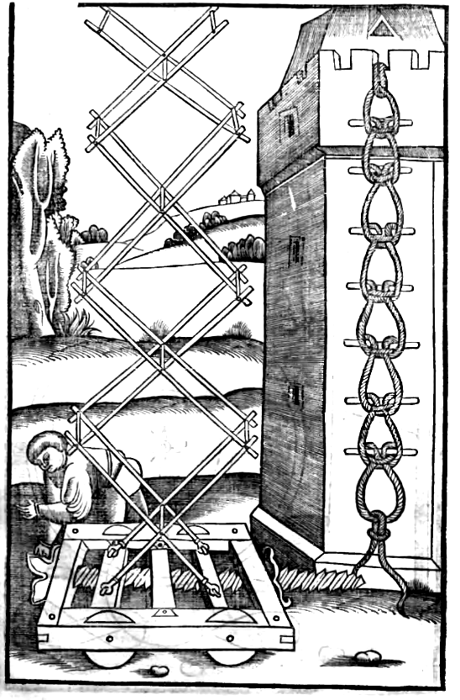
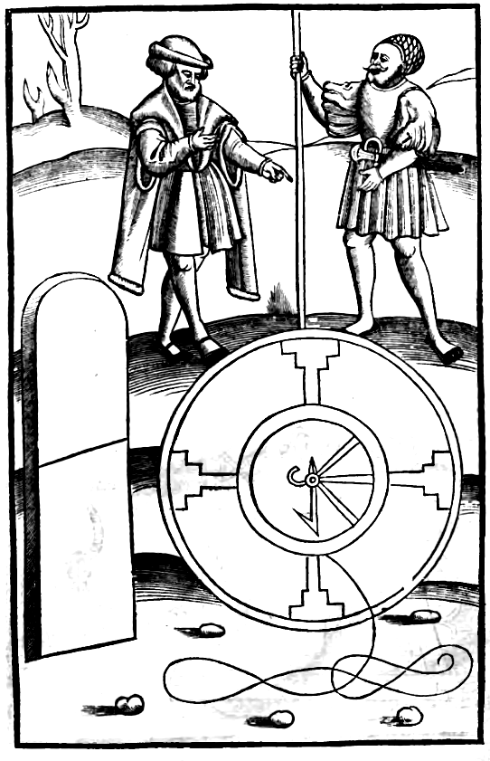
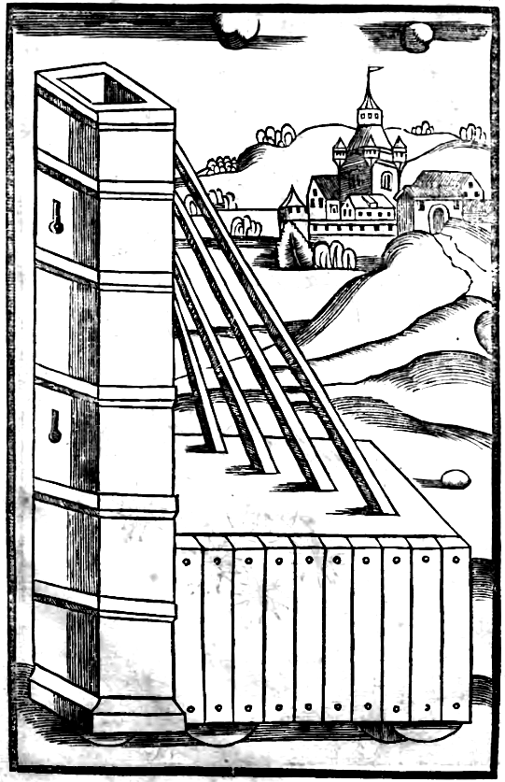
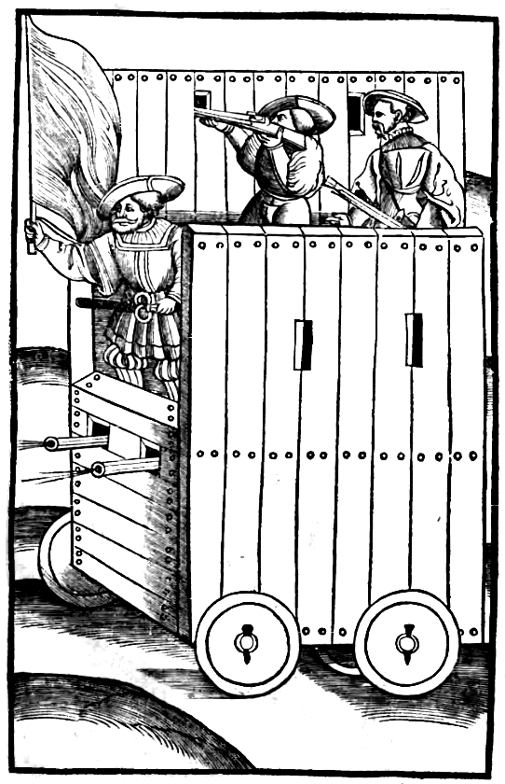
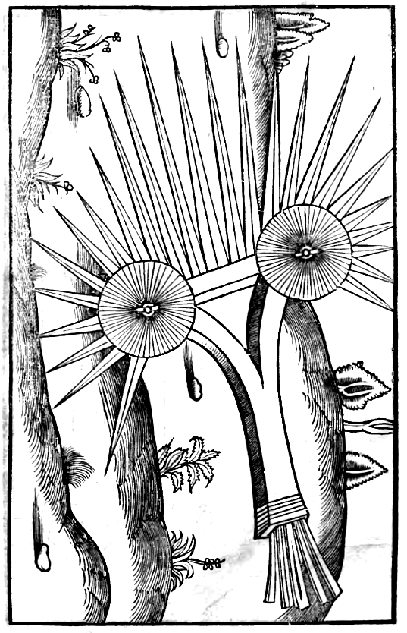
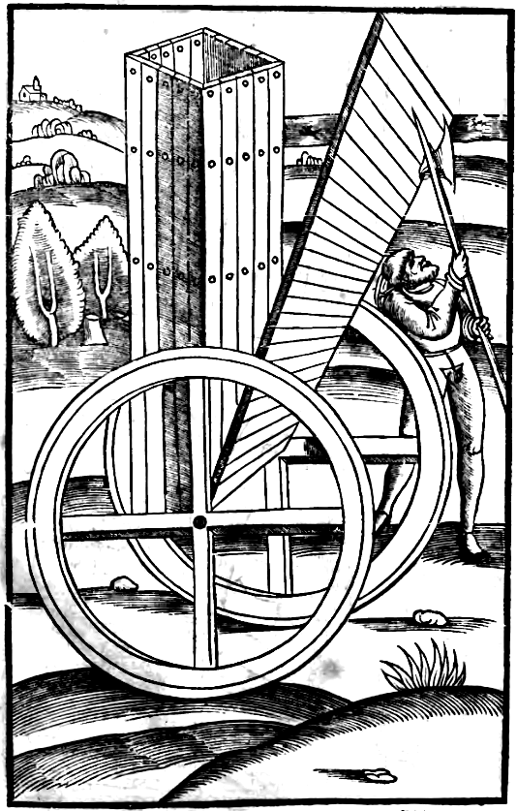
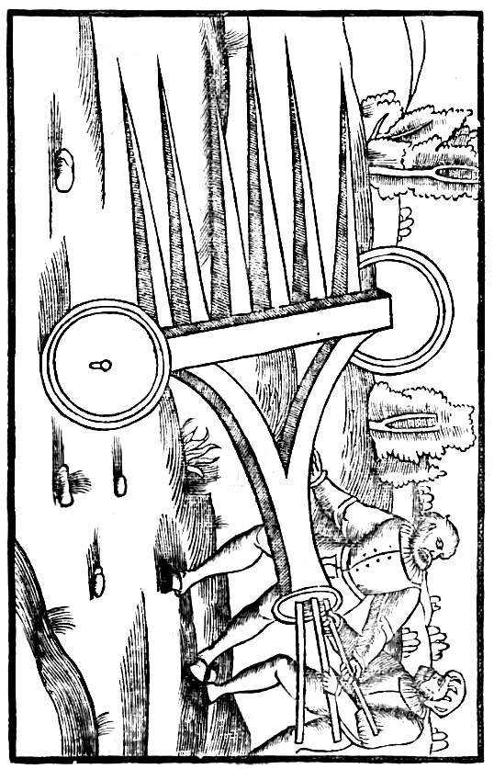
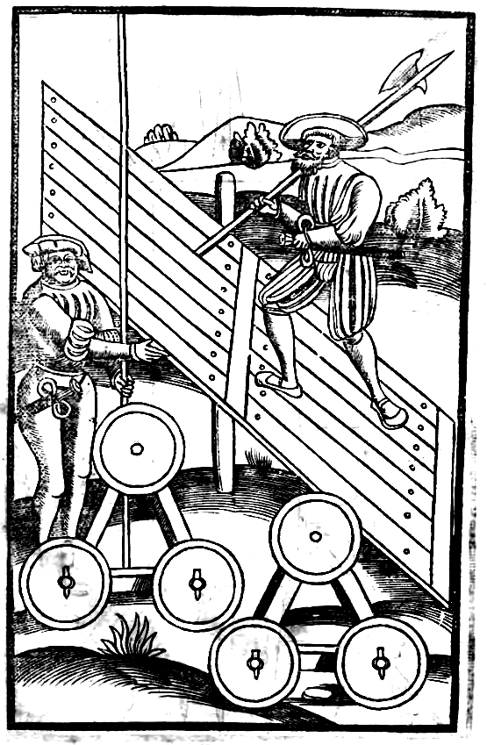
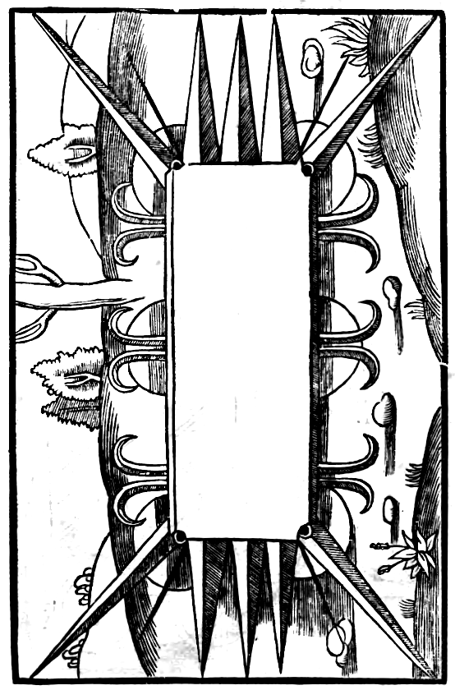
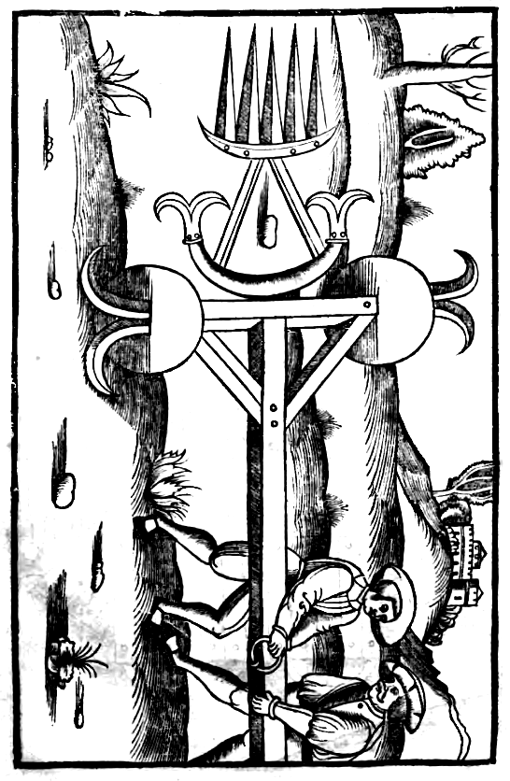
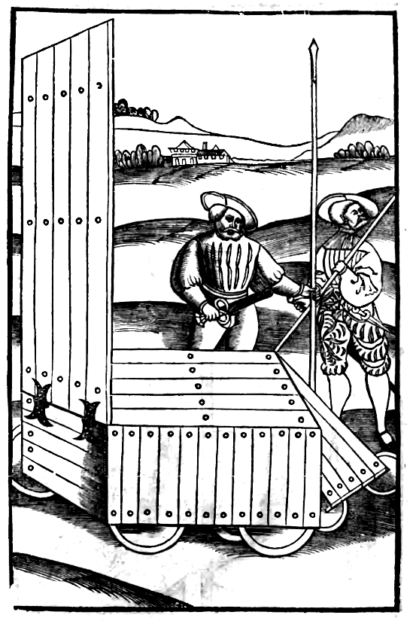
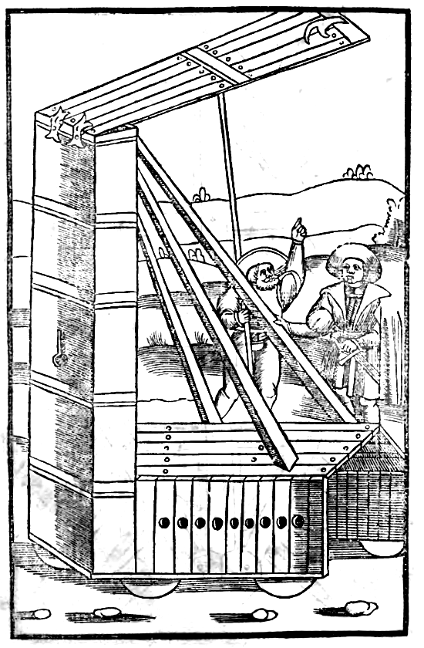
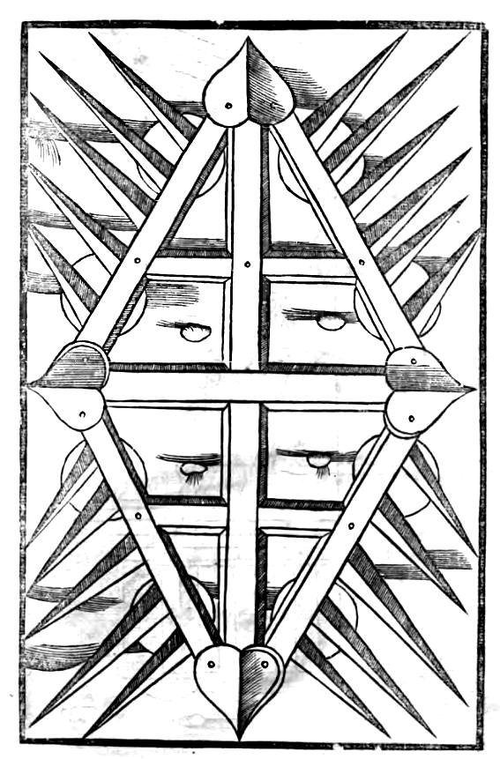
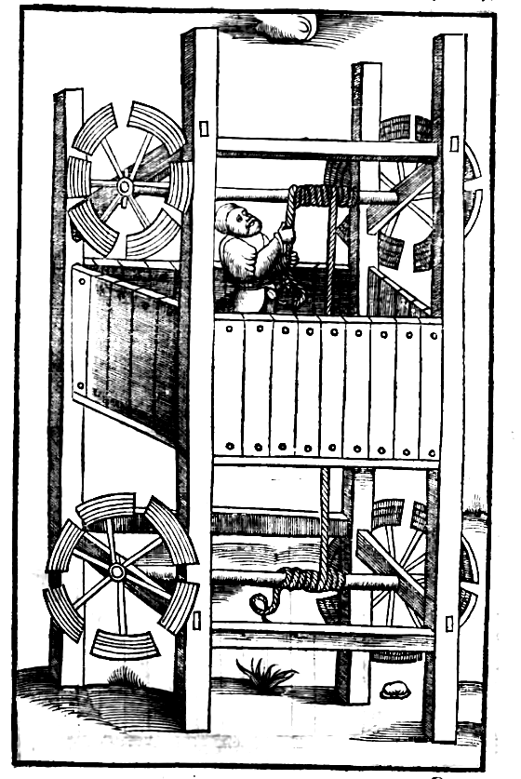
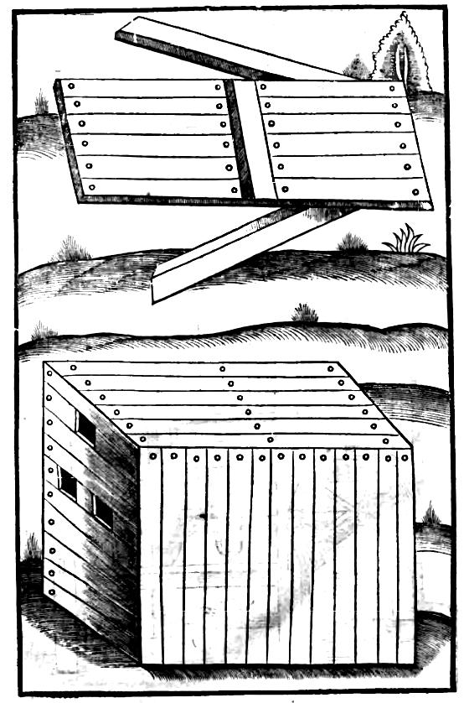
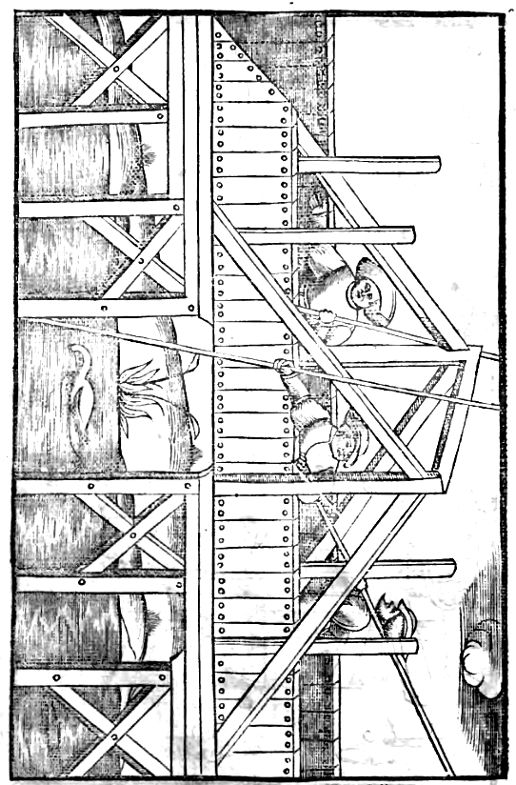
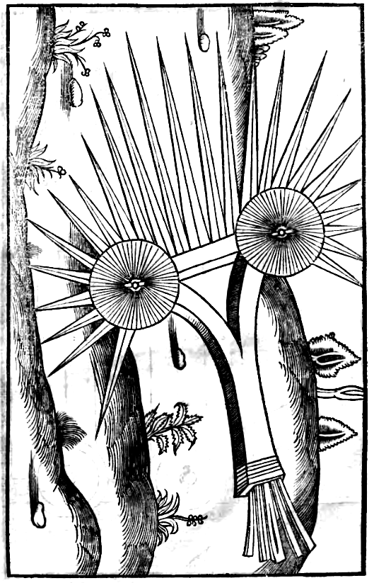
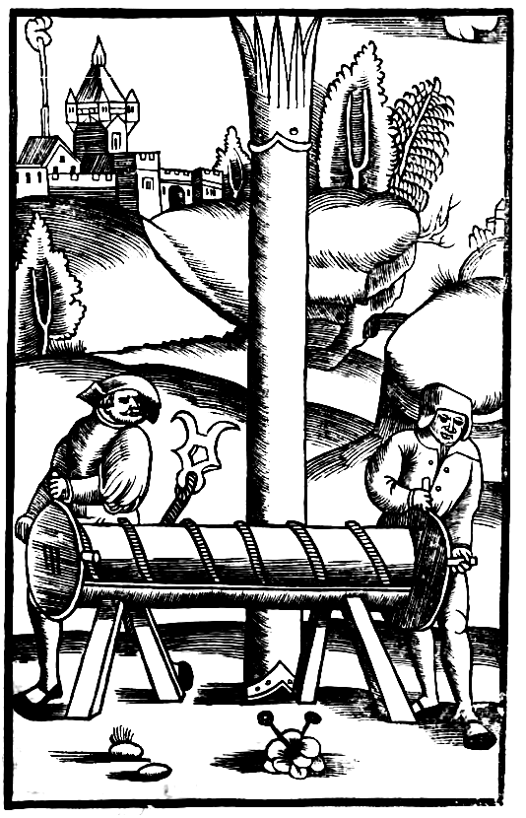
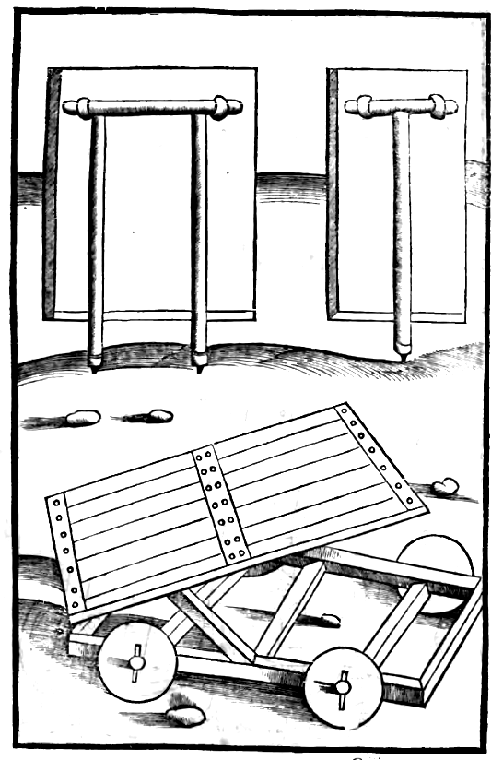
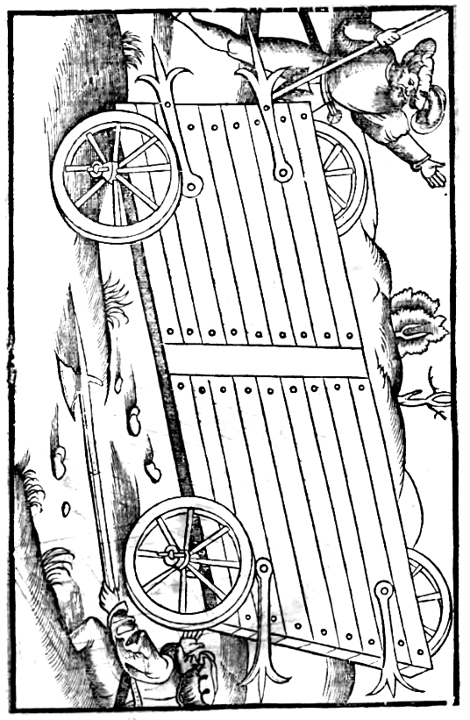
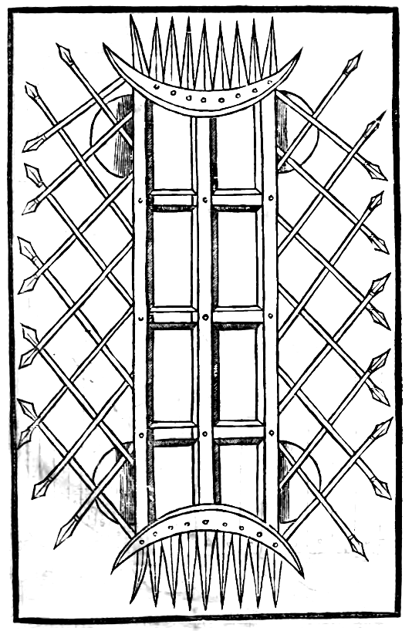
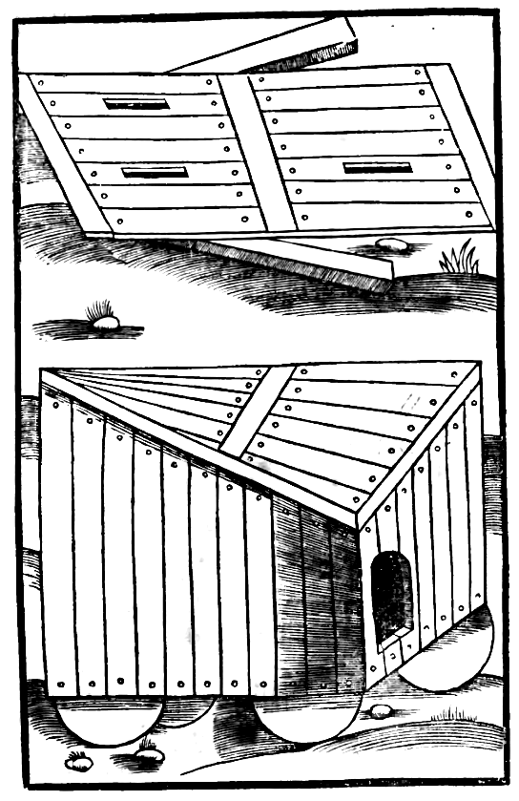
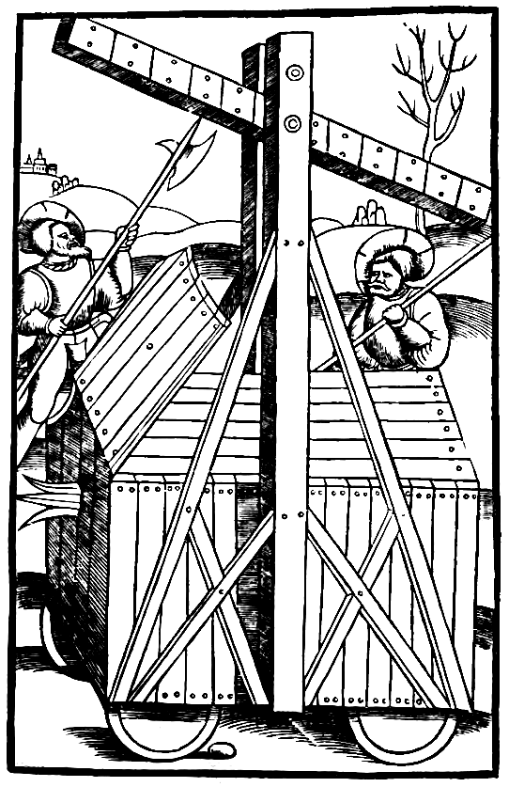
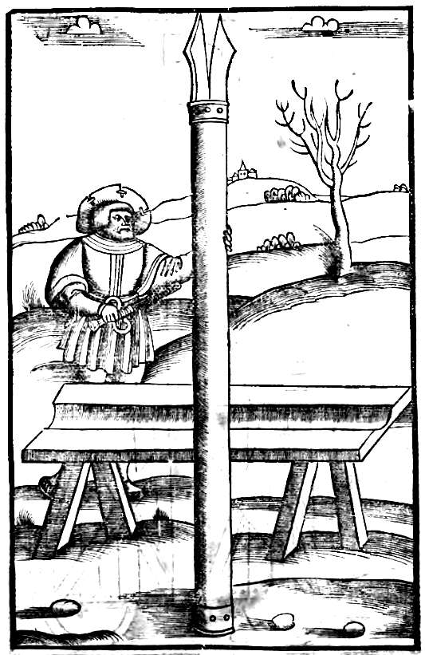
FLAVII VEGETII RENATI DE RE MILITARI,

Libri Tertii Prologus.

Athenienses & Lacedaemonios ac Macedonas rerum potitos, prisci testantur annales. Verum apud Athenienses, non solum rei bellicae, sed etiam diuersarum artium viguit industria: Lacedaemoniis autem praecipua fuit cura bellorum. Primi nanque experimenta pugnarum de euentibus colligentes, artem praeliorum scripsisse firmantur vsque eo, vt rem militarem, quae virtute sola, vel certe felicitate creditur contineri, ad disciplinam peritiaeque studia reuocarent: ac magistros armorum (quos taktikoÝj appellauerunt) iuuentutem suam vsum varietatemque pugnandi praeciperent edocere. O viros summa admiratione laudandos, qui eam praecipue artem ediscere voluerunt, sine qua aliae artes esse non possunt. Horum sequentes instituta Romani, Martii operis praecepta, & vsu retinuerunt, & literis prodiderunt. Quae per diuersos autores libros que dispersa, Imperator inuicte, mediocritatem meam abbreuiare iussisti, ne vel fastidium nasceretur ex plurimis, vel plenitudo fidei deesset in paruis. Quantum autem in praeliis Lacedaemoniorum disciplina profuerit (vt omittam caeteros) Xanthippi declaratur exemplo, qui Attilium Regulum, Romanumque exercitum saepe victorem, cum Carthaginensibus, non virtute, sed artis solo fere auxilio, prostratis exercitibus, cepit ac domuit, vnoque congressu triumphans, bellum omne confecit. Nec minus Hannibal petiturus Italiam Lacedaemonium doctorem quaesiuit armorum: cuius monitis tot Consules, tantasque legiones, inferior numero ac viribus, interemit. Ergo qui desiderat pacem, praeparet bellum. Qui victoriam cupit, militem imbuat diligenter. Qui secundos optat euentus, dimicet arte non casu. Nemo prouocare, nemo audet offendere, quem intelligit superiorem fore, si pugnet.

Qui modus debeat esse exercitus. Cap. I.
Primus liber tyronum delectum exercitiumque deprompsit, sequens legionis institutionem disciplinamque edocuit militarem, hic autem tertius classicum sonat. Ideo enim illa praemissa sunt, vt haec, in quibus peritia certaminum & victoriae summa consistit, disciplinae ordine custodito, intelligerentur celerius, & amplius adiuuarent. Exercitus diciturtam legionum, quam etiam auxiliorum, nec non etiam equitum ad gerendum bellum multitudo collecta. Huius modus a magistris quaeritur armorum. Nam cum Xerxis & Darii & Mithridatis caeterorumque regum, qui innumerabiles armauerant populos exempla leguntur, euidenter apparet nimium copiosos exercitus, magis propria multitudiue [multitudine], quam hostium virtute depressos. Nam pluribus casibus subiacet amplior multitudo. In itineribus pro mole sua semper est tardior. In longiore autem agmine, etiam a paucis superuentum assolet pati. In locis autem asperis vel fluminibus transeundis, propter impedimentorum moras saepe decipitur. Praeterea ingenti labore numerosis animalibus equisque pabula colliguntur. Rei quoque frumentariae difficultas, quae in omni est expeditione vitanda, cito maiores fatigat exercitus. Nam quanto libet studio praeparetur annona, tanto maturius defit, quanto pluribus erogatur. Ipsa quoque aqua nimiae multitudini aliquando vix sufficit. Quod si casu acies verterit tergum, necesse est multos cadere de multis, & illos qui effugerint, vt semel territos, postea formidare conflictum . Veteres autem, qui remedia difficultatum experimentis didicerant, non tam numerosos, quam eruditos armis habere exercitus voluerunt. Itaque in leuioribus bellis vnam legionem, mixtis auxiliis, hoc est, decem millia peditum, & duo millia equitum, crediderunt posse sufficere, quam manum Praetores velut minores duces, ad expeditionem saepe ducebant. Quod si magnae hostium copiae dicerentur, consularis potestas cum .xx. millibus peditum, & quatuor equitum, tamquam comes maior mittebatur. Quod si infinita multitudo de gentibus fortissimis rebellasset, tunc nimia necessitate cogente, duo duces & duo mittebantur exercitus, cum eiusmodi praecepto, vt prouiderent ne quid respub. [respublicam] detrimenti capiat, Consules ambo. Denique cum in diuersis regionibus contra diuersos hostes a Pop. Rom. [Populo Romano] annis pene omnibus pugnaretur, ideo sufficiebant militum copiae, quod vtilius iudicabant non tam grandes exercitus habere, quam armis instructos. Illa tamen ratione seruata, ne vnquam amplior multitudo sociorum auxiliarium esset in castris, quam ciuium Romanorum.

Quemadmodum sanitas gubernetur exercitus. Cap. ii.
Nunc (quod vel maxime prouidendum est) quemadmodum sanitas custodiatur exercitus, admonebo: hoc est, locis, aquis, temperie, medicina, exercitio. Locis, ne in pestilenti regione iuxta morbosas paludes, ne aridis & sine opacitate arborum campis, aut collibus, ne sine tentoriis aestate milites commorentur: ne tardius egressi, & calore solis, & fatigatione itineris contrahant morbum, sed potius in aestate ante lucem ad loca, coepto itinere destinata perueniant. Ne saeua hyeme iter per niues ac pruinas noctibus faciant, aut lignorum patiantur inopiam, aut minor illis vestium suppetat copia. Nec sanitati enim, nec expeditioni idoneus miles est, qui algere compellitur. Nec perniciosis, nec palustribus aquis vtatur exercitus. Nam malae, aquae potus, veneno similis, pestilentiam bibentibus generat. Iam vero vt hoc casu aegri contubernales oportunis cibis reficiantur, ac medicorum arte curentur. Principum Tribunorumque & ipsius Comitis, qui maiorem sustinet potestatem, iugis quaeretur diligentia. Male enim cum his agitur, quibus necessitas & belli incumbit & morbi. Sed rei militaris periti, plus quotidiana armorum exercitia ad sanitatem militum putauerunt prodesse, quam medicos. Itaque pedites sine intermissione imbribus vel niuibus sub tecto, reliquis diebus exerceri in campo voluerunt. Similiter equites non solum in planis, sed etiam in abruptis, & fossarum hiatu difficillimis semitis, seque & equos suos assidue exercere iusserunt, vt nihil iis in necessitate praelii accidere posset incognitum. Ex quo intelligitur, quanto studiosius armorum artem docendus sit semper exercitus, cum ei & laboris consuetudo in castris sanitatem, & in conflictu possit praestare victoriam. Si autumnali aestiuoque tempore diutius in iisdem locis militum multitudo consistat, ex contagione aquarum & odore ipsius foeditatis vitiatis haustibus & aere corrupto perniciosissimus nascitur morbus, qui prohiberi non potest aliter, nisi frequenti mutatione castrorum.

Quanta cura prouidenda sint atque seruanda pabula & frumenta. Cap. iii
Ordo postulat, vt de commeatu pabuli frumentique dicatur. Saepius enim penuria, quam pugna consumit exercitum, & ferro seuior fames est. Deinde reliquis casibus potest in tempore subueniri, at pabulatio & annona in necessitate remedium non habent, nisi ante condantur. In omni expeditione vnum & maximum consilium est, vt tibi sufficiat victus, hostes frangat inopia. Ante igitur quam inchoetur bellum, de copiis expensisque solers debet esse tractatus, vt pabula, frumentum, caetere, que annonariae species, quas a prouincialibus consuetudo deposcit, maturius exigantur, & in opportunis ad rem gerendam ac munitissimis locis, amplior semper modus quam sufficit aggregetur. Quod si tributa deficiunt, praerogato auro comparanda sunt omnia. Necque enim diuitiarum secura possessio est, nisi armorum defensione seruetur. Frequenter autem necessitas geminatur, & obsidio saepe sit longior quam putatur, cum aduersarii etiam ipsi esurientes circunsidere non desinant, quos fame sperant esse vincendos. Praeterea quicquid in pecore, vel quacumque fruge vinoque hostis inferens bellum ad victum suum poterit occupare, non solum admonitis per edicta possessoribus, sed etiam coactis per electos perscrutatores ad castella idonea & armatorum firmata praesidiis, vel ad tutissimas conferendum est ciuitates, vrgendique prouinciales, vt ante irruptionem seque & sua moenibus condant. Reparatio enim murorum tormentorumque omnium ante curanda est. Nam si semel hostes praeueniunt occupatos, metu vniuersa turbatur. Et quae ex aliis vrbibus petenda sunt, interclusis itineribus denegantur. Sed fidelis seruatorum custodia, & erogatio moderata, consueuit sufficere pro copia, maxime si ab initio procurentur. Caeterum sera parsimonia est, tum seruare cum deficit. In arduis expeditionibus, per capita magis militum que per dignitates ab antiquis probebantur annonae, ita vt post necessitatem eisdem ad rep. [republica] redderentur. Hyeme lignorum & pabuli, aestate aquarum vitanda est difficultas. Frumenti vero, vini & aceti, nec non etiam salis omni tempore necessitas declinanda, ita vt vrbes atque castella ab iis militibus, qui minus prompti inueniuntur in acie, armis, sagittis, fustibalis, fundis etiam & saxis, onagris, balistisque defendatur. Praecipueque cauendum videtur, ne aduersariorum dolo atque periuriis decipiatur, prouincialium incauta simplicitas. Frequentius enim conuentionum pacisque simulatio credulis quam arma nocuerunt. Qua ratione famem collecti patiuntur hostes, dispersi vero crebris superuentibus facile vincuntur.

Quemadmodum oporteat prouidere ne milites seditionem faciant. Cap. iiii.
Interdum mouet tumultum ex diuersis locis collectus exercitus: & cum pugnare nolit, irasci se simulat, vt non ducatur ad bellum: quod ii praecipue faciunt qui in sedibus ociose delicateque vixerunt. Nam asperitate insoliti laboris offensi, quem in expeditione necesse est sustinere, praeterea metuentes praelium, qui armorum exercitia declinant, ad eiusmodi praecipitantur audaciam. Cui vulneri multiplex medicina consueuit opponi, vt dum adhuc separati sunt in sedibus suis, tribunorum vel vicariorum, nec non etiam principum ad omnem disciplinam arctissima seueritate teneantur, nihilque aliud, nisi deuotionem moderationemque custodiant, nullis commeatibus vacent. Ad nomen, ad signa obseruare non desinant. Campi cursionem (vt ipsi appellant) inspectionemque armorum assidue faciant. Ad sagittas iaciendas, ad missilia dirigenda, ad iactandos lapides, vel funda, vel manu. Ad armaturae gestum, ad vectes iactandos: pro similitudine gladiorum, punctim caesimque feriendo, multo die vsque ad sudorem sunt frequentissime detinendi. Cursu etiam & saltu ad transmittendas fossas nihilominus imbuendi, si mare vel fluuius vicinus est sedibus. Aestiuo tempore ad natandu cogendi sunt omnes. Praeterea syluam caedere, iter per dumosa & abrupta facere, materiem dolare, aperire fossam, occupare aliquem locum, & ne a contubernalibus detrudantur, in scutis inuicem obuiantibus niti. Ita exercitati atque eruditi in sedibus milites Rhomanii siue legionari, siue auxiliares, siue equites fuerint, cum ad expeditionem ex diuersis conuenerint locis, aemulatione virtutis, praelium magis necesse habeant optare per ocium. Nemo cogitat de tumultu, qui fiduciam de arte vel viribus gerit. Dux aurem esse debet attentus, vt in omnibus legionibus siue auxiliis, vel vexillationibus, a tribunis, vicariis principibusque, si qui turbulenti vel seditiosi fuerint milites, non pro inuidia suggerentium, sed pro rerum veritate cognoscat, eosque prudentiori consilio segregatos a castris, ad agendum aliquid quod ipsis prope videatur optabile: aut ad castella vrbesque deputet muniendas atque seruandas ad tanta subtilitate, vt cum abiiciuntur, videantur electi. Nunquam enim ad contumaciam pari consensu multitudo prorumpit, sed incitantur a paucis qui vitiorum scelerumque impunitate sperant peccare cum plurimis. Quod si fieri medicinam necessitas extrema persuaserit, rectius est more maiorum in aurores criminum vindicari: ad omnes metus, ad paucos poena perueniat. Laudabiliores tamen duces sunt, quorum exercitus ad modestiam labor & vsus instituit, quam illi quorum milites ad obedientiam, suppliciorum formido compellit.

Signorum militarium quot sint genera. Cap. V.
Multa quidem sunt ediscenda atque obseruanda pugnantibus: siquidem nulla sit negligentiae venia, vbi de salute certatur. Sed inter reliqua nihil magis ad victoriam proficit, quam monitis obtemperare signorum. Nam cum voce sola inter praeliorum tumultus regi multitudo non possit, & cum pro necessitate rerum plura ex tempore iubenda atque facienda sint, antiquus omnium gentium vsus inuenit, quomodo quod solus dux vtile iudicasset, per signa totus agnosceret & sequeretur exercitus. Tria itaque genera constat esse signorum, vocalia, semiuocalia muta. Quorum vocalia & semiuocalia percipiuntur auribus: Muta vero referuntur ad oculos. Vocalia dicuntur quae, voce humana pronunciantur, sicut in vigiliis vel in praelio pro signo dicitur: vt puta, victoria, palma, virtus, deus nobiscum, triumphus Imperatoris, & alia quaecunque voluerint dare ii [is] qui in exercitu habent maximam potestatem. Sciendum tamen est, ista vocabula quotidie debere variari, ne ex vsu hostes signum agnoscant, & exploratores inter nostros versentur impune. Semiuocalia sunt quae per tubam, aut cornua, aut buccinam dantur. Tuba quae, directa est, appellatur. Buccina, quae in semetipsam aereo circulo flectitur. Cornu quod ex vris agrestibus, argento nexum, temperatum arte, & spiritu, quem canentis flatus emittit, auditur. Nam indubitatis per haec sonis agnoscit exercitus, vtrum stare aut progredi, an certe regredi oporteat: vtrum longe persequi fugientes, an receptui canere. Muta signa sunt aquilae, dracones, vexilla, flammulae rufae [tufae], pinnae. Quocunque enim haec ferri iusserit ductor, eo necesse est signum suum comitantes milites pergant. Sunt & alia muta signa, quae dux belli in equis, aut indumentis, & etiam in ipsis armis, vt dignoscatur hostis, praecipit custodiri. Praeterea manu aliquid, vel flagello, more barbarico, vel certe mota qua vtitur veste, significat. Quae omnia in sedibus, itineribus, in omni exercitatione castrensi, vniuersi milites & sequi, & intelligere consuescant. Continuus enim vsus necessari videtur in pace eius rei, quae in praelii confusione seruanda sit. Item mutum & commune signum est, quotiens proficiscente turba excitatus puluis ad similitudinem nubium surgit, hostiumque prodit aduentum: similiter si diuisae sint copiae, per noctem flammae, per diem fumus significat sociis quod aliter nunciari non potest. Aliquando in castellorum aut vrbium turribus appendunt trabes: quibus aliquando erectis, aliquando depositis indicant quae geruntur.

Quanta sit seruanda cautela cum vicinis hostibus mouetur exercitus. Cap. VI.
Qvi rem militarem studiosius didicerunt, asserunt plura in itineribus, qui in ipsa acie pericula solere contingere. Nam in conflictu armati sunt omnes milites & hostem cominus vident, & ad oppugnandum animo veniunt parati. In itinere autem minus armatus minusque attentus est miles, & superuentus impetu vel fraude repente turbatur. Ideo omni cura, omnique diligentia prouidere dux debet, ne proficiscens patiatur in cursum, vel si non facile, at sine damno repellat illatum. Primum itineraria omnium regionum, in quibus bellum geritur, plenissime debet habere perscripta: ita vt locorum interualla, non solum passuum numero, sed etiam viarum qualitates perdiscat: compendia, diuerticula, montes, flumina, ad fidem descripta consideret: vsque eo, vt solertiores duces, itineraria prouinciarum, in quibus necessitas geritur, non tantum adnotata, sed etiam picta habuisse firmentur, vt non solum consilio mentis, verum aspectu oculorum viam profecturis eligerent. Ad haec [hoc] a prudentioribus & honoratis locorumque gnaris, separatim debet vniuersa perquirere, & veritatem colligere de pluribus. Praeterea sub periculo eligendarum viarum, duces idoneos, scientesque percipere, eosque custodiae mancipare, addita poenae contestatione vel praemii. Erunt enim vtiles, cum intelligent nec fugiendi sibi copiam superesse, & fidei praemium, perfidiae parata supplicia. Prouidendum quoque vt sapientes exercitatique quaerantur, ne duorum aut trium error discrimen pariat vniuersis. Interdum autem impetita rusticitas plura promittit, & credit se scire quae nescit. Sed cautelae caput est, vt ad quae loca vel quibus itineribus sit profecturus exercitus, ignoretur. Tutissimum nanque in expeditionibus creditur facienda nesciri. Ob hoc veteres Minotauri signum in legionibus habuerunt, vt quemadmodum ille in intimo & secretissimo labyrintho abditus perhibetur, ita ducis consilium semper esset occultum. Securum iter agitur, quod agendum hostes minime suspicantur. Verum, quia exploratores altrinsecus missi, perfectionem suspicionibus vel oculis deprehendunt, & interdum transfugae proditoresque non desunt, quemadmodum occurri ingruentibus debeat, intimetur. Dux cum agmine exercitus profecturus, fidelissimos, argutissimosque cum equis probatissimis mittat, qui loca, per quae, iter faciendum est, in progressu & a tergo, dextra, leuaque perlustrent, ne aliquas aduersarii moliantur insidias. Tutius autem operantur exploratores noctibus quam diebus. Nam quodammodo ipse sui proditor inuenitur, cuius speculator fuerit ab aduersariis deprehensus. Primi ergo equites iter arripiant, inde pedites: impedimenta, sagittarii, calones, vehiculaque in medio collocentur, ita vt expedita pars peditum & equitum subsequatur. Nam ambulantibus, interdum quidem a fronte, sed frequentius a tergo superuentus infertur. A lateribus quoque pari armatorum manu impedimenta claudenda sunt. Nam insidiatores in alio loco impulsant, transuerso frequenter incursu. Illud quoque praecipue obseruadum est, vt ea pars ad quam hostis venturus creditur, oppositis electissimis equitibus & leui armatura, nec non etiam peditibus sagittariis muniatur. Quod si vndique circunfunduntur inimici, vndique preparata debent esse subsidia. Ne vero repentinus tumultus amplius noceat, ante commonendi sunt milites, vt parati sint animo, vt arma in manibus habeant. Nam in necessitate subita quae conterrent, prouisa non solent esse formidini. Antiqui diligentissime praecauebant, ne a calonibus interdum vulneratis, interdum timentibus, & sagittariis clamore pauefactis, pugnantes milites turbarentur: ne dispersi longius aut conglobati, amplius quam expedit impedirent suos, hostibusque prodessent. Et ideo ad exemplum militum, etiam impedimenta sub quibusdam signis ordinanda duxerunt. Denique ex ipsis calonibus (quos galeanos vocant) idoneos ac peritos vsu legebant, quos non amplius quam ducentis sagisarciariis puerisque praeficerent. Hisque vexilla dabant, vt scirent ad quae, signa deberent impedimenta colligere. Sed pugnatores ab impedimentis laxamento aliquo diuiduntur, ne constipati laedantur in praelio, ambulante exercitu. Vt locorum varietas aduenerit, ita defensionis ratio varietur. Nam in campis patentibus equites magis solent impugnare quam pedites. At vero in locis syluestribus vel montosis, siue palustribus pedestres magis formidandae sunt copiae. Illud quoque vitandum, ne per negligenti in aliis festinantibus, aliis tardius incedentibus, interrumpatur acies aut forte tenuetur. Continuo enim hostes inter prolata peruadunt. Praeponendi ergo sunt exercitatissimi campi doctores, vicarii, vel tribuni, qui alacriores tardent, & pigrius incedentes accelerare compellant. Nam qui multum praecesserint, superuentu facto, non tam redire quam fugere cupiunt. Qui vero extremi sunt, deserti a suis, vi hostium ac propria desperatione superantur. Sciendum est etiam, quod aduersarii in his locis quae sibi oportuna intelligunt, subsessas occultius collocant, vel aperto Marte impetum faciunt. Sed ne secreta noceant, ducis praestat industria, quae omnia prius conuenit explorare. Deprehensa quoque subsessa, si circumueniatur vtiliter, plus periculi sustinet quam parabat inferre. Aperta autem vis si praeparetur in montibus, altiora loca praemissis sunt praesidiis occupanda, vt cum hostis aduenerit reperiatur inferior, nec audeat obuiare, cum tam a fronte quam supra caput suum cernat armatos. Quod si angustae sint viae, sed tamen tutae melius est praecedere cum securibus ac dolabris milites, & cum labore vias aperire, quam in in optimo itinere periculum sustinere. Praeterea noscere debemus hostium consuetudine: vtrum nocte, an incipiente die, an hora reficiendi, lassis superuenire consueuerint: & id vitare quod illos facturos ex more putamus. Iam vero vtrum peditibus an equitibus, vtrum funditoribus, vtrum contatis, an sagittariis amplius valeant, vtrum numero hominum an armorum munitione praecellant, nos scire conuenit: & ordinare quod nobis vtile, illis docetur aduersum. Tractare quoque, per diem an per noctem iter expediat inchoare: quae & quanta locorum interualla sint, ad quae cupimus properare: ne aestate aquae penuria obsit euntibus, ne hyeme difficiles aut inuiae occurrant paludes, maioresque torrentes: & impedito itinere circunueniatur exercitus, priusquam ad destinata perueniat. Vt nostra commoditas est, ista sapienter vitare, ita si aduersariorum imperitia vel dissimulatio occasionem nobis dederit, non oportet dimitti, sed explorare solicite proditores, ac transfugas inuitare, vt quid hostis moliatur, in praesenti vel in futurum possimus agnoscere: paratisque equitibus ac leui armatura ambulantes eosdem, vel pabula victumque quaerentes, improuiso terrore decipere.

Quemadmodum flumina, quae maiora sunt, transeantur. Cap. VII.
In transitu fluuiorum grauis molestia negligentibus frequenter emergit. Nam si qua aqua violentior fuerit, aut alueus latior, impedimenta, pueros, & interdum ipsos ignauos solet mergere bellatores. Ergo explorato vado, duae acies equitum, electis animalibus ordinantur, interuallis competentibus separatae, vt per medium pedites & impedimenta transeant. Nam acies superior, aquarum impetum frangit: inferior, qui rapti submersique fuerint, colligit atque transponit. At cum altior fluctus nec peditem nec equitem patiatur, si per plana decurrat ductis multifariam spargitur fossis, diuisusque facile transitur. Nauigio vero amnes, hastilibus fixis, ac superpositis tabulamentis peruii fiunt: vel certe tumultuario opere colligatis inanibus cuppis, additisque trabibus transitum praebent. Expediti vero equites fasces de cannis aridis vel vlua facere consueuerunt, super quos loricas & arma, ne inundentur, imponunt: ipsi equique natando transeunt, colligatisque secum fasces pertrahunt sarcinis. Sed commodius repertum est, vt monoxylos , hoc est, paulo latiores scaphas [scaphulas], ex singulis trabibus excauatas, per genere ligni & subtilitate leuissimas, carpentis secum portet exercitus, tabulis pariter & clauis ferreis praeparatis. Ita absque mora constructus pons, & funibus (qui praeterea habendi sunt) vinctus, lapidei arcus soliditatem praestat in tempore. Sed instant aduersarii ad transitus fluminum, insidiasque vel superuentus facere consueuerunt. Ob quam necessitate in vtraque ripa collocantur armata praesidia, ne alueo interueniente, diuisi opprimantur ab hostibus. Cautius tamen est sudes ex vtraque parte praefigere ac sine detrimento, si qua vis illata fuerit, sustinere. Quod si pons non tantum ad transitum, sed etiam recursum & commeatum necessarius fuerit, tunc in vtroque capite, percussis latioribus fossis, aggereque constructo, defensores milites debet accipere, a quibus tam diu teneatur, quam diu necessitas locorum postulabit.

Quemadmodum castra debeant ordinari. Cap. VIII.
Consequens videtur, itineris obseruatione descripta, ad castrorum (in quibus manendum est) venire rationem. Non enim belli tempore ad statiua vel ad mansionem murata ciuitas semper occurrit, & incautum est plenumque discriminis, exercitum passim sine aliqua munitione considere: cum militibus ad capiendum cibum occupatis, aut munera facienda dispersis, facile nectantur insidiae. Postremo noctis obscuritas, necessitas somni, pascentium equorum dispersio, occasionem superuentibus praestat. In metandis castris non sufficit bonum locum eligere, nisi talis sit, vt alter eo non possit melior inueniri: ne vtilior praetermissus a nobis, & ab aduersariis occupatus, apportet incommodum. Cauendum quoque ne per aestate aut aqua morbosa in proximo aut salubris aqua sit longius: Hyeme, ne pabulatio desit aut lignorum copia: ne subitis tempestatibus campus, in quo manendum est, soleat inundari: ne sit in abruptis ac deuiis, & circunsedentibus aduersariis difficilis praestetur egressus: ne ex superioribus locis, missa ab hostibus, in cum tela perueniant. Quibus vt oportet caute studioseque prouisis, pro necessitate loci vel quadrata, vel rotunda, vel trigona, vel oblonga castra constitues. Nec vtilitati praeiudicat forma. Tamen pulchriora creduntur, quibus vltra latitudinis spacium tertia pars additur longitudini. Ita autem ab agri mensoribus podismum mensurae colligi oportet, vt ad quantitatem concludatur exercitus. Nam propugnatores angusta constipant, & vltra quam conuenit latiora diffundunt. Tribus autem modis diffiniunt castra muniti posse. Primum in vnius noctis transitum, itineris occupationem leuiorem cum sublati cespites circundantur, & aggerem faciunt, supra quem valli, hoc est, sudes vel tribuli lignei per ordinem digeruntur. Cespes [Caespes] autem circumciditur ferramentis, qui herbarum radicibus continet terram: fit altus semissem, latus pedem, longus pedem semis. Quod si terra solutior fuerit, vt ad similitudinem lateris, cespes non possit abscindi, tunc opere tumultuario fossa producitur, lata pedes quinque, alta tres: cuius intrinsecus agger excrescit, vt sine metu securus quiescat exercitus. Statiua autem castra aestate vel hyeme, hoste vicino, maiore labore ac cura firmantur. Nam singulae centuriae, diuidentibus campi doctoribus & principibus, accipiunt pedaturas, & scutis vel sarcinis suis in orbem circa propria signa depositis, cincti gladio, fossam aperiunt latam aut nouem, aut vndecim, aut tredecim pedibus: vel, si maior aduersariorum vis metuitur, pedibus decem & septem (imparem enim numerum obseruari moris est) tum sepibus ductis vel interpositis stipitibus ramisque arborum, ne facile terra dilabatur, agger erigitur. Super quem ad similitudinem muri, pinnae, & propugnacula componuntur. Opus vero centuriones decempedis metiuntur, ne quis minus foderit, aut errauerit alicuius ignauia. Id etiam tribuni circumeunt, nec ante discedunt qui strenui sunt, quam fuerint omnia perfecta. Ne tamen aliquis superuentus laborantibus fiat, omnes equites & pars peditum, quae non operatur, dignitatis priuilegio ante fossam in praecinctu armata consistit, vt ingruentes repellat inimicos. Prima igitur signa locis suis intra castra ponuntur, quia nihil est venerabilius eorum maiestate militibus. Duci praetorium , eiusque comitibus praeparatur. tribunis tabernacula collocantur, quibus per contubernales ad munia deputatos, aqua, lignum, & pabula ministrantur. Tunc pro gradu legionibus & auxiliis, equitibus, & peditibus, loca in quibus papiliones tendant, deputantur in castris: ac de singulis centuriis quaterni equites & quaterni pedites, qui excubitum noctibus faciunt, eliguntur. Et quia impossibile videbatur in speculis per totam noctem vigilantes singulos permanere, ideo in quatuor partes ad clepsydram sunt diuisae vigiliae, vt non amplius quam tribus horis nocturnis necesse sit vigilare. A tubicine omnes vigiliae committuntur. Et finitis horis a cornicine reuocantur. Idoneos tamen tribuni & probatissimos eligunt, qui vigilias circumeant, & renuncient, si qua emerserit culpa, quos circuitores appellant. Nunc militiae factus est gradus, & circitores appellantur. Sciendum tamen est, equites extra vallum nocturnas excubias facere debere. Per diem autem castris positis, alii mane, alii post meridiem propter fatigationem hominum equorumque angarias faciunt. Inter praecipua conuenit ducem prouidere siue in castris, siue in ciuitate consistat, vt animalium pascua, subuectio frumenti, caeterarumque specierum, aquatio, lignatio, pabulatio, secura ab hostium reddatur incursu. Quod aliter non potest euenire, nisi per loca idonea, qua nostrorum ambulat commeatus, praesidia disponantur, siue illae ciuitates sint, siue castella munita. Quod si non reperitur antiqua munitio, oportunis locis circundata maioribus fossis tumultuaria castella firmantur. Nam a castris diminuto vocabulo sunt nuncupata castella. Intra quae in angariis aliquanti pedites, equitesque degentes, tutum iter commeatibus praestant. Difficile enim hostis ad ea loca audet accedere, in quibus a fronte & a tergo nouit aduersarios commorari.

Quae & quanta consyderanda sint, vt intelligatur vtrum superuentibus & insidiis, an publico debeat Marte confligi. Cap. IX.
Qvisquis hos artis bellicae commentarios, ex probatissimis autoribus breuiatos legere dignabitur, quam primum legem praelii, depugnandique cupit audire praecepta: sed conflictus publicus duarum vel trium horarum certamine diffinitur: postquam partis eius, quae superata fuerit, spes omnis intercidit. Ideo omnia ante cogitanda sunt, ante tentanda, ante facienda, quam ad vltimum veniatur abruptum. Boni enim duces, non aperto Marte praelium, in quo est commune periculum, sed ex occulto semper attentant vt integris suis, quantum possint hostes interimant certe vel terreant: in qua parte quae necessaria admodum sunt, ab antiquis reperta perscribam. Praecipua ars & vtilitas ducis est, vt adhibitis ex vniuerso exercitu scientibns [scientibus] belli & sapientibus viris, de suis & hostium copiis, saepius tracter: omni (quam plurimum nocet adulatione summota, vtrum maiorem numerum pugnatorum ipse an hostes habeant, vtrum ipsius, an aduersariorum homines magis armati sint & muniti. Qui magis exercitati, qui sint in necessitatibus fortiores. Quaerendum est etiam, vtra pars equites, vtra pedites habeat meliores. Sciendumque in peditibus maxime consistere robur exercitus: & inter ipsos equites, qui contatis, qui sagittariis antecedant. Qui plures loricas induerit, quis vtiliores equos adduxerit. Postremo ipsa loca in quibus pugnandum est, vtrum inimicis an nobis videantur accommoda. Nam si equitatum gaudemus, campos optare debemus: si pedite, loca eligere angusta, fossis, paludibus, vel arboribus impedita, & aliquoties montosa, cui magis victus abundet quam desit. Nam fames (vt dicitur) intrinsecus pugnat, & vincit saepius sine ferro. Maxime autem tractandum est, vtrum protrahi necessitatem expediat, an celerius dimicari: interdum enim sperat aduersarius expeditionem cito posse finiri: & si dilatus fuerit in longum, aut penuria exercitus maceratur, aut desiderio suarum reuocatur ad propria: aut nihil magnum faciens, per desperationem abire compellitur. Tunc fracti labore & taedio plurimi deserunt, aliquanti produnt, aliquanti se tradunt. Quia aduersis rebus rarior fides est, & nudari incipit qui copiosus aduenerat. Ad rem pertinet nosse qualis ipse aduersarius vel eius comites optimatesque sint: vtrum temerarii, an cauti, an audaces, an timidi, scientes artem bellicam, an ex vsu temere pugnantes: quae gentes cum his fortes, quae ignauae pugnauerint: nostra auxilia cuius fidei qualiumque [quarumque] sint virium, quos illius animos copiae, quos habeat noster exercitus, quae pars sibi magis victoriam repromittat. Huiusmodi enim cogitationibus virtus augetur, aut frangitur. Desperantibus autem crescit audacia adhortatione ducis, & si nihil ipse timere videatur, crescit animus, si ex insidiis vel occasione aliquid fortiter fecerit, si hostibus aduersae res coeperint euenire, si vel infirmiores aut minus armatos ex inimicis potuerit superare. Cauendum autem est ne dubitantem aut formidantem exercitum ad pugnam publicam aliquando producas. Interest vtrum tyrones an veteres milites habeas, vtrum ante breue tempus in expeditionibus fuerint, an annos aliquot in pace durarint. Nam pro tyronibus accipiendi sunt, qui pugnare longo tempore desierunt. Sed cum legiones, auxilia, vel equites ex diuersis aduenerint locis, dux optimus & separatim singulos numeros per tribunos electos, quorum scitur industria, ad omnia genera exercere debet armorum: & post in vnum collectos, quasi depugnaturos conflictu publico exercebit. Ipse saepius tentabit quicquid artis possit habere, quid virium, quemadmodum sibi ipsi consentiant, vtrum ad tubarum monita, ad signorum indicia, ad praecepta vel nutum suum diligenter obtemperent. Si errant in aliquibus, exerceantur atque doceantur quam diu possint esse perfecti. Si vero in campi cursione, in sagittando, in iaculando, in ordinanda acie ad plenum fuerint eruditi, ne sic quidem temere occasione captata, ad publicam deducendi sunt pugnam, sed ante minoribus praeliis imbuendi. Dux itaque vigilans, sobrius, prudens tanquam de ciuili causa inter partes iudicaturus, adhibito consilio, de suis & aduersarii copiis iudicet. Et si multis rebus superior inuenitur, opportunum sibi differat inire conflictum. Si vero aduersarium intelligit potiorem [fortiorem], certamem publicum vitet. Nam pauciores numero & inferiores viribus, superuentus & insidias facientes, sub bonis ducibus reportauerunt saepe victoriam.

Quid oporteat fieri, si quis desuetum a pugna habeat exercitum vel tyronem. Cap. X.
Omnes artes omniaque opera quotidiano vsu & iugi exercitatione proficiunt. Quod si in paruis verum est, quanto magis decet in maximis custodiri? Quis autem dubitat artem bellicam rebus omnibus esse potiorem, per quam libertas retinetur, & dignitas prouinciae propagatur, & conseruatur imperium? Hanc quondam relictis doctrinis omnibus Lacedaemonii, postea coluere Romani. Hanc solam hodie quoque Barbari putant esse seruandam. Caetera autem in hac arte consistere omnia, aut per hanc assequi se posse confidunt. Haec dimicaturis est necessaria, per quam vitam retineant, & victoriam consequantur. Dux ergo cui tantae potestatis insignia tribuuntur, cuius fidei atque virtuti possessorum fortunae, tutela vrbium, salus militum, reip. [reipublicae] creditur gloria, no tantum pro vniuerso exercitu, sed etiam pro singulis contubernalibus debet esse solicitus. Si quid enim illis eueniat in bello, & ipsius culpa & publica videtur iniuria. Ergo si tyronem, vel diu armis desuetum ducit exercitum, singularum legionum siue auxiliorum. Necnon etiam vexillationem vires, animos, consuetudine, diligenter exploret. Sciat etiam (si potest fieri) nominatim quis comes, quis tribunus, quis domesticus, quis contubernalis, quantum possit in bello, autoritatemque maximam seueritate sumat, omnes culpas militares legibus vindicet, nulli errantium credatur ignoscere, in diuersis locis ex diuersis occasionibus omnium experimenta praecipiat. His (vt oportet) ita curatis, cum dispersi ad praedandum securi oberrant hostes, tunc probatos equites vel pedites cum tyronibus, aut inferioribus mittat, vt ex occasione, fusis inimicis, & illis peritia, & reliquis crescat audacia. Ad transitus fluuiorum, ad praecipitia montium, ad syluarum angustias, ad paludum aut viarum difficultates, superuentus nullo sciente disponat, atque iter suum ita temperet, vt aut cibum capientes, aut dormientes, aut vacantes certe, securos, inermes, discalciatos, districtis equis, nihil suspicantes ipse paratus inuadat, quatenus in huiusmodi certaminibus sui fiduciam colligant. Nam qui ante longum tempus, aut omnino nunquam videre homines vulnerari, vel occidi, cum primum aspexerint, perhorrescunt: & pauore confusi, de fuga magis quam de conflictu incipiunt cogitare. Praeterea, si excurrant aduersarii, longo itinere fatigatos aggrediatur, & vltimus aut certe insperatus superueniat. Eos etiam qui longe a suis aut pabuli aut praedae gratia commorantur, subito occupet cum delectis. Illa enim ante tentanda sunt, quae si male cesserint, minus noceant: si bene, plurimum prosint. Inter hostes discordiarum serere causas sapientis est ducis. Nulla enim, quamuis sit minima natio, cito potest ab aduersariis deleri [perdeleri], nisi propriis simultatibus [simulantibus] seipsa consumpserit. Nam sic ciuile odium ad inimicorum perniciem praeceps est, ad vtilitatem suae defensionis incautum. Vnum illud in hoc opere praedicandum est, vt nemo desperet fieri posse quae facta sunt. Dicat aliquis: Multi sunt anni, quibus nullus fossa, aggere, vallo, mansurum circundat exercitu. Respondebitur, si fuisset ista cautela, nihil nocturni aut diurni superuentus hostium nocere potuisset. Persae, imitantes Romanos, ductis fossis castra constituunt: & quia arenosa sunt prope omnia, saccos, quos inanes portauerant ex puluerulenta (quae ibi effoditur) terra complent, eorumque cumulo aggerem faciunt. Omnes barbari carris suis in orbem connexis ad similitudinem castrorum, securas a superuenientibus exigunt noctes. Veremur ne discere nequeamus, quae ad nobis alii didicerunt? Haec ex vsu librisque discenda, quae antea seruabantur, sed omissa diu nemo queaesiuit: quia vigentibus pacis officiis, procul aberat bellorum necessitas. Sed ne impossibile videatur armorum disciplina, cuius vsus intercidit, reparari posse, doceamur exemplis. Apud veteres res militaris in obliuionem saepius venit, sed a libris repetita est, postea ducum auctoritate firmata. Scipio Aphricanus sub aliis imperatoribus Hispanienses exercitus frequenter victos accepit: hos disciplinae regula custodita, omni opere fossisque faciendis ita diligenter exercuit, vt diceret fodientes luto inquinari debere, qui sanguine hostium madere voluissent. Tum ipse denique Numantinos sic, capta ciuitate, concremauit, vt nullus euaserit. Metellus in Aphrica Albino imperante subiugatum accepit exercitum, quem ita emendauit veteribus institutis, & disciplina maiorum, vt postea eos, a quibus sub iugum missi fuerant superarent. Cymbri quoque Cepionis & Manilii & Syllani legiones inter Gallias deleuerunt: quarum reliquias cum C. Marius suscepisset, ita erudiuit scientia & arte pugnandi, vt innumerabile multitudinem non solum Cymbrorum, sed etiam Teutonum & Vmbrorum publico Marte deleret. Facilius autem est ad virtutem instruere nouos milites quam reuocare perterritos.

Quae ipso die procuranda sint vel agantur, quo publica committitur pugna. Cap. XI.
Praemissis leuioribus artibus belli, ad publici conflictus incertum & fatalem diem nationibus ac populis, ratio disciplinae militaris inuitat. Nam in euentu aperti Martis victoriae plenitudo consistit. Hoc ergo tempore tanto magis duces debent esse soliciti, quanto maior speratur diligentibus gloria, & maius periculum comitatur ignauos: in quo momento peritiae vsus, pugnandi doctrina, consiliumque dominatur. Veteribus saeculis mos fuit, parco cibo curatos milites ad certamen educere, vt citatiores sumpta redderet esca, & longiore conflictu non fatigarentur inedia. Praeterea obseruandum est praesentibus hostibus, siue ex castris siue ex ciuitate producas ad praelium, ne dum per angusta portarum particulatim procedat exercitus, a collectis & praeparatis debilitetur inimicis. Ideoque prouidendum est, vt ante omnes milites egrediantur portas, & aciem prius construant, quam hostis adueniat. Quod si intra ciuitatem manentibus imparatis aduenerint, aut differatur egressus aut certe dissimuletur: vt quum aduersarii insultare coeperint his quos non putant exituros, cum ad praedam vel redeundum conuerterint animum, cum ordines soluerint, tunc illis stupentibus lectissimi quique prorumpant, & confestim aggrediantur ignaros. Obseruatur autem ne longo spacio fatigentur milites, ne lassos post cursum equos ad publicum praelium cogas: multum virium labore itineris pugnaturus amittit. Quid faciet qui ad aciem anhelus aduentat? Hoc & veteres declinarunt & superiori nostra aetate, cum Romani duces per imperitiam non cauissent (nequid amplius dicam) exercitus perdiderunt. Impar enim conditio est, lassum cum requieto, sudantem cum alacri, currentem cum eo qui steterit inire conflictum.

Inuestigandum quid sentiant milites pugnaturi. Cap. xii.
Ipsa die qua certaturi sunt milites, quid sentiant diligenter conuenit explorare. Nam formido vel fiducia ex vultu, verbis, incessu, motibus cernitur. Nec confidas satis, si tyro praelium cupit: inexpertis enim dulcis est pugna. Et noueris re oportere differre, si exercitati bellatores metuerint dimicare. Monitis tamen & oratione ducis exercitui virtus accrescit & animus: praecipue si futuri certaminis talem acceperint rationem, qua sperent se facile ad victoriam peruenturos. Tunc inimicorum ignauia, vel error ostendendus est: vel si ante a nobis superati sunt, commemorandum. Dicenda etiam quibus militum mentes odio aduersariorum, in iram, & indignationem moueantur. Animis pene omnium hominum hoc naturaliter euenit, vt trepident cum ad conflictum venerint. Sine dubio autem formidolosiores sunt, quorum mentes ipse confundit aspectus. Sed hoc remedio formido lenitur, si antequam dimices, frequenter exercitum tuum locis tutioribus ordines, vnde & videre hostem & agnoscere consuescant. Interdum audeant aliquid ex occasione, aut fugent, aut interimant inimicos. Inimicorum mores, aduersariorum arma & equos recognoscant. Nam quae ex vsu sunt, non timentur.

Quemadmodum idoneus locus eligatur ad pugnam. Cap. xiii.
Bonum ducem conuenit nosse magnam partem victoriae, ipsum locum, in quo dimicandum est, possidere. Elabora ergo, vt conserturus manum, primum auxilium capias ex loco, qui tanto vtilior iudicatur, quanto superior fuerit occupatus. In subiectos enim vehementius tela descendunt, & maiore impetu obnitentes, pars altior pellit. Qui aduerso nititur cliuo, duplex subit, & cum loco & cum hoste certamen. Sed illa distantia est, quod si de peditibus tuis victoriam speras contra equites hostium, loca aspera, inaequalia, montosa debes eligere. Si vero de equitibus tuis contra aduersariorum pedites victoriam quaeris, sequi debes paulo quidem editiora loca, sed plana atque patentia, neque syluis, neque paludibus impedita.

Quemadmodum acies debeat ordinari, vt in conflictu reddatur inuicta. Cap. xiiii.
Ordinaturus aciem tria debet ante prospicere, solem, puluerem, & ventum. Nam sol ante faciem eripit visum: ventus contrarius tua inflectit ac deprimit. hostium adiuuat tela. Puluis a fronte congestus oculos implet & claudit. Haec momento eo quo acies ordinantur, etiam imperiti vitare solent: sed duci prouido cauendum est in futurum, ne post paululum accedente die noceat solis mutata conuersio, nec ventus aduersus hora solita eo pugnante nascatur. Ita ergo constituantur ordines, vt haec post occipitium nostrum sint, & (si potest fieri) aduersariorum impetant faciem. Acies dicitur exercitus instructus: frons quae aduersum hostem spectat. Haec in pugna publica, si sapienter disponitur, plurimum iuuat, si inperite, quamuis optimi bellatores sint, mala ordinatione franguntur. Instructionis lex est, vt in primo exercitati & veteres milites conlocentur, quos antea principes vocabant, in secundo ordine circumdati cataphractis sagittarii & optimi milites cum spiculis vel lanceis ordinentur, quos prius hastatos vocabant. Singuli autem armati in directum ternos pedes inter se occupare consueuerunt, hoc est, in mille passibus mille sescenti sexaginta sex pedites ordinantur in longum, vt nec acies interluceat & spatium sit arma tractandi; inter ordinem autem & ordinem a tergo in latum sex pedes distare voluerunt, vt haberent pugnantes spatium accedendi atque recedendi; vehementius enim cum saltu cursuque tela mittuntur. In his duobus ordinibus & aetate maturi & vsu confidentes & muniti etiam grauioribus armis conlocantur. Hi enim ad vicem muri nec cedere nec sequi aliquando cogendi sunt, ne ordines turbent, sed venientes aduersarios excipere & stando pugnandoque repellere vel fugare. Tertius ordo disponitur de armaturis velocissimis, de sagittariis iuuenibus, de bonis iaculatoribus, quos antea ferentarios nominabant. Quartus item ordo construitur de scutatis expeditissimis, de sagittariis iunioribus, de his, qui alacriter uerutis vel mattiobarbulis, quas plumbatas nominant, dimicant, qui dicebantur leuis armatura. Sciendum ergo est stantibus duobus primis ordinibus tertium & quartum ordinem ad prouocandum cum missilibus & sagittis primo loco semper exire. Qui si hostes in fugam vertere potuerint, ipsi cum equitibus persecuntur; sin vero ab hostibus pulsi fuerint, redeunt ad primam ac secundam aciem & inter ipsos recipiunt se ad loca sua. Prima autem & secunda acies, cum ad spathas & ad pila, ut dicitur, uentum fuerit, totum sustinet bellum. In quinta acie ponebantur interdum carroballistae & manuballistarii fundibulatores funditores. Fundibulatores sunt qui fustibalis lapides iaciunt. Fustibalus fustis est longus pedibus quottuor, cui per medium ligatur funda de corio & utraque manu inpulsus prope ad instar onagri dirigit saxa. Funditores sunt qui fundis lino vel saetis factis (has enim dicunt esse meliores) contorto circa caput brachio dirigunt saxa. Quibus scuta deerant, siue lapidibus manu iactis siue missibilibus in hoc ordine dimicabant, quos accensos tamquam iuniores & postea additos nominabant. Sextus ordo post omnes a firmissimis & scutatis & omni genere armorum munitis bellatoribus tenebatur; quos antiqui triarios appellabant. Hi, ut requieti & integri acrius inuaderent hostes, post ultimas acies sedere consueuerant. Si quid enim primis ordinibus accidisset, de horum uiribus reparationis spes tota pendebat.

Ratio podismi, quantum spatium in acie inter singulos homines in longum vel inter singulos ordines in latum debeat custodiri.. Cap. xv.
Explanato, qualiter debeant acies instrui, nunc podismum mensuramque ipsius ordinationis exponam. In mille passibus campi una acies mille sescentos sexaginta sex suscipiet pedites, propterea quia singuli pugnatores ternos occupant pedes. Quod si sex acies in mille passibus campi volueris ordinare, nouem milia nongenti nonaginta sex pedites sunt necessarii. Si autem in terno hunc numerum volueris tendere, duo millia passuum comprehendes. Sed melius est plures acies facere, quam milites spargere. Senos autem pedes a tergo inter singulas acies in latum diximus patere debere, & ipsi bellatores stantes singulos obtinent pedes. Ideoque si sex acies ordinaueris, quadraginta & duos pedes in latum, & mille passus in longum, 10000 hominum tenebit exercitus. Si autem in ternos ordinare volueris 21 pedes in latum, & duo millia passuum in longum, 10000 tenebit exercitus. Ad hanc rationem siue 20000, fiue 30000 peditum fuerint iuxta mensuram podismi, sine aliqua dubitatione difficultatis poterunt ordinari, nec dux fallitur cum sciat qui locus quantos possit capere armatos. Denique si angustior locus sit, vel multitudo sufficiat, iam inde nouem vel amplius acies ordinari conuenit. Magis enim expedit, vt conferti pugnent, quam longius separati ad suis. Nam si nimium fuerit acies attenuata, cito ab aduersariis facta impressione perrumpitur, & nullum postea poterit esse remedium. Qui autem numeri in dextro cornu, qui in sinistro, qui in medio debeant ordinari, vel iuxta dignitates eorum seruatur ex more, vel certe pro qualitate hostium commutatur.

De equitibus ordinandis. Cap. xvi.
Constructa acie peditum, equites ponuntur in cornibus, ita vt loricati omnes, & contati iuncti sint peditibus. Sagittarii autem, vel qui loricas non habent longius euagentur. A fortioribus nanque equitibus, peditum protegenda sunt latera: & a velocioribus atque expeditis, hostium cornua perfindenda sunt atque turbanda. Scire dux debet contra quos grumos, hoc est, globos hostium, quos equites oporteat ponere. Nam nescio qua occulta ratione, immo pene diuina, alii contra alios dimicant melius: & qui fortiores vicerant, ab inferioribus saepe vincuntur. Quod si equites impares fuerint, more veterum velocissimi cum scutis leuibus pedites, ad hoc ipsum exercitati iisdem miscendi sunt, quos expeditos velites nominabant. Quo facto quamuis fortissimi hostium venerint equites, tamen aduersus mixtum agmen pares esse non possunt. Vnum hoc remedium duces veteres inuenerunt, vt assuefacerent iuuenes currentes egregie, & inter binos equites, singulos ex his pedites collocarent, cum leuioribus scutis, gladiis, atque missilibus.

De subsidiis quae post aciem collocantur. Cap. xvii.
Sed optima ratio est, & ad victoriam plurimum confert, vt lectissimos de peditibus, equitibus, cum vicariis, comitibus, tribunisque vacantibus, habeat dux post aciem praeparatos: alios circa cornua, alios circa medium, vt sicubi hostis vehementer insistit, ne rumpatur acies prouolent subito, & suppleant loca: additaque virtute, inimicorum audaciam frangant. Hoc primi Lacones inuenerunt, quos imitati sunt Carthaginenses, Romani postea vbique seruauerunt. Hac dispositione nulla melior inuenitur. Nam directa acies hoc solum agere debet si potest, vt hostem repellat, aut fundat. Si cuneus agendus sit, aut forfex, superfluos habere debes post aciem, de quibus cuneum aut forficem facias: si ducenda sit Serra, item ex abundantibus ducetur: nam si de loco suo ordinatum militem transferre coeperis, vniuersa turbabis. Si globus hostium separarus, aut alam tuam, aut partem aliquam vrgere coeperit, nisi superfluos habeas quos contra globos possis opponere, siue equites, siue pedites de acie tuleris, dum aliam vis defendere, aliam periculosius denudabis. Quod si bellatorum tibi copia non abundat, melius est aciem habere breuiorem, dummodo in subsidiis colloces plurimos. Nam plures circa medias partes campi, ex peditibus bene armatis debes habere lectissimos, de quibus cuneum facias, & statim aciem hostium rumpas. Circa cornua autem de contatis loricatisque equitibus ad hoc seruatis, & leui armatura peditum, alas hostium circumuenire te conuenit.

In quo loco primus dux stare debeat, in quo secundus, in quo tertius. Cap. xviii.
Dvx qui praecipuam sustinet potestatem inter equites & pedites in parte dextra stare consueuit. Hic enim locus est in quo tota acies gubernatur ex quo rectus est liberque procursus. Ideo autem in vtrosque consistit, vt & consilio regere, & autoritate tam equites quam pedites ad pugnam possit hortari. Hic de equitibus supernumerariis, mixtis peditibus expeditis, aduersariorum sinistrum cornu, quod contra ipsum stat, circuire [circumire] & a tergo semper vrgere debet. Secundus dux in media acie ponitur peditum, qui eam sustentet & firmet. Hic fortissimos pedites, & bene armatos de superfluis secum habere debet, de quibus aut ipse cuneum faciat, & hostium aciem rumpat: aut si aduersarii cuneum fecerint, ipse forficem faciat, vt cuneo illi possit occurrere. In sinistra parte exercitus, tertius dux esse debet, satis bellicosus & prouidus, quia sinistra pars difficilior est & velut manca in acie consistit. Hic bonos equites supernumerarios & velocissimos pedites secum habere debet, de quibus sinistrum cornu semper extendat, ne circunueniatur ab hostibus. Clamor autem (quem quidam barritum vocant) prius non debet attolli, quam acies vtraque se iunxerit. lmperitorum enim vel ignauorum est vociferari de longe, cum hostes magis terreantur, si cum telorum ictu clamoris horror accesserit. Semper autem studere debes, vt prior instruas aciem, quam hostis, quia ex arbitrio tuo potes facere quod tibi vtile iudicas, cum nullus obsistat: deinde & tuis auges confidentia, & aduersariis fiduciam minuis, quia fortiores videntur qui prouocare non dubitant. Inimici autem incipiunt formidare, qui vident contra se acies ordinari. Hinc additur maximum commodum, quia tu instructus paratusque ordinantem & trepidum aduersarium praeoccupas. Pars enim victoriae est inimicum turbare antequam dimices.

Quibus remediis virtuti vel dolis hostium resistatur in acie. Cap. xix.
Exceptis superuenientibus vel incursionibus repentinis ex occasione, quam num quae dux exercitus amittit, iam in itineribus, satigatis, in fluminum transgressione diuisis, in paludibus occupatis, in iugis montium laboratibus, in campis sparsis, atque securis in mansione dormientibus oportunum praelium semper infertur: cum aliis negotiis occupatus hostis, prius interimatur quam praeparare se possit. Quod si cauti sunt aduersarii, & insidiarum nulla sit copia, tunc aduersum praesentes, scientes, videntesque, aequa conditione pugnatur. Inde ars belli, non minus in hoc aperto conflictu, quam in occultis fraudibus adiuuat eruditos. Cauendum vel maxime, ne ab ala, cornuque sinistro (quod saepius euenit) aut certe dextro (quod tamen raro contingit) circunueniantur tui a multitudine hostium, a vagantibus globis, quos Grumos [drungos] vocant. Quod si acciderit, vnum remedium est, vt alam cornuque replices & rotundes: quatenus conuersi tui, sociorum terga defendant. Sed & in angulo ipsius extremitatis fortissimi collocentur, quia ibi impetus amplior fieri consueuit. Item aduersum cuneum hostium, certis resistitur modis. Cuneus dicitur multitudo peditum, quae iuncta cum acie primo angustior, deinde latior procedit, & aduersariorum ordines rumpit: quia a pluribus in vnum locum tela mittuntur. Quam rem milites nominant caput porcinum Contra quem ordinatio ponitur: quam forficem vocant. Nam electissimis militibus confertis in V literam ordo componitur: & illum cuneum excipit, atque ex vtraque parte concludit, quo facto aciem non potest erumpere. Item serra dicitur, quae a strenuis directa ante frontem opponitur hostibus, vt turbata acies reparetur. Globus autem dicitur, qui a sua acie separatus, vago superuentu incursat inimicos, contra quem alter populosior vel fortior immittitur globus. Obseruandum quoque est, ne sub tempore, quo iam committitur pugna, velis ordines commutare, aut de locis suis aliquos numeros ad alia transferre. Statim enim nascitur tumultus atque confusio, & imparatis conturbatisque facilius hostis incumbit.

Quot generibus pugna publica committatur, & quomodo etiam qui inferior est numero & viribus, valeat victoriam obtinere. Cap. xx.
De pugnationum septem sunt genera, quum infesta ex vtraque parte signa confligunt. Vna depugnatio est fronte longa, quadrato exercitu, sicut etiam nunc prope semper solet praelium fieri. Sed hoc genus de pugnationis periti armorum non optimum iudicant, quia cum in prolixo spacio tenditur acies, non aequalis semper campus occurrit, & hiat aliquando in medio sinus, aut curuatura fit, & ita in eo loco acies frequenter irrumpitur. Praeterea si multitudine aduersarius antecedit, a lateribus aut dextram aut sinistram alam circunuenit, in quo periculum magnum est, nisi supernumerarios habeas qui sustineat, hostemque repellant. Hoc genere solus debet confligere, qui & plures & fortes habuerit bellatores, vt ex vtroque cornu hostem circunueniat, & quasi in sinum sui concludat exercitus. Secunda depugnatio est publica, quam plurimis melior. In qua si paucos strenuos loco idoneo ordianueris, etiam si multitudine hostium & virtute turberis, tamen poteris reportare victoriam. Huius talis est modus. Cum instructae acies ad congressum veniut, tunc tu sinistram alam tuam a dextra aduersarii tui longius separabis, ne vel missilia ad eam vel sagittae perueniant. Dextram autem alam tuam sinistrae alae illius iunge, & ibi primum inchoa praelium: ita vt cum peditibus optimis, & probatissimis equitibus sinistram partem illius, ad quam te iunxeris, aggrediaris atque circumeas, & detrudendo atque supercurrendo ad hostium terga peruenias. Quod si semel aduersarios exinde pellere coeperis, accedentibus tuis indubitatam victoriam consequeris, & pars exercitus tui, quam ab hoste submoueris, secura durabit. Ad similitudinem autem a literae vel libellae fabrilis, acies in hoc dimicandi genere constituitur. Quod si te prior aduersarius fecerit, quos post aciem supernumerarios diximus debere poni, tam equites quam pedites ad sinistrum tuum colliges cornu, & sic aduersario resistes magnis viribus, ne arte pellaris. Tertia de pugnatio est similis secundae: sed in hoc deterior, quod a sinistro cornu tuo cum illius incipis dextro confligere. Nam quasi mancus impetus est eorum, & aperte cum difficultate aggrediuntur hostes, qui in sinistro dimicant cornu. Quod apertius explanabo. Si quando alam tuam sinistram longe habueris meliorem, tunc & fortissimos equites peditesque, coniunge, & in congressu ipsam primam applica ad alam hostium dexteram, & quantum potes aduersarii dextram partem pellere & circuire festina. Tu(am) autem aliam exercitus partem, in qua deteriores bellatores habere te nosti, a sinistra illius longe separa, ne vel gladiis inuadatur, vel ad eam tela perueniant. In hoc genere cauendum est, ne inimicorum cuneis transuersa tua acies elidatur. Hoc autem modo vno casu vtiliter pugnabitur, si aduersarius infirmius dextrum cornu habuerit, & tu longe fortius sinistrum. Quarta depugnatio talis est, cum ordinaueris aciem, ante quadringentos vel quingentos passus, quam ad hostem peruenias, non sperante eo, subito ambas alas tuas incitare te conuenit, vt ex vtroque cornu improuisos hostes vertas in fugam, & celerius victoriam consequaris. Sed hoc genus certaminis licet cito superet, si exercitatos fortissimosque produxerit, tamen periculosum est, quia mediam aciem suam, qui sic dimicat, denudare compellitur, & in duas partes exercitum separare. Et si primo impetu victus non fuerit inimicus, habet postea occasionem, qua inuadat & diuisa cornua, & mediam aciem destitutam. Quinta depugnatio est quartae, similis. Sed hoc vnum amplius habet, quia leuem armaturam & sagittarios ante primam aciem ponit, vt illis resistentibus non possit acies irrumpi. Nam sic de dextro cornu suo, illius sinistrum & de sinistro cornu suo, illius dextrum aggreditur. Quod si fugare poterit, statim vincit: sin minus, media acies illius non laborat: quia a leui armatura sagittariisque defenditur. Sexta depugnatio optima est, & prope similis secundae qua vtuntur qui de numero suorum, & de virtute desperant. Et si bene ordinauerint quamuis cum paucioribus, semper victoriam consequuntur. Nam cum instructa acies ad hostes accedit, dextram alam tuam sinistrae alae hostium iunge, & ibi per equites probatissimos & velocissimos pedites incipe praeliari. Reliquam autem partem exercitus tui, longissime a dextra parte illius remoue, & directum porrige, quasi veru. Nam si partem sinistram illius & a lateribus & a tergo coeperis caedere, sine dubio vertes in fugam. Aduersarius autem nec de dextra parte sua, nec de media acie potest suis laborantibus subuenire, quia acies tua extenditur, & tota se porrigit ad similitudinem I literae longissimeque recedit ab hostibus. Quo genere in itineribus saepe confligitur. Septima depugnatio est, quae loci beneficio adiuuat dimicantem. In hac quoque & cum paucioribus, & cum minus fortibus poteris aduersarium sustinere, si montem, aut mare, aut flumen, aut lacum, aut ciuitatem, aut paludes, aut abrupta in parte vna habeas, ex qua hostis non possit accedere, reliquum exercitum tuum directa acie ordines. Sed in illa ala quae munitionem non habet, omnes equites & ferentarios ponas. Tunc securius pro tuo arbitrio cum hoste confliges, quia ab vna parte loci natura te munit, ab alia duplex prope ponitur equitatus. Illud tamen obseruandum est, quo nihil melius inuenitur, vt siue de dextero cornu tuo cum illius sinistro pugnare volueris, ibi fortissimos ponas: siue de sinistro cum illius dextro, ibi strenuissimos colloces: siue in medio facere cuneos volueris, per quos hostium acies rumpas, in cuneo exercitatissimos ordines bellatores. Victoria enim per paucos fieri consueuit. Tantum est vt electi a duce sapientissimo, in his locis in quibus ratio & vtilitas postulat, ordinentur.

Viam abscedendi ab hostibus dandam, vt deleantur facilius fugientes. Cap. XXI.
Plerique rei militaris ignari, pleniorem victoriam credunt, si aduersarios aut locorum angustiis, aut armatorum multitudine circundederint, vt aditum non inueniant abscedendi. Sed clausis ex desperatione crescit audacia, & cum spei nihil est, sumit arma formido. Libenter cupit commori, qui sine dubio scit se esse moriturum. Ideoque Scipionis laudata sententia est, qui dixit, viam hostibus qua fugerent, non esse muniendam. Nam cum abscedendi aditu patefacto, mentes omnium ad praebenda terga consenserint, multi more pecorum trucidantur. Nec insequentium vllum periculum est, cum victi (quibus defendi poterant) arma conuerterint in fugam. Hoc genere quanto maior fuerit exercitus, tanto facilius multitudo prosternitur. Neque enim ibi requirendus est numerus, vbi animus semel territus, non tam tela hostium cupit declinare, quam vultum. Caeterum clausi, licet exigui numero & infirmi viribus, hoc ipso tamen sunt hostibus pares, quia desperantes sciunt aliud sibi licere non posse. Nam vna salus victis, nullam sperare salutem.

Quemadmodum ab hoste recedatur, si consilium pugnae displiceat. Cap. XXII.
Digestis omnibus quae ratio militaris experimentis & arte seruauit, vnum superest docere, quemadmodum recedatur ab hostibus. Nam disciplinae bellicae & exemplorum periti, nusquam maius periculum imminere testantur. Qui enim ante congressum recedit ex acie, & suis fiduciam minuit & inimicis addit audaciam. Verum quia hoc saepius necesse est euenire, quibus modis tuto possit fieri, declarandum est. Primum vt tui nesciant ideo te recedere, quia declinas inire conflictum, sed credant arte aliqua se ideo reuocari, vt ad oportuniorem locum inuitetur hostis, vt facilius superetur: aut certe insequentibus aduersariis secretiores collocentur insidiae. Nam necesse est ad fugam parati sint, qui ducem suum sentiunt desperare. Illud quoque vitandum est, ne hostes te recedere sentiant, & statim irruant. Propterea plerique ante pedites, suos equites posuerunt, vt discurrentes aduersarios videre non sinerent, quando pedites abscedebant. Item articulatim incipientes a primis, singulas acies subducebant, retroque reuocabant, in gradu suo manentibus reliquis: quos sensim postea cessimque ad illos iungebant, quos subduxerant. Primum aliquantum exploratis itineribus, noctu cum exercitu recedebant: vt hostes die orto, cum intellexissent, non possent comprehendere praecedentes. Praeterea leuis armatura praemittebatur ad colles, ad quo subito tuto reuocaretur exercitus: & si hostes insequi voluissent, a leui armatura, quae antea occupauerat locum, additis equitibus fundebantur. Nihil enim periculosius existimatur, quam, si inconsulte insequentibus, ab his qui in subsessa fuerint vel ante se parauerint, obuietur. Hoc tempus est quo oportune collocantur insidiae, quia aduersum fugientes, maior audacia & minor cura est. Necessario autem amplior securitas grauius solet habere discrimen. Imparatis, cibum capientibus, in itinere lassis, equos suos pascentibus, ac nihil tale suspicantibus superuentus assolet fieri. Quod & nobis vitandum est, & hosti in eiusmodi occasionibus pernicies inferenda. Hoc enim casu oppressis, nec virtus potest, nec multitudo prodesse: quia qui in acie publica vincitur pugna, licet & ibi ars plurimum prosit, tamen ad defensionem sua potest accusare fortunam. Qui vero superuentus & subsessas insidias passus est, culpam suam non potest excusare: quia hoc euitare potuit, & per speculatores idoneos ante cognoscere. Cum receditur, talis fraus fieri consueuit. Recto itinere pauci equites consequuntur, valida manus occulte per alia mittitur loca: vbi ad agmen inimicorum peruenerunt equites, tentant leuiter atque discedunt. Ille credit quicquid insidiarum fuerat praeteriisse, & sine cura resoluitur in negligentiam. Tunc illa manus, quae secreto itinere destinata fuerat, superueniens opprimit ignorantes. Multi cum ab hoste discedunt, si per syluas ituri sunt, praemittunt qui abrupta vel angusta occupent loca, ne ibidem ab aduersariis patiantur insidias. Et rurfus post se praecisis arboribus vias claudunt, quas compedes vocant, vt aduersariis facultatem adimant persequendi, & pene vtrique parti in itinere ad subsessas communis occasio est. Nam qui praecedit, oportunis vallibus, vel syluosis montibus, quasi post se relinquit insidias, in quas cum inciderit inimicus, recurrit ipse & adiuuat suos. Qui vero sequitur auersis semitis, longe ante destinat expeditos, & praecedendo aduersarium arcet a transitu, vt deceptum a tergo & a fronte concludat. Dormientibus noctu aduersariis, & qui praecesserit potest regredi, & qui sequitur, quantumuis intersit, potest superuenire per fraudem. In transfretatione fluuiorum, qui praecedit, illam partem tentat opprimere, quae praemissa transierat, dum reliqui alueo separantur. Qui autem festinato itinere sequitur, illos qui non potuerunt transire, conturbat.

De camelis & cataphractis equitibus. Cap. XXIII.
Camelos aliquante, nationes apud veteres in acie produxerunt, vt Vrsiliani in Aphrica. Macetes hodie quoque producunt. Sed hoc genus animalium arenis & tolerandae siti aptum, confusas etiam puluere vento vias absque errore dirigere memoratur. Caeterum praeter nouitatem, si ab insolitis dimoueatur inefficax bello est. Cataphracti equites propter munimina quae gerunt, a vulneribus quidem tuti, sed propter impedimentum & pondus armorum, capi eos facile est: & laqueis frequenter obnoxii, contra dispersos pedites, quam contra equites in certamine meliores: tamen aut ante legiones positi, aut cum legionariis mixti, quando cominus (hoc est manu ad manum) pugnatur, acies hostium saepe rumpunt.

Quomodo quadrigis falcatis, vel elephantis in acie possit obsisti. Cap. XXIIII.
Qvadrigas falcatasin bello rex Antiochus & Mithridates habuerunt. Quae vt primum magnum in acie intulere terrorem, ita postmodum fuere derisui. Nam diffilile [difficile] currus falcatus planum semper inuenit agrum, & leui impedimento retinetur: vnoque afflicto aut vulnerato equo decipitur. Sed maxime hac Romanorum militum arte perierunt. Vbi ad pugnam ventum est, repente toto campo Romani tribulos abiecerunt, in quos currentes quadrigae cum incidissent, deletae sunt. Tribulus autem est quatuor palis confixum propugnaculum, quod quomodo abieceris, tribus radiis stat, & erecto quarto infestum est. Elephanti in praelis magnitudine corporum, barritus horrore, formae ipsius nouitate, homines equosque conturbant. Hos contra Romanum exercitum primus in Lucania rex Pyrrhus eduxit. Postea Hannibal in Aphrica. Rex Antiochus in oriente, Iugurtha in Numidia copiosos habuerunt, aduersus quos diuersa resistendi excogitarunt genera armorum. Nam & Centurio in Lucania gladio manum (quam promuscidem vocant) vni abscidit, & bini cataphracti equi iungebantur ad currum quibus insidentes clibanarii, sarissas , hoc est, longissimos contos in elephantos dirigebant. Nam muniti ferro, nec a sagittariis, quos vehebant beluae, laedebantur, & earum impetum equorum celeritate vitabant. Alii contra elephantos cataphractos milites immiserunt: ita vt in brachiis eorum, & in cassidibus vel humeris, aculei ingentes ponerentur ex ferro, ne manu sua elephas bellatorem contra se venientem posset apprehendere. Praecipue tamen velites antiqui aduersum elephantos ordinarunt. Velites autem erant iuuenes, leui armatura, corpore alacri, qui ex equis missilia optime dirigebant. Hi equis praecurrentibus ad latiores lanceas vel maiora spicula beluas occidebant: sed crescente audacia, postea collecti, plures milites pariter pila, hoc est, missilia, in elephantos congerebant, eosque vulneribus elidebant. Illud tamen additum est, vt funditores cum fustibalis & fundis, rotundis lapidibus destinatus, . Indos (per quos regebantur elephanti) cum ipsis turribus affligerent atque mactarent, quo nihil tutius inuenitur. Praeterea venientibus beluis, qua irrupissent aciem, spacium milites dabant. Quae cum in agmen medium peruenissent, circumfusis vndique armatorum globis, cum magistris absque vulneribus capiebantur illaesae. Carrobalistas aliquanto maiores (hae enim longius & vehementius spicula dirigunt) superpositas curriculis, cum binis equis aut mulis post aciem ordinari conuenit, & cum sub iactu teli accesserint, bestiae sagittis balistariorum transfiguntur. Latius tamen & firmius contra eas praefigitur ferrum, cum in magnis corporibus maiora sint vulnera. Aduersum elephanthos plura exempla & machinamenta retulimus, vt si quando necessitas postulauerit, sciatur quae sint tam immanibus beluis opponenda.

Quid fieri debeat, si vel pars vel totus exercitus fugerit. Cap. XXV.
Sciendum vero est, si pars exercitus vicerit & pars fugerit, minime desperandum, cum in eiusmodi necessitate, ducis constantia totam sibi possit vendicare victoriam. Innumerabilibus hoc accidit bellis, & pro superioribus sunt habiti qui minime desperarunt. Nam in simili conditione fortior creditur, quem aduersa non frangunt. Prior ergo de caesis hostibus spolia capiat, & quod ipsi dicunt, colligat campum , prior clamore ac buccinis exultare videatur. Hac fiducia perterrebit inimicos, ita suis fiduciam geminabit, quasi victor ex omni parte discesserit. Quod si aliquo casu omnis acie fundatur exercitus perniciosa clade, tamen reparationis multis fortuna non defuit, & medicina quaerenda est. Dux ergo prouidus sub ea cautela publico debet Marte confligere, vt si quid pro varietate bellorum, vel conditionis humanae secus acciderit, absque graui detrimento liberet victos. Nam si vicini fuerint colles, si post terga municio, si caeteris abscedentibus fortissimi quique restiterint, se suosque seruabunt. Frequenter iam fusa acies, dispersos ac passim sequentes, reparatis viribus interemit. Nam nunquam exultantibus maius solet esse discrimen, quam cum ex subita ferocia subito in formidinem commutantur. Sed quicunque conuentus fuerit, colligendi sunt superstites, bello erigendi adhortationibus congruis & armorum instauratione refouendi. Tunc noui delectus, noua quaeruntur auxilia: & (quod amplius prodest) captatis occasionibus in ipsos victores per occultas insidias impetus faciendus est, ac sic audacia reparanda. Nec oportunitas deerit, cum pro felicitate superbius &: incautius mentes est efferantur humanae. Si quis hunc casum vltimum putat, cogitet euentus omnium praeliorum, inter initia contra illos magis fuisse, quibus victoria debebatur.

Regulae bellorum generales. Cap. XXVI.
In omnibus praeliis expeditionis conditio talis est, vt quicquid cibi prodest, aduersario noceat: quod illum adiuuat, tibi semper officiat. Nunquam igitur ad illius arbitrium aliquid facere, aut dissimulare debemus, sed id solum agere, quod nobis vtile iudicamus. Contra te enim incipis esse, si imiteris quod fecit ille pro se: & rursus quicquid pro tua parte tentaueris, contra illum erit, si voluerit imitari. In bello, qui plus in angariis vigilauerit plusque in exercendo milite laborauerit, minus periculum sustinebit. Nunquam miles in aciem producendus est, cuius antea experimenta non ceperis. Aut inopia, aut superuentibus, aut terrore melius est hostem domare, quam praelio: in quo amplius solet fortuna potestatis habere quam virtus.

Nulla consilia meliora sunt, quam illa quae ignorauerit aduersarius antequam facias.
Occasio in praelio amplius solet iuuare quam virtus.
In solicitandis suscipiendisque hostibus, si cum fide veniant, magna fiducia est: quia aduersarium amplius transfugae frangunt quam perempti.
Melius est post aciem plura seruare praesidia, quam latius militem spargere.
Difficile vincitur, qui vere potest de suis & de aduersarii copiis iudicare.
Amplius valet virtus, quam multitudo.
Paucos viros fortes natura procreat, bona institutione plures reddit industria.
Exercitus labore proficit, ocio consenescit.
Nunquam ad certamen publicum produxeris militem, nisi cum eum videris sperare victoriam.
Subita conterrent hostes, vsitata vilescunt.
Qui dispersis suis inconsulte insequitur, quam ipse acceperat, aduersario vult dare victoriam.
Qui frumentum necessariumque commeatum non praeparat: vincitur sine ferro.
Qui multitudine & virtute praecedit, quadrata dimicet fronte, qui primus est modus.
Qui imparem se iudicat, dextro cornu suo sinistrum cornu pellat inimici, qui est secundus modus.
Qui sinistram alam fortissimam habere se nouerit, dextram alam hostis inuadat, qui est tertius modus.
Qui habet exercitatissimos milites, in vtroque cornu pariter praelium debet incipere, qui est quartus modus.
Qui leuem armaturam optime regit, vtranque alam hostis inuadat, ferentariis ante mediam aciem constitutis, qui est quintus modus.
Qui nec numero militum, nec virtute considit, si depugnaturus est, de dextra sua sinistram alam hostium pulset, reliquis suis porrectis in similitudinem veru, qui sextus est modus.
Qui pauciores infirmioresque habere se nouit, septimo modo ex vno latere aut montem, aut ciuitate, aut mare, aut fluuium, aut aliquod debet habere subsidium.
Qui confidit equitatu, altiora loca quaerat equitibus, & rem magis per equites gerat.
Qui confidit pedestribus copiis, altiora loca peditibus quaerat: & rem magis per pedites gerat.
Cum explorator hostium latenter oberret in castris, omnes ad tentoria sua per diem redire iubeantur, & statim deprehenditur explorator.
Cum consilium tuum cognoueris aduersariis proditum, dispositionem mutare te conuenit.
Quid fieri debeat, tractato cum multis: quid vero facturus sis, cum paucissimis ac fidelissimis, vel potius ipse tecum.
Milites poena & timor in sedibus corrigunt, in expeditione spes & praemia faciunt meliores.
Boni duces publico certamine nunquam nisi ex occasione, aut nimia necessitate confligunt.
Magna dispositio est, hostem fame magis vrgere quam ferro.
De equitatu sunt multa praecepta, sed cum haec pars militiae, vsu exercitii, armorum genere, & equorum nobilitate profecerit, ex libris nihil arbitror colligendum, cum praesens doctrina sufficiat.
Quo genere depugnaturus sis, nesciant hostes: ne aliquibus remediis resistere moliantur.

Digesta sunt Imperator inuicte, quae nobilissimi autores, diuersis probata temporibus, per experimentorum fidem, memoriae tradiderunt, vt ad sagittandi peritiam, quam in serenitate tua Persa miratur: ad equitandi scientiam vel decorem, quae Hunnorum, Alanorumque natio velit imitari, si possit: ad currendi velocitatem, quam Saracenus Indusque non aequat: ad armaturae exercitatione, cuius campi doctores vel pro parte exempla intellexisse se gaudent, regula praeliandi, immo vincendi artificium ingeratur, quatenus virtute pariter ac dispositione mirabili, reip. [reipublicae] tuae & Imperatoris officium exhibeas & militis.

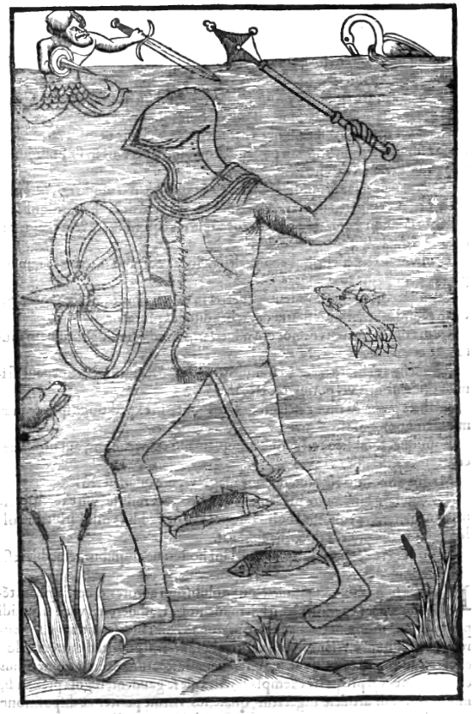
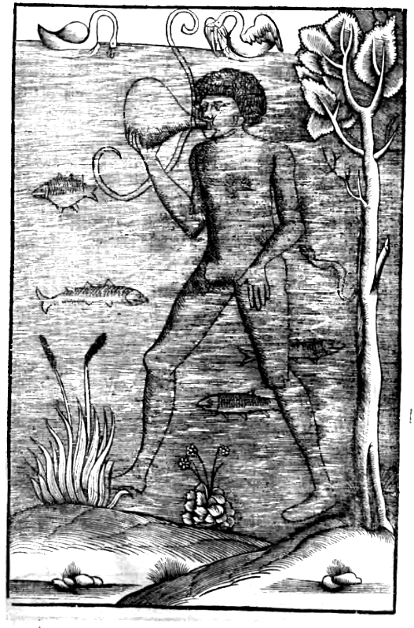
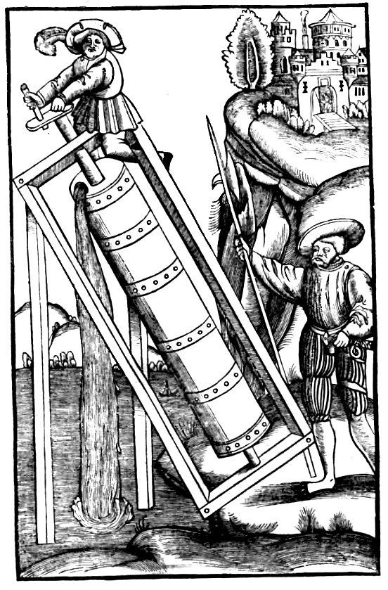
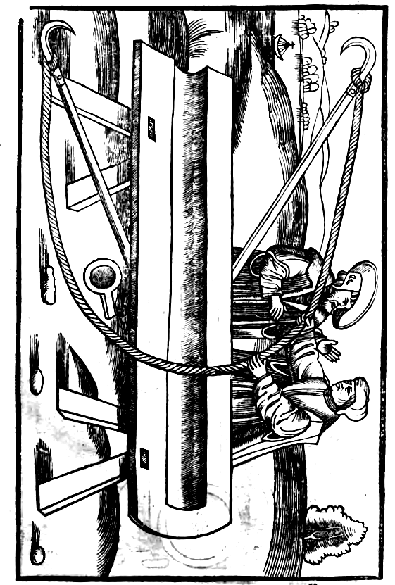
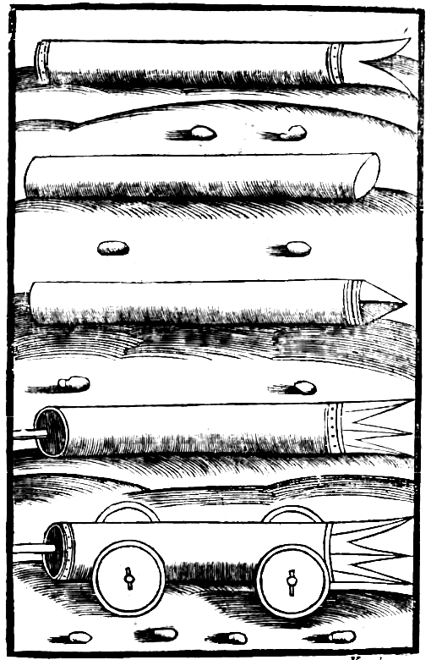
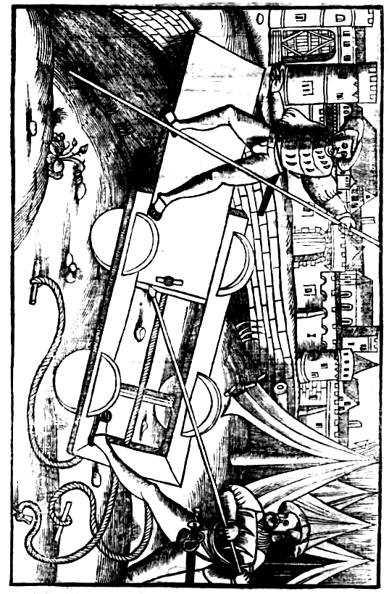
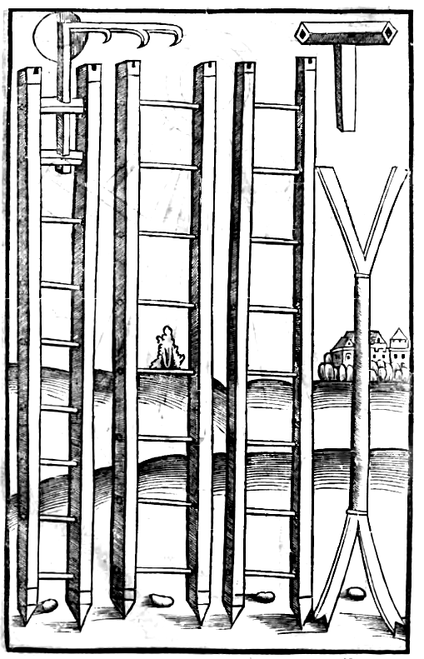
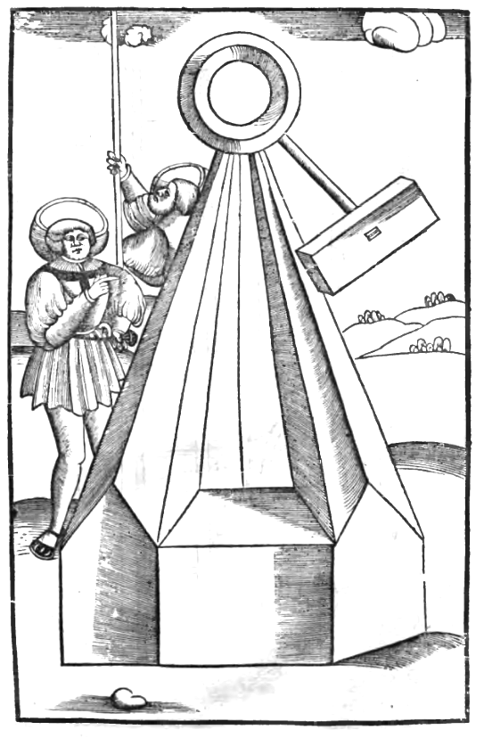
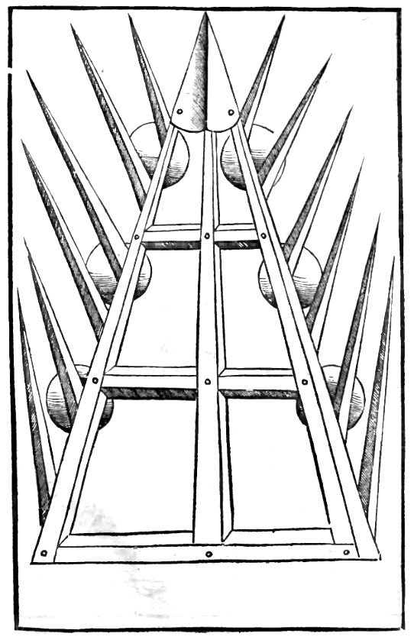
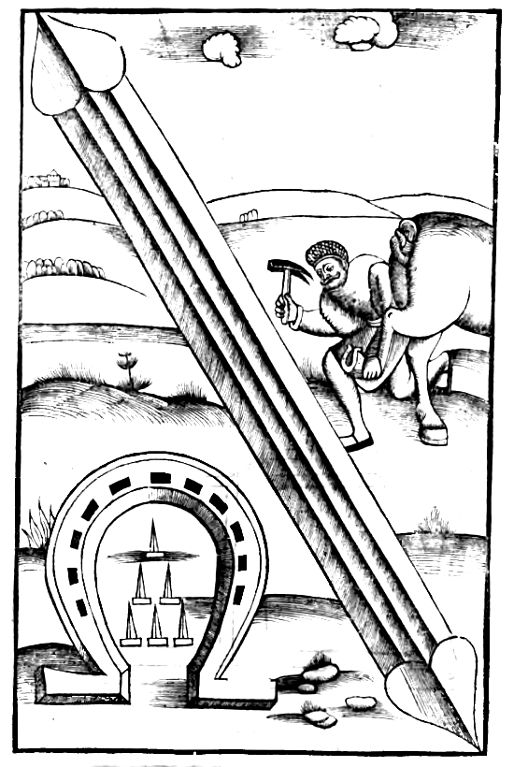
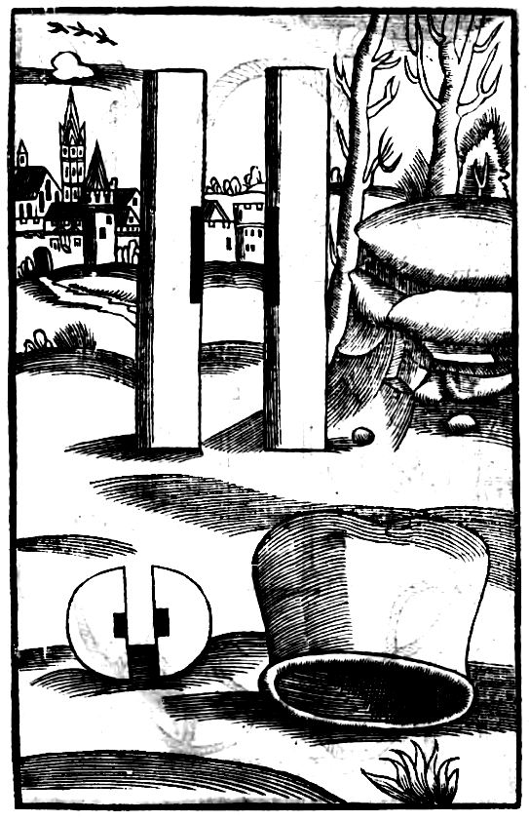
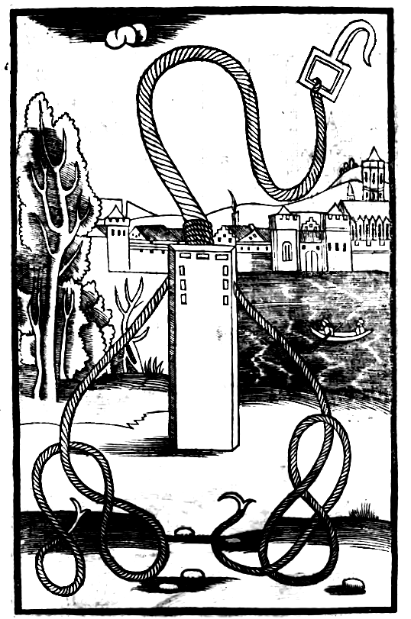
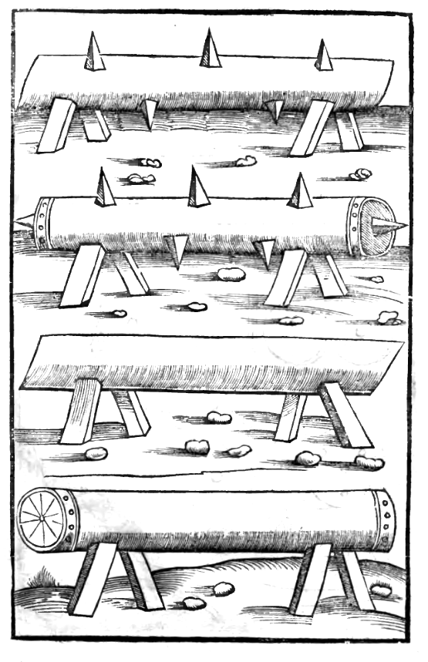
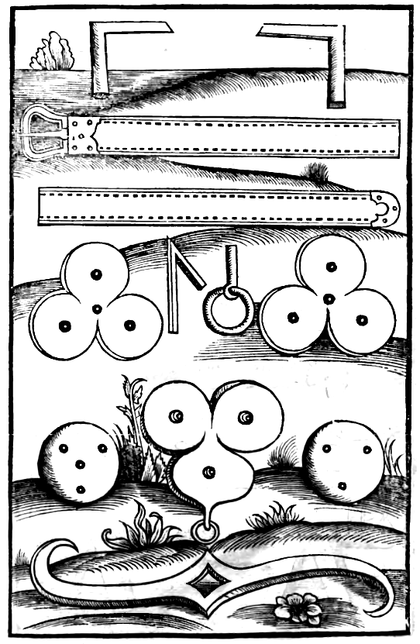
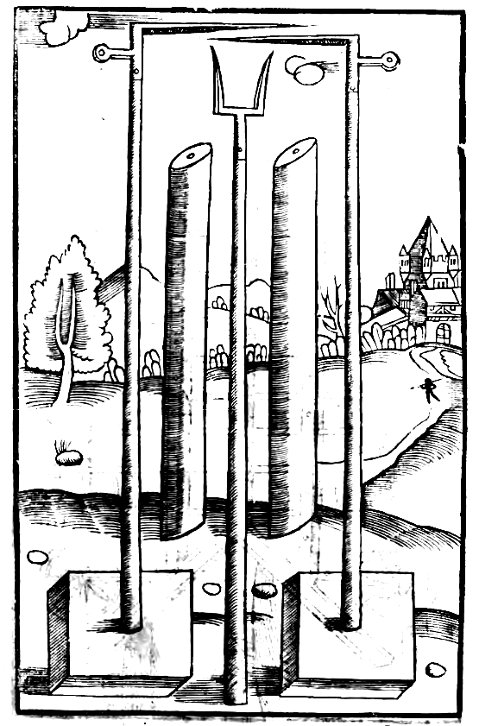
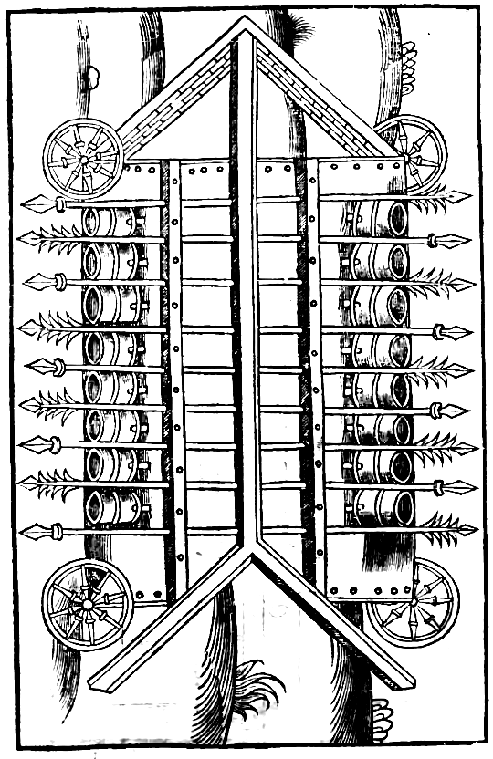
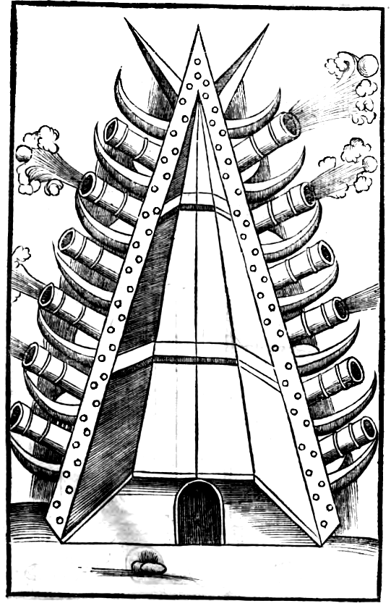
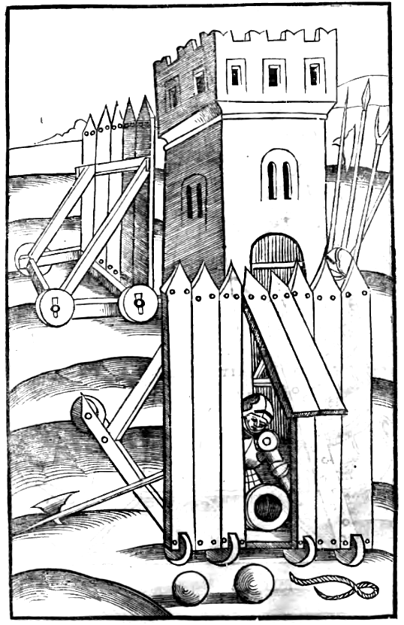
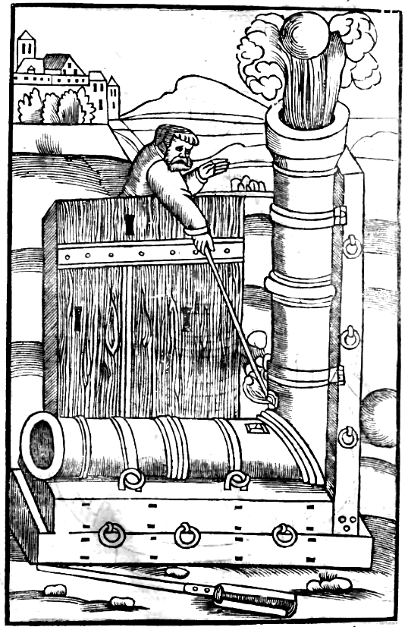
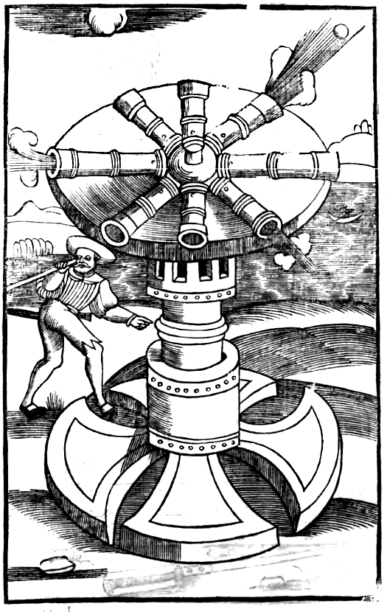
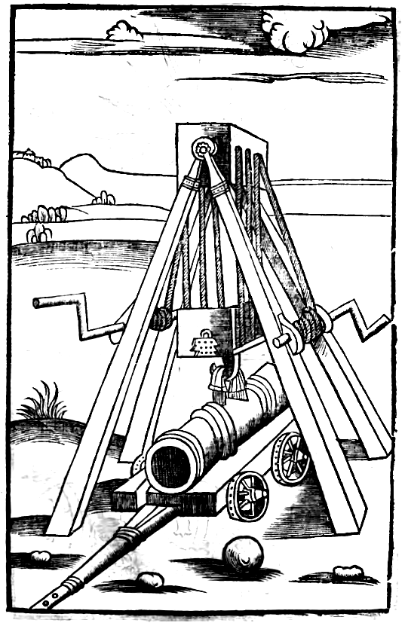
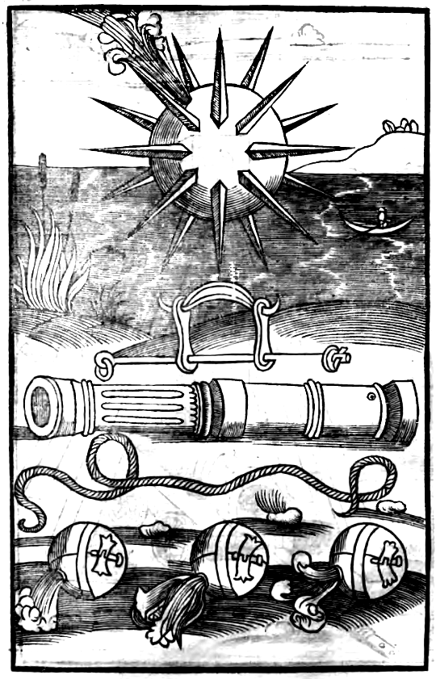
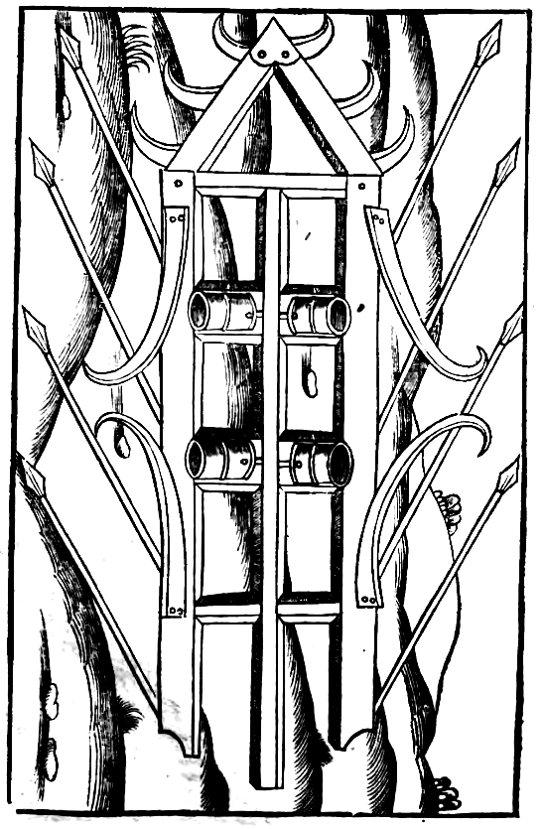
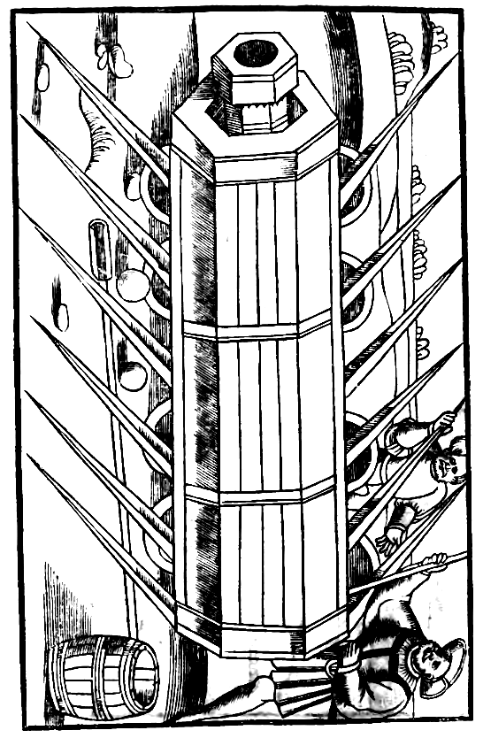
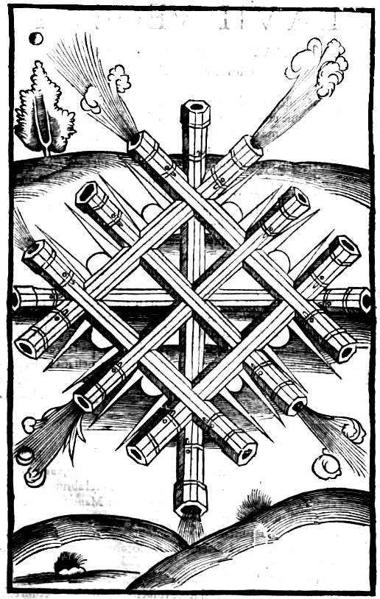
FLAVII VEGETII RENATI DE RE MILITARI

Libri Quarti Prologus.

Agrestem incultamque hominum initio saeculi vitam, a communione mutorum animalium vel ferarum, vrbium constitutio prima discreuit. In his nomen reip. [reipublicae] peperit communis vtilitas. Ideo potentissimae nationes ac principes consecrati nulla in maiorem gloriam putauerunt, quam aut fundare nouas ciuitates, vel ab aliis conditas in nomen suum sub quadam amplificatione transferre. In quo opere clementia serenitatis tuae, obtinet palmam. Ab aliis enim vel paucae, vel singulae, a pietate tua innumerabiles vrbes ita iugi labore perfectae sunt, vt non tam humana manu conditae, quam diuino nutu videantur paratae. Cunctos itaque imperatores foelicitate, moderatione, castimonia, exemplis, indulgentia, studiorum amore praecellis. Regni animique tui bona cernimus. Haec enim anticipare & superior optauit aetas, & extendi in perpetuum ventura desyderat [desiderat]. Quibus rebus tantum vniuerso orbi praesti tum gratulamur bonum, quantum vel humana mens petere, vel gratia potuit diuina conferre. Sed dispositionibus vestrae clementiae, quantum profecerit murorum elaborata constructio, Roma documentum est, quae salutem ciuium Capitolinae arcis defensione seruauit, vt gloriosius postea totius orbis possideret imperium. Ad complementum ergo operis maiestatis vestrae, praeceptione suscepti, rationes quibus vel nostrae ciuitates defendendae sunt, vel hostium subruendae, ex diuersis autoribus in ordinem digeram: nec laboris pigebit, cum omnibus profutura credantur.

Ciuitates aut opere, aut natura, aut vtroque debere muniri. Cap. i.
Vrbes atque castella aut natura muniuntur, aut manu, aut vtroque, quod firmius ducitur. Natura, aut loco edito vel abrupto, aut circunfuso mari siue paludibus vel fluminibus. Manu, fossis, ac muris. In illo naturali beneficio tutissimum eligetur consilium, in plano quaeritur fundantis industria. Videmus antiquissimas ciuitates ita in campis patentibus constitutas, vt deficiente auxilio locorum, arte tamen & opere redderentur inuictae.

Non directos, sed angulosos muros faciendos. Cap. ii.
Ambitum muri directum veteres ducere voluerunt, ne ad ictus arietum esset dispositus, sed sinuosis anfractibus iactis fundamentis clausere vrbes, crebrioresque turres in ipsis angulis ediderunt. Propterea, quia si quis ad murum tali ordinatione constructum, vel scalas, vel machinas voluerit admouere, non solum a fronte, sed etiam a lateribus & prope a tergo veluti in sinum circumclusus opprimitur.

Quemadmodum murus e terra iungatur aggestus, vt nunquam possit elidi. Cap. III.
Mvrus autem vt nunquam possit elidi hac ratione perficitur. Interuallo vicenum pedum interposito, duo intrinsecus parietes fabricantur. Deinde terra, quae de fossis fuerit egesta, inter illos mittitur, vectibusque densatur: ita vt a muro primus paries parum inferior, secundus longe minor ducatur, vt de plano ciuitatis ad similitudinem graduum quasi cliuo molliusque ad propugnacula possit ascendi. Quia nec murus vllis potest arietibus rumpi, quem terra confirmat, & quouis casu destructis lapidibus, ea quae inter parietes densata fuerit, ad muri vicem ingruentibus moles obsistit.

De cataractis, & portis, ne exurantur ab ignibus. Cap. IIII.
Cauetur praeterea, ne portae subiectis ignibus exurantur. Propter quod sunt coriis & ferro tegendae. Sed amplius prodest quod inuenit antiquitas, vt ante portam addatur propugnaculum, in cuius ingressu ponitur cataracta, quae annulis ferreis ac funibus pendet, vt si hostes intrauerint, demissa eadem extinguantur inclusi. Ita tamen supra portam murus est ordinandus, vt accipiat foramina, per quae de superiore parte effusa aqua, subiectum extinguat incendium.

De fossis faciendis. Cap. V.
Fossae autem ante vrbes altissimae latissimaeque faciendae sunt, vt nec facile possint coaequari replerique ab obsidentibus, & cum aquis coeperint inundari, ab aduersario cuniculum continuari minime patiantur. Nam duplici modo opus subterraneum peragi, earum altitudine & inundatione prohibetur.

Ne sagittis hostium homines laedantur in muro. Cap. VI.
Formidatur ne multitudo sagittariorum, de propugnaculis exterritis defensoribus, appositisque scalis, occupet murum. Aduersum quod cataphractas atque scuta in ciuitatibus debent habere quam plurima. Deinde propugnacula duplicia, saga ciliciaque tendantur, impetumque excipiant sagittarum. Nec enim facile transeunt spicula quod cedit ac fluctuat. Inuentum quoque remedium est, vt de ligno crates facerent, quas metellas vocauerunt, lapidibusque complerent: ea arte inter bina propugnacula constitutas, vt si per scalas ascendissent hostes, & partem aliquam ipsius contigissent, supra caput suum vergerent saxa.

Quibus modis prouidendum sit, ne famem patiantur obsessi. Cap. VII.
Mvlta defensionum oppugnationumque sunt genera, quae locis competentibus inseremus. Nunc sciendum est obsidendi duas esse species. Vnam cum aduersarius opportunis locis praesidiis ordinatis, continuis insultibus impugnat obsessos. Alteram cum vel aqua prohibet inclusos, vel deditionem sperat a fame, quando omnes prohibuerit commeatus. Hoc enim consilio, ipse ociosus ac tutus fatigat inimicum. Ad quos casus, possessores, quamuis leui suspicione pulsati, omnem alimoniam victus intra muros debent studiosissime collocare, vt ipsis exuberet substantia, aduersarios inopia cogat abscedere. Non solum autem porcinum, sed & omne animalium genus, quod inclusum seruari potest, deputari oportet ad lardum, vt adminiculo carnis frumenta sufficiant. Aues autem cortales & sine expensa inciuitate nutriuntur, & propter aegrotantes sunt necessariae. Pabula equis congerenda praecipue, & quae apportari nequiuerint, exurenda. Vini, aceti, caeterarumque frugum vel pomorum congerendae sunt copiae, nihilque quod suis proficiat, hostibus relinquendum est. Nam vt hortorum cura in viridariis domorum, vel aries exerceatur, vtilitatis aut voluptatis ratio persuadet. Parum autem proficit plurimum collegisse, nisi ab exordio dimensione salubri per idoneos procuratores erogatio temperetur. Nunquam periclitati sunt fame, qui frugalitatem inter copiam seruare coeperunt. Imbellis quoque aetas ac sexus propter necessitatem victus foris frequenter exclusa est, ne penuria opprimeret armatos, a quibus saepe moenia seruabantur.

Quae species praeparandae sint pro defensione murorum. Cap. VIII.
Exurimenta, bitumen, sulphur, picem liquidam, oleum quod incendiarium vocant, ad exurendas hostium machinas, conuenit praeparari. Ad arma facienda ferrum vtriusque temperaturae, & carbones seruantur in conditis: ligna quoque hastilibus sagittisque necessaria reponuntur. Saxa rotunda de fluuiis quae pro rotunditate grauiora sunt & aptiora, mittentibus diligentissime colliguntur, ex quibus muri replentur & turres. Minima etiam fundis siue fustibalis vel manibus iacienda. Maiora per onagros diriguntur. Maxima vero pondere, formaque volubili, in propugnaculis diriguntur, vt dimissa per praeceps, non solum hostes obruant subeuntes, sed etiam machinamenta confringant. Rotae quoque de lignis viridibus ingentissimae fabricantur, vel intercisi ex validissimis arboribus cylindri (quas taleas vocant) vt sint volubiles laeuigantur: quae per pronum labentia subito impetu bellatores sternunt, equosque solent deterrere. Trabes quoque & tabulata vel diuerse, magnitudinis clauos ferreos esse oportet in promptu (Nam talibus, oppugnantium machinis per alias machinas consueuit obsisti) praecipue cum subitis operibus addenda sit muris vel propugnaculis altitudo, ne aduesariorum mobiles turres superemineant & capiant ciuitatem.

Quid faciendum si neruorum defuerit copia. Cap. IX.
Neruorum quoque copiam summo studio expedit colligi: quia onagri vel balistae caeteraque tormenta, nisi funibus neruinis intenta, nihil prosunt. Equorum tamen setae de caudis ac iubis ad balistas vtiles asseruntur. Indubitatum vero est crines foeminarum in eiusmodi tormentis non minorem habere virturem, Romanae necessitatis experimento. Nam in obsidione Capitolii corruptis iugi ac longa fatigatione tormentis, cum neruorum copia defecisset, matronae abscissos crines viris suis obtulere pugnantibus, reparatisque machinis aduersariorum impetum repulerunt. Maluerunt enim pudicissimae foeminae deformato ad tempus capite libere viuere cum maritis, quam hostibus integro decore seuire. Cornua quoque vel cruda coria proficit colligi ad cataphractas tegendas, aliaque machinamenta siue munimina.

Quid faciendum ne aquae inopiam patiantur obsessi. Cap. X.
Magna vrbis vtilitas est, cum perennes fontes murus includit. Quod si natura non praestat, cuiuslibet altitudinis effodiendi sunt putei, aquarumque haustus funibus extrahendi. Sed interdum sicciora sunt loca, quae montibus sunt saxisque munita, in quibus superposita castella extra murum inferiores reperiunt fontium venas, ac de propugnaculis vel turribus destinatis protegunt telis, vt aquatoribus liber praestetur accessus. Quod si vltra iactum teli, in cliuo tamen ciuitatis subiecta sit vena, castellum paruulum (quem Burgum vocant) inter ciuitatem & fontem conuenit fabricari, ibique balistas sagittariosque constitui, vt aqua defendatur ab hostibus. Praeterea in omnibus publicis aedificiis, multisque priuatis, cisternae sunt diligentissime substituendae, vt receptacula aquis pluuialibus, quae, de tectis effluunt, praestent. Difficile enim vincit sitis eos, qui quamuis exigua aqua ad potum tantum in obsidione sunt vsi.

Si sal defuerit quid faciendum sit. Cap. XI.
Si maritima sit ciuitas & sal defuerit, liquor ex mari sumptus, per alueos aliaque patula vasa diffunditur, qui a calore solis duratur in salem. Quod si hostis ab vnda prohibeat (nam hoc saepe accidit) harenas, quas exagitatum ventis mare superfuderat, aliquando colligunt, & dulci aqua eluunt, quae sole siccata nihilo minus mutatur in salem.

Quid faciendum cum primo impetu venitur ad muros. Cap, XII.
Violenta autem impugnatio, quando castellis vel ciuitatibus praeparatur, mutuo vtrinque periculo, sed maiore oppugnantium sanguine, exercentur luctuosa certamina. Illi enim qui muros inuadere cupiunt, terrifico apparatu expositis copiis, in spem deditionis formidinem geminant, tubarum strepitu hominumque permixto. Tunc, quia timor magis frangit insuetos, primo impetu stupentibus oppidanis, si discriminum experimenta non norunt, dum admotis scalis inuaditur ciuitas, resistere debent omni virtute. Quod si a fidentibus siue militaribus viris repellatur prima congressio, statim clausis crescit audacia, & iam non terrore, sed viribus & arte confligitur.

Enumeratio machinarum quibus muri oppugnantur. Cap. XIII.
Admouentur etiam testudines, arietes, falces, vincae, plutei, musculi, turres, de quibus singulis qualiter fabricentur, quo etiam pacto praelientur vel repellantur, edisseram.

De ariete, falce, testudine. Cap. XIIII.
De materia ac tabulatis testudo contexitur, quae ne exuratur incendio, coriis vel ciliciis centonibusque vestitur. Haec intrinsecus accipit trabem, quae adunco praefigitur ferro, quod Falx vocatur , ab eo quod incurua est, vt de muro extrahat lapides: aut certe ipsius caput vestitur ferro, & appellatur Aries: vel quod habet durissimam frontem, quae subruat muros: vel quod more arietum retrocedit, vt cum impetu vehementius feriat. Testudo autem a similitudine verae testudinis vocabulum sumpsit, quia sicut illa modo reducit, modo profert caput, ita machinamentum interdum reducit trabem, interdum exerit, vt fortius caedat.

De vineis, pluteis & aggere. Cap. XV.
Vineas dixerunt veteres, quas nunc militari barbaricoque vsu causias vocant. Ex lignis leuioribus machina colligatur, alta pedibus 8, lata pedibus 7, longa pedibus 6. Huius tectum munitione duplici, tabulatis cratibusque contexitur. Latera quoque vimine sepiuntur, ne saxorum telorumque impetu penetrentur. Extrinsecus autem, ne immisso concremetur incendio, crudis ac recentibus corus vel centonibus operitur. Istae, cum plures factae fuerint, iunguntur in ordinem, sub quibus obsidentes tuti ad subruenda penetrant murorum fundamenta. Plutei dicuntur, qui ad similitudinem absidis contexuntur e vimine, & ciliciis vel coriis proteguntur, ternisque rotulis, quarum vna in medio, duae in capitibus apponuntur, in quamcunque partem volueris admouentur more carpenti: quos obsidentes applicant muris, eorumque munitione protecti, sagittis siue fundis vel missilibus defensores omnes de propugnaculis ciuitatis exturbant, vt scalis ascendendi facilior praestetur occasio. Agger autem ex terra lignisque extollitur contra murum, de quo tela iactantur.

De Musculis. Cap. XVI.
Mvsculos dicunt minores machinas, quibus protecti bellatores, si lutum obfuerit aut ciuitatis fossatum, apportatis lapidibus, lignis, ac terra, non solum complent, sed etiam solidant, vt turres ambulatoriae sine impedimento iungantur ad murum. Vocantur autem a marinis beluis Musculi. Nam quemadmodum illi, cum minores sint, tamen balenis auxilium adminiculumque iugiter exhibent: ita istae machinae breuiores, deputatae turribus magnis, aduentui illarum parant viam, itineraque praemuniunt.

De turribus ambulatoris. Cap. XVII.
Tvrres autem dicuntur machinamenta, ad aedificiorum speciem, ex trabibus tabulatisque compacta: & ne tantum opus hostili concremetur incendio diligentissime ex crudis coriis vel centonibus communitur, quibus pro modo latitudinis additur altitudo. Nam interdum tricenos pedes per quadrum, interdum quadragenos vel quinquagenos latae sunt. Proceritas autem ipsarum tanta sit, vt non solum muros, sed etiam turres lapideas altitudine superent. His plures rotae mechanica arte subduntur, quarum lapsu volubili magnitudo tam alta mouetur. Praesens autem periculum ciuitatis est, si ad murum fuerit turris admota. Plures enim accipit scalas, & diuerso genere conatur irrumpere. Nam in inferioribus habet arietem, cuius impetu destruit muros, circa vero mediam partem accipit pontem, factum de duabus trabibus, septumque de vimine, quem cito prolatum inter turrim murumque constituunt, & per eum ingredientes de machina bellatores in ciuitatem transeunt, & occupant muros. In superioribus autem turris illius partibus contati & sagittarii collocantur, qui defensores vrbis contis, missilibus, saxisque ex alto prosternant. Quo facto ciuitas capitur sine mora. Quid enim auxilii superest, cum hi qui de murorum altitudine sperabant, repente supra se aspiciant altiorem hostium murum?

Quemadmodum ambulatoria turris possit incendi. Cap. XVIII.
Hvic tam manifesto discrimini occurritur multis modis. Primum si considentia vel virtus est militaris, eruptione facta, globus egreditur armatorum, & vi hostibus pulsis machinamentum illud ingens direptis coriis ignis exurit. Quod si oppidani exire non audeant, maiores balistas, malleolos, vel phalaricas cum incendio destinant, vt perruptis coriis vel centonibus, intrinsecus flamma condatur. Malleoli velut sagittae, sunt, & vbi adhaeserint (quia ardentes sunt) vniuersa conflagrant. Phalarica autem ad modum hastae valido praefigitur ferro, inter tubum & hastile sulphure, resina, bitumine, stupisque conuoluitur infuso oleo, quod incendiarium vocant, quae balistae impetu destinata, praerupto munimine ardens figitur ligno, turritamque machinam frequenter incendit. Depositi quoque homines funibus, cum hostes dormiunt in laternis portant lucernas, & incensis machinis rursus leuantur in murum.

Quemadmodum altitudo muris addatur. Cap. XIX.
Praeterea partem muri, ad quam machina conatur accedere, caemento atque lapidibus, vel luto siue lateribus, postremo tabulatis extruendo faciunt altiorem, ne defensores moenium desuper vrbi ventura possit opprimere. Constat autem inefficax machinamentum reddi, si inueniatur inferius. Verum obsidentes eiusmodi dolum adhibere consueuerunt. Primo talem extruunt turrem, quae propugnaculis ciuitatis videatur inferior. Deinde secreto aliam de tabulatis intrinsecus turriculam faciunt, & cum muris fuerit machina sociata, subito funibus trocleisque de medio turricula illa producitur de qua egredientes armati (quia altior inuenitur) statim capiunt ciuitatem.

Quo pacto fodiatur terra, vt machina nocere non possit. Cap. XX.
Interdum longissimas ferratasque trabes opponunt machinae venienti, eamque a muri vicinitate propellunt. Sed cum Rhodiorum ciuitas oppugnaretur ab hostibus, & turris ambulatoria super murorum altitudinem ac turrium omnium pararetur, mechanici ingenio inuentum est tale remedium. Per noctem sub fundamento muri cuniculum fodit, & illum ad quem die postero turris fuerat promouenda, nullo hostium sentiente, egesta terra cauauit intrinsecus: & cum rotis suis moles fuisset impulsa, atque ad locum qui subtus cauatus fuerat venisset, tanto pondere solo cedente subsedit, vt nec iungi muris, aut moueri vlterius potuerit. Ita ciuitas liberata est, derelictaque machina.

De scalis, sambuca, exostra, & tollenone. Cap. XXI.
Admotis turribus funditores lapidibus, sagittarii iaculis, manubalistarii vel arcubalistarii sagittis, iaculatores plumbatis ac missilibus, e muris submouent hostes. Hoc facto, scalis appositis occupant ciuitatem. Sed qui scalis nituntur, frequenter periculum sustinent, exemplo Capanei, a quo primum haec scalarum oppugnatio perhibetur inuenta: qui tanta vi occisus est a Thebanis, vt extinctus fulmine diceretur. Et ideo sambuca, exostra & tollenone obsidentes in murum hostium penetrant. Sambuca dicitur ad similitudinem citharae. Nam quemadmodum in cithara chordae sunt, ita in trabe, quae iuxta turrim ponitur, funes sunt, qui pontem de superiore parte trochleis laxant, vt ascendat ad murum, statimque de turri exeunt bellatores, & peream transeuntes moenia vrbis inuadunt. Exostra dicitur pons quem superius exposuimus, qui de turri in murum repente protenditur. Tolleno dicitur quoties vna trabs in terram praealte defigitur, cui in summo vertice alia transuersa trabs longior dimensa medietate connectitur, eo libramento, vt si vnum caput depresseris, aliud erigatur. In vno ergo capite cratibus siue tabulatis contexitur machina, in qua pauci collocantur armati. Tunc per funes vno attracto depressoque, alio capite eleuati imponuntur in murum.

De balistis, onagris, scorpionibus, arcubalistis, fustibalis, fundis, per quae tormenta defenditur murus. Cap. XXII.
Aduersum haec obsessos defendere consueuerunt balistae, onagri, scorpiones, arcubalistae, fustibali, sagittarii, fundae. Balista funibus, neruis chordisque tenditur, quae quanto prolixiora brachiola habuerit, hoc est quanto maior fuerit, tanto spicula longius emittit: quae & si iuxta artem mechanicam temperetur, & ab exercitatis hominibus, qui mensuram eius ante collegerint, dirigatur, penetrat quod cumque percusserit. Onager autem dirigit lapides, sed pro neruorum crassitudine & magnitudine, saxorum pondera iaculatur. Nam quanto amplior fuerit, tanto maiora saxa fulminis more contorquet. His duobus generibus nulla tormentorum species vehementior inuenitur. Scorpiones dicebantur quas nunc manubalistas vocant: ideo sic nuncupati, quod paruis subtilibusque spiculis inferant mortem. Fustibalos, arcubalistas & fundas describere superfluum puto, quae praesens vsus agnoscit: saxis tamen grauioribus per onagrum destinatis, non solum equi eliduntur & homines, sed etiam hostium machinamenta franguntur.

Aduersum arietes prosunt culcitrae, laquei, lupi, & columnae grauiores Cap. XXIII.
Aduersum arietes etiam vel falces, sunt plura remedia. Aliquanti centones & culcitras fustibus calcant, & illis opponunt locis quae caedit aries, vt impetus machinae materia molliore fractus, non destruat murum. Alii laqueis captos arietes, per multitudinem hominum de muro in obliquum trahunt, & cum ipsis testudinibus euertunt. Plures in modum forficis dentatum funibus alligant ferrum, quod lupum vocant, apprehensumque arietem aut euertunt, aut ita suspendunt vt impetum non habeat feriendi. Interdum bases columnae marmoreae vibrato impetu iaciuntur e muris, arietesque confringunt. Quod si tanta vis fuerit, vt murus arietibus perforetur, & (quod saepe accidit) decidat, salutis vna spes superest vt destructis domibus alius intrinsecus murus addatur, hostesque inter binos parietes (si penetrare tentauerint) perimantur.

De Cuniculis per quos murus defoditur. Cap. XXIIII.
Aliud genus oppugnationis est subterraneum atque secretum, quod Cuniculum vocant: a leporibus qui casulas sub terras fodiunt, ibique conduntur. Adhibita ergo multitudine ad speciem metallorum, in quibus auri argentique venas bessorum rimatur industria, magno labore terra defoditur, cauatoque specu in exitium ciuitatis inferna quaeritur via: quae fraus duplicibus operatur insidiis. Aut enim penetrant vrbem, & noctu non sentientibus oppidanis egrediuntur per cuniculum, reseratisque portis suorum agmen ducunt, hostesque in ipsis domibus perimunt ignorantes: aut certe cum ad murorum fundamenta peruenerint, suffodiunt eorum maximam partem, appositis siccioribus lignis, ruinamque muri tumultuario opere suspendunt. Sarmenta insuper iungunt, aliaque fomenta flammarum. Tunc praeparatis bellatoribus subter ignis immittitur, combustisque columnis ligneis atque tabulatis, muro subito corruente, irruptioni aditus reseratur.

Quid facere debeant oppidani, si hostis irruperit ciuitatem. Cap. XXV.
Innumerabilibus declaratur exemplis, saepe caesos ad internicionem hostes, qui inuaserant ciuitatem. Quod sine dubio euenit, si oppidani muros ac turres obtinuerint, vel altiora loca occupauerint. Tunc enim de fenestris ac tectis omnis aetas ac sexus irrupentes obruunt saxis, aliisque generibus telorum: quod ne sustineant obsidentes, portas ciuitatis aperire consueuerunt, vt resistere desinant, fugiendi potestate concessa. Necessitas enim quaedam virtutis est, desperatio in hoc casu. Vnum oppidanis auxilium est, siue per diem, siue per noctem hostis intrauerit, vt muros turresque teneant, ac loca superiora conscendant, hostesque per vicos & plateas vndique obruant dimicantes.

Quae sit adhibenda cautela, ne hostes furtim occupent murum. Cap. XXVI.
Frequenter dolum excogitant obsidentes, ac simulata desperatione longius abeunt. Sed vbi post metum, murorum vigilis derelictis, requieuerit incauta securitas, tenebrarum ac noctis occasione captata, cum scalis clanculum veniunt, murosque conscendunt. Propter quod maior est adhibenda custodia cum hostis abscesserit, & in ipsis muris ac turribus tuguriola locanda, in quibus vigiles hybernis mensibus ab imbribus vel frigore, aestiuis defendantur a sole. Illud quoque vsus inuenit, vt acerrimos ac sagacissimos canes in turribus nutriant, qui aduentum hostium odore praesentiant, latratuque testentur. Anseres quoque non minore solertia nocturnos superuentus clamoribus indicant. Nam ingressi Capitolinam arcem Galli, Romanum nomen eruerant, nisi clamore anserum excitatus Manlius restitisset. Mira diligentia siue fortuna viros, qui vniuersum orbem erant missuri sub iugum, auis vna seruauit.

Quomdo [Quando] oppidanis inferantur insidiae. Cap. XXVII.
Non solum in obsidionibus, sed in vniuerso genere bellorum, super omnia ducitur, hostium consuetudinem explorare diligenter ac nosse. Oportunitas enim insidiarum aliter non potest inueniri, nisi scias quibus horis aduersarius a laboris intentione discedat, quibus reddatur incautior: interdum medio die, interdum ad vesperum, saepe nocte, aliquando eo tempore quo sumitur cibus, cum vtriusque partis milites ad requiem aut curanda corpora disperguntur. Quod in ciuitate cum coeperit fieri, obsidentes astu se a praelio subtrahunt, vt aduersariorum negligentiae licentiam tribuant. Quae ipsa impunitate cum creuerit, repente admotis machinis, vel appositis scalis occupant ciuitatem. Et ideo in muris saxa caeteraque tormenta ponuntur in promptu, vt cognitis insidiis occurrentes, ad manus habeant quod supra capita hostium euoluant atque iaculentur.

Quid faciant obsidentes ne ab oppidanis patiantur insidias. Cap.XXVIII.
Cvm negligentia interuenerit paribus insidiis subiacent obsidentes. Nam siue cibo siue somno fuerint occupati, siue ocio aut aliqua necessitate dispersi, tunc oppidani repente prorumpunt, ignorantes perimunt, arietes, machinas, ipsosque aggeres ignibus concremant, omniaque in perniciem suam fabricata opera subuertunt. Propter hoc obsidentes vltra iactum teli fossam faciunt, eamque non solum vallis & sudibus, sed etiam turriculis instruunt, vt erumpentibus ex ciuitate possint obsistere, quod opus Loriculam vocant, & saepe cum obsidio describitur, inuenitur in historiis Loricula vrbem esse circundatam.

Quo genere tormentorum defendantur ciuitates. Cap. XXIX.
Sed ex alto destinata missilia, siue plumbatae, vel lanceae, veruta, vel spicula in subiectos vehementius cadunt. Sagittae quoque arcubus missae, & saxa manibus, fundis, fiue fustibalis directa, quanto de excelsiori loco exeunt, tanto longius penetrant. Balistae vero & onagri, si a peritis diligentissime temperantur, vniuersa praecidunt, a quibus nec virtus vlla, nec munimina possunt defendere bellatores. Nam more fulminis, quicquid percusserint, aut dissoluere, aut irrumpere consueuerunt.

Quemadmodum mensura colligatur ad scalas vel machinas faciendas. Cap. XXX.
Ad capiendos muros, scalae vel machinae plurimum valent, si ea magnitudine compactae fuerint, vt altitudinem exuperent ciuitatis. Mensura autem colligitur duplici modo: aut enim linum tenue & expeditum vno capite nectitur in sagitta, quae cum ad muri fastigia directa peruenerit, ex mensura lini, murorum altitudo deprehenditur: aut certe cum sol obliquus vmbram turrium murorumque iaculatur in terram, tunc ignorantibus aduersariis, vmbrae illius spacium mensuratur, itemque decempeda figitur, & vmbra illius similiter mensuratur. Quo collecto numero, nemo dubitat ex vmbra decempedae inueniri altitudinem ciuitatis, cum sciatur quanta altitudo, quantum vmbrae mittat in longum. Quae ad oppugnandas vel defendendas vrbes autores bellicarum artium prodiderunt, vel quae recentior necessitatum vsus inuenit, pro publica (vt arbitror) vtilitate digessi, illud iterum iterumque commoneris, vt solertissime caueatur, ne quando aut potus inopia emergat, aut cibi, quibus malis nulla arte succurritur: ideoque intra muros tanto plura condenda sunt, quanto scitur clausurae, tempus in obsidentium potestate consistere.

Praecepta belli naualis. Cap. xxxi.
Praecepto maiestatis tuae, imperator inuicte, terrestris praelii rationibus absolutis, naualis belli residua (vt opinor) est portio: de cuius artibus ideo pauciora dicenda sunt: quia iamdudum pacato mari, cum barbaris nationibus agitur terrestre certamen. Romanus autem populus pro decore & vtilitate magnitudinis suae, non propter necessitatem tumultus alicuius classem parabat ex tempore. Sed ne quando necessitatem sustineret, semper habuit praeparatam. Nemo enim bello lacessere, aut facere audet iniuriam ei regno vel populo, quem expeditum & promptum ad resistendum vindicandumque cognoscit. Apud Misenum ergo & Rauennam singulae legiones Romani nominis cum classibus stabant, ne longius a tutela vrbis abscederent: & cum ratio postulasset, sine mora, sine circuitu ad omnes mundi partes nauigio peruenirent. Nam Misenatium classis, Galliam, Hispanias, Mauritaniam, Aphricam, Aegyptum, Sardiniam, atque Siciliam in proximo habebat. Classis autem Rauennatium, Epiron, Macedoniam, Achaiam, Propontidem, Pontum, Orientem, Cretam, Cyprum petere directa nauigatione consueuerat: quia in rebus bellicis celeritas amplius solet prodesse quam virtus.

Nomina iudicum qui praeerant classi. Cap. xxxii.
Liburnis autem, quae in Campania stabant, praefectus classis Misenatium praeerat. Eas vero quae Ionio in mari locatae fuerant, praefectus classis Rauennatium retinebat, sub quibus erant deni tribuni per cohortes singulas constituti. Singulae autem Liburnae singulos nauarchos, id est, quasi nauicularios habebant, qui exceptis caeteris nautarum officiis, gubernatoribus atque remigibus & militibus exercendis, quotidianam curam & iugem exhibebant industriam.

Vnde appellentur Liburnae. Cap. xxxiii.
Diuersae autem prouincia: quibusdam temporibus mari plurimum potuerunt & ideo diuersa eis genera nauium fuerunt. Sed Augusto dimicante Actiaco praelio cum Liburnorum auxiliis praecipue victus fuisset Antonius, experimento tanti certaminis patuit Liburnorum naues caeteris aptiores. Ergo similitudine & nomine vsurpato, ad earumdem instar classem Romani principes texuerunt. Liburnia nanque Dalmatiae, pars est Iadertinae subiacens ciuitati, cuius exemplo nunc naues bellicae fabricantur, & appellantur Liburnae.

Qua diligentia fabricentur Liburnae. Cap. XXXIIII.
Sed cum in domibus struendis arenae vel lapidum qualitas requiratur, tanto magis in fabricandis nauibus diligenter cuncta quaerenda sunt, quanto maius periculum est nauem vitiosam esse quam domum. Ex cypresso ergo & pinu domestica, siue sylvestry larice, & abiete praecipue Liburna contexitur, vtilius aereis claui quam ferreis configenda. Quae licet grauior aliquanto videatur expensa, tamem, quia amplius durat, lucrum probatur afferre. Nam ferreos clauos tempore & humore celeriter rubigo consumit, aerei autem etiam in fluctibus propriam substantiam seruant.

Qua obseruatione sit caedenda materies. Cap. XXXV.
Obseruandum praecipue, vt a quintadecima luna vsque ad vigesimam tertiam arbores praecidantur, ex quibus Liburnae contexendae sunt. His enim tantum octo diebus caesa materies immunis seruatur a carie: reliquis autem diebus praecisa, etiam eodem anno interna vermium labe exesa in puluerem vertitur: quod ars ipsa & omnium architectorum quotidianus vsus edocuit, & contemplatione ipsius religionis agnoscimus, quam pro aeternitate his tantum diebus placuit celebrari.

Quo mense fint caedendae trabes. Cap. XXXVI.
Caeduntur autem trabes vtiliter post solstitium aestiuum, id est, per menses, Iulium, Augustum, & per autumnale aequinoctium vsque ad calendas lanuarias. His nanque mensibus arescente humore sicciora, & ideo fortiora sunt ligna. Illud etiam cauendum, ne continuo vt deiectae fuerint trabes secentur, vel statim vt sectae fuerint mittantur in nauem: Siquidem & adhuc solidae arbores & iam diuisae per tabulas duplices ad maiorem siccitatem mereantur inducias. Nam quae virides compinguntur, cum natiuum humorem exudauerint, contrahuntur & rimas faciunt latiores, quo nihil est periculosius nauigantibus.

De modo Liburnarum. Cap. XXXVII.
Qvod ad magnitudinem pertinet, minimae Liburnae remorum habent singulos ordines, paulo maiores binos, idoneae mensurae ternos vel quaternos, interdum qui nos sortiuntur remigum gradus. Nec hoc cuiquam enorme videatur, cum in Actiaco praelio longe maiora referantur concurrisse nauigia, vt senorum etiam vel vltra ordinum fuerint. Scaphae tamen maioribus Liburnis exploratoriae sociantur, quae vicenos prope remiges in singulis partibus habeant, quas Britanni pictas vocant. Per has & superuentus fieri & commeatus aduersariorum nauium aliquando intercipi assolet, & speculandi studio aduentus earum vel consilium deprehendi. Ne tamen exploratoriae naues candore prodantur, colore veneto (qui marinus est fluctibus similis) vela tinguntur & funes: cera etiam qua vngere solent naues, inficitur. Nautae quoque vel milites Venetam vestem induunt, vt non solum per noctem sed etiam per diem facilius lateant explorantes.

Nomina ventorum & numerus. Cap. XXXVIII.
Qvicumque exercitum armatis classibus vehit, turbinum signa debet ante praenoscere. Procellis nanque & fluctibus liburnae grauius quam vi hostium: saepe perierunt. In qua parte, naturalis philosophiae tota est adhibenda solertia, qua, ventorum & tempestatum coelesti ratione natura colligitur. Et pro acerbitate pelagi, sicut cautos & prouidos cautela tutatur, ita negligentes extinguit incuria. Igitur ventorum numerum atque vocabula ars nauigandi primum debet inspicere. Veteres autem iuxta positionem cardinum tantum quatuor ventos principales a singulis coeli partibus flare credebant, sed experimento posterior aetas duodecim comprehendit. Horum vocabula ad submouendam dubitationem non solum Graeca, sed etiam Latina protulimus, ita vt ventis principalibus declaratis, eos qui ipsis dextra laeuaque, iuncti sunt indicemus. A verno itaque solstitio, id est, ab orientali cardine, sumimus exordium, ex quo ventus oritur ¥phlièthj, id est, subsolanus. Huic a dextra adiungitur kaik…aj [siue euroborus]. A sinistra Ÿuroj siue vulturnus. Meridianum autem cardinem possidet nÒtoj, id est, auster. Huic a dextra iungitur leukonÒtoj id est, albus notus. A sinistra libonÒtoj id est corus. Occidentalem vero cardinem tenet zšfuroj. Huic a dextra iungitur l…y siue Aphricus. A sinistra, ‡£pux siue Fauonius. Septentrionalem vero cardinem sortitus est Aparctias siue septentrio, cui adhaeret a dextra trask…aj siue Circius. A sinistra bor©j, id est, aquilo. Hi saepe singuli interdum duo, magnis autem tempestatibus etiam tres pariter flare consueuerunt. Horum impetu maria, quae sua sponte tranquilla sunt & quieta, vndis aestuantibus saeuiunt. Horum flatu pro natura temporum vel locorum ex procellis serenitas redditur, & rursus in procellas serena mutantur. Nam secundo spiramine optatos classis inuenit portus, aduerso stare vel regredi, aut discrimen sustinere compellitur. Et ideo difficile naufragium pertulit, qui ventorum rationem diligenter inspexit.

Quibus mensibus tutius nauigetur Cap. XXXIX.
Sequitur mensium dierumque tractatus. Neque enim integro anno vis atque acerbitas maris patitur nauigantes, sed quidam menses aptissimi, quidam dubii, reliqui classibus intractabiles sunt lege naturae. Phaenitae decursu, id est, post ortum Pleadum a die sexto kalendas lunii vsque ad arcturi ortum, id est, in diem 18 kalendas octobris secura nauigatio creditur, quia aestatis beneficio ventorum acerbitas mitigatur. Post hoc tempus vsque in tertium Idus nouembris incerta nauigatio est, & discrimini propior: propterea quia post septembris Idus oritur arcturus vehementissimum sidus. Octauo kalendas octobris aequinoxiales euenit acerba tempestas. Circa nonas vero octobris Hoedi pluuiales, quinto Idus eiusdem Taurus. A nouembri autem mense crebris tempestatibus nauigia conturbat Vergiliarum hyemalis occasus. Ex die igitur tertio Iduum Nouembris vsque in diem sextum Iduum Martu maria clauduntur. Nam lux minima, noxque prolixa, nubium densitas, aëris obscuritas, ventorum, hymbrium, vel niuium geminata saeuitia non solum classes a pelago, sed etiam commeantes a terrestri itinere deturbat. Post natalem vero (vt ita dicam) nauigationis qui solemni certamine publicoque spectaculo multarum gentium celebrantur, plurimorum siderum ipsiusque temporis ratione vsque in idus Maias periculose maria tentantur: non quod negociatorum cesset industria, sed quia maior adhibenda est cautela, quando exercitus nauigat cum liburnis, quam cum priuatorum mercium festinat audacia.

Quemadmodum tempestatum obseruentur signa. Cap. XL.
Praeterea aliquorum ortus occasusque siderum tempestates vehementissimas commouent, in quibus licet certi dies auctorum attestatione signentur, tamen quia diuersis casibus aliquando mutantur, confitendum est quod coelestes causas humana conditio ad plenum scire prohibetur. Nauticae igitur obseruationis curam trifariam diuidunt. Aut enim circa diem statum [statutum], aut ante, vel postea tempestates fieri compertum est. Vnde praecedentes proce…masij, nascentes die solemni œpice…masij, subsequentes metace…masij, graeco vocabulo nuncupauerunt. Sed omnia enumerare nominatim aut ineptum videtur, aut longum, cum auctores plurimi, non solum mensium, sed etiam dierum rationem diligenter expresserint, transitusque siderum, quos planetas vocant, quum praescripto cursu diei arbitrio creatoris suscipiunt signa vel deserunt, frequenter assolent serena turbare Interluniorum autem dies tempestatibus plenos, & nauigantibus quam maxime metuendos, non solum peritiae ratio, sed etiam vulgi vsus intelligit.

De prognosticis quibus noscitur serenitas & turbatio aëris. CAP. XLI
Mvltis quoque signis & de tranquillo procellae, & de tempestatibus serena produntur, quae velut in speculo lunae orbis ostendit. Rubicundus enim color ventos, caeruleus indicat pluuias. Ex vtroque commixtus, nimbos & furentes procellas. Laetus orbis ac lucidus serenitatem nauigiis repromittit, quam gestat in vultu: praecipue si quarto ortu neque obtusis cornibus rutilat, neque infuso fuerit humore fuscata. Sol quoque ex oriens vel diem condens, interest vtrum aequalibus gaudeat radiis, an obiecta nube varietur, vtrum solido splendore fulgidus, an ventis vrgentibus igneus, neve pallidus vel pluuia sit impendente maculosus. Aër vero & mare ipsum nubiumque magnitudo vel species solicitos instruit nautas. Aliquanta ab auibus, aliquanta significantur a piscibus, quae Vergilius in Georgicis diuino pene comprehendit ingenio, & Varro in libris naualibus diligenter excoluit. Haec gubernatores sese scire profitentur, sed eatenus quatenus eos imperitiae vsus instruit, non altior doctrina firmauit.

De aestuariis, hoc est, de rheumate. Cap. XLII.
Elementum pelagi tertia pars est mundi, quod praeter ventorum flatum suo quoque spiramine motuque vegetatur. Nam certis horis, diebus pariter ac noctibus aestu quodam (quod rheuma vocant) vltro citroque procurrit, & more torrentium fluminum nunc exundat in terras, nunc refluit in altitudinem suam. Haec reciprocantis meatus ambiguitas, cursum nauium secunda adiuuat, retardat aduersa: quae dimicaturo magna sunt cautione vitanda. Neque enim auxilio remorum rheumatis impetus vincitur, cui interdum cedit & ventus. Et quoniam in diuersis regionibus diuerso lunae crescentis minuentisque statu, certis horis ista variantur, ideo praelium nauale gesturus, consuetudinem pelagi vel loci, ante congressum debet agnoscere.

De locorum notitia siue remigibus. Cap. XLIII.
Nautarum gubernatorumque solertia est, loca in quibus nauigatur, portusque cognoscere, vt infesta prominentibus vel latentibus scopulis vadosa ac sicca vitentur. Tanto enim securitas maior est, quanto mare altius fuerit. In nautis diligentia, in gubernatoribus peritia, in remigibus virtus eligitur. Propterea quia naualis pugna tranquillo committitur mari, liburnarumque, moles non ventorum flatibus, sed remorum pulsu aduersarios percutit rostris, eorumque rursum impetus vitat. In quo opere lacerti remigum, & ars clauum regentis magistri victoriam praestat.

De telis tormentisque naualibus. Cap. XLIIII.
Mvlta quidem armorum genera praelium terrestre desyderat, sed nauale certamen non solum plures armorum species, verum etiam machinas, & tormenta flagitat, tanquam in muris dimicetur & turribus. Quid enim crudelius congressione nauali, vbi & aquis homines perimuntur & flammis? Praecipua ergo esse debet tegminum cura, vt cataphracti vel loricati, galeati etiam & ocreis muniti sint milites. De onere namque armorum nemo potest conqueri, qui stans pugnat in nauibus. Scuta quoque validiora propter ictus lapidum, & ampliora sumantur propter falces, & harpagones aliaque, naualia genera telorum. Sagittis, missilibus, fundis, fustibalis, plumbatis, onagris, balistis, scorpionibus, iacula inuicem diriguntur & saxa: & (quod est grauius) qui de virtute praesumunt, admotis liburnis iniectis pontibus in aduersariorum transeunt naues, ibique gladiis manu ad manum (vt dicitur) cominus dimicant. In maioribus etiam liburnis propugnacula turresque constituunt, vt tanquam de muro, ita de excelsioribus tabulatis facilius vulnerent &: perimant inimicos. Oleo incendiario, stuppa, sulphure, & bitumine obuolutae & ardentes sagittae per balistas in hosticarum nauium alueos infiguntur, inunctasque cera & pice & resina tabulas tot fomentis ignium repente succendunt. Alii ferro interimuntur & saxo, alii ardere coguntur in fluctibus: inter tanta tamen mortium genera, qui acerrimus casus est, absumenda piscibus insepulta sunt corpora.

Qemadmodum [Quemadmodum] nauali bello collocentur insidiae. Cap. XLV.
Ad instar autem terrestris praelii superuentus fiunt ignorantibus nautis, vel circa opportunas insularum angustias collocantur insidiae. Idque agitur vt imperati facilius deleantur, si longo remigio fatigati sunt hostium nautae, si vento vrgentur aduerso, si pro rostris est rheuma, si nihil suspicantes dormiunt inimici, si statio quam tenent exitum non habet, si dimicandi optata venit occasio, fortunae beneficiis iungendae sunt manus, & ex opportunitate praelium conserendum. Quod si cautela hostium, euitatis insidiis, publico Marte confligat, tunc liburnarum instruendae sunt acies, non directae, vt in campo, sed incuruae ad similitudinem lunae, ita vt productis cornibus acies media sinuetur: vt si aduersarii prorumpere tentauerint, ipsa ordinatione circundati deprimantur. In cornibus autem praecipuum robur & liburnarum collocetur & militum.

Quid fiat cum aperto Marte nauale committitur bellum. Cap. XLVI.
Praeterea vtile est, vt alto & libero mari tua semper classis vtatur, inimicorum vero semper pellatur ad littus: quia pugnandi impetum perdunt, qui detruduntur in terras. In huiusmodi certamine tria armorum genera solent ad victoriam plurimum prodesse, asseres, falces, bipennes. Asser dicitur cum trabs subtilis ac longa ad similitudine antennae pendet in malo, vtroque capite ferrato. Hunc siue a dextra siue a sinistra parte aduersariorum se iunxerint naues pro vice arietis vi impellunt, qui bellatores hostium siue nautas sine dubio prosternit ac perimit ipsamque nauem saepius perforat Falx autem dicitur acutissimum ferrum curuatum ad similitudinem falcis, quod contis longioribus inditum, collatorios funes, quibus antenna suspenditur, repente praecidit, collapsisque velis liburnam pigriorem & inutilem reddit. Bipennis est securis habens ex vtraque parte latissimum & acutissimum ferrum. Per has in medio ardore pugnandi peritissimi nautae vel milites cum minoribus scaphulis secreto incidunt funes, quibus aduersariorum ligata sunt gubernacula. Quo facto, statim capitur tanquam inermis & debilis nauis. Quid enim salutis superest ei qui amiserit clauum? Delusoriis, queis in Danubio quotidianis vtuntur excubiis, reticendum puto, quia artis amplius in his frequentior vsus inuenit, quam vetus doctrina monstrauerit.

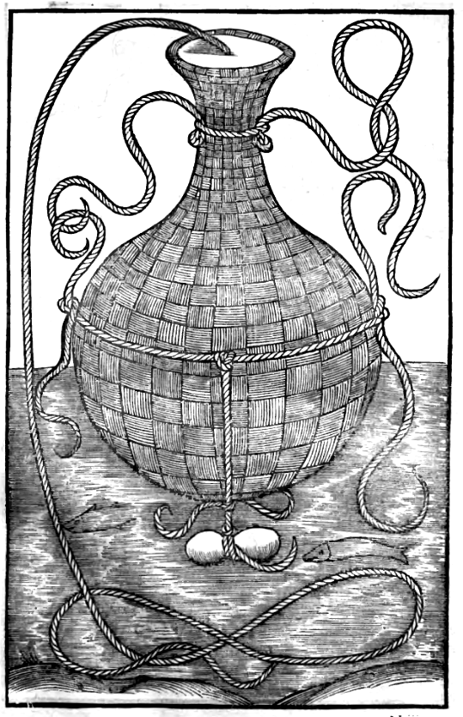
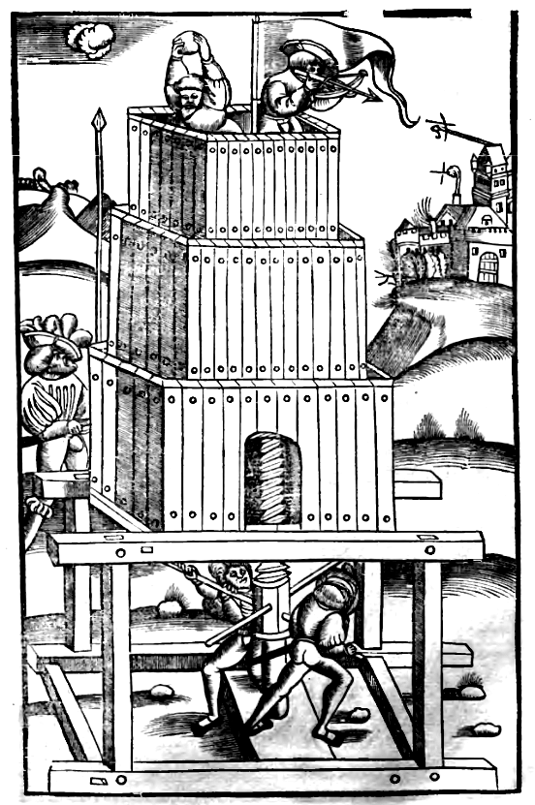
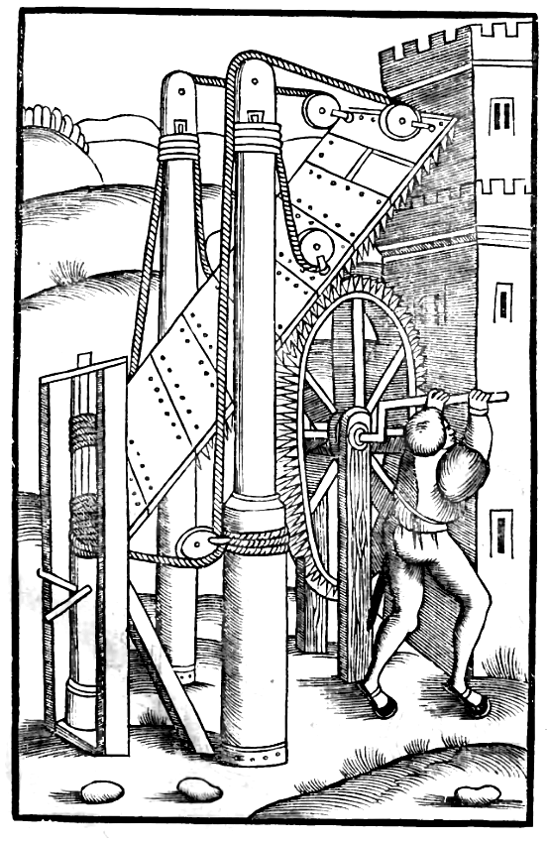
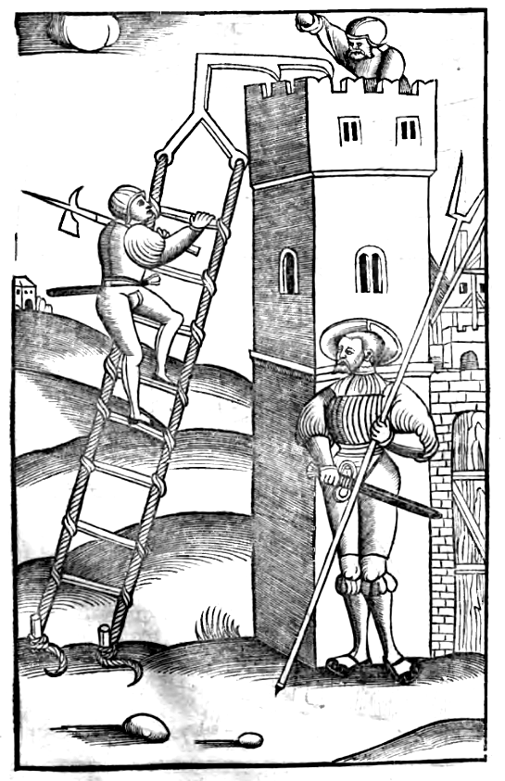
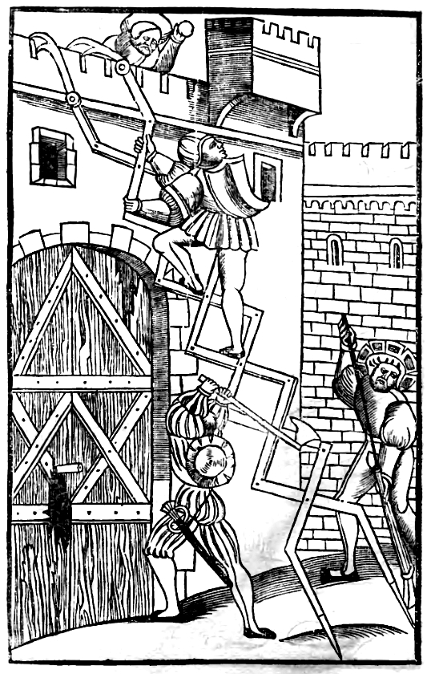
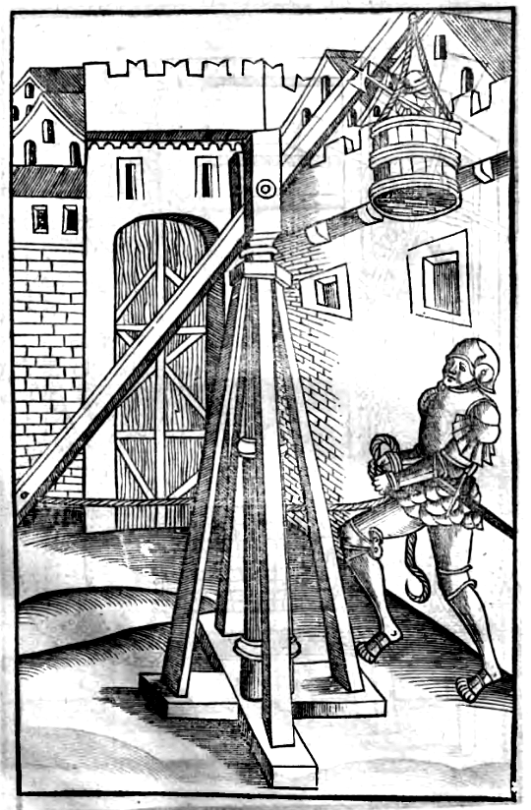
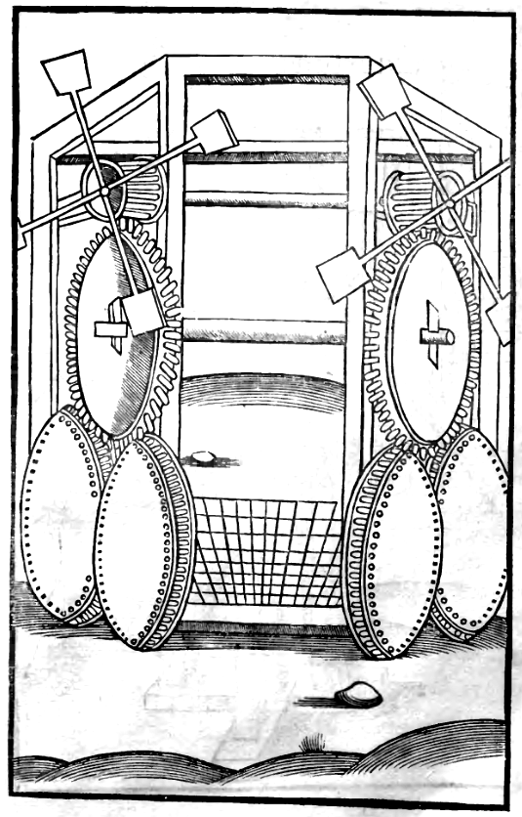
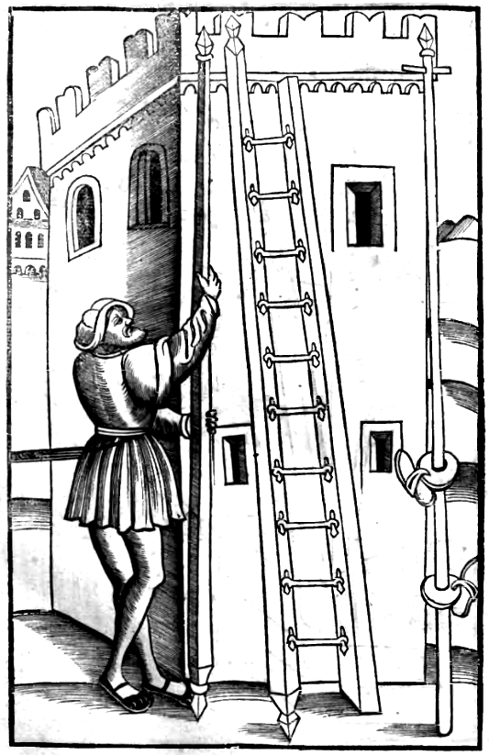
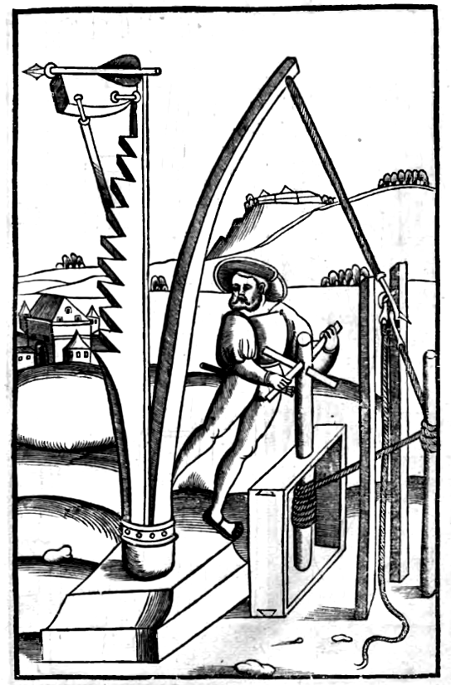
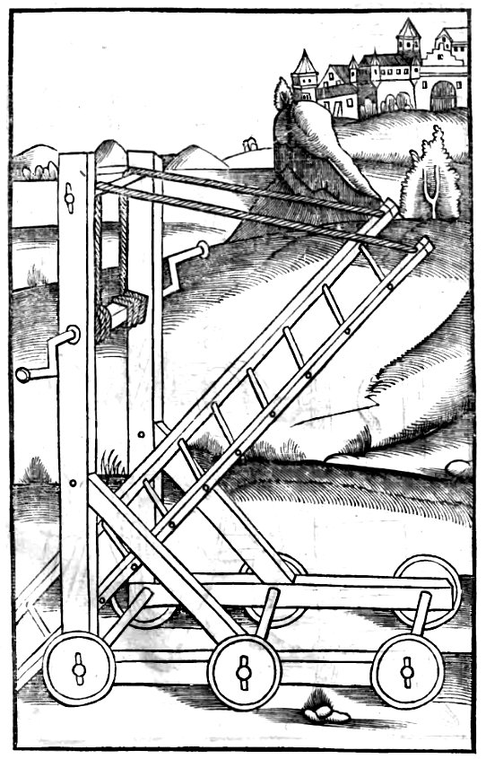
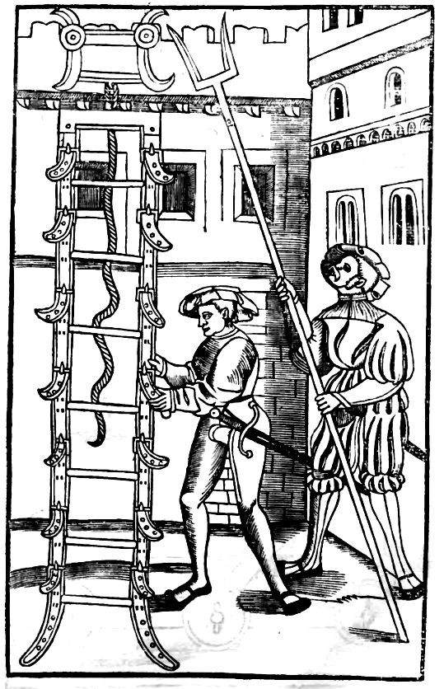
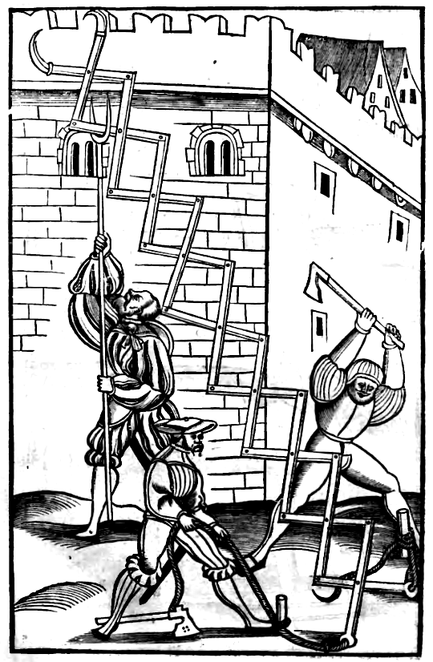
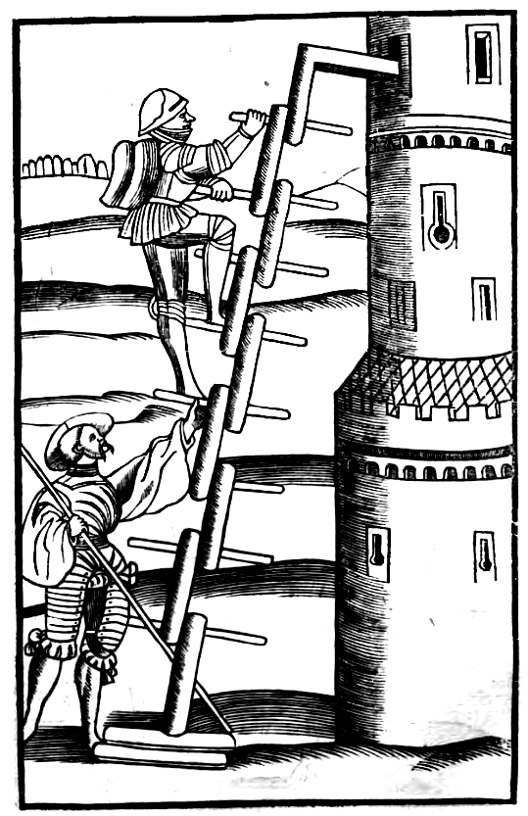
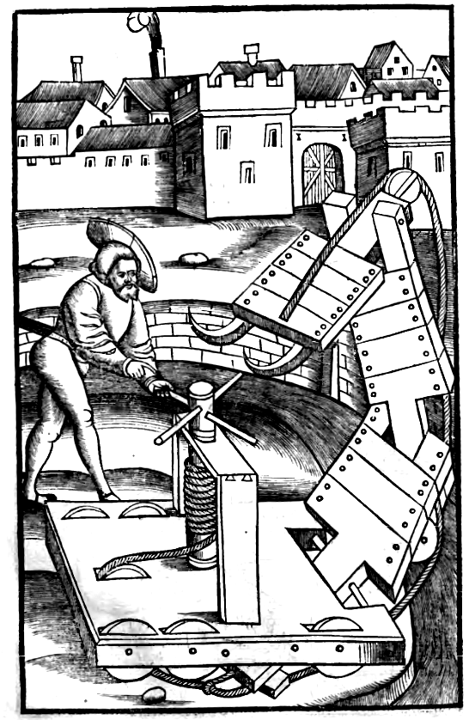
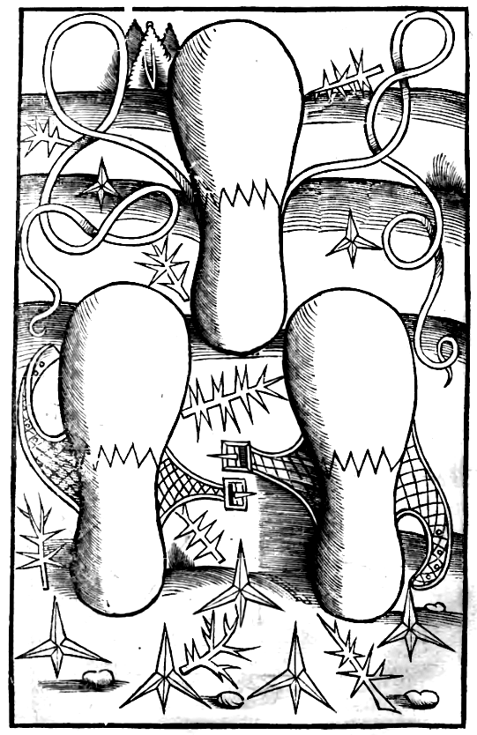
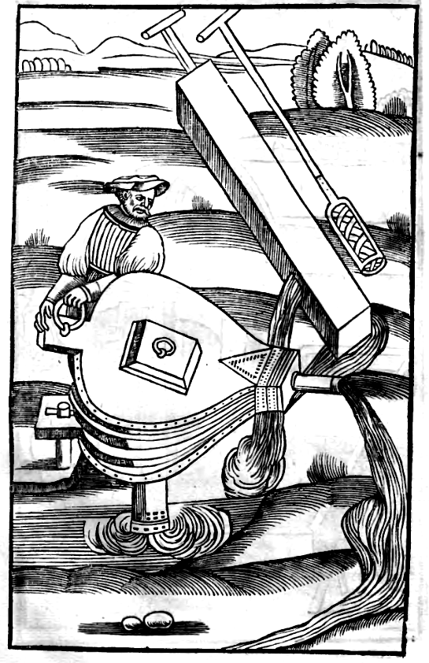
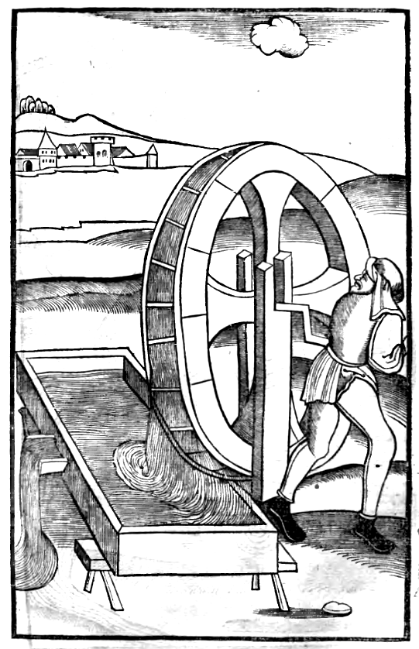
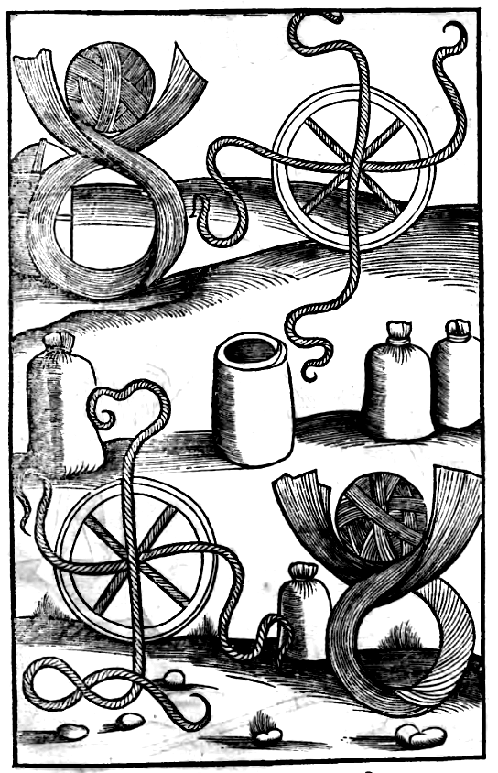
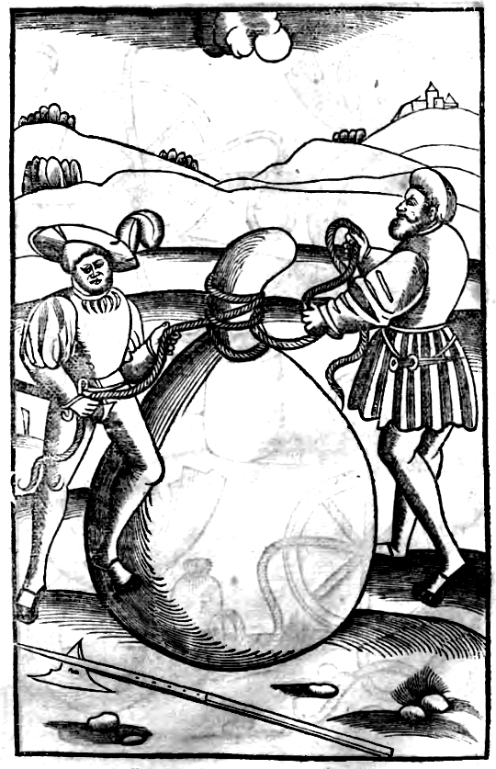
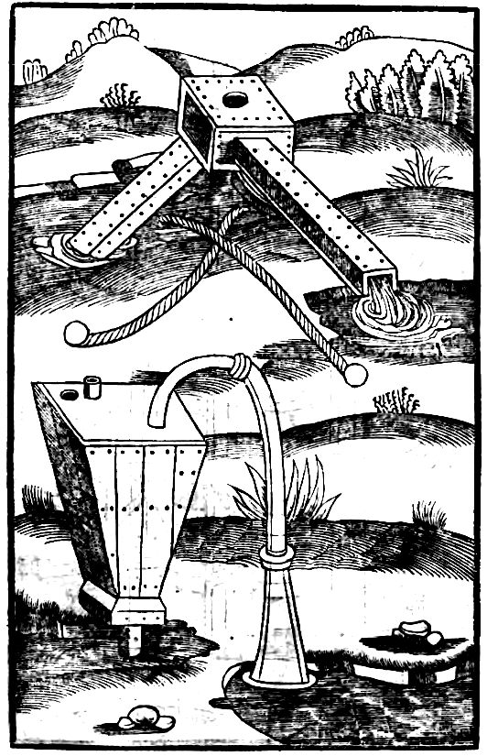
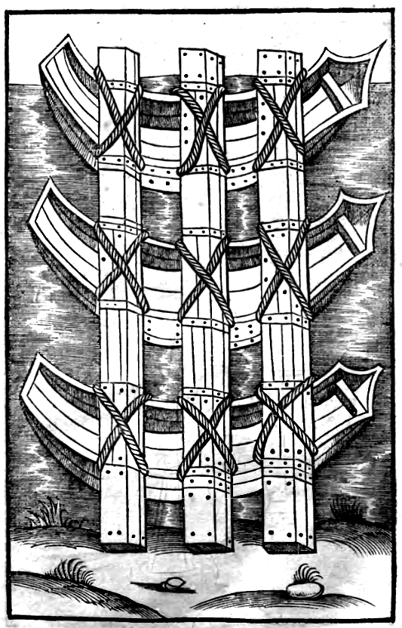
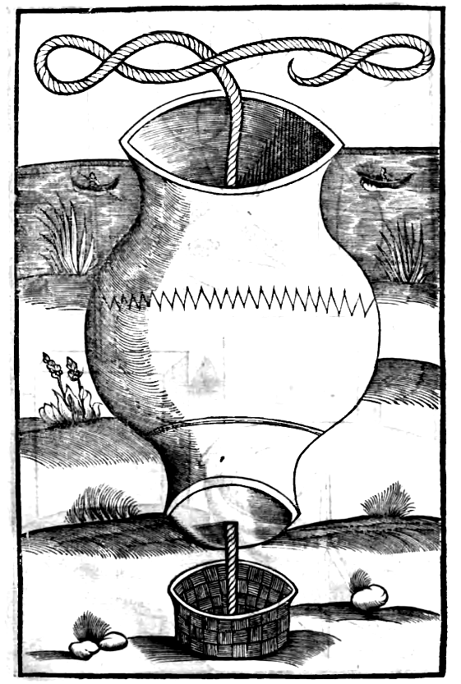
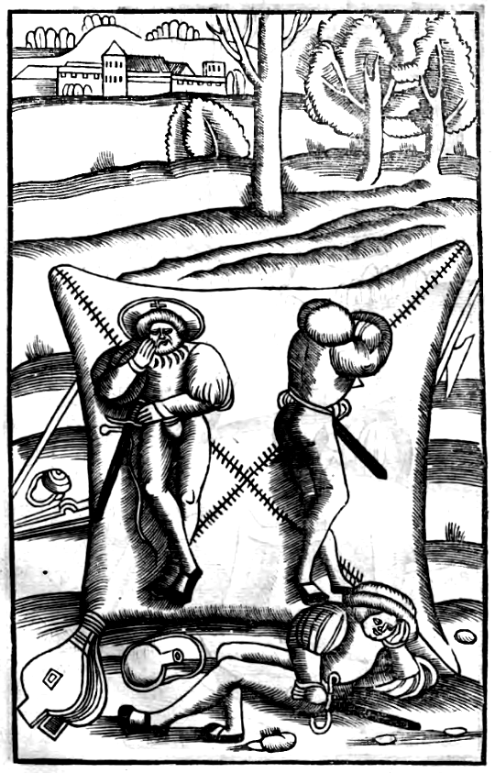
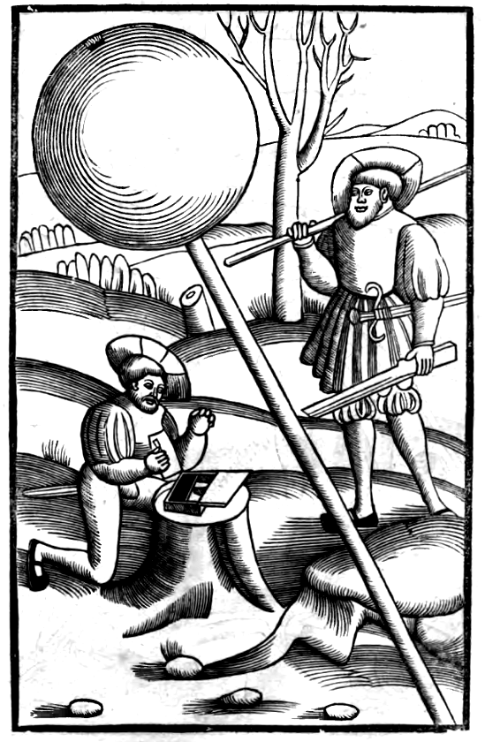
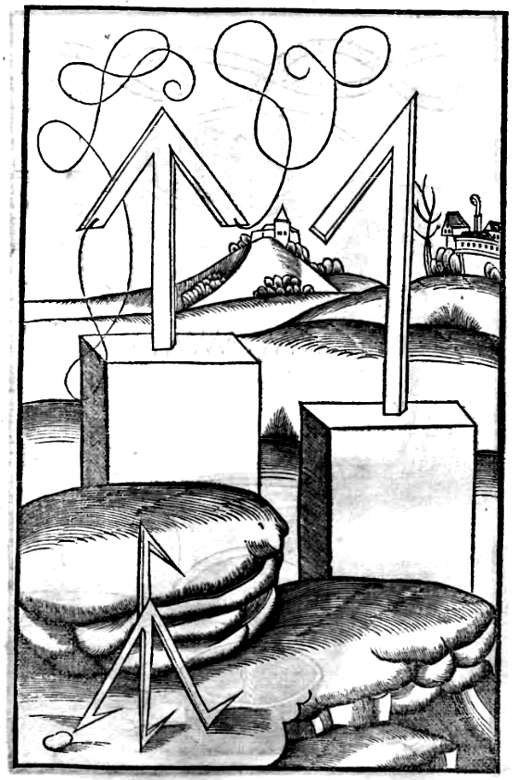
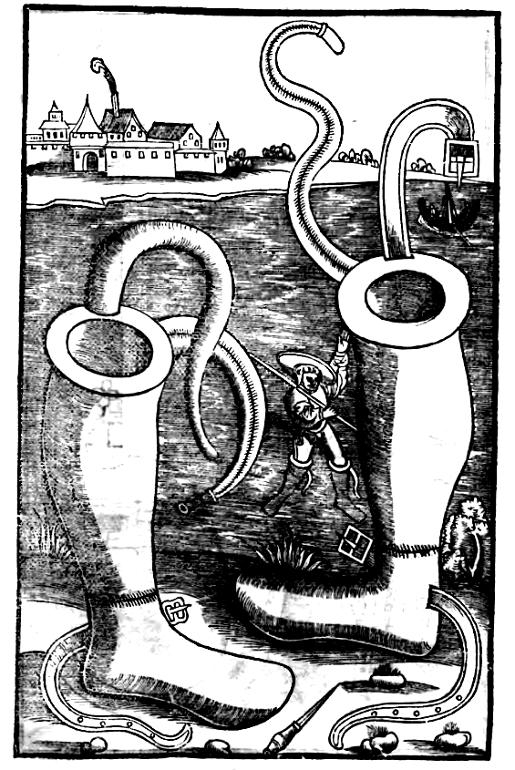
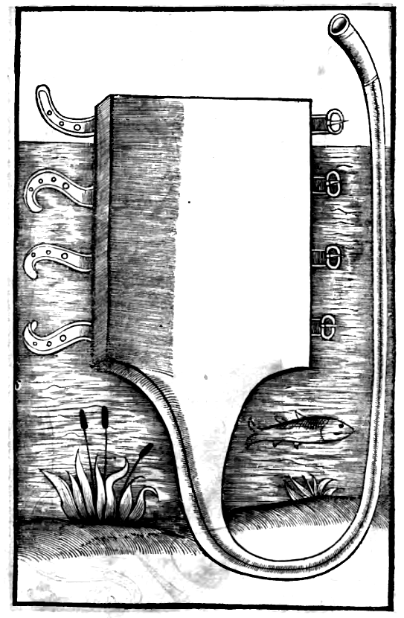
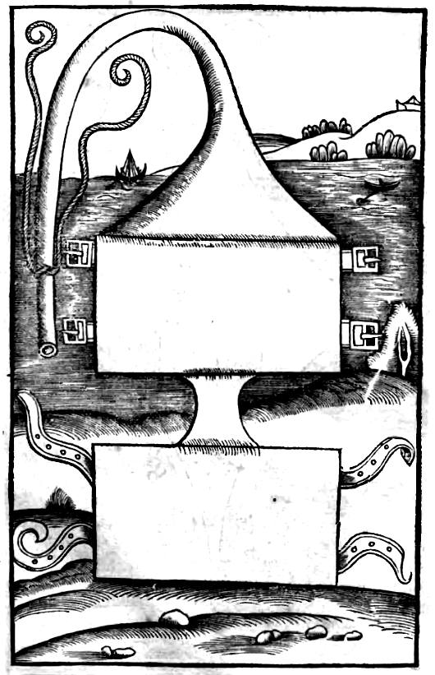
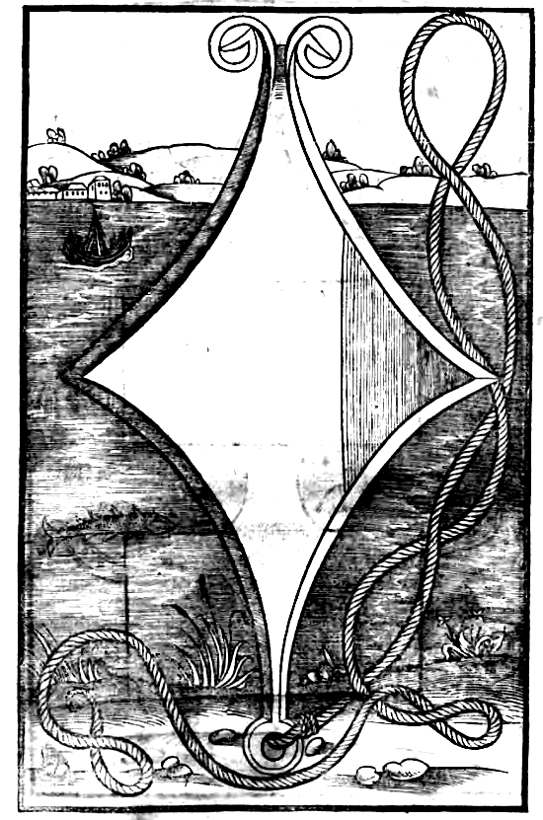
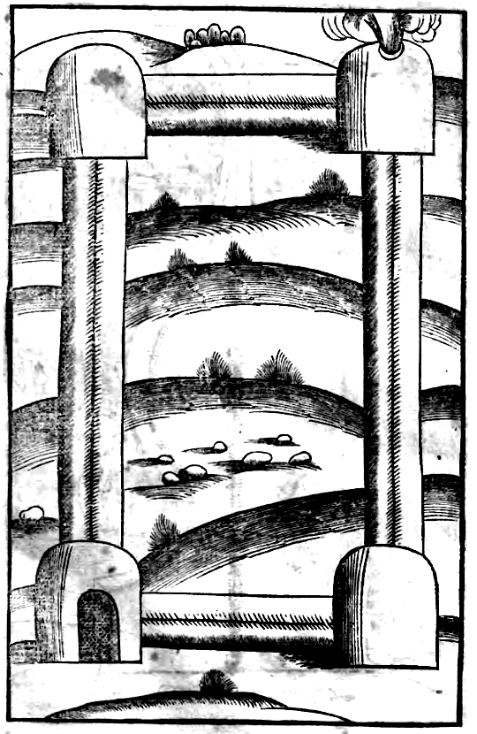
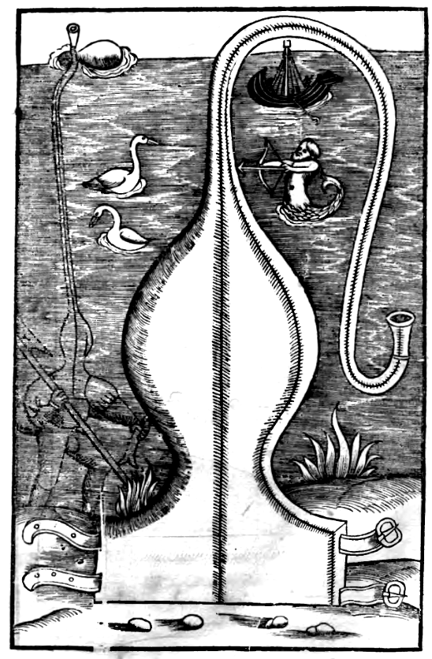
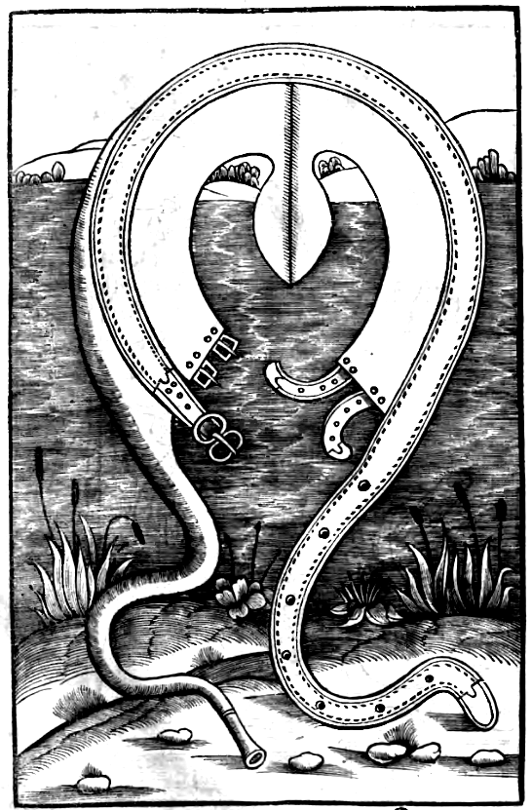
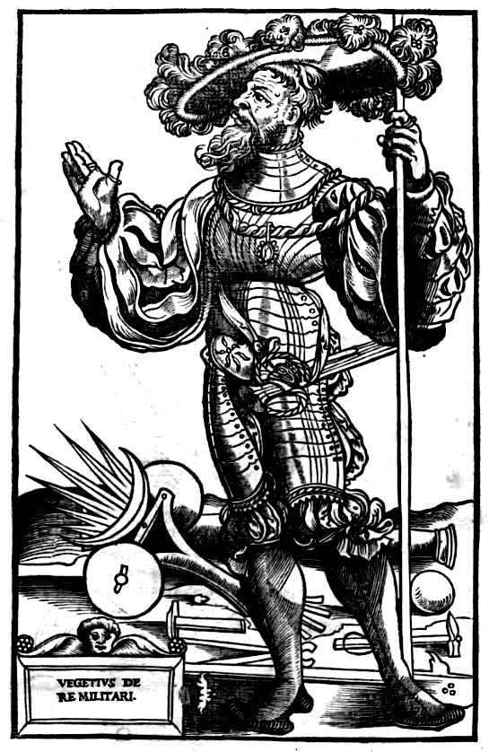
SEXTI IVLII FRONTINI VIRI CONSVLARIS
Strategematicon

Praefatio.
Cvm ad astruendam rei militaris scientiam, vnus ex numero studiosorum eius accesserim, eique destinationi, quantum cura nostra valuit, satisfecisse visus sim, deberi adhuc institutae arbitror operae, vt solertia ducum facta, quae a Graecis vna strat»ghmatikîn appellatione comprehensa sunt, expeditis amplectar commentariis. Ita enim consilii quoque, & prouidentiae exemplis succincti duces erunt, vnde illis excogitandi gerendique similia facultas nutriatur. Praeterea continget, ne de euentu trepidet inuentionis suae, qui probatis eam experimentis comparabit. Illud neque ignoro, neque inficior, etiam rerum gestarum scriptores indagine operis sui, hanc quoque partem esse complexos: & ab autoribus exemplorum, quicquid insigne aliquo modo fuit traditum: sed (vt opinor) occupatis velocitate consuli debet: longum est enim singula & sparsa per immensum corpus historiarum prosequi: & hi qui notabilia excerpserunt, ipso velut aceruo rerum, confuderunt legentem. Nostra sedulitas impendet operam, vt quemadmodum res poscet, ipsum quod exigitur, quasi ad interrogatum exihibeatur: circumspectis enim generibus, praeparaui oportuna exemplorum veluti consilia. Quo magis autem discreta, ad rerum varietatem apte collocarentur, in tres libros ea diducimus. In primo erunt exempla, quae competant praelio nondum commisso. In secundo, quae ad praelium, & confectam pacationem pertineant. Tertius, inferendae soluendaeque obsidionis habebit strat»ghmata, quibus deinceps generibus suas species attribui. Huic labori non iniuste veniam paciscat, ne me pro incurioso reprehendat, qui praeteritum aliquod a nobis repererit [reppererit] exemplum . Quis enim ad percensenda omnia monumenta, quae vtraque lingua tradita sunt, sufficiat: vnde multa transire mihi ipse permisi, quod me non sine causa fecisse scient qui aliorum libros eadem promittentium legerint. Verum facile erit sub vnaquaque specie suggerere. Nam cum hoc opus, sicut caetera, vsus potius aliorum, quam meae commendationis causa aggressus sim, adiuuari me ab his, qui aliquid illi astruent, non argui credam. Si qui erunt quibus volumina haec cordi sint, meminerint, vt parent gratiam strathghmatikîn & strathghm£twn per quam possimus similem naturam discernere. Nam tum [Namque] omnia, quae a duce prouide, vtiliter, constanter, magnifice fiunt strathghmatik¦ [strathgika] habebuntur, si in specie eorum sunt strathg»mata. Eorum proprie vis in arte solertiaque posita proficit, tam vbi cauendus, quam vbi opprimendus hostis sit. Qua in re, cum verborum quoque illustris extiterit effectus, vt factorum ita dictorum exempla posuimus.

Finis praefationis.

Species eorvm qvae instrvent dvcem in his quae ante praelium gerenda sunt.

De occultandis consiliis. Cap. I.
Marcus Porcius Cato, deuictas a se Hispaniae ciuitates existimabat in tempore rebellaturas, fiducia murorum: scripsit itaque singulis, vt diruerent munimenta, minatus bellum, nisi confestim obtemperassent: epistolasque vniuersis ciuitatibus eodem die reddi iussit: vnaquaeque vrbium sibi soli credidit imperatum. Contumaces conspiratio potuit facere, si omnibus idem denunciari notum fuisset.
Hamilcar dux Poenorum, vt in Siciliam inopinatus appelleret classem, non pronunciauit quo proficisceretur, sed tabellas, in quibus scriptum erat, quam partem peti vellet, vniuersis gubernatoribus dedit signatas, praecepitque ne quis legeret, nisi vi tempestatis a cursu praetoriae nauis abductus esset.
C. Laelius ad Syphacem profectus legatus, quosdam ex tribunis & centurionibus, per speciem seruitutis ac ministerii exploratores secum duxit, ex quibus, L. Statorium, quia saepius in eisdem castris fuerat, quidam ex hostibus videbantur agnoscere, occultandae conditionis eius causa, baculo vt seruum castigauit.
Tarquinius Superbus pater principes Gabiorum interficiendos arbitratus quia hoc nemini volebat innotescere commissum, nihil nuncio respondit, qui ad eum ad consilio erat missus: tamen virga, eminentia papauerum capita, cum forte in horto ambularet, decussit. Nuncius sine responsione reuersus, renunciauit adolescenti Tarquinio, quid agentem patrem vidisset: ille intellexit idem
esse eminentibus faciendum.
C. Caesar qui suspectam habebat Aegyptiorum fidem, per speciem securitatis, inspectione vrbis, atque operum, ac simul licentioribus conuiuiis deditus, videri voluit captum sese gratia locorum, & ad mores Alexandrinos vitamque deficere, atque inter eam dissimulationem praeparatis subsidiis, occupauit Aegyptum.
Ventidius Parthico bello aduersus Pachorum regem, non ignarus Pharneum quemdam, natione Cyrresten, ex his qui socii videbantur, omnia quae apud ipsos agebantur, nunciare Parthis, perfidiam barbari ad vtilitates suas couertit. Nam quae maxime fieri cupiebat, ea vereri se ne acciderent: quae timebat, ea vt euenirent optare se simulabat. Solicitus itaque, ne Parthi ante transirent Euphraten, quam sibi superuenirent legiones, quas in Capadocia trans Taurum habebat, studiose cum proditore egit, vt solenni perfidia Parthis suaderet, per Zeugma traiicerent exercitum, qua & breuissimum iter est, & omisso alueo Euphrates decurrit. Namque si illac venirent, asseuerabat se oportunitatem collium vsurum, ad eludendos sagittarios. Omnia autem vereri, si se in patentes campos proiecissent. Inducti hac affirmatione barbari, inferiore itinere, per circuitum adduxerunt exercitum: dumque fusiores ripas, & ob hoc operosiores pontes iungunt, instrumentaque moliuntur, xl. amplius dies impenderunt: quo spacio Ventidius ad contrahendas vsus est copias: eisque triduo antequam Parthus adueniret receptis, acie commissa vicit Parthos, & interfecit.
Mithridates circumuallante Pompeio, fugam in proximam diem moliens, huius consilii obscurandi causa, latius & vsque ad applicitas hosti valles, pabulatus, colloquia quoque cum pluribus, auertendae suspicionis causa, in posterum constituit. Ignes etiam frequentiores per tota castra fieri iussit. Secunda deinde vigilia praeter ipsa castra hostium, agmen eduxit.
Imperator Caesar Domitianus Aug. Germanicus, cum Germanos, qui in armis erant, vellet opprimere, nec ignoraret maiore bellum molitione inituros, si aduentum tanti ducis praesensissent, profectionem suam censu obtexuit Galliarum. Sub quibus inopinato bello affusus, contusa immanium ferocia nationum, prouinciis consuluit.
Cl. Nero, cum cuperet Hasdrubalem, copiasque eius antequam Hannibali fratri iungerentur occidere, iccircoque festinaret, se Liuio Salinatori collegae suo, cui bellum mandatum fuerat (parum fidens viribus quae sub ipso erant) adiungere, neque tamen discessum suum ab Hannibale, cui oppositus erat, sentiri vellet, X millia fortissimorum militum delegit, praecepitque legatis quos relinquebat, vt eaedem stationes & vigiliae aeque agerentur, totidem ignes arderent, eademque facies castrorum seruaretur, ne quid Hannibal suspicatus, auderet aduersus paucitatem relictorum. Cum deinde in Vmbria, occultatis itineribus, collegae se iunxisset, vetuit castra ampliari, ne quod signum aduentus sui daret Poeno, detrectaturo pugnam si Consulum iunctas vires intellexisset. Igitur inscium duplicatis aggressus copiis superauit, & velocius omni nuncio, rediit ad Hannibalem. Ita ex duobus callidissimis ducibus Poenorum eodem consilio alterum celauit, alterum oppressit.
Themistocles Athenarum dux exhortans suos ad suscitandos festinanter muros, quos iussu Lacedaemoniorum deiecerant, legatis Lacedaemone missis, qui interpellarent, respondit venturum se ad diluendam hanc existimationem, & peruenit Lacedaemonem: ibi simulato morbo aliquantum temporis extraxit, & postquam intellexit suspectam esse tergiuersationem suam, contendit falsum ad eos rumorem & rogauit, vt mitterent aliquos ex principibus, quibus crederent de munitione Athenarum. Suis deinde clam scripsit, vt eos qui venissent retinerent donec refectis operibus, confiterentur Lacedaemoniis, munitas esse Athenas, nec aliter principes eorum redire posse, quam ipse remissus foret: quod facile praestiterunt Lacedaemonii, ne vnius interitum multorum morte pensarent.
L. Furius exercitu producto in locum iniquum, cum constituisset occultare solicitudinem suam, ne reliqui trepidarent, paulatim se inflectens, tanquam circuitu maiore hostem aggressurus, conuerso agmine, ignarum rei quae, agebatur exercitum, incolumem reduxit.
Metellus Pius, in Hispania interrogatus, quid postera die facturus esset, Tunicam meam si id eloqui posset (inquit) comburerem.
M. Licinius Crassus, percontanti quo tempore castra moturus esset, respondit, Vereris ne tubam non exaudias?

De explorandis consiliis hostium. Cap. II.
Scipio Aphricanus, capta occasione mittendae ad Syphacem legationis, cum Laelio feruorum habitu tribunos & centuriones electissimos ire iussit, quibus curae esset perspicere regias vires: hi vt liberius castrorum positionem scrutarentur, equum de industria dimissum, tanquam fugientem persectati, maximam partem munimentorum circuierunt: quae cum nunciassent, incendio confectum est bellum.
Q. Fabius Maximus bello Hetrusco, cum adhuc incognitae forent Romanis ducibus sagaciores explorandi viae, fratrem Fabium Caesonem, peritum linguae Hetruscae, iussit Hetrusco habitu penetrare Ciminiam syluam, ante militi nostro intentatam: quod is adeo prudenter atque industrie fecit, vt transgressus syluam, Vmbros Camertes cum animaduertisset non alienos nomini Romano, ad societatem compulerit.
Carthaginenses cum animaduertissent Alexandri ita magnas opes, vt Aphricae quoque immineret, vnum ex ciuibus virum acrem, nomine Hamilcarem Rhodinum, iusserunt simulato exilio ire ad regem, omnique studio in amicitiam eius peruenire, qua is potitus, consilia eius nota ciuibus suis faciebat.
Iidem Carthaginenses miserum, qui per speciem legatorum longo tempore Romae morarentur, exciperentque consilia nostrorum.
M. Cato in Hispania, quia ad hostium consilia alia via peruenire non poterat, iussit trecentos milites simul impetum facere in stationem hostium, raptumque vnum ex his in castra perferre incolumem: tortus ille, omnia suorum arcana confessus est.
C. Marius cos. [consul] bello Cymbrico & Teutonico, ad excutiendam Gallorum & Lygurum fidem, literas eis misit, quarum pars prior praecipiebat, ne interiores quae praesignatae erant, ante tempus certum aperirentur, easdem postea ante praestitutum diem repetiit, & quia resignatas repererat [reppererat], intellexit hostilia agitari.
Est etiam aliud explorandi genus, quo ipsi duces nullo extrinsecus adiutorio, per se prouident. Sicut Aemilius Paulus cos. bello Hetrusco apud oppidum Coloniam demissurus exercitum in planiciem, contemplatus procul auium multitudinem citatiore volatu e sylua consurrexisse, intellexit illic aliquid insidiarum latere, quod & turbatae aues, & simul plures euolauerant. Praemissis igitur exploratoribus, comperit X milia Boiorum, excipiendo ibi Romanorum agmini imminere: eaque, alio quam expectabatur latere missis legionibus, circumfudit.
Similiter Thyamenus Horestis filius, cum audisset iugum ab hostibus natura munitum teneri, praemisit sciscitaturos quid rei foret, ac referentibus eis non esse verum quod opinaretur, ingressus iter, vt vidit ex suspecto iugo magnam vim auium simul euolasse, neque omnino residere arbitratus est latere illic agmen hostium: itaque circumducto exercitu elusit insidiatores.
Hasdrubal frater Annibalis, tunc Liuii & Neronis exercitum (quanquam hoc illi non duplicatis castris dissimularent) intellexit, quod ab itinere strigosiores notabat equos, & coloratiora hominum, vt ex via, corpora.

De custodiendo statu belli. Cap. III.
Alexander Macedo cum haberet vehementem exercitum, semper cum statum belli elegit vt acie confligeret.
C. Caesar bello ciuili cum exercitum veteranum haberet, hostium autem tyronem esse sciret, acie semper decertare studuit.
Fab. Maximus aduersus Annibalem, successibus praeliorum insolentem, recedere ab ancipiti discrimine, & tueri tantummodo Italiam constituit, Cunctatorisque nomen, & per hoc summi ducis meruit.
Byzantii aduersus Philippum omne praeliandi discrimen vitantes, omissa etiam finium tutela, intra munitiones oppidi se receperunt: assecutique sunt, vt Philippus obsidionalis morae impatiens recederet.
Hasdrubal Gisgonis filius, secundo Punico bello in Hispaniam ductum exercitum (cum P. Scipio instaret) per vrbes diuisit: itaque factum est, vt Scipio, ne oppugnatione plurium oppidorum distringeretur, in hyberna suos reduceret.
Themistocles aduentante Xerxes (quia necque praelio pedestri, neque finium tutelae, neque obsidioni credebat sufficere Athenienses) autor fuit eis liberos & coniuges Troezena, & in alias vrbes emittendi, relictoque oppido, statum belli ad nauale praelium transferendi. Idem fecit in eadem ciuitate Pericles aduersum Lacedaemonios.
Scipio manente in Italia Hannibale, transmisso in Aphricam exercitu, necessitatem Carthaginensibus imposuit reuocandi Hannibalem: sicque a domesticis finibus hostile transtulit bellum.
Athenienses cum Deceleam castellum ipsorum Lacedaemonii communissent, & frequentius vexarentur, classem, quae Peloponesum infestaret miserunt: consecutique sunt, vt exercitus Lacedaemoniorum, qui Deceleae erat, reuocaretur.
Imperator Caesar Domitianus Augustus, cum Germani more suo e saltibus & obscuris latebris sub inde impugnarent nostros, tutumque ingressum in profunda syluarum haberent, militibus per centum viginti millia passuum actis, non mutauit tantum statum belli, sed & subdidit ditioni suae hostes, quorum refugia nudauerat.

De transducendo exercitu per loca hosti infesta. Cap. IIII.
AEmilius Paulus Cos [consul] cum in Lucanos iuxta littus angusto itinere exercitum duceret, & Tarentini ei classe insidiati, agmen eius scorpionibus aggressi essent, captiuis latera euntium praetexuit, quorum respectu hostes inhibuere tela.
Agesilaus Lacedaemonius, cum praeda onustus ex Phrigia rediret, insequerenturque hostes, & ad locorum opportunitatem lacesserent agmen eius, ordinem captiuorum ab vtroque latere exercitus fui applicuit: quibus dum parcitur ab hoste, spacium transeundi habuerunt Lacedaemonii. Idem, tenentibus angustias Thebanis, per quas transire habebat, flexit iter quasi Thebas contenderet exterritis Thebanis digressisque ad tutanda moenia, repetitum iter quod destinauerat emensus est, nullo obsistente.
Nicostratus dux Aetolorum aduersus Epirotas, cum ei aditus in fines eorum angusti fierent, per alterum locum irrupturum se ostendens, omni illa ad prohibendum occurrente Epirotarum multitudine, reliquit suos paucos, qui speciem remanentis exercitus praeberent, & ipse cum caetera manu, qua non expectabatur aditus, intrauit.
Autophraudates Perses, cum in Pisidiam exercitum duceret, & angustias quasdam Pisidae occuparent, simulata vexatione traiiciendi, instituit reducere: quod cum Pisidae credidissent, ille nocte validissimam manum ad eundem locum occupandum praemisit, ac postero die totum traiecit exercitum.
Philippus Macedonum rex Graeciam petens, cum Thermopylas occupatas audiret, & ad eum legati Aetolorum venissent acturi de pace, retentis eis, ipse magnis itineribus ad angustias pertendit; securisque custodibus, & legatorum reditus expectantibus, inopinarus Thermopylas traiecit.
Iphicrates dux Atheniensium, aduersus Anaxibium Lacedaemonium in Hellesponto circa Abydon, cum transducendum exercitum haberet per loca quae stationibus hostium tenebantur, alterum autem latus eius transitus abscissi montes premerent, alterum mare ablueret, aliquamdiu moratus, cum incidisset frigidior solito dies, & ob hoc nemini suspectus, delegit firmissimos quosque quibus oleo ac mero calefactis, praecepit vt ipsam oram maris legerent, abruptiora tranarent: atque ita custodes angustiarum inopinatus oppressit a tergo.
Cn. Pompeius cum flumen transire propter oppositum exercitum hostium non posset, assidue producere & reducere in castra instituit: deinde in eamdem persuasionem hoste perducto, ne vllam viam ad progressum Romanorum teneret, repente impetu facto transitum rapuit.
Alexander Macedo, prohibente rege Indorum Poro traiici exercitum per flumen Hydaspem, aduersus aquam assidue procurrere iussit suos: & vbi eo more exercitationis assuetus est (quia Porus aduersa ripa caueret) per superiorem partem subitum transmisit exercitum. Idemque Indi fluminis traiectu prohibitus ab hoste, diuersis locis in flumine equites instituit immittere, & transitum minari: cumque expectatione barbaros teneret intentos, insulam paulo remotiorem, primum exiguo, deinde maiore praesidio occupauit, atque inde in vlteriorem ripam transmisit. Ad quam manum opprimendam, cum vniuersi se hostes effudissent, ipse libero vado transgressus, omnes copias coniunxit.
Xenophon, vlteriorem ripam Armeniis tenentibus, duos iussit quaeri aditus: & cum ad citeriore repulsus esset, transiit ad superiorem. Inde quoque prohibitus hostium occursu; repetiit vadum inferius, iussa ibidem militum parte subsistere, ex qua cum Armenii ad inferioris vadi tutelam rediissent, per superius transgrederetur. Armenii credentes decursuros omnes, decepti sunt a remanentibus. Hi cum resistente nullo vadum superassent, transeuntium suorum fuere propugnatores.
P. Claudius Cos. primo bello Punico, cum ad Rhegio Messanam traiicere militem nequiret, custodientibus fretum Poenis, sparsit rumorem, quasi bellum iniussu populi inceptum gerere non posset, classemque Italiam versus se agere simulauit: digressis deinde Poenis, quae profectioni eius habuerant fidem, circumactas naues appulit Siciliae.
Lacedaemoniorum duces cum Siracusas nauigare destinassent, & Poenorum dispositam penitus [per litus] classem timerent, X punicas naues, quas captiuas habebant, veluti victrices, primas iusserunt agi, a latere iunctis ac puppe religatis allis, qua specie deceptis Poenis, transierunt.
Philippus cum angustias maris, quae Cyaneae appellantur, trasnauigare propter Atheniensium classem, quae opportunitatem loci custodiebat, non posset, scripsit Antipatro Thraciam rebellari praesidiis, quae ibi reliquerat, interceptis, vt sequeretur omissis omnibus, quae epistolae vt interciperentur ab hoste, curauit. Athenienses arcana Macedonum excepisse visi, classem abduxerunt. Philippus nullo prohibente angustias freti liberauit. Idem quia Cherronesum, quae iuris Atheniensium erat, occupare prohiberetur, tenentibus transitum non Byzantiorum tantum, sed Rhodiorum quoque & Chiorum nauibus, conciliauit animos eorum reddendo naues quas ceperat, quasi sequestres futuros ordinandae pacis inter se atque Byzantios, qui causa belli erat: tractaque per magnum tempus postulatione, cum de industria subinde aliquid in conditionibus retexeret, classem per id tempus praeparauit: eaque in angustias freti imparato hoste subito euasit.
Chabrias Atheniensis, cum adire portum Samiorum obstante nauali hostium praesidio non posset paucas e suis nauibus praeter portum missas, iussit transire, arbitratus qui in statione erant, persecuturos: hisque per hoc consilium euocatis, nullo obstante portum cum reliqua adeptus est classe.

De euadendo ex locis difficillimis. Cap. V.
Q. Sertorius in Hispania, cum a tergo instante hoste flumen traiicere haberet, vallum in ripa eius in modum cauae lunae duxit, & oneratum materiis incendit. atque ita exclusis hostibus fluuium libere transgressus est.
Similiter Pelopidas Thebanus, bello Thessalico transitum quaesiuit: namque castris ampliore lacum supra ripa complexus, vallum ceruolis & alio materiae genere constructum incendit: dumque ignibus submouerentur hostes, ipse fluuium superauit.
Q. Luctatius Catulus, cum a Cymbris pulsus vnam spem salutis haberet, si flumem liberasset, cuius ripam hostes tenebant: in proximo monte copias ostendit, tamquam ibi castra positurus: ac praecepit suis ne sarcinas soluerent, aut onera deponerent, ne <ve> quis ab ordinibus aut signis discederet: & quo magis persuasionem hostium confirmaret, pauca tabernacula in conspectu erigi iussit, ignesque fieri, & quosdam vallum struere, quosdam in lignationem, vt conspicerentur exire: quod Cymbri vere agi existimantes, & ipsi castris delegerunt locum: dispersique in proximos agros ad comparanda ea quae necessaria sunt mansuris. occasionem dederunt Catulo non solum flumen traiiciendi, sed etiam castra eorum infestandi.
Croesus cum Halim vado transire non posset, neque nauium aut pontis faciendi copiam haberet, fossa superiori parte post castra deducta, alueum fluminis a tergo exercitus sui reddidit.
Cn. Pompeius, Brundusii, cum excedere[t] Italia & transferre bellum proposuisset, instante a tergo Caesare, conscensurus classem, quasdam obstruxit vias, alias parietibus intersepsit, alias intercidit fossis, easque sudibus erectis praeclusas operuit cratibus, humo aggesta, quosdam aditus qui ad portum ferebant trabibus transmissis, & in densum ordinem structis, ingenti mole tutatus. Quibus perpetratis, ad speciem retinendae vrbis raros pro moenibus sagittarios reliquit, caeteras copias sine tumultu ad naues reduxit: nauigantem cum mox sagittarii quoque per itinera nota digressi paruis nauigiis consecuti sunt.
Cn. Duillius cos. [consul] in portu Syracusano, quem temere intrauerat, obiecta ad ingressum catena clausus, vniuersos in puppim re[t]tulit milites, atque ita resupina nauigia magna remigantium vi concitauit, leuatae prorae super catenam processerunt, qua parte superata, transgressi rursus milites proras presserunt in quas versum pondus de cursum super catenam dedit nauibus.
Lysander Lacedaemonius cum in portu Atheniensium cum tota classe obsideretur, obrutus hostium nauibus, ab ea parte qua faucibus angustissimis influit mare, milites suos clam in littus egredi iussit, & subiectis totis ad proximum naues portum Monoecium traiecit.
Herculeius legatus Sertorii, cum in Hispania inter duos montes abruptos longum & angustum iter ingressus, paucas duceret cohortes, comperissetque ingentem manum hostium aduenire, fossam transuersam inter montes praessit, vallumque materia extructum incendit, atque ita intercluso hoste euasit.
C. Caesar bello ciuili cum aduersus Afranium copias educeret, & recipiendi se sine periculo facultatem non haberet, sicut constiterat, prima & fecunda acie furtim a tergo ad opus applicata, xv.pedum fossam fecit, intra quam sub occasum folis armati se milites eius receperunt.
Pericles Atheniensis, a Peloponensibus in eum locum conpulsus, qui vndique abruptis cinctus, duos tantum exitus habebat, ab altera parte fossam ingentis latitudinis duxit, velut hostis excludendi causa: ab altera militem agere coepit tanquam pro eum erupturus. Ii qui obsidebant, cum per fossam, quam ipse fecerat, exercitum Periclis non crederent euasurum, vniuersi a limite obstiterunt. Pericles pontibus quos praeparauerat fossae iniectis, suos qua non resistebatur, emisit.
Lysimachus ex his vnus, in quos opes Alexandri transierunt, cum aeditum collem castris destinasset, imprudentia autem suorum in inferiorem deductus, vereretur ex superiore hostium incursum, triplices fossas intra vallum obiecit: deinde sublimibus fossis circa omnia tentoria ductis, tota castra confodit: & intercepto hostium aditu, simul humo quoque, & frondibus quas fossis superiecerat, facto impetu in superiora euasit.
Cn. Fonteius Crassus in Hispania cum tribus millibus hominum praedatum praefectus, ad Hasdrubalem, & ad primos tantum ordines relato consilio, incipiente nocte, quo tempore minime expectabatur per stationes hostium prorupit.
L. Furius exercitu perducto in locum iniquum, cum constituisset occultare solicitudinem suam: ne reliqui trepidarent, paulatim inflexit iter, tanquam circuitu maiore hostem aggressurus, conuersoque agmine ignarum rei quae agebatur, exercitum incolumem reduxit.
P. Decius Tr. bello Samnitico, Cornelio Cosso cos. [consul] iniquis locis deprehenso ab hostibus, suasit vt ad occupandum collem, qui erat in propinquo, modicam manum mitteret, seque ducem iis qui mittebantur, obtulit: auocatus in diuersum hostis dimisit consulem. Decium autem cinxit, obseditque. Ille per angustias; noctu eruptione facta, cum eluctatus esset. Decius incolumis cum militibus, consuli accessit.
Idem fecit sub Attilio Calatino cos. [consul] is cuius varie tradunt nomen. Alii, Laberium, nonnulli Q. Caeditium, plurimi Calphurnium, flammam vocitatum scripserunt. Hic cum dimissum exercitum in eam vallem videret, cuius latera omnia superiora hostis insederat, depoposcit & accepit trecentos milites, quos adhortatus vt virtute sua exercitum seruarent, in mediam vallem decurrit, & ad opprimendos eos vndique descendit hostis, longoque & aspero praelio retentus, occasionem consuli ad extrahendum exercitum dedit.
L. Minutius cos. [consul] in Lyguria dimisso in angustias exercitu, cum iam omnibus obuersaretur Caudinae cladis exemplum, Numidas auxiliares, tam propter ipsorum quam propter equorum deformitatem despiciendos, iussit adequitare faucibus quae tenebantur. Primo intenti hostes ne lacescerentur, stationem obiecerunt: de industria Numidae ad augendum sui contemptum, labi equis, & per ludibrium spectaculo esse affectauerunt, ad nouitatem rei laxatis ordinibus, Barbari in spectaculum vsque resoluti sunt. Quod vbi animaduerterunt Numidae, paulatim succedentes, additis calcaribus per intermissas hostium stationes eruperunt: qui deinde cum proximos irruerent agros, necesse Lyguribus fuit auocari ad defendenda sua, inclusosque Romanos emittere.
L. Sylla bello sociali apud Eserniam inter angustias deprehensus, ad exercitum hostium, cui Duillius praeerat, colloquio petito, de conditionibus pacis agitabat sine effectu: hostem tamen propter inducias negligentia resolutum animaduertens, nocte profectus, relicto buccinatore, qui vigilias ad fidem remanentium diuideret, & quarta vigilia commissa, eum sequeretur, iucolumes [incolumes] suos cum omnibus impedimentis tormentisque in tuta perduxit.
Idem aduersus Archelaum praefectum Mithridatis in Capadocia, iniquitate locorum & multitudine hostium praessus, fecit pacis mentionem: interpositoque tempore etiam induciarum, & per haec auocata intentione, aduersarium euasit.
Hasdrubal frater Annibalis, cum saltum euadere non posset, faucibus eius obsessis, egit cum C. Nerone, recepitque dimissum se Hispania excessurum: cauillatus deinde conditionibus, dies aliquot extraxit, quibus omnibus, non emisit per angustos tramites, & ob id neglectos dimittere per partes exercitum: ipse deinde cum reliquis expeditis facile effugit.
Spartacus fossam, qua erat ad M. Crasso circundatus, caesis captiuorum pecorumque corporibus noctu repleuit, & supergressus est. Idem cum in Lesbio obsessus, ea parte qua mons asperrimus erat, ideoque custoditus, ex vimine syluestri cathenas conseruit, quibus demissus non solum euasit, verum etiam ex alio latere gladio ita terruit, vt aliquot cohortes, gladiatoribus quatuor & septuaginta cesserint. Idem cum a L. Varino Procos. praeclusus esset, palis per modica interualla fixis ante portam, erecta cadauera, adornata veste atque armis, alligauit, vt procul intuentibus stationis species esset, ignibus per tota castra factis, imagine vana deluso hoste, copias silentio noctis eduxit.
Brasidas dux Lacedaemoniorum, circa Amphipolim ab Atheniensium multitudine numero impar deprehensus, claudendum se praestitit, vt per longum coronae ambitum extenuaret hostilem frequentiam, quaque rarissimi obstabant, erupit.
Iphicrates in Thracia cum depresso loco castra posuisset, explorasset autem ab hoste proximum teneri collem, ex quo vnus ad opprimendum ipsos descensus erat, nocte paucis intra castra relictis, imperauit vt multos ignes faceret, eductoque exercitu & disposito circa latera praedicta viae, passus est transire barbaros: locorumque iniquitate, in qua ipse fuerat, in illos conuersa, parte exercitus terga eorum cecidit, parte castra fecit.
Dareus , vt falleret Scythas discessu, canes atque asinos in castris reliquit, quos cum latrantes rudentesque hostis audiret, remanere Darium credidit.
Eundem errorem obiecturi nostris Lygures, per diuersa loca bubalos laqueis ad arbores alligauerunt, qui deducti frequentiore mugitu speciem remanentium praebebant hostium.
Hanno ab hostibus clausus, locum irruptioni maxime aptu, aggestis leuibus materiis incendit, tamen hoste ad caeteros exitus custodiendos auocato, milites per ipsam flammam eduxit: admonito ora scutis, crura veste contegere.
Annibal, vt iniquitatem locorum, & inopiam instante Fabio Maximo effugeret, noctu boues, quibus ad cornua fasciculos alligauerat, sarmentorum subiecto igne, dimisit, cumque ipso motu adolescente flamma turbaretur pecus, magna discursatione montes, in quos actum erat collustrauit: Romani qui ad speculandum concurrerant, primo prodigium opinati sunt, deinde cum cuncta Fabio renunciassent, ille de insidiarum metu suos castris continuit, barbari obsistente nullo profecti sunt.

De insidiis in itinere factis. Cap. VI.
Fvluius Nobilior, cum ex Samnio in Lucanos exercitum educeret, & cognouisset a perfugis, hostes nouissimum agmen eius aggressuros, fortissimam legionem primo ire, vltimo sequi iussit impedimenta, ita factum pro occasione amplexi hostes, diripere sarcinas coeperunt. Fuluius legionis de qua supradictum est, quinque cohortes in dextram partem viae direxit, quinque ad sinistram, atque ita praedationi intentos hostes, explicato per vtraque latera milite, clausit ceciditque. Idem hostibus tergum eius in itinere prementibus, dum flumine interueniente, non ita magno vt transitum prohiberet, moraretur tamen rapiditate, alteram legionem in occulto citra flumen collocauit, vt hostes paucitate contempta audacius sequerentur: quod vbi factum est, legio qua: ob hoc disposita erat, ex insidiis hostem aggressa vastauit.
Iphicrates in Thraciam cum propter conditionem locorum, longum agmen deduceret, & nunciatum ei esset hostes summum id aggressuros, cohortes in vtraque latera secedere, & consistere iussit, caeteros fugere & iter maturare. Transeunte autem toto agmine, lectissimos quosque retinuit, & ita passim circa praedam occupatos hostes, iam etiam fatigatos, ipse requietis & ordinatis suis aggressus fudit, exuitque praeda.
Boii in sylua Litana, qua transiturus erat noster exercitus, succiderant arbores, ita vt ex parte exigua sustentatae starent donec impellerentur, delituerant deinde ad extremas ipsi, vbi, ingresso syluam hoste, proximas vlteriores impulerunt, eo modo propagata pariter supra Romanos ruina, magnam manum eliserunt.

Quemadmodum ea quibus deficimur, videantur non deesse, aut vsus eorum expleatur. Cap. VII.
L. Caecilius Metellus, quia vsu nauium quibus elephantes transportaret deficiebatur, vincit dolia constrauitque tabulamentis, ac super ea positos, per Siculum fretum transmisit.
Annibal cum ad praealti fluminis transitum elephantes non posset pellere, neque nauium aut materiarum, quibus rates continerentur, copiam haberet, iussit ferocissimum elephantum sub aure vulnerari, & cum qui vulnerasset, transnato statim flumine procurrere: elephantus exasperatus ad persequendum doloris sui authorem, tranauit amnem, & reliquis idem audendi dedit exemplum.
Carthaginensium duces instructuri classem, quia sparto deficiebantur, crinibus tonsarum mulierum ad funes efficiendos vsi sunt. Idem Massilienses & Rhodii fecerunt.
M. Antonius a Mutina profugus, cortices pro scutis militibus suis dedit. Spartaco copiisque eius, scuta ex vimine fuerunt, quae coriis tegebantur. Non alienus (vt arbitror) hic locus est, referendi factum Alexandri Macedonis illud nobile, qui per deserta Africae itinera, grauissima siti cum exercitu affectus, oblatam sibi a milite in galea aquam spectantibus vniuersis effudit, vtihlior exemplo temperantiae, quam si communicare potuisset.

De distringendis hostibus. Cap. VIII.
Coriolanus cum ignominiam damnationis suae bello vlcisceretur, populationem patriciorum agrorum inhibuit, deustis vastatisque plebeiorum: vt discordiam moueret, qua consensus Romanorum distringeretur.
Annibal Fabium, cui necque virtute necque artibus bellandi par erat, vt infamia distringeret, agris eius abstinuit. caeteros populatus. Contra ille, ne suspecta ciuibus sides esset, magnitudine animi effecit publicatis possessionibus suis.
Fab. Maximus quinto Cos. [consul] cum Gallorum, Vmbrorum, Etruscorum, Samnitiumque, aduersus P. R. exercitus coissent, contra quos & ipse trans Apenninum [in <Setin>ante] montem castra communiebat, scripsit Fuluio & Posthumio, qui in praesidio vrbi erant, copias ad Sitium [Clusium] mouerent: quibus assecutis, ad sua defendenda Etrusci, Vmbrique descenderunt: relictos Samnites Gallosque Fabius & collega Decius aggressi vicerunt.
M. Curius aduersus Sabinos, qui ingenti exercitu conscripto, relictis finibus suis, nostros occupauerant, occultis itineribus manum misit, quae desolatos agros eorum vicosque, per diuersa incendit. Sabini ad arcendam domesticam vastiratem [vastitatem] recesserunt. Curio contigit & vacuos infestare hostium fines, & exercitum sine praelio auertere, sparsumque caedere.
T. Didius paucitati suorum diffidens, cum in aduentum earum legionum quas expectabat trahere bellum & occurrere eis hostem comperisset, concione aduocata aptari iussit milites ad pugnam, ac de industria negligentius custodiri captiuos: ex quibus pauci qui profugere nunciauerunt suis pugnam imminere. At illi, ne suspicione praelii deducerent vires, omiserunt occurrere eis quibus insidiabantur legiones tutissime, nullo excipiente, ad Didium peruenerunt.
Bello Punico quaedam ciuitates, quae a Romanis deficere ad Poenos destinauerant, cum obsides dedissent, quos recipere ante quam desciscerent studebant, simulauerunt seditionem inter finitimos ortam, quam Romanorum legati dirimere deberent, missosque eos velut contraria pignora retinuerunt, nec ante reddiderunt quam ipsi recuperarent suos.
Legati Romanorum cum misissent ad Antiochum regem, qui secum Annibalem victis iam Carthaginensibus habebat, consiliumque eius aduersus Romanos instruebat, crebris cum Annibale colloquiis effecerunt, vt is regi fieret suspectus, cui gratissimus alioqui erat & vtilis propter calliditatem & peritiam bellandi.
Qu. Metellus aduersus Iugurtham bellum gerens, missos ad se legatos eius corrupit, vt sibi proderent regem. Cum etiam alii venissent, idem fecit. Eodem consilio vsus est & aduersus tertios. Sed de captiuitate lugurthae res parum processit, viuum enim tradi sibi volebat, plurimum tamen consecutus est: nam cum interceptae fuissent epistolae eius ad regios amicos scriptae, in omnes eos rex animaduertit, spoliatusque consiliis amicos postea parare non potuit.
C. Caesar perexceptum quendam aquatorem, cum comperisset Afranium Petreiumque castra noctu moturos, vt citra vexationem suorum, hostilia impediret consilia, in initio statim noctis vasa conclamare milites, & praeter aduersariorum castra agi mulos cum fremitu, & sonum iussit continuare, quos retentos volebat & arbitrari castra Caesarem mouere.
Scipio Aphricanus ad excipienda auxilia cum commeatibus, Annibali Venticium Termum dimisit, ipse subuenturus.
Dionysius Syracusanorum tyrannus, cum Aphri ingenti multitudine traiecturi essent in Siciliam, ad eum oppugnandum, castella pluribus locis communiit, custodibusque praecepit, vt ea aduenienti hosti dederent, dimissique Syracusas occulte redirent. Aphris necesse fuit capta castella praesidio ibi tenere, quos Dionysius redactos ad quam voluerat paucitatem, pene iam par numero aggressus vicit, cum suos contraxisset & aduersarios sparsisset.
Agesilaus Lacedaemonius, cum inferret bellum Tysapherni, Cariam se petere simulauit: quasi aptius locis montuosis, aduersus hostem equitatu praeualentem pugnaturus. Per hanc consilii ostensionem aduocato in Cariam Tysapherne, ipse Lydiam, vbi caput hostium regni erat, irrupit: oppressisque qui illic agebant, pecunia regia potitus est.

De seditione militum compescenda. Cap. IX.
A. Manlius Cos. cum comperisset coniurasse milites in hybernis Campaniae, vt iugulatis hospitibus, ipsi res eorum inuaderent, rumorem sparsit eodem loco hybernaturos: atque ita coniuratorum consilio turbato, Campaniam periculo liberauit, & ex occasione nocentes puniuit.
Lucius Sylla cum legiones ciuium Romanorum perniciosa seditione furerent, consilio restituit sanitatem efferatis. Propere enim annunciari iussit, hostem adesse, & ad arma vocantium clamorem tolli, signa canere: discussa seditio est, vniuersis aduersus hostem consentientibus.
Cn. Pompeius, trucidato ab exercitu Mediolani senatu, ne tumultum moueret, si solos euocasset nocentes, mixtos eis qui extra delictum erant, venire iussit: ita & noxii minore cum metu, quia non segregari, ideoque non ex causa culpae videbantur accersiti, comparuerunt, & illi quibus integra erat conscientia, custodiendis quoque nocentibus attenderunt, ne illorum fuga inquinarentur.
Caesar cum quaedam legiones eius, seditionem mouissent, adeo vt in perniciem quoque ducis viderentur consurrecturae, dissimulato metu, processit ad milites, postulantibusque missionem, vltro minaci vultu dedit: exauctoratos poenitentia coegit satisfacere Imperatori, obsequentioresque in reliquum operas aedere.

Quemadmodum intempestiua postulatio pugnae, inhibeatur. Cap. X.
Q. Sertorius, quod experimento didicerat, imparem se vniuerso Romanorum exercitui, vt barbaros quoque in consulte pugnam exposcentes doceret, adductis in conspectum duobus equis, altero, praeualido, altero admodum exili duos admouit iuuenes similiter affectos, robustum & gracilem: ac robustiori imperauit, equo exili vniuersam caudam abrumpere, gracili autem, valentiorem per singulos vellere: cumque gracilis fecisset quod imperatum erat, validissimus cum in infirmi equi cauda sine effectu luctaretur, Iam (inquit Sertorius) Romanorum cohortium (per hoc vobis exemplum ostendi) milites, insuperabiles sunt vniuersas aggredientibus: easdem lacerabit & carpet, qui per partes attentauerit.
Idem cum videret suos pugnae signum inconsulte flagitantes, crederetque rupturos imperium nisi congrederentur, permisit turmae equitum ad lacessendos hostes ire, laborantique submisit alias, & sic recepit omnes: tutisque vtrisque & sine noxa ostendit quis exitus flagitatam pugnam mansisset: obsequentissimis inde eis vsus est.
Agesilaus Lacedaemonius cum aduersus Thebanos castra super ripam posuisset, multoque maiorem hostium manum esse intelligeret, & ideo suos arcere a cupiditate decernendi veller, dixit responso deum se ex collibus pugnare iussum: & ita exiguo praesidio ad ripam posito accessit in colles. Quod Thebani pro metu interpretati transierunt flumen, & cum facile depulissent praesidium, caeteros insecuti auidius, iniquitate locorum a paucioribus victi sunt.
Scorylo dux Dacorum cum sciret dissociatum armis ciuilibus populum Rom. neque tamen tentandum arbitraretur, quia externo bello posset concordia in ciues coalescere, duos canes in conspectu popularium commisit, hisque acerrime inter ipsos pugnantibus, lupum ostendit, quem protinus canes, omissa inter se ira, aggressi sunt, quo exemplo, prohibuit barbaros ab impetu Romanis profuturo.

Quemadmodum fit incitandus exercitus ad praelium. Cap. XI.
M. Fabius & Cn. Manlius Coss. aduersus Hetruscos, propter seditiones detrectante praelium exercitu, vltro simularunt cunctationem, donec milites probris hostium coacti, pugnam deposcerent, iurarentque se ex ea victores redituros.
Fuluius nobilior cum aduersus Samnitium numerosum exercitum, & successibus tumidum, paruis copiis necesse haberet decertare, simulauit vnam legionem hostium a se corruptam ad proditionem: imperauitque (ad eius rei fidem) tribunis, & primis ordinibus & centurionibus quantum quisque numeratae pecuniae, aut auri argentique haberet, conferret, vt repraesentari merces proditoribus posset: se autem his qui contulissent pollicitus est, consummata victoria, ampla insuper praemia daturum. Quae sua persuasio Romanis alacritatem attulit & fiduciam: vnde etiam praeclara victoria, commisso statim bello peracta est.
C. Caefar aduersus Germanos & Ariouistum pugnaturus, confusis suorum animis, pro concione dixit, nullius se eo die opera nisi decimae legionis vsurum: quo consecutus est, vt decimani, tanquam praecipuae fortitudinis testimonio cogerentur, & caeteri pudore, ne penes alios gloria virtutis esset.
Q. Fabius, qui egregie sciebat, & Romanos eius esse libertatis, quae contumelia exasperaretur, & ad Poenis nihil iustum aut moderatum expectabat, misit legatos Carthaginem de conditionibus pacis: quas cum illi iniquitatis & insolentiae plenas retulissent, exercitus Romanorum ad pugnandum concitatus est.
Agesilaus Lacedaemoniorum dux, cum prope ab Orchomeno socia ciuitate castra haberet, comperissetque plerosque ex militibus praeciosissima rerum deponere intra munimenta, praecepit oppidanis, ne quid ad exercitum suum pertinens reciperetur, quo ardentius dimicaret miles, qui sciret sibi pro omnibus suis pugnandum.
Epaminundas dux Thebanorum aduersus Lacedaemonios dimicaturus, vt non solum viribus milites sui, verum etiam affectibus adiuuarentur, pronunciauit in concione, destinatum Lacedaemoniis si victoria potirentur, omnes virilis sexus interficere, vxoribus autem eorum & liberis in seruitutem adductis, Thebas diruere, qua denunciatione concitati, primo impetu Thebani Lacedaemonios expugnauerunt.
Eutidas dux Lacedaemoniorum pugnaturus eodem die, quo classe vicerant socii, quamuis ignarus actae rei, vulgauit nunciatam sibi victoria partium, quo constantiores ad pugnam milites haberet.
Aulus Posthumius praelio quo cum Latinis conflixit, oblata specie duorum in equis iuuenum, animos suorum erexit, Pollucem & Castorem adesse dicens, ac sic praelium restituit.
Archidamus Lacedaemonius aduersus Arcadas bellum gerens, arma in castris statuit, & circa ea duci equos noctu clam imperauit: quorum vestigia mane (tanquam Castor & Pollux perequitassent) ostendens, adfuturos eosdem ipsis praeliantibus persuasit.
Pericles dux Atheniensium initurus praelium, cum animaduertisset lucum, ex quo vtraque acies conspici poterat, densissimae opacitatis, vastum alioqui & Diti patri sacrum, ingentis illic staturae hominem, altissimis cothurnis, & veste purpurea, coma venerabilem in curru candidorum equorum sublimem constituit, qui dato signo pugnae, proueheretur: & voce Periclem nomine appellans, cohortaretur eum, diceretque deos Atheniensibus adesse: quo pene primo coniectu teli hostes terga dederunt.
L. Sylla, quo paratiorem militem ad pugnandum haberet, praedici sibi a diis futura simulauit. Postremo etiam in conspectu exercitus, priusquam in aciem descenderet signum modicae amplitudinis, quod Delphis sustulerat orabat, petebatque vt promissam victoriam maturaret.
C. Marius sagam quandam ex Syria habuit, a qua se dimicationum euentus praediscere simulabat.
Q. Sertorius, cum barbaro, & rationis indocili milite vteretur, ceruam candidam insignis formae per Lusitaniam ducebat, & ab ea, quae agenda aut vitanda essent, praenoscere se asseuerebat, vt barbari ad omnia tanquam diuinitus imperata obedirent.
Hoc genere Strategematicon non ea tantum parte vtendum est, qua imperitos existimabimus esse, apud quos his vtemur, sed multo magis ea, quae talia erunt, excogitabuntur, vt ab his monstrata credantur.
Alexander Macedo sacrificaturus, inscripsit medicamento aruspicis manum, quam ille extis erat suppositurus: literae significabant victoriam Alexandro dari, quas cum iecur calidum rapuisset, & a rege militi esset ostensum, auxit animum, tanquam deo spondente victoriam.
Idem fecit Innides aruspex, praelium Eumenecum Gallis commissuro.
Epaminundas Thebanus, aduersus Lacedaemonios fiduciam suorum religione adiuuandam ratus, arma quae ornamentis affixa in templis erant, nocte subtraxit, persuasitque militibus, deos iter suum sequi, vt praeliantibus ipsis adessent.
Agesilaus Lacedaemonius, cum quosdam Persarum cepisset, quorum habitus multum terroris praefert, quoties veste tegitur, nudatos militibus suis (vt alba corpora & vmbratica contemnerent) ostendit.
Gelo Syracusarum tyrannus bello aduersus Poenos suscepto, cum multos cepisset infirmissimum quemque praecipue ex auxiliaribus qui nigerrimi erant, nudatum in conspectu suorum produxit, vt persuaderet contemnendos.
Cyrus rex Persarum vt concitaret animos popularium, tota die in excidenda quadam sylua eos fatigauit, deinde postridie praestitit eis liberalissimas epulas, & interrogauit, vtro magis gauderet: cumque ei praesentia probassent: At qui per haec (inquit) ad illa perueuiendum est. Nam liberi beatique esse, nisi Medos viceritis, non potestis: atque ita eos ad cupidicatem praelii concitauit.
L. Sylla quia aduersus Archelaum praefectum Mithridatis, apud Pyrea pigrioribus ad praelium militibus vtebatur, opere eos fatigando compulit ad poscendum vltro pugnae signum.
Fabius Maximus veritus, ne qua fiducia nauium, ad quas refugium erat, minus constanter pugnaret exercitus, incendi eas, priusquam iniret praelium, iussit.

De dissoluendo metu quo milites ex aduersis omnibus conciderunt. Cap. XII.
Scipio ex Italia in Aphricam transportando exercitum, cum egrediens nauem prolapsus esset, & ob hoc attonitos milites cerneret, id quod trepidationem afferebat, constantia & magnitudine animi, in hortationem conuertit: & ludite (inquit) milites, Aphricam oppressi.
C. Caesar cum forte conscendens nauem lapsus esset, Tenco te terra mater (inquit) qua interpretatione effecit, vt repetiturus illas a quibus proficiscebatur terras videretur. T. Sempronius Gracchus Cos. acie aduersus Picentes directa, cum subitus terraemotus vtrasque partes confudisset, exhortatione confirmauit suos, & impulit, vt consternatum superstitione hostem inuaderet, adhortatusque deuicit.
Sertorius, cum equitum scuta extrinsecus, equorumque pectora cruenta subito prodigio apparuissent, victoriam portendi interpretatus est, quoniam illae partes solerent hostili cruore respergi.
Epaminundas Thebanus contristatis militibus, quod ex hasta eius ornamentum insulae more dependens, ventus ablatum in sepulchrum Lacedaemonii cuiusdam depulerat: Nolite (inquit) milites trepidare, Lacedaemonis significatur interitus. Sepulchra enim funeribus ornantur.
Idem cum fax de coelo nocte delapsa, eos qui aduerterunt terruisset: Lumen (inquit) hoc numina ostendunt.
Idem instante aduersus Lacedaemonios pugna, cum sedile in quo resederat, succubuisset, & id vulgo pro tristi significatione confusi milites interpretarentur, Immo (inquit) vetamur sedere.
Lu. Sulpitius Gallus defectum Lunae imminentem, ne pro ostento exciperent milites, praedixit futurum, additis rationibus causisque defectionis.
Agathocles Syracusanus aduersus Poenos simili eiusdem sideris diminutione, qua sub diem pugnae, vt prodigio milites sui consternati erant, ratione qua id accideret ex posita, docuit quicquid illud foret, ad rerum naturam, non ad ipsorum propositum pertinere.
Pericles, cum in castra eius fulmen decidisset, terruissetque milites, aduocata concione, lapidibus in conspectu omnium collisis, ignem excussit, sedauitque turbationem, cum docuisset similiter nubium attritu excuti fulmen.
Timotheus Atheniensis classe dimicaturus aduersus Corcyraeos, gubernatori suo qui proficiscenti iam classi signum receptui coeperat dare, quia ex remigibus quendam sternutantem audierat, Miraris (inquit) ex tot millibus vnum perfrixisse.
Chalabrias Atheniensis classe dimicaturus, excusso ante nauem ipsius fulmine, exterritis per tale prodigium militibus, Nunc (inquit) potissimum iucunda pugna est, cum deorum maximus Iupiter adesse numen suum classi nostrae ostendit.

FINIS PRIMI LIBRI

SEXTI IVLII FRONTINI VIRI CONSVLARIS
strategematum libri secundi

Praefatio.
Dispositis primo libro exemplis instructuris (vt mea fert opinio) ducem, in his quae ante commissum praelium agenda sunt, deinceps reddemus pertinentia ad ea quae in ipso praelio agi solent, & deinde ea quae, post praelium: & eorum quae ad praelium pertinent species sunt.

De tempore ad pvgnam eligendo. Cap I
Pvblius Scipio in Hispania, cum comperisset Hasdrubalem Poenorum ducem ieiuno exercitu mane processisse in aciem, continuit in horam septimam suos: quibus praeceperat vt quiescerent, & cibum caperent: cumque hostes, inedia, siti, mora sub armis fatigati, repetere castra coepissent, subito copias eduxit, & commisso praelio vicit.
Metellus Pius in Hispania aduersus Herculeium, cum ille oriente protinus die instructam aciem vallo eius admouisset, feruidissimo tunc tempore anni, intra castra suos continuit, in horam diei sextam, atque ita fatigatos aestu, facile integris & recentibus vicit suorum viribus.
Idem iunctis cum Pompeio castris aduersus Sertorium in Hispania, cum saepe instruxisset aciem, hoste, qui imparem se duobus credebat, pugnam detrectante: quodam deinde tempore, quum Sertorianos milites animaduertisset magno impetu instinctos deposcentes pugnam, humerosque exercentes, & lanceas vibrantes, existimauit ardori cedendum in tempore, recepitque exercitum, & Pompeio idem faciendi autor fuit.
Posthumius Cos. in Sicilia, cum castra eius a Punicis trium milium passuum spacio distarent, & dictatores Carthaginensium quotidie ante ipsa munimenta Romanorum, dirigerent aciem, exigua manu leuibus assidue praeliis pro vallo resistebat; quam consuetudinem contemnente iam Poeno, reliquis omnibus per quietem intra vallum praeparatis, ex more pristino, cum paucis sustinuit incursum aduersariorum, ac solito diutius detinuit, quibus fatigatis post sextam horam, etiam se recipientibus, & cum inedia quoque laborarent, per recentes suos, hostem, quem praedicta profligauerant incommoda, fugauit.
Iphicrates Atheniensis quia explorauerat, eodem assidue tempore hostes cibum capere, maturius vesci suos iussit, & eduxit in aciem, aggressusque hostem ita detinuit, vt ei nec confligendi, nec abeundi daret facultatem. Inclinato deinde iam die reduxit suos, & nihilominus in armis retinuit: fatigati hostes non statione magis quam inedia, statim ad corporis curam & cibum capiendum festinauerunt: Iphicrates rursus eduxit, & incompositi hostis aggressus est castra.
Idem cum aduersus Lacedaemonios pluribus diebus castra cominus haberet, & vtraque pars certis temporibus assidue pabulatum lignatumque procederet, quodam die militu habitu, seruos lixasque dimisit ad munera, milites retinuit, & cum hostes dispersi essent ad similia munera, expugnauit castra eorum, inermesque cum fasciculis passim ad tumultum recurrentes facile aut cecidit, aut cepit.
Verginius Cos. in Volscis cum procurrere hostes effusos ex longinquo vidisset, quiescere suos ac defix a tenere pila iussit. Tunc anhelantes, integris viribus exercitus sui aggressus auertit.
Fab. Max. non ignarus Gallos & Samnites primo impetu praeualere, suorum autem infatigabiles spiritus, inter moras decertandi etiam incalescere, imperauit militibus, vt contenti essent primo congressu sustinere, vt hostem mora fatigarent: quod vbi successit, admoto etiam subsidio suis, in prima acie vniuersis viribus oppressum fudit hostem.
Philippus ad Cheroniam, memor sibi esse militem longo vsu duratum, Atheniensibus acrem quidem, sed exercitatum & impetu tantum violentum, ex industria praelium traxit: mox que languentibus iam Atheniensibus, concitatius intulit signa, & ipsos cecidit.
Lacedaemonii certiores ab exploratoribus facti, Messenios in eam exarsisse rabie, vt in praelium cum coniugibus ac liberis descenderent, pugnam distulerunt.
C. Caesar bello ciuili cum exercitum Afranii & Petreii circumuallatum, sici angeret, isque ob hoc exasperatus, interfectis omnibus impedimentis ad pugnam descendisset, continuit suos, arbitratus alienum dimicationi tempus, quod aduersarios & ira & desperatio incenderat.
Cn. Pompeius fugientem Mithridatem, cupiens ad praelium compellere, elegit tempus dimicationi nocturnum, vt abeunti se opponeret: atque ita praeparatus, subitam hostibus necessitatem decertandi iniecit. Praeterea sic constituit aciem, vt Ponticorum quidem oculos aduersa luna perstringeret, suis autem illustrem & conspicuum praeberet hostem.
Iugurtham autem constat memorem virtutis Romanorum, semper inclinato die committere praelia solitum, vt si fugarentur sui, oportunam noctem haberent ad delitescendum.
Lucullus aduersus Mithridatem &Tigranem, in Armenia maiore apud Tigranocertam, cum ipse non amplius xv.millia armatorum haberet, hostis autem innumerabilem multitudinem, eoque ipso inhabilem, vsus hoc eius incommodo, nondum ordinatam hostium aciem inuasit, atque ita protinus dissipauit, vt ipsi quoque reges abiectis insignibus fugerent.
Cl. Tiberius Nero aduersus Pannonios, cum barbari feroces in aciem oriente statim die processissent, continuit suos, passusque est suos nebula & imbribus qui forte illo die crebri erant, verberari, ac demum vt fessum stando & pluuia non solum animo, sed & lassitudine deficere animaduertit, signo dato adortus superauit.
C. Caesar in Germania, quia compererat Ariouisto Germanorum regi institutum, & quasi legem militibus non pugnandi decrescente luna, tum potissimum acie commissa impeditos religione hostes vicit.
D. Aug. Vespasianus, Iudaeos Saturni die, quo eis nefas est quicquam seriae rei agere, adortus superauit.
Lysander Lacedaemonius aduersus Athenienses apud Aaegeopotamon instituit certo tempore infestari naues Atheniensium, deinde reuocare classem, qua re in consuetudinem perducta, cum Athenienses post digressum eius ad contrahendas copias dispergerentur, extendit ex consuetudine classem, & recepit. Tum hostium maxima parte ex more dilapsa, reliquos adortus occidit, & vniuersas naues cepit.

De loco ad pugnam eligendo. Cap. II.
Marcus Curius, quia phalangi regis Pyrrhi explicatae resisti non posse animaduertebat, dedit operam, vt in angustiis confligeret, vbi conferta sibi ipsa esset impedimento.
Cn. Pompeius in Capadocia elegit locum castris aeditum, vnde adiuuante procliuio impetum militum, facile ipso decursu Mithridatem superauit.
C. Caesar aduersus Pharnacem Mithtidatis filium dimicaturus, in colle instruxit aciem, quae res expeditam ei fecit victoriam. Nam pila ex aedito in subeuntes barbaros emissa, protinus eos auerterunt.
Lucullus aduersus Mithridatem & Tygranem, in Armenia maiore, apud Tigranocertam dimicaturus, collis proximi planum verticem raptim cum copiarum parte adeptus, in subiectos hostes decurrit, & equitatum eorum a latere inuasit, aduersumque, & eorumdem partem peditum perturbatam insequutus, clarissimam victoriam retulit.
Ventidius aduersus Parthos non ante milite eduxit, quam illi quingentis non amplius passibus abessent, atque ita procursione subita adeo se admouit, vt sagittas quibus ex longinquo vsus est, cominus applicitus eluderet: quo consilio, quia quandam fiduciae etiam speciem ostentauerat, celeriter barbaros debellauit.
Hannibal apud Numistronem, contra Marcellum pugnaturus, cauas & praeruptas vias obiecit a latere, ipsaque loci natura pro munimentis vsus, clarissimum ducem vicit.
Idem apud Cannas cum comperisset Volturnum amnem, vltra reliquorum naturam fluminum ingentes auras mane perflare, quae arenarum &c pulueris vertices agerent, sic direxit aciem, vt tota vis a tergo suis, Romanis in ora & oculos incideret: quibus incommodis mire hosti aduersantibus, illam memorabilem adeptus est victoriam.
Marius aduersus Cymbros ac Theutonos constituta die pugnaturus, firmatum cibo militem ante castra collocauit, vt per aliquantum spacii, quo aduersarii dirimebantur, exercitus hostium potius labore itineris profligaretur: fatigationi eorum deinde incommodum aliud obiecit, ita ordinata suorum acie, vt aduerso sole, & vento & puluere barbarorum occuparetur exercitus.
Cleomenes Lacedaemonius aduersus Hippiam Atheniensem, qui equitatu praeualebat, planiciem in qua dimicaturus erat, arboribus prostratis impediuit, & inuiam equiti fecit.
Iberi in Aphrica ingenti hostium multitudine excepti, timentesque ne circumirentur, applicuerunt se flumini, quod altis in ea regione ripis profluebat: qui ita a tergo amne defensi, & subinde cum virtute praestarent, incursando in proximos, omnem hostium exercitum strauerunt.
Xantippus Lacedaemonius sola loci commutatione, fortunam Punici belli conuertit: nam cum desperantibus iam Carthaginensibus mercede solicitatus, animaduertisset Afros quidem qui equitatu & elephantis praestabant, colles sectari: a Romanis autem, quorum robur in peditibus erat, campestria teneri, Poenos in plana deduxit: vbi per elephantos, dissipatis ordinibus Romanorum, sparsos milites per Numidas persecutus, eorum exercitum fudit: in illam diem terra marique victorem.
Epaminundas dux Thebanorum, aduersus Lacedaemonios directurus aciem, pro fronte eius decurrere equitibus iussis, cum ingentem puluerem oculis hostium obiecisset, expectationemque equestris certaminis praetendisset, circumducto pedite ab ea parte ex qua decursus in aduersam hostium aciem ferebat, inopinantium terga adortus cecidit.
Lacedaemonii ccc.contra iunumerabilem [innumerabilem] multitudinem Persarum, Thermopylas occupauerunt, quarum angustiae non amplius, quam parem numerum cominus pugnaturum, poterant admittere: eaque ratione quantum ad congressus facultatem, aequati numero barbarorum, virtute autem praestantes, magnam eorum partem occiderunt: nec superati forent, nisi per proditorem Ephyaltem Trachiniam circumductus hostis, a tergo eos oppressisset.
Themistocles dux Atheniesium cum videret vtilissimum Graeciae, aduersus multitudinem Xerxis nauium, in angustiis Salaminis decernere, idque persuadere ciuibus non posset, solertia effecit vt barbaris, ad vtilitates suas Graeci compellerentur, simulata namque proditione. misit ad Xerxem, qui indicaret populares suos de fuga cogitare, difficilioremque rem ei futuram, si singulas ciuitates obsidione aggrederetur. Qua ratione effecit vt exercitus Barbarorum primum inquietaretur, dum tota nocte in statione custodiae est: deinde, vt sui mane integris viribus, cum dictis barbaris vigilia marcentibus confligerent, loco vt voluerat arcto, in quo Xerxes multitudine, qua praestabat, vti non posset.

De acie ordinanda. Cap. III.
Cneus Scipio in Hispania aduersus Hannonem ad oppidum Indibilem, cum animaduertisset Punicam aciem ita directam, vt in dextro cornu Hispani constituerentur, robustus quidem miles, sed qui alienum negotium ageret: in sinistro autem Afri minus viribus firmi, sed animi constantioris, reducto sinistro latere, suorum dextro cornu, quod validissimis militibus extruxerat, obliqua acie cum hoste conflixit. Deinde, fusis fugatisque Afris, Hispanos, qui in recessu spectantium more steterant, facile in deditionem compulit.
Philippus Macedonum rex aduersus Illyricos gerens bellum, vt animaduertit frontem hostium stipatam, electis de toto exercitu viris, latera infirmiora, fortissimis suorum in dextro cornu collocatis, sinistrum latus hostium inuasit, turbataque acie tota victoriam profligauit.
Parmenes Thebanus, conspecta Persarum acie, quae robustissimas copias in dextro cornu collocatas habebat, simili ratione & ipse suos ordinauit, omnemque equitatum, & fortissimum quemque peditum in dextro cornu, infirmissimos autem contra fortissimos hostium posuit, praecepitque vt ad primum impetum eorum sibi fuga consulerent, & in syluestria confragosaque loca se reciperent: ita frustrato robore exercitus, ipse optima parte virium suarum, dextro cornu, totam circuiuit aciem hostium & euertit.
P. Cor. Scipio, cui postea Africano cognomen fuit, aduersus Asdrubalem ducem Poenorum in Hispania bellum gerens, ita per continuos dies ordinatum produxit exercitum, vt media acies fortissimis fundaretur: sed cum hostes quoque eadem ratione assidue ordinati procederent, Scipio eo die quo statuerat decernere, commutauit instructionis ordinem, &: firmissimos, id est, legionarios in cornibus collocauit, ac leuem armaturam in media acie, sed retractatam: ita cornibus quibus ipse praeualebat infirmissimas hostium partes lunata acie aggressus facile fudit.
Metellus in Hispania eo praelio quo Herculeium deuicit, cum comperisset cohortes eius, quae validissimae vocabantur, in media acie locatas, ipse mediam suorum aciem reduxit, ne eam partem ante cum hoste confligeret, quam cornibus confligatis, medios vndique cirunuenissent [circumuenissent].
Artaxerxes aduersus Graecos, qui Persidam intrauerant, cum multitudine superaret, latius quam hostes acie instructa, in fronte equitem, leuemque armaturam in cornibus collocauit, atque ita ex industria lentius procedente media acie, copias hostium cinxit ceciditque.
Contra Annibal ad Cannas reductis cornibus productaque media acie, nostros primo impetu protrusit. Idem conserto praelio, paulatim inuicem sinuantibus, procedentibusque ad praeceptum cornibus, auide insequentem hostem in mediam aciem suam recepit, & ex vtraque parte compressum cecidit, veterano & diu edocto vsus exercitu: hoc enim genus ordinationis exequi, nisi peritus, & ad omne momentum respondens miles .vix. potest.
Liuius Salinator & Cl. Nero cum Asdrubal bello Punico secundo decertandi necessitatem euitans in colle confragoso post vineas aciem direxisset, ipsi reductis in latera viribus, vacua fronte ex vtraque parte circumuenerunt eum, atque ita aggressi superauerunt. Annibal quum frequentibus praeliis a Cl. Marcello superaretur, nouissime sic castra metabatur, vt aut montibus, aut paludibus, aut simili locorum aliqua oportunitate adiutus, aciem eo modo collocaret, vt vincentibus quidem Romanis, pene indemnem recipere posset intra munimenta exercitum, cedentibus autem, instandi liberum haberet arbitrium
Xantippus Lacedaemonius in Africa aduersus M. Attilium Regulum leuem armaturam in prima acie collocauit, in subsidio autem robur exercitus, praecepitque auxiliaribus, vt emissis telis cederent hosti: & cum se intra suorum ordines recepissent, confestim in latera discurrerent, & a cornibus rursus erumperent, exceptumque iam hostem a robustioribus & ipsi circumirent.
Sertorius idem in Hispania aduersus Pompeium fecit. Cleandridas Lacedaemonius aduersus Lycaonas densam instruxit aciem, vt longe minoris exercitus speciem praeberet: securioribus inde hostibus, in ipso certamine diduxit ordines ad lateribus circumuentos eos fudit.
Castronius Lacedaemonius, cum in auxilium Aegyptiis aduersus Persas venisset, & sciret firmiorem esse Graecum militem, magisque a Persis timeri, commutatis armis Graecos in prima posuit acie, & cum illi aequo Marte pugnaret, submisit Aegyptiorum manum: Persae cum Graecis, quos Aegyptios opinabantur, restitissent, superueniente multitudine, quam vt Graecorum expauerant, cesserunt.
Cn. Pompeius in Albania, quia hostes & numero & equitatu praeualebant, iuxta collem in angustiis protegere galeas, ne fulgore earum conspicui fierent, iussit equites: deinde in aequum procedere, ac velut praetendente peditibus, praecepitque eis vt ad primum impetum hostium refugerent, & simul ac ad pedites ventum esset, in latera discederent: quod vbi explicitum est, patefacto loco subita pedi
tum surrexit acies, inuectosque temere hostes, inopinato, interfusa praelio cecidit.
M. Antonius aduersus Parthos, qui infinita multitudine sagittarum exercitum eius obruebant, subsidere suos, & testudinem facere iussit, supra quam transmissis sagittis, sine militum noxa exhaustus est hostis.
Annibal aduersus Scipionem im Aphrica, cum haberet exercitum ex Poenis & auxiliaribus, quorum pars non solum ex diuersis partibus, sed etiam ex Italicis constabat, post elephantos lxxx qui in prima fronte positi hostium turbarent aciem, auxiliares Gallos &: Lygures & Baleares Maurosque posuit, vt non fugere possent, Poenis a tergo stantibus, & hostem oppositi si non infestarent, at certe fatigarent, tum suis & Macedonibus, qui iam fessos Romanos integri exciperent, in summa acie collocatis, nouissimos Italicos constituit, quorum & timebat fidem & segnitiem verebatur, quoniam plerosque eorum ab Italia inuitos extraxerat. Scipio aduersus hanc formam, robur legionis, triplici acie in fronte ordinatum per hastatos & principes & triarios opposuit, nec continuas construxit cohortes, sed manipulis inter se distantibus spacium dedit, per quod elephanti ab hostibus acti facile transmitti sine perturbatione ordinum possent ea ipsa interualla expeditis velitibus impleuit, ne interluceret acies, dato eis praecepto, vt ad impetum elephantorum, vel retro vel in latera concederent. Equitatum deinde in cornua diuisit & dextro Romanis equitibus Laelium, sinistro Numidis Masinissam praeposuit: quae tam prudens ordinatio, non dubiae causa victoriae fuit.
Archelaus aduersus L. Syllam, in fronte ad perturbandum hostem falcatas quadrigas locauit, in fecunda acie phalangem Macedonicam, in tertia Romanorum more armatos auxiliares, mixtis fugitiuis Italicae gentis, quorum peruicaciae plurimum fidebat, leuem armaturam vltimo statuit. In vtroque deinde latere equiratum, cuius amplum numerum habebat, circumeundi hostis causa posuit. Contra haec Sylla fossas amplae latitudinis in vtroque latere duxit, & capitibus earum castella communiuit: qua ratione, ne circumiretur ab hoste, &: peditum numero, &: maxime equitatu superante, consecutus est. Triplicem deinde peditum aciem ordinauit, relictis interuallis, per leuem armatura, & equitem, quem in nouissima collocauerat, vt cum res exegisset emitteret eum: tum prosignanis, qui in secunda acie erat imperauit, vt densos numerososque palos firme in terram defigerent, interque eos, appropinquantibus quadrigis ante signa nostram aciem recepit, tum demum sublato vniuersorsum clamore velites &: leuem armaturam ingerere tela iussit, quibus factis quadrigae hostium aut implicitae palis aut exterritae clamore telisque, in suos conuersae sunt, turbaueruntque Macedonum instructuram: qua cedente cum Sylla staret & Archelaus equitem opposuisset, Romani equites subito emissi auerterunt eos consummaruntque victoriam.
C. Caesar Gallorum falcatas quadrigas eadem ratione palis defixis excepit inhibuitque.
Alexander ad Arbela cum hostium multitudinem veteretur, virtuti autem suorum fideret, aciem in omnem partem spectantem ordinauit, vt circumuenti, vndique pugnare possent.
Paulus aduersus Persen Macedonum regem, cum phalangem suorum duplicem, mediam in partem direxisset, eamque leui armatura cinxisset, & equitem in vtroque cornu collocasset, triplicem aciem cuneis instruxit, inter quos subinde velites emisit. Quo genere cum profligari nihil videret, cedere instituit, vt hac simulatione perduceret hostes in confragosa loca, quae ex industria captauerat. Cum sic quoque suspecta calliditate recedentium, sequeretur ordinata phalanx, equites a sinistro cornu praeter ora phalangis iussit transcurrere, citatis equis tectis, vt obiectis armis ipso impetu praefringerent hostium spicula: quo genere telorum exarmati Macedones soluerunt aciem, & terga verterunt.
Pyrrhus pro Tarentinis apud Asculum, secundum Homericum versum quo pessimi in medium recipiuntur, dextro cornu Samnitas Epirotasque, sinistro Brutios atque Lucanos cum Salentinis, in media acie Tarentinos collocauit, equitatum & elephantos in subsidiis esse iussit. Contra Coss. aptissime diuisis in cornua equitibus, legiones in prima acie & in subsidiis collocarunt, & his immiscuerunt auxilia. Vtrinque xl. millia constat fuisse, Pyrrhi dimidia pars exercitus amissa, apud Romanos quinque millia desiderata sunt.
Cn. Pompeius aduersus C. Caesarem palustri praelio Pharfaliae triplicem instruxit aciem, quarum singulae denos ordines haberent in latitudinem. Legiones secundum virtutem cuiusque firmissimas in cornibus & in medio collocauit, spacia his interposita tyronibus suppleuit, dextro latere DC. equites, propter flumen Enipeum, quod & alueo suo &: alluuie regionem impedierat, reliquum equitatum in sinistro cornu cum auxiliis omnibus collocauit, vt inde Iulianum exercitum circuiret. Aduersus hanc ordinationem Iulius Caesar & ipse triplice acie, dispositis in fronte legionibus, sinistrum latus, ne circuiri posset, admouit paludibus. In dextro cornu posuit equitem, cui velocissimos miscuit peditum, &: ad morem equestris pugnae exercitatos, sed deinde cohortes in subsidio retinuit, ad res futuras: sed dextro latere conuersas in obliquum, vnde equitatum hostium expectabat, collocauit: nec vlla res ad victoriam plus eo die Caesari contulit: effusum namque Pompei equitatum inopinato subinde lati excursu auerterunt, caedendumque tradiderunt.
Imperator Caes. Germanicus, cum subinde Catii equestre praelium, in syluas refugiendo reducerent, iussit suos equites, simul atque ad impedimenta ventum esset, equis desilire, pedestrique pugna confligere: quo genere consequutus est ne quis non locus eius victoriam miraretur.
C. Duillius cum videret graues suas naues mobilitate Punicae classis eludi, irritamque virtutem militum fieri, excogitauit manus ferreas, quae vbi hostilem apprehenderent nauem, superiecto ponte, transgrediebatur Romanus, & in ipsorum ratibus cominus trucidabat.

De acie hostium turbanda. Cap. IIII.
Papyrius Cursor, filius consulis, cum aequo Marte aduersus obstinatos Samnites concurreret, ignorantibus suis praecepit Spurio Naucio, vt pauci calones, & agasones mulis insidentes, ramosque per terram trahentes, a colle transuerso magno tumultu decurrerent: quibus prospectis proclamauit victorem adesse collegam, vt occuparent ipsi praesentis praelii gloriam: quo facto & Romanis fiducia concitatis, propulere, propulsi terga vertere.
F. Rutilius Maximus, quarto consulatu in Samnio, omni modo frustra conatus aciem hostium perrumpere, nouissime hastatos subduxit ordinibus, & cum Scipione legato suo circummisit, iussitque collem capere, ex quo decurri poterat in hostium terga: quod vbi factum est, Romanis creuit animus, & Samnites perterriti fugam molientes caesi sunt.
Minutius Russus Imp. cum a Scordiscis Dacisque premeretur, quibus impar erat numero, praemisit fratrem & paucos equites vna cum aeneatoribus: praecepitque, vt cum vidisset contractum praelium, subitus ex diuerso se ostenderet, iuberetque aeneatores concinere: sonantibus montium iugis, species ingentis multitudinis offusa est hostibus, qua perterriti dedere terga.
Acilius Glabrio Cos. aduersus Antiochi regis aciem, quam is in Achaiam per angustias thermopylarum direxerat, iniquitatibus loci non irritus tantum, sed cum iactura quoque repulsus esset, nisi circummissus ab eo Porcius Cato qui tum tribunus militum a populo factus in exercitu erat, deiectis, iugis Callidromi montis, Aetolis, qui praesidio tenebantur, supereminentem castris regiis collem, a tergo subitus apparuisset: quo facto perturbatis Antiochi copiis, vtrinque irrupere Romani, & fusis fugatisque castra ceperunt.
C. Sulpitius Petreius Cos. contra Gallos dimicaturus, iussit muliones clam in montes proximos cum mulis abire, & inde conserto iam praelio, velut equis insidentes ostentare se pugnantibus: quare Galli existimantes aduentare auxilia Romanis, cessere, iam pene victores.
Marius circa aquas Sextias, cum in animo haberet postera die depugnare aduersus Theutonos, Marcellum cum parua manu equitum peditumque noctu post terga hostium misit, & ad implendam multitudinis speciem, agasones lixasque armatos simul ire iussit, iumentorumque magnam partem instratorum cum centunculis, vt per hoc facies equitatus obiiceretur, praecepitque vt cum animaduertissent committi praelium, ipsi in terga hostium descenderent: qui apparatus tantum terroris intulit, vt asperrimi hostes in fugam versi sint.
Licinius Crassus fugitiuorum bello apud Calamarcum educturus militem, aduersus Castum & Canimocum duces Gallorum, xii. cohortes cum C. Promptino & cum Qu. Marcio Ruffo legatis post montem circummisit: quae cum commisso iam praelio, a tergo clamore iam sublato, decurrissent, ita fuderunt hostes, vt vbique fugam pro pugna capesserent.
M. Marcellus cum vereretur ne paucitatem eius, militum clamor detegeret, simul lixas calonesque, & omnis generis sequelas conclamare iussit, atque ita hostem magni exercitus specie exterruit.
Valerius Leuinus aduersus Pyrrhum, occiso quodam gregali, tenens gladium cruentum, exercitui vtrique persuasit Pyrrhum interemptum. Quamobrem hostes destitutos se ducis morte credentes, consternati a mendacio, se pauidi in castra receperunt.
Iugurtha in Numidia aduersus C. Marium, cum Latinae quoque linguae usum ei conuersatio pristina castrorum dedisset, in primam acie procurrit, & occisum a se C. Marium tum Latine clamare coepit, atque ita multos nostrorum auertit.
Myronides Atheniensis dubio praelio aduersus Thebanos rem gerens, repente in dextro suorum cornu prosiliit, & exclamauit se iam sinistro vicisse: qua re & suis alacritate &: hostibus metu iniecto vicit.
Croesus praeualido hostium equitatui camelorum gregem opposuit: quorum nouitate & horrore consternati equi, non solum insidentes praecipitauerunt, sed peditum quoque suorum ordines pertriuerunt, vincendosque hosti praebuerunt.
Pyrrhus Epirotarum rex, pro Tarentinis aduersus Rom. eodem modo elephantis ad perturbandam aciem vsus est.
Poeni quoque aduersus Romanos idem fecerunt frequenter. Volscorum castra cum prope virgulta syluasque posita essent, Camillus ea omnia, quae conceptum ignem vsque in vallum proferre poterant, incendit, & sic aduersarios exuit castris.
M. Crassus bello sociali eodem modo prope cum copiis omnibus interemptus est.
Hispani contra Hamilcarem boues vehiculis adiunctos in prima fronte constituerunt, vehiculaque taedae & sepi & sulphuris plena, signo pugnae dato, incenderunt: actis deinde in hostem bobus consternatam aciem perruperunt.
Phalisci & Tarquinienses, compluribus suorum in habitu sacerdotum subornatis, faces & angues furiali habitu praeferentibus, aciem Romanorum turbauerunt. Idem Veientes & Fidenates facibus arreptis fecerunt.
Atheas rex Scytharum cum aduersus ampliorem Triballorum exercitum confligeret, iussit a foeminis & pueris omnique imbelli turba, greges asinorum, ac boum ad postremam hostium aciem admoueri, & erectas hastas praeferros famam deinde diffudit, tanquam auxilia sibi ab vlterioribus Scythis aduentarent, qua asseueratione auertit hostem.

De insidiis. Cap. V.
Romulus per latebras copiarum parte disposita cum ad Fidenas accessisset, simulata fuga temere hostes insequutos eo perduxit vbi occultos habebat milites, qui vndique adorti effusos & incautos ceciderunt.
Quintus Fabius Maximus Cos. auxilio Sutrinis missus aduersus Hetruscos, omnes hostium copias in se conuertit: deinde simulato timore, in superiora loca velut fugiens recessit, effuseque subeuntes aggressus, non aciem tantum superauit, sed etiam castris exuit.
Sempronius Graechus aduersus Celtiberos, metu simulato, continuit exercitum: emissa deinde armatura leui, quae hostem lacesseret, ac statim pedem referente, euocauit hostem: deinde inordinatos aggressus, vsque con cecidit, vt etiam castra caperet.
Qu. Metellus Cos. in Sicilia bellum gerens aduersus Hasdrubale, ob eius ingentem exercitum & cxxx. elephatos intentior, dissidentia simulata, intra Panormum copias tenuit, fossamque ingentis magnitudinis ante se duxit conspecto deinde exercitu Hasdrubalis, qui in prima acie elephantos habebat, praecepit hastatis, tela in beluas iacerent, protinusque se intra munimenta reciperent: ea ludificatione rectores elephantorum concitati, in ipsam fossam elephantos egerunt: quo vt primum illaqueati sunt, partim magnitudine telorum confecti, partim retro in suos acti, totam aciem turbauerunt. Tunc Metellus, hanc operiens occasionem, cum toto exercitu erupit & aggressus a latere Poenos cecidit, ipsisque vt elephantis potitus est.
Tamiris Scytharum regina, Cyrum Persarum ducem, aequo Marte certantem, simulato metu elicuit ad notas militi suo angustias, atque ibi repente conuerso agmine, natura loci adiuta, deuicit.
Aegyptii conflicturi acie in eis campis quibus iunctae paludes erant, alga eas contexerunt, commissoque praelio fugam simulantes in insidias se vocauerunt, qui rapidius vecti per ignota loca, limo inhaeserunt, circumuentique sunt.
Viriatus ex latrone dux Celtiberorum cedere se Romanis equitibus simulans, vsque ad locum voraginosum & prealtum eos perduxit: & cum ipse per solidos ac notos sibi transitus euaderet, Romanos ignaros locorum immersosque limo cecidit.
Fuluius Imp. Cymbrico bello collatis cum hoste castris, equites suos iussit succedere ad munitiones eorum, lacessitisque barbaris, simulata fuga recessit: hoc cum per aliquot dies fecisset, auide insequentibus Cymbris animaduertit castra eorum solita nudari: itaque per partem exercitus custodita consuetudine, ipse cum expeditis post castra hostium concedit occultus, effusisque eis ex more repente adortus, & desertum proruit vallum & castra cepit.
Cn. Fuluius cum in finibus nostris exercitus Faliscorum, longe nostro maior castra posuisset per suos milites quaedam procul a castris aedificia succendit, vt Falisci suos id fecisse credentes, spe praedae diffunderentur.
Alexander ex Epirotis aduersus Illyricos collocata in insidiis manu, quosdam ex suis habitu Illyriorum instruxit, & iussit vastare suam, id est, Epiroticam regionem: quod cum Illyrii viderent fieri, ipsi passim praedari coeperunt, eo securius quod praecedentes veluti pro exploratoribus habebant, a quibus ex industria in loca iniqua deducti, caesi fugatique sunt.
Leptenes quoque Syracusanus aduersus Carthaginenses vastari suos agros & incendi villas castellaque quaedam imperauit. Carthaginenses a suis id fieri rati, & ipsi tanquam in adiutorium exierunt, exceptique ab insidiatoribus fusi sunt.
Maharbal missus a Carthaginens. aduersus Afros rebellantes, cum sciret gentem auidam esse vini, magnum eius modum mandragora permiscuit, cuius inter venenum ac soporem media vis est, tunc praelio leui commisso, ex industria cessit: nocte deinde intempesta, relictis intra castra quibusdam sarcinis, & omni vino infecto fugam simulauit: cumque barbari occupatis castris, in gaudium effusi, medicatum auide merum hausissent, & in modum defunctorum strati iacerent, reuersus cepit eos ac trucidauit.
Hannibal cum sciret sua & Romanorum castra, in eis locis esse, quae lignis deficiebantur, ex industria, in regione deserta plurimos armentorum greges intra vallum reliquit: qua velut praeda Romani potiti in summis lignationis angustiis, insalubribus se cibis onerarunt: Hannibal reducto nocte exercitu, securos eos & semicruda graues carne, maiorem in modum vexauit.
Tyberius Gracchus in Hispania certior factus hostem inopem commercio laborare, instructissima castra omnibus esculentis deseruit, quae adeptum hostem & repertis intemperanter repletum, grauemque, reducto exercitu subito oppressit.
Hi qui aduersus Erythreos bellum gerebant, speculatorem eorum in loco aedito depraehensum occiderunt, & vestem eius militi suo dederunt, qui ex eodem iugo Erythreos signo dato in insidias euocauit.
Arabes, cum esset nota consuetudo eorum qua de aduentu hostium interdiu fumo, nocte igne significare instituerant, vt fine intermissione ea fierent praeceperunt, aduentantibus autem aduersariis intermitterent, quicum cesantibus luminibus existimarent ignorari aduentum suum, auidius ingressi oppressique sunt.
Alexander Macedo, cum hostis in saltu aeditiore castra communisset, seducta parte copiarum, praecepit his quos relinquebat, vt ex more ignes excitarent, speciemque praeberent totius exercitus: ipse perauias regiones circumducta manu, hostem superiore aggressus loco depulit.
Memnon Rhodius rex, cum equitatu praeualeret, & hostem in collibus se continentem, in campos vellet deducere quosdam ex militibus suis, sub specie perfugae, misit in hostium castra, qui affirmarent exercitum Memnonis iam perniciosa seditione furere, & vt subinde aliqua pars eius dilaberetur. Huic affirmationi vt fidem faceret, passim in conspectu hostium iussit parua castella muniri, velut in ea se recepturi essent qui dissidebant hac persuasione solicitati qui in montibus se continuerant, in plana descenderunt, & dum castella tentant, ab equitatu circumuenti sunt.
Harridas rex Molossorum bello peritus ab Ardie Illyrico, maiorem aliquanto exercitum habente, molitus imbelles suorum, in vicinam regionem Aetoliae famam sparsit, sic tanquam vrbes ac res suas Aetolis concederet. Ipse cum his qui arma ferre poterant insidias in montibus, & locis confragosis distribuit. Illyrii timentes ne quae Molossorum erant, ab Aetolis occuparentur, velut ad praedam festinantes, neglectis ordinibus accelerare coeperunt, quos dissipatos, nihil tale expectantes, Harridas ex insidus fudit fugauitque.
T. Labienus C. Caesaris legatus aduersus Gallos, ante aduentum Germanorum quos auxilio his venturos sciebat, confligere cupiens, dissidentiam simulauit, positisque in diuersa ripa castris, profectionem edixit in posterum diem. Galli credentes eum fugere, flumen quod medium erat, instituerunt transmittere. Labienus circumacto exercitu, inter ipsas superandi amnis difficultates eos cecidit.
Hannibal cum explorasset negligenter castra Fuluii Ro. ducis munita, ipsum praeterea multa temere audere, prima luce cum densiores nebulae praestarent obscuritatem, paucos milites munitionum nostrarum vigilibus ostendit, quo Fuluius repente mouit exercitum, Hannibal per diuersam partem castra eius occupauit: & ita in tergum Romanorum effusus, octo millia fortissimorum militum cum ipso duce trucidauit.
Idem Hannibal, cum inter Fabium dictatorem & Minutium magistrum equitam diuisus esset exercitus, & Fabius occasionibus immineret, Minutius pugnandi cupiditate flagraret, castra in campo qui medius inter hostes erat, posuit: & cum partem peditum in confragosis rupibus celasset, ipse ad euocandum hostem misit qui proximum tumulum occuparent: ad quos opprimendos cum eduxisset copias Minutius, insidiatores ab Hannibale dispositi, subito consurrexerunt, & delessent Minutii exercitum, nisi Fabius periclitantibus subuenisset.
Idem Hannibal cum ad Trebiam in conspectu haberet Sempronii longi Cos. castra, medio amne interfluente seuissima hyeme Magonem & electos in insidiis posuit. Deinde Numidas equites, ad eliciendam Sempronii crudelitatem, adequitare vallo eius iussit: quibus praeceperat, vt ad primum nostrum in cursum per nota refugerent vada. Hos consul & adortus temere, & secutus, ieiunum exercitu in maximo frigore transitu fluminis rigere fecit. Mox torpore, & inedia affectis Hannibal suum militem opposuit, quem ad id ignibus, oleoque & cibo fouerat: nec defuit partibus Mago, quin terga hostium in hoc ordinatus caederet.
Idem ad Trasimenum, cum arcta quaedam via in radices montis & campos patentes duceret, simulata fuga per angustias ad patentia euasit, ibique castra posuit, ac nocte dispositis militibus, & per collem qui imminebat, & in lateribus angustiarum prima luce, nebula quoque adiutus, aciem direxit. Flaminius velut fugientem insequens, cum angustias esset ingressus, non ante prouidit insidias, quam simul a fronte, lateribus, tergo circumfusus, ad internecionem cum exercitu caederetur.
Idem Hannibal aduersus Iunium dictatore, nocte intempesta sexcentis equitibus imperauit, vt in plures turmas segregati per vices, sine intermissione circa castra hostium se ostentarent. Ita tota nocte Romanis in vallo statione ac pluuia, quae forte continua fuerat, inquietatis confectisque, cum receptui signum iam Iunius dedisset, Hannibal suos requietos reduxit, & castra eius inuasit.
Epaminundas Thebanus in eundem modum, cum Lacedaemonii Athmon vallo ducto Peloponeson tuerentur, paucorum opera leuis armaturae, tota nocte inquietauit hostem: ac deinde prima luce vocatis suis, cum Lacedaemonii se recepissent, subito vniuersum exercitum quem quietum habuerat, admouit, & per ipsa munimenta destituta propugnatoribus irrupit.
Hannibal directa acie ad Cannas DC. equites Numidas iussis transfugere qui ad fidem faciendam, gladios & scuta nostris tradidere: & in vltimum agmen recepti, vbi primum concurri coepit, strictis minoribus (quos occultauerant) gladiis, scutis iacentium assumptis, Romanorum aciem ceciderunt.
Iapyges P. Licinio proconsuli pagos quoque sub specie deditionis obtulerunt, qui recepti, & postrema acie collocati, terga Romanorum ceciderunt.
Scipio Aphricanus cum aduersa haberet bina hostium castra, Syphacis & Carthaginens. statuit Syphacis vbi multa incendiis alimenta erant aggredi nocte, ignemque iniicere, vt ex ea re Numidas quidem ex suis castris trepidantes caederet; Poenos autem, quos certum erat ad succurrendum sociis procursuros, insidiis dispositis exciperet, vtrumque ex sententia cessit.
Mithridates ad Lucullo virtute frequenter superatus, insidiis cum appetiit, Adathante quodam eminente viribus subornato, vt transfugeret: & fide pacta hosti, facinus perpetraret: quod is strenue quidem, sed sine euentu conatus est: receptus enim ad Lucullo in gregem equitum, non sine tacita custodia habitus est: quia nec credi subito transfugae, nec inhiberi reliquos oportebat. Cum deinde frequentibus excursionibus, promptam & enixam operam exhiberet, fide acquisita tempus elegit, quo missa principia quietem omnibus castrensibus dabant, praetoriumque secretius praestabant: casus adiuuit Lucullum. Nam qui ad vigilantem usque admitteretur, fatigatum nocturnis cogitationibus illo tempore quiescentem inuenit. Cum deinde, tanquam nunciaturus aliquid subitum ac necessarium intrare vellet, & pertinaciter ad seruis valetudini domini consulentibus excluderetur, veritus ne suspectus esset, equis quos ante portam paratos habebat, ad Mithridatem refugit irritus.
Sertorius in Hispania cum apud Lauronem oppidum, vicina castra Pompei castris haberet, & duae tantummodo regiones essent, ex quibus pabulum peti posset, vna in propinquo, altera longius sita, eam quae in propinquo erat subinde a leui armatura infestari, vlteriorem autem vetuit ab vllo armato adiri, donec persuasit aduersariis, tutioremque esse quae erat remotior: quam cum petiissent Pompeiani Octauium Graecimum cum decem cohortibus, in morem Romanorum armatis, & decem Hispanorum leuis armaturae, &: Tarquinium priscum cum duobus millibus equitum ire iubet ad insidias tendendas pabulatoribus: illi strenue imperata faciunt. Explorata enim locorum natura, in vicina sylua nocte praedictas copias abscondunt, ita vt in prima parte leues Hispanos, aptissimos ad furta bellorum ponerent: paulo interius scutatos, in remotissimo equites, ne fremitu equorum cogitata proderentur, quiescere omnes silentio seruato in horam tertiam diei iubet cum deinde Pompeiani securi seruatique pabulo de reditu cogitarent, & hi quoque qui in statione fuerant, quiete inuitati ad pabulum colligendum dilaberentur, emissi primum Hispani, velocitate gentili in planis effunduntur, & cum vulnerant confunduntque, nihil tale expectantes, prius deinde quam resisti his inciperet scutati erumpunt e saltu, & redeuntes in ordinem consternunt, vertuntque fugientibus equites immissi toto eo spacio quo rediebatur in castra persecuti caeduntur: curatum quoque ne quis effugeret, nam reliqui ccl. equites praemissi facile per compendia itinerum effusis habenis, antequam ad castra Pompei perueniretur conuersi, occurrerunt eis qui primi fugerant. Ad cuius rei sensum Pompeio immittente legionem cum Laelio in praesidium suorum, subducti in dextrum latus velut cesserunt equites, deinde & cum ita legionem hanc tergo infestarent, cum iam etiam a fronte qui pabulatores persecuti erant incursarent, sic legio quoque inter duas acies hostium cum legato suo elisa est, ad cuius praesidium Pompeio totum educente exercitum. Sertorius quoque e collibus suos instructos ostendit, effecitque ne Pompeio expediret, ita praeter duplex damnum, eadem solertia illatum, spectatorem quoque cum cladis suorum continuit: hoc primum praelium inter Sertorium & Pompeium fuit, x. millia hominum de Pompei exercitu amissa, & omnia impedimenta: Liuius autor est.
Pompeius in Hispania, dispositis ante, qui ex occulto aggrederentur, simulato metu, deduxit instantem hostem in loca infesta: deinde vbi res poposcerunt, conuersos & in fronte & vtrisque lateribus ad internitionem cecidit, capto etiam duce eorum Perpenna.
Idem aduersus Mithridatem in Armenia, numero & genere equitum praaeualentem, tria millia leuis armaturae, & D. equites nocte in valle sub virgultis, quae inter bina castra erant, disposuit: prima deinde luce in stationem hostium emisit equites ita firmatos, vt cum vniuersus cum exercitu hostium equitatus praelium inisset, seruatis ordinibus paulatim cederent, donec spacium darent consurgendi a tergo, ob hoc dispositis: quod postquam ex sententia contigit, conuersis qui terga dedisse videbantur, medium hostem trepidantem cecidit: ipsos etiam equos pedite cominus accedente confodit, eoque praelio fiduciam regi quam in equestribus copiis habebat, detraxit.
Crassus bello fugitiuorum apud Cathenam bina castra cominus cum hostium castris vallauit: nocte deinde communitis copiis manente praetorio in maioribus castris, vt fallerent hostes, ipse omnes copias eduxit, & in radicibus praedicti montis constituit: diuisoque equitatu: praecepit. L. Quintio partem Spartaco obiiceret, pugnaque eum frustraretur: parte alia Gallos Germanosque ex factione Casti & Gannici eliceret ad pugnam, & pugna simulata deduceret, nisi ipse aciem instruxerit. Quos cum barbari inscquuti essent, equite recedente in cornua subito acies Romana adaperta cum clamore cucurrit, xxxv. millia armatorum eo praelio interfecta cum ipsis ducibus Liuius tradidit, receptas quinque Romanas aquilas, signa sex & xx. multa spolia, inter quae quinque fasces cum securibus.
C. Cassius in Syria aduersus Parthos ducens aciem, equite ostendit a fronte cum a tergo peditem in confragoso loco occultasset, dein cedente equitatu & per nota se recipiente, in praeparatas insidias produxit exercitum Parthorum, & cecidit.
Venditius Parthos & Labienum alacres successibus victoriarum, dum suos ipse per simulationem metus, continet, euocauit: & in loca iniqua deductos, aggressus per obreptionem adeo debellauit, vt destituti Labieno prouincia excederent Parthi.
Idem aduersus Pharnastanis Parthos, cum ipse exiguum numerum militum haberet, illis autem fiduciam ex multitudine videret increscere, ad latus castrorum, xviii. cohortes in obscura valle posuit, equitatu post terga militum collocato. Tum paucos admodum milites in hostem misit, qui vbi simulata fuga hostem effuse sequentem, vltra locum insidiarum perduxit, coorta a latere acie, praecipitaris in fugam his, Pharnastanem interfecit.
C. Caesar suis & Afranianis castris contrarias tenentibus planicies, cum vtriusque partis plurimum interesset colles proximos occupare, idemque propter saxorum asperitatem esset difficile, tanquam Ilerdam repetiturum, retro agmen ordinauit, faciente inopia fidem destinationi. Intra breuissimum deinde spacium, exiguo circuitu flexit repente ad montes occupandos. Quo viso perturbati Afraniani, velut captis castris, & ipsi effuso cursu eosdem montes petiere: quod futurum cum praedestinasset Caesar, partim peditatu, quem praemiserat, partim a tergo submissis equitibus inordinatos est adortus.
Antonius apud forum Gallorum cum Pansam Cos. aduentare comperisset, insidiis per syluestria Aemiliae viae dispositis, agmen eius excepit, fuditque: & ipsum eo vulnere affecit, quo intra paucos dies exanimaretur.
Iuba rex, in Africo bello ciuili Curionis animum simulato regressu impulit in vanam alacritatem: cuius spei vanitate deceptus Curio, dum tanquam fugientem Saboram regium praefectum persequitur, deuenit in patenes campos, vbi Numidarum circumuentus equitatu, perdito exercitu cecidit.
Melanthus dux Atheniensium cum prouocatus a rege hostium Xantho Boeotio descendisset ad pugnam, vt primum cominus stetit, inique (inquit) Xanthe, & contra pactum facis, aduersus solum enim cum altero processisti: cumque admiratus ille quisnam se comitaretur, respexit, auersum vno ictu confecit.
Iphicrates Atheniens. ad Cherronesum cum sciret Lacedaemoniorum ducem Anaxibium, exercitum pedestri itinere ducere, firmissimam manum militum eduxit e nauibus, & in insidiis collocauit naues autem omnium, tanquam onustas milite, palam transnauigare iussit, ita securos & nihil expectantes Lacedaemonios, a tergo ingressus itinere oppressit fuditque.
Liburni cum vadosa loca obsedissent, capitibus tamtum eminentibus, fidem fecerunt hosti alti maris, ac triremem, quae eos persequebatur, implicatam vado ceperunt.
Alcibiades dux Atheniens. in Hellesponto aduersus Numidarum & Lacedaemoniorum ducem, cum amplum exercitum & plures naues haberet, nocte expositis in terram quibusdam militum suorum parte quoque nauium post quaedam promontoria occulta, ipse cum paucis profectus, ita vt contemptu sui hostem inuitaret, eumdem insequentem fugit, donec in praeparatas insidias perduceret: aduersum deinde, & egredientem in terram, per eos quos adhoc ipsum exposuerat cecidit.
Idem nauali praelio decertaturus, constituit malos quosdam in promontorio, praecepitque his quos ibi relinquebat, vt cum praelium commissum sensissent, panderent vela. Quo facto consequutus est, vt hostes aliam classem in auxilium superuenire ei arbitrati, verterentur.
Memnon Rhodius nauali praelio cum haberet cc. nauium classem & hostium naues elicere ad praelium vellet, ita ordinauit suos, vt paucarum nauium malos erigerent, easque primas agi iuberent hostes autem procul conspicati numerum arborum, & ex eo nauium quoque coniectantes, obtulerunt se certamini, & a pluribus occupati superatique sunt.
Timotheus dux Atheniens. aduersus Lacedaemonios nauali acie decertaturus, cum instructa classis eorum ad pugnandum processisset, ex velocissimis nauibus xx. praemisit, quae omni arte varioque flexu eluderent hostem, vt autem primum sensit, deinde minus agiliter moueri aduersam partem, progressus praelaxatos facile superauit.

De emittendo hoste ne clausus praelium ex desperatione redintegret. Cap. VI.
Gallos, eo praelio quod Camilli ductu gestum est, desiderantes nauigia quibus Tyberim transirent, Senatus censuit transuehendos, & commeatibus quoque persequendos. Eiusdem generis hominibus postea per Pomptinum agrum fugientibus via data est, quae Gallica appellatur.
L. Martius eques Ro. cui duobus Scipionibus occisis, exercitus imperium detulit, cum circumuenti ab eo Poeni, ne inulti morerentur, acrius pugnarent, laxatis manipulis, & concesso fugae spacio, dissipatos sine periculo suorum trucidauit.
C. Caesar Germanos inclusos, ex desperatione fortius pugnantes, emitti iussit: fugientesque aggressus est.
Hannibal cum ad Trasimenum inclusi Germani acerrime pugnarent, deductis ordinibus fecit eis abeundi potestatem, euntesque sint suorum sanguine strauit.
Antigonus rex Macedonum Aetolis, qui in obsidionem ab eo compulsi, fame vrgebantur, statuerantque eruptione facta commori, viam fugae dedit, atque ita infracto impetu eorum, insecutus auersos cecidit.
Agesilaus Lacedaemonius aduersus Thebanos cum acie confligeret, intellexissetque hostes locorum conditione clausos, ob desperationem fortius dimicare: laxatis suorum ordinibus apertaque Thebanis ad euadendum via, rursus in abeuntes contraxit aciem, & sine iactura suorum cecidit auersos.
Cn. Manlius Cos. cum ex acie reuersus capta ab Hetruscis Romana castra inuenisset, omnibus portis statione circumdatis, inclusos hostes, in eam rabiem efferauit, vt ipse in praelio caderet. Quod vt animaduerterunt legati eius, ab vna parte remota statione, exitum Hetruscis dederunt, & effusos persecuti, occurrente altero consule Fabio, ceciderunt.
Themistocles victo Xerxe, volentes suos pontem rumpere prohibuit, cum docuisset potibus esse, cum expelli ex Europa, quam cogi ex desperatione pugnare.
Idem misit ad eum, qui indicaret in quo periculo esset, nisi fuga maturaret.
Pyrrhus Epirotarum rex cum quandam ciuitatem cepisset, clausisque portis ex vltima necessitate fortiter dimicantes eos, qui inclusi erant, animaduertisset, locum illis ad fugam dedit. Idem inter caetera praecepta imperatoria memoriae tradidit, non esse pertinaciter instandum hosti fugienti: non solum ne fortius ex necessitate resisteret, sed vt postea quoque facilius acie cederet, ratus non vsque ad perniciem fugientibus instaturos victores.

De dissimulandis aduersis. Cap. VII.
Tvllus Hostilius rex Romanorum, commisso aduersus Veientes praelio, cum Albani deserto exercitu Romanorum, proximos peterent tumulos, eaque res turbasset nostrorum animos, clare pronunciauit iussu suo Albanos id fecisse, vt hostem circumueniret. Quae res & terrorem Veientibus, & Romanis fiduciam attulit, remque inclinatam consilio reslituit [restituit].
Lucius Sylla, cum praefectus eius comitante non exigua equitum manu, commisso iam praelio ad hostes transfugisset, pronunciauit iussu suo id factum, eaque ratione militum animos non tantum ad confusione retraxit, sed quadam etiam spe vtilitatis, quae id consilium secutura esset consummauit.
Idem cum auxiliates eius missi ab ipso, circumuenti ab hostibus & interfecti essent, verereturque ne propter hoc damnum, vniuersus trepidaret exercitus, pronunciauit auxiliares.qui ad defectionem conspirassent, consilio a se in loca iniqua deductos: ita manifestissimam cladem, vltionis simulatione velauit, & militum animos hac persuasione confirmauit.
Scipio, cum Syphacis legati nunciarent ei regis sui nomine, ne fiducia societatis eius, ex Sicilia in Aphricam transiret, veritus ne confunderentur animi suorum abscissa peregrina societate, dimisit ire legatos, & famam diffudit, tanquam vltro a Syphace accerseretur.
Qu. Sertorius cum acie decertaret, barbarum qui ei nunciauerat Hirculeium periisse, pugione traiecit, ne & in aliorum id noticiam perferret, & ob hoc animi suorum infirmarentur.
Alcibiades Atheniens. cum ab Abydenis praelio vrgeretur, subitoque magno cursu tristem aduertisset aduentare tabellanum, prohibuit palam dicere quid afferret. Deinde secreto sciscitatus a Pharnabazo regio praefecto classem suam oppugnari, celatis & hostibus & militibus praelium finiit, ac protinus ad eripiendam classem ducto exercitu opem tulit suis.
Hannibalem venientem in Italiam tria millia carpentariorum reliquerunt, quo ille exemplo ne & caeteri mouerentur, edixit a se esse dimissos, & in super in fidem eius rei, paucos leuissimae operae domum remisit.
L. Lucullus, cum animaduertisset Macedonas equites, quos in auxilio habebat, subito consensu ad hostem transfugere, signa canere iussit, & turmas quae eos sequerentur immisit, hostis committi praelium ratus, transfugientes telis excepit Macedones, qui cum viderent neque recipi se ab aduersariis, & premi ab his quos deserebant, necessario ad iustum praelium conuersi hostem inuaserunt.
Datames dux Persarum aduersus Authofradatem in Capodocia, cum partem equitum suorum transfugere comperisset, caeteros omnes venire secum iussit, assecutusque transfugas collaudauit, quod eum alacriter praecessissent, hortatusque est eos etiam, vt fortiter hostem adorirentur: pudor transfugis attulit poenitentiam, & consilium suum (quia non putabant deprehensum) mutauerunt.
T. Quntius Capitolinus Cos. cedentibus Romanis ementitus est in altero cornu hostes fugatos, & ita confirmatis suis victoriam retulit.
Cn. Manlius aduersus Hetruscos, vulnerato collega Fabio, qui sinistrum cornu ducebat, & ob id parte cedente, quod etiam occisum crederent consulem, cum turmis equitum occurrit, clamitans & collegam viuere, & se dextro cornu vicisse. Qua constantia redintegratis animis suorum vicit.
Marius aduersus Cymbros & l heutonos, cum metatores eius per imprudentiam ita castris locum cepissent, vt sub potestate barbarorum esset aqua, flagitantibus eam suis, digito hostem ostendens, illinc (inquit) petenda est. Quo instinctu assecutus est, vt protinus barbari tollerentur.
T. Labienus post Pharsalicam pugnam, cum victis partibus Dyrrhachium refugisset, miscuit vera falsis, & non celato exitu pugnae, aequatam partium fortunam, graui vulnere Caesaris finxit, & hac assimulatione reliquis Pompeianarum partium fiduciam fecit.
M. Cato cum Ambraciam, eo tempore quo sociae naues ab Aetolis oppugnabantur, imprudens vno lembo appulisset, quanquam nihil secum praesidii haberet, coepit signum voce gestuque dare, quo videretur subsequentes suorum naues vocare: eaque asseueratione hostem terruit, tanquam plane appropinquarent, qui quasi e proximo citabantur. Aetoli, ne aduentu Romanae classis opprimerentur reliquerunc oppugnationem.

De constituenda per constantiam acie. Cap. VIII.
Seruius Tullius adolescens, praelio quo Tarquinius rex aduersus Sabinos conflixit, signiferis segnius dimicantibus raptum signum hoste misit, cuius recipiendi gratia Romani ita ardenter pugnauerunt, vt & signu & victoriam retulerint.
Furius Agrippa Cos. cedente cornu, signum militare ereptum signifero, in hostes Hernicos & Equos misit, quo facto eius praelium restitutum est. Summa enim alacritate Romani ad recipiendum signum incubuerunt.
T. Quintius Capitolinus Cos. signum in hostes Phaliscos eiecit, militesque id repetere iussit.
M. Furius Camillus Tr. Mil. consulati potestate, cunctante exercitu arreptum manu signiferum in hostes Volscos & Latinos traxit, caeteros puduit non sequi.
Saluius Pelignus bello Persico idem fecit.
Qu. Furius auerso exercitu, cum occurrisset, affirmauit non recepturum se in castra quenquam [quemquam] nisi victorem, reductisque in aciem, victoria potitus est.
Scipio apud Numan tiam, cum auersum suum videret exercitum, pronunciauit sibi pro hoste futurum, quisquis in castra redisset.
Sinilius Priscus dictator, cum signa legionum ferri in hostes Phaliscos iussisset, signiferum cunctantem occidi imperauit, quo exemplo perterriti hostem inuaserunt.
Cossus Cornelius magister equitum aduersus Fidenates idem fecit.
Tarquinius aduersus Sabinos cunctantes equites, detractis frenis concitatisque equites procurrere & prorumpere aciem iussit.
M. Attulius Cos. bello Samnitico, ex acie refugientibus in castra militibus aciem suorum opposuit, affirmans secum & cum bonis ciuibus dimicaturos eos, nisi cum hostibus maluissent, ea ratione vniuersos in aciem reduxit.
L. Sylla, cedentibus iam legionibus exercitui Mithridatico, ductu Archelai, stricto gladio in primam aciem procurrit, appellansque milites dixit, si quis quaesisset vbi Imperatorem reliquissent, responderent pugnantem in Boeotia, cuius rei pudore vniuersi eum secuti sunt.
Diuus Iulius ad Mundam suis referentibus pedem, equum suum abduci a conspectu suo iussit, & in primam aciem pedes prosiliit: milites dum destituere Imperatorem erubescunt, redintegrarunt praelium.
Philippus veritus ne impetum Scytharum sui non sustinerent, fidelissimos equitum a tergo posuit, praecepitque ne quem commilitonum ex acie fugere paterentur, perseuerantius abeuntes trucidarent. Qua denunciatione cum effecisset, vit etiam timidissimi mallent ab hostibus quam a suis interfici, victoriam acquisiuit.

De his quae post praelium fiunt si res prospere cesserint, & de confirmandis reliquiis belli. Cap. IX.
C. Marius, victis praelio Teutonis, reliquias eorum (quia nox circumuenerat) circumsedens, sublatis subinde clamoribus, per paucos suorum territauit, insomnemque hostem detinuit, ex eo consecutus vt postero die irrequietum facilius debellaret.
Claudius Nero victis Poenis, quos Asdrubale duce in Italiam ex Hispania traiicientes exceperat, caput Asdrubalis in castra Annibalis eiecit: quo factum est vt & Annibal luctu (nam frater occisus erat) & exercitus desperatione aduentantis praesidii affligeretur.
Lucius Sylla his qui Praeneste obsidebantur occisorum in praelio ducum capita hastis praefixa ostendit, atque ita obstinatorum peruicaciam fregit.
Arminius dux Germanorum, capita eorum quos occiderat similiter praefixa, ad vallum hostium admoueri iussit.
Domitius Corbulo cum Tygranocertam obsideret, & Armenii pertinaciter viderentur tolerare obsidionem, in quedam ex Megistanis quos ceperat animaduertit, caputque eius balista excussum, intra munimenta hostium misit, id forte decidit in medium consilium, quod tum maxime habebant barbari, ad cuius conspectum velut ostento consternati ad deditionem festinauerunt.
Hermocrates Syracusanus, superatis acie Carthaginen. veritus ne captiui, quorum ingentem manum in potestatem redegerat, parum diligenter custodirentur qui euentus dimicationis in epulas, & securitatem compellere victores poterat, finxit proxima nocte equitatum hostilem venturum: qua expectatione assecutus est, vt solito attentius vigiliae agerentur. Idem rebus prospere gestis, & ob id resolutis suis in nimiam securitatem somnoque & mero pressis, in castra transfugam misit, qui praemoneret se fuga elapsum, dispositas etiam vbique ad Syracusanis insidias, quarum metu recepit aciem. Illi cum aduentarent persecuti in fossas deciderunt, & eo modo victi sunt.

Si res durius cesserit, de aduersis emendandis. Cap. X.
Titus Didius in Hispania, cum acerrimo praelio conflixisset, quod nox diremerat, magno numero vtrinque caeso, complura suorum corpora atra nocte sepelienda curauit. Hispani postero die ad simile officium progressi, quia plures ex ipsorum numero quam ex Romanis caesos repererant, victos se esse secundum eam dinumerationem argumentati, ad conditiones Imperatoris descenderunt.
T. Martius eques Romanus, qui reliquiis exercitus duorum Scipionum praefuit, cum in propinquo bina castra Poenorum paucis millibus passuum distarent, cohortatus milites, proxima castra in tempesta nocte adortus est: & cum hostem victoriae fiducia incompositum aggressus, ne nuncios quidem cladis reliquisset, breuissimo tempore militi ad requiem dato, eadem nocte raptim famam rei gestae praegressus, altera eorundem castra inuasit. Ita bis simili vsus euentu deletis vbique Poenis, amissas populo Romano Hispanias restituit

De dubiorum animis in fide retinendis. Cap. XI.
P. Valerius Epidauri, timens oppidanorum perfidiam, quia parum praesidii habebat, gymnicos ludos procul ab vrbe apparauit. Quo cum omnis fere multitudo spectandi causa exisset, clausit portas, nec in eas antea admisit Epidaurios quam obsides ad principibus acciperet.
Cn. Pompeius cum suspectos haberet Causenses, & vereretur ne praesidium non reciperent, petiit ab eis vt aegros interim apud se refici paterentur: fortissimis deinde, habitu languentium missis, ciuitatem occupauit continuitque.
Alexander deuicta perdomitaque Thracia petens Asiam, veritus ne post ipsius discessum sumerent arma, reges eorum praefectosque & omnes quibus videbatur inesse cura detractae libertatis, secum velut honoris causa traxit: ignobilibus autem relictis, plebeos praefecit: consecutus vti principes beneficiis eius obstricti nihil nouare vellent: plebs vero non posset quidem spoliata principibus.
Ancipater conspecto priore Neciorum exercitu (qui audita morte Alexandri ad infestandum imperium eius confluxerant) dissimulans se scire qua mente venissent, gratias his egit, quod auxilium ferendum Alexandro aduersus Lacedaemonios conuenissent: adiecitque id se regi scripturum. Caeterum ipsos quia sibi opera eorum in praesentia non esset necessaria, abirent domos hortatus est: & hac asseueratione periculum quod ex nouitate rerum imminebat discussit.
Scipio Aphricanus in Hispania, cum inter captiuas eximiae, formae, virgo alias, & nobilis, ad eum perducta esset, omniumque oculos in se conuerteret, summa custodia habitam, sponso nomine Alicio reddidit: insuperque aurum quod parentes eius redempturi captiuam domum Scipioni attulerant, eidem sponso, pro nuptiali munere dedit: qua multiplici magnificentia vniuersa gens victa lmperio po. Ro. (populo Romano) accessit.
Alexandrum quoque Macedonem traditum est eximiae pulchritudinis virgini captiuae cum finitimae gentis principi fuisset desponsata, summa abstinentia ita pepercisse, vt illam ne aspexerit quidem. Qua mox ad sponsum remissa, vniuersae gentis, per hoc beneficium, animos conciliauit sibi.
Imp. Caesar Aug. Germanicus, eo bello quo victis hostibus cognomem Germanici meruit, cum in finibus Cubiorum castella poneret, pro fructibus eorum locorum, quae vallo comprehendebat, precium solui iussit:atque ea iustitiae fama omnium fidem astrinxit.

Quae facienda sint pro castris si satis fiduciae in praesentibus copiis non habeamus. Cap. XII.
Titus Quintius Cos. cum Volsci castra eius aggressuri forent, cohortem tantummodo in statione detinuit, reliquum exercitum ad quiescendum dimisit: aeneatoribus praecepit, vt vallum insidentes equis circumirent, concinerentque. Qua facie & simulatione cum propulsasset, & detinuisset per totam noctem hostes, ad lucis exortum fessos vigilia, repente facta eruptione facile superauit.
Quintius Sertorius in Hispania hostium equitatui maxime impar, qui vsque ad ipsas munitiones nimia fiducia succedebat, nocte scrobes aperuit, & ante eas aciem direxit: cum demum turmales secundum consuetudinem redire vellent, pronunciauit comperisse insidias se ab hostibus dispositas: idcirco ne discederent a signis neve laxarent agmen. Quod cum soluere ex disciplina fecisset, exceptus, forte veris insidiis, quia praedixerat, interritos milites habuit.
Phares dux Atheniensium cum expectaret auxilia, & vereretur ne interea contemptu praesentis paucitatis hostes castra eius oppugnarent, complures ex iis quos habebat, per aduersam partem nocte missos, iussit qua praecipue conspicui forent hostibus, redire in castra, & accedentium nouarum virium speciem praebere: atque ita simulatis auxiliis tutatus est, donec instrueretur expectatis.
Iphicrates Atheniensis cum campestribus locis castra haberet, explorassetque Thraces ex collibus, per quos vribus erat descensus, nocte ad diripienda castra venturos clam duxit exercitu, & in vtroque viae latere per quam transituri erant Thraces, distributum collocauit: hostemque decurrentem in castra, in quibus multi ignes per paucorum curam instituti, speciem manentis ibi multiudinis [multitudinis] seruabant, a lateribus adortus oppressit.

De effugiendo. Cap. XIII.
Galli pugnaturi cum Attalo, aurum omne & argentum certis custodibus tradiderunt, quibus si acie fugissent parceretur, quo facilius colligenda praeda hostem impeditum effugerent.
Triphon Syriae rex victus, per totum iter fugiens, pecuniam sparsit: cumque sectantes Antiochi equites, moratus effugit.
Quintus Sertorius pulsus acie a Quinto Metello Pio, ne fugam quidem sibi tutam arbitratus, milites dispersos abire iussit, admonitos in quem locum vellet conuenire.
Viriatus dux Lusitanorum copias nostras, locorumque iniquitatem euasit eadem qua Sertorius ratione, sparso exercitu, deinde recollecto.
Horatius Cocles vrgente Porsennae exercitu iussit suos per pontem redire in vrbe, cumque (ne casu sequeretur hostis) intercidere. Quod dum efficitur, in capite eius propugnator ipse insequentes detinuit. Audito denique fragore pontis abrupti, deiecit se in alueum: cumque non armis, sed vulneribus oneratus tranauit.
Afranius in Hispania ad Ilerdam, cum Caesarem fugeret, instante eo castra posuit: cum idem Caesar fecisset, & pabulatum suos dimisisset, ille signum repente itineri dedit.
Antonius cum ex Parthis sibi instantibus reciperet exercitu, & quoties prima luce moueret toties vrgentibus Barbarorum sagittis infestaretur, abeuntium agmen in quintam horam continuit suisque fidem constantiorem fecit: qua persuasione digressis inde Parthis, iustum iter alio die sine interpellatione confecit.
Philippus in Epiro victus, ne fugientem cum Romani premerent, inducias ad sepeliendum eos qui caesii erant impetrauit: & ob id remissioribus custodibus euasit.
Publius Cl. nauali praelio superatus a Poenis, cum per hostium praesidia necesse haberet erumpere, reliquas viginti naues tamquam victrices iussit ornari, atque ita Poenis existimantibus superiores fuisse acie nostros, terribilis excessit.
Poeni classe superari quia instantem auertere Romanum studebant, simulauerunt in vada naues suas incidisse, haerentesque imitati, effecerunt vt victos eorum timens casum, spacium ad euadendum daret.
Comminius Atrabas cum victus a D. Iulio ex Gallia in Britanniam fugeret, & forte ad oceanum secundo vento quidem, sed aestu recedente venisset, quamuis naues in siccis littoribus haererent, pandi nihilominus vela iussit. Quae cum persequens cum Caesar ex longinquo tumentia, & flatu plena vidisset, ratus prospero sibi eripi cursu recessit.

Finis libri Secundi.

SEXTI IVLII FRONTINI VIRI CONSVLARIS
Strategematum libri Tertii

Praefatio.
Si priores libri responderunt titulis suis, & lectorem hucusque cum attentione perduxerunt, aedam nunc circa oppugnationes vrbium defensionesque strategemata: nec morabor vlla praelocutione, prius traditurus quae oppugnandis vrbibus vsui sunt, tum quae obsessos instruere possint: depositis autem operibus & machinamentis, quorum expleta iampridem inuentione, nullam video vltra artium materiam, has circa expugnationem species strategematon fecimus.

De repentino impetu. Cap. I.
T. Quintius Cos. victis acie Equis & Volscis, cum Antium oppidum expugnare statuisset, ad concionem vocato exercitu, exposuit quam id necessarium & facile esset, si non differretur: eoque impetu, quem exhortatio concitauerat, aggressus est vrbem.
Marcus Cato animaduertit in Hispania potiri se quodam oppido posse, si inopinantes inuaderet quatridui itaque iter, biduo per confragosa & deserta emensus, nihil tale metuentes oppressit hostes: victoribus deinde suis causam tam facilis euentus requirentibus, dixit: tum illos victoriam adeptos, cum quatridui iter biduo arripuerunt.

De fallendis iis qui obsidentur, Cap. II.
Domitius Caluinus cum obsideret Lucam oppidum Lygurum, situ non tamtum & operibus, verum etiam propugnatorum praestantia tutu, circuiri muros frequenter omnibus copiis instituit, easdemque reducere in castra. Qua consuetudine inductis ita oppidanis, vt crederent exercitationis id gratia facere Romanum, & ob hoc nil ab eo conatu cauentibus, morem illum ob ambulandi in subitum direxit impetum: occupatisque moenibus oppressit, vt se ipsos dederent & oppidum.
C. Duillius Cos. subinde exercendo milites remigesque, consecutus est vt securis Carthaginensibus vsque in id tempus innoxiae consuetudinis, subito admota classe murum occuparet.
Annibal in Italia multas vrbes cepit, cum Romanorum habitu quosdam suorum ex longo belli vsu latine quoque loquentes praemitteret.
Arcades Messeniorum castellum obsidentes, factis quibusdam armis ad similitudinem hostilium, eo tempore quo successura alia praesidia his explorauerant, instructi eorum qui expectabantur ornatu, admissique per hunc errorem vt socii possessionem loci, strage hostium adepti sunt.
Cimon dux Atheniensium in Caria insidiatus cuidam ciuitati, religiosum incolis templum Dianae lucumque qui extra muros erat noctu improuisus incendit: effusisque oppidanis ad opem aduersus ignes ferendam, vacuam defensoribus cepit vrbem.
Alcibiades dux Atheniensis cum ciuitatem Agrigentinorum egregie munitam obsideret, petito ab eis consilio, diu tamquam de rebus ad commune pertinentibus disseruit in theatro, vbi ex more Graecorum locus consultationi praebebatur, dumque consilii specie tenet multitudinem, Athenienses quos ad id praeparauerat incustoditam vrbem ceperunt.
Epaminundas Thebanus in Arcadia die festo effuse extra moenia vagantibus hostium foeminis, plerosque ex militibus suis muliebri ornatu immiscuit: qua simulatione illi intra portas sub noctem recepti, ceperunt oppidum, & suis aperuerunt.
Aristippus Lacedaemonius, festo die Tegeatarum, quo omnis multitudo ad celebrandum Mineruae sacrum vrbe egressa erat, iumenta saccis frumentariis palea refertis onusta, Tegeam misit, agentibus ea militibus, qui negociatorum specie inobseruati portas aperuerunt suis.
Antiochus in Cappadocia ex castello Suenda quod obsidebat, iumenta frumentatum egressa intercepit: occisisque calonibus, eorundem vestitu milites suos tanquam frumentum reportantes submisit. Quo errore illi custodibus deceptis, castellum intrauerunt, admiseruntque milites Antiochi.
Thebani cum portum Sycioniorum nulla vi redigere in potestatem suam possent, nauem ingentem armatis compleuerunt, expositae super merce, vt negociatorum specie fallerent: ab ea deinde parte murorum, quae longissime remota erat, apparere paucos disposuerunt, cum quibus e naue quidam egressi inermes simulata rixa, occurrerunt: Sycioniis ad dirimendum id iurgium aduocatis, Thebana: naues & portum vacantem & vrbem occupauerunt.
Thymarcus Aetolus occiso Charmade Ptolomaei regis praefecto, chlamyde interempti & galero ad Macedonicum ornatus est habitum: per hunc errorem pro Charmade in Samniorum portum receptus occupauit.

De eliciendis ad proditionem. Cap. III.
Papyrius Cursor Cos. apud Tarentum, Miloni, qui tum praesidio Epirotarum vrbem obtinebat, salutem ipsi & popularibus, si per illum oppido potiretur, pollicitus est. Quibus praemiis ille corruptus, persuasit Tarentinis vt se legatum ad consulem mitterent, a quo plena promissa ex pacto referens, in securitatem oppidanos resoluit, atque ita incustoditam vrbem Cursori tradidit.
Marcellus cum Syracusanum quendam Sosistratum ad proditionem solicitasset, ex eo cognouit remissiores custodias fore die festo, quo Epicides praebiturus esset vini epularumque copiam, insidiatus igitur hilaritati & quae eam sequebatur socordiae, munimenta conscendit, vigilibusque caesis, aperuit exercitui Romano vrbem nobilibus victoriis claram.
Tarquinius Superbus cum Gabio sin deditionem accipere non posset, filium suum Sext. Tarquinium caesum virgis ad hostem misit, is incusata patris saeuitia persuasit Gabinis, vt odio suo aduersus regem vterentur, & dux ad bellum electus tradidit patri Gabios.
Cyrus Persarum rex suum comitem Zapyrum explorata eius fide, truncata de industria facie, ad hostes dimisit: ille assentante iniunam fide, creditus inimicissimus Cyro, cum hanc persuasionem adiuuaret, procurrendo propius quotiens acie decertaretur, & in eum tela dirigendo, commissam sibi Babyloniorum urbem tradidit Cyro.
Philippus, oppido Saniorum exclusus, Apollonidi praefecto eorum ad proditionem corrupto persuasit, ut plaustrum lapide quadrato oneratum in ipso aditu portae poneret: confestim deinde signo dato insecutus oppidanos circa impedita portae claustra trepidantis oppressit.
Hannibal apud Tarentum, quae a praesidio Romano duce Livio tenebatur, Cononeum quendam Tarentinum, quem ad proditionem sollicitaverat, eiusmodi fallacia instruxit, ut ille per causam venandi noctu procederet, quasi id per hostem interdiu non liceret. Egresso ipsi apros subministrabant,quos ille tamquam ex captura Livio offerret; idque cum saepius factum esset & ideo minus observaretur, quadam nocte Hannibal venatorum habitu Poenos comitibus eius immiscuit: qui cum onusti venatione, quam ferebant, recepti essent a custodibus, protinus eos adorti occiderunt. Tum fracta porta admissus cum exercitu Hannibal omnes Romanos interfecit,exceptis his, qui in arcem profugerant.
Lysimachus, rex Macedonum, cum Ephesios oppugnaret & illi in auxilio haberent Mandronem archipiratam, qui plerumque oneratas praeda naves Ephesum appellebat, corrupto ei ad proditionem iunxit fortissimos Macedonum, quos ille restrictis manibus pro captivis Ephesum introduceret:postea raptis ex arce armis urbem Lysimacho tradiderunt.

Per quae hostes ad inopiam redigantur Cap. IV
Fabius Maximus vastatis Campanorum agris, ne quid eis ad fiduciam obsidionis superesset, recessit sementis tempore, ut frumentum, quod reliquum habebant, in sationes conferrent: reversus deinde renata protrivit & ad famem redactis potitus est.
Antigonus adversus Athenienses idem fecit.
Dionysius, multis urbibus captis, cum Reginos aggredi vellet, qui copiis abundabant, simulabat pacem petitque ab eis, ut commeatus exercitui ipsius sumministrarent: quod cum impetrasset, exhausto oppidanorum frumento aggressus urbem alimentis destitutam superavit.
Idem & adversus Himeraeos fecisse dicitur.
Alexander oppugnaturus Leucadiam commeatibus abundantem prius castella, quae in confinio erant, cepit omnesque ex his Leucadiam passus est confugere, ut alimenta inter multos celerius absumerentur.
Phalaris Agrigentinus, cum quaedam loca munitione tuta in Sicilia oppugnaret, simulato foedere frumenta, quae residua habere se dicebat, apud eos deposuit: deinde data opera, ut camerae tectorum, in quibus id conferebatur,rescissae pluviam reciperent, [id] fiducia conditi commeatus proprio tritico abusos initio aestatis aggressus inopia compulit ad deditionem.

Quemadmodum persuadeatur, obsidionem permansuram Cap V
Clearchus Lacedaemonius, exploratum habens Thracas omnia victui necessaria in montes comportasse unaque spe sustentari, quod crederent eum commeatus inopia recessurum, per id tempus, quo legatos eorum venturos opinabatur, aliquem ex captivis in conspectu iussit occidi & membratim tanquam alimenti causa in contubernia distribuit. Thraces nihil non facturum perseuerantiae causa cum credentes, qui tam detestabiles epulas sustinuisset experiri, in deditionem venerunt.
Tyberius Gracchus Lusitanis dicentibus in decem annos cibaria se habere, & ideo obsidionem non cxpauescere, Vndecimo, inquit, anno vos capiam. Qua voce perterriti Lusitani quanquam instructi commeatibus, statim se tradiderunt.
Aul. Torquato Graecam vrbem oppugnanti, cum diceretur iuuentutem ibi studiose iaculis & sagittis exerceri, Pluris eam, inquit, propediem vendam.

De destructione praesidiorum hostium. Cap. VI.
Scipio Annibale in Aphricam reuerso, cum plura oppida, quae ratio illi in potestatem redigenda dictabat, firmis praesidiis diuersae partis obtinerentur, subinde aliquam manum submittebat ad infestanda ea, nouissime etiam tanquam direpturus ciuitates aderat, deinde simulato metu refugiebat: Annibal ratus veram esse eius trepidationem, deductis vndique praesidiis tanquam de summa rerum dimicaturus insequi coepit: ita consecutus Scipio quod petierat nudatas propugnatoribus vrbes, per Masinissam & Numidas cepit.
P. Cornelius Scipio intellecta difficultate expugnandi Delminum, quia omnium concursu defendebatur, aggredi alia oppida coepit, & euocatis ad sua defendenda singulis, vacuatum auxiliis Delminum cepit.
Pyrrhus Epirotarum rex, aduersus Illyricos cum ciuitatem, quae caput gentis erat, redigere in potestatem suam vellet, eius desperatione caeteras vrbes petere coepit: consecutusque est, vt hostes fiducia velut satis munitae vrbis eius tutelam aliarum dilaberentur. Quo facto ipse rursus reuocatis omnibus suis, vacuam eam defensoribus cepit.
Cornelius Ruffinus Cos. cum aliquanto tempore Crotonam oppidum frustra obsedisset, quod inexpugnabile faciebat assumpta in praesidia Lucanorum manus, simulauit se coepto desistere: captiuum deinde magno praemio solicitatum, misit Crotonam, (tanquam ex custodia effugisset) qui persuasit discessisse Romanos, id verum Crotonenses arbitrati, dimisere auxilia, destitutique propugnatoribus, inopinati, & inualidi capti sunt.
Mago dux Carthaginensium victo Cn. Pisone, & in quadam turre circumsepto, suspicatus ventura ei subsidia, per fugam misit qui persuaderet appropinquantibus captum iam Pisonem: qua ratione deterritis eis, reliqua victoriae consummauit.
Alcibiades in Sicilia cum Syracusanos capere vellet, ex Catanensibus apud quos tum exercitum continebat, quendam exploratae solertiae submisit Syracusanis: is in publicum consilium introductus, persuasit infestissimos esse Catanenses Atheniensibus, & si adiuuarentur a Syracusanis, futurum vt opprimerent eos & Alcibiadem: qua re adducti Syracusani vniuersis viribus Catanam petituri processerunt, relicta ipsorum vrbe: quam a tergo adortus Alcibiades desolatam, vt sperauerat, afflixit.
Cleonymus Atheniensis Troezenios qui praesidio Craterum tenebant aggressus, tela quaedam (vt in quibus scriptum erat venisse se ad liberandum eorum rempub.) intra muros iecit: & eodem tempore captiuos quosdam conciliatos sibi remisit, qui Craterum detrectarent. Per hoc consilium seditione intestina apud obsessos conciliata, admoto exercitu potitus est ciuitate.

De fluminum deriuatione & vitatione aquarum. Cap. VII.
Pvblius Seruilius Isauram oppidum flumine (ex quo hostes aquabantur) auerso, ad deditionem siti compulit.
C. Caesar in Gallia Caduceorum ciuitatem amne cinctam & fontibus abundantem, ad inopiam aquae redegit, cum fontes cuniculis auertisset, & fluminis vsum per sagittarios arcuisset.
L. Metellus in Hispania citeriore, castra hostium in humili loco posita, fluuium ex superiore parte immisit & subita inundatione turbatos, per dispositos in hoc ipsum insidiatores cecidit.
Alexander apud Babylonem, quae media flumine Eufrate diuidebatur, fossam pariter & aggerem instituit, vt in vsum eius extimarent hostes aggeri terram, atque ita subito flumine auerso, per alueum veterem (qui siccatus ingressum praebebat) vrbem intrauit.
Semiramis aduersus eosdem Babylonios eodem Eufrate auerso, idem fecisse dicitur.
Clisthenes Sycionius ductum aquarum in oppidum Criseorum ferentem rupit: mox affectis siti restituit aquam elleboro corruptam, qua vsos profluuio ventris decipiens cepit.

De iniiciendo obsessis pauore. Cap. VIII.
Philippus cum Trinassum castellum nulla vi capere posset, terram ante ipsos muros aggessit, simulauitque agi cuniculum: castellanique, quia subrutos se existimarant, dediderunt.
Pelopidas Thebanus Magnetum duo oppida simul oppugnaturus, non ita longo spacio distantia quo tempore ad alterum eorum exercitum admouebat, praecepit, vt ex composito ab aliis castris quatuor equites coronati, notabili alacritate velut victoriam nunciantes venirent: ad cuius simulationem curauit vt sylua quae in medio erat incenderetur, praebitura speciem vrbis ardentis: praeterea quosdam captiuorum habitu eodem iussit perduci. Qua asseueratione perterriti, qui obsidebantur dum in parte iam se superatos existimarent, defecerunt.
Cyrus rex Persarum incluso Sardibus Croeso, qua praeruptus mons nullum aditum praestabat, ad moenia malos exequantes [exaequantes] altitudinem iugi subrexit, quibus simulachra hominum armata Persici habitus imposuerat, noctuque eos monti admouit. Tum prima luce ex altera parte muros aggressus est, vbi orto sole simulachra illa, armarorum referentia habitum, refulserunt, oppidani captam vrbem a tergo credentes, & hocin fugam dilapsi victoriam hostibus concesserunt.

De irruptione ex diuersa parte quam expectamus. Cap. IX.
Scipio apud Carthaginem sub discessum aestus maritimi secucus deum (vt dicebat) ducem, ad muros vrbis accessit: & cedente stagno, qua non expectabatur, irrupit.
Fabius Maximus Cunctatoris filius, apud Arpos praesidio Annibalis occupatos, considerato situ vrbis, sexcentos milites obscura nocte misit: qui per munitam eoque minus frequentem oppidi partem scalis euecti in murum, portas reuellerent, hi adiuti decidentium aquarum sono, qui operis strepitum obscurabat, iussa peragunt, ipse dato signo ab alia parte aggressus cepit Arpos.
C. Marius bello Iugurthino apud flumen Mulucham, cum oppugnaret castellum in monte saxeo situm, quod vna & angusta semita adibatur, caetera parte velut cum saltu praecipiti, nunciato sibi per Lygurem quendam ex auxiliis gregalem militem, qui forte aquatum progressus, dum per saxa montis cochleas legit, ad summum peruenerat, eripi posse castellum, paucos centuriones, quibus perfectissimos cum velocissimis militibus aeneatores immiscuerat, misit: capite pedibusque nudis, vt profectus visusque per saxa facilior foret, scutis armisque a tergo aptatis, hi Lygure duce & telis & clauis quibus in ascensu nitebantur adiuti, cum ad posteriora &ob id vacua defensoribus castelli peruenissent, concinere & tumultuari, vt praeceptum erat coeperunt: ad quod constitutum Marius constantius adhortatus suos, acrius instare castellanis coepit: quos ab imbelli multitudine suorum reuocatos tanquam capti a tergo essent, insecutus castellum cepit.
Lucius Cornelius Cos. complura Sardiniae cepit oppida, dum fortissimas partes copiarum noctu exponit, quibus praecipiebat, vt delitescerent, operirenturque tempus, quo ipse noctu appelleret: occurrentibus deinde aduentanti hostibus, & ab ipso per simulationem fugae longius ad persequendum auocatis, illi in relictas ab eis vrbes impetum facerent.
Pericles Atheniensium dux cum oppugnaret quandam ciuitatem magno consensu defendentium tutam, nocte ab ea parte murorum quae mari adiacecebat [adiacebat] classicum cani, clamoremque attolli iussit: hostes penetrari illac in oppidum rati, reliquerunt portas, per quas Pericles destitutas praesidio irrupit.
Alcibiades dux Atheniensium Cyzicum oppugnandi eius causa nocte improuisus accessit: & ex diuersa parte moenium cornicines canere iussit: suffice re propugnationi murorum poterant ad id latus, a quo solo se tentari putabant, cum confluerent, qua non obsidebantur muros transcendit. Thrasybulus dux in Milesiorum, vt portum Sycioniorum occuparet, a terra subinde oppidanos tentauit: & illo quo lacessebantur conuersis hostibus, classe inspectata portum cepit.
Philippus in obsidione cuiusdam maritimae vrbis, binas naues procul a conspectu contabulauit superstruxitque eis turres: aliis deinde turribus adortus a terra, domibus propugnatores distrinxit, turritas naues a mari applicauit, & qua non resistebatur subiit muros.
Pericles Peloponesorum castellum oppugnaturus, in quod duo omnino erant accessus, alterum fossa interclusit, alterum munire instituit: castellani securiores ab altera parte facti, eam solam quam munire videbant custodire coeperunt. Pericles praeparatis pontibus iniectisque super fossam aqua non cauebatur subiitt castellum.
Antiochus aduersus Ephesios, Rhodiis quos in auxilio habebat praecepit, vt nocte portum cum magno strepitu inuaderent: ad quam partem omni multitudine cum tumultu decurrente, nudatis defensore reliquis munitionibus ipse aggressus ex aduerso ciuitatem cepit.

De insidiis per quas eliciantur obsessi. Cap. X.
Cato in conspectu Lacetanorum quos obsidebat, reliquis suorum submtis Suessanos quosdam ex auxiliaribus, maxime imbelles, aggredi moenia iussit: hos cum facta eruptione Lacetani facile auertissent, & fugientes auide insecuti essent, illis quas occultauerat cohortibus oppidum cepit.
Lucius Scipio in Sardinia, cuiusdam ciuitatis per tumulum relicta oppugnatione quam instruxerat, speciem fugientis praestitit: insecutisque temere oppidanis, per eos quos in proximo occultauerat, oppidum iuuasit.
Annibal cum obsideret ciuitatem Hymeram, castra sua capi de industria passus est, iussis recedere Poenis, tanquam praeualeret hostis. Quo euentu Hymeraeis ita deceptis, vt gaudio impulsi relicta vrbe procurrerent ad Punicum vallum, Annibal vacuam vrbem, per eos quos in insidiis ad hanc ipsam occasionem posuerat, cepit. Idem vt Saguntinos eliceret, rara acie ad muros accedens, ad primam eruptionem oppidanorum simulata fuga cessit, interpositoque exercitu ab oppido interclusos hostes a suis, in medio trucidauit.
Himilco Carthaginensis, apud Agrigentum, iuxta oppidum partem copiarum in insidiis posuit. praecepitque his, vt cum processissent oppidani ligna humida incenderent, deinde cum reliqua parte exercitus luce ad eliciendos hostes progressus, simulata fuga persequentes oppidanos longius cedendo protraxit: insidiatores prope moenia imperatum ignem acerbum subiecerunt, vnde obortum contemplati sumum Agrigentini, incensam ciuitatem suam existimauerunt: defendendaeque eius gratia, dum trepide recurrunt, obuiis eis qui insidiati iuxta muros erant, & a tergo instantibus quos persecuti fuerant, in medio trucidati sunt.
Viriatus disposito per occulta milite, paucos misit qui abigerent pecora Socobrigentium, ad quae illi vindicanda cum frequentes procurrissent, simulantesque fugam praedatores persequerentur, deducti in insidias caesique sunt.
Scordisci equites cum Heracleae duarum partium praesidio praepositus esset Lucullus, pecora abigere simulantes, prouocarunt eruptionem: fugam deinde mentiti, sequentem Lucullum in insidias deduxerunt, & octingentos cum eo milites occiderunt.
Chares dux Atheniensium, ciuitatem aggressurus littori appositam, post quaedam promontoria occulte habita classe, e nauibus velocissimam praeter hostilia praesidia ire iussit: qua visa, cum omnia nauigia, quae pro custodia portus agebantur, ad persequendam euolassent, Chares in indefensum portum cum reliqua classe inuectus, etiam ciuitatem occupauit.
Barca dux Poenorum, in Sicilia Lilybaeum nostris terra marique obsidentibus partem classis suae procul armatam iussit ostendi, ad eius conspectum cum euolassent nostri, ipse reliquis quas in occulto tenuerat nauibus, Lilybaei portum occupauit.

De simulatione regressus. Cap. XI
Phormion dux Atheniensium, cum depopulatus esset agros Chalcidensium legatis eorum de ea re quaerentibus benigne respondit: & nocte qua dimissurus illos erat, finxit literas sibi superuenisse ciuium suorum, propter quas redeundum haberet, ac paulum regressus dimisit legatos, his omnia tuta & abisse Phormionem renunciantibus, Chalcidenses spe & oblatae humanitatis & abducti exercitus, remissa vrbis custodia, cum confestim Phormiom reuertisset, prohibere inexpectatam vim non potuerant.
Agesilaus dux Lacedaemoniorum cum Phocenses obsideret, & intellexisset eos qui tunc praesidio illis erant, iam grauari belli incommodo, paululum regressus tanquam ad alios actus, liberam occasionem recedendi his dedit: non multo post milite reducto, destitutos Phocenses superauit.
Alcibiades aduersus Byzantios, qui se moenibus continebant, insidias disposuit, & simulato regressu, incautos eos oppressit.
Viriatus cum tridui iter discedens confecisset, idem illud vno remensus securos Segobrienses & sacrificio cum maxime occupatos oppressit.
Epaminundas Mantiniam cum Lacedaemonios in subsidium hosti venisse animaduerteret, rarus posse Lacedaemonem occupari, si clam illo profectus esset, nocte crebros ignes fieri iussit, vt specie remanendi occultaret profectionem: sed a transfuga proditus, assecuto exercitu Lacedaemoniorum, itinere quidem quo Spartam petebat, destitit: idem tamen consilium conuertit ad Mantinienses, aeque enim ignibus factis Lacedaemonios quasi maneret frustratus, per xl. millia passuum Mantiniam reuertitur, eamque auxilio destitutam occupauit.

Ex contrario circa tutelam obsessorum, de exercitanda cura suorum. Cap. XII.
Alcibiades Athenien. ciuitate sua a Lacedaemoniis obsessa, veritus negligentiam vigilum, denunciauit his qui in stationibus erant, vt obseruarent lumen quod nocte ostensurus esset ex arce, & ad conspectum eius ipsi quoque lumina attollerent. In quo munere qui cessasset, poenam passurum: dum solicite expectatur signum ducis, peruigilatum ab omnibus & suspectae noctis periculum euitatum est.
Iphicrates dux Atheniensium cum praesidio Corinthum teneret, & sub aduentum hostium ipse vigilias circumiret, vigilem quem dormientem viderat, transfixit cuspide, quod factum quibusdam tanquam saeuum increpantibus, Qualem inueni, inquit, talem reliqui. Epaminundas Thebanus idem fecisse dicitur.

De emittendo & recipiendo nuncio. Cap. XIII.
Romani obsessi in Capitolio ad Camillum ab exilio implorandum miserunt Pontium Commium, qui vt stationes Gallorum falleret, per saxa Tarpeia dimissus, transnato Tyberi Veios peruenit, & perpetrata legatione similiter ad suos rediit.
Campani diligenter Romanis, a quibus obsessi erant, custodias agentibus, quemdam pro transfuga subornatum miserunt, qui occultatam baltheo [balteo] epistolam inuenta effugiendi occasione ad Poenos pertulit.
Venatione quoque & pecoribus quidam insuerunt literas, membranis mandatas.
Alioqui & iumentum in aduersam partem infulserunt, dum stationes transeunt. Nonnulli interiora vaginarum inscripserunt.
L. Lucullus Cyricenos obsessos a Mithridate, vt certiores aduentus sui faceret, cum praesidiis hostium teneretur introitus vrbis, qui vnus & angustus ponte modico insulam continenti iungit, militem e suis sciolum nandi, & nauticae artis peritum, iussit insidentem duobus inflatis vtribus, literas insutas habentibus, quos ab inferiore parte duabus regulis inter se distantibus commiserat, ire septem millium passuum traiectum. Quod ita perite gregalis fecit, vt cruribus velut gubernaculis dimissis cursum dirigeret, & procul visentes, qui in statione erant, marinae specie beluae deciperet.
Hircius Cos. ad Decimum Brutum, qui Mutinae ab Antonio obsidebatur, literas subinde misit plumbo scriptas, quibus ad brachium religatis, milites Scultellam amnem transnabant.
Idem columbis (quas inclusas ante tenebris & fame affecerat) epistolas seta ad collum religabat, easque a propinquo in quantum poterat moenibus loco emittebat: illae lucis cibique auidae, altissima aedificiorum petentes excipiebantur a Bruto, qui eo modo de omnibus rebus certior fiebat: vtique postquam disposito quibusdam locis cibo columbas illuc deuolare instituerat.

De introducendis auxiliis & commeatibus suggerendis. Cap. XIIII.
Bello ciuili, cum Ategua vrbs in Hispania Pompeianorum partium obsideretur, Maurus interrex, tanquam Caesarianus Tribuni cornicularius vigiles quosdam excitauit, e quibus aliquos euitans, constantia fallaciae suae per medias Caesaris copias praesidium Pompei traduxit.
Annibale obsidente Casilinum Romani farinam doliis secunda aqua Vulturi fluminis demittebant, vt ab obsessis exciperetur, quibus cum obiecta per medium amnem cathena Annibal obstitisset, nuces sparsere, quae cum aqua ferente ad oppidum defluerent, eo commeatu sociorum necessitatem sustentauerunt.
Hircius Mutinensibus obsessis ab Antonio salem, quo maxime indigebant, cuppis conditum, per amnem Saniturnum intromisit. Idem pecora secunda aqua dimisit, quae excepta sustentauerunt necessariorum inopiam.

Quemadmodum efficiatur vt abundare videantur quae deerunt. Cap. XV.
Romani cum ad Gallis Capitolium obsideretur, in extrema iam fame panem in hostem iactauerunt: consecutique vt abundare commeatibus viderentur, obsidionem donec Camillus subueniret tolerauerunt.
Athenienses aduersus Lacedaemonios idem fecisse dicuntur.
Hi qui ab Annibale Casilini obsidebantur ad extremam famem peruenisse crediti, cum etiam herbas alimentis eorum Annibal saepe arato loco qui erat inter castra ipsius & moeni praeriperet, semina in praeparatum locum iecerunt: consecuti vt habere viderentur, quo victum sustentarent vsque ad satorum prouentum.
Reliqui ex Variana clade, cum obsiderentur, quia defici frumento videbantur, horrea tota nocte circumduxerunt: captiuos deinde praecisis manibus dimiserunt, hi circumsidentibus suis persuaserunt, ne spem maturae expugnationis reponerent in fame Romanorum, quibus alimentorum ingens copia superesset.
Thraces in arduo monte obsessi, in quem hostibus accessus non erat, collato viritim exiguo tritico, aut caseo pauerunt pecora, & in hostium praesidia dimiserunt: quibus exceptis occisisque, cum frumenti vestigia in visceribus eorum apparuissent, opinatus hostis magnam vim tritici superesse eis, qui inde etiam pecora pascerent, recessit ab obsidione.
Thrasybulus dux Milesiorum cum longa obsidione milites sui angerentur ab Aliatte, qui sperabat eos ad deditionem fame posse compelli, sub aduentum legatorum Alliattis frumentum omne in forum compellere iussit: & conuiuiis sub id tempus institutis per totam vrbem epulas praestitt: atque ita persuasit hosti superessae ipsis copias, quibus diuturnam sustinerent obsidionem.

Qua ratione proditoribus & transfugis occurratur, Cap. XVI.
Cl. Marcellus cognito consilio Battei Nolani, qui corrumpere ad defectionem populares studebat, & Annibali gratificabatur, quod illius beneficio curatus inter Cannenses saucius, & ex captiuitate remissus ad suos erat, quia interficere eum (ne supplicio eius reliquos concitaret Nolanos) non audebat, ac cercitum ad se allocutus est, dicens, fortissimum eum militem esse, quae antea ignorasset: hortatusque, est, vt secum moraretur: & super verborum honorem, equo quoque donauit. Qua benignitate non illius tantum fidem, sed etiam popularium qui ex illo pendebant, sibi obligauit.
Amilcar dux Poenorum, cum frequenter auxiliares Galli a Romanos transirent, etiam ex consuetudine, vt socii exciperentur, sibi fidelissimos subornauit ad dissimulandam transitionem, qui Romanos excipiendorum causa eorum progressos caeciderunt [ceciderunt]. Quae solertia Amilcari non tantum ad praesentem profuit successum, sed in posterum praestitit, vt Romanis veri quoque transfugae forent suspecti.
Hanno Carthaginensium Imperator in Sicilia, cum comperisset Gallorum mercenariorum circiter quatuor milia conspirasse ad transfugiendum a Romanos, quod aliquot mensium mercedes non receperant, animaduertere autem in eos non auderet, metu seditionis, promisit prolationis iniuriam, liberalitate pensaturum: quo nomine gratias agentibus Gallis, per tempus idoneum datis pollicitis, fidelissimum dispensatorem ad Otacilium cos. misit: qui tanquam rationibus interuersis transfugisset, nunciauit nocte proxima Gallorum quatuor milia, quae praedatum forent missa, posse excipi. Otacilius nec statim credidit transfugae, nec tamen rem spernendam ratus, disposuit insidiis lectissimam manum suorum, ab ea Galli excepti dupliciter, Hannonis consilio satisfecerunt & Romanos caeciderunt, & ipsi omnes interfecti sunt.
Annibal simili consilio se a transfugis vltus est. Nam cum aliquos ex militibus suis sciret transfugisse proxima nocte, nec ignoraret exploratores hostium in castris suis esse, palam pronuntiauit, non debere transfugas vocari solertissimos milites, qui ipsius iussu exierint ad excipienda hostium consilia, auditis quae pronunciauit, retulerunt exploratores ad suos. Tum comprehensi a Romanis transfugae & amputatis manibus remissi sunt.
Diodorus cum praesidio Amphipolim tueretur, & duo milia Thracum suspecta haberet quae videbantur vrbem direptura, mentitus est paucas hostium naues proximo littori applicuisse, easque, diripi posse. Qua spe simulatos Thraca emisit, ac deinde clausis portis non recepit.

De eruptionibus. Cap. XVII.
Romani, qui in praesidio Panormitanorum erant, veniente ad obsidionem Hasdrubale, raros ex industria in muris posuerunt defensores: quorum paucitate contempta, cum incautus muris succederet Hasdrubal, eruptione facta ceciderunt eum.
Aemilius Paulus vniuersis Lyguribus improuiso adortis castra eius, simulato timore militem diu continuit, deinde fatigate iam hoste, a quatuor portis eruptione facta strauit cepitque Lygures.
Velius praefectus Romanorum arcem Tarentinorum tenens, misit ad Hasdrubalem legatos, vti abire sibi incolumi liceret, ea simulatione ad securitatem perductum hostem eruptione facta cecidit.
C. Pompeius circumfossos ad Dyrrhachium non tantum obsidione liberauit suos, verum etiam post eruptionem, quam opportuno & loco & tempore se cerat, Caesarem ad castellum, quod duplici munitione instructum erat, auide irrumpentem, exterior ipse circumfusus corona obligauit, vt ille inter eos quos obsidebat, & eos qui extra circumuenerant medius, non leue periculum & detrimentum senserit.
Flauius Fimbria in Asia apud Hildinacum aduersum filium Mithridatis brachiis a latere ductis, deinde fossa in fronte percussa, quietum in vallo militem tenuit, donec hostilis equitatus intraret angustias munimentorum, tunc eruptione facta sex milia eorum cecidit.
C. Caesar in Gallia deletis ab Ambiorige Titurii Sabini & Cottae legatorum copiis, cum a Q. Cicerone, qui & ipse oppugnabatur, certior factus, cum duabus legionibus aduentaret, conuersis hostibus metum simulauit, militesque, in castris quae ampliora solito industria fecerat tenuit: Galli praesumpta iam victoria, velut ad praedam castrorum tendentes, fossas implere, & vallum detrahere coeperunt: qua re praelio aptatos, Caesar emisso repente vndique milite trucidauit.
Titurius Sabinus aduersus Gallorum amplum exercitum continendo militem iuxta munimenta, praestitit eis suspicionem metuentis: cuius augendae causa perfugam misit, qui affirmaret exercitum Romanum in desperatione esse, ac fugam cogitare: Barbari oblata victoriae spe concitati, lignis sarmentisque se onera uerunt, quibus fossas complerent: ingentique cursu castra nostra in colle posita petiuerunt,vnde in eos Titurius vniuersas immisit copias, multisque Gallorum caesis plurimos in deditionem accepit.
Asculani oppugnaturo oppidum Pompeio cum paucos senes aegros in muris ostendissent, ob id securos Romanos eruptione facta fugauerunt.
Numantini obsessi, ne pro vallo quidem instruxerunt aciem, ad eoque se continuerunt, vt Popilio Lenati fiducia fieret, scalis oppidum aggrediendi. Quo deinde suspicante insidias (quia ne tunc quidem obsistebatur) ac suos reuocante, eruptione facta auersos & descendentes adorti sunt.

De constantia obsessorum. Cap. XVIII.
Romani assidente moenibus Annibale ostentandae fiduciae gratia, supplementum exercitibus, quos in Hispania habebant, diuersa porta miserunt.
Idem agrum in quo castra Annibal habebat, defuncto forte domino, vaenalem [venalem] ad id precium licendo perduxerunt, quo is ager ante bellum vaenierat [venierat]: Hi dum ab Annibale obsiderentur, & ipsi obsiderent Capuam, decreuerunt ne nisi capta ea, reuocaretur inde exercitus.

Finis Libri tertii.

SEXTI IVLIl FRONTINI VIRI CONSVLARIS
Strategematon Libri Quarti

Praefatio.
Mvlta lectione conquisitis Strategematibus, & non exiguo scrupulo digestis, vt promissum trium librorum implerem, si modo impleui, in hoc exhibebo ea quae parum apte descriptioni priorum ad speciem alligata subiici videbantur, & erant exempla potius strategicon quam strategemata. Quae idcirco separaui, quia quamuis clara, diuersa: tamen erant substantiae: ne si qui forte in aliqua ex his incidissent, similitudine indocte praetermissa opinarentur:& sane velut residua expedienda sunt, in quo sicut antea, & ipse ordinem per species seruare conabor.

De disciplina Cap. I.
Pvblius Scipio ad Numantiam, corruptum superiorum ducum socordia exercitum correxit, dimisso ingenti lixarum numero, redactis ad munus quotidiana exercitatione militibus, quibus cum frequens iniungeret iter, portare complurium dierum cibaria imperauit, ita vt frigora & hymbres pati, vada fluminum pedibus traiicere assuesceret miles: exprobrante subinde Imperatore timiditatem & ignauiam, frangente delicatioris vsus ac parum neccessaria expeditioni vasa. Quod maxime nobiliter accidit C. Meuio tribuno, cui dixisse traditur Scipio, Mihi paulisper, tibi & reipub. semper nequam eris.
Q. Metellus bello lugurthino,similiter lapsam militum disciplinam pari seueritate restituit, cum insuper prohibuisset alia carne quam assa elixa ve milites vti.
Pyrrhus delectori suo fertur dixisse, Tu grandes elige, ego eos fortes reddam.
Lucio Flacco & C. Varrone Coss. milites primo iureiurando facti sunt, ante enim sacramento tantummodo a tribunis rogabantur: ceterum ipsi inter se tantum coniurabant se fugae atque formidinis causa non abituros: neque ex ordine recessuros, nisi teli petendi feriendive hostis aut ciuis seruandi causa.
Scipio Aphricanus, cum ornatum scutum elegantius cuiusdam vidisset, dixit non semirari [semitari], quo tanta cura ornasset, in quo plus praesidii quam in gladio haberet.
Philippus cum primum exercitum constitueret, vehiculorum vsum omnibus interdixit, equitibus non amplius quam singulos calones habere permisit: peditibus autem denis singulos, qui molas & funes ferrent in aestiua exeuntibus, xxx. dierum farinam collo portare imperauit.
Caius Marius recidendorum impedimentorum gratia, quibus maxime exercitus agmen oneratur, vasa & cibaria militum in fasciculos aptata furcis imposuit, sub quibus & habile onus & facilis requies esset: vnde & in prouerbium tractum est Muli Mariani .
Theogenes Atheniensis cum exercitum Megaram duceret, petentibus ordines respondit ibi se daturum: dein clam equites praemisit, eosque hostium specie impetum in suos retorquere iussit quo facto quos tum habebat, tanquam ad hostium occursum praepararentur, permisit ita ordinari aciem, vt quo quis voluissed [voluisset] loco consisteret, & cum inertissimus quisque retro se dedisset, strenui autem in fronte prosiluissent, vt quenque inuenerat stantem, ita ad ordines militiae, prouexit.
Lysander Lacedaemonius, egressum via quendam castigabat: cui dicenti ad nullius rei rapinam se ab agmine recessisse, respondit, ne speciem quidem rapturi praebeas volo.
Antigonus cum suum filium diuertisse audisset in eius domum cui tres filiae insignes specie essent, Audio, inquit, fili anguste habitare te, pluribus dominis domum possidentibus, hospitium laxius accipe: iustoque commigrare edixit, ne quos minor quinquaginta annos natus, hospitio matris familias vteretur.
Q. Metellus Cos. quamuis nulla lege impediretur, quin filium contubernalem perpetuum haberet, maluit tamen eum in ordine merere.
Publius Rutilius Cos. cum secundum leges in contubernio suo filium posset habere, in legione militem fecit.
T. Scaurus filium, quod in saltu Tridentino loco hostibus cesserat, in conspectum suum venire vetuit: adolescens verecundia ignominiae pressus mortem sibi consciuit.
Castra antiquitus Romani caeteraeque gentes passim per corpora cohortium velut mapalia constituere soliti erant, cum solos vrbium muros nosset antiquitas.
Pyrrhus Epirotarum rex, primus totum exercitum sub eodem vallo continere instituit. Romani deinde victo eo in Campis Arusinis, circa vrbem Statuentum castris eius potiti & ordinatione notata paulatim ad hanc vsque metationem, quae nunc effecta est peruenerunt.
P. Natica in hybernis, quamuis classis vsus non esset necessarius, ne tamen desidia miles corrumperetur, aut per ocii licentiam sociis iniuriam inferret, naues aedificare instituit.
M. Cato memoriae tradidit, in furto comprehensis inter commilitones dextras esse praecisas: aut si lentius animaduertere voluissent in principes, sanguinem missum.
Clearchus dux Lacedaemoniorum exercitui dicebat, Imperatorem potius quam hostem metui debere, significans eos, qui in praelio dubiam mortem timuisset, certum, si deseruissent, manere supplicium.
Appii Claudii sententia, senatus eos qui a Pyrrho rege Epirotarum capti, & postea remissi erant, equites ad peditem redegit, pedites ad leuam armaturam, omnibus extra vallum iussis tendere, donec bina hostium spolia singuli referrent.
Otacilius Crassus Cos. eos quam ab Annibale sub iugum missi redierant, tendere extra vallum iussit, vt immuniti assuescerent periculis, & aduersus hostem audentiores fierent.
P. Cornelio Nasica, Decimo Iunio Coss. qui exercitum deseruerant damnati, virgis caesi publice vaenierunt.
Domitius Corbulo in Armenia, duas alas & tres cohortes, quae ad castellum initio hostibus cesserant, extra vallum iussit tendere, donec assiduo labore & prosperis excursionibus redimerent ignominiam.
Aurelius Cotta Cos. cum ad opus equites necessitate cogente iussisset accedere, eorumque pars detrectasset imperium, questus apud censores effecit vt notarentur a patribus, deinde obtinuit, ne eis praeterita aera procederent. Tribuni quoque plebis de eadem re ad populum pertulerunt, omniumque, consensu stabilita disciplina est.
Q. Metellus Macedonicus in Hispania quinque cohortes, quae hostibus cesserant, testamentum facere iussas, ad locum recuperandum remisit, minatus non nisi post victoriam receptum iri.
P. Valerio consuli senatus praecepit exercitum ad Sirim victum ducere Serinum, ibique castra munire, & hyemem sub tentoriis exigere.
Senatus cum turpiter fugati eius milites essent, decreuit ne auxilia ei submitterentur, nisi captis eius legionibus, quae punico bello militiam detrectauerant: at in Siciliam velut relegatis per vii annos ordeum ex senatusconsulto datum est.
L. Piso cum Titium praefectum cohortis, quod loco fugitiuus cesserat, cincto togae praeciso, soluta tunica, nudis pedibus. in principiis quotidie stare, dum vigiles venirent, iussit conuiuiis & balneo abstinere.
Sylla cohortem & centuriones, quorum stationem hostis perruperat, galeatos & discinctos perstare in principiis iussit.
Domitius Corbulo in Armenia, Aemilio Ruso praefecto equitum, quia hostibus cesserat, & parum instructam armis alam habebat, vestimenta per lictorem scidit: eidemque, vt erat foedato habitu, perstare in principiis donec mitterentur, imperauit.
Attilius Regulus cum ex Samnio in Lucernam transgrederetur, exercitusque eius obuiis hostibus aduersus esset, opposita cohorte iussit fugientes pro defectoribus caedi.
Cotta Cos. in Sicilia, in Valerium Nobilem tribunum militum ex gente Valeria virgis animaduertit.
Idem P. Aurelium sanguine sibi iunctum, quem obsidioni Lipararum ipse ad auspicia repetenda Messanam transiturus praefecerat, cum ager incensus, & capta castra esset, virgis caesum in numerum gregalium peditum referri, & muneribus fungi iussit.
Fuluius Flaccus Censor Fuluium fratrem suum, quia legionem, in qua tribunus militum erat, iniussu consulis dimiserat, a senatu mouit.
M. Cato ab hostili littore, in quo per aliquot dies manserat: cum tradito profectionis signo classem soluisset, & relictus e militibus quidam alta voce & gestu expostularet, vti tolleretur, circumacto ad littus vniuersa classe comprehensum supplicio affici iussit: & quem occisuri per ignominiam hostes fuerant, exemplo potius impendit.
Appius Claud. ex his qui loco cesserant decimum quemque militem, sorte ductum, fuste percussit. Fab. Rullus Cos. ex duabus legionibus, quae loco cesserant sorte ductos in conspectu militum securi percussit. Aquirius [Aquilius] ternos ex centuriis, quorum statio ab hoste perrupta erat, securi percussit. M. Antonius cum agger ab hostibus incensus esset, ex his qui in opere fuerant duarum cohortium militem decimauit, & in singulos ex his centuriones animaduertit, legatum cum ignominia dimisit, reliquis ex legione ordeum dari iussit.
In legionem, quae Regium oppidum iniussu ducis diruerat, animaduersum est, ita vt quatuor milia tradita custodiae necarentur. Praeterea senatusconsulto cautum est, ne quem ex iis sepelire vel lugere fas esset.
L. Papyrius Cursor dictator Fabium Rutilium, magistrum equitum, quod aduersus dictum eius, quamuis prospere pugnauerat, virgis poposcit caesum, securi percussurus: nec contentioni aut precibus militum concessit animaduersionem, eumque profugientem Romam persecutus est: nec ibi quidem remisso prius supplicii metu, quam ad genua eius & Fabiuscum patre prouolueretur & pariter senatus ac populus rogarent.
Manlius cui Imperioso postea cognome fuit, filium quod is contra edictum patris cum hoste pugnauerat, quamuis victorem, in conspectu exercitus virgis caesum securi percussit.
Manlius filius, exercitu pro se aduersus patrem seditionem parante, negauit tanti esse quemquam, vt propter illum disciplina corrumperetur, & obtinuit vt ipsum puniri paterentur.
Q. Fabius Maximus transfugarum dexteras praecidit.
M. Curio Cos. bello Dardanico, circa Dirachium, cum ex quinque legionibus vna, seditione facta, militiam detrectasset, secuturamque se temeritatem ducis in expeditionem asperam & insidiosam negasset, quatuor legiones eduxit armatas & consistere ordinibus, detectis armis velut in acie, iuisit, post haec seditiosam legionem inermem procedere, discinctamque in conspectu armati exercitus, stramenta coëgit secare postero autem die similiter fossam discinctos milites facere, nullisque precibus legionis ab eo impetrari potuit, ne signa eius submitteret, nomenque aboleret, milites autem in supplementum caeterarum legionum distribueret.
Q. Fuluio, Appio Claudio Coss. ex pugna cannensi in Siciliam a Senatu relegati postulauerunt a Cos. M. Marcello, vt in praelium ducerentur, ille Senatum consuluit: senatus negauit sibi placere committi his rempub. quam deseruissent: Marcello tamen permisit facere quod videretur, dum ne quis eorum munere vacaret, neve donaretur, neve quod praemium ferret, aut in Italiam reportaretur, dum Poeni in ea fuissent.
M. Salinator consularis damnatus est a populo, quod praedam non aequaliter diuiserat militibus.
Cum ab Lyguribus in praelio Q. Petilius Cos. interfectus esset, decreuit senatus, vti ea legio, in cuius acie Cos. erat occisus, tota infrequens referretur, stipendium ei annuum non daretur, aeraque rescinderentur.

De effectu disciplinae. Cap. II.
Bruti & Cassii exercitus, memoriae proditum est, bello ciuili cum vna per Macedoniam iter facerent, priorque Brutus ad fluuium, in quo pontem iungi oportebat, peruenisset, Cassii tamen exercitum & in efficiendo ponte, & in transitu maturando praecessisse; qui vigor disciplinae effecit, ne non solum in operibus, verum etiam in summa belli praestarent Cassiani Brutianis.
C. Marius, cum facultatem eligendi exercitus haberet, ex duobus qui sub Rutilio, & qui sub Metello, ac postea sub se ipso meruerant, Rutilianum quendam minorem, qui certioris disciplinae arbitrabatur praeoptauit.
Domitius Corbulo, duabus legionibus & paucissimis auxiliis disciplina correpta Parthos sustinuit.
Alexander Macedo xl milibus hominum, iam inde a Philippo patre disciplinae assuefactis, orbem terrarum aggressus, innumeras hostium copias vicit.
Cyrus bello aduersus Persas, xiiii milibus armatorum immensas difficultates superauit.
Epaminundas dux Thebanorum iiii milibus hominum ex quibus cccc, tantum equites erant, Lacedaemoniorum exercitum, xxiiii milium peditum, equitum mille sexcentorum vicit. A iiii milibus Graecorum, qui numerus in auxiliis Cyri aduersus Artaxerxem fuit, centum milia barbarorum, praelio superata sunt.
Eadem Graecorum praelio xiiii milia, amissis ducibus reditus sui cura vni ex corpore suo Xenophonti Atheniensi demandata, per iniqua & incognita loca, incolumia reuersa sunt.
Xerxes a ccc Lacedaemoniorum ad Thermopylas vexatus, cum vix eos confecisset, hoc se deceptum aiebat, quod multos quidem homines haberet, viros autem disciplinae tenaces nullos.

De continentia. Cap. III.
Marcum Catonem vino eodem, quo remiges, contentum fuisse traditur.
Fabricius cum Cyneas legatus Epirotarum grande pondus auri dono ei daret, non accepto eo, dixit, malle se habentibus id imperare quam habere.
Attilius Regulus cum summis rebus praefuisset, adeo pauper fuit, vt se, coniugem, liberosque toleraret agello, qui colebatur per vnum villicum, cuius audita morte, scripsit senatui de successore, destitutis rebus obitu serui necessariam esse praesentiam suam.
Cn. Scipio, post res prospere gestas in Hispania, in summa paupertate decessit, nec ea quidem relicta pecunia, quae sufficeret in dotem filiarum, quas ob inopiam publice dotauit senatus
Idem praestiterunt Athenienses filiis Aristidis, post amplissimarum rerum administrationem, in maxima paupertate defuncti. Epaminundas dux Thebanorum tantae abstinentiae fuit, vt in supellectili eius, praeter ahenum & veru vnicum nihil inueniretur.
Annibal surgere de nocte solitus, ante noctem non requiescebat, crepusculo demum ad coenam vacabat neque amplius quam duobus lectis discumbebatur apud eum.
Idem cum sub Hasdrubale Imperatore militaret, plerumque super nudam humum sagulo tectus, somnos capiebat.
Aemilianum Scipionem traditur in itinere cum amicis ambulantem, accepto pane vesci solitum. Idem & de Alexandro Macedone dicitur.
Massinissam nonagesimum aetatis annum agentem, meridie ante tabernaculum stantem, vel ambulantem capere solitum cibos legimus.
C. Curius, cum victis ab eo Sabinis, ex Senatusconsulto ampliaret ei modus agri, quem consummati milites accipiebant, gregalium portione contentus fuit: malum ciuem dicens, cui non esset id, quod caeteris satis.
Vniuesi quoque exercitus notabilis saepe fuit continentia, sicuti eius qui sub M. Scauro meruit: namque memoriae tradidit Scaurus, pomiferam arborem quam in pede castrorum fuerat complexa metatio, postero die abeunte exercitu intactis fructibus relictam.
Auspiciis Imp. Caes. Domitiani Augusti, Germanico bello, quod Iulius Ciuilis in Gallia mouerat, Lingonum opulentissima ciuitas, quae ad Ciuilem desciuerat, cum adueniente exercitu Caesaris populationem timeret, quod contra expectationem inuiolata, nihil ex rebus suis amiserat ad obsequium redacta septuaginta milia armatorum tradidit ei.
L. Mummius, qui Corintho capta non Italiam solum, sed etiam Prouinciam tabulis statuisque exornauit, adeo nihil ex tantis manubiis in suum conuertit: vt filiam eius inopem senatus ex publico dotauerit.

De iustitia. Cap. IIII.
Camillo Phaliscos obsidenti, ludimagister liberos Phaliscorum, tanquam ambulandi causa extra murum eductos, tradidit, dicens repetendis eis obsidibus necessario ciuitatem imperata facturam. Camillus non solum spreuit perfidiam, sed & restrictis post terga manibus magistrum virgis agendum ad parentes tradidit pueris, adeptus beneficio victoria, quam fraude non concupierat. Nam Phalisci ob hanc iusticiam sponte ei se dediderunt.
Ad Fabricium ducem Romanorum medicus Pyrrhi Epirotarum regis peruenit, pollicitusque est daturum se Pyrrho venenum, si merces sibi, in qua operae precium foret, constitueretur. Quo facinore Fabricius egere victoriam suam non arbitratus, regi medicum detexit: atque ea fide meruit, vt ad appetendam amicitiam Romanorum compelleret Pyrrhum.

De constantia Cap. V.
Cn. Pompeius minantibus direpturos pecuniam militibus, quae in triumpho ferretur, Seruilio & Glaucia cohortantibus vt diuideret eam, ne seditio fieret, affirmauit non triumphaturum se, sed potius moriturum, quam licentiae militum succumberet, castigatisque oratione graui laureatos fasces obiecit, vt ab illorum inciperent direptione, eaque inuidia redegit eos ad modestiam.
C. Caesar seditione in tumultu[m] ciuilium armorum, ac tum maxime tumentibus animis legionem totam exauctorauit, ducibus seditionis securi percussis: mox eos quos exauctorauerat, ignominiam deprecantes restituit, & optimos milites habuit.
Posthumius consularis cohortatus suos, cum interrogatus esset a militibus quid imperaret, dixit, vt se imitarentur: & arrepto signo hostes primus inuasit, quem decuti victoriam adepti sunt.
[C]l. Marcellus cum in manus Gallorum imprudens incidisset, circumspiciendae, regionis, qua euaderet causa, equum in orbem flexit: deinde cum omnia esse infesta vidisset, precatus deos in medios hostes irrupit, quibus inopinata andacia [audacia] perculsis, ducem quoque eorum trucidauit, atque vbi spes salutis vix superfuerat, inde opima retulit spolia.
L. Paulus amisso ad Cannas exercitu, offerente equum Lentulo quo fugeret, superesse cladi (quanquam non per ipsum contractae) noluit, sed in eo saxo, cui se vulneratus acclinauerat, persedit, donec ab hostibus oppressus confoderetur.
Varro collega eius vel maiore constantia post eandem cladem vixit, gratiaeque ei a senatu & populo actae sunt, quod non desperasset remp [rempublicam]. Non autem vitae cupiditate sed reipub. amore se superfuisse reliquo aetatis suae tempore approbauit. Nam & barbam capillumque submisit, & postea nunquam recubans cibum cepit, honoribusque cum ei deferrentur a pop. renunciauit, dicens foelicioribus magistratibus reip. opus esse.
Sempron. Tuditanus, & C. Octauius Trib. militum omnibus fusis ad Cannas, cum in minoribus castris circumsiderentur suaserunt commilitonibus, vt stringerent gladios, & per hostium praesidia erumperent secum, id sibi esse animi, etiam si nemini ad erumpendum audacia fuisset, affirmans: de cunctantibus xii omnino equitibus vel peditibus quam comitari sustinuerant repertis, incolumes Canusium peruenerunt.
C. Fonteius Crassus in Hispania, cum tribus milibus hominum praedatum profectus, locoque iniquo circumuentus ab Asdrubale ad primos tantum ordines relato consilio, incipiente nocte (quo tempore minime expectabatur) per stationes hostium erupit.
P. Decius Tribunus militum, bello Samnitico, Cornelio consuli iniquis locis deprehenso ab hostibus, suasit, vt ad occupandum collem, qui in propinquo erat, modicam manum mitteret seque ducem his, qui mittebantur obtulit, auocatus in diuersa hostis emisit consulem. Decium autem cinxit obseditque: illas quoque angustias, nocte eruptione facta, cum eluctatus esset, Decius incolumis cum militibus consuli accessit.
Idem fecit sub Attilio Calatino consule cuius varie traduntur nomina, alia Liberium, nonnulli Caedicium, quam plurimi Calphurnium Flammam vocitatum scripserunt. Hic cum demissum in eam vallem videret exercitum, cuius omnia latera quae, erant superiora hostis insederat, depoposcit, & accepit a consule trecentos milites, quos hortatus vt virtute sua exercitum seruarent, in mediam vallem decurrit: ad opprimendos eos vndique descendit hostis, longoque & aspero praelio retentus, occationem consuli ad extrahendum exercitum dedit.
C. Caesar aduersus Germanos & regem Ariouistum pugnaturus confusior animis pro concione dixit, nullius se eo die opera, nisi decimae legionis vsurum: quo assecutus est, vt & decumani tamquam praecipuae fortitudinis testimonio concitarentur, & caeteri pudore ne penes alios gloria virtutis esset.
Lacaedemonius quidam nobilis, Philippo denunciante multis se prohibiturum, nisi ciuitas sibi traderetur. Num inquit &pro patria mori nos prohibebit?
Leonidas Lacedaemonius, cum dicerentur Persae sagittarum multitudine nubes esse facturi, fertur dixisse, melius in vmbra propugnabimus.
Caelius praetor vrbanus, cum ei ius dicenti picus in capite insedisset, & aruspices respondissent, dimissa aue, hostium victoriam fore: necata, populum Romanum superiorem, ac Caelium cum familia periturum, auem occidit, qua occisa, nostro exercitu vincente, ipse cum xiiii Caeliis ex eadem familia in praelio est occisus: hunc quidam non Caelium sed Laelium fuisse, & Laelios non Caelios perisse credunt.
P. Decius primo pater, postea filius, in magistratu se pro republica deuouerunt, admissisque in hostem equis, adepti victoriam patriae contulerunt.
P. Crassus, cum bellum aduersus Aristonicum in Asia gerens, inter Aeliam & Myrinam in hostium copias incidisset, viuusque abduceretur, execratus in consule Romano captiuitatem, virga qua ad equum erat vsus, Thraci (a quo tenebatur) oculum eruit, atque ab eo per dolorem concitato transuerberatus, dedecus seruitutis vt voluerat effugit.
M. Cato Censorii filius, in acie decidente equo prolapsus, cum se recollegisset, animaduertissetque gladium excidisse vagina, veritus ignominiam rediit in hostem: ex eoque aliquot vulneribus recuperato gladio, demum reuersus est ad suos.
Petilini a Poenis obsessi, parentes & liberos propter inopiam eiecerunt, ipsi coriis madefactis & igne siccatis, foliisque arborum & omni genere animalium vitam trahentes xi. menses obsidionem tolerauerunt.
Hispani cum Fabrescense omnia eadem passi sunt, nec oppidum Herculeio tradiderunt.
Casilini obsidente Annibale tantam inopiam perpessi sunt, vt centum denariis murem vaenisse, proditum memoriae sit, eiusque venditorem fame periisse, emptorem autem vixisse, fidem tamen seruare Romanis perseuerauerunt.
Cyzicum cum oppugnaret Mithridates, captiuos eius vrbis produxit, ostenditque, obsessis arbitratus futurum vt miseratione suorum compelleret ad deditionem oppidanos: at illi cohortati ad patiendum fortiter mortem captiuos, seruare Romanis fidem perseuerauerunt.
Aeginenses cum a Viatotis liberi & coniuges caederentur, praeoptauerunt spectare suplicia [supplicia] pignorum suorum, quam a Romanis deficere.
Numantini ne se dederent, fame mori praefixis foribus domuum suarum maluerunt.

De affectu & moderatione. Cap. VI.
Qvintus Fabius hortante filio vt locum idoneum paucorum iactura caperet, Vis ne, inquit, tu ex illis paucis esse?
Xenophom cum equo veheretur, & pedites iugum quoddam occupare iussisset, vnum ex eis obmurmurantem, [audiens] quod diceret, facile tam laboriosa sedentem imperare, desiliit, & gregalem equo imposuit, cursuque ipse pedestri ad destinatum iugum contendens peruenit, cuius facti ruborem cum perpeti miles non posset, irridentibus commilitonibus sponte descendit. Xenophontem vix vniuersi perpulerunt vt conscenderet equum, & laborem suum in necessaria duci munera reseruaret.
Alexander cum hyeme duceret exercitum, residens ad ignem recognoscere praetereuntes copias coepit, cumque conspexisset quendam prope exanimatum frigore, considere loco suo iussit: dixitque ei, Si in Persis natus esses, in regia sella redisse tibi capitale foret, in Macedonia nato conceditur.
Diuus Augustus Vespasianus, cum quendam adolescentem honeste natum militiae inhabilem, angustiarum rei familiaris causa eductum, ad longiorem ordinem rescisset, censu constituto, honesta missione exautorauit.

De variis consiliis. Cap. VII.

Caesar dicebat idem esse sibi consilium aduersus hostem, quod plerisque me dicis contra vitia corporum, fame potius quam ferro superandi.
Domitius Corbulo dolabra, id est, operibus hoste vincendum esse dicebat.
L. Paulus imperatorem senem moribus dicebat esse oportere, significans moderatiora sequenda consilia.
Scipio Aphricanus fertur dixisse, cum eum parum quidam pugnacem dicerent, Imperatorem me mater, non bellatorem peperit.
C. Marius Theutono prouocanti eum & postulanti vt prodiret, respondit, si cupidus mortis esset, laqueo cum vitam posse finire: cunque demonstraret ei gladiatorem contemptae staturae & prope exactae aetatis, obiecit ei, dixitque si cum superasset, cum victore congressurum.
Q. Sertorius experimento didicerat se imparem vniuerso Romanorum exercitui, vt barbaros quoque inconsulte pugnam deposcentes doceret, adductis in conspectum duobus equis, eorum praeualido alteri, alteri admodum exili, duos admouit iuuenes similiter electos, robustum & gracilem: robustiori imperauit equi exilis vniuersam caudam abrumpere, gracili autem valentioris per singulos pilos vellere: cunque gracili successisset quod imperatum erat, validissimus cum infirmi equi cauda sine effectu luctaretur, naturam (inquit) Sertorius Romanorum vinum per hoc vobis exemplum ostendi milites insuperabiles sunt vniuersos aggredienti, eos lacerabit & carpet qui per partes attentauerit.
Valerius Leninus Cos. cum intra castra sua exploratorem hostium deprehendisset, magnamque copiarum suarum fiduciam haberet, circumduci eum iussit: terrendique hostis causa, exercitus suos visendos speculatoribus eorum, quoti es voluissent patere.
Caelius Primipilaris, qui in Germania post Varianam cladem obsessis nostris pro duce fuit, veritus ne barbari ligna, quae congesta erant vallo admouerent, & castra eius incenderent, simulata lignorum inopia missis vndique qui ea furarentur effecit vt Germani vniuersos truncos amolirentur.
Cn. Scipio bello nauali amphoras pice & teda plenas, in hostium classem iaculatus est, quarum iactus & pondere foret noxius & diffundendo, quae continuerant alimentum praestarent incendio.
Annibal regi Antiocho monstrauit, vt in hostium classem vascula iacularetur viperis plena, quarum metu perterriti milites ad dimicatione & nauticis ministeriis impedirentur.
Idem fecit iam cedente classe sua Prusias.
Marcus Porcius, impetu in classem hostium cum transiluisset, deturbatis ex ea Poenis. eorumque armis, & insignibus, inter suos distributis, multas naues hostium, quos sociali habitu fefellerat mersit.
Athenienses, cum subinde a Lacedaemoniis infestarentur, diebus festis, quos sacros Mineruae extra vrbem celebrabant, omnem quidem colentium imitatio nem expresserunt, armis tantum & veste celatis: peracto ritu suo, non statim Athenas reuersi, sed protinus inde raptim acto Lacedaemonem versus agmine, eo tempore, quo minime timebantur, agrum hostium, quibus subinde praedae fuerant, vltro depopulati sunt.
Cassius onerarias naues, non magni ad alia vsus, accensas, opportuno vento in classem hostium misit, & incendio eam consumpsit.
M. Liuius fuso Asdrubale hortantibus eum quibusdam, vt hostem ad inter necionem [internicionem] persequeretur, respondit: Aliqui & supersint, qui de victoria nostra hostibus nuncient.
Scipio Aphricanus dicere solitus est, hosti non solam dandam esse viam fugiendi, sed etiam muniendam.
Pericles Atheniensis affirmauit incolumes futuros testes, si deponerent ferrum: eiusque obsecutos conditionibus, vniuersos qui in sagulis ferreas fibulas habuissent, interfici iussit. Hasdrubal subigendorum Numidarum causa ingressus fines eorum, resistere parantibus affirmauit, ad capiendos se venisse elephantos, quibus ferax est Numidia: vt hoc permitterent, poscentibus securitatem pro misit, & ex ea persuasione auocatos adortus sub leges redegit.
Alcetas Lacedaemonius, vt Thebanorum commeatum facilius ex inopinato aggrederetur, in occulto paratis nauibus, tanquam vna omnino haberet triremem, vicibus in eam remigem exercebat: quodam deinde tempore omnes naues in Thebanos transnauigantes immisit, & commeatibus eorum potitus est.
Ptolomaeus aduersus Perdiccam exercitu praeualentem ipse inualidus, omne pecudum genus, religatis ad tergum quae traherent carpentis, agendum per paucos curauit equites, ipse praegressus cum copiis quas habebat effecit, vt puluis, quem pecora excitauerant, speciem magni sequentis exercitus moueret, cuius expectatione territum vicit hostem.
Myrodines Atheniensis aduersus Thebanos equitatu praeualentes pugnaturus, in campis suos edocuit, manentibus esse spem aliquam salutis, cedentibus autem preniciosissimum: qua ratione confirmatis militibus, victoriam consecutus est.
L. Pinarius in Sicilia praesidio Hennae praepositus, claues portarum, quas penes se habebat, reposcentibus magistratibus Hennemsium, quod suspectos eos tamquam transitionem ad Poenum pararent habebat, petiit vnius noctis ad deliberationem spacium: indicataque militibus fraude Graecorum, cum praecepisset vt parati postera die signum expectarent, prima luce assistentibus militibus redditurum se claues dixit, si idem omnes Hennenses censuissent: ob eam causam vniuersa multitudine conuocata in theatrum, & idem flagitante, manifesta deficiendi voluntate, signo militibus dato vniuersos Hennenies caecidit.
Iphicrates dux Atheniensium, classem suam hostili habitu instruxit, & ad eos quos suspectos habebat inuectus, cum effuso studio exciperetur, deprehensa eorum perfidia oppidum diripuit.
Tigracus cum edixisset futurum, vt ex Volonum numero, fortibus libertatem daret, ignauos crucibus affigeret, & quatuor milia ex his, quia segnius pugnauerant metu poenae in quendam munitum collem coissent, misit qui eis dicerent, totum sibi exercitum Volonum vicisse videri, quod hostes fugissent: & sic eos & sua fide & ipsorum metu exolutos recepit.
Hannibal post praelium, quo ingentem cladem ad Trasimenum Romani acceperunt, cum sex millia hostium, interposita pactione, in potestatem suam redegisset, socios Latini nominis, benigne in ciuitates suas dimisit, dictitans se Italiae liberandae causa bellum gerere, eorumque opera aliquot populos in deditionem accepit.
Mago cum Locri obsiderentur ad Crispino, classis nostrae praefecto, diffudit ad Romana castra rumorem, Hannibalem caeso Marcello ad liberandos obsidione Locros, venire: clam deinde equites emissos, iussit a montibus, qui in conspectu erant, se ostendere: quo facto effecit vt Crispinus Hannibalem adesse ratus, conscenderet naues ac fugeret.
Scipio Aemilianus ad Numantiam, omnibus non cohortibus tantum, sed centuriis sagittarios & funditores interposuit.
Pelopidas Thebanus, cum a Thessalis in fugam versus, flumen in quo tumultuarium fecerat pontem liberasset, ne sequentibus hostibus idem transitus maneret, nouissimo agmini praecepit, incenderent pontem.
Romani cum Campanis equitibus nullo modo pares essent, Q. Neuius Centurio in exercitu Fuluii Flacci Procos. excogitauit, vt delectos ex toto exercitu, qui velocissimi videbantur, & mediocris staturae erant parmulis non amplis, & galericulis gladiisque, ac septenis singulos hastis quaternorum cit citer pedum armare, eosque adiunctos equitibus, iuberet vsque ad moenia prouehi: deinde ibi positis nostris equitibus incipere inter hostium equitatum praeliari: quo facto, vehementer & ipsi Campani afflicti sunt & maxime equi eorum, quibus turbatis prona nostris victoria fuit.
P. Scipio in Lydia cum die ac nocte imbre continuo vexatum exercitum Antiochi videret, nec homines tantum aut equos deficere, verum arcus quoque madentibus neruis inhabiles factos, exhortatus est fratrem, vt postero, quamuis religioso die, committeretur praelium: quam sententiam secuta victoria est.
Catonem vastantem Hispaniam, legati Ilergetum qui sociorum populus erat, adierunt oraueruntque auxilia: ille ne aut abnegato adiutorio socios alienaret, aut diducto exercitu vires minueret, tertiam partem militum cibaria parare, & naues ascendere iussit, dato praecepto, vt causati ventos, retro redirent: praecedens interim aduentantis auxilii rumor, vt Ilergetum excitauit animos, ita hostium consilia discussit.
C. Caesar cum in partibus Pompeianis magna equitum Romanorum esset manus, eaque armorum scientia milites conficeret, ora oculosque eorum gladiis peti iussit, & sic aduersam faciem caedere coëgit.
Vaccaei, cum a Sempronio Graccho collatis signis vrgerentur, vniuersas copias cinxere plaustris, quae impleuerant fortissimis viris, muliebri veste tectis. Sempronium quoque, tanquam aduersus foeminas, audentius ad obsidendos hostes consurgentem, hi qui in plaustris erant aggressi fugauerunt.
Eumenes Sardianus ex successoribus Alexandri in castello quodam clausus, quo exercere equos non poterat, certis quotidie horis ita suspendebat, vt posterioribus pedibus innixi, prioribus alleuaris, cum naturalem assistendi appetunt consuetudinem, ad sudorem vimque crura iactarent.
M. Cato, pollicentibus Barbaris duces itinerum, & insuper praesidium, si magna summa eis promitteretur, non dubitauit polliceri: quia aut victoribus ex spoliis hostilibus poterat dare, aut intersectis exoluebatur promissio.
Q. Maximus transfugere ad hostes volentem Statilium nobilem clarae operae equitem, vocari ad se iussit: eique excusauit, quod inuidia commilitonum, virtutes illius ad id tempus ignorasset. Tum donato ei equo, pecuniam insuper largitus, obtinuit vt quem ex conscientia trepidum accersierat, laetum dimitterer & ex dubio in reliquum non minus fidentem quam fortem haberet equitem.
Philippus, cum audisset Pythiam quendam bonum pugnatorem, alienatum sibi, quod tres filias inops vix aleret, nec ad rege adiuuaretur, monentibus quibusdam vti cum caueret, Quid si, inquit, partem aegram corporis haberem, abscinderem potius quam curarem? deinde familiariter secreto elicitum Pythiam, accepta difficultate necessitatum domesticarum, pecunia instruxit: ac meliorem fidelioremque habuit, quam habuerat antequam offenderet.
T. Quintus Crispinus, post infaustam aduersus Poenos dimicationem, qua collegam Marcellum amiserat, cum comperisset positum annulo interfecti Hannibalem, literas circa municipia totius Italae dimisit, ne crederent epistolis, si quae Marcelli annulo obsignatae perferrentur: monitione consecutus vt Salapia & aliae vrbes frustra Hannibalis dolis tentarentur.
Post Cannensem cladem, perculsis ita Romanorum animis, vt pars magna reliquiarum nobilissimis autoribus deserendae Italiae iniret consilium, Publius Scipio adolescens admodum, impetu facto, in eo ipso, in quo talia agitabantur coetu, pronunciauit, manu se sua interfecturum, nisi qui iurasset non esse sibi mentem destituendae reipublicae: cunque ipse se primus religione tali obligasset, stricto gladio mortem vni ex proximis minatus, nisi acciperet sacramentum: illum metu, caeteros etiam exemplo coëgit ad iurandum.
Volscorum castra cum prope a virgultis syluaque posita essent, Camillus ea omnia, quae conceptum ignem, vsque in vallum perferre poterant, incendit, & sic aduersarios exuit castris.
Publius Crassus bello sociali eodem modo prope cum copiis omnibus interceptus est.
Quintus Metellus in Hispania castra moturus, cum in agmine milites continerent se in castra, Hermocrates detentos eos, postero die habilioribus iam suis tradidit, bellumque confecit.
Milciades cum ingentem Persarum multitudinem apud Marathonem fudisset, Athenienses circa gratulationem morantes compulit vt festinarent ad opem vrbi ferendam, quam classis Persarum petebat, cumque praecurrisset implessetque moenia armatis, Persae rati ingentem esse numerum Atheniensium, & alio milite apud Marathonem pugnatum, alium pro muris suis opponi, circumactis ex templo nauibus Asiam repetierunt.
Pisistratus Atheniensis cum excepisset Megarensium classem, qua illi ad Eleussin noctu applicuerant, vt operatas Cereris sacro foeminas Atheniensium raperent: magnaque aedita [edita] caede eorum vltus esset suos, eadem quae ceperat nauigia Atheniensi milite compleuit, quibusdam matronis habitu captiuarum in conspectu locatis: qua facie decepti Megarenses, tanquam suis & cum successu renauigantibus effusi obuii, inermesque rursus oppressi sunt.
Conon dux Atheniensium, victa classe Persarum apud insulam Cypron. milites suos captiuis armis induit, & iisdem barbarorum nauibus ad hostem nauigauit in Pamphiliam apud flumen Eurymedonta. Persae quia & nauigia & habitum superstantium agnoscerent, nil cauerunt: subito itaque oppressi, eodem die, & nauali & pedestri praelio victi sunt.

Finis
AELIANI DE INSTRVENDIS ACIEBVS
Opus ad divvm Hadrianum, a Theodoro Thessalonicense latinum factum,
& Antonio Panormitae Alphonsi regis praeceptori dicatum.

PRAEFATIO.
Scientiam Graecis acierum instruendarum solitam, diue Hadriane, quam ab Homeri vsque temporibus sumpsisse initium certum est, literis complures mandauerunt autores superiores, qui parum eam quam nos habere in rebus mathematicis credimur, disciplinam tenuere. Quam ob rem, pace omnium dixerim, ita persuasu, de hac eadem tractare scientia volui, vt posteros nostra potius quam illorum antiquorum praecepta lecturos confiderem: tamen quod Romanam huiuscemodi rei facultatem ac peritiam, vt verum fatear, ignorarem, diu dubitaui an rem repetere in vsumque reuocare deberem, iam lapsam, desitam, & forsan minime propterea vtilem, ob eam doctrinam quam tui Romani inuenere: sed cum ad diuum Neruam patrem tuum salutandi visendique gratia Formias venissem, diesque nonnullos apud Frontinum virum consularem insignem, & rei militaris peritum, diuerterem, intellexi sane non minus studii ab eo ipso graece impendi quam Romane scientiae militari, atque ita negligendum: praeterea quod de acierum instructione more Graecorum docere non censui, ratus scilicet nunquam apud Frontinum posse id studium seruari, nisi haud deterius eo genere ordinandi, quod Romani exercent, haberetur.
Formam igitur operis quam notaueram quidem aliquando literis, sed numquam edere ausus sum, propter tuam summam peritiam & virtutem, qua facile omnes qui copiis vnquam imperauerint antecellis, modo perficiendam expoliendamque repetii ea cum diligentia, vt prae omnibus veterum autorum Graecorum operibus posset meo iudicio comprobari. Nam dilucide quidem ordinateque expositionis ratione futurum ita affirmauerim, vt qui opus hoc legant, longe & plenius possint doceri & facilius, quam ex iis quae antiquiores reliquerunt: sed quanquam hoc ita est, tamen non sine pudore summaque retractione mittere opus militare ad re poteram, tam multorum magnorumque bellorum magistrum atque Imperatorem: haud enim fieri potest quin haec tenuiora videantur, si cum tuis conferri volueris.
At si vt peregrinam scientiam & rationum elegantiusculam quandam legeris commentationem, credo nonnihil capies delectationis, praesertim si in his vel Alexandri Macedonis ingenium ac studium militare contempleris.
Summas autem & veluti capita eorum quae explicantur praeposui omnium, vt quando per tuas occupationes minus plura legere liceat, paucis quae liber continet intelligere posses & quae placuerit legere, facile sine vlla iactura temporis inuenires.

Primus omnium quos nouerimus poëta Homerus acierum instruendarum scientiam tenuisse, ac homines ea praeditos facultate probasse laudauisseque videtur. Quale illud de Menestheo carmen legimus, Nulla quidem huic similem mortalem protulit aetas: Ordine qui Martis turmas equitemque locaret.
Et quidem de Homerica disciplina armorum legimus opera Stratoclis, Hermiae, & Frontini nostrae aetatis viri consularis: sed latius Aeneas genus id instruendi exposuit, qui de tota quoque re militari satis operum edidit, quae Cyneam Thessalum redegisse in breuitatem constat.
Pyrrhus etiam Epirota quemadmodum copiae instrui deberent, scripsit: & Alexander eius filius, Clearchus, itemque Pausanias, Euangelus & Polybius Megalopolitanus, vir in vario literarum studio delectatus, & Scipionis familiaris.
Ad haec Eupolemus atque Iphicrates, Posidonius Stoicus etiam artem instruendarum acierum scripsere, pluresque alii, aut prima quaedam imbuendi erudimenta edidere, vt Bryon, aut pleniores tractatus, quos Topicos a denotatione locorum inscripserunt.
Verum enumerare omnes qui aliquid de re militari scriptum reliequerunt, longum & superuacuum est: omnium tamen opera legi, & quid de iis iudicem dicam: omnes fere ita mihi vnanimiter scripsisse, quasi docere homines vellent non ignaros, sed satis earum rerum peritos, quas explicare statuerent.
Quod igitur nobis in commodum, cum primum rei huiusmodi disciplinam affectaremus, occurrebat, vt neque praeceptores nostrae aetatis idoneos haberemus, neque satisfacere posse veterum illa praecepta putaremus, id pro viribus enitemur, ne aliis eueniat committamus: quamobrem quoties minus sententiam nostram verbis satis exprimere possumus, adiumento vtimur figurarum descriptionis: vt ipse conspectus visu intelligentiae subueniat.
Nusquam tamen antiquorum autorum vocabulis vti omittam, vt qui primus his nostris erudimentis imbuatur, nihil postea peregrinum sibi sonare arbitretur, cum illorum opera audiet. Credo autem neminem fore, qui nostra hac via & ratione institutus, non facile veterum quoque omnia possit opera intelligere.
Vtilem omnium maxime disciplinam hanc esse intelligi ex iis licet, quae Plato philosophus in eo opere quod edidit de legibus, disserit. Cretensium enim legum latorem ita leges condidisse affirmat, tanquam homines semper parati essent ad bellum, atque in procinctu dimicandi consisterent: omnibus namque inter se vrbibus bellum geri, quod non aliquo praecone aut feciali, sed ab ipsa rerum natura indiceretur.
Quod cum ita sit, quaenam alia esse potest disciplina vel potior, vel humanae vitae commodior quam haec rei militaris? Initium vero sumendum ab iis censeo quae absolute ad bellum atque perfecte apparantur, quarum duplices esse copias nouimus: Aut terrestres enim aut nauales. Terrestres quae terra praelientur. Nauales quae mari aut fluuiis classe decertent. Sed de instructione naualis ordinis alias, nunc quae ad terrestrem pertinent expeditionem exponemus.
Hominum igitur quos ad bellum colligimus numerus ita constat, vt partim bellatores sint, partim imbelles, tantum ad vsus necessarios bellatorum &: ministeria accommodati. Bellatores ii sunt qui ad decertandum instruuntur, armisque aduersarium inuadunt.
Imbelles reliqui omnes habentur, vt medici, vt tabernarii, vt serui, & caeteri qui exercitum ministerii causa sequuntur. Bellatorum alii pedites, alii, vectores. Pedites qui pedibus in terra enituntur: Vectores qui aliquo ferantur vehiculo: quorum duplex est genus.
Nam alii equis, alii elephantis vehuntur quinetiam qui equo vtuntur, seorsum in duas partes distinguuntur: quippe qui aut in curribus constent, aut equis ipsis insideant: hae sunt vniuersi generis differentiae. Membrum pedestre atque equestre multiplex est: quod vero in elephantis & curribus versari, proposui, nulla euariat differentia.
Pedestris itaque ordo in partes digeritur tres, Armatos, Velites, Peltatos. Armati grauissimis inter pedites armis vti consueuerunt more Macedonum, & ob eam rem grauis armaturae dicuntur, ac nomen illud Armati speciale accipiunt. Nam scutum amplius & rotundum gerunt, & hastam longiorem.
Velites leuissime omnium armantur , quocirca vel expeditos nuncupari eosdem licuit: non loricam induunt, non ocrea muniuntur, non clypeum aut scutum graue gerere soliti sunt: sed telis tantum vtuntur aut sagittis, iaculis, lapide aut ex funda, aut ex manu: quo in genere Argili telum ponendum est.
Peltatis similis Macedonicae illi armatura in vsu est, sed leuior. Nam & pelta scutum paruum leueque est , & conti eorum longe sarissis sunt breuiores: denique genus id armatura locum inter velites & armatos tenere apertum est, videlicet grauius quam velites, leuiusquam armati: quamobrem sunt complures qui eos cum velitibus leuis iungant, & vtrosque vocare velint leuem armaturam.
Equestres copiae quae a quadrigis seiungi & per turmas locari debent, modo armandi inter se distant. Pars enim armis tota obsepta est, & hinc cataphracti nomen sortita est, pars non tota armis integitur.
Cataphractos igitur intelligi eos volo, qui non solu sua corpora, sed etiam equos lorica vndique muniunt. Partis autem non cataphractae, alii hastati habentur, alii ferentarii.
Hastati qui manus conserunt, & cominus hasta decertant, quorum alii scutum gerunt, & inde scutati dicuntur. Alii sine scuto hasta impugnant, qui nomine speciali Hastati vocantur, & contati.
Ferentarii equites ii dicuntur, qui eminus solent dimicare: quorum alii iaculis, alii arcu vtuntur.
Iaculantur quos Tarentinos vocamus. Arcu vtuntur qui equites sagittarii, & a nonnullis Scythae etiam vocantur.
Tarentinorum duo sunt genera, nam alii longius iaculantur, & ob eam rem equites iaculatores dicuntur, & Tarentini speciali vocabulo. Alii cum semel aut bis iaculum miserint, quo leuiori vtuntur, manus de caetero cum aduersario conserunt, & cominus pugnare incipiunt, non secus quam quos hastatos appellari retulimus.
Leues hos nominari solitum est. Ergo Tarentinorum alii, Tarentini nomine suo vocantur, qui de longe iaculari consueuerunt: alii leues, qui pugnam cominus subeunt. Exposui genera copiarum numero ix, armatos, peltatos, velites, equites hastatos, equites iaculatores, equites sagittarios, equites cataphractos, currus, elephantos: sed cum phalanx quaeque, collegia, praefecturas, ordines, numerumque idoneum contineat, atque etiam verba sortiatur, quae tum ad praecepta quotidiani exercitii, tum ad praelium ipsum accommodentur, de his singulis doceamus necesse est.
Primum igitur in hac disciplina & praecipuum est, vt ex multitudine hominum quam fusam inordinatamque acceperimus, idoneos eligamus, & locis conuenientibus instruamus, hoc est, decuriemus, & condecuriemus, atque vt numerum statuamus copiarum, qui modice commodeque ad belli rationem & vsum suppeditet, quippe cum & in itinere, & in castris, & in praelis ipsis instructum haberi exercitum sit perquam vtile. Iam saepius magnas copias inordinatas a paucis ordinatis militibus profligatas legimus: quamobrem Aeneas ita genus id disciplinae definit, vt scientia sit bellicae motionis.
Polybius vero scientiam esse inquit, qua homines militari ordini admittantur, decurientur, condecurientur, denique aptentur & erudiantur ad belli vsum & rationem. Decuriare igitur est decurias instituere. Est autem decuria numerus hominum, qui a duce vno positione simplici subinde deductus serie, cesset vel in octaum vel in duo decimum vel in decimumsextum.
Numerus enim decuriae varie ad hunc modum a diuersis autoribus datur. Verum in re nobis proposita sexdecim describantur: cum hic numerus, tum ad phalangis longitudinem modice habeat, tum, si vsus aliquado exigat altitudinem, vel duplicari in xxxii. vt augeatur, vel dimidiari, vt in viii. diminuatur, nihil postpositis expeditis militibus esse possit impedimento.
Nam siue iaculentur siue funda aut arcu vtantur, facile suo iactu altitudinem phalangis exuperent. Optimus cuiusque decuriae praeponi & ductor caeterorum omnium esse debet, qui & decurio, & decanus, & dux, & primus, & praestes nuncupatur. Vltimum decuriae tergiductorem vocamus.
Totam vero ipsam decuriam, ordinem, versum & decaniam, nonnulli etiam enomotiam, quasi auctorationem a sacramento militari appellant.
Sed sunt qui enomotiam, quartam esse decuriae partem asserant, praefectumque enomotarcham praeponant. Duas item enomotias dimoeriam, quasi bipartitam vocant, & principem Dimoeritam, ita vt semidecuriam dimoeriam quoque liceat vocitari, & semidecurionem Dimoeritam, qui secundus decuriae est: nam qui proxime decurionem postponitur, substes dicitur, qui vero hunc sequitur, praestes.
Item substes qui proximus ab hoc praestite est, ac deinceps in hunc modum praestes substesque locatur, vt ordo totus ex praestitibus & substitibus positis alternatim conficiatur.
Vnde merito decuriam ita quoque definiunt, vt versus sit ex primis secundisque pro virtute institutis, atque vni decurioni obtemperantibus.
Condecuriare, est primae decuriae secundam ita apponere, vt lateri primi versus decurionis, decurio secundi versus respondeat, & lateri substitis primi decurionis, substes primus secundae decuriae, ac deinceps ad hunc modum.
Astes vero is dicitur qui ita appositus viget, verbi gratia, decurionis primae decuriae astes, decurio secundae decuriae est, & substitis primae, substes secundae, itaque deinceps: quoties igitur post secudam decuriam tertia & quarta & reliquae deinceps adiiciuntur, talis constructio condecuriatio dicitur, totaque coagmentatio phalanx, siue legio.
Cuius longitudo prima decurionum ordinatio est, quae & frons, & facies, & acies, & iugum, & os, & duces, & praestites, & primi decuriarum vocari solita est.
Quantum vero phalangis pone frontem ad tergi vsque ductores porrigitur, id altitudo nominatur. Stare per directum in longum astites, iugare dicitur. Stare per directum in latum praestites subititesque, versare vocabulum accipit.
Phalanx seorsum in primas summasque partes duas a fronte per totam sui altitudinem secatur, quarum altera cornu dextrum & caput vocatur, altera cornu laeuum & pes dicitur: qua autem longitudo ita secatur, oris & vmbilici nomine vtimur.

Post armatorum phalangem pone leuis locatur armatura. Equites vero ab hac loco tertio statuuntur: fieri tamen potest, vt vsus vel secus dipsoni interdum exigat, quod in progressu operis explicabimus.
Nunc quantus armatorum atque equitum numerus esse debeat, & quemadmodum singulos oporteat ordinari, & ordines magna cum celeritate transformari necessitate incumbente conueniat, & quaenam disciplina mouendi de singulis ordinibus habeatur, exponemus.
Numerum statuere certum copiarum nulla probabili ratione possumus. Prout enim rem suam quisque plus minusue apparatus desiderare intelligit, ita modum describet.
Sciendum tamen eos numeros deligi oportere, qui ad ordinum transformationem possint occurrere habiliores, hoc est, quoties phalangis longitudinem augere, altitudinem diminuere, aut econtrario agere voluerimus: quamobrem genus numeri illud probamus, quod subinde in partes aequas vsque in vnitatem possit diuidi: vnde autores qui de acierum instructione scripsere, magna ex parte phalangem grauis armaturae numero xvi. mil. ccclxxxiiii. institui censent oportere.
Leuis armaturae subduplo eius numeri, itemque huius subduplo equitum phalangem describunt. Nam xvi. mil. ccclxxxiiii. numerus dimidiari subinde vsque in vni- tatem potest. Formae igitur descriptionisque gratia hunc ponimus numerum.
Vnde sit, vt quoniam decuriam xvi. hominibus constare proposuerimus, M xxiiii. decurias confici necesse sit. Decuriae in ordines digeruntur, quibus singulis vel nomen proprium inditum est: duae namque decuriae dilochiam, velut duplarem quandam decuriam siue armaturam constituunt, hominum xxxii, cuius ordinis princeps dilochita duplaris quidam decurio nuncupatur.
Quatuor decuriae tetrarchiam, quadruplarem dixerim decuriam faciunt, hominum lxiiii, cui praeest tetrarcha, quadruplaris decurio. Duae quadruplares illae centuriam constituunt, hominum cxxviii. decuriarum viii. cuius praefectus, Centurio, & a nonnullis ordinarius dicitur.
Duae centuriae manipulum reddunt, decuriarum xvi. hominum cclvi. cui manipularius praeest. Sunt qui genus hoc ordinis cclvi. Xenagiam a mercenario milite vocent, eiusque principem Xenagum. In hisce singulis cclvj.hominum manipulis homines superordinarii v. habentur: Signifer, Tubicen, Minister, Praeco, Tergidux.
Quadram habere hunc ordinem formam certum est, longitudine ad xvi. altitudineque ad totidem. Duo manipuli pentacosiarchiam, cohortem quingentariam componunt, hominum D. xii. centuriarum xxxii. cuius princeps pentacosiarcha, Tribunus minor. Duae cohortes quingentariae moerarchiam, id est, cohortem milliariam faciunt, hominum M. xxiiii. centuriarum lxiiii. cuius praefectus moerarcha, Tribunus maior.
Duae millenariae meros, hoc est, partem constituunt, hominum ii. mil. xlviiii. cuius praefectum moerarcham a parte quasi Partarium dicimus, decuriarum cxxviii. Genus hoc ordinis nonnulli telos nuncupauerunt, praefectumque eius telarcham.
Duae partes phalangarchiam phalangem simplarem consummant, hominum iiii. mil. xcvi. decuriarum cclvi. cuius praefectus phalangarcha, princeps phalangis simplaris dicitur: nonnulli strategiam, id est, praeturam hunc ordinem vocant: & Strategum, id est, praetorem eius principem nominant. Duae simplares phalanges duplarem phalangem reddunt hominum viii mil.cxcii, decuriarum d.xii. sunt qui ordinem hunc meros, id est, parte appellari velint, quod modo cornu & alam diximus nominari.
Duae duplares phalanges quadruplarem phalangem coagmentant, decuriarum m.xxiiii.hominum xvi m.ccclxxxi i. Sunt itaque in tota phalange siue legione cornua duo, phalanges simplares quatuor, partes octo, cohortes miliariae xvi, quingentariae xxxii, manipuli lxiiii. Centuriae cxxviii. Centuriae quadruplares cclvi. Decuriae duplares d xii. Decuriae M xxiiii.
Optimus quisque praefectorum phalangum simplarium in prima simplari, hoc est, in dextro cornu statuint: secundus virtute, in secunda, hoc est, i laeuo cornu locant: tertius cum secunda in laeuam ponitur media versus secturam: quartus cum prima in dextram, hic etiam mediam versus sectura.
Quod cum prima & quarta praefectos habeant, primum virtute & quartum, secunda autem & tertia secundum virtute & tertium, pares vtique virtute suorum principum constant. Nam si in quatuor magnitudinibus insunt proportiones aequales, quod ad prima & quarta proueniat, magnitudine id ei esse aequale quod sit a secunda & tertia, apertum in disciplinis mathematicis est.

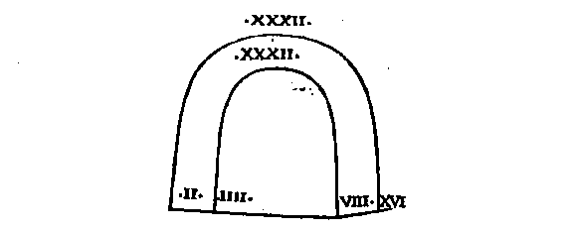
Prima igitur & quarta secundam & tertiam aequiparant: partium quoque praefecti ita ordinantur, vt primus virtute in laeuo primae phalangis simplaris statuatur. Secundus in dextero secundae. Tertius in laeuo terciae. Quartus in dextro quartae. In singulis etiam decuriis quadruplaribus decuriones ita locantur, vt primae decuriae princeps virtute excellat, quartae secundum virtutis locum obtineat, tertiae tertium, secundae quartum: ita enim virtute pares intra se constent, cum prima primum & quartum uirtute habeat, secunda autem secundum virtute & tertium. Item cum in singulis manipulis quatuor decima: duplares contineantur, hac eadem ratione vel in his ipsis principes ordinemus, vt primae quadruplaris praefectus in dextro ponatur, & virtute caeteris sit praestantior. Quartae laeuum teneat cornu, & virtute secundus habeatur. Tertiae in dextro constituatur, & virtute sit tertius. Secundae in laeuo locetur, quartus virtutis ratione. Hanc eandem proportionem siue comparationem vel in maioribus praefecturis seruabimus.

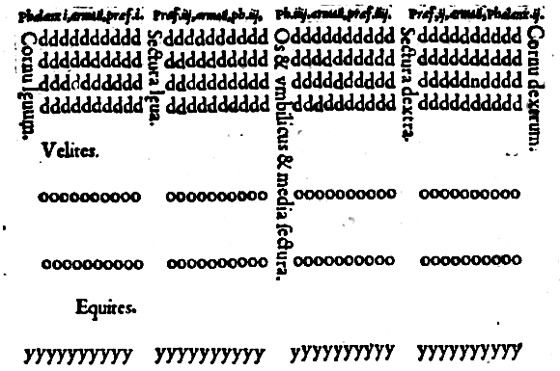
Nvnc de interuallis quibus armati inter se distent tum in longum tum in altum, agemus. Differentia triplex est interualli. Nam homo ordinatus cubita quatuor occupat. Densatus duo. Constipatus vnum. Densatio igitur est cum ex laxioribus arctiora reddimus interualla: atque ita per astitem substitemque corpus phalangis colligimus, & militem vniuersum facimus tum in longum tum in latum adductiorem, verum ita vt recipere possit immutationem. Constipatio est quoties phalanx per astitem ac substitem arctius sese colligit, quam modo densari retulimus, adeo vt ob frequentiam militis nulla vel dextrorsus vel sinistrorsus possit fieri declinatio.
Densatur, cum phalangem duci in hostes placet imperatori. Constipatur, cum hosti aggredienti resistendum in robore est. Cum itaque fronte phalangis decuriones M xxiii compleant, ii certe ordinati, cubita iiii mil. xcvi longitudinis occupabunt, hoc est, stadia, x & cubita xcvi Densati stadia quinque, cubita xlviii.
Constipati stadia occupabunt ii, & semis, & cubita xxiiii Armabitur phalanx scuto & hasta. Scutum optimum quod Macedonicum, aeneum, mediocriter cauum, ad octo dodrantum magnitudinem.
Hasta nulla cubitis octo breuior, longissima, quae eatenus sumi potest, quatenus tenere miles & vti facile valeat.
Decuriones vt pote duces decuriarum phalangis, optimos esse omnino conuenit, ita vt & statura & viribus corporis praestantiores caeteris sint, & rei militaris peritiores. Hoc enim iugum phalangem continet vniuersam, & in vsu praecipuum est. Vt enim gladius pondere sui ferri posterioris & mole, aciem efficaciorem praestat, idem in phalange existimandum esse, vt pro acie ac oris cuiusdam robore ipse sit ordo decurionum. Pondus autem & molem & magnitudinis additamentum afferat constituta in tergo militum multitudo.
Curandum quo ad fieri potest, vt etiam iugum secundum milite constet idoneo. Nam eius quoque ordinis ista in frontem prominet, & adiuncta priori vtilis ex propinquo est, & vel desiderato vel sauciato decurione, secundus se in parte priore constituens, ordinis incolumitatem seruabit. Tertium item iugum & quartum & reliqua deinceps pro virtute instituemus, vt qui deterior sit, iis subinde posterior collocetur. Macedonica phalanx inexpugnabilis & intoleranda hostibus habita est genere suo instructionis & ordinis.
Miles enim armatus vel in duobus cubitis stat quoties densari imminens praelium postulat. Sarisse. Longitudo ad cubita xiiii, quorum duo manus auferunt, reliqua xii prominent .
Ita que sit vt secundi suas sarissas super armatos iugi prioris prominentes, ad decem cubita habeant: tertii ad octo, quarti ad sex, quinti ad quatuor, sexti ad duo.
Ab his nulla item sarissa primum superat iugum. Quod cum per singulos iugi primi sarissae quinque aut sex promineant, species formidolosa existat, consentaneum est. Miles item firmus ac robustus constat quinque sexque sarissis obseptus, & tot tantisque fultus innixusque facultatibus commilitonum.
Qumetiam qui post sextum positi sint iugum, & si minus sarissis agunt, tamen pondere sui corporis prominentes, augent vires totius phalangis & facultatem, nec fugiendi vllam ducibus & praestitibus relinquunt occasionem, nonnulli hastam posterioris militis longiorem quam prioris sumi idcirco voluerunt, vt etiam qui in tertio & quarto iugo locati essent, spiculis suis pari fronte hoste in possent excipere.
Tergidux superordinarius singulorum ordinum prudens peritusque esse debet, qui prouideat & procuret quemadmodum milites ordinis totius versent inter sese atque iugent: & recedentes vel metu, vel aliqua alia causa, prohibeat, & restitui cogat in ordinem atque etiam cum constipandum sit, compellat militem, cogatque, si vsus exigit, in arctum quam maxime adduci.
Ita enim sit, vt vires & robur phalanx accipiat. Quas ob res non modo in fronte, verum etiam in tergo legionis principem & ducem aliquem statui, necessarium ducimus.
Haec de decuriatione armatorum phalangis dixisse sufficiat. Nunc de velite. Instruet imperator suum velitem pro paratu ex consilio hostium, modo in fronte, modo in dextra, modo in leua, nonnunquam etiam in tergo, videlicet quemadmodum res vsusque exigit. Nos exempli gratia sic instruimus.

Decurias quoque in ordine velitum statuemus M. xxiiii, videlicet totidem quot phalanx continet armatorum: vt sub prima armatorum decuria, prima velitum ordinetur, & sub secundam secunda, & deinceps sub singulis singulae constituantur, non tamen ex xvi hominibus has instituemus, sed ex viii, ita vt M. xxiiii decuriae compleant hominum viii mil. cxcii.
Nomina eorum & ordines ita accipe. Quatuor decurias velitum systasin, id est, constitutionem vocamus, hominum xxxii. Duas constitutiones pentecontarchiam, semicenturiam dixerim, hominum .lxiiii.
Duas semicenturias, centuriam: hominum cxxxviii. Inesse singulis centuriis debent superordinarii quinque, Signifer, Tergidux, Tubicen, Minister, Praeco.
Duas centurias psilagiam a ducentis velitibus, quasi velitariam, vel expeditariam nominamus, hominum ccxlvi. Duas velitarias xenagiam a mercenario milite, velut mercenariam dicimus, hominum D xii. Duas mercenarias systema, tanquam constitutoriam appellamus, hominum M xxiiii. Duas constitutorias epixenagiam ceu ad mercenariam, hominum ii. mil. xlviii. Duas ad mercenarias stiphos, hominum iiii. mil. xcvi.
Duo stiphoe epitagma, velut additam legionem, decuriarum M. xxiiii. hominum viii. mil. cxcii. In his quoque superordinarios viii. inesse solitum est, quorum iiii Epixenagi, hoc est, duces siue principes ad mercenariae illius habentur, reliqui Systematarchae praeficiunt principes seu praefecti eius quam constitutoriam interpretamur. Iaculatores sagittarii, & omnes qui aliquo teli genere vtantur, vtiles ad eam rem esse constat, vt praelium exordiantur, hostem prouocent, feriant, saucient eminus, & prosternant: fundant aciem, repellant equitem, cogant aduersarium procursantem loco cedere, explorent, perlustrent quae loca suspecta, locent insidias: hi denique & primum certamen subeunt, & vna cum caeteris pugnant: & quamquam caeteri desierunt, ipsi perseuerant in dimicatione omnino genus hoc militum cum operam praestet celeriorem agatque eminus, multa efficere potest & praeclara.

De Acie Equestri.
Equitum acies autores superiores, aut quadratas, aut parte altera longiores, aut Rhombi cuncive gerentes speciem, tradidere. Sed nemo suam fere satis expressit sententiam. Quamobrem nos descriptione etiam figurarum, formas explicabimus acierum ipsas, quo possint facilius percipi. Aciebus ad Rhombi similitudinem formatis Thessalos primos vsos comperimus, qui plurimum equitatu valuerunt, Iasone (vt ferunt) autore generis huius aciei, vt pote ad omnes vsus accomodatioris: equites enim constituti in hac forma vertere sese in quemuis prospectum possunt, minimeque vel a tergo vel a latere capientur.
Quippe cum praestantiores, Rhombi latera teneant & principes, angulos regant. Stat enim in priore angulo turmae ipsius praefectus, in dextro autem & sinistro, qui custodes vocantur lateris, statuuntur. In reliquo vero angulo ducem seu ductorem tergi locari solitum est.
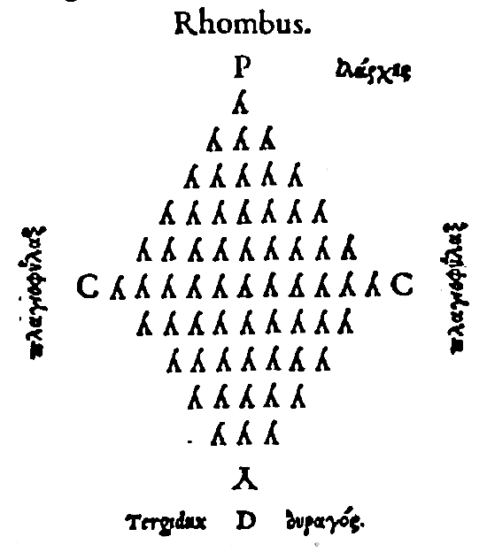

Cvneatis Scythae vtuntur & Thraces. Quinetiam Macedones vsi sunt suadente rege Philippo. Efficacius enim genus id arbitratum est, quam quadratum: ob eam scilicet rem, quod suos principes circumpositos habeat, & fronte exigua constet, & equitandi vsum per quodlibet interuallum facilem praebeat regressum & progressum celeriorem.
Quippe quod minus difficiles illos circuitus habeat, quos quadratae acies sortiuntur. Quadratis aciebus Persae & Siculi ac plerique Graecorum vfi sunt, existimantes & ad compositionem & ad equitantium coitionem accommodatius: & omnino hoc disciplinae genus seruare multis in rebus praestantius.
Nam & instructio, quoniam per versus ac iuga ordinetur, occurrit facilior, & principes in hoc vno formandi genere hostem vniuersi aggrediuntur.

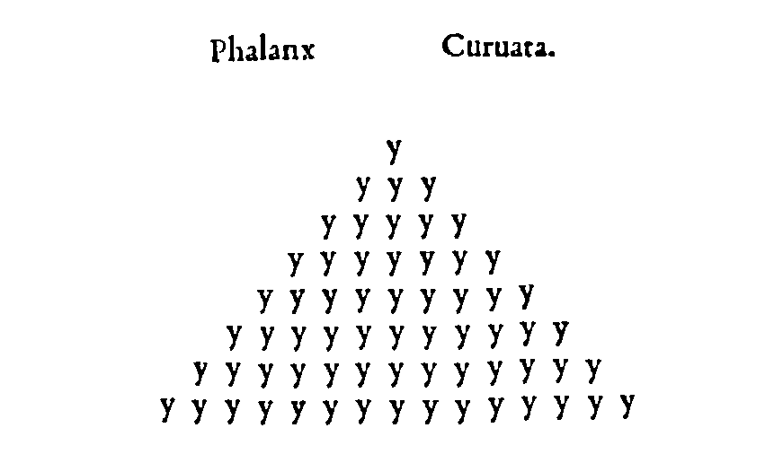

Optimae inter quadratas habentur quae duplici, tam in longum quam in altum, numero constent. Exempli gratia, viii. in longum, quatuor in altum, aut x. in longum, v. in altum, quae numero parte altera longiores consistunt: figura autem seu forma quadrae instituuntur.
Etenim longitudo equi a capite ad caudam respectu suae latitudinis plures eos habere debet qui per iuga ordinentur, quam eos qui in versus se porrigant. Nonnulli triplicem esse longitudinis numerum ad altitudinis probant, scilicet ita arbitrantes fore, vt quadra forma efficiatur.
Triplicem enim propemodum longitudinem habere ad suorum armorum latitudinem videmus. Quapropter cum nouem in fronte statuant, tres in latum componunt.
Haud enim fieri potest, vt equitum multitudo posteriorem eandem praestet vtilitatem, quam in pedestribus copiis, vbi scilicet pone renitentes, primorem continent altitudinem.
Equitum namque omnium numerus, corpus pondusque vnum consistit.
Itaque sit vt si posteriores prioribus iuncti renitantur, nihil suo impulsu proficiant. Immo vna cum aliis labantur, & perturbatis ordinibus grauius suo errore quam virtute hostium versentur necesse sit.
Quamobrem ita euent, vt quoties equestris longitudinis numerus aeque &: altitudinis constet, numerus ipse quadratus sit. Forma autem altitudinis parte altera longior.
Ast quoties turmae forma quadrata est, e contrario euenit, vt equitum numerus parte altera longior existat.
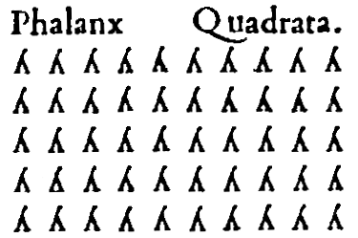

Rhombi formam omnium maxime necessariam venisse in vsum creditur, eo quod prae caeteris omnibus constituto praefecto turmae, equites qui in lateribus ordinantur, non equo suo illi praefecto iugent, sed ita subiiciantur, vt eorum capita iuxta armos equi praefectu apponantur.
Interuallisque inter sese iustis equites tum dextri, tum laeui, tum etiam posteriores discernantur, ne frequentia turbet ordinem, cum equi immitiores in proximos sibi equos conuersi calcitrent, & militibus vulnera infligant.
Autores autem huius generis aut ita disponunt, vt equites &: versent & iugent: aut ita vt versent quidem sed non iugent: aut ita vt iugent, sed non versent.
Quae singula quemadmodum se habeant dicam. Qui Rhombos simul & versare & iugare voluerunt, medium & maximum iugum turmae, numero impari statuunt: vt xi. aut xiii aut xv. cui ex parte vtraque, priore, inquam, posterioreque adiungunt binario primis illis pauciores: verbigratia, si maximum illud iugum equitibus constet xv. addita iuga vtrinque denis aut ternis componunt, & quae item post haec vtrinque adiungunt, denis singulisque conficiunt, at que ita binario subinde pauciores adiiciunt, dum singuli relinquantur, totaque turma equitibus consumetur cxiii.
Rhombus qui versat & iugat.
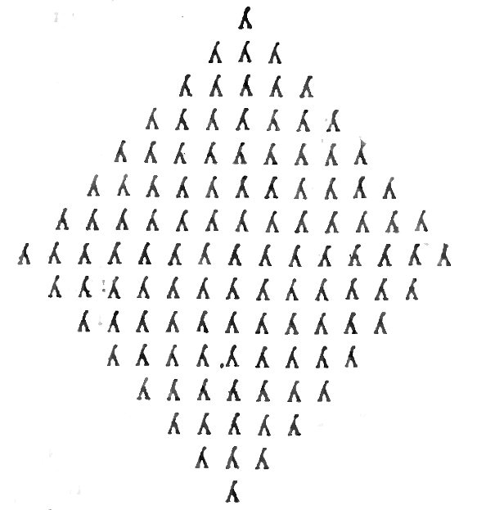

Rhombum dimidiatum & iam transformatum in triquetrum, cuneum seu rostrum vocamus. Qua propter cunei quoque forma perinde explicata iam est: quod aciei genus cum suum medium exiens in acutum habeat, & motum facile quorsum velit sortiatur, expedite admodum vel molem posteriorem sua cum fronte circumagit, & celeriter potest immutari.

Cuneus qui versat & iugat vel rostrum.
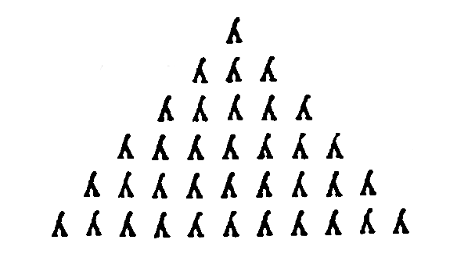
Alii ita instruxere, vt equites qui rhombum conficerent, neque versarent neque iugarent. Ita enim & conuersiones & transitiones equitum posse facilius fieri existimarunt, cum non ante, non pone, non a latere quicquam impediret.
Statuunt primum praefectum turmae, mox ad eius vtrunque latus adiungunt singulos loco submissiore, vt quod dictum iam est, capita iunctorum equorum iuxta armos praepositi equi ordinentur.
Et primus ordo qui duo latera rhombi contineat numero impari, xi. equitibus constet, praefecto medio constituto, quinis autem in vtraque partem suppositis. Deinde iugi principem post turmae totius praefectum collocant.
Tum in eius partem vtramque simili ratione quaternos subiiciunt, vt totus secundi ordinis numerus nouenarius sit, binario minor priore: & quasi duo aequidistantia latera duobus illis rhombi lateribus primis constituantur.
Mox tertium septenario describunt, atque, ita subinde binario diminuentes, in vnum vsque deueniunt. Et haec turma equitibus constat xxxvi.
Hoc genere Polybius vtitur, sed numero hominum lxiiii. Et forma literae λ deorsum inversae y.

Rhombus qui neque versat neque iugat

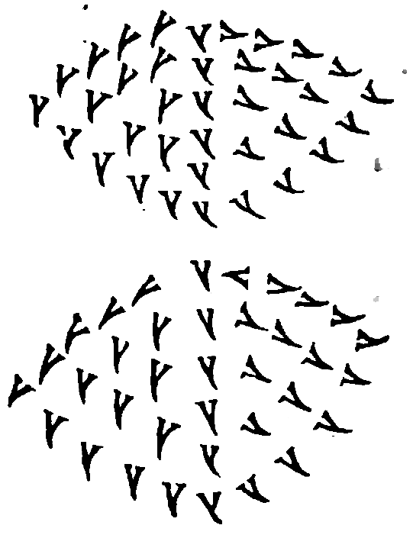

Svnt quae ex versantibus quidem, sed no praeterea ex iugantibus constent, quae ad hunc modum constituuntur. Versu aliquot equitibus instituto, quorum primus praefectus sit turmae, vltimus autem tergiductor, in eius latus vtrumque versus alios numero hominum vnitate minores disponens, qua eques per interiecta interualla distat ab equite.
Quod si in primo decem sint equites, vterque appositus nouenis constabit, & tertii octonis, atque ita numerus subinde decrescet, dum in vnum deueniat: sic enim fieri potest, vt equites inter se versent quidem, sed non iugent. Vtile genus quoque id disponendi est ad declinationes, quas agi in vtrum libet latus solitum est.

Vocatur autem quae ad dextram sit, in hastam declinatio: quae autem ad laeuam, in habenam.

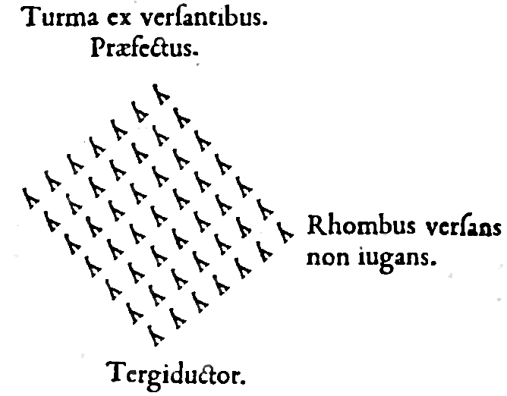

At si turma ex iugantibus quidem, sed non ex versantibus consistere debeat, in hunc modum dispones, medium & maximum iugum numero constitues impari. Caetera autem subinde per media interualla adiunges, quemadmodum in superiore turma proposui, atque ita efficietur, vt turma ex iugantibus tantum consistat.

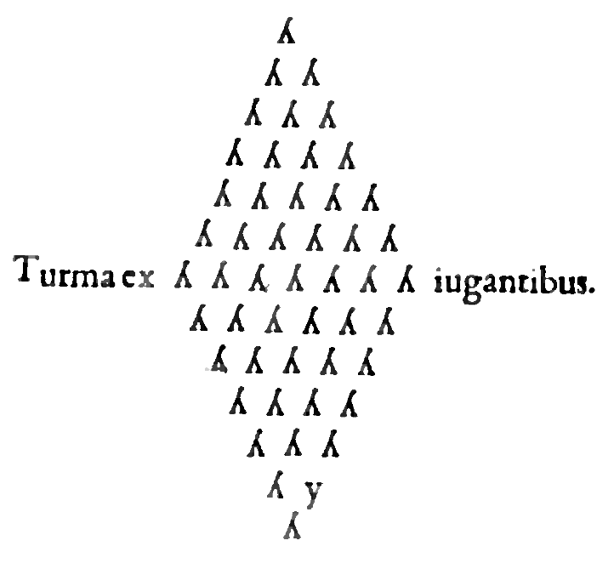

Tvrmas vario modo vt etiam leuem armaturam statuimus: aut enim ante phalangem, aut in latere, aut post leuem armaturam: sed nos describendi exempli gratia post leuem locauimus. Et prima equitibus constet lxiiii. cuius primum iugum equites compleant xv. secundum xiii. tertium xi. Et reliqua subinde binario vsque in vnum decrescant.
Signum is feret qui in secundo iugo a laeua principi iugi astat. Omnes turmae numero lxiiii. statuentur, equites liii. millia cxvi. Duae turmae Epilarchiam, hoc est, turmam duplarem constituunt, equitum cxxviii.
Duae duplares Tarentinam reddunt, equitum cclvi. Duae Tarentinae magisterium, equitum D xii. Duo magisteria Ephipparchiam duplare magisterium, equitum M xxiiii. Duplicatum duplare magisterium telos, equitum ii. mil. xlviii.
Duplicatum telos epitagma, id est, summam ordinis huc agminis facit, equitum iiii. mil. xcvi. Explicatae iam sunt variae sententia veterum, quemadmodum turmae instruantur, sed quoniam in his magnam differentiam esse constat, non sine delectu vti debemus, sed quotidianis exercitiis saepius experiri genera instruendi singula. Itaque secure in praeliis quod facilius commodiusque probetur, admittere officium est. Quid enim stultitius quam cum minimis de rebus homines diligenter inquirant, ambigant, perscrutentur, de his tam amplis, tam necessariis non ante periculum facere accuratissime velint, quam certamina subeant. Quod tamen genus turmae probaueris, id licet & augere numero hominum, & minuere.

Decurruum & elephantorum institutione quanquam vsus eorum rarus est, tamen doctrinae gratia plenioris, exponam nomina, quibus autores superiores vsos comperio. Duos currus zygarchiam, id est, parilem vocanr. Duas pariles, coniugationem. Duas coniugationes, episyzygarchiam, duplarem coniugationem.
Duas duplares, harmatarchiam currulem. Duplicatam; currulem, cornu. Duplicatum cornu, phalangem. Pluribus vti phalangibus curruum licet, vocabulis iisdem quae modo exposui.
Curribus autem ipsis aut expeditis, aut salcatis vsos comperimus. In ordine elephantorum qui vni prae est elephanto, zoarchus ab animalis praefectura vocatus est: qui duobus imperar. Therarchus a fera, quasi ferarius, & constitutio talis Therarchia, feraria.
Qui quatuor dominatur, epitherarchus, duplicaris ferarius: & haec constitutio epitherarchia, duplaris feraria. Qui octo praefectus est, iIarcha, hoc est, turmae princeps, & constitutio ista ilarchia, turmae praefectura.
Qui sexdecim prae est, elephantarcha, id est, elephantorum praefectus: & constitutio elephantarchia, praefectura elephantorum: qui triginta duobus imperat, ceratarcha, id est, cornu praefectus: & constitutio, ceratarchia, cornu praefectura.
Quod autem cx lxiiii. constat, id phalangem vocamus elephantorum, cuius praefectus Elephantarcha vocatus est.

Genera perfectarum copiarum, & nomina constitutionum & ordinum exercitus omnia in hunc modum notata animaduertimus, vocabula de caetero quae in praeceptis versantur explicasse vtile est: vt iam pridem milites quid quodque significet certiores, facile quae per aciem imperantur, intelligere possint & facere.
Est quod declinatio appelletur, cuius duplex est genus: aut enim in hastam, aut in scutum. Immutationem item dicimus, & conuersionem & reuersionem, & inflexionem. Ad haec versare, iugare, reddere in arrectum, euoluere, duplicare.
Addo inductionem, dextram deductionem, leuam deductionem. Phalangem transuersam, phalangem arrectam, phalangem obliquam.
Intercalationem, praepositionem, impositionem, suppositionem, postpositionem, appositionem. Quid quodlibet eorum significet breuiter exponam. Nec ignoro, non apud omnes autores praecepta eisdem esse nominibus tradita. Declinatio est motio militum singulorum cum vel in hastam, hoc est, dextrorsum sese conuertunt, vel in scutum, hoc est, sinistrorsum. Quod commode agitur, quoties hostes existunt a latere cornu, vtique superandi aut aduersi itineris gratia, aut ob aliquem vsum alium quemadmodum singulis in rebus ostendam. Duplicata autem declinatio partem versus eandcm, ora militis in hostilem a tergo conatum transfert. Quae res Immutatio dicitur, & vel in hastam, vel in scutum fieri solita est.
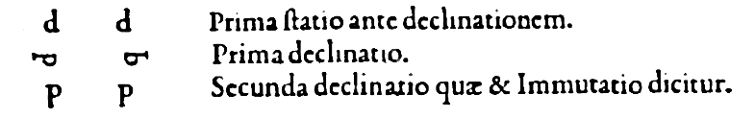

Discrimen duplex notatur immutationis: aut enim ab hostibus, aut in hostes immutantur. Quamobrem immutationem ita definiunt, vt prioris aspectus translatio sit in aspectum posteriorem, hoc est, tergi aut e contrario.
Immutatio igitur ab hoste, bis in hastam milite declinante efficitur. In hostem autem, his declinante in scutum fieri assolet. Conuersio est cum densatis copiis per astitem substitemque, totum phalangis corpus tanquam hominem vnum vel in hastam vertimus vel in scutum, ita vt circa primum decurionem velut centrum omnes circumagantur, atque ita locum priorem immutent, vt aspectum dextrum accipiant, singulis substitibus & astitibus loca seruantibus, suo hoc modo.

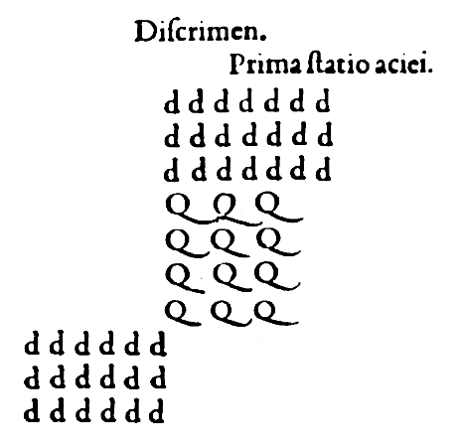

Reuersio est conuersionis restitutio in eundem locum, quem ante copiae densa instructione obtinebant, quam conuersio fieret. Inflexio est militum ex duabus conuersionibus motio, ita vt locum accipiant posteriorem.



Deflexio est militum ex tribus conuersionibus motio, ita vt si ad hastam agantur, transeant in leuum aspectum: si ad scutum, in dextrum.

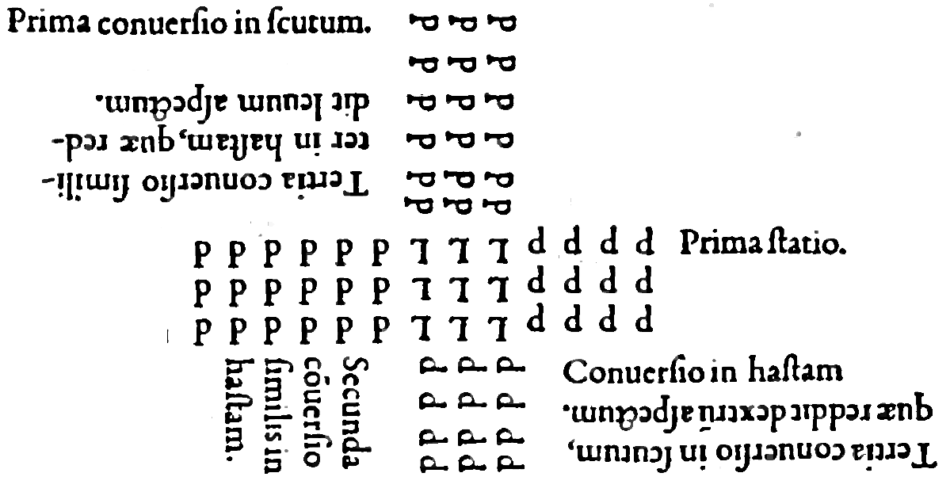

Versare est singulos sua in decuria e directo decurioni & tergiductori con stare aequa inter sese conseruantes interualla.
Iugare , est singulos sua in decuria e directo suo astiti stare, seruantes simili modo interualla. Iugant ergo praefecto primae decuriae omnes decuriarum praefecti. Substiti vero primi praefecti substites caeterorum omnium principum, ac deinceps ad hunc modum.
Reddere in arrectum , est militis ora ad primum aspectum restitutere. Verbi gratia, si miles aduersus hostes constitutus imperetur declinare in hastam, deinde praecipiatur in arrectum restitui, rurfus in hostem conuerti, aduersumque stare oportebit.
Euolutionum duo sunt genera, alterum per decurias, alterum per iuga. Vtrumque in tres digeritur species, Macedonicam, Laconicam, Choreum, quae & Persica & Cretensis nominatur.
Macedonica est, quae primorem phalangis locum commutat, & frontem in tergum aspectumque posteriorem traducit.
Laconica est, quae locum phalangis posteriorem commutat: & pari ratione relicto primore aspectu, sumit posteriorem, tergumque efficit frontem.
Persica illa quam & Cretensem & Choreum diximus nuncupari, locum eumdem seruare phalangis, militibus singulis commutantibus sua loca, ita vt praefectus decuriae locum tergiductoris accipiat, & tergiductor vicem praestet decurionis, fronsque ex tergo aspectui posteriori reddatur.
Euolutiones per iuga fieri solent, quoties cornua transferri ad intercisa siue secturas, & intercisa ad cornua melius est, vt mediae copiarum partes corroborentur: & aut dextrae, per leuas, aut leuae per dextras reddatur validiores.
Qui ne per maiores exercitus partes faciant euolutiones, cauent, hoste propinquo, per minores ordines eas securius faciunt. Quemadmodum autem euolui oporteat, dicam.
Euolutio per versum, quae nomen Macedone accipit, fieri solet, cum decurio locum immutat, & postpositi omnes couersi de hasta sequuntur, interuallisque iisdem seruatis, & consistunt per ordinem.
Genus Laconicum agitur, cum decurio immutatur de hasta vniuersam decuria transfert, & locum sibi parem alium accipit, & reliqui omnes sectantes recto se constituunt ordine & aptant, aut cum tergiductor immutatur.
Primus autem subsistens conuersus de hasta ante tergiductorem se collocat, caeterique omnes sectantes, alter sese prae, altero ponit, donec praefectus decuriae primus constituatur.
Choreus ita sit ut decurio de hasta mutatus decuriam antecedat & caeteri omnes sequantur. Dum ipse praefectus locum tergiductoris accipiat & tergiductor praefecti ita per decurias euolui solitum est.
Quo eodem more per iuga quoque euoluimos quotiens per ordinem euoluendum sit ut qui libet ordo aut locum seruans eundem euoluat aut dextrorsum sinistrorsumque transeat. Nihilo enim secus quam modo rettulimus agi oportebit. Duplicandi duo sunt genera.
Aut enim per iuga: aut per altum duplicamus. Vtrunque vel numero sit vel loco. Numero duplicabitur longitudo siquae. M. xxiiii. militibus constat. M. M. xlviii reddatur insertis & substitibus altitudinis in militum interualla eodem quem logitudo occupat loco.
Quod facimus quotiens densare longitudinem placet. At vbi restituent placuit euoluere sua in loca iubemus eos quos inseruimus longitudini. Sed sunt qui genus hoc duplicandi improbent praesertim hoste propinquo- Expeditasque copias atque etiam equites cornibus iungi.
Itaque speciem dari duplicationes sine duplicandi accessione censeant. Duplicanda est longitudo quotiens aut superare cornu hostium uolumus aut ne nostrum superetur cauemus.
Altitudineue duplicare solemus vel addita secunda decuria primae ita ut secundae praefectus pone primae praefectum proximus collocetur secundus secundae quartus primae constituatur & tertius secundae: sextus primae ordinetur ac deinceps ad hunc modum ut tota secunda decuria primae inseratur & quartae simili ratione in tertiam: & omnes numero pares decuriae in impares: vel his eisdem decuriis paribus per euolutionem adiunctis tergo imparium.
Aut igitur ita duplicanda est altitudo aut numero eodem seruato milites sese longius porrigent quamtenus sui versum & spacium altitudinis duplicent.
Cum aunt restitui opportuerit aut interiectos adiunctosue tergo milites illos in suas decurias revocabimus aut spacia coartabimus quaeque interuallo auximus laxiore.

Transuersa est phalanx quae longitudine multo productiore constat quam altitudine. Arrecta est quae per cornu progredit longe, productiore altitudine constat quam longitudine omninoque plus longitudines quam altitudines henat: oblongum id consueuimus noniare. Arrectum vero e directo quod plus altitudinis quam longitudinis henat quo circa phalangem quoque interpretari licet his eisdem nominibus. Obliqua est quae alterum cornu quod libuerit propinquum obiiciens hostibus eoque decertans alterum semotius teneat manens aggrediendi opportunitatem.
Intercalatio est intervallis praepositi militis inserimus per directum aliquos ex his quos postponi placuerat. Praepositio est cum vel ex utraque parte acici vel ex altera tantum fronti proponimus aliquos ratione auxilii. Impositio est cum leuem armaturam interuallis alternatim phalangis totius inserimus.
Postpositio seu subiectio est cum leuem armaturam phalangi incuruae postponimus. Ita ut forma omnium copiarum portae triplicis speciem praeferat.

Sequitur ut quemadmodum ordines conuerti ex suo loco suaeque instructioni restitui debent doceamus. Cum itaque ordines conuerti in hastam assuescere uolumus praecipitur decuriae dextri extremi quiescere. Caeteras omnes per singulos declinare in hastam dextrorsumque procedere. Tum reddere in arrectum. Deinde iuga posteriora colligere, atque ita densato milite conuerti in hastam. Quo facto si restitui suum in locum placuerit, iubebimur immutari ad scutum, hoc est, quemque in locu vergere auersum, tum ordinem totum reuerti, hoc est, quemadmodum milite obdensato conuersus spectauit dextrorsum, ita totum transferri in locum vnde conuerti inceperat.
Mox decuriones quiescant, reliqui procedant per iuga. Deinde immutentur vt vergant quorsum principio spectabant, cu, decuria dextri extremi quiescat. Haec enim suum iam obtinet locum, reliquae omnes ad scutum declinent, & procedentes restituantur.
Ad postremum sursum praecipicur. Itaque suum quisque recipit locum & seruat. At si conuertere ordine ad scutum velimus, praecipitur decuriam laeui extremi quiescere: haec enim suam iam habet positionem, reliquos omnes declinare in scutum, sinistrorsumque procedere, tum reddere in arrectum.
Deinde iuga posteriora colligere, mox ad scutum conuerti, vt iam actum sit quod voluerimus, hinc si restituere placet non secus quam illos in hasta conuersos restituemus: quippe qui rurfus quemque in hasta immutari praecipiamus, deinde ordinem reuerti, mox decuriones quiescere, & reliquos omnes procedere per iuga, tum immutari, postmodum decuriam laeui extremi quiescere, vt pote suum iam locum obtinentem: reliquas declinantes in hastam procedere, dum iusta recipiant interualla: ad postremum reddere in arrectum, atque ita omnes suum locum recipient. Si autem inflectere ad hastam placuerit, duas simul conuersiones ordinis faciemus.
Itaque efficietur, vt decuriones a prospectu aduerso in auersum per ordinis immutationem transeant. At cum restituere volumus, praecipitur ite ad hastam inflectere, hoc est, duas item couersiones ibidem ordinibus dare.
Ita enim sit, vt eodem spectent decuriones, quorsum principio constituti spectabant, antequam vlla inflexio fieret. Haec cum fecerimus, decuriones quiescere praecipiemus, reliquos immutatos iuga relaxare posteriora, tum rursus mutari, & ordinis postremam decuriam dextra quiescere.
Iam enim haec suum in locum restituta est, reliquos declinantes in scutum, procedere, & suis interuallis restitui, mox reddere in arrectum.
Itaque ordines primum suumque locum recipient. Sed si inflectere ad scutum velimus, praeceptis vtemur contrariis, hoc est, bis inflecti in scutum: quo facto, restitutionem agemus, quod ex his quae modo exposui apertum iam est.
Deflexio agitur, cum ordinem ter partem versus eandem conuertimus, hoc est, aut in hastam, aut in scutum: facit porro inflexio in hastam, vt militum ora transferantur a parte primore ad posteriorem. Deflexio autem facit, vt a primore vel ad laeuam deueniant, vel ad dextram: nam si ad hastam deflectitur, in laeua transfertur: si ad scutum, in dextram.
Si phalangem densari cornu versus dextrum placuerit, praecipiemus decuriam cornu dextri quiescere, reliquas autem declinari in hastam, atque in dextra colligere, tum reddere in arrectum, & iuga posteriora colligere.
Cum autem restituere libet, quiescere decuriones, reliquos immutari, & iuga relaxare posteriora. Deinde rursus mutari mox decuriam cornu dextri quiescere. Iam enim restitutum in dextro est: reliqui ad scutum declinare suos duces sequantur, & primis interuallis receptis reddant in arrectum.
Si autem cornu versus sinistrum densari phalangem libuerit, praeceptis e contrario vtemur. Mediam item phalange si densari placuerit, praecipiemus dextram duplarem phalangem declinare ad scutum, laeuam ad hastam, tum procedere mediam versus phalangem, mox omnes reddere in arrectum, iugaque posteriora colligere. At si phalangem primis instituere locis velimus, praecipitur immutari, & per iuga procedere, excepto primo: tum omnes rursus mutari, & dextram duplarem phalangem declinare in hastam, laeuam autem in scutum: mox sectari suos ductores, donec ad prima deueniat interualla.
Deinde reddere in arrectum. Sed quoties immutatur, si per densationem agitur, erecta teneri spicula omnia, ne impediant, conuenit. Iis eisdem exercitiis ac praeceptis leuis quoque armatura instituenda erudiendaque est.
Sunt certe praecepta haec Immutationum, Conuersionum, Inflexionum, Euolutionum, & Resti-tutionum vtilia ad subitos hostium superuentus, quos vel a latere vel a fronte intulerint.
Macedonicam euolutionem Macedones inuenisse proditum est. Laconicam ad Lacedaemonios referunt auctores, quocirca ita nuncupari meruerunt. Philippum tamen qui Macedonum imperium auxit, & Graecis apud Cheroneam [Choroniam] profligatis, Graeciae imperauit, ac eius filium Alexandrum, qui breui Asiam in suam ditionem redegit, Macedonicam neglexisse euolutionem legimus, vt nisi summa vtendi necessitas cogeret, nunquam vterentur. Laconicae vsu vtrumque aduersarios deuicisse ferunt.
Datur enim Macedonicae vitio, quod hoste repente a tergo superueniente, non sine magna turbatione ageretur. Nam cum posteriores conuerterent sese in locum priorem, & rem haudquaquam fugae dissimilem facerent, hostes audaciores reddebantur:& iam milites qui ita euoluissent, deterrere ac persequi poterant.
Laconica certe e contrario agit. Vbi enim duces vna cum sequente milite verterunt sese obuios in hostem a tergo superuenientem, terrorem inferre nimirum possunt & turbationem.
Sed assuefaciendae sunt copiae, tam pedestres, quam equestres, partim voce, partim signis, quae visu percipi valeant, vt rem apte ac opportune, quam quisque exigat vsus, possint expedire.
Nonnulla etiam tuba praecipi conuenit. Ita enim plenius omnia ministrabuntur.
Certiora sunt ea quae voce indicantur, nisi quid sit impedimento. Sed tranquilliora, quae signis mandentur, videlicet cum res nulla est quae obstet atque obscuret. Vox autem percipi interdum non potest, aut propter armorum sonitum, aut propter equorum transitum & hinnitum, aut propter impedimentorum tumultum, &: totius multitudinis strepitum.
Signa quoque multis rationibus obliterari possunt ac euanescere, nam &: crassitudine aëris, & puluere excito, & imbre, & solis splendore opposito.
Ad haec locorum inaequalitate & frequentia arborum. Adde quod interdum fieri non potest, vt signum ad vnunquemque vsum praeparemus, cum longe plura possint occurrere, quam quibus assuefacti sint milites.
Nouis autem rebus quid nam consueti signi asseratur. Non tamen concidi ita potest, vt praeceptum simul & vocis & signi incertum sit.

De itineribus
Nvnc de itineribus dicam, si ante quot modis expediri solet iter, diffiniam. Itinerum aliud arrecta inductio est, aliud deductio, aut dextra, aut laeua: & aut simplici, aut duplici latere, aut triplici, aut quadruplici agminis procedetur.
Simplici cum ex parte vna aduersarium aggressurum suspicamur: duplici, cum ex duabus: triplici, cum ex tribus: quadruplici, cum vndique.
Vnde sit vt iter aut simplici phalange agatur, aut duplici, aut triplici, aut quadruplici. Arrecta inductio est, cum ordo ordinem sequitur. Verbi gratia, quum vel xenagia praecedente reliquae sequuntur xenagiae, vel quadruplarem decuriam reliquae ordinatim sectantur.
Item quae agitur per cornu altitudine longe productiore quam longitudine: nec pluribus quam duabus decuriis, hominibus denis compositis, constet ordo. Huic opponitur genus aciei quod Coelembolum, quasi rostrum cauum nominamus: quod ita instruitur, vt duplicatae phalangis praecedentia cornua inter se distent, sequentia iungantur, ad formam literae v, sicut descriptio ostendit.
Quae vt primos disiectos, ita iunctos inter se habet vltimos. Cum enim arrecta illa inductio medium aduersariorum petat, habet id cauum rostrum in promptu, vt soluta coniunctione extremorum impetum copiarum primarum frustretur, lateraque inuadat arrectae inductionis inimici. Quin etiam triplex phalanx obiici huic eidem generi ira potest, vt vna alterius cornu impugnet, secunda reliquum cornu aggrediatur, media & tertia impetum maneat & conflictum.

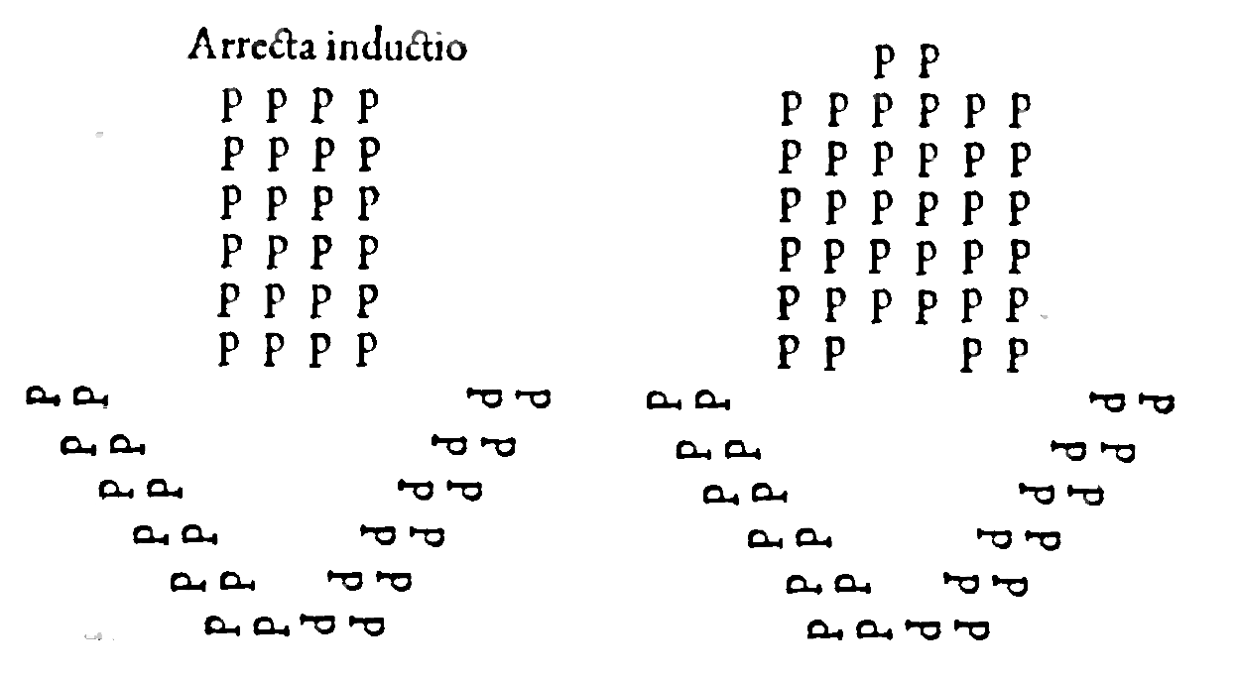

Deductio est, cum phalanx suos duces, hoc est, decuriones aut parte dextera habet deducentes, quae dextra deductio dicitur: aut laeua, quae deductio laeua nuncupatur: non item per decuriam, sed per iuga ambulans, cornu praeposito & latere instructa, aut duplici, aut triplici, aut etiam quadruplici, prout hostem existimet aggressurum.
Sed quasi vtraque phalangis pars suo latere conflictum ineat primum, ita describatur, vt longitudinem triplicem quam altitudinem habeat.
Frons enim x, altitudo tribus constat hominibus. Quamobrem miles non tantum ex directo, verum etiam ex latere aggressus, conflictum tum excipere tum inferre, nimirum per exercitationem debet condiscere.

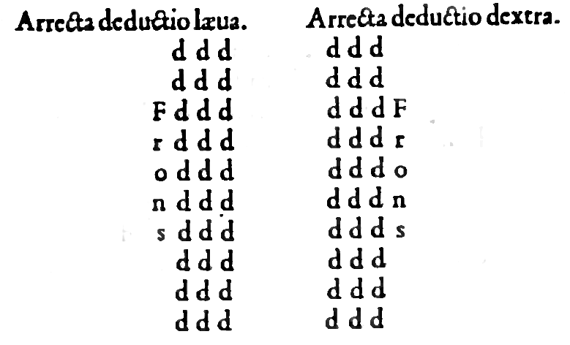

Phalanx quae antistomus a duplici frontis seu oris obiectu, quasi occeps vocata est, ita instruitur, vt medii tergis inter sese oppositis constent, extremi autem confligant cum aduersariis. Perutilis haec pedestribus copiis est, cum aduersus largam hostium equestrem copiam dimicant: melius enim resistunt circumuentioni, & multiplici equitum inuasioni.
Valet hoc instruendi genus potissimum contra barbaros, qui loca Istro amni vicina incolunt: quos amphippos cognominant, a mutatione equorum: ex aliis enim equis in alios transilire consueuerunt.
Equestres, quae opponuntur copiae, forma constantes quadrata, in ordines duos parte altera longiores, pro vsus necessitate diuisae sunt, vt totidem membris phalangis peditum bipartitae obiiciantur.

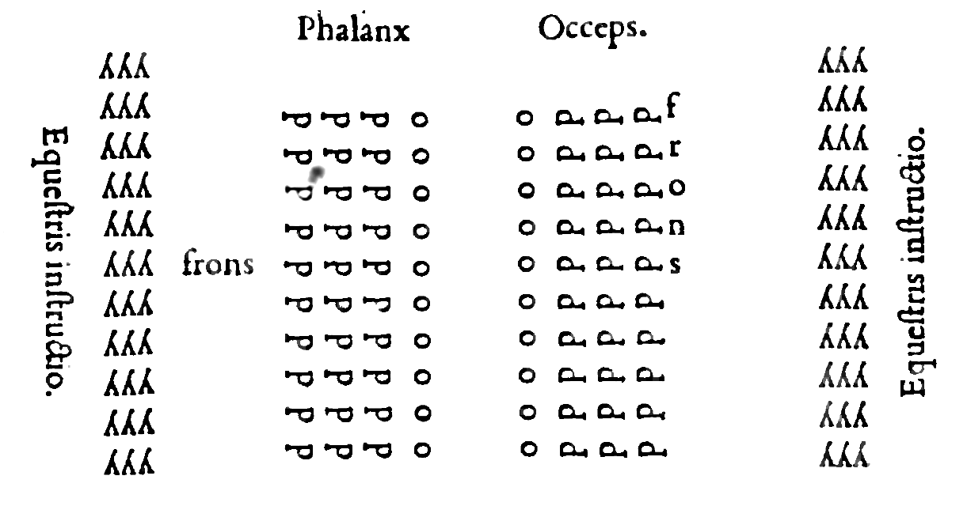

Phalanx amphistomus, nomen a duplici fronte siue ore in lateribus instituto acceperat, ita vt latericeps quaedam & anceps posset nominari. Similis superiori occipiti est, praeterquam quod illa suis extremis decerrat, haec suis lateribus dimicat.
Caetera vero quae de superiore exposui, huic quoque conueniunt: omnia hastis longioribus, tam haec quam superior illa pugnat, more Alanorum & Sauromatarum.
Spectat decuriarum dimidium in partem priorem, reliqui conuersi sunt in posteriorem, ita vt dimidiati milites oppositis inter se tergis praelientur fronte duplici, altera priore, quam decuriones consiciant: altera posteriore, quam tergiductores: cum etiam in duplarem phalangem copiae diuidi possunt, vt frons prior altera constituatur phalange, posterior altera constet.

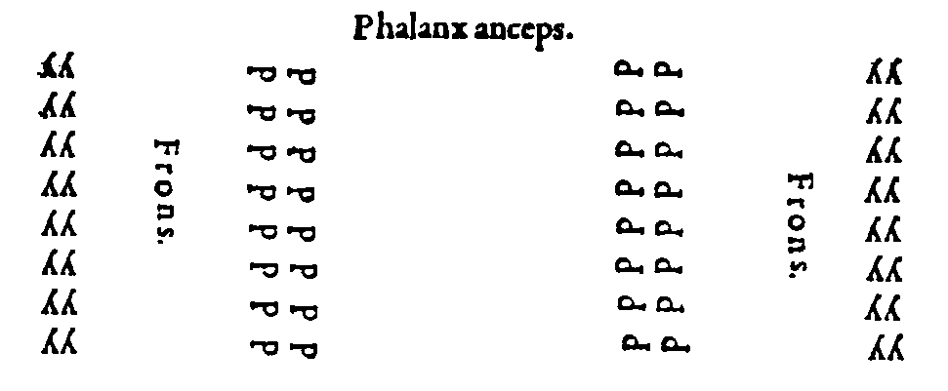

Phalanx duplaris antistomus, hoc est, occeps nuncupatur, quae suos duces non extra per deductiones, sed intus aduersos inter se positos habeat: tergi autem ductores extra videlicet in dextram leuamque, deductionem distinctos. Forma haec instrui solet, quoties aduersarii equites forma rostri aggrediuntur.
Cum enim rostrum exeat in mucronem, ducesque sequentes de latere habeat, tentantesque frontem copiarum pedestrium rumpere, ne id eueniat duces peditum in medio stant, vt impetum aduersariorum vel impediant, vel re infecta faciant praeterire.
Qui enim rostro instructi aggrediuntur, ea spe sunt, vt medios aciei profligant, omnesque turbent copias. Quod cum principes copiarum pedestrium intelligant, vtraque ex parte sese veluti murum constituunt, & paulo inter se distantes, vergentesque, ad locum penitiorem, impetum irritum reddunt aduersariorum Genus id instruendi equestre quod rostrum dicimus, Philippum regem Macedonum inuenisse scribitur.
Praeponere ille strenuos omnes solebat, vt eorum virtute miles quoque deterior contineretur, opusque vna cum praestantioribus prosequeretur, more spiculi aut ensis, cuius acie pro sua soliditate, suoque acumine facile transadigente, reliquum etiam ferrum, quanquam hebes esset, non sine efficacia penetraret.

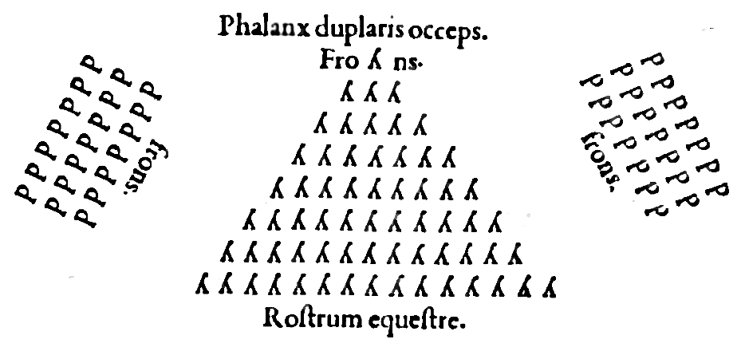

Phalanx duplaris Peristomus seu Amphistomus, id est, latericeps siue anceps illa est, cuius partes per deductionem cornu praeposito oblique procedant, & dextra habeat praefectos, & leua tergiductores intus. Cum enim aduersa acies quadra diuidat se in duo obliqua cornua, dextrum & sinistrum, cupiens aciem hostium similem circumuenire, hac de causa, qui circumuentum sibi vident imminentem, in duplicem mobilem phalangem sese afformant, & partem sui alteram in leuum dirigunt cornu, alteram vertunt in dextrum. Vndenomem peristomi, hoc est, latericipitis, genus id accipit. Quippe quod latere suo vtroque frontem spectantem in hostem habeat.

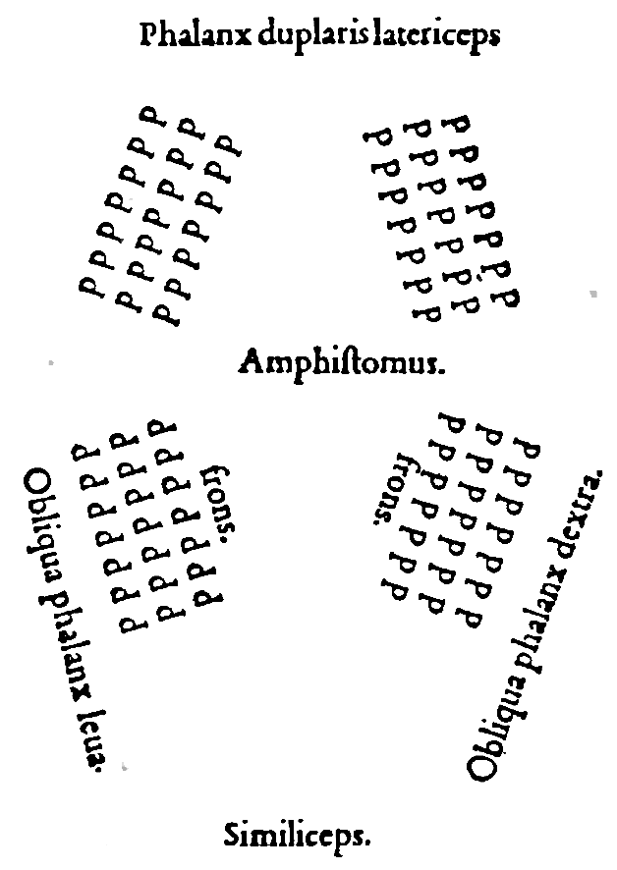

Phalanx homoeostomus, a similitudine oris seu frontis nominata, quam similicipitem appellarim, ita sit, vt decuriam perfectam, hoc est, hominum xvi, mouentem in hostem sequatur alia similis: vnde homoeostomus dicta est.
Nam & qui sequuntur simili fronte & forma comitantur. Opponitur haec genere aciei, quod plinthum a latere vocant: quem si placet, Laterculum dices.
Ordinatur id genus tam forma quam numero aequilaterum. Forma in quam cum vndi que equalibus constet spaciis. Numero autem cum quot hominibus longitudo componatur, totidem etiam altitudo. In hoc eodem ordinis genere omni ex latere armatos apponi solitum est, nullo vel sagittario vel funditore adiuncto.
Consicitur hic laterculus ex duabus dimoeriis: decuriae nanque dimidium dimoeriam dicimus. Cum enim decuria sexdecim constat hominibus debeat, dimoeria octo constat. Bipartita id interpretetur si placet, quo ad melius vocabulum inuenerimus.

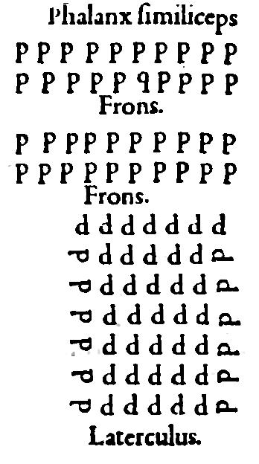

PHalanx duplaris Homoeostomus est, cum partes aequali progredientes itinere, aut in dextra deductione ambae continent suos duces, aut in leua.



Phalanx Heterostomus a frontis diuersitate appellata, quam Versicipitem dixerim, ita instruitur, vt ambulans per inductionem duces ordinis praecedentis habeat (vt sit) in dextra deductione, sequentis autem in leua, ita vt ordines alternata principum locatione procedant. Nullus enim eodem latere suos continet principes, quo antecedens.

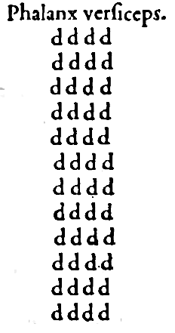

TVrmam quae ad speciem oui instruitur Ilion Thessalus excogitarat, vnde Ile vocata est, suosque Thessalos eo ipse genere instruendi exercuit. Vtile hoc est cum singulis suis angulis habeat principes. Primum Ilarcham, hoc, turmae praefectum: vltimum tergiductorem, vtrinque autem lateris custodes.
Opponitur huic acies, quae forma lunae cornibus in partem ductis priorem formetur, ducesque, suis in cornibus habeat, & suis brachiis cricumuenire [circumuenire] aduersas equitum copias tentet. Quamobrem illae more Tarentinorum a longe iaculantur, circularem retorquentes accessum & turbantes. Tarentinos iaculatores appello, sicut inter initia operis dictum est, a Tarento Calabriae oppido, cuius equites paruo quodam iaculo vti consueuerunt.
Est & altera turma oui similitudinem gerens, de qua nihil amplius dici potest, quam ita esse compositam, vt verset quidem, sed non iuget. Nam eius vsum commoditatemque superius exposuimus.
Ergo genus id inuentum ab Ileone Thessalo, mandatum post exercitationi ab Iasone Medeae marito. Tutum etiam & percommodum esse, cum vndique custodiatur decurione, tergiductore, custodibus lateris, apertum iam est.
Constat haec turma ex equitibus sagittariis more Armeniorum & Parthorum. Opponitur ei acies pedestris quae Epicampius emprosthia dicitur, id est inflexa antica, ob eam rem, quia ductis cornibus in partem priorem in sinum se circumagit, flexumque imitatur.
Fraudem haec in sagittarios equites ita emolitur, vt vel egressos & cominus dimicantes suo complectatur sinu, & circumueniat: vel cornibus suis perturbet illorum robur, & frangat, atque ita medio milite alacriore possit euincere.



Qvin etiam genus habetur phalangis, quae Epicampius opisthia dicitur, contrario modo quam superior informata. Cum enim illa ante se flectat, haec sua cornua in partem ducit posteriorem, itaque vt illa antica, sic haec postica nominetur. Vtilis ea quoque ad fraudem est: quippe quae parte media patens, paucos qui praecedant ostendat multos autem qui pone subsequantur habeat: vt si conflictum tolerarint superarintque, satis sit: sin minus, facile ad vtramque, suorum partem recurrere, iungique maiori ordini valeant. Quae autem contra id genus opponitur, incurua ob id appellata est, quoniam in portionem flectitur orbis.
Studet haec suas copias paruas esse ostendere frontis incuruae ratione. Quippe cum omnia quae in orbem globumve formantur, parua suo quidem ambitu esse videantur: quanquam, si explicentur, in duplum se porrigunt: quod liquidum in columnis est, quae cum in orbem se colligant, vndecunque aspiciantur, dimidium sui tantum patere patiuntur, reliquum penitus occultant. Est autem optimum instruendi artificium, vt plus inferas aduersariis copiarum, quam primo aspectu ostendas.

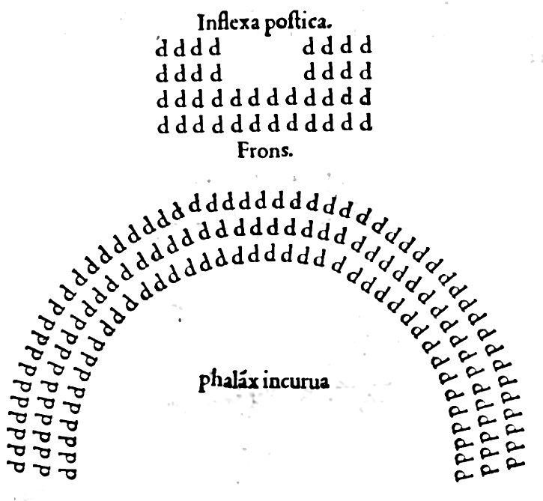

Equestris phalanx quadrata & si forma seu figura quadra instruitur, tamen non numero quoque aptatur quadro. Haud enim in quadratis numerum certo modo describimus. Sed licet etiam duplicem ad altitudinem reddere longitudinem videlicet pro vsu imperatoris.
Persae potissimum forma hac vsi sunt, & Siculi, & Grecorum complures, cum & facilem esse instructum animaduerterent, & vsum commodiorem.
Opponit ei phalanx pedestris quod rostrum vocamus, ita instructa, vt latera omnia armatis composita habeat. Translata haec forma ab equestribus rostris est. Verum in ordine equestri vnus in fronte primore satis sit. At in pedestri non vnus occursioni hostium sufficit, sed tres propugnent necesse est.
Sic Epaminodas Thebanus imperator cum apud Leuctra aduersus Lacedaemonios decertaret, constipatis in rostrum copiis, ingentem exercitum profligauit. Effici genus instruendi hoc solet, quoties duplaris antistomus, hoc est, anceps illa sua cornua priora coniungit, posteriora feiungit, ad formam literae V deorsum inuersae Ʌ.

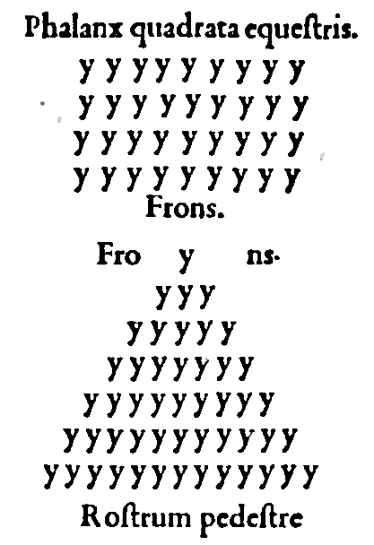

Genus quod Plaesium parte altera longius appellamus, multiplici longitudine quam altitudine constare, & omni ex latere armatis componisagittariis ac funditoribus constitutis in medio, solitum est.
Qui contra eiusmodi formam praeliantur, genus phalangis quam implexam vocamus obiiciunt, vt suae formae inaequalitate prouocent Plaesium aduersum impetum facere in eos qui prominent, atque ita resoluant densam Plaesii instructionem.
Et quidem decuriones implexae phalangis duces aduersos obseruant vt si densa acie illi agant, ipsi quoque densa excipiant.
Sin illi resoluantur, ipsi etiam diuisi occurrant.

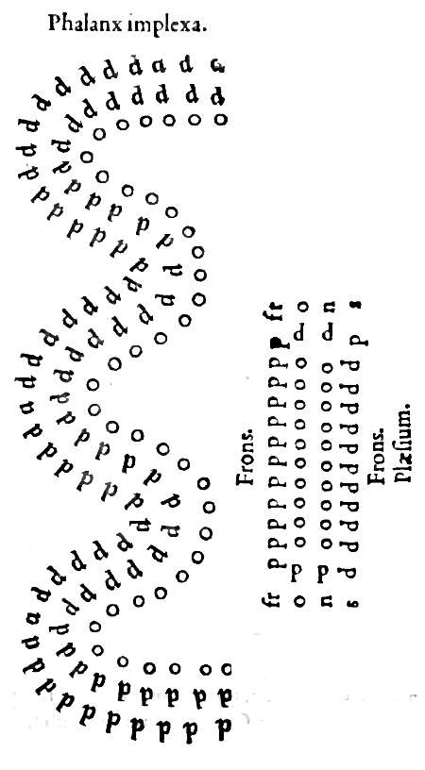

Phalangis circumuentio est, cum cornu vtrumque superat aduersarios, hoc est, excedit, & quasi complectitur.

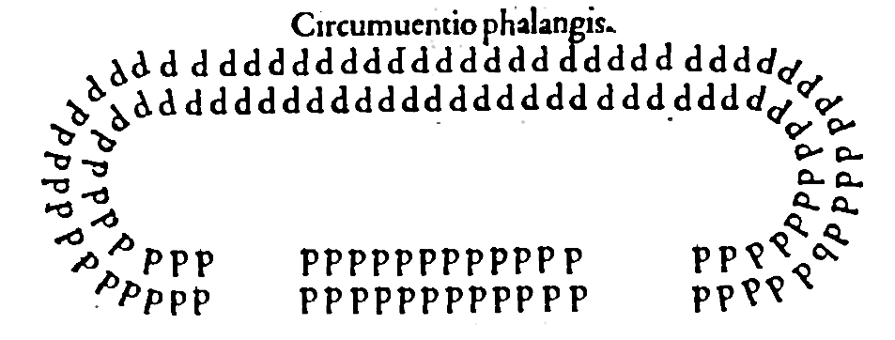

Alterius cornu circumuentio est, cum altero cornu hostem superamus. Vnde sit, vt qui sua phalange superat, idem etiam cornu superet aduersarium: qui autem cornu superat non propterea idem phalange superet. Fieri enim potest vt etiam paucioribus copiis hostem superes tuo cornu & complectaris.

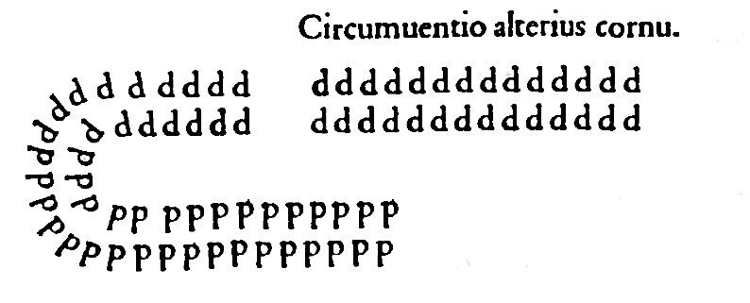
Extenuatio est cum altitudo phalangis contrahitur, vt cx xvi quibus constat hominibus redigatur in pauciores.
Impedimenta haberi in primis necessarium est, & ducem iis constituere probum conuenit. Modis quinque possunt duci impedimenta. Aut enim praecedent copias omnes, aut sequentur, aut in alterutro latere constituentur, aut in medio copiarum claudentur. Ponentur ante phalangem, si hostilem agrum ingredieris. Post phalangem, si latera metuis. Intra phalangem, si planum agmen placuerit ducere.

Postremo praecepta repetemus colligemusque omnia acierum instruendarum, si prius admonuerimus breuiter quicquid praecipi vsus exigat, id & breue esse & omni ambiguitate carere oportere, non enim solum celeritate est opus verum & claritate vocabuli, ne alii hoc, alii illud, & plerumque contrarium faciant.
Verbi gratia si dixeris, declina: verbo hoc audito possunt alii declinare in hastam, alii in scutum, quae res non parum inferret perturbationis. Cum itaque generis ac totius loco habeatur vocabulum illud, declina, adiungere debemus ad hastam, aut ad scutum, prout res exigit: & quidem ante, vt pars toti anteponatur hoc modo.
Ad hastam declinat ita enim omnes idem sine errore facient. Item immuta aut euolue, generis praefert communitatem: quam ob rem partem siue speciem praeponemus, vt in hastam immutare. Sic itaque praecipiemus, Laconicam euolue, Macedonicam euolue, Choreum euolue.
Nam si euolue Laconicam dixeris aut euolue Macedonicam, eueniet vt diuersae euoluendi agantur species. Hac igitur ratione cauendum est, ne quid ambigue, ne quid obscure incerteque praecipiatur: & vt species suis anteponantur generibus, seruandum omnino est. luuat porro ad eam rem plurimum silentium militum. Quocirca silendum in primis attendendumque imperabis: quod Homerus quoque poëta praeclare illis carminibus notat,

Sic argiua phalanx in praelia densa moueri
Assidue pariterque suos dux quisque regebat
Imperitans:.alii mox festinare silentes.
Dixeris haud tantas gentes sub pectore vocem
Condere, conspecti metuentes principis ora.
Barbarorum contra tumultum & turbam pecori ita comparat.
Ac veluti innumerae domini locupletis in aula
Ad mulctram coguntur oues, balatibus illae
Perculsae charae sobolis, voce omnia replent,
Sic Troum audiri per campos vndique clamor.
Et alibi eadem de re ita refert,
Tum Phryges ingenti strepitu & clamore seruntur,
More gruum passis liquido super aëre pennis.
Quae postquam gelidas hyemes hymbremque niualem
Fugere, Oceani repetunt clangoribus vndas.
Ait animos taciti spirantes ire Pelasgi,
Alter in auxilium alterius properare parati.

Age ad arma, adsiste ad arma, impedimenta a phalange secedant. Miles attendat praeceptis, suscipe, recipe, dista, erige spiculum, versa iuga, respice praecedentem, suam decuriam dirigat tergiductor. Constituta interualla conserua, ad hastam declina, collige, ita consiste, in arrectum redde, ad scutum declina, collige, ita consiste. Ad hastam immutare, collige. Ita consiste. Altitudinem duplica, restitue. Laconicam euolue restitue. Macedonicam euolue, restitue. Choreum euolue, restitue: ad hastam couerte, restitue ad hastam: inflecte, restitue. Haec de aciebus instruendis habui quae breuiter ad te scriberem, Imperator, tibi victoriam, hostibus profligationem allatura. Vale.

Finis Aeliani.
MODESTI LIBELLVS
DE VOCABVLIS REI MILITARIS,
ad Tacitum Augustum.

Res militaris in tres diuiditur partes, equites, pedites, classes. Equitum alas dicunt, eo quod ad similitudinem alarum ab vtraque parte protegant acies, quae vexillationes vocantur, ad velo quia velis, hoc est, flammulis vtantur.
Est & aliud genus equitum qui legionarii vocantur, propterea quod connexi sint legioni. Verum ipsi pedites in duas diuisi sunt partes, hoc est, in legiones, & in auxilia. Auxilia a fociis vel foederatis gentibus mittebantur.
Legio autem ab eligendo appellata est, quod vocabulum, eorum desiderat fidem atque diligentiam, qui milites probant. Producendi vero tyrones sunt semper ad campum, & secundum matriculae ordinem in aciem dirigendi, ita vt primo simplex & extensa sit acies, ne quos sinus, ne quas habeat curuationes, sed aequali legitimoque, spacio miles distet a milite: & praecipiendum, vt subito duplicent aciem, ita vt in ipso impetu is ad quem respondere solet, ordo seruetur.
Tertio praecipiendum, vt quadratam aciem repente constituant, quo facto in Tyronium quem cuneum vocant, acies ipsa vertenda est: quae ordinatio plurimum prodesse consueuit in bello. Auxiliares cum ducuntur ad praelium, ex diuersis locis & ex diuersis moribus venientes, nec disciplina inter se, nec notitia, nec affectione consentiunt: & alia instituta, & alius inter eos est: vsus armorum. Necesse est autem tarde ad victoriam peruenire, qui discrepant antequam dimicent.
Legionibus semper auxilia tanquam leuis armatura in acie iungebantur, vt in iis praeliandi magis adminiculum esset quam principale subsidium. In omnibus autoribus inuenitur singulos consules aduersum hostes copiosissimos non amplius quam binas duxisse legiones, additis auxiliis sociorum, tanta in illis erat exercitatio, tanta fiducia, vbi cuiuis bello duae legiones crederentur sufficere posse. Sciendum est enim, in vna legione decem cohortes esse debere: sed prima cohors reliquas & numero militum & dignitate praecedit: nam genere atque institutione literarum viros electissimos quaerit.
Haec enim suscipit aquilam, quae praecipuum signum in Romano est semper exercitu, & totius legionis insigne. Imagines Imperatorum, has enim imagines tamquam diuina & praesentia signa singuli venerantur. Habet pedites mille cv. Equites loricatos cxxxii: & appellatur cohors militaria: haec caput est legionis.
Ab hac enim cum pugnandum est, prima acies incipit ordinari. Secunda cohors habet pedites dlx. equites lxvi. & appellatur cohors quingentaria. Tertia cohors similiter habet pedites dlx. equites lxvi. sed in hac cohorte tertia validiores & probati milites, qui in media acie consistant. Cohors quarta, habet pedites dlv. equites lxvi. Cohors quinta habet pedites dlv, equites lxvi. Sed quinta cohors strenuos desiderat milites: quia sicut prima in dextro, ita quinta in sinistro ponitur cornu. Hae quinque cohortes in prima acie ordinatur.
Sexta cohors habet pedites dlv, equites lxvi. in prima quoque enucleati asscribendi sunt iuniores: qua in secunda acie post aquilam & imagines cohors sexta consistit. Cohors septima habet pedites dlv equites lxvi. Cohors octaua habet pedites dlv, equites lxvi: sed & ipsa animosos desiderat viros: quia in secunda acie consistit in medio. Cohors nona habet pedites dlv, equites lxvi. Cohors decima habet pedites dlv, equites lxvi & ipsa bonos consueuit accipere bellatores: qua sicut in secunda acie sexta dextrum, ita decima sinistrum possidet cornu. Iis decem cohortibus legio plena fundant, quae habet pedites vi mil. cv equites dccxxvi. Minor itaque, numerus armatoru in vnaquaque, legione esse debet. Maior aunt consueuit esse: & non tantum vna cohortem, sed etiam alias miliarias, si fuerit iussa, suscipere.
Tribunus maior per epistolam sacram Imperatoris iudicio destinant. Minor tribunus prouenit ex labore. Tribunus aunt vocatur ex tribu, quia praeest militibus quos ex tribu primus Romulus legit. Ordinarii dicutur, qui in praelio primos ordines ducunt. Aquiliferi qui aquilam portant. Imaginarii, qui Imperatoris imagines ferunt. Optiones ab optando appellari, quae antecedentibus aegritudine praepeditis, hi tanquam adoptati, cum eorum vicario solent vniuersa curare. Signiferi, qui signa portant, quos nunc draconarios vocant.
Tesserarii, qui tesseras per contubernia militum nunciant. Tessera aunt dicitur praeceptum ducis, quo vel ad aliquod opus, vel ad bellum mouetur exercitus. Torquarii duplares, torquariii simplares, quibus torquis aureus solius virtutis praemium fuit, quem qui meruisset, praeter laudem interdum duplam consequebatur annonam. Item primus hastatus duas centurias, id est, cc homines ducebat in acie secunda, quem nunc ducentarium vocat, princeps autem primae cohortis centuriam semis, hoc est, cl homines gubernat. Sic decem centurionibus regebatur, quibus magnae vtilitatis gratia magnus honor a veteribus est constitutus, vt centeri milites ex tota legione omni labore ac deuotione contenderent ad tanta premia peruenire.
Erant etiam centuriones qui singulas centurias curabat, qui nunc centenarii nominantur. Erant decani x militibus praepositi, qui nunc caput contubernii vocantur. Secunda cohors habet centuriones v. Similiter tertia & quarta, vsque ad decima cohorte.
In tota aunt legione erant centuriones lxvi. Sed legati Imp. (Imperatoris) ex consularibus ad exercitus mittebantur, quibus legiones & auxilia vniuersa obtemperabant in ordinatione pacis, vel necessitate bellorum, in quorum locum illustres viros constat magistros militum substitutos, a quibus non tantum binae legiones, sed etiam plures numero gubernantur.
Proprius aunt iudex erat praefectus legionis, habens comitiuam primi ordinis dignitatem, qui absente legato tanquam vicarius ipsius potestatem maximam retinebat: tribuni vel centuriones, caeterique milites eius praecepta seruabant vigiliarum siue profectionis.
Tesseras ab eodem petebant. Si miles crimen aliquod admisisset, authoritate praefecti legionis a tribuno deputabat ad poenam. Arma omnium militum, item equi, vestes, & annona ad curam ipsius pertinebant. Disciplina, seueritas, exercitus non solum peditum sed etiam equitum legionariorum praecepto eius quotidie curabatur. Primum signum totius legionis est aquila, quam aquilifer portat. Dracones etiam per singulas cohortes a Draconariis feruntur ad praelium. Sed antiquae qui sciebant in acie commisso bello celeriter ordines aciesque, turbari atque confundi, & ne hoc posset accidere, cohortes in centurias diuiserunt, & singulis centuriis singula vexilla constituerunt: ita vt ex qua cohorte vel quota esset centuria, in illo vexillo literis esset asscriptum; [quod] quidam intuentes vel legentes milites, in quemuis tumultum a contubernalibus suis oberrare non possent. Centuriones insuper qui nunc centurii vocantur, nimirum bellicosas loricas transuersis cassidum cristis, vt a suis facilius noscerentur, habebant: quique singulas gubernare iusserunt cateruas, vt nullus existeret error: cum cuncti milites sequerentur, non solum vexillum suum, sed etiam centurionem, qui signum habebat in galea. Rursus ipsae centuriae in contubernia diuisae sunt, vt decem militibus sub vno papilione degentibus vnus quasi praeesset decanus, qui caput contubernii nominatur. Contubernium aunt manipulus vocabatur, ab eo qui coniunctis manibus pariter dimicabant. Quemadmodum inter pedites centuria vel manipulus appellatur, ita inter equites turma dicitur: & habet vna turma equites xxxii.
Huic qui praeest, decurio nominatur. Pedites qui decem decadibus centuriae praeerant, ab vno centurione sub vno vexillo gubernantur. Similiter xxxii equites ab vno decurione sub vno vexillo reguntur. Praeterea centurio eligendus est, qui sit magnis viribus & procera statura, qui hastas vel missilia perite iaculetur, & fortiter.
Similiter eligendus est decurio, qui turmae equitum praeponitur, in primis habili corpore, vt loricatus & armis circundatus omnibus, cum summa admiratione equum possit ascendere, equitare fortissime, conto scienter vti, sagittas doctissime mittere, turmales suos, id est, sub cura sua equites positos erudire ad oina quae equestris pugna deposcit.
Nunc qualiter instruenda sit acies si pugna immineat, declaratur vnius legionis exemploque si vsus exegerit, transferri possit ad plures.
Equites locantur in cornibus. Acies peditum a prima cohorte incipit ordinari in cornu dextro, huic cohors secunda coniungitur. Tertia cohors in media acie collocatur, huic annectitur quarta. Quinta vero cohors sinistrum suscipit cornu, sed ante signa, & circa signa, necnon etiam in prima acie dimicantes principes vocabatur, hoc est ordinarii, caeterique principales. Haec erat grauis armatura, quae habebat cassides cataphractas, ocreas in cruribus, scuta, gladios maiores, quos spathas vocant, & alios minores, quos semispathas nominant, plumbatas quinas positas in scutis, quas primo impetu iaciunt. Item bina missilia, vnum maius, ferro triangulo vnciarum quinque, hastile pedum quinque semis, quod pilum vocabant, nunc spiculum dicitur, ad cuius iactum exercebantur praecipue milites, quod arte & virtute directum, & scutatos pedites & loricatos equites saepe transuerberat: aliud minus, ferro vnciarum quinque, hastili trium pedum semis, quidem tunc verriculum, nunc verutrum dicitur: prima acies principum, secunda hastatorum armis talibus dicetur instructa.
Sed in secunda acie dextro cornu cohors sexta ponebatur, cui iungebatur septima. Octaua cohors mediam acie tenebat, nona comitante. Decima cohors in secunda acie semper obtinet cornu. Instructionis vero lex est, vt in primo ordine exercitati & veteres milites collocentur, quos antea principes vocabat. In secundo ordine circundati cataphractis, & optimi milites cum spiculis vel lanceis ordinentur, quos prohastatos vocabant. Inter ordinem a tergo vallatum sex pedes distare voluerunt, vt haberent pugnantes spacium accedendi atque recedendi: vehementius enim cum saltu cursuque tela mittuntur. In his duobus ordinibus aetate maturi & vsu confidentes, & muniti grauioribus armis collocantur. Hi enim ad vicem muri nec cedere nec sequi aliu debent, ne turbentur ordines, sed aduersarios vehementes excipere, & stando pugnandoque repellere vel fugare. Tertius ordo disponitur de armatis velocissimis, de sagittariis iuuenibus, de bonis iaculatoribus, quos antea ferentarios nominabant. Quartus autem ordo constituitur de scutatis expeditissimis: de sagittariis iunioribus, de his qui alacriter se agunt verutis vel martiobarbulis, quas plumbatas nominant, qui dicebantur leuis armaturae.
Sciendum est ergo stantibus primis ordinibus, tertium, & quartum ordinem ad prouocandum cum missilibus & sagittis primo loco semper exire: qui si hostes in fugam vertere poterunt, ipsi cum equitibus persequuntur: si vero ab hostibus pulsi fuerint, redeunt ad primam & secundam aciem, & inter ipsas recipiunt se ad loca sua.
Prima autem & secunda acies cum ad machaeras, id est, spatas & pila (vt dicitur) ventum fuerit, totum sustinent bellum. In quinta acie ponebantur balistarii, funditores, tragularii, fustibulatores qui fustibalis lapides iaciunt.
Fustibalus est longus pedes quatuor, cui per medium ligatur funda de corio, & vtraque manu impulsus, prope ad instar onagri dirigit saxa. Sextus ordo post omnes a firmissimis & scutatis & omni genere armorum munitis bellatores tenebat, quos antiqui Triarios appellabant. Hi vt requieti & integri acrius inuaderent hostes, post vltimas acies sedere consueuerant.
Sed si quid in primis ordinibus accidisset, de eorum viribus reparationis spes tota pendebat. Omnes autem signarii, quamuis pedites sint, loricas minores accipiebant, & galeas ad terrorem hostium vrsinis pellibus tectas.
Centuriones vero habebant cataphractas, & scuta, & galleas ferreas, transuersis & argentatis cristis, vt facilius agnoscerentur a suis. Illud autem sciendum est & modis omnibus retinendum, quod commisso bello, prima ac secunda acies stabat immota. Triarii quoque residebant.
Ferentarii autem armatura leuis, & sagittarii, & funditores aduersarios prouocabant, ante aciem procedentes, si hostes fugare poterant, sequebantur: sed si eorum virtute ac multitudine premebantur, reuertebantur ad suos, & post eos stabant.
Excipiebat autem praelium grauis armatura, & tanquam murus (vt ita dicam) ferreus stabat, & non solum missilibus, sed etiam gladiis cominus dimicabant. Et si hostes fugassent, non sequebatur grauis armatura, ne aciem suam ordinationemque, turbaret, & dispersos recurrentes hostes in compositos opprimeret, sed leuis armatura cum funditoribus, sagittariis, & equitibus fugientes sequebatur inimicos.
Hac dispositione ac cautela sine periculo legio vincebat, aut superata seruabatur incolumis, quia legionis vis est facile nec fugere, nec sequi: sed ne milites aliquando in tumultu praelii a suis contubernalibus aberrarent, diuersis cohortibus diuersa in scutis signa pingebant.
Praeterea in aduerso vniuscuiusque militis erat nomen literis ascriptum, addito ex qua essent cohorte, quave centuria.
Ex his autem apparet legionem bene institutam quasi inuictissimam esse ciuitatem, quae omnia praelio necessaria secum vbique portaret: nec metueret repentinum hostium superuetum, quae etiam in mediis campis subito fossa valloque muniretur.
Habet praeterea legio tubicines, cornicines, buccinatores. Tubicines ad praelium vocant milites, & rursus receptui canunt. Cornicines quoties canunt, non milites sed signa ad eorum obtemperant nutum. Ergo quoties ad aliquod opus exituri sunt soli milites, tubicines canunt: quoties mouenda sunt signa, cornicines canunt. Classiarii autem appellantur buccinatores qui cornu ducunt exercitum: hoc insigne videtur imperii, quia classicum canit in parte praesente vel cum in militem capitaliter a inaduertitur.
Hoc enim ex imperialibus legibus fieri necesse est. Siue ergo ad vigilias vel ad gratias faciendas siue ad opus aliquod vel ad cursionem campi exeunt milites tubicine vocante operantur. Rursus Tubicine admonente cessant. Cum autem mouentur signa aut iam mota figenda sunt: Cornicines canunt. Quod ideo in omnibus exercitiis & processibus custoditur ut in ipfa pugna facilius obtemperent milites siue eos pugnare siue stare siue sequi vel redire praecipiunt Duces.
Si quidem ratio manifesta est semper in acie debere fieri quod necessario faciendum uidetur in praelio. De singulis centuriis quaterni equites & quaterni pedites excubitum nocte faciunt
Et qua impossibile uidebat in speculis uigilantes singulos permanere ideo in iiii pedites ad desideris sunt diuise uigiliae ut non amplius que tribus horis nocturnis necessarium sit uigilare. A tubicine omnes uigiliae committuntur & finitis horis a cornicine reuocant. Constructa acie peditum equites ponuntur in cornibus ita ut loricati omnes & contecti iuncti sint pedibus. Sagictarii autem vel qui loricas no habent longius euagentur a fortioribus nanque equitibus peditum protegenda sunt latera & a uelocioribus atque ex peditis hostium cornua semper fundenda atque turbanda.
Scire dux debet contra quos hoc est globos hostium quot equites oporteat poni. Nam nescio qua occultatione immo paene diuina alii contra alios dimicant melius & qui fortiores uicerant ab inferioribus saepe uincuntur: Quod si equites impares fuerint more ueterutus uelocissimi cum scutis leuibus pedites ad hoc ipsum exercitati iisdem miscendi sunt, quos ex peditos quasi uolitantes uelites nominabant.
Quo facto quauis fortissimi equites hostium euenerint tamen aduersus mixturis agmen pares esse non possunt. Vnum hac remedium omnes duces ueteres inuenerunt ut asuescere facerent iuuenes currentes egregie & inter binos equites singulos ex his pedites collocarent cum leuioribus scutis gladiis atque missilibus. Elephanti in praelis magnitudine corporis barriti horrore formae ipsius nouitate homines equos quae conturbant hos conntra Romanum exercitum primus in Lucania rex Pyrrhus eduxit: postea Hannibal in Aphrica: rex Antiochus in Oriente: lugurta in Numidia copiosos habuerunt aduersus quos diuersa cogitarunt genera armatorum. Nam Centurio in Lucania gladio manum quem promuscidem uocant uni abscidit: & bini cataphracti equi iungebantur ad currum quibus insidentes anclenassarissas hoc est longissimos contos in elephantos dirigebant. Alii contra elephantos cataphractos milites immiserunt ita ut in brachiis coris vel in cassidibus vel humeris aculei ingentes ponerentur ex ferro ne Elephas bellatorem contra se uenientem posset apprehendere. Praecipue tamen antiqui uelites aduersus elephantes ordinauerunt. Velites autem erant iuuenes leui armatura corpe alacri qui ex equis optime missilia dirigebant hi equis praecurrentibus ad latiores lanceas vel maiora spicula heluas occidebant: Sed crescente audacia postea collecti plures milites pariter pila id est missilia in elephantes congerebant eosque vulneribus elidebant illud additum est ut funditores cum fustibalis & fundis rotundis lapidibus destinatis in illos per quos regebantur elephantes cum ipsis turribus affligerent atque mactarent, quo nihil tutius inuenitur, postea venientibus beluis, quasi irrupissent aciem, spacium milites dabant: quae cum in agmen medium peruenissent, circumfusis vndique armatorum globis, a magistris militum absque vulneribus capiebantur illaesi.
Sed optima ratio est, & ad victoriam plurimum confert, vt lectissimos de peditibus equitibusque, cum vicariis comitibus, tribunisque vacantibus habeat dux post aciem in subsidiis praeparatos, alios circa cornua, alios circa medium, vt sicubi hostis vehementer insistit, ne rumpatur acies, prouolent subito, & suppleant loca, additaque virtute, inimicorum audaciam frangant. Huius cautelam primi Lacones inuenerunt, imitati Chartaginenses.
Alteram post haec vbique seruarunt: hac dispositione nulla melior inuenitur. Nam directa acies hoc solum agere debet, petere vt hostem repellat, aut fundat. Si cuneus sit agendus, aut forfex, superfluos habere debebit, de quibus cuneum forficemque faciens ducenda sit. Gnauiter ex abundantibus ducitur. Nam si de loco suo ordinatum militem transferre coeperis, vniuersa turbabis. Quod si bellatorum copia tibi non abundat, melius est habere aciem breuiorem, dummodo in subsidiis colloces plurimos.
Cum explorator hostium latenter oberrat in castris, omnes ad tentorium suum per diem redire iubeantur: statim deprehenditur explorator. Cum consilium tuum cognoueris aduersariis proditum, dispositionem mutare te conuenit. Raro enim manet absconditum, quod ad notitiam multitudinis iam peruenit Fieri quid debeat tractato cum multis: quid vero facturus sis, cum paucissimis ac fidelissimis, vel potius ipse tecum. Haec Martii operis praecepta per diuersos autorum libros dispersa, Imperator inuicte, mediocritatem meam abbreuiare iussisti, ne vel fastidium nasceretur ex plurimis, vel plenitudo fidei deesset in paruis.
Neque enim degenerauit in hominibus Martius calor, nec defectae, sunt terrae, quae Lacedaemones, quae Athenienses, quae Marsos quae Samnites, quae Pelignos, quae ipsos progenuere Romanos. Nonne Epiri armis plurimum aliquando valuerunt. Nonne Macedones ac Thessali superatis Persis, vsque ad Indiam bellando penetrarunt. Dacos autem & Mysos & Traces inter bellicosos semper fuisse manifestum est, vt ipsum Martem fabulae apud eos natum esse confirment.
Longum est si vniuersarum prouinciarum vires enumerare contendam, cum omnes in Romani imperii ditione consistant. Sed longa securitas pacis homines partim ad delectationem ocii, partim ad ciuilia traduxit officia: ita cura exercitii militaris primo negligentius agi, postea dissimulari, ad postremum olim in obliuionem perducta cognoscitur.

FINIS.



opportet.
subiecisse.
vindicando.
quam rudis.
cominus habere.
que res.
Quintius Cincinnatus dictator.
imbuuntur.
alacritas.
Salusti in Catilimar.
Marii diligentia.
Tydeus armis.
Ex Vergilii iiii. Georgico.
electus.
electio.
indicti.
Scriptores rei militaris.
Pompeii exercitium.
Campus Martius.
Galearii.
Paloroum vsus.
Veterum consuetudo.
Catonis sententia.
Claudii iaculatores.
Aphricani iaculatores.
Balearibus funda primo reperta.
Martiobarbuli.
mutuati.
capitibus.
mirus Murus pedestris excratus.
Triarii.
Pila.
Bebrae.
Praetoria porta.
Decumana porta.
egesta.
constituendus.
dimicandum in terra hostis.
exercitii.
xx excursu annorum.
sit.
timore.
iussum.
gessi.
alii alacres.
Vexillationes.
Equites legionarii.
Classium duo genera.
Exercitus
Peditum duo genera.
Phalanges Cursus.
Legio.
Auxiliares.
Legionariis armatura.
posit cum.
matora.
Cato rei militares scriptor.
pictis.
puniceis.
Militiae sacramenta.
hac etiam.
Legio plena.
Principia
Tribunus.
Ordinarii.
Augustales.
Flauiales.
Aquiliferi.
Imaginarii.
Optiones.
Signiferi.
Tesserarii.
Tessera quod.
Campigeni.
Metatores.
Beneficiarii.
Librarii.
Tubicines, Cornicines, Buccinatores.
Armaturae.
Mensores.
Torquati.
Canditati.
Munificies.
Centurio primipili.
Primus hastatus.
Ducenarius.
Princeps primae cohortis.
Hastatus secundus.
Triarius prior.
Centuriones
Centenarii.
Decani.
Caput contubernii
Praefectus legionis.
serratur.
dimicationem
Aquila.
Dracones.
Vexillia.
Centenarii.
transuersis.
Decanus.
Manipulus.
Turma.
Decurio.
Turmales.
Principes.
Spatha.
Semispatha.
Pilum.
Spiculum.
Verriculii.
Ferentarii.
Scutati.
Funditores.
Tragularii.
Triarii.
quod.
Dogmata.
instructam.
notuit.
Schola militares.
Accensi.
Supernumerarius.
Depositarii signiferi.
Primipili centurio.
Primicerius.
Cornices & buccinatores.
Classicum.
Ad palum exerceri.
Scopa.
Harpagones.
Lupi.
Lacedaemoniorum circa bellum cura.
Xanthippus rei militaris peritus.
Hannibal rei militaris studiosus.
Exercitus.
Exercitus Romani.
tempore.
paludosis.
verum.
Annonaria species.
transiliendas
Signa vocalia
Tessera mutuanda.
Signa semiuocalia.
Tuba.
Buccina.
Cornu.
Signa muta.
Itineraria.
Calones Galearii.
interponendi.
Subsessa.
quam.
colligatosque fecum fasces, pertrahunt ad socios.
Monoxyli.
Cespes.
semis pedem.
Statiua castra.
Praetorium
Vigilia.
Circuitores.
Circitores.
Angaria.
Castellum ad castris.
Lacedaemonii.
Persarum mos in fossis ducendis.
superauit.
Tigurinorum.
magnitudo.
Formido.
Quibus dux exercitum monueat.
Remedium in formidine militum.
expandere.
Grumi.
Velites.
inordinatum
Cuneus.
Caput porcinum.
Forfex.
Serra.
Globus.
medium,
Tribulus.
Pyrrhus elephantos primus in Italiam duxit.
Promuscis.
Sarissa.
Velites.
in hos.
Carrobalista.
Colligere campum.
exhibita.
Respublica
vericrentur.
non poterit.
portus.
Mulierum Romanorum crines.
Burgus.
Falx.
Aries.
cattos.
Plutei.
cassidis.
Musculi.
Malleoli.
Phalarica.
Rhodiorum astutia.
Capaneus.
Sambuca.
Exostra.
Tolleno
Balista.
Onager.
Scorpiones.
Cuniculus.
Loricula.
Nauarchi.
Nauicularii.
Liburnia.
Religio pro aeternitate.
mercantur.
Color venetus.
Circius siue corus.
caecias.
Natalis nauigationis
Prochemasis.
Epichemasis.
Metachemasis.
Intermedios
Rheuma.
remigum.
Asser.
Falx
Bipennis.
Trium librorum divisio.
Id est, gestascu consilia militaria.
Tyriestem.
vereri se ne tuba id audiet.
signatae.
agmina imminere.
subsidioni.
captiuos lateri.
aditum.
Autophrates.
assecutus.
cursu in
proras cesserunt
Munichie.
similibus
confudit
rustratus
Besbio / Vespio
Glodium
Darius
certos
certa
ultima
sufferre
Latina
consternentur
voluisset
Samnium
suspectatione praeliis
virum
Liv. Lib. 7. ab urb. con. CL. Martium Ruti. habet.
Prope
accesserunt
singula
Scorio
decimam cogeret, & caeteros puderet
locum
ante coniectum
magam
Scythia
Indis
auxiliatoribus
militibus
iustum
issent
decernendi
Aegospotamum
Mumistronem
Parmenes
Barbaros
recta
pernicitat
eum postsignanis
Palestrialis alias, palaepharsali
diducerent
Agellius
Calliodromiacolis
Calamatium Castrum & Tanonicum
Acies
Tomyria
Hannibal
citarent
campestribus
Cantemnam
commutatis
vbi
peditum
Praediuinasset
auersum
confirmauit
auxiliaribus
per relegatos
idonis
Natames
aduersum
toleraturi
quod
enim
Catinenses
Lucio
Gratia restitudo
Galliorum
Chares
fusi essent
eique insectandae
reliquo
a ventisque mutari
Lucriam
expressit
Sueda
Carmeade
Phiades
Delminum
Illyrios
Trenassum
frequentatum
consulto
gladiisque
firmissimas
penetratii
absistebatur
finxit
acerbis
Lartha
admissurus
Portam
miserunt
auersam partem inflixerunt
Cyzicenos
Scultenam
Aregua
delicere
instructis
occiderunt
dicitur pollicitus
compressi
didiacum alias rhyndacum
necessarius nequaquam eris
Sacramento rogari
Muli Mariani
Fatuentum
omnibus
distinctamque
Numeroque rescinderetur
punctauit
correcta
nocabat
sacculo
numerare uellet
deductum
reiecisset
sperandi
dirupit
fuissent
spatulis
suos
Illeigetum
vndique
Quin. Sertorium
Homerus
Pedites & vectores
Armati gravis armatura
Velites
Peltati
Pelta
Leuis armatura.
Equestres copiae
Cataphracti
Hastati & contati
Ferentarij
Scythae
Tarentini
Decuria
id est, sectura ipsa dimetiens
Phalanx
Chiliarchiam
Chiliarchos
leuii cornu
Macedonica phalanx
Sarisse macedonicae
Tergidux superordinarius
Superordinarii.
Quadrata acies.
laxitatem
ζυγαρχίαμ
xcvi
Phalangarcha
Declinatio
Declinatio in scuti & in hastam
Reuersio anastrophe
Inflexio ζῠερισπασμός
Versare
Iugare
Reddere in arrectum
collabi simul omnia possunt
Amphippi
professionis
Martis patria.

