 | IpRed | IpRouter | MASCARA | IP Min | Ip Max
LAN A | 162.168.0.0/24 | 192.168.0.254 | 255.255.255.0 | 192.168.0.1 | 192.168.0.254
LAN B | 192.168.1.0 /28 | 192.168.1.14 | 255.255.255.240 | 192.168.1.1 | 192.168.1.14
LAN C | 192.172.0.0 | 192.173.255.254 | 255..254.0.0 | 192.172.0.1 | 192.172.255.254

LAN A
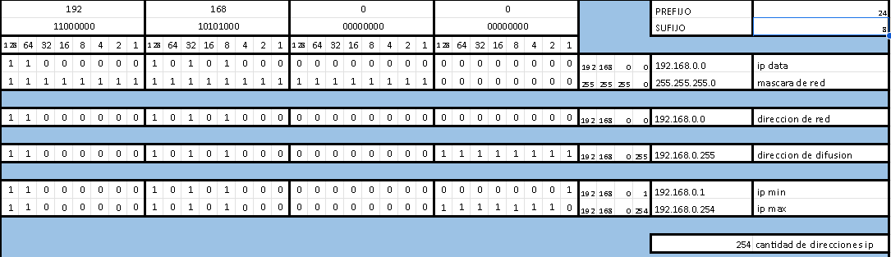
LAN B
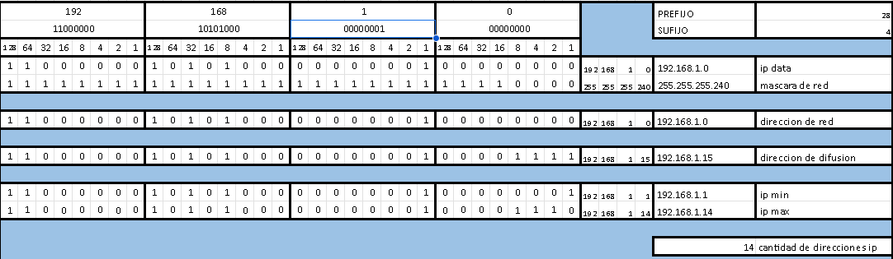
LAN C
