Test Documentation — Vehicle Washing Management System

Cover Page
Table 1
Document identification data
Field | Value
Project | Vehicle Washing Management System (Vehicle Washing / LavaRápido)
Deliverable | Test documentation (section 2.5.4)
Program | Software Analysis and Development Technologist (ADSO)
Group (ficha) | 3145556
Apprentices | Brayan Estiven Patiño Cabrera, Juan Camilo Guilombo Osorio, Merari Urbano
Instructor | Karol Daniela Correa
Training center | Industria
Date | October 19, 2026
This document gathers the test plan, the inventory of automated tests in the repositories, their actual results when run on October 19, 2026 (including the end-to-end, performance, and responsive design tests against the complete system), and the 42 functional test cases, run the same day, traced to the SRS v7.4 requirements (lavarapido-docs/01_INFORME_DE_ESPECIFICACION_DE_REQUISITOS). Its structure follows the ISO/IEC/IEEE 29119-3 standard for test documentation (International Organization for Standardization [ISO], 2021). No result in this document is assumed.

1. Test Plan

1.1 Scope
The web application, the mobile application, and the seven backend services on their develop branch are tested. Offensive security testing is out of scope; load is only checked through the RNF-001 response time measurement.

1.2 Test Types and Tools
Table 2
Test types, actual tool, and where each applies
Type | What it verifies | Tool | Where
Domain unit tests | Rules of entities and value objects (states, validations) | JUnit 5 (spring-boot-starter-test); xUnit 2 | src/test/.../domain in Java; tests/PaymentService.Domain.UnitTests
Application unit tests | Use cases with in-memory repositories (test doubles) | JUnit 5 with fakes (Fakes.java, InMemory*Repository); xUnit with InMemoryPorts.cs | application/usecase and PaymentService.Application.UnitTests
Web integration (controller + security) | Routes, HTTP status codes, JWT, and roles with MockMvc | spring-boot-starter-webmvc-test, spring-security-test | *ApiWebTest.java, ApiSecurityWebTest.java, AdminNotificationControllerTest.java
Gateway route integration | Each public route reaches its service | Spring Boot Test | GatewayRoutesTest.java
Persistence integration | EF Core mapping against a real SQL Server | xUnit + DatabaseFixture | PaymentService.Infrastructure.IntegrationTests (requires a database)
Web UI unit tests | Angular components, guards, and services | Vitest 4 + jsdom (@angular/build:unit-test) | Web/src/**/*.spec.ts
Functional / acceptance | End-to-end flows per role against the deployed system | Manual, with Postman or Swagger UI for the API and a browser / Expo Go for the UI | Cases CP-01 to CP-33 (section 4)
Cross-service (end-to-end) and RNF | Booking with operator choice and automatic assignment, complete flow of the three roles, inspection report, access rules per role; 95th percentile response time (RNF-001); web screens at 360 px (RNF-008) | Node 24 (node:test and fetch) and Playwright Core with headless Edge | lavarapido-infra/e2e
Note. Tools documented in JUnit (n.d.), xUnit.net (n.d.), and Vitest (n.d.).

1.3 Environment
Table 3
Execution environment for the tests (October 19, 2026)
Item | Version
Operating system | Windows 11 Home Single Language 10.0.26300
Node.js / npm | 24.14.0 / 11.9.0
JDK | Java 25.0.4 (the projects compile for Java 21) with each service's Maven Wrapper
.NET SDK | 9.0.306; the project targets net8.0 and the tests were run with DOTNET_ROLL_FORWARD=Major
Database and messaging | SQL Server 2022, RabbitMQ 4.3, and Mailpit on Docker 28.4 (Docker Desktop). The unit tests do not need them; the 7 payment persistence tests used an isolated database, LavaRapidoPaymentIT, created with the same changelogs
Services | The six services and the gateway running on the machine (./mvnw spring-boot:run and dotnet run) against that infrastructure; email went to Mailpit so no real person was written to. The web with ng serve and the mobile app with npx expo start --web

1.4 Criteria
- Passed: the actual result matches the expected one.
- Failed: the result differs; the error is recorded.
- Blocked: could not run because a dependency was missing (for example, the database).
- Exit: the release is accepted when the automated suites pass and the high-priority functional cases are passed.

2. Automated Test Inventory
The repositories have 550 test methods: 507 in the backend and 43 in the web. The mobile app has no automated tests; it is checked with the TypeScript build and the screen walk-through (section 3.2).
Table 4
Tests per artifact (count of @Test/@ParameterizedTest, [Fact]/[Theory]/[IntegrationFact], and it())
Artifact | Files | Methods | What they cover
api-gateway | 1 | 8 | Routing of each /api/v1/** prefix to its service, and that /internal/** is not exposed by the gateway (GatewayRoutesTest)
security-service | 17 | 135 | Registration, sign-in with lockout after failed attempts, password recovery, profile and address, user administration and role change, roles and permissions, preferences, value objects, password policy, JWT issuing and HTTP security by role (ApiSecurityWebTest)
customer-service | 6 | 50 | Customer account, license plates, vehicle CRUD, security.user_registered listener and web API
booking-service | 7 | 43 | Booking life cycle, availability and the reason a time is not available, bays (ServiceBayTest), catalog, business data (EstablishmentTest), preferred operator in the event and web API
operations-service | 11 | 55 | Manual and automatic assignment, free operators, start window, execution, rating, absences, operator metrics, team summary, operator profile, inspection report and web API
notification-service | 12 | 106 | Notification use cases, message factory per event, notices in the account's language, reminders, alerts for bookings without an operator, new version notice, device tokens and admin controller
payment-service (.NET) | 9 | 110 | Payment and receipt, reused reference, history with filters, promotions, loyalty points, payment policy, command and query services, and 7 persistence tests against SQL Server
Web (Angular) | 37 | 43 | Creation of components, guards and services (should create smoke tests), API error messages, and payment account selection
Mobile | 0 | 0 | No automated tests
Note. Support files (Fakes.java, InMemory*.java, InMemoryPorts.cs, DatabaseFixture.cs) are not counted as tests. The 7 payment persistence tests skip themselves when the PAYMENT_INTEGRATION_DB variable is not set (DatabaseFixture.cs:16-21).
Backend tests are domain and application tests with in-memory doubles, plus controller tests with MockMvc. Most web tests check that each component is created; api-error.spec.ts and payment.spec.ts test real rules (the API error messages and the payment account selection).

3. Execution Results
On October 19, 2026, with the develop branch of the ten repositories updated that day, the eight automated suites were run: 655 tests, all passed and none skipped. This time the 7 payment persistence tests also ran, against the isolated LavaRapidoPaymentIT database.
Table 5
Actual results per artifact (October 19, 2026)
Artifact | Command | Run | Passed | Failed | Skipped | Duration
Web (Angular) | npx ng test --watch=false | 43 | 43 | 0 | 0 | 6.7 s
api-gateway | ./mvnw test | 34 | 34 | 0 | 0 | 12.2 s
security-service | ./mvnw test | 151 | 151 | 0 | 0 | 9.7 s
customer-service | ./mvnw test | 69 | 69 | 0 | 0 | 7.4 s
booking-service | ./mvnw test | 43 | 43 | 0 | 0 | 6.8 s
operations-service | ./mvnw test | 55 | 55 | 0 | 0 | 7.6 s
notification-service | ./mvnw test | 112 | 112 | 0 | 0 | 0.6 s
payment-service: domain | dotnet test PaymentService.sln | 113 | 113 | 0 | 0 | 0.3 s
payment-service: application | (same command) | 28 | 28 | 0 | 0 | 0.4 s
payment-service: integration | (same command, with PAYMENT_INTEGRATION_DB) | 7 | 7 | 0 | 0 | 2 s
Total |  | 655 | 655 | 0 | 0
Note. Sources: Vitest output, the ./mvnw test summary (Tests run:) and the surefire reports of each Java service, and the dotnet test output. Maven durations add up the time of the test classes, without the build. More tests run than there are methods in Table 4 because parameterized tests (@ParameterizedTest, [Theory]) run once per data item. In customer-service the tests attribute of the surefire XML says 68 because of a nested test class; Maven runs and counts 69, which is the right number (the previous version of this document had taken 68).
Figure 1
Result of the Java service tests (October 19, 2026)
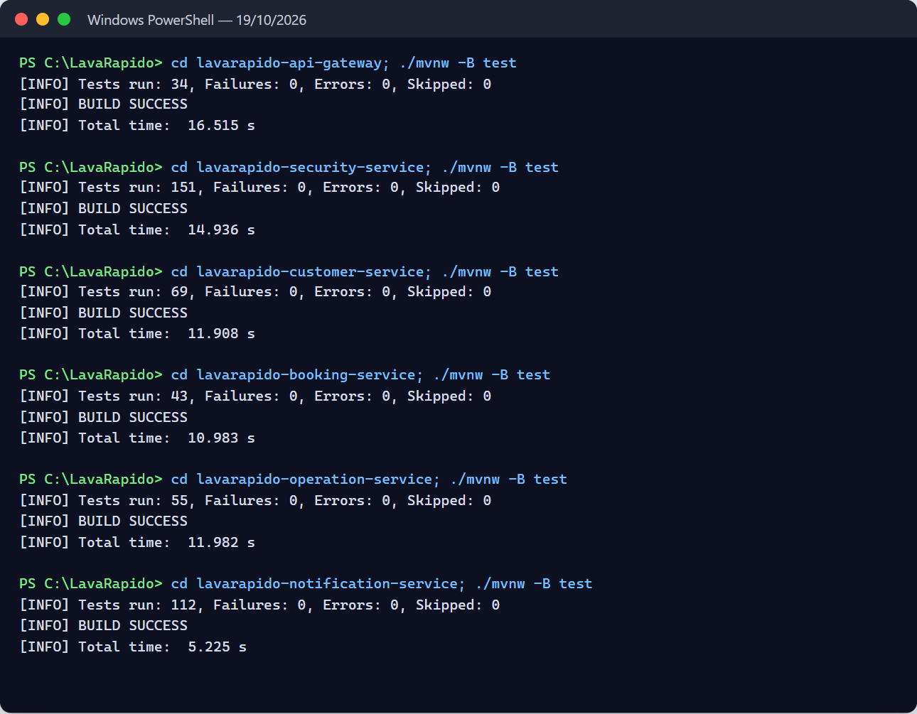
Figure 2
Result of the payment-service tests, including the persistence ones
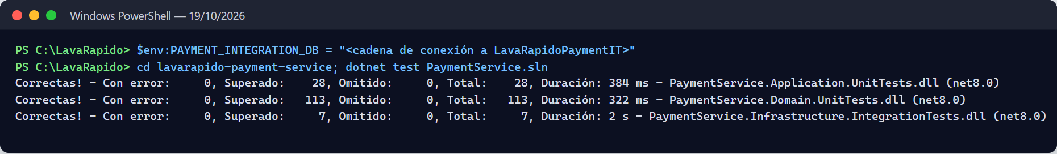
Figure 3
Web tests and production build, and TypeScript build of the mobile app
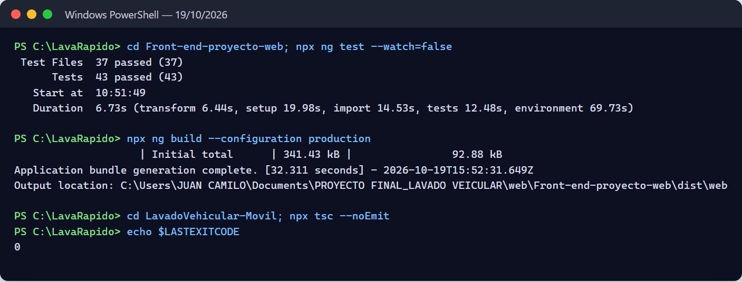
Execution remarks:
- The line ERROR ... Could not send the password recovery email: SMTP down in the security-service log is caused on purpose by EmailResetCodeNotifierTest, which simulates a down SMTP server. It is not a failure.
- Vitest shows a build warning: src/test-providers.ts is not in the tsconfig. It does not affect the results.
- The run used JDK 25 and .NET SDK 9 on projects for Java 21 and .NET 8. GitHub Actions runs the same tests with Temurin 21 and .NET 8 on every change (Deployment Document).

3.1 End-to-End Tests
On October 19, 2026, node --test "e2e/*.test.js" was run from lavarapido-infra, with the complete system running and E2E_OPERATOR_ID=2 (the test operator of the local database). The 19 tests passed in 11.2 s. Each test deletes what it creates and leaves the customer's points as they were.
Table 5a
End-to-end tests (October 19, 2026)
File | Tests | What it walks through | Result
access-rules.test.js | 7 | Permissions by role and internal routes, profile address, payment history filters, tax data only for the administrator, operator profile, time outside opening hours (reason: OUTSIDE_HOURS), and the token of an account that does not exist | 7 passed
booking-flow.test.js | 5 (1 + 4 subtests) | Booking choosing an operator, automatic assignment through RabbitMQ, customer notices, day summary, and internal routes outside the gateway | 5 passed
full-flow.test.js | 6 (1 + 5 subtests) | Booking → reported payment → approval with points → service start and finish → rating, checking each notice | 6 passed
inspection-flow.test.js | 1 | Inspection report with findings and photos, publishing, customer notice, and public link | 1 passed
Total | 19 |  | 19 passed
Figure 4
Output of the end-to-end tests
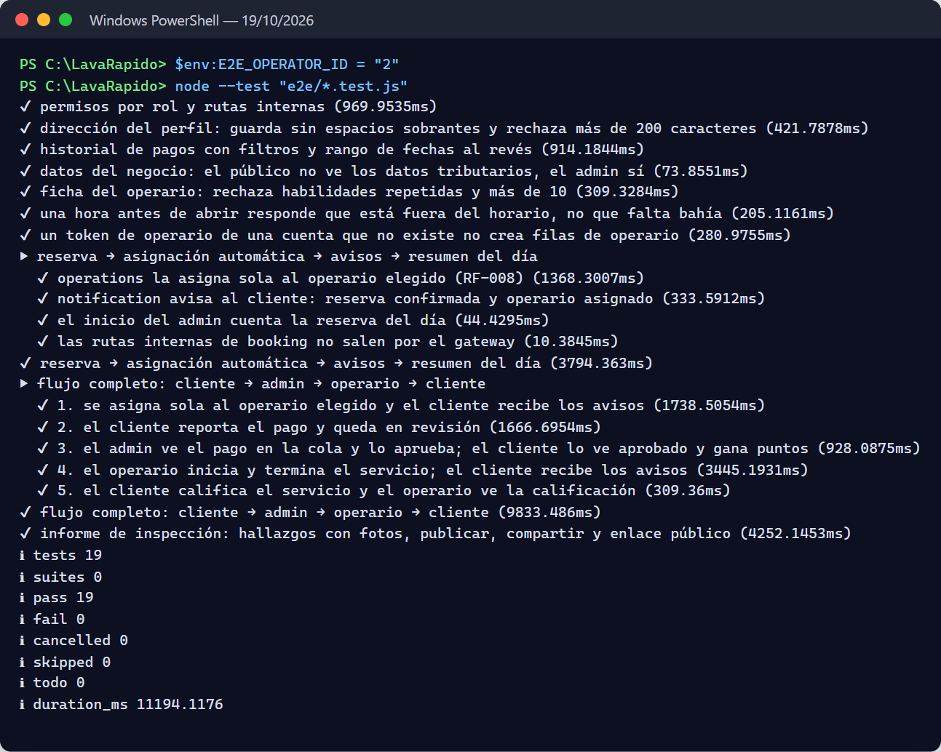

3.2 Performance and Responsive Design
The same day, the response time of the most used reads (NFR-001) was measured with node e2e/performance.js: 30 requests per endpoint through the gateway. All of them were far below the 2 s limit at the 95th percentile.
Table 5b
Response time per endpoint (NFR-001, October 19, 2026)
Endpoint | p50 | p95 | Maximum
Public catalog | 16 ms | 19 ms | 19 ms
Public opening hours | 9 ms | 10 ms | 11 ms
My bookings (customer) | 39 ms | 49 ms | 55 ms
My payments (customer) | 40 ms | 46 ms | 46 ms
My notices (customer) | 14 ms | 17 ms | 18 ms
Day bookings (administrator) | 15 ms | 19 ms | 20 ms
Day summary (administrator) | 18 ms | 39 ms | 41 ms
Operators (administrator) | 27 ms | 43 ms | 43 ms
Figure 5
Response time measurement
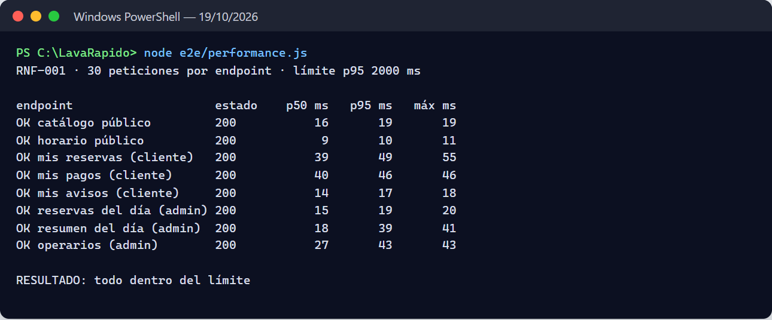
For responsive design (NFR-008), Playwright (headless Edge) went through the screens of the four web groups (public, customer, operator, and administrator) at 360 and 768 px, with the suite's width-360.js script and a check that also looks for elements past the right edge outside a container with its own scrolling.
Table 5c
Responsive design check (October 19, 2026)
Test | Scope | Result
Web at 360 px (e2e/width-360.js) | 12 screens: public, customer, and administrator | None goes beyond 360 px
Web at 360 px | 33 screens: 4 public, 8 customer, 9 operator, and 12 administrator | None scrolls sideways or cuts content; no page errors or 5xx responses
Web at 768 px | The same 33 screens | None scrolls sideways or cuts content
Mobile app at 360 px (npx expo start --web) | 15 screens: the five of the bottom menu of each role (customer, operator, and administrator), with temporary accounts deleted at the end | None scrolls sideways; no page errors
Build | npx ng build --configuration production (web) and npx tsc --noEmit (app) | No errors
Figure 6
Check of the web screens at 360 px
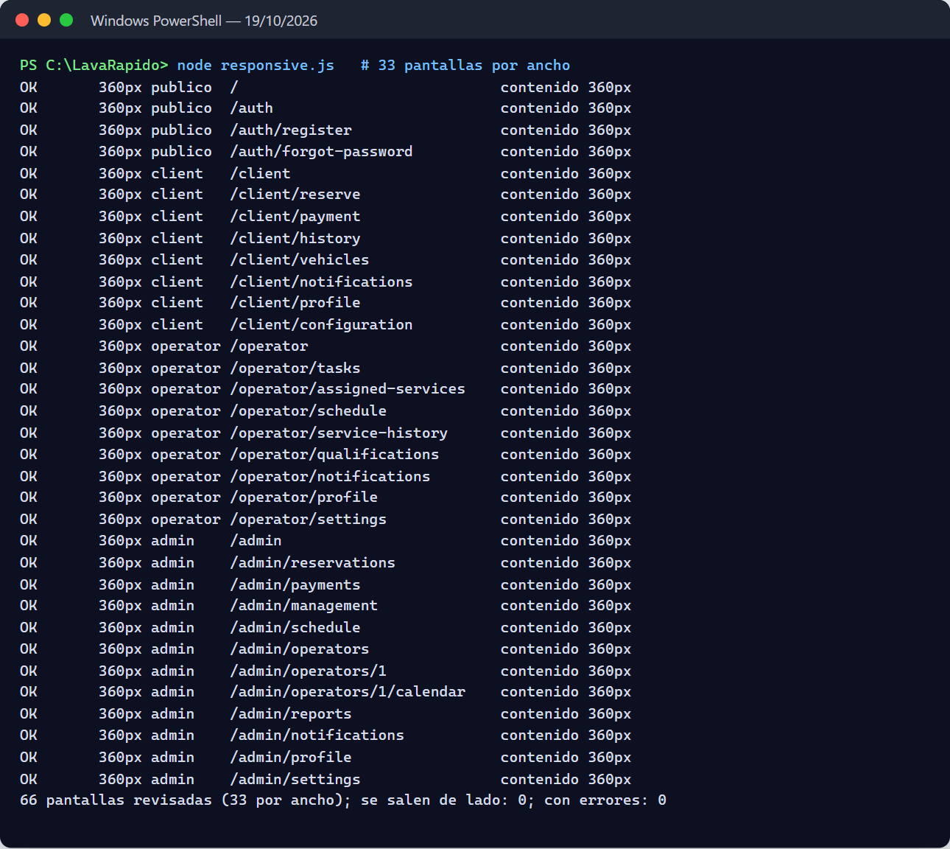
Note. Taking or picking photos with the phone camera and gallery cannot be automated in this test; it remains to be tested on an Android device.

4. Functional Test Cases
Cases CP-01 to CP-33 were defined on SRS v4 and first run on October 9, 2026; cases CP-34 to CP-42 cover the requirements implemented afterwards (RF-004b, RF-008, RF-010, RF-015, RF-022, RF-036, RF-037, and RF-038) and the role change of RF-028. All 42 were run on October 19, 2026, against the full system through the API Gateway (the same calls the web and mobile clients make), with a script that creates its own accounts and data and deletes them at the end. All 42 passed (Figure 7).
Table 6
Functional test cases
ID | RF | Case | Precondition | Steps | Data | Expected result | Actual result | Status
CP-01 | RF-001 | Successful customer sign-up | Email not registered | Sign up and log in | ID, name, phone, new email, and valid password | Account created with the CLIENT role; the profile is created in customer-service | Sign-up 201; sign-in 200 with the CLIENT role; customer profile created in customer-service | Passed
CP-02 | RF-001 | Sign-up with a duplicate email | The email already exists | Sign up with the same email | Email from CP-01 | "Email already registered" message; no account is created | 409 EMAIL_ALREADY_REGISTERED; there is still one account with that email | Passed
CP-03 | RF-002 | Login by role | CLIENT, OPERATOR, and ADMIN users | Log in with each one | Valid credentials | Redirects to /client, /operator, or /admin by role | The three sign-ins return 200 with the CLIENT, OPERATOR, and ADMIN roles; the web redirects by that role | Passed
CP-04 | RF-002 | Wrong credentials | — | Log in with a wrong password, then with a nonexistent email | Two attempts | Same generic message in both; it does not reveal whether the email exists | Both: 401 INVALID_CREDENTIALS (same response) | Passed
CP-05 | RF-003 | Recover password | Registered user; Mailpit running | Request a code, read it in Mailpit, verify it, and set a new password | 6-digit code | Password changed; login with the new one works | 6-digit code read in Mailpit; verification 204; change 204; sign-in with the new password 200 | Passed
CP-06 | RF-003 | Code locked after attempts | Code requested | Enter 5 wrong codes, then the right one | 5 invalid codes | The right code is no longer accepted | The 5 wrong codes: 400; then the right one too: 400 INVALID_RESET_CODE | Passed
CP-07 | RF-004 | Password change with a wrong current password | Logged in | Change the password with the wrong current one | Wrong current password | "Incorrect current password" error; nothing changes | 400 INCORRECT_CURRENT_PASSWORD; the previous password still works | Passed
CP-08 | RF-005 | Create a booking | Customer with an SUV | Choose vehicle, Basic service, a free date and time | SUV, Basic | Booking created; price COP 23,000 (seed price of Basic for SUV) | Booking created (201) with a total of $23,000, the seed price of Basic for SUV | Passed
CP-09 | RF-006 | Time slot taken | Active bays of a slot booked | Book the same slot until it is full | Several customer vehicles | The booking is not saved; up to five alternative times on the same day are offered | Three bookings took the three active bays; the fourth: 409 SLOT_UNAVAILABLE (NO_FREE_BAY) with 5 alternative times | Passed
CP-10 | RF-007 | Cancel a booking before it starts | Booking CONFIRMED | Cancel with a reason | Reason CUSTOMER_REQUEST | Booking is CANCELLED with the reason stored | 200, booking CANCELLED with the reason CUSTOMER_REQUEST stored | Passed
CP-11 | RF-007 | Change a booking in progress | Booking IN_PROGRESS | Try to cancel | — | Action blocked with a message | 409 BOOKING_NOT_CHANGEABLE | Passed
CP-12 | RF-009 | Assign an unavailable operator | Operator with an absence at the booking time | Check candidates and try to assign them; then assign an available one | Absent operator | The operator is not allowed; available operators are listed first | The operator without a shift shows OPERATOR_NOT_ON_SHIFT and assigning them returns 409; the available ones come first; assigning the available one: 200 | Passed
CP-13 | RF-011 | Operator sees their services | Booking assigned to the operator | Check assigned services | — | List with customer and vehicle data | 200; the service carries the customer name, plate, vehicle, and services | Passed
CP-14 | RF-012b | Start and finish a service | Assigned service PENDING, 15 min before its time | Another operator tries to start; the assigned one starts and finishes | — | States IN_PROGRESS and COMPLETED; the other operator gets an error | Another operator: 404 BOOKING_NOT_FOUND; the assigned one starts (200) and finishes (200); the booking ends COMPLETED | Passed
CP-15 | RF-012 | Rate a service once | Booking COMPLETED | Rate 5 stars; try to rate again | 5, comment | First rating saved; the second is rejected | First rating 201; the second 409 ALREADY_RATED | Passed
CP-16 | RF-013 | Payment methods | Payment accounts configured | Check methods (admin) and accounts (customer) | — | Cash, Nequi, Daviplata, and bank transfer; cash shows no QR | Methods: Cash, Nequi, Daviplata, and Transfer; the customer sees the active accounts; cash without QR | Passed
CP-17 | RF-013b | Upload a receipt | Booking awaiting payment | Pay with Nequi attaching image, amount, and reference | PNG < 10 MB | Payment created in review with its receipt | 201; payment IN_REVIEW with its receipt and the amount computed by the server | Passed
CP-18 | RF-014 | Approve and reject payments | Payments in review | Approve one and reject another with a reason | Rejection reason | States APPROVED and REJECTED; the customer gets a notification | APPROVED and REJECTED; the customer got PAYMENT_CONFIRMED and PAYMENT_REJECTED | Passed
CP-19 | RF-016 | Duplicate reference | Approved payment with reference R1 | Upload another receipt with R1 on another booking | Reference R1 | Receipt rejected | 409 TRANSACTION_REFERENCE_REUSED | Passed
CP-20 | RF-018 | Booking notification | MESSAGING_ENABLED=true | Confirm a booking; open notifications; mark as read | — | The notification arrives; the unread counter goes down | BOOKING_CONFIRMED arrived; the unread counter dropped by 1 when it was marked | Passed
CP-21 | RF-020 | Language saved on the account | Logged in | Switch to English; start a new session | en | The UI opens in English | Saved 200; in a new session the account language is English | Passed
CP-22 | RF-021 | Schedule exception | — | Create a "closed" exception and check availability that day | 10/20/2026 | No times available that day | Exception created (201); there are no free times that day | Passed
CP-23 | RF-024 | Create and deactivate a promotion | Admin session | Create a 10% promotion and deactivate it | 10% discount | Promotion visible, then inactive | Created (201) and deactivated (200); the list shows it paused | Passed
CP-24 | RF-026 | Earn points | Service with 10 points configured | Approve the booking payment; check the balance | — | The balance grows by the service points | The balance goes up 30 points, those of the service | Passed
CP-25 | RF-027 | Deactivate one's own account | Customer session | Deactivate the account with the current password and try to log in | Current password | The session is revoked and login is rejected | Deactivation 204; the new sign-in returns 403 ACCOUNT_DISABLED | Passed
CP-26 | RF-028 | Create an operator and restrict by role | Admin and customer sessions | Admin creates an operator; the customer calls GET /admin/users | Operator data | OPERATOR account created; the customer gets 403 | OPERATOR account created (201) and listed; the customer gets 403 | Passed
CP-27 | RF-029 | Edit the permission matrix | Admin session | Remove EDIT_DATA from OPERATOR; try to create a role | Permission EDIT_DATA | The matrix is saved; roles cannot be created | Matrix saved (200); creating a role returns 405 (roles are fixed) | Passed
CP-28 | RF-030 | Register a vehicle with a duplicate plate | Customer with a registered vehicle | Register another vehicle with the same plate | Plate FPW653 | Registration is rejected | 409 PLATE_ALREADY_REGISTERED | Passed
CP-29 | RF-031 | Price change without affecting bookings | Confirmed booking with Basic | Admin raises the Basic/SUV price; check the existing booking and create a new one | COP 23,000 → 24,000 | The existing one keeps its price; the new one uses the new price | The existing booking keeps $23,000; the new one costs $24,000 | Passed
CP-30 | RF-032 | Bay under maintenance | BAY-04 under maintenance (seed) | Fill a slot and check which bays were used | — | The bay under maintenance is not used for new bookings | With Bay 1 under maintenance, two bookings at the same time went to bays 2 and 3 and the third got 409 | Passed
CP-31 | RF-033 | Disallowed status transition | Booking CANCELLED | Admin tries to change it to CONFIRMED | — | Rejected | 409 INVALID_STATUS_TRANSITION | Passed
CP-32 | RF-034 | Deactivated payment account | Active Daviplata account | Admin deactivates it; the customer checks accounts | — | The account is no longer shown to the customer | Account deactivated (200); the customer no longer sees it | Passed
CP-33 | RF-035 | Refund an approved payment | Payment APPROVED | Admin refunds | — | Status REFUNDED; payment.refunded is published and the customer is notified | Status REFUNDED; the customer got PAYMENT_REFUNDED and the booking points were reversed | Passed
CP-34 | RF-004b | Lockout after failed attempts | Active account | Sign in 5 times with a wrong password and then with the right one | Email of a new account | At the fifth failure the account is locked for 15 minutes; the right password does not work either | Attempts: 401, 401, 401, 401, and 423; with the right password: 423 ACCOUNT_LOCKED | Passed
CP-35 | RF-008 | Automatic operator assignment | Operators with a shift that day | Book without choosing an operator | Basic service, SUV | The booking is assigned to a free operator without the administrator | The booking was assigned to a free operator without the administrator | Passed
CP-36 | RF-010 | The customer chooses the operator | The operator has a shift and is free | List the free operators and book choosing one | preferredOperatorId | The booking stays with the chosen operator | The chosen operator shows as free and the booking stayed with them | Passed
CP-37 | RF-015 | Payment history with filters | The customer has two payments | Query the history with the day of the paid bookings, with another day, and with an inverted range | Dates | Only that day's payments come out; the inverted range is rejected | With the day of the paid bookings, their 2 payments come out; with another day, none; the inverted range returns 400 INVALID_DATE_RANGE | Passed
CP-38 | RF-022 | Operator absence | Operator with a shift | Record an absence that day, list the candidates for a booking that day, and record a past absence | Whole-day absence | The operator shows as absent; the past absence is rejected | Absence recorded (201); that day the operator shows OPERATOR_ABSENT; the past absence returns 400 ABSENCE_IN_PAST | Passed
CP-39 | RF-037 | Business data to be completed | System with migration 111 applied | Read the data, save an invalid phone, and then a valid support line | 3-digit phone | The real business data is empty; the invalid phone is rejected; the valid change shows on the public page | The tax data and channels were empty; the invalid phone returns 400 ESTABLISHMENT_INVALID_PHONE; the valid change (200) shows on the public page | Passed
CP-40 | RF-038 | Operator profile | Operator created | Save a specialty and a skill | EXPERT skill | The profile is saved | 200; profile saved with its specialty and one skill | Passed
CP-41 | RF-036 | Inspection report | Confirmed booking of a 200-minute service | Start the report, finish a phase, publish, share, and open the public link | Temporary 200-minute service | The customer gets the notice and the link opens without a session with the plate masked | Report started (200), published (200), and shared (204); the customer got INSPECTION_REPORT and the link opens without a session and without the full plate | Passed
CP-42 | RF-028 | Role change and administrator accounts | Test administrator and operator | Try to change one's own role, disable an administrator, and turn an operator into a customer | Roles | The first two are rejected; the role change closes the user's sessions | Changing their own role: 403 CANNOT_CHANGE_OWN_ROLE; disabling an administrator: 403 ADMIN_CANNOT_BE_DISABLED; the operator becomes a customer (200) and their sessions are closed | Passed
Note. The prices in the test data come from the seed changelogs (103-seed-catalog.sql, 104-seed-booking-catalogs.sql). The script creates a test customer, two operators, and an administrator, with emails of the prueba.lavarapido.test domain, and its own vehicles and bookings. At the end it deletes everything it created and restores the Basic price, the permission matrix, the bay, the payment account, and the business data; the database was checked to have nothing left. The recovery emails were read in Mailpit. Evidence: execution log with the HTTP code and the error code of each step (Figure 7).
Figure 7
Run of the 42 functional cases (October 19, 2026)
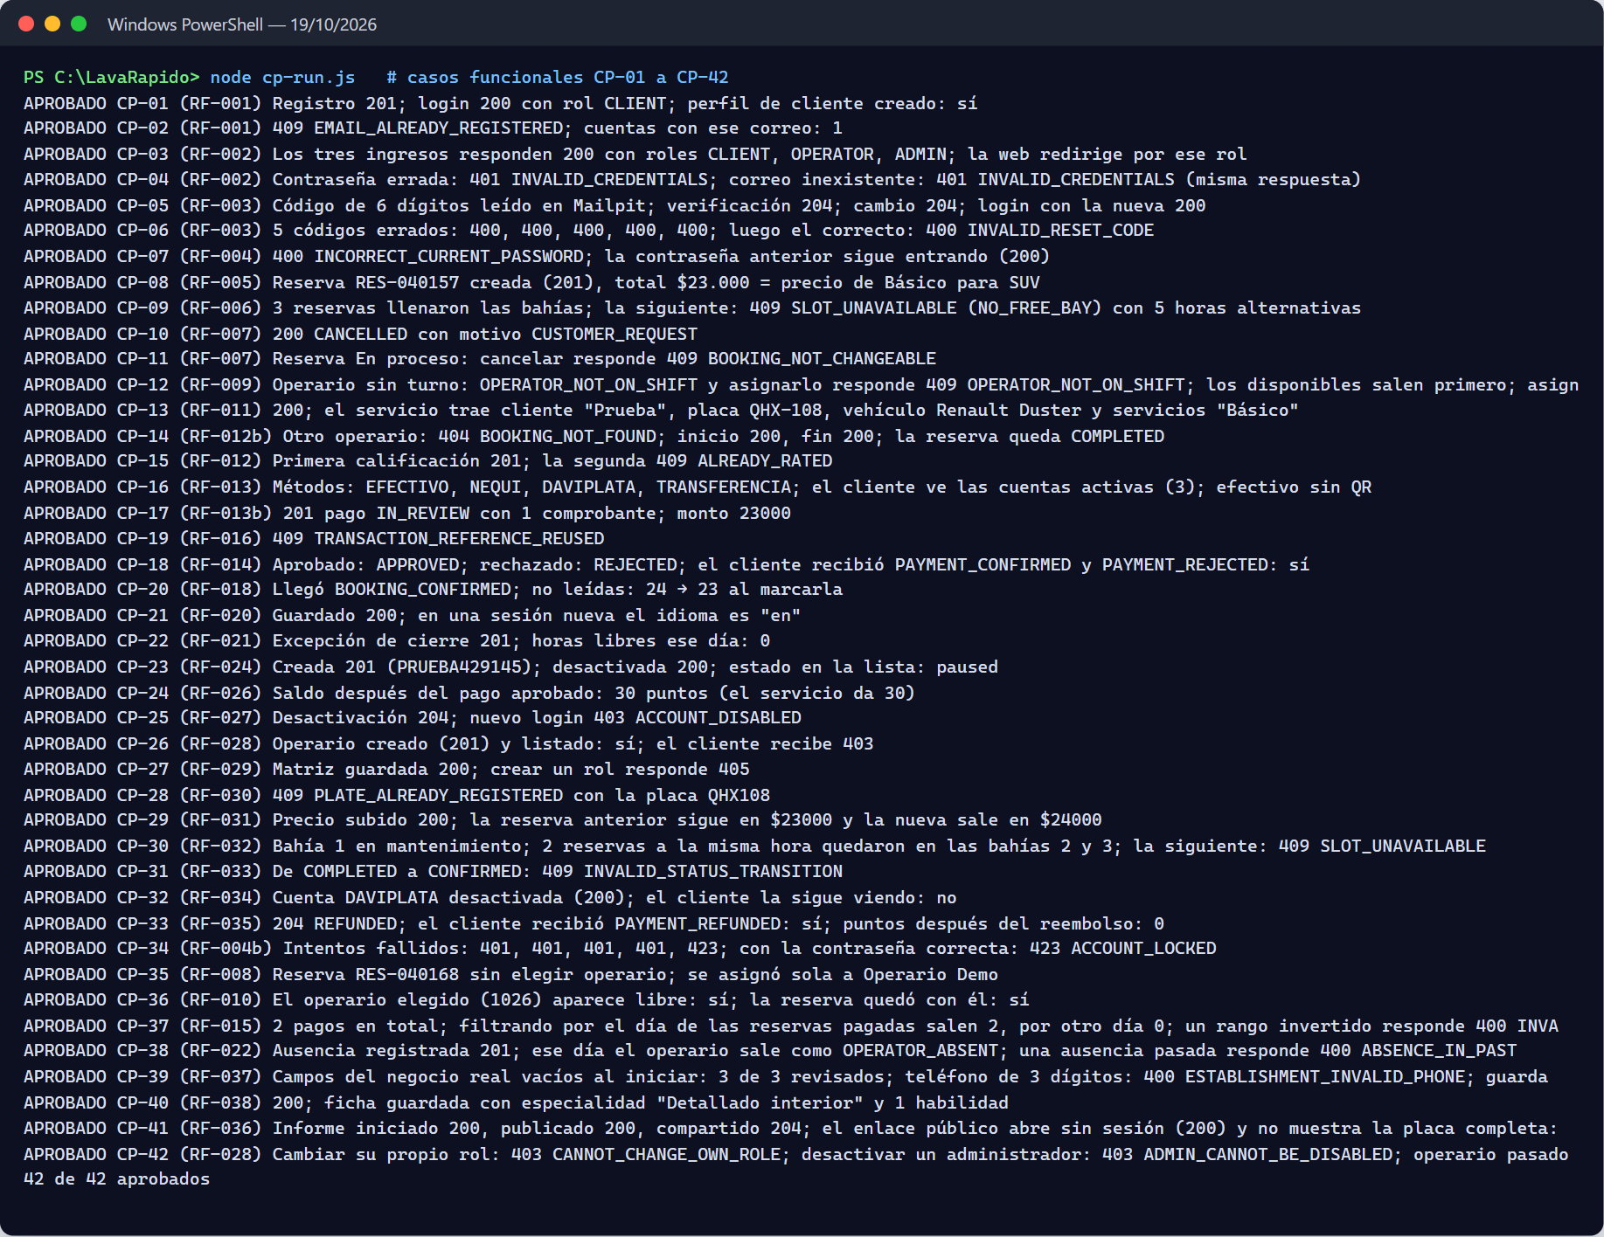

5. Traceability Matrix
Of the 41 requirements in SRS v7.4, 38 have a functional case and 39 a related automated test; RF-032 and RF-034 only have a functional case, and RF-017, RF-023, and RF-025 only an automated test.
Table 7
RF → status → endpoint / screen → test case
RF | Status (SRS v7) | Endpoint (prefix /api/v1) | Web screen | Functional case | Related automated test
RF-001 | Implemented | POST /auth/register | /auth/register | CP-01, CP-02 | AccountRegistrationServiceTest, UserRegisteredListenerTest
RF-002 | Implemented | POST /auth/login | /auth | CP-03, CP-04 | AuthenticationServiceTest, JwtTokenIssuerTest, ApiSecurityWebTest
RF-003 | Implemented | POST /auth/password/forgot, /verify, /reset | /auth/forgot-password | CP-05, CP-06 | PasswordRecoveryServiceTest, PasswordResetTokenTest
RF-004 | Implemented | PUT /users/me/password | /client/profile | CP-07 | UserProfileAndAdministrationTest, PasswordPolicyTest
RF-004b | Implemented | POST /auth/login (423 ACCOUNT_LOCKED) | /auth | CP-34 | AuthenticationServiceTest (lockout and window), PasswordRecoveryServiceTest (a reset lifts it), ApiSecurityWebTest (423)
RF-027 | Implemented | GET/PATCH /users/me, GET/PUT /users/me/address, PUT /users/me/email, POST /auth/logout, POST /users/me/deactivate | /client/profile | CP-25 | UserProfileAndAdministrationTest, PersonAddressServiceTest, AuthenticationServiceTest
RF-028 | Implemented | GET/POST /admin/users, PATCH /admin/users/{id}/status, PATCH /admin/users/{id}/role | /admin/management, /admin/operators | CP-26, CP-42 | UserProfileAndAdministrationTest, ApiSecurityWebTest
RF-029 | Implemented | GET /admin/roles-permissions, PUT /admin/roles-permissions/{role} | /admin/management | CP-27 | RolePermissionAdministrationServiceTest
RF-030 | Implemented | /vehicles, GET /vehicle-types, GET /admin/vehicles | /client/vehicles | CP-28 | CustomerVehicleServiceTest, LicensePlateTest, CustomerApiWebTest
RF-031 | Implemented | GET /catalog/services, /admin/catalog/services | /admin/management | CP-29 | CatalogServiceTest
RF-021 | Implemented | PUT /admin/schedule/business-hours, POST /admin/schedule/exceptions | /admin/schedule | CP-22 | AvailabilityPolicyTest
RF-032 | Implemented | /admin/bays | /admin/schedule | CP-30 | —
RF-037 | Implemented | GET/PUT /admin/establishment, GET /establishment | /admin/settings | CP-39 | EstablishmentTest, BookingApiWebTest
RF-005 | Implemented | POST /bookings, GET /catalog/services | /client/reserve | CP-08 | BookingServiceTest, BookingTest
RF-006 | Implemented | GET /bookings/availability | /client/reserve | CP-09 | AvailabilityPolicyTest
RF-007 | Implemented | PUT /bookings/{id}, POST /bookings/{id}/cancel | /client/history | CP-10, CP-11 | BookingTest, BookingApiWebTest
RF-033 | Implemented | GET /admin/bookings, PATCH /admin/bookings/{id}/status | /admin/reservations | CP-31 | BookingTest, BookingServiceTest
RF-008 | Implemented | booking.confirmed event, GET /internal/v1/bookings | /admin/reservations | CP-35 | AutoAssignmentPolicyTest, OperationsServiceTest (automatic assignment, deactivated account), booking-flow.test.js
RF-009 | Implemented | GET /admin/assignments/{id}/candidates, PUT /admin/assignments/{id} | /admin/reservations | CP-12 | AssignmentPolicyTest, OperationsServiceTest
RF-010 | Implemented | GET /operators/available, POST /bookings (preferredOperatorId) | /client/reserve | CP-36 | OperationsServiceTest (free operators), OperationsApiWebTest, booking-flow.test.js
RF-011 | Implemented | GET /operator/services | /operator/assigned-services | CP-13 | OperationsServiceTest
RF-012b | Implemented | POST /operator/services/{id}/start, /finish | /operator/assigned-services | CP-14 | StartPolicyTest, ServiceExecutionTest
RF-012 | Implemented | POST /ratings/{bookingId} | /client/history | CP-15 | ServiceExecutionTest
RF-022 | Implemented | PUT /admin/operators/{id}/availability, /absences, GET /admin/operators/summary | /admin/operators/:id | CP-38 | AssignmentPolicyTest, TeamSummaryCalculatorTest
RF-036 | Implemented | /admin/inspections/{bookingId}/**, GET /public/inspections/{token} | /admin/reservations/:id/inspection, /report/:token | CP-41 | InspectionReportTest, OperationsApiWebTest
RF-038 | Implemented | GET /admin/operators/profiles, PUT /admin/operators/{id}/profile | /admin/operators/:id | CP-40 | OperatorProfileServiceTest
RF-034 | Implemented | /admin/payment-accounts, GET /payment-accounts | /admin/settings | CP-32 | —
RF-013 | Implemented | GET /payment-accounts | /client/payment | CP-16 | PaymentQueryServiceTests
RF-013b | Implemented | POST /payments | /client/payment | CP-17 | PaymentTests, PaymentCommandServiceTests
RF-014 | Implemented | POST /admin/payments/{id}/approve, /reject | /admin/payments | CP-18 | PaymentTests, PaymentCommandServiceTests
RF-015 | Implemented | GET /payments/me?from=&to=&service= | /client/history | CP-37 | PaymentQueryServiceTests (order and filters)
RF-016 | Implemented | POST /payments | /client/payment | CP-19 | PaymentPolicyTests, PaymentCommandServiceTests (reused reference)
RF-035 | Implemented | POST /admin/payments/{id}/refund | /admin/payments | CP-33 | PaymentTests, PaymentCommandServiceTests
RF-017 | Implemented | GET /admin/bookings/day-summary, GET /operators/my-bookings and dashboard stores | /client, /operator, /admin | — | BookingServiceTest (day summary), web smoke tests (dashboard.spec.ts)
RF-018 | Implemented | /notifications/* + RabbitMQ events | /*/notifications | CP-20 | NotificationUseCasesTest, NotificationFactoryTest, BookingReminderServiceTest, LocalizedNotificationsTest, UnassignedBookingAlertTest, StaffNotificationsTest
RF-019 | Implemented | PUT /users/me/preferences | /*/configuration | Covered by CP-21 | UserPreferenceServiceTest
RF-020 | Implemented | PUT /users/me/preferences | /*/configuration | CP-21 | UserPreferenceServiceTest, UserPreferenceTest
RF-023 | Partial | GET /admin/operators/{id}/metrics, GET /admin/operators/summary, payment and booking stores | /admin/reports, /admin/operators/:id | — | OperatorMetricsCalculatorTest, TeamSummaryCalculatorTest
RF-024 | Implemented | /admin/promotions | /admin/management | CP-23 | PromotionTests
RF-025 | Implemented | POST /loyalty/redeem | /client/payment | — | CustomerPromotionServiceTests
RF-026 | Implemented | GET /loyalty/balance | /client | CP-24 | LoyaltyTransactionTests
Note. The automated test column points to the file whose name and methods match the requirement; code coverage was not measured. booking-flow.test.js is in lavarapido-infra/e2e and needs the system running.

6. Findings and Open Items
Table 8
Testing gaps found
# | Gap | Recommendation
1 | The mobile app has no automated tests | Add Jest with jest-expo, at least for validators (shared/validators) and services (core/services)
2 | Most of the 43 web tests only check that the component is created | Test more real rules: authGuard by role, authInterceptor on 401, booking form
3 | The 7 payment persistence tests need a migrated database and skip without it; on October 19 they were run against LavaRapidoPaymentIT and passed | Document in the README how to create the test database and set PAYMENT_INTEGRATION_DB, and run them in GitHub Actions with a SQL Server service
4 | For RF-023 (reports) only the operator metrics and the team summary are tested; the PDF/Excel export has no test | Add a functional case for reports and the PDF/Excel export
5 | RF-032 (bays) and RF-034 (payment accounts) have no dedicated automated tests: ScheduleService and PaymentAccountService have no test class | Add unit tests for those two services
6 | The requirements implemented after October 9 (RF-004b, RF-008, RF-010, RF-015, RF-022, RF-036, RF-037, and RF-038) had no functional case of their own | Closed on October 19, 2026, with cases CP-34 to CP-41
Table 9
Defects found while running the system
# | Defect | Evidence | Severity
1 | The administrator dashboard always says "¡Hola, Laura!" regardless of who logs in | Web/src/app/features/admin/pages/dashboard/dashboard.ts:73 (adminName = 'Laura'); "Laura Méndez" is also hard-coded in payment-review-modal.html:167 | Low
2 | In the operator's "Assigned services" (web), the Customer column shows the license plate | Web/src/app/features/operator/pages/assigned-services/assigned-services.ts:141 | Medium
3 | On the customer home (mobile), "Assigned operator" is empty even though the booking has an operator | Booking RES-060003, assigned in CP-12; mobile screenshot | Medium
4 | The brand name is inconsistent: "AquaWash" (mobile), "Car Wash" and "Lavado Vehicular" (web), "Express Car Wash" (establishment) | Web and mobile screenshots | Low
5 | The landing page advertises a "mobile wash service" and "wherever you are", but SRS v4 defines a single-location car wash | Landing screenshot; SRS v4, section 1 | Low
6 | If there are two accounts of the same method (two Nequi), the payment screen shows both selected at once | Customer Payments screenshot | Low
7 | When logging out, the web and the app showed "Your session expired", because a 401 that arrived after the token was deleted was taken as an expired session | auth-interceptor.ts (web) and AuthServiceContext.tsx (mobile) | Medium
8 | On a phone (360 px) there were buttons off the screen in the landing bar, overlapping titles, the ☰ button over the titles, Assigned services badges off the screen, Management filters outside their card, and Settings switches over their text | Responsive design check of October 17, 2026 (Table 5c) | Medium
9 | In the mobile app, the date and search inputs were squashed when placed in a column (History and Ratings) | shared/components/screen/FilterInputs.tsx | Low
10 | The customer's next service progress showed 10% or 25% although the wash had not started | features/client/pages/dashboard/dashboard.ts (web) and modules/client/models/client.ts (mobile) | Low
Note. Defects 7 to 10 were fixed between October 16 and 17, 2026, on the develop branch of the web and the app; 8 and 9 were measured again with no overflow (Table 5c).
Note. Code review of October 16, 2026: the six defects are fixed. The dashboard greets with the session name and the payment review shows the reviewer (1); the Client column shows the customer name (2); the customer home shows the assigned operator on the web and on mobile (3); the brand is LavaRápido on the web and on mobile (4); the home page describes the service at the car wash (5); and the payment screen selects by account and shows the holder when two accounts share a method (6, payment.spec.ts).

References
International Organization for Standardization. (2021). Software and systems engineering — Software testing — Part 3: Test documentation (ISO/IEC/IEEE 29119-3:2021). https://www.iso.org/standard/79429.html
JUnit. (n.d.). JUnit 5 user guide. Retrieved October 9, 2026, from https://junit.org/junit5/docs/current/user-guide/
Vitest. (n.d.). Vitest documentation. Retrieved October 9, 2026, from https://vitest.dev/
xUnit.net. (n.d.). xUnit.net documentation. Retrieved October 9, 2026, from https://xunit.net/

