Software Analysis: Dynamic Views of the LavaRápido System
Juan Camilo Guilombo Osorio, Brayan Estiven Patiño Cabrera and Merari Urbano Quintero
Centro de la Industria, la Empresa y los Servicios, Servicio Nacional de Aprendizaje (SENA), Huila Regional
Software Analysis and Development Technologist program (ADSO), group (ficha) 3145556
Instructor: Karol Daniela Correa
Version 2.7, October 26, 2026

Introduction
This document shows how LavaRápido behaves when someone uses it: what happens, in which order, and between which screens and services. It is organized in four parts:
- Use cases by actor, with their «include»/«extend» relationships.
- Sequence diagrams of the main flows: from the screen to the gateway, from the gateway to the service, and from the service to the database or to another service.
- Activity diagrams of the business processes.
- State diagrams of the entities that change status (booking, payment, service execution, promotion and inspection report).
On October 21, 2026, the following were updated against the code of that day: the sign-out that voids the token (section 2.8), the lock on operator assignment (section 2.4), the receipt of at most 2 MB and the cash option that only appears while its account is active (sections 2.5 and 3.4), and the handling of bookings that ended without anyone closing them (sections 4.1 and 4.3): the system only changes the status when there is no doubt, and the rest goes to the administrator's "To close" list. On October 20, 2026, the content was checked again against the code: the client only cancels (the administrator reschedules), the role change of accounts was removed, the sequences and states that did not match were corrected, and the use case and other diagrams were redrawn with straight lines and no crossings. On October 19, 2026, use cases CU31 and CU32, password recovery (section 2.10) and the account life cycle (section 4.6) were added, and the screenshots of the screen inventory were taken again with demo data. On October 17, 2026, the consent to the legal documents at registration (section 2.1) and the inspection report from the mobile app (section 2.9) were added. The diagrams are written in Mermaid. They were checked against the code and the running system on October 9, 2026, and updated against the code on October 15, 2026 with the account lockout, automatic assignment, operator choice, the service start window, the alert for bookings without an operator and the inspection report. The screen inventory, with screenshots by role, is at the end. On October 23, 2026 (version 2.5) it was added that recovering the password revokes all sessions (section 2.10) and that, if security-service does not answer, the gateway lets the request through (fail-open); the rest of the analysis still holds against develop of that day. On October 24, 2026 (version 2.6), against develop of that day, the permission matrix became read-only (sections 2.7 and 3.6 and the screen inventory) and the automatic cancellation of expired scheduled bookings was removed, because every booking is created confirmed (section 4.1). On October 26, 2026 (version 2.7), against develop of that day, payment at booking was added: the customer chooses how they will pay when booking, with at most one active cash booking (sections 2.2 and 3.2); payment-service announces with payment.reported when the customer uploads the receipt (section 2.5), and a booking with digital payment that reaches its deadline without a receipt is cancelled automatically with the reason PAYMENT_TIMEOUT, after asking payment-service (sections 2.11 and 4.1).
The full specification of each requirement and use case (actors, precondition, main flow, alternative flows and postcondition) is in the Software Requirements Specification, sections 5 and 7.3; here they are cited by their identifier (RF-XXX, CUXX).

1. Use Cases by Actor

1.1 Use Case Diagram
The 32 use cases are presented in four diagrams, one per actor, grouped by module.
Use cases common to the three roles
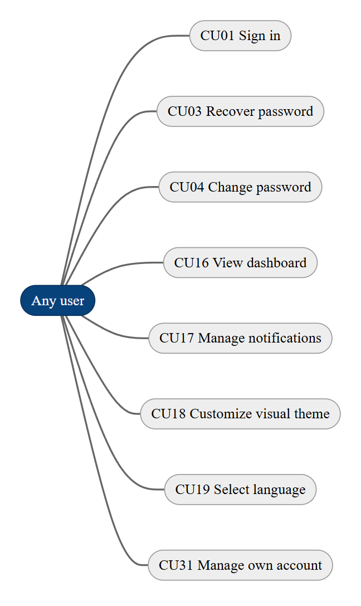
Customer use cases
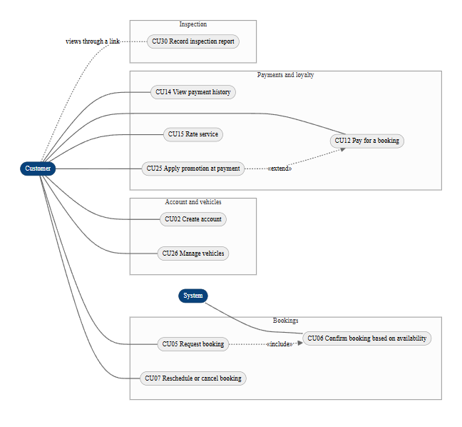
Operator use cases
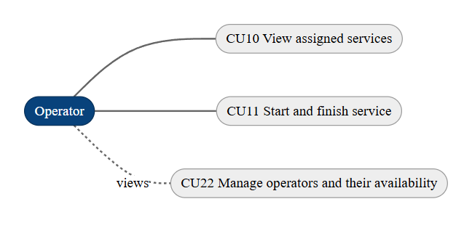
Administrator and System use cases
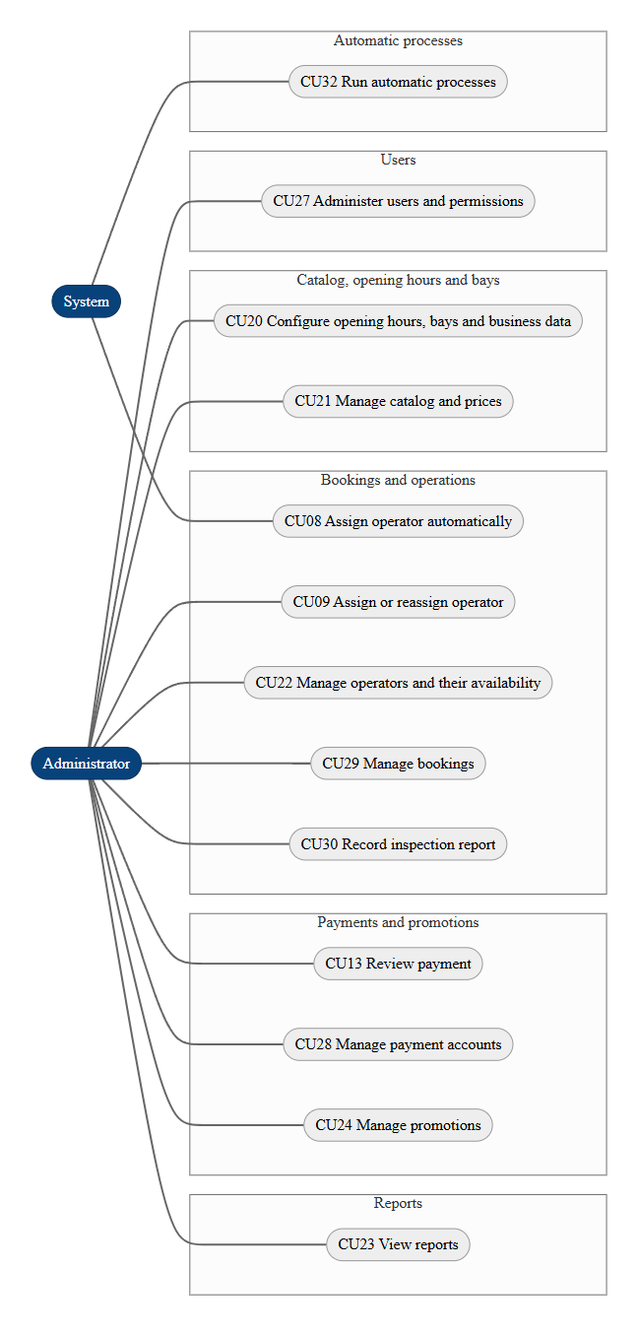
Note. «include» means that CU05 always runs CU06; «extend» means that CU25 optionally extends CU12. CU22 appears as view-only for the operator and as management for the administrator, who is the one recording shifts, absences and the operator profile (RF-022, RF-038). The system runs CU08 each time a booking is confirmed, and CU32 groups the processes that run without anyone asking for them (reminders, alerts, notices and the first administrator). The customer does not record the inspection report (CU30): they view it through the link the administrator shares. In CU07 the customer cancels from the history or the payment screen; a new date or time is set by the administrator from Bookings (CU29), since neither the web nor the app has a reschedule screen for the customer. In CU27 the role is chosen when the account is created; the users list does not change it.

1.2 Actor and Use Case Matrix
Actor | Use cases
All roles | CU01, CU03, CU04, CU16, CU17, CU18, CU19, CU31
Customer | CU02, CU05, CU06, CU07, CU12, CU14, CU15, CU25, CU26, CU30 (view only)
Operator | CU10, CU11, CU22 (view only)
Administrator | CU09, CU13, CU20, CU21, CU22, CU23, CU24, CU27, CU28, CU29, CU30
System | CU06 (included in CU05), CU08, CU32
The specification of each of the 32 use cases (precondition, main flow, alternative flows, postcondition, status) is in the Software Requirements Specification, Tables 23 to 54.

2. Sequence Diagrams
Each diagram follows the path of the request (screen, gateway, services, database and RabbitMQ) with the class and endpoint names from the code. The first five are based on the diagrams in vehicle-w-docs/08-uml/diagrams/source/; the next ones cover loyalty, roles and permissions, the account lockout and the inspection report.

2.1 Registration and welcome (RF-001, RF-018)
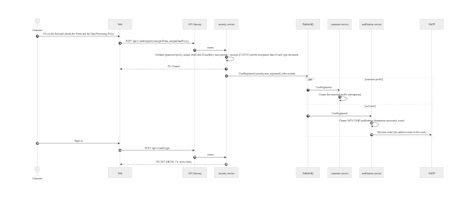
Source: security-service (AccountRegistrationService, AuthenticationService, migration 039-security-app-user-legal-consent.sql), event security.user_registered. The web and the mobile app do not send the form until both boxes are checked; the server stores the dates only when both arrive accepted.

2.2 Booking a wash (RF-005, RF-006, RF-010)
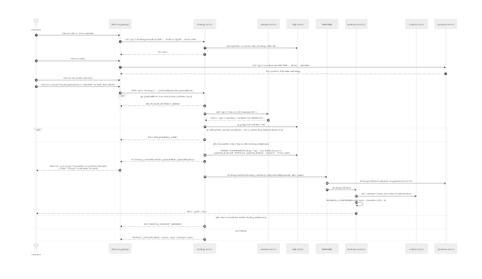
Source: booking-service (BookingService.create, Booking.confirmNew, AvailabilityPolicy, PaymentPolicy), operations-service (AvailableOperatorsController), contracts in 07-api/contracts/openapi/. The cash limit (BOOKING_CASH_ACTIVE_LIMIT, 1) is counted with the schedule locked and only with the active bookings (Scheduled, Confirmed, or In progress) made by the customer themselves (booked_by). The administrator does not have to send paymentMode, and their bookings have no deadline or limit.

2.3 Reminders and alert for bookings without an operator (ADR-011)
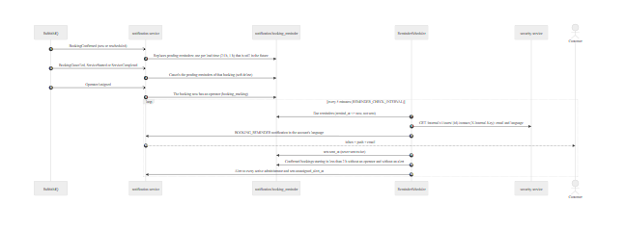
Source: notification-service (BookingReminderService, ReminderScheduler, StaffNotificationService, migration 031).

2.4 Operator assignment, execution and rating (RF-008, RF-009, RF-010, RF-011, RF-012, RF-012b)
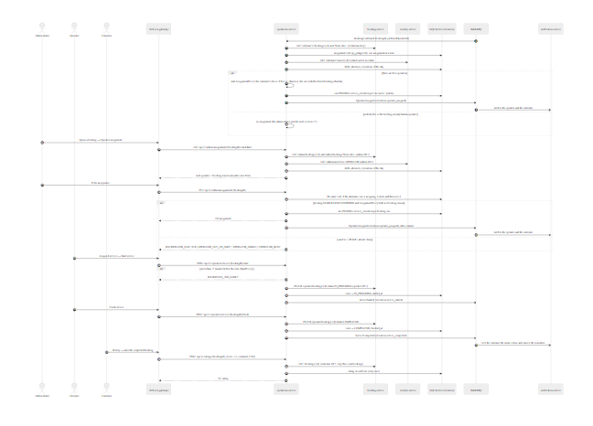
Source: operations-service (BookingConfirmedListener, OperationsService.autoAssign / candidates / assign / start / finish / rate, ExecutionPersistenceAdapter.lockAssignments, AssignmentPolicy, AutoAssignmentPolicy, StartPolicy, ADR-014). The lock prevents a simultaneous manual and automatic assignment from giving the same operator two services at the same time.

2.5 Payment by receipt and review (RF-013, RF-013b, RF-014)
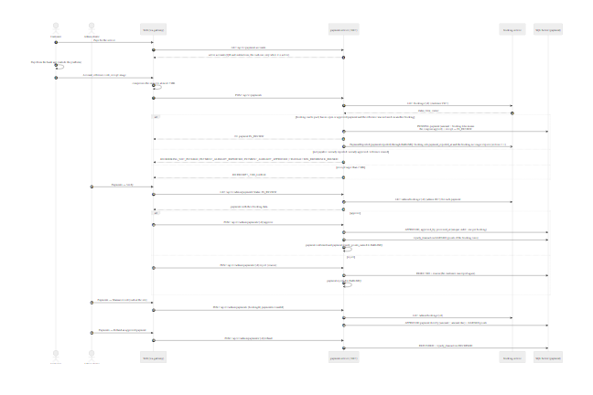
Source: payment-service (PaymentCommandService.ReportAsync / ApproveAsync / RejectAsync / RegisterInPersonAsync / RefundAsync, BookingPaymentGuard, LoyaltyRewardService, Payment aggregate, ADR-008, ADR-013). notification-service turns each payment.* event into a notice for the customer.

2.6 Coupon redemption and loyalty points (RF-024, RF-025, RF-026)
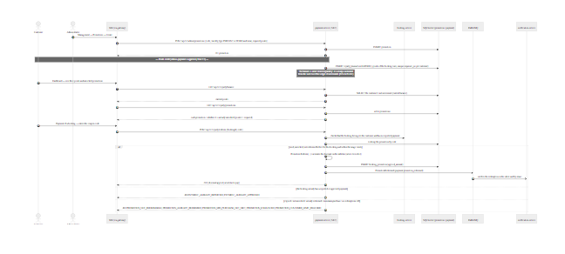
Source: payment-service (LoyaltyController, CustomerPromotionService.RedeemAsync, Promotion.Redeem aggregate, LoyaltyLedgerRepository), ADR-015.

2.7 Roles and permissions management (RF-029)
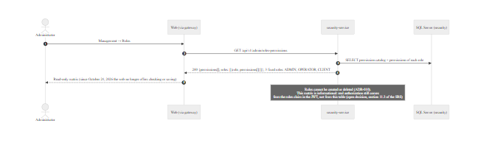
Source: security-service (RolePermissionController, RolePermissionAdministrationService, migration 026-security-role-permissions.sql), ADR-015.

2.8 Sign-in with lockout after failed attempts and sign-out (RF-002, RF-004b, RF-027)
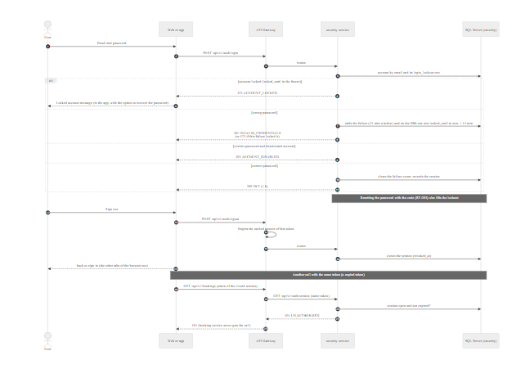
Source: security-service (AuthenticationService.login / logout / isActive, ActiveSessionValidator, LoginLockout, PasswordRecoveryService, migration 034-security-login-lockout.sql) and the gateway (SessionCheckFilter). The gateway keeps each answer of /api/v1/auth/session (if security-service does not answer within 3 seconds, it lets the request through: fail-open) for 30 seconds per token, so an open session costs one extra call every half minute, not one per request. A session also closes when the administrator deactivates the account or the owner closes it; that reaches the other services within the same 30 seconds.

2.9 Vehicle inspection report (RF-036)
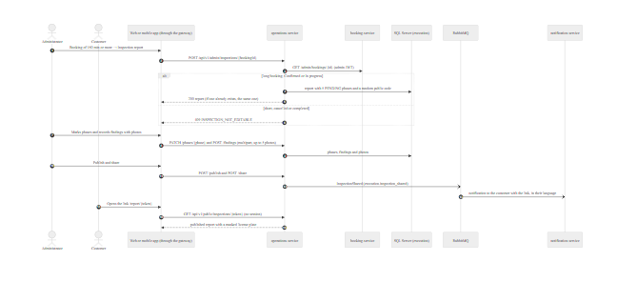
Source: operations-service (InspectionReport, migration 033-execution-inspection-report.sql), notification-service (shared report notice), web (features/admin/pages/inspection), and mobile app (AdminInspectionScreen, InspectionService). In the app the photos are taken with the camera or picked from the gallery and shrunk on the phone before the POST /findings; the Publish and share link button opens the phone share menu.

2.10 Password recovery with a 6-digit code (RF-003)
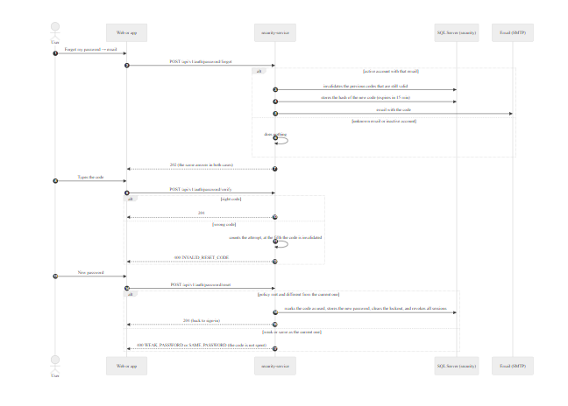
Source: security-service (PasswordRecoveryService, PasswordResetToken, PasswordRecoveryPolicy with code-ttl: 15m and max-failed-attempts: 5, SecureRandomResetCodeGenerator, EmailResetCodeNotifier). The forgot answer does not reveal whether the email exists.

2.11 Expiry of the digital payment (RF-005, RF-033, RN-BOOK-03)
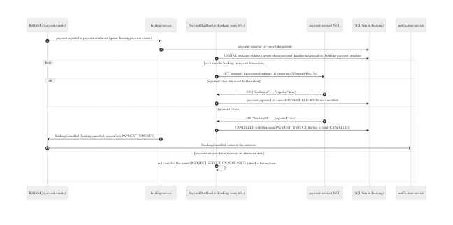
Source: booking-service (PaymentEventsListener, RabbitConsumerConfig, PaymentDeadlineJob, BookingService.cancelForPaymentTimeout, PaymentServiceDirectory, PaymentTimeoutOutcome) and payment-service (InternalPaymentsController, InternalApiKeyAuthenticationHandler). Since there is no Outbox, a payment.reported event can be lost; that is why the job asks payment-service before cancelling (AC-89). For payment, reported is true if the booking has an IN_REVIEW or APPROVED payment. The job is turned off with BOOKING_PAYMENT_EXPIRY_ENABLED=false, and the interval is BOOKING_PAYMENT_EXPIRY_INTERVAL (60 s).

3. Activity Diagrams
The activity diagrams show the business processes as they work in the system. There is no payment gateway: the customer uploads a receipt and the administrator reviews it (ADR-008).

3.1 Authentication (RF-001 to RF-004)
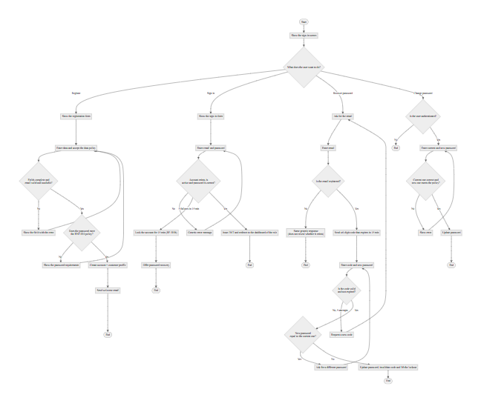

3.2 Booking a wash (RF-005, RF-006, RF-007, RF-010)
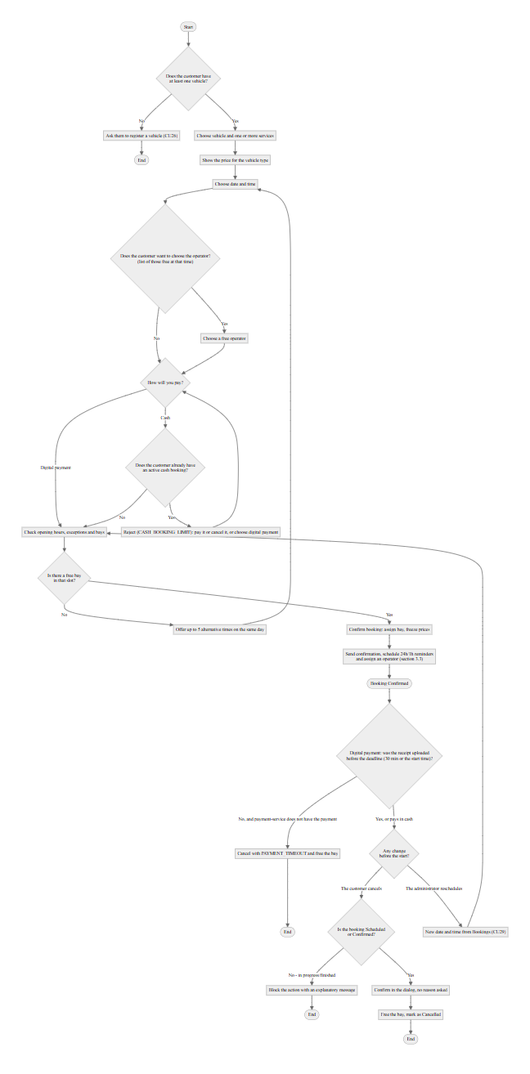

3.3 Operator assignment and service execution (RF-008, RF-009, RF-010, RF-011, RF-012b)
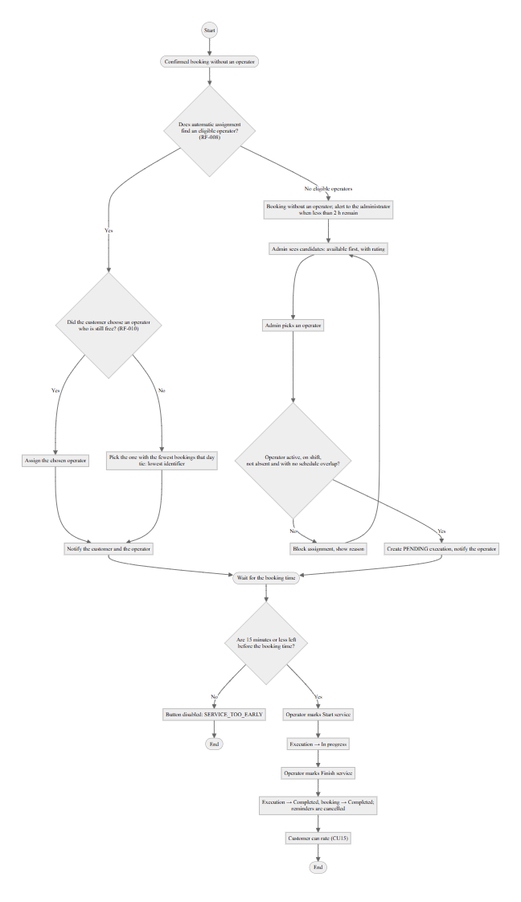

3.4 Paying for a booking (RF-013, RF-013b, RF-014, RF-016)
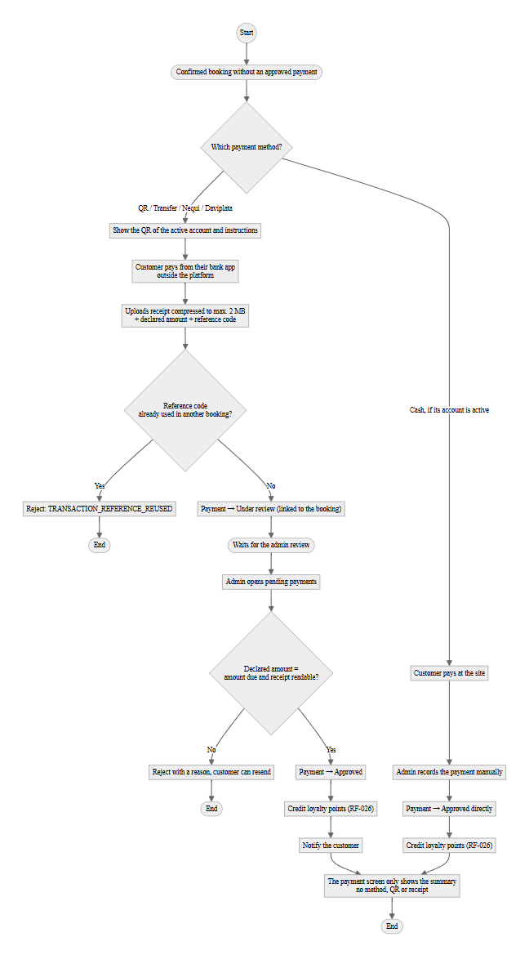

3.5 Redeeming a loyalty coupon (RF-024, RF-025, RF-026)
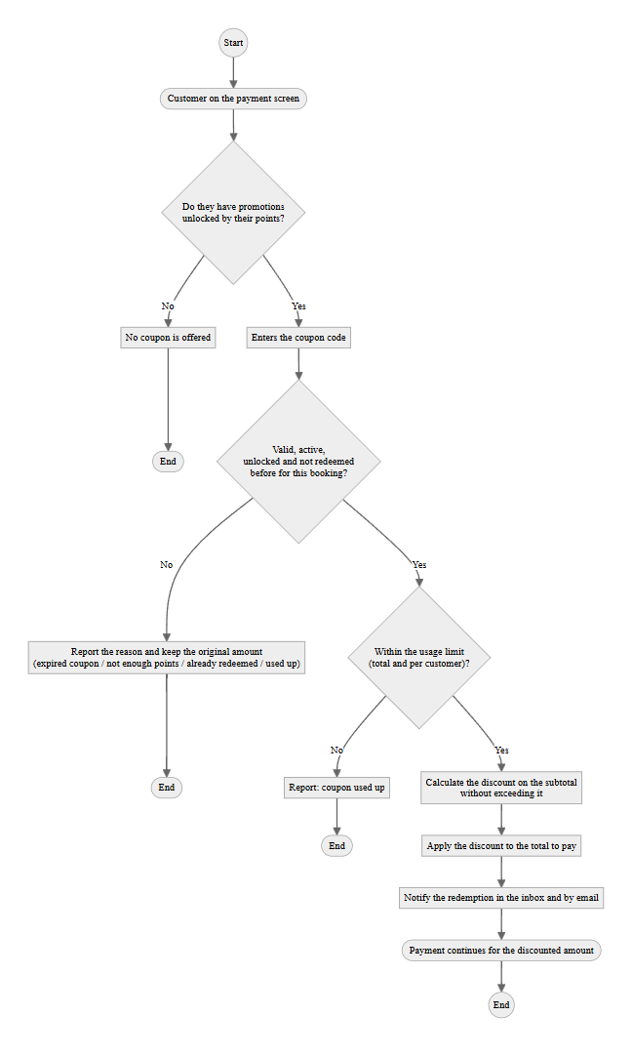

3.6 Managing roles and permissions (RF-029)
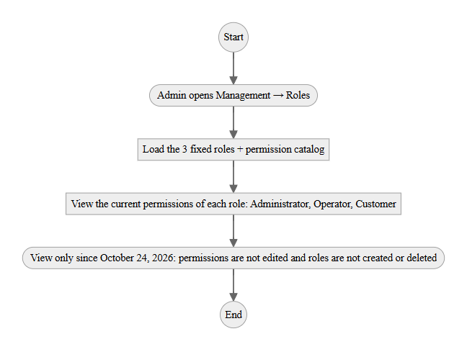

4. State Diagrams

4.1 Booking life cycle (RF-006, RF-007)
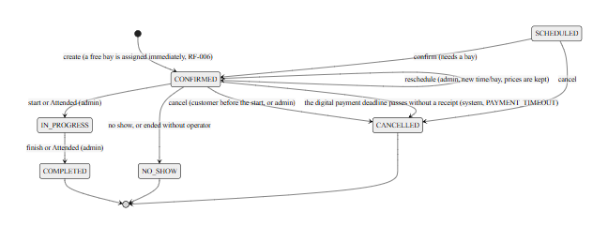
Source: booking-service (Booking.moveTo, Booking.cancel, BookingStatus) and operations-service (FollowUpJob, FollowUpPolicy). Bookings that ended and nobody closed: the system only decides on its own when there is no doubt. Until October 23, 2026 ExpiredBookingsJob cancelled bookings still SCHEDULED; it was removed on October 24 (B-07) because it never acted: every booking is created and rescheduled as CONFIRMED. Every 5 minutes, the operations FollowUpJob asks booking (POST /internal/v1/bookings/{id}/no-show) to set to NO_SHOW a CONFIRMED booking that never had an operator and ended more than an hour ago; booking checks again that it expired and, if not, answers 409 BOOKING_NOT_EXPIRED. A CONFIRMED booking with an operator that nobody started (NOT_STARTED) and an IN_PROGRESS one that nobody finished one hour after its end (NOT_FINISHED) never change status on their own: they go to the administrator's "To close" list, and the administrator resolves them with "Attended" (the booking goes through IN_PROGRESS and ends COMPLETED, without publishing ServiceCompleted) or with "No-show" (only if it was never started). This avoids recording as a no-show a service that was actually done and that the operator forgot to mark. There is never an automatic refund: payments are reviewed by the administrator. Only SCHEDULED and CONFIRMED can be rescheduled or cancelled (RF-007). The customer only cancels, before the start time and without writing a reason (the booking stores CUSTOMER_REQUEST); the administrator reschedules (CU29) and may choose the cancellation reason. SCHEDULED exists in the model, but the current flow always creates the booking directly as CONFIRMED. Since October 26, 2026, PaymentDeadlineJob cancels with the reason PAYMENT_TIMEOUT a booking with digital payment that reached its deadline without a receipt, only if payment-service confirms it does not have the payment (section 2.11); rescheduling changes neither the payment mode nor the deadline.

4.2 Payment life cycle (RF-013b, RF-014, ADR-008)
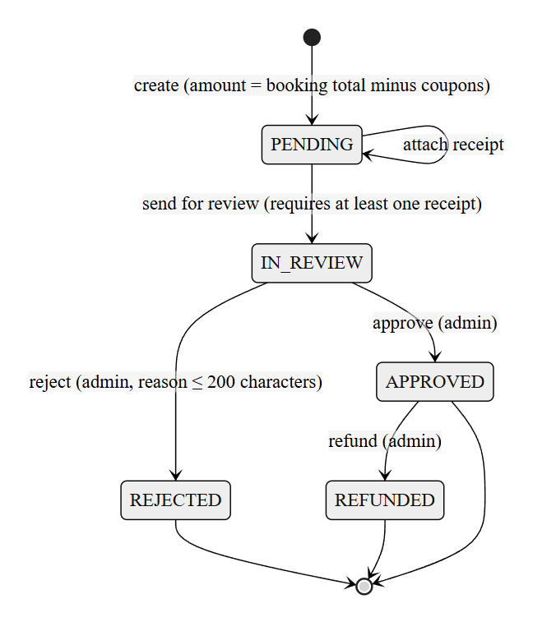
Source: payment-service, Payment aggregate. A booking allows only one approved payment and only one open payment at a time; after REJECTED the customer can report a new payment. A customer payment goes from PENDING to IN_REVIEW in the same request; the cash payment the administrator registers is APPROVED at once.

4.3 Service execution life cycle (RF-012b)
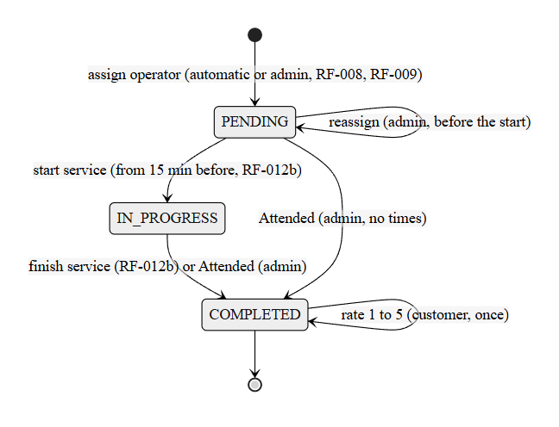
Source: operations-service (ServiceExecution, StartPolicy, FollowUpPolicy). COMPLETED enables the customer's rating (RF-012). When the administrator closes a service from "To close" as "Attended", the lines end COMPLETED without made-up times: with no start time they do not count for punctuality and with no end time they add no worked hours, but they do count as a service done and as revenue. The operator can still start the same service late, because starting has no upper limit, and then the real times count. If a service with an operator is not started or not finished on time, operations notifies the operator and every active administrator once (inbox and push, migration 040). PAUSED and WITH_ISSUE exist in the execution.execution_status catalog, but no use case uses them today.

4.4 Promotion life cycle (RF-024)
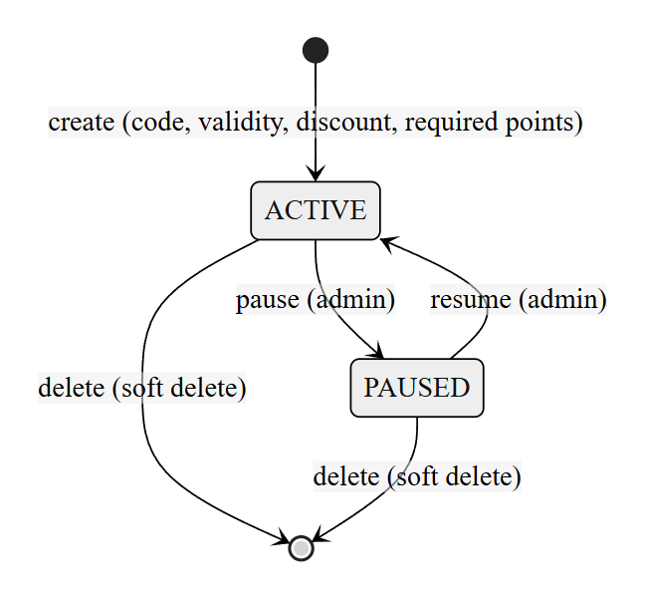
Source: payment-service, Promotion.SetActive, Promotion.StatusFor, Promotion.IsAvailableOn. The only thing stored is whether it is active or paused; the administrator's screen shows "scheduled" until the start date arrives. Only an active promotion within its validity period can be redeemed (RF-024, RN-PROMO-01): after the end date it is no longer offered or redeemed, although no "expired" status is stored.

4.5 Inspection report and its phases (RF-036)
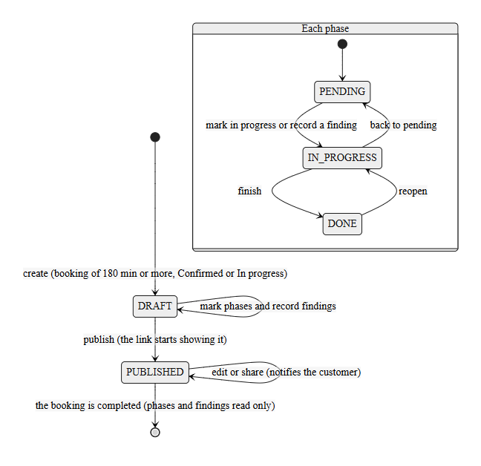
Source: operations-service, InspectionReport (publish, requirePublished, setPhaseStatus, addFinding). The phases are reception, exterior, interior, engine and delivery; only a published report can be shared, and it is edited while the booking is still Confirmed or In progress.

4.6 User account (RF-002, RF-004b, RF-027, RF-028)
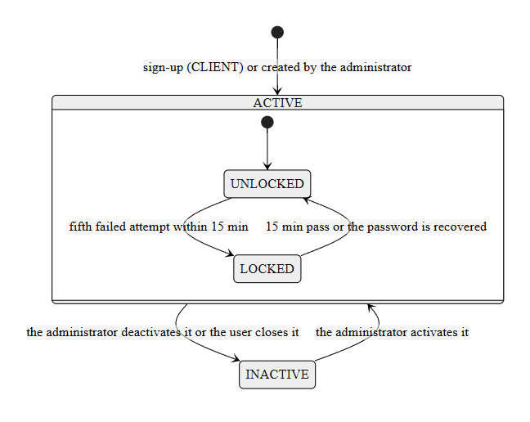
Source: security-service (UserAccount, LoginLockout, UserAdministrationService.changeStatus, AccountDeactivationService). A successful sign-in before the fifth attempt clears the failure count. The user closes their account with the password. A locked account answers 423 even with the right password; an inactive one answers 403 after the password is checked. No administrator account can be deactivated (403 ADMIN_CANNOT_BE_DISABLED), and an administrator cannot deactivate or close their own account (403 CANNOT_DISABLE_OWN_ACCOUNT). Each account has one role, set when it is created: there is no role change. When it becomes inactive, all its sessions are closed and their tokens stop working within 30 seconds (section 2.8).

5. Screen Inventory (mockup)
Screen by screen and by role, including the create and edit modals of each module. All screenshots are in the capturas/ folder of this document. The Management → Users screenshot was taken again on October 20, 2026: the table only shows the user type and has the Enabled and Disabled filters. Since October 20, clicking a notification or a booking of the history opens its detail, with a button to go to the related section (for example, Go to payment).

5.1 Common screens (no session)
Screen | Evidence
Sign-in | 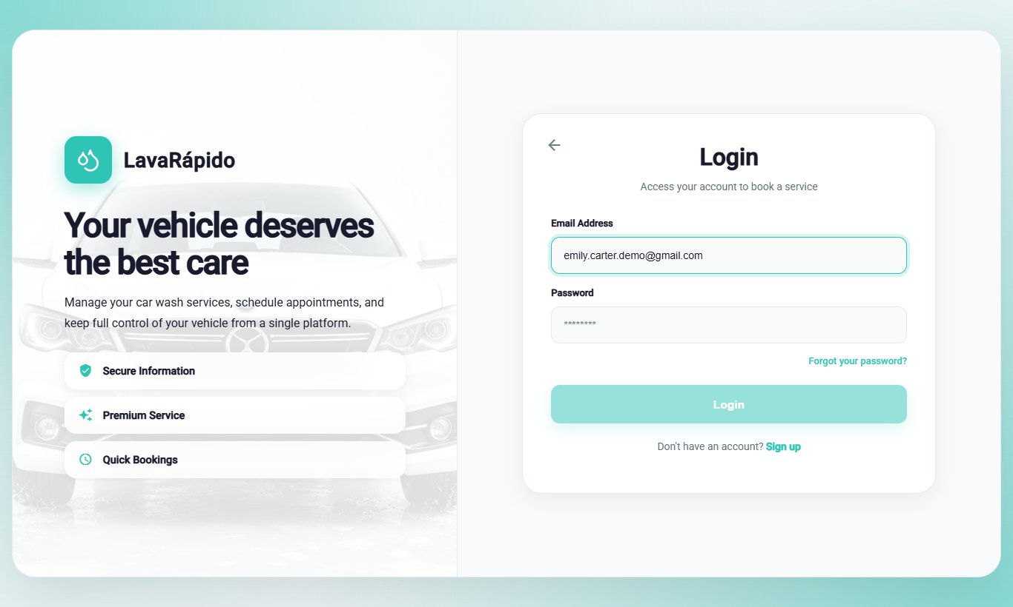
Registration | 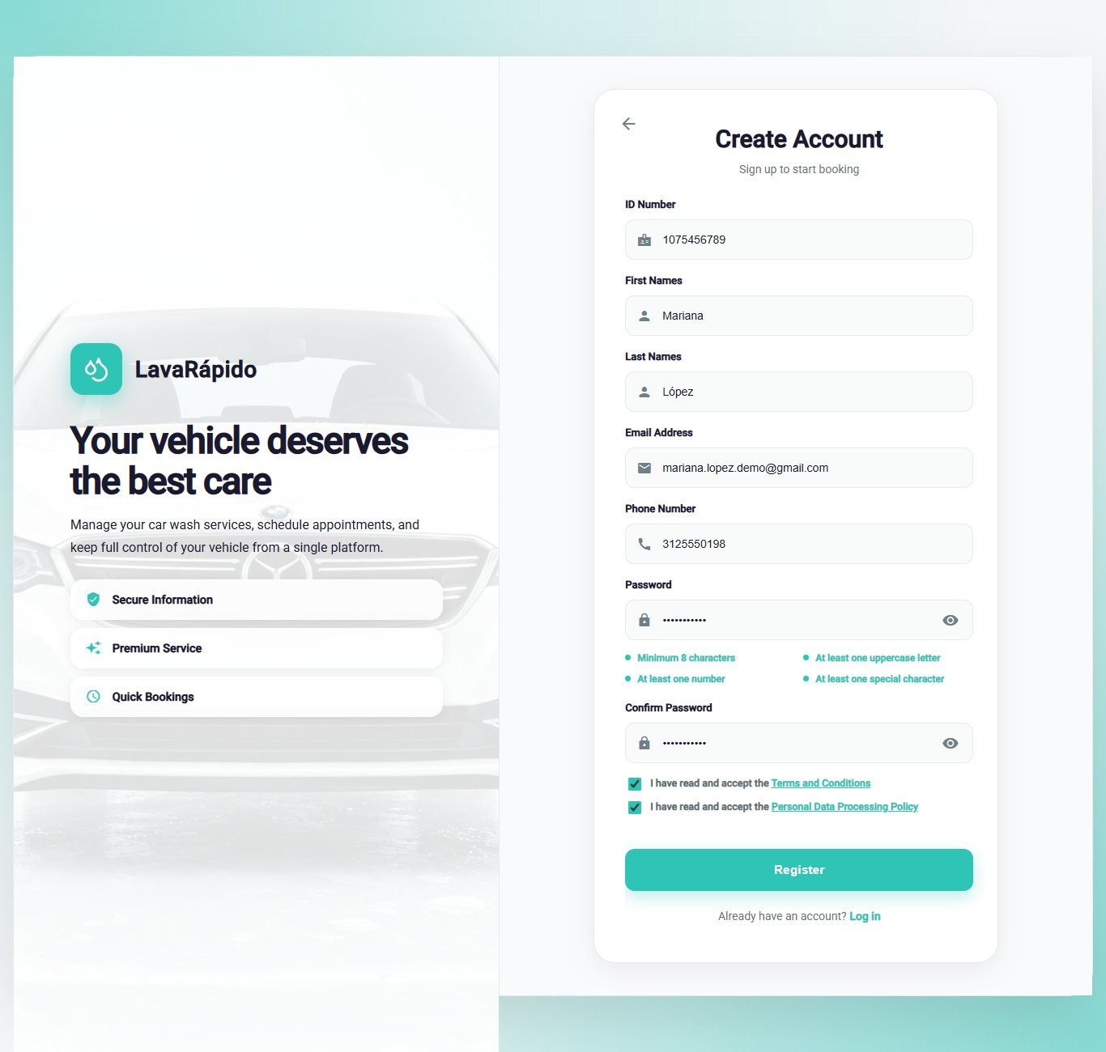
Password recovery | 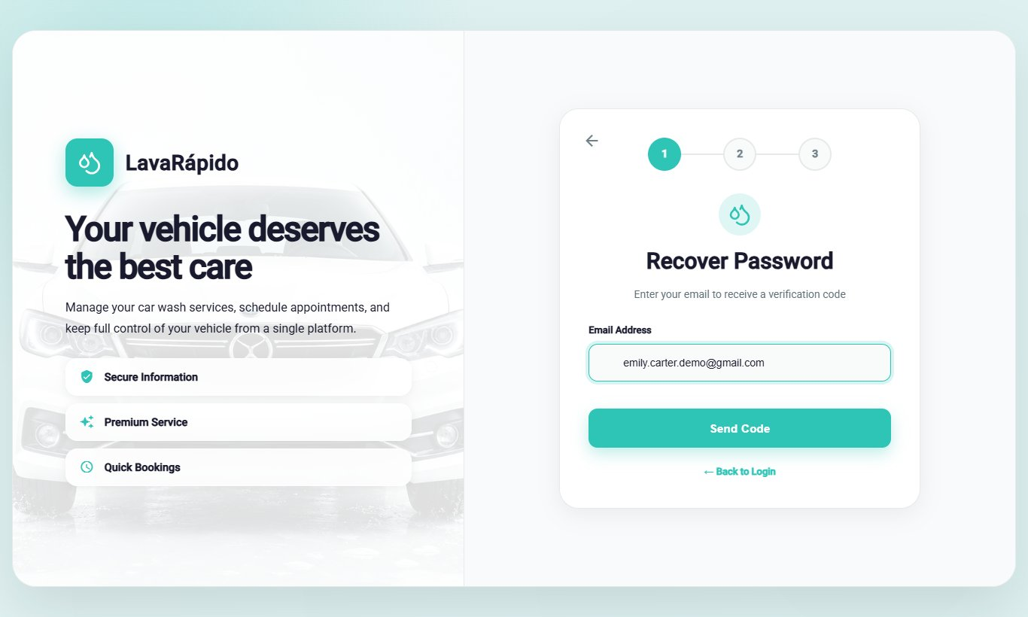

5.2 Administrator role
Screen | Evidence
Dashboard | 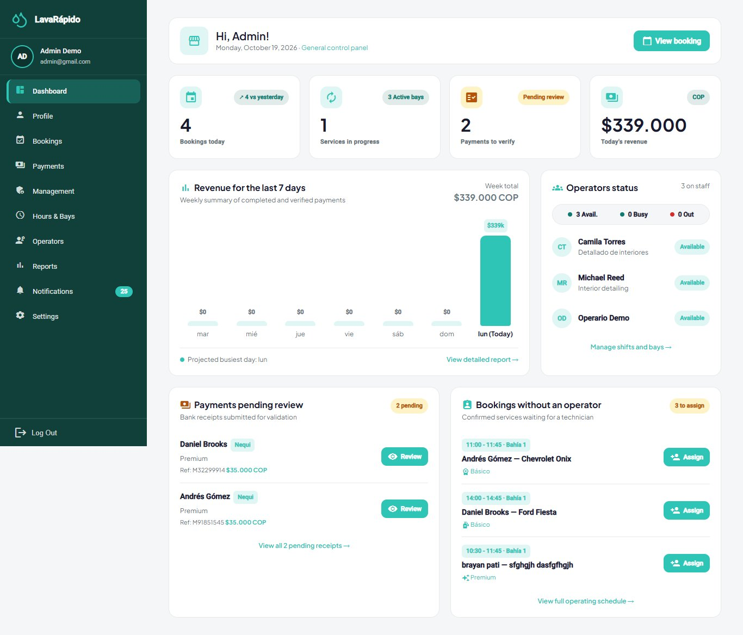
Management → Users | 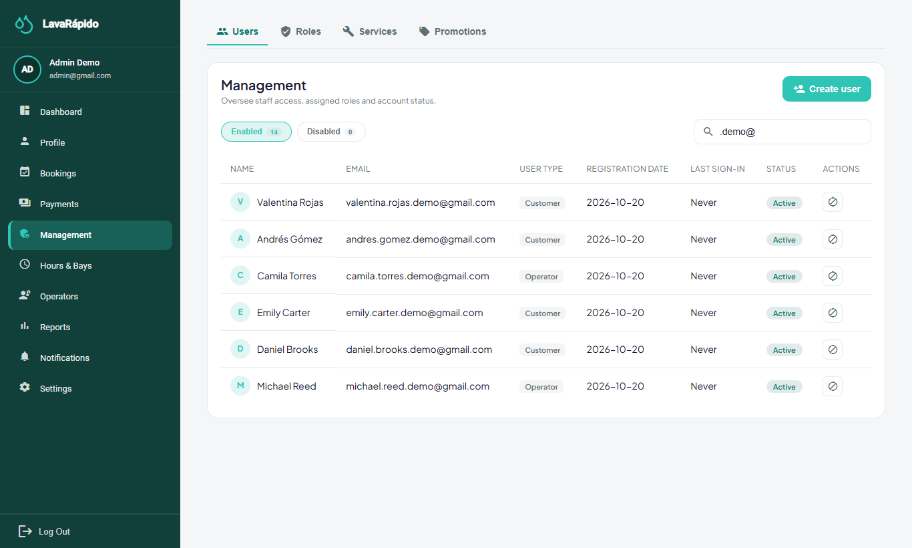
Modal: Create user | 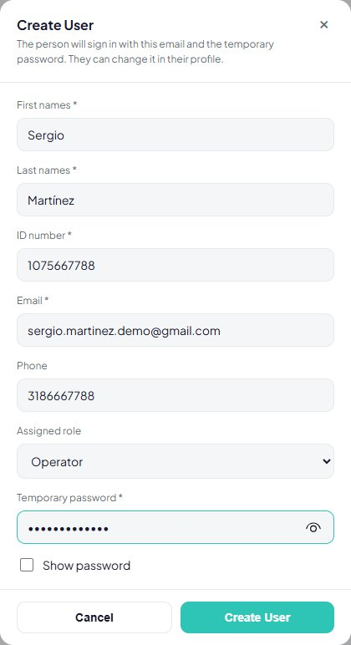
Management → Roles | 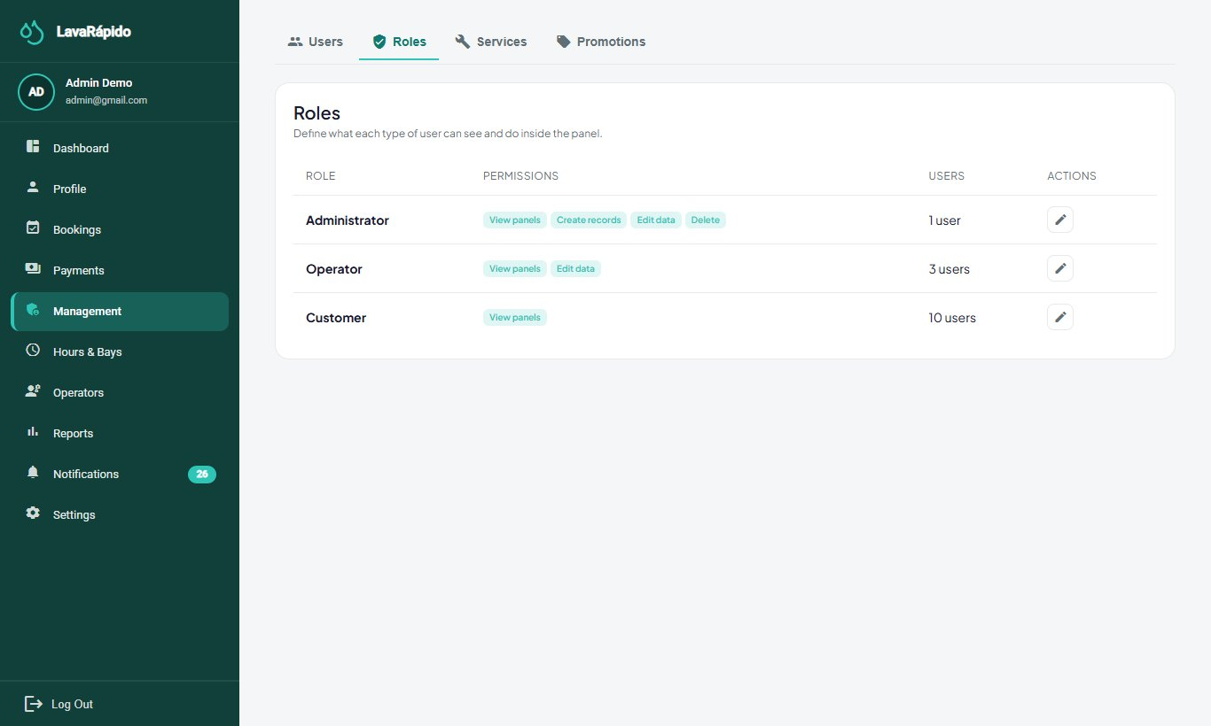
Modal: Edit role permissions (removed on October 24, 2026: the matrix is read-only) | 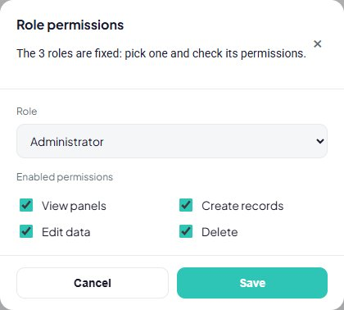
Management → Services (catalog) | 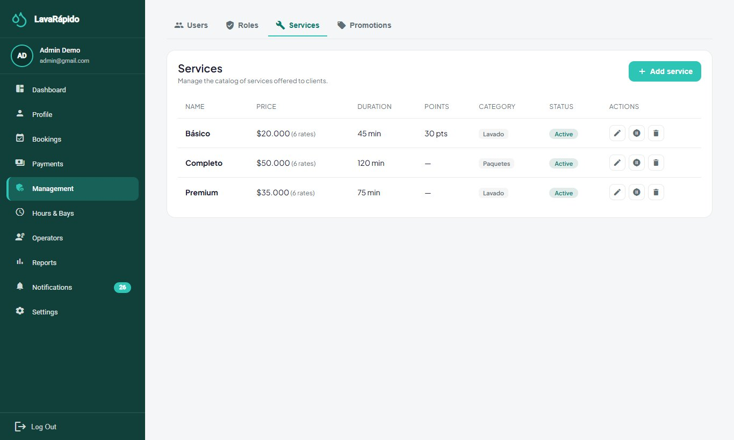
Modal: Add service | 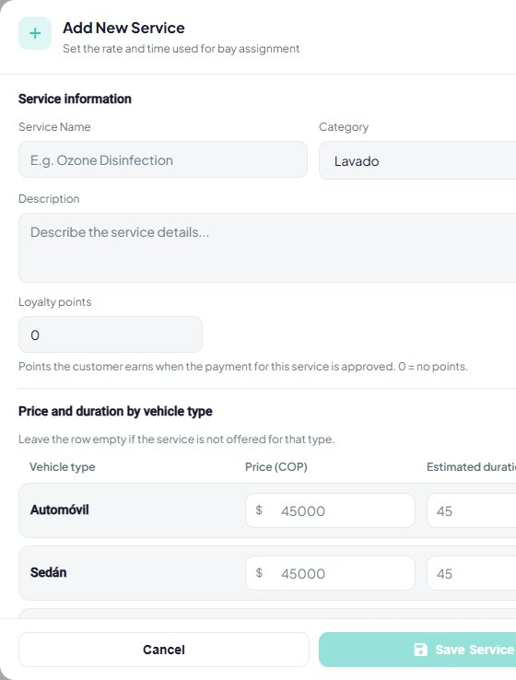
Management → Promotions | 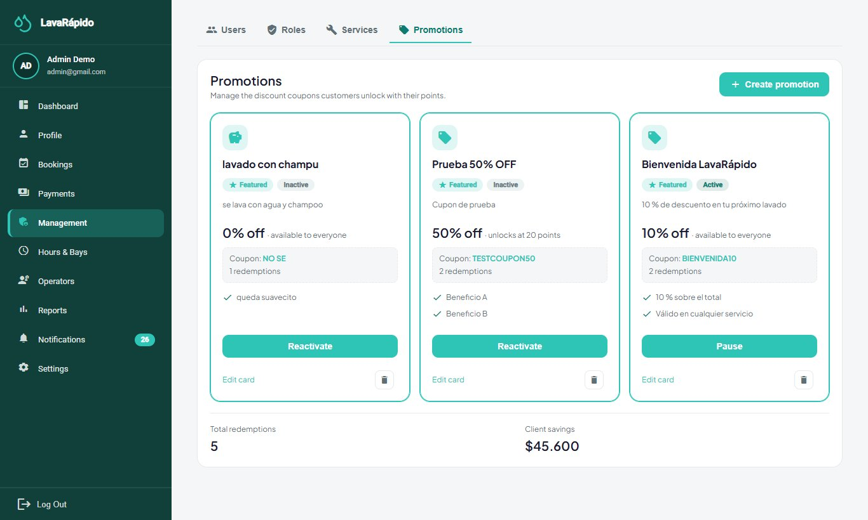
Modal: Create promotion | 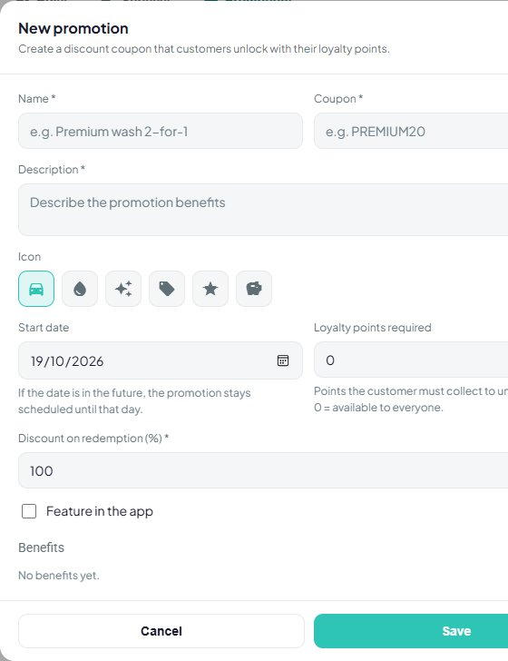
Opening hours and bays | 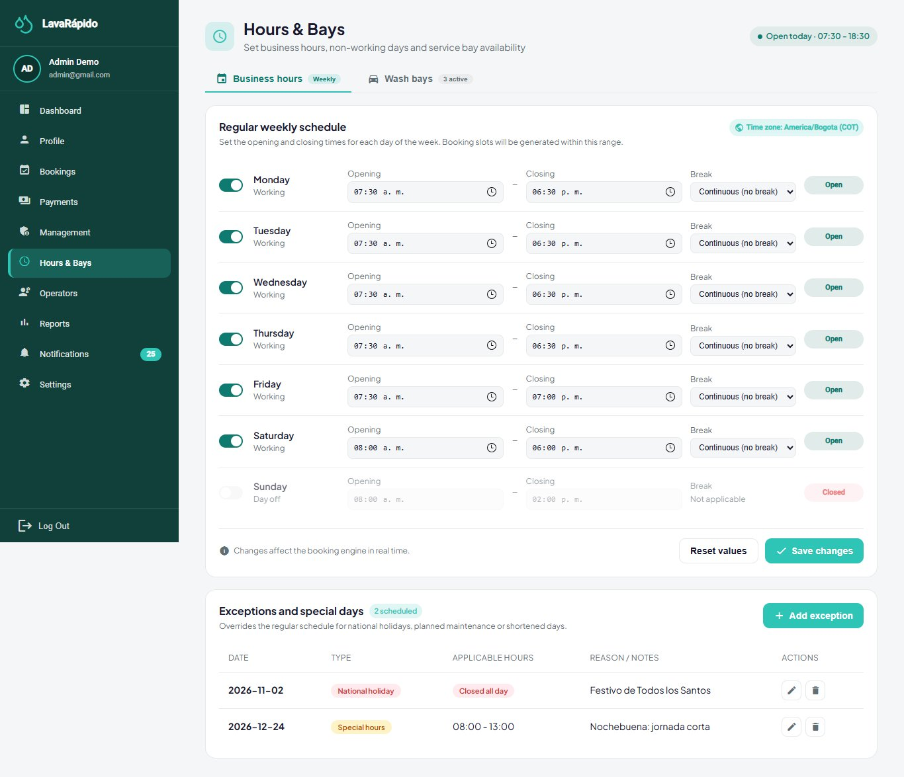
Modal: Add opening-hours exception | 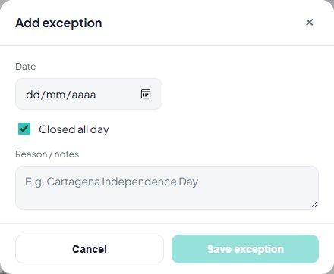
Operators | 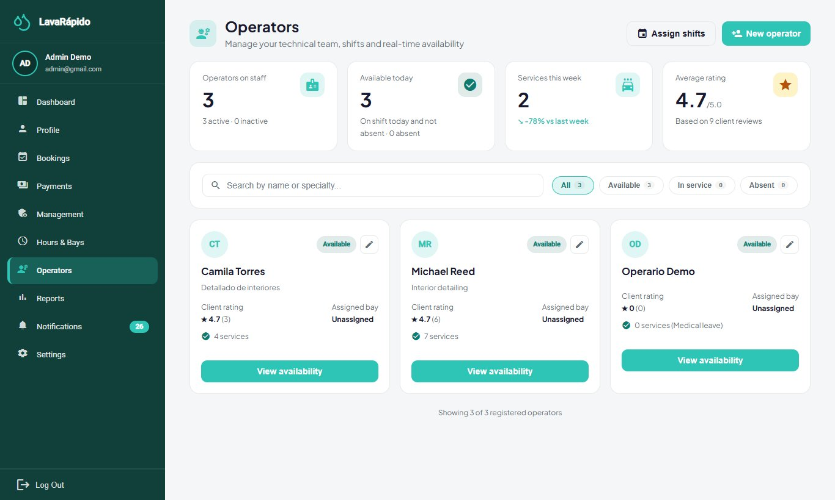
Modal: New operator
Modal: Assign shift | 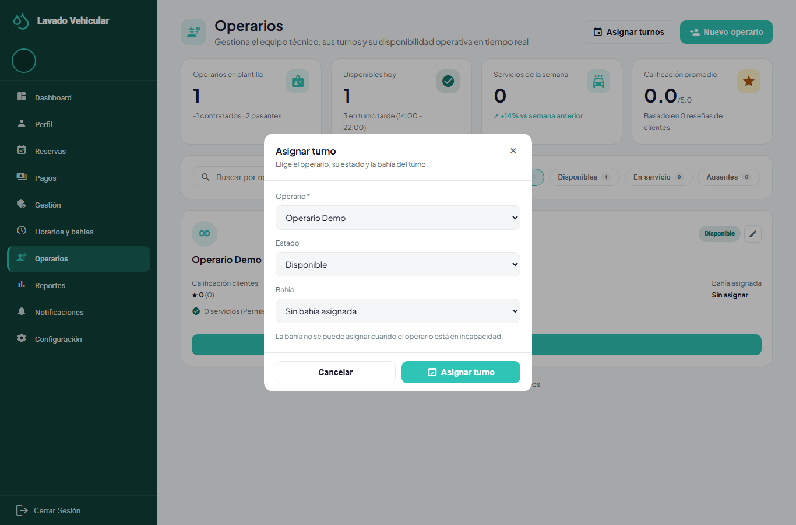
Bookings | 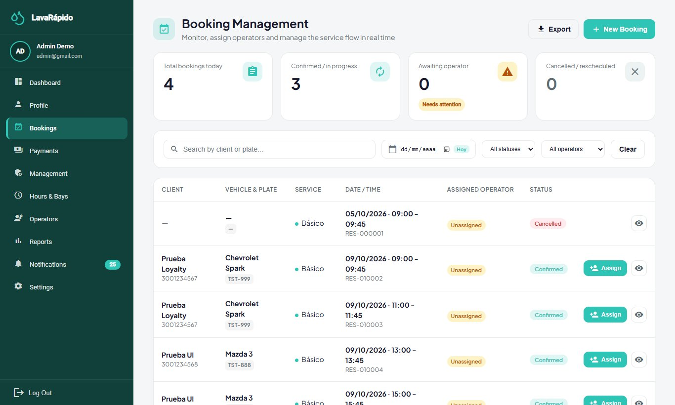
Modal: Assign an operator to a booking | 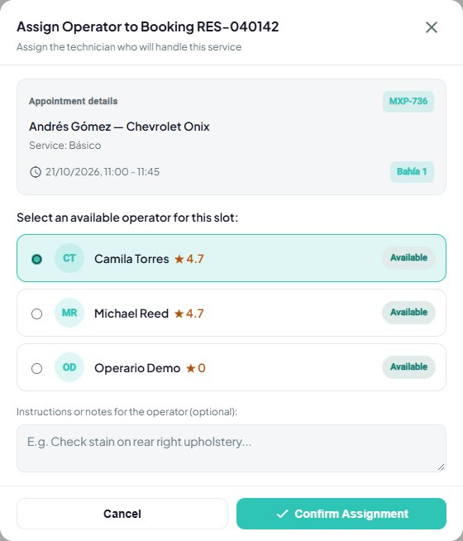
Payments | 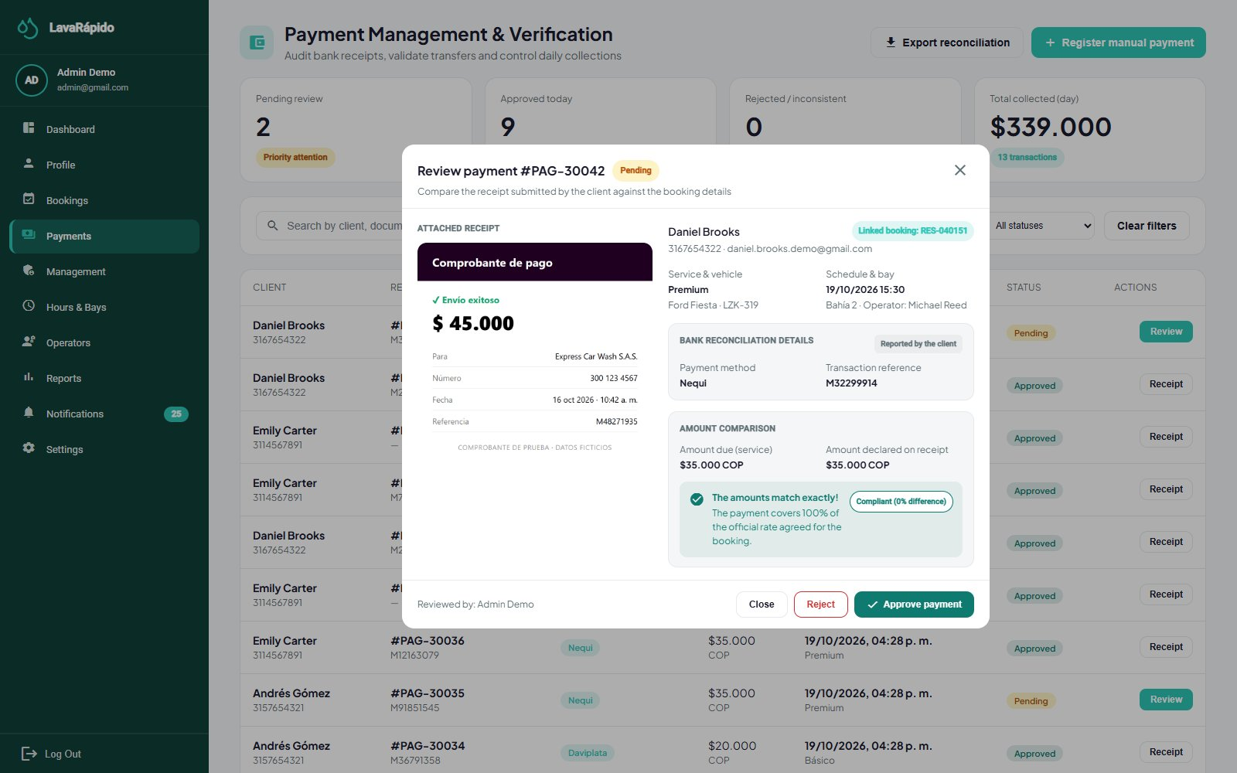
Modal: Record manual payment | 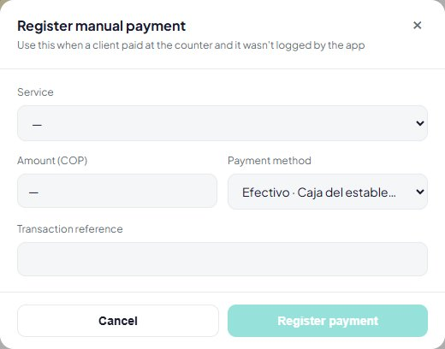
Reports | 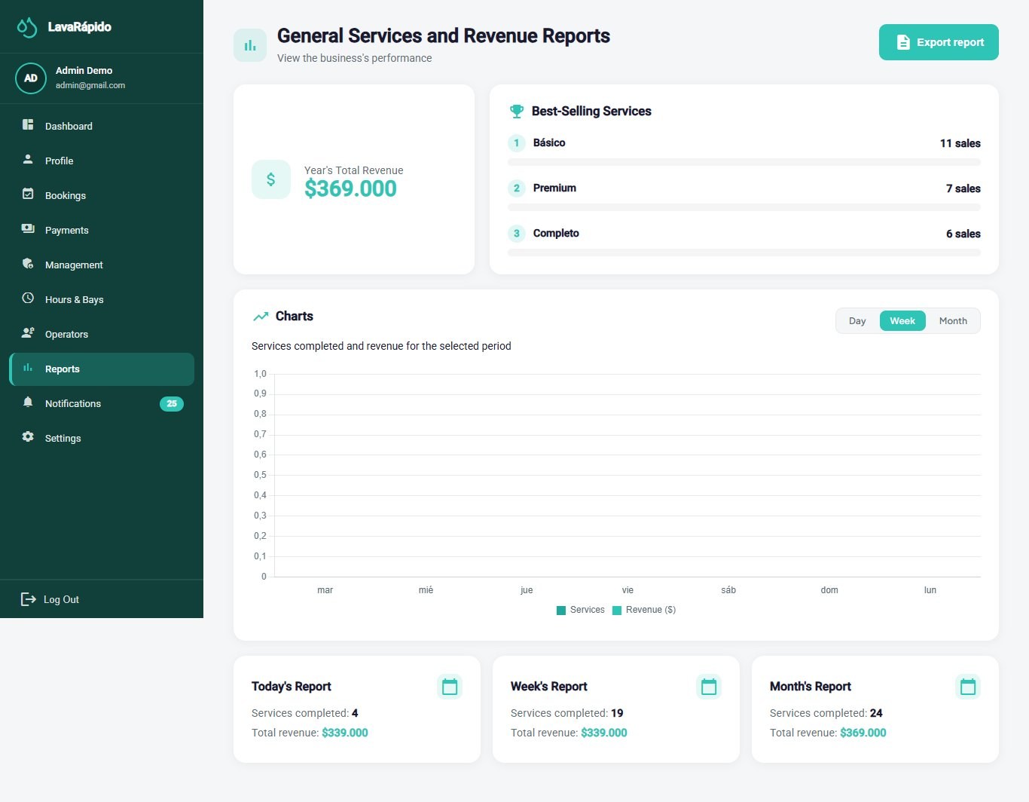
Settings → Payment accounts | 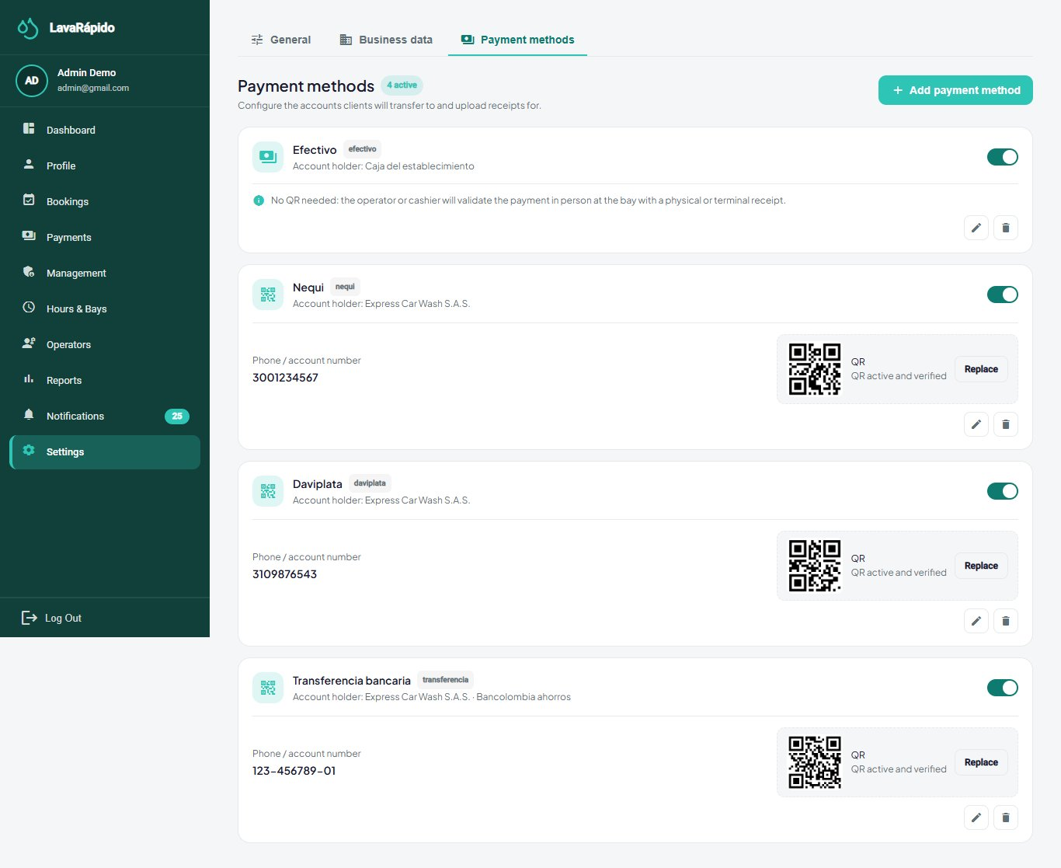
Modal: Add payment account | 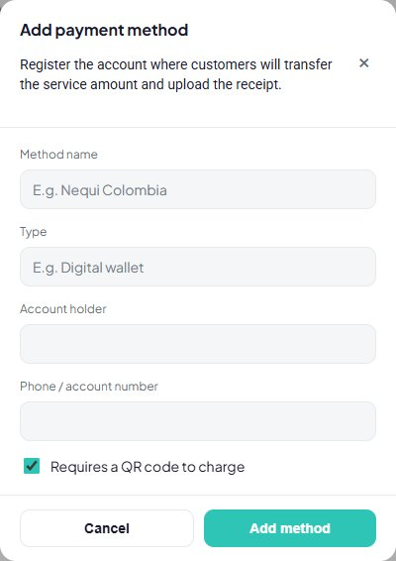
Notifications | 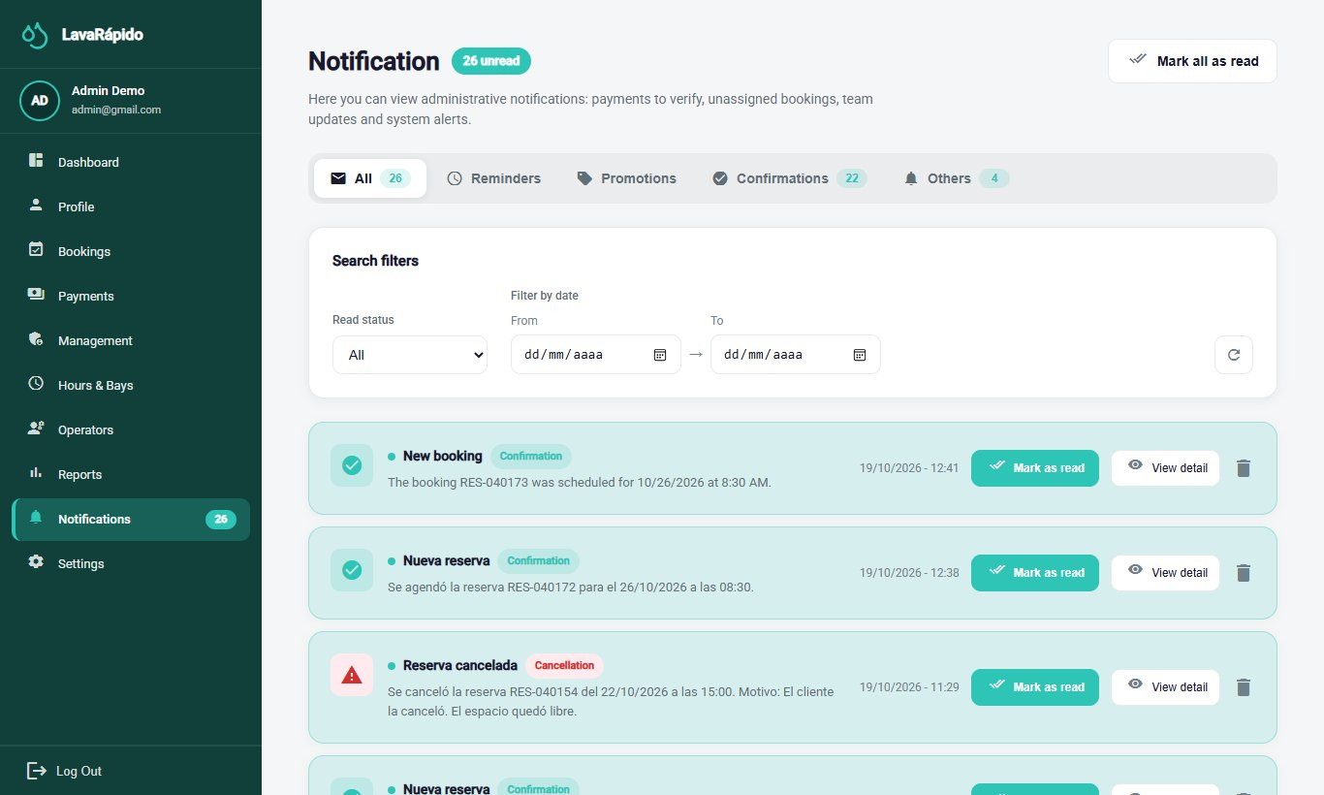
Profile | 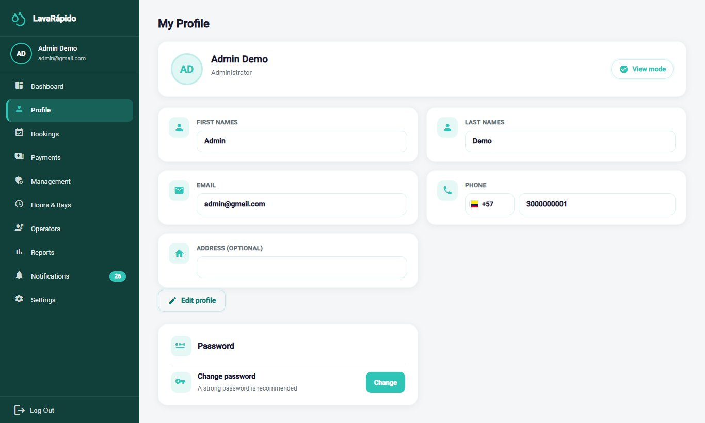

5.3 Customer role
Screen | Evidence
Dashboard | 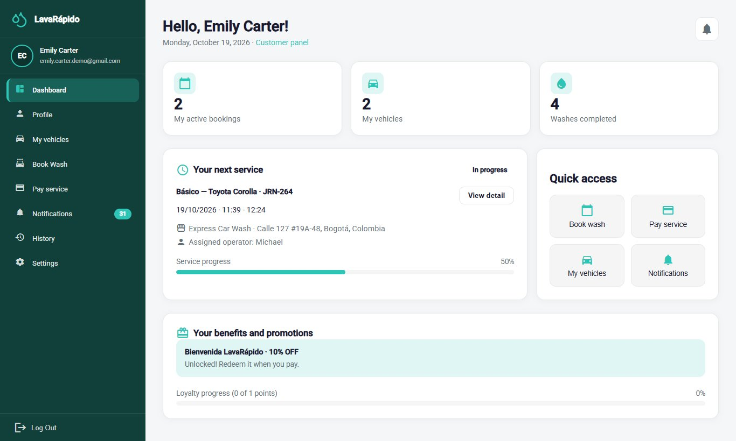
Modal: View details of the next service | 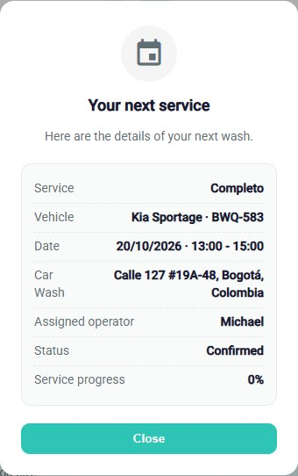
My vehicles | 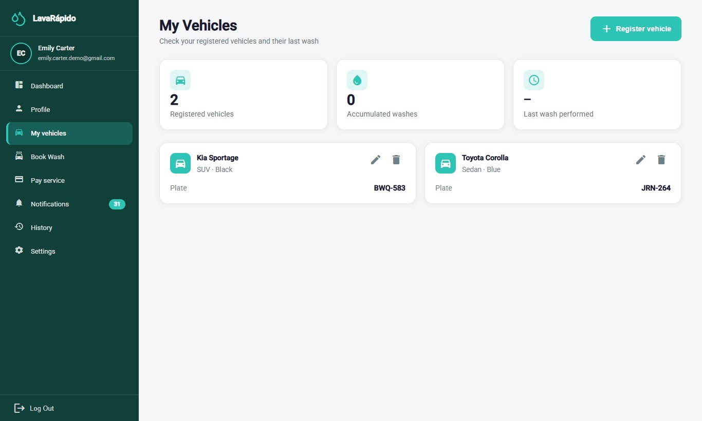
Modal: Register vehicle | 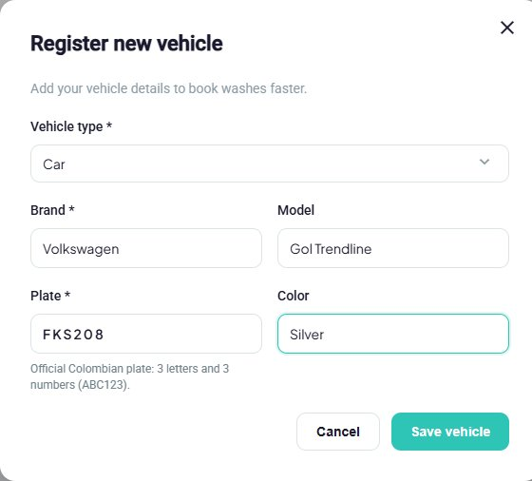
Book a wash | 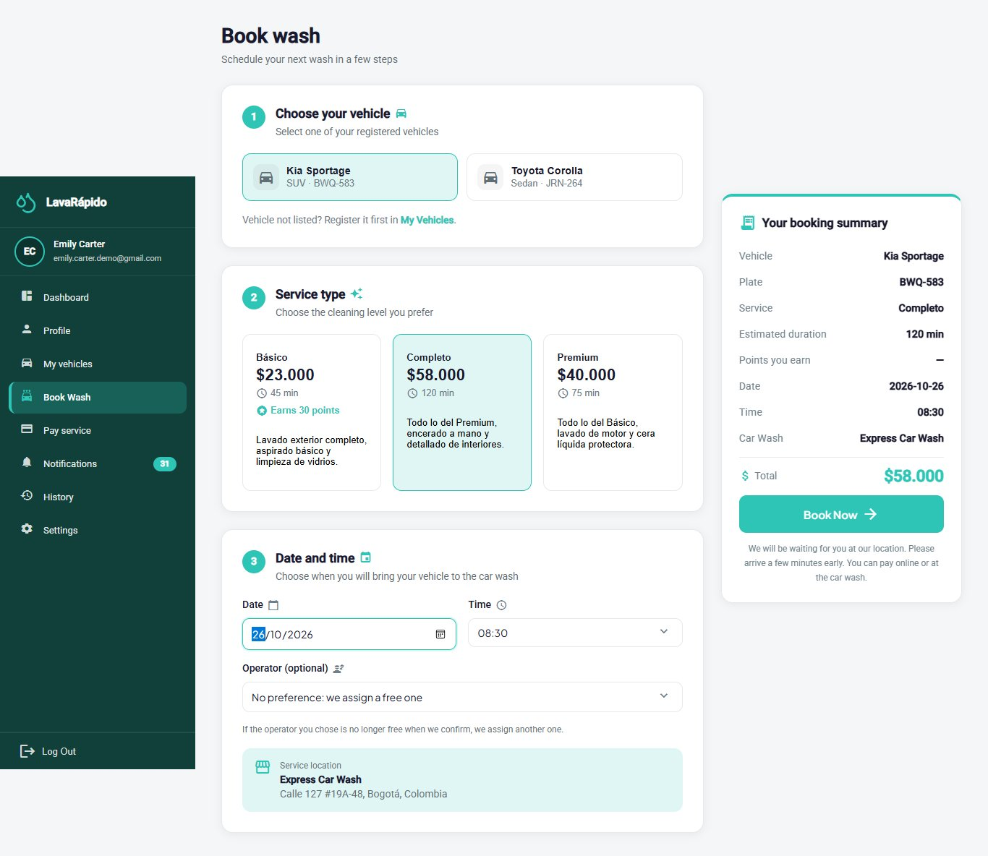
Booking history | 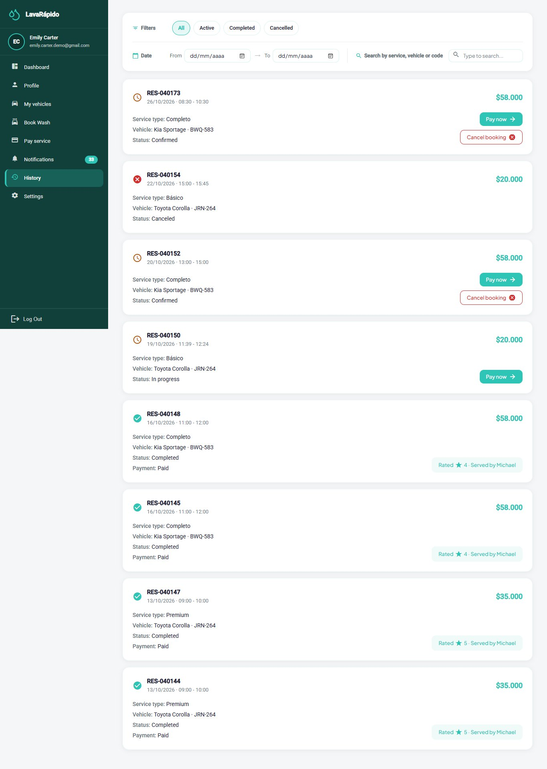
Pay for a service | 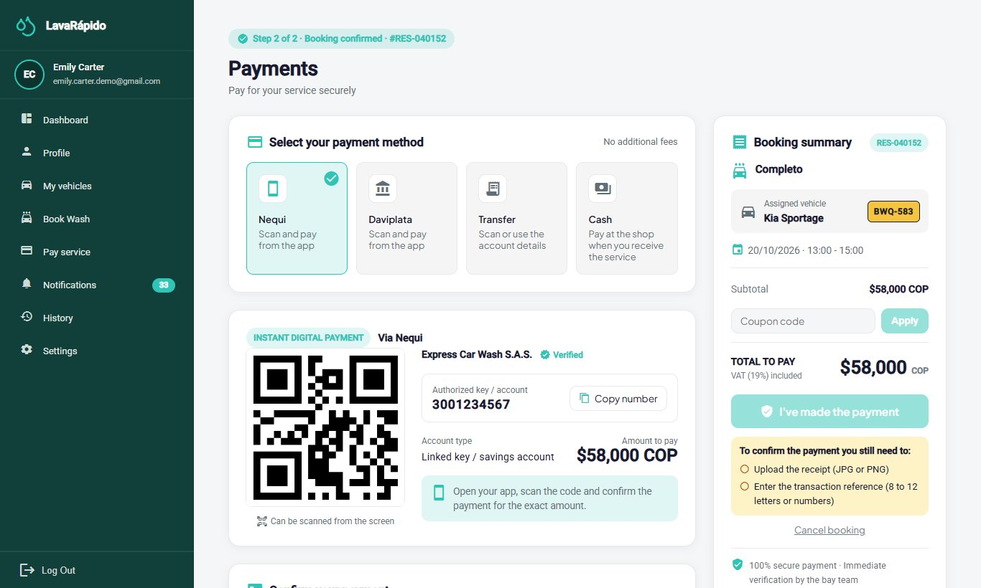
Modal: Confirm booking cancellation | 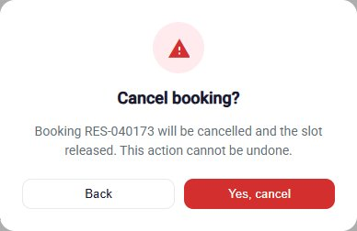
Notifications | 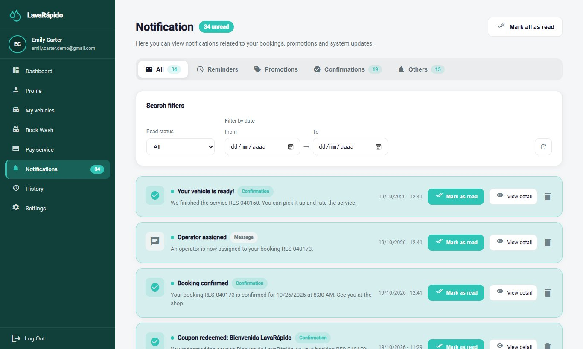
Settings (theme and language) | 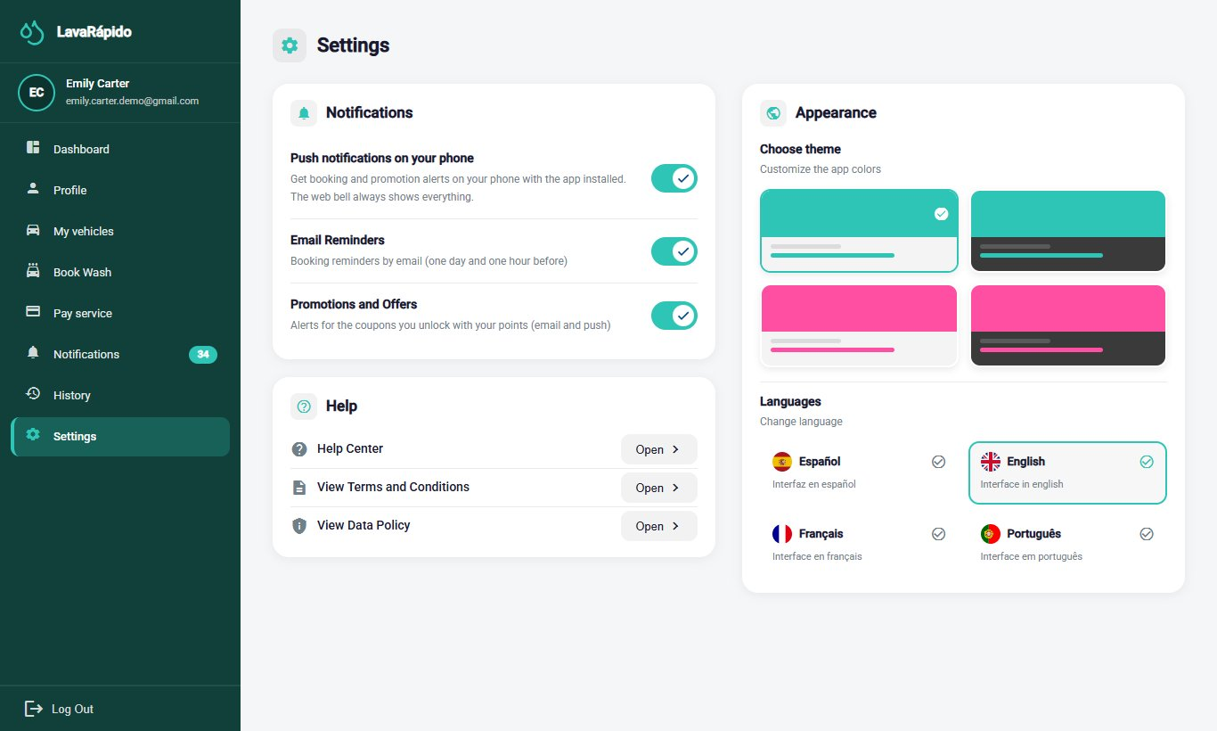

5.4 Operator role
Screen | Evidence
Main dashboard | 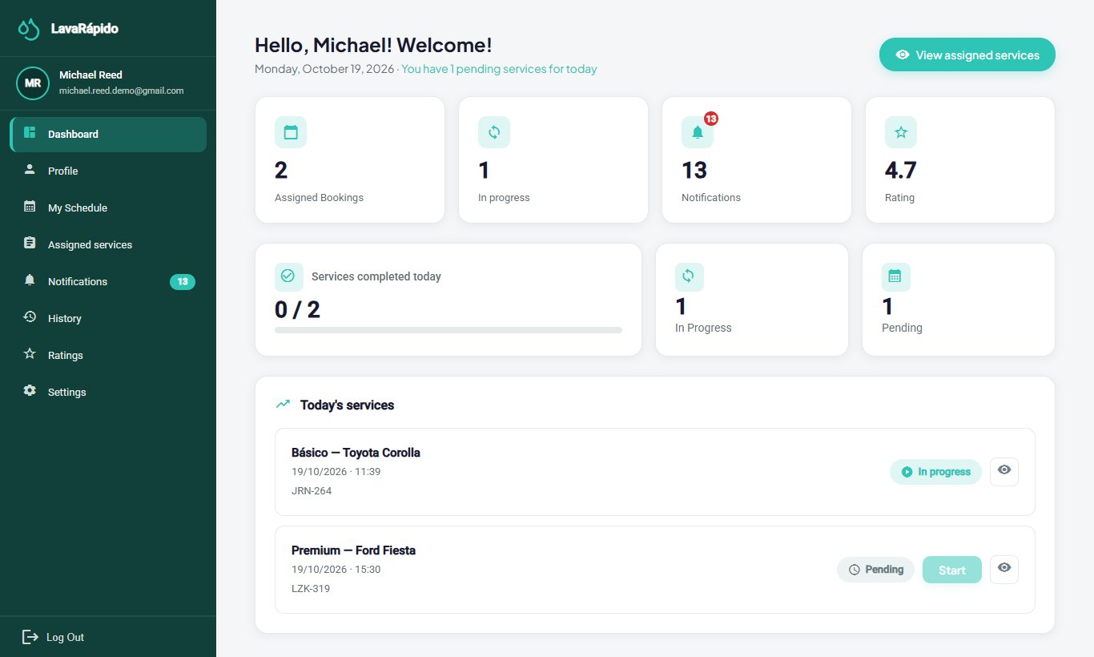
Assigned services | 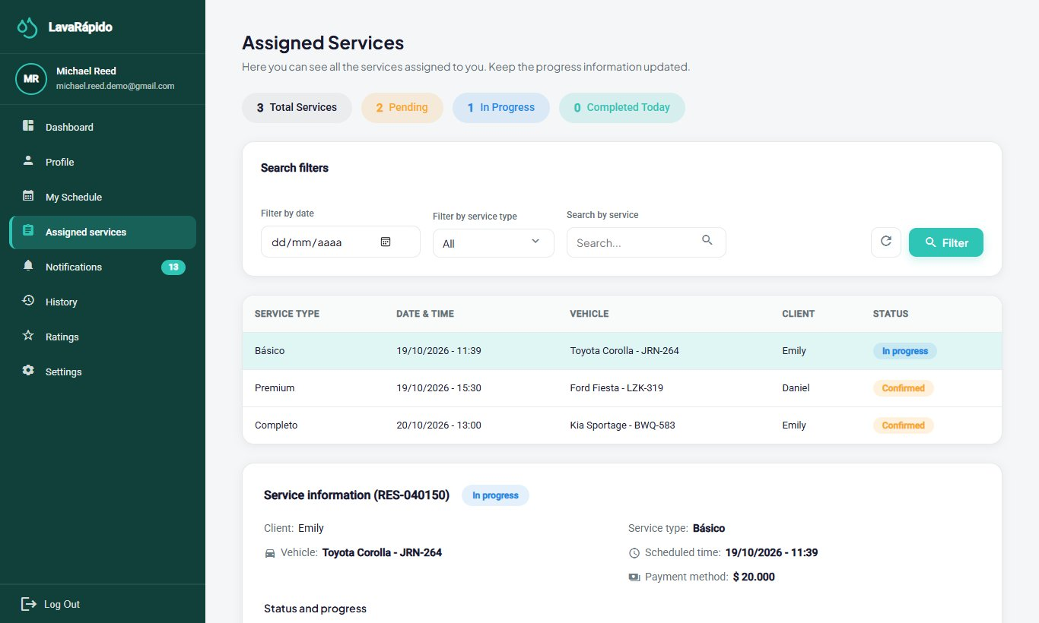
My schedule (availability) | 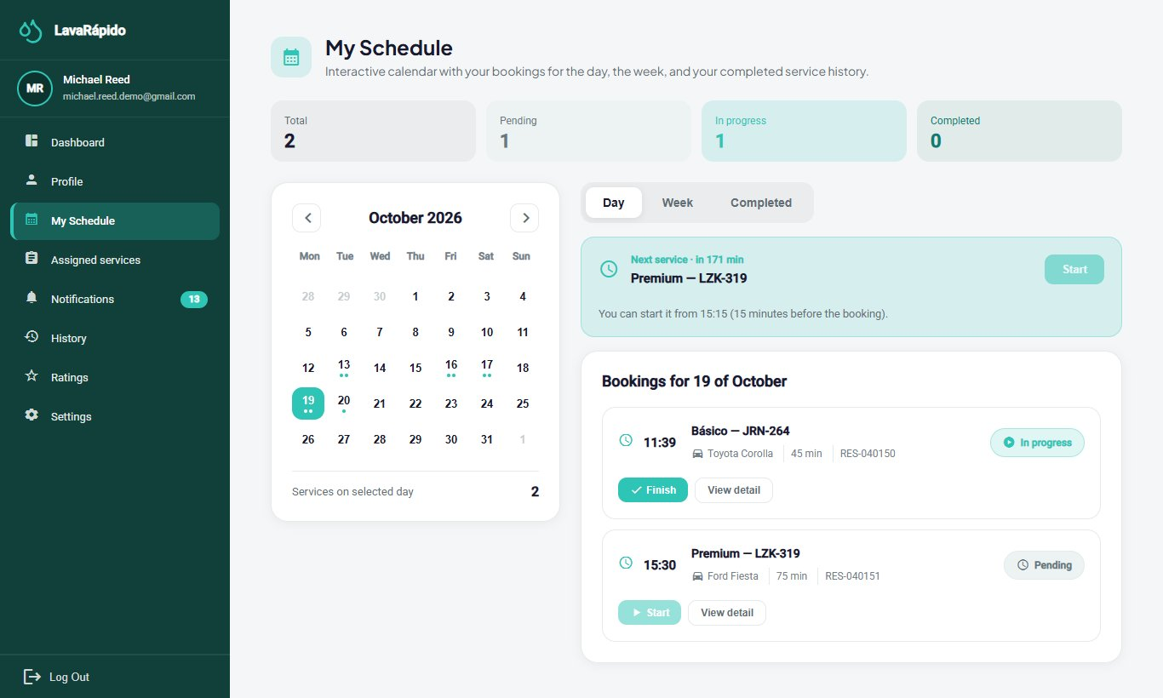
Service history | 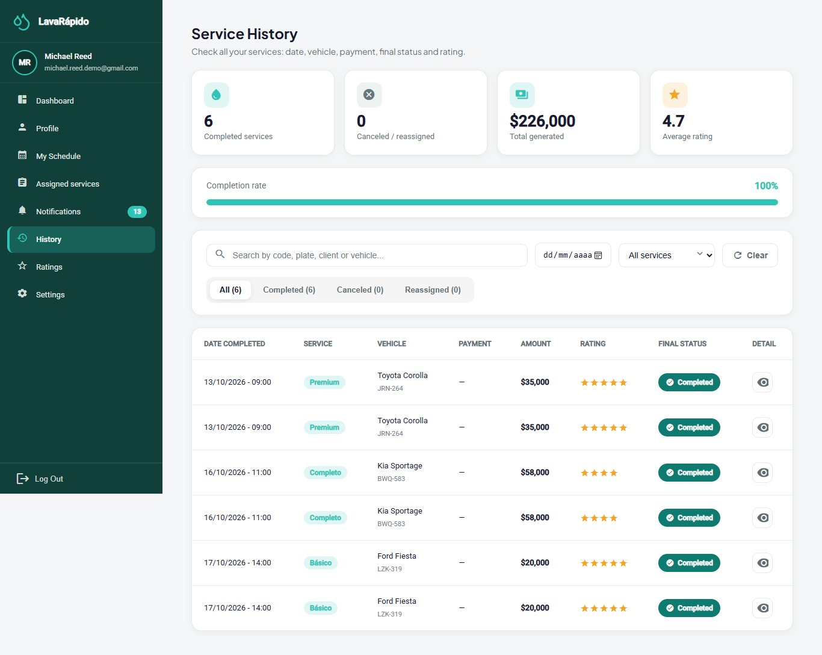
Ratings received | 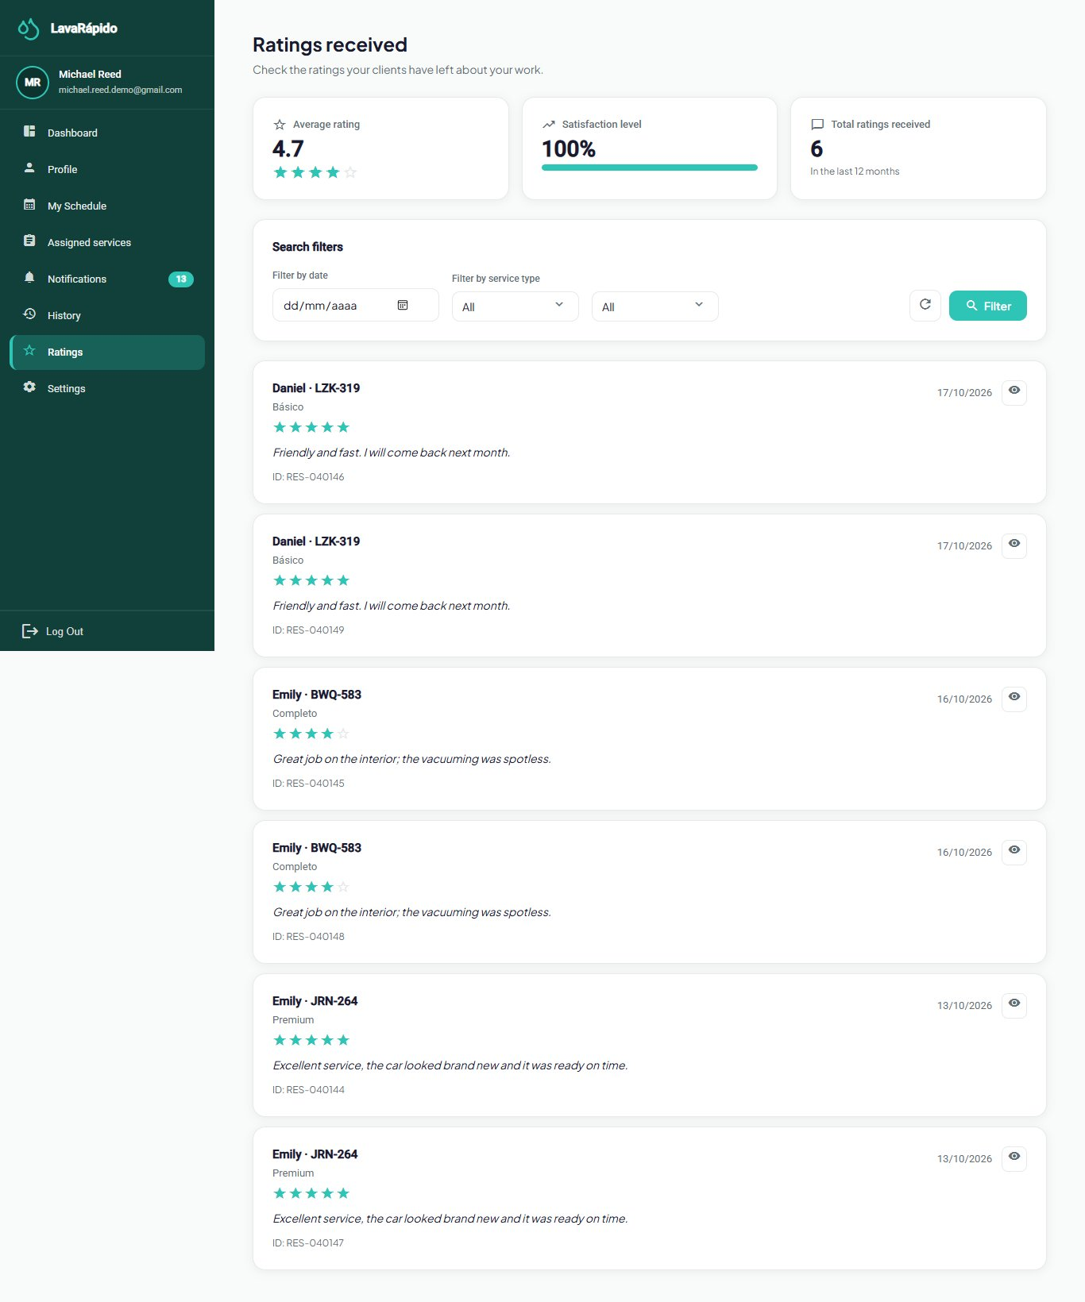

Correlation with the Software Requirements Specification
Dynamic view in this document | Requirements it illustrates
§2.1 Registration and welcome | RF-001, RF-018
§2.2 Booking a wash | RF-005, RF-006, RF-010
§2.3 Reminders and alert | RF-018
§2.4 Assignment and execution | RF-008, RF-009, RF-010, RF-011, RF-012, RF-012b
§2.5 Payment by receipt | RF-013, RF-013b, RF-014, RF-016
§2.6 Coupon redemption and points | RF-024, RF-025, RF-026
§2.7 Roles and permissions | RF-029
§2.8 Sign-in with lockout | RF-002, RF-003, RF-004b
§2.9 Inspection report | RF-036, RF-018
§2.11 Expiry of the digital payment | RF-005, RF-033
§3.1 to §3.6 Activities | The whole authentication, booking, operations, payment and promotion module
§4.1 to §4.5 States | RF-006, RF-007, RF-012b, RF-013b, RF-014, RF-024, RF-036

