Deployment Document — LavaRápido Vehicular
Vehicle wash management system · ADSO training project (SENA) Software implementation procedure on the production server.

Table of Contents
- General Information and Version Control
- Scope, Topology and Architecture
- Prerequisites and Preparation (Pre-deployment)
- Step-by-Step Deployment Procedure (Runbook)
- Verification, Testing and Evidence Plan (Smoke Tests)

1. General Information and Version Control

1.1 Deployment Fact Sheet

1.1.1 System identification and version (Release Tag)
Field | Value
System | LavaRápido Vehicular — bookings, payments and operations management for a car wash
Components | 6 backend microservices, API Gateway, web application, Android mobile app
Version (Release Tag) | v1.0.0 (pending: create the tag when develop is merged into main)
Deployed branch | develop (in every repository)
Mobile app version | 1.1.0 (versionCode 5), APK published on 2026-10-19 + over-the-air updates (EAS Update)
Repositories | lavarapido-infra, lavarapido-api-gateway, lavarapido-security-service, lavarapido-customer-service, lavarapido-booking-service, lavarapido-operation-service, lavarapido-notification-service, lavarapido-payment-service, Front-end-proyecto-web, LavadoVehicular-Movil
Public address | https://lavarapidovehicular.northcentralus.cloudapp.azure.com

1.1.2 Scheduled date, time and maintenance window
Field | Value
Initial deployment date | October 16, 2026
Maintenance window | 02:30 – 05:30 (Colombia time, UTC-5)
Actual duration | ~2 h 30 min (provisioning, image builds, HTTPS setup and testing)
User downtime | Not applicable: first deployment (no users in production yet)
Window for future updates | Outside the car wash's business hours (before 07:00 or after 18:00)
Latest update | 2026-10-19, 03:20 (server time), with update-server.sh: develop code up to October 17 and 18 and migration 039

1.1.3 Target environment (VPS / Staging / Production)
Field | Value
Environment | Academic production (also used as staging for the team's tests)
Provider | Microsoft Azure (Azure for Students subscription)
Type | Linux virtual machine (IaaS), equivalent to a VPS
Region | North Central US
Alternate environment | Hostinger KVM 2 VPS (purchased, pending payment activation)

1.1.4 Roles and responsibilities matrix (DevOps, Tech Lead, QA, DBA)
Responsibilities according to the services each member maintains on GitHub. To be confirmed with the team.
Role | Owner | Deployment responsibilities
DevOps | Brayan Cabrera | Server, Docker Compose, Caddy/HTTPS, deployment and update scripts
Tech Lead | Brayan Cabrera | Release approval, change review, team coordination
QA | (to be assigned) | Smoke tests and functional validation per role (client, operator, administrator)
DBA | (to be assigned) | Migrations, backups and database verification
booking-service and customer-service owner | Camilo Guilombo | Changes and verification of their services
payment-service and mobile app owner | Merari Urbano Quintero | Changes and verification of payments and the app

1.2 Document Version History
Version | Date | Author | Description
1.0 | 2026-10-16 | Brayan Cabrera | Initial version: deployment on Azure
1.1 | 2026-10-16 | Brayan Cabrera | Portainer CE installed, real evidence (5.4) and correction of Liquibase schemas and tables
1.2 | 2026-10-16 | Juan Camilo Guilombo | Table count corrected (57) and first administrator created with the environment variables
1.3 | 2026-10-19 | Juan Camilo Guilombo | Update of 2026-10-19 (migration 039 and app 1.1.0), SSH access with a personal key per member, deployment from GitHub Actions, continuous integration in the 10 repositories, and new terminal and web evidence
1.4 | 2026-10-20 | Development team | Topology diagram: customer-service also connects to RabbitMQ (it consumes security.user_registered to create the customer profile)

1.3 Change Summary (Release Notes)

1.3.1 New features
Platform and deployment
- Full deployment with Docker Compose and a production file (docker-compose.prod.yml).
- Automatic HTTPS with Caddy and a Let's Encrypt certificate (automatic renewal).
- Creation of the first administrator when installing on an empty database (ADMIN_EMAIL / ADMIN_PASSWORD).
- Server installation script (setup-server.sh) and one-step update script (update-server.sh).
- Android app download from the web (button and QR code) at the fixed address /app/LavaRapidoVehicular.apk.
Notifications
- Push notifications in the mobile app (Expo + Firebase) implemented with the Command pattern.
- Delivery through channels (push and email) with failure isolation.
- Notices in the account's language (Spanish, English, French and Portuguese).
- Notice to administrators about upcoming bookings without an operator.
- New app version notice by push and in the inbox.
- The web bell refreshes by itself and shows a floating notice with new notifications.
Bookings and operations
- Automatic operator assignment when a booking is confirmed (RF-008).
- The client can choose the operator among the available ones (RF-010).
- The operator can only start the service from 15 minutes before the booking.
- Vehicle inspection report with phases, findings and photos, shared with the client.
- Daily summary and operator team metrics for the administrator.
Payments and accounts
- Payment history sorted and filterable by date and service (RF-015/016).
- Account lockout for 15 minutes after 5 failed login attempts (RF-004b).
- Business data editable by the administrator and profile address stored in the backend.
Mobile app
- New version notice and over-the-internet updates (EAS Update) without reinstalling.
- Icon with the project logo and the name "LavaRapidoVehicular".

1.3.2 Bug fixes
- An approved payment was shown as "under verification" on the payments screen (web and mobile).
- The deployed web received 403 on every call because of the services' CORS configuration.
- security-service did not start when an administrator already existed (query outside a transaction).
- The app's operator list did not show a newly created operator until logging out.
- A late 401 after logging out showed the "session expired" notice.
- The new APK announcement could not read the inter-service key because of file permissions.
- Pending reminders kept being sent after the service was started or finished.
- No operator is assigned to bookings whose time has already passed, and cancelled bookings are no longer listed as pending.
- The web requested a non-existent favicon.ico (404 error in the console) and used deprecated translation options (console warning).

1.3.3 Infrastructure and dependency changes
Change | Detail
Docker images | Java: eclipse-temurin:21-jdk (build) and 21-jre (runtime) · .NET: dotnet/sdk:8.0 and aspnet:8.0 · Web: node:22-alpine and nginx:1.27-alpine
Infrastructure services | mcr.microsoft.com/mssql/server:2022-latest (Express), rabbitmq:4-management, caddy:2-alpine, liquibase/liquibase:4.29
New migrations | 032 (business data), 033 (inspection report), 034 (login lockout), 035 (address), 036 (registration date), 037 (operator profile), 038 (new-version notice type), and 039 (acceptance of the legal documents, applied on 2026-10-19)
Web dependencies | qrcode 1.5.4
Mobile dependencies | expo-notifications, expo-device, expo-build-properties, expo-updates, expo-application
External services | Expo Push + Firebase Cloud Messaging (push), Gmail SMTP (email), EAS (app builds and updates)

1.3.4 Breaking changes
- New mandatory variables on the server. Without them, Docker Compose does not start:
  - INTERNAL_API_KEY, PUBLIC_URL, RABBITMQ_USERNAME and RABBITMQ_PASSWORD;
  - RABBITMQ_* cannot be guest/guest.
- First administrator: the demo accounts (admin@gmail.com, etc.) only exist in development. In production the administrator is created with ADMIN_EMAIL / ADMIN_PASSWORD.
- Mobile app: the Android package changed to com.vehiclecarwash.app. Previous versions must be uninstalled once; later ones install on top.
- CORS: each service only accepts the origin defined in PUBLIC_URL.

1.3.5 Update of 2026-10-19
On 2026-10-19 at 03:20 (server time), update-server.sh was run. The develop changes up to October 17 and 18 were deployed:
- Database: migration 039, which stores the date and time each person accepts the Terms and the Data Processing Policy.
- Backend: the payment-service health check queries the database, payment-service handles the correlation identifier, the schedule error carries the reason (reason), two simultaneous requests no longer fail when creating the same operator, and a bay cannot be created in maintenance.
- Web: the payment screen selects by account, the profile option is called "Deactivate my account", Angular is on 21.2.25 and xlsx on 0.20.3, and there are layout fixes for phones.
- Mobile app: version 1.1.0 (versionCode 5), published on 2026-10-19 at 05:03, with the version shown in Settings.
The changes pushed afterwards are left for the next update: the error messages with spring.web.error in the Java services and the latest web and app fixes.

2. Scope, Topology and Architecture

2.1 Components and Artifacts in Scope

2.1.1 Administration panel (Portainer CE)
Status: installed on 2026-10-16. Panel to view the containers' status, logs and resource usage and restart them. Deployment and updates are still done with the scripts (section 4.3).
Artifact | Image | Access
Portainer CE | portainer/portainer-ce:2.21.5 (~11 MB of RAM) | Only through an SSH tunnel (https://localhost:9443); listens on 127.0.0.1, not exposed to the internet
Environment | local (socket /var/run/docker.sock) | Stack lavarapido visible as Compose · Limited (created outside Portainer)

2.1.2 Web Frontend Layer (SPA / Nginx Web Server)
Artifact | Technology | Image / container
Web application | Angular 21 (SPA), i18n in 4 languages | lavarapido/web:local → lavarapido-web
Web server | nginx 1.27: serves the build and forwards /api to the gateway | inside lavarapido-web
Reverse proxy and HTTPS | Caddy 2 (Let's Encrypt) | lavarapido-caddy
Android mobile app | Expo / React Native, APK built with EAS | Served at /app/LavaRapidoVehicular.apk

2.1.3 Backend API Layer (Java Spring Boot / C# .NET Core)
Service | Technology | Internal port | Responsibility
api-gateway | Spring Cloud Gateway (Java 21) | 8080 | Single entry point for /api/v1
security-service | Spring Boot (Java 21) | 3001 | Accounts, login, JWT, roles, preferences
customer-service | Spring Boot (Java 21) | 3002 | Clients and vehicles
booking-service | Spring Boot (Java 21) | 3003 | Catalog, schedule, bookings
operations-service | Spring Boot (Java 21) | 3004 | Operators, assignment, execution, ratings, inspection
payment-service | ASP.NET Core 8 (C#) | 3005 | Payments, receipts, loyalty and promotions
notification-service | Spring Boot (Java 21) | 3006 | Inbox, email, push, reminders
rabbitmq | RabbitMQ 4 | 5672 | Events between services (exchange carwash.events)

2.1.4 Persistence Layer (SQL Server)
Artifact | Detail
Engine | Microsoft SQL Server 2022, Express edition (container lavarapido-sqlserver)
Database | LavaRapido: 9 schemas and 57 tables — security (11), customer (3), booking (10), catalog (3), execution (11), notification (6), payment (7), promotion (5), audit (1)
Migrations | Liquibase: the Java services apply them on startup; payment-service applies them with the payment-migrate container. Each service keeps its history in dbo.DATABASECHANGELOG_<SERVICE>
Persistent volumes | sqlserver-data (database), rabbitmq-data (queues), caddy-data (certificates)

2.2 Network and Infrastructure Architecture Diagram

2.2.1 VPS server topology
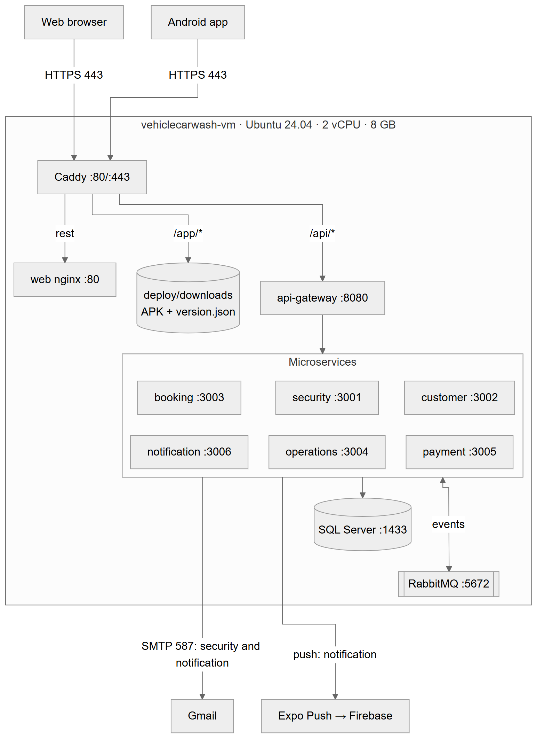

2.2.2 Internal container network (Docker Bridge Network)
- All containers are on the bridge network lavarapido_default, created by Docker Compose.
- They call each other by service name: sqlserver, rabbitmq, security-service, api-gateway, web, etc. Docker's internal DNS is 127.0.0.11.
- The /internal/** routes (calls between services) are protected with the X-Internal-Key header (INTERNAL_API_KEY). The gateway does not publish them.
- No port of the internal network is published on the machine, except Caddy's.

2.2.3 Routing and Reverse Proxy with TLS/HTTPS certificates
Public route | Destination | Notes
https://<domain>/api/* | api-gateway:8080 | REST API v1 for the web and the app
https://<domain>/app/* | deploy/downloads folder | APK and version.json (no cache)
https://<domain>/* | web:80 | Angular SPA (routes → index.html)
http://<domain>/* | 308 redirect to HTTPS | Automatic (Caddy)
- Certificate: Let's Encrypt, issued and renewed automatically by Caddy (expires on 2027-01-14 and is renewed before). It is stored in the caddy-data volume.
- Domain: Azure DNS label on the public IP: lavarapidovehicular.northcentralus.cloudapp.azure.com.
- Configuration: lavarapido-infra/deploy/Caddyfile.

2.3 Environments, IP Addressing and Ports Matrix
Environment | Host | IP / URL | Use
Development | Each member's PC | localhost (web 4200, mobile 8081, gateway 8080) | Programming and local testing (Mailpit catches the emails)
Academic production | Azure VM vehiclecarwash-vm | Static IP 64.236.160.129 · https://lavarapidovehicular.northcentralus.cloudapp.azure.com | Presentation, team testing, installed app
Alternate production (pending) | Hostinger KVM 2 VPS | To be assigned | Migration once the payment is activated

Port | Service | Exposed to the internet?
22 | SSH (key only) | Yes (administration)
80 / 443 | Caddy | Yes
8080 | api-gateway | No (internal network only)
3001–3006 | Microservices | No
1433 | SQL Server | No
5672 / 15672 | RabbitMQ / panel | No
9443 | Portainer CE | No (only 127.0.0.1, through an SSH tunnel)

3. Prerequisites and Preparation (Pre-deployment)

3.1 Operating System and VPS Prerequisites Checklist

3.1.1 Available hardware resources (CPU, RAM, disk)
Resource | Minimum required | Available (Azure B2as_v2) | Measured in operation | ✓
CPU | 2 x86-64 vCPU (SQL Server does not run on ARM) | 2 AMD x64 vCPU | Peaks only while building images | ✅
RAM | 8 GB | 7.7 GB + 4 GB of swap | 3.3 GB used with the 12 containers, Portainer included (2026-10-19) | ✅
Disk | 30 GB | 64 GB standard SSD | 26 GB used of 61 GB (42%), mostly images and build cache (2026-10-19) | ✅
Operating system | Ubuntu 24.04 or 26.04 LTS | Ubuntu 24.04.4 LTS | — | ✅
Network | Ports 22, 80 and 443 open | Azure security group | Verified from the internet | ✅

3.1.2 Docker engine status and local socket
docker --version # Docker version 29.x
docker compose version # Docker Compose v5.x
sudo systemctl is-enabled docker # enabled → starts with the machine
sudo systemctl is-active docker # active
ls -l /var/run/docker.sock # local engine socket
deploy/setup-server.sh installs Docker (official get.docker.com script) if missing, enables it on boot and creates 4 GB of swap.

3.2 Backup Strategy and Execution
Status: procedure defined; periodic automation is pending. It is run manually before every deployment that includes migrations.

3.2.1 Logical database backup (Dump / Snapshot)
cd ~/lavarapido/lavarapido-infra
P=$(grep '^DB_PASSWORD=' .env.production | cut -d= -f2-)
sudo docker exec -e SQLCMDPASSWORD="$P" lavarapido-sqlserver /opt/mssql-tools18/bin/sqlcmd \
-S localhost -U sa -C -Q "BACKUP DATABASE [LavaRapido] TO DISK = N'/var/opt/mssql/backup/LavaRapido_$(date +%F).bak' WITH COMPRESSION, INIT"
sudo docker cp lavarapido-sqlserver:/var/opt/mssql/backup/LavaRapido_$(date +%F).bak ~/backups/
Infrastructure-level complement: disk snapshot of the VM from the Azure portal (Disks → Create snapshot).

3.2.2 Backup of Docker persistent volumes
mkdir -p ~/backups
for v in lavarapido_sqlserver-data lavarapido_rabbitmq-data lavarapido_caddy-data; do
sudo docker run --rm -v "$v":/data:ro -v ~/backups:/backup alpine \
tar czf "/backup/${v}_$(date +%F).tar.gz" -C /data .
done
For a consistent backup of sqlserver-data, the BACKUP DATABASE from 3.2.1 is preferred, because it can be done while the database is running.

3.2.3 Backup of Stack configurations and previous variables
cd ~/lavarapido/lavarapido-infra
cp .env.production ~/backups/env.production_$(date +%F) # contains secrets: chmod 600
chmod 600 ~/backups/env.production_*
git -C ~/lavarapido/lavarapido-infra rev-parse HEAD > ~/backups/infra-commit_$(date +%F).txt
The stack configuration (docker-compose.yml, docker-compose.prod.yml, deploy/Caddyfile) is versioned on GitHub (lavarapido-infra). To go back, a git checkout <commit> and a new up -d are enough.

3.3 Environment Variables and Secrets Management
- Secrets live only in ~/lavarapido/lavarapido-infra/.env.production (permissions 600), which is in .gitignore.
- The template without values is .env.production.example.
- Key generation: the keys were generated on the server with openssl rand -base64 48 and were never copied or displayed.
- First administrator: the owner wrote ADMIN_EMAIL and ADMIN_PASSWORD directly in .env.production on the server; security-service created the account at startup because there was no administrator yet (AdministratorBootstrapRunner). The password is not in any repository.

3.3.1 Database connection parameters
Variable | Description
DB_PASSWORD | sa password (8+ characters, uppercase, lowercase, number and symbol)
DB_NAME | LavaRapido
DB_USERNAME | sa (pending improvement: a user with limited permissions)
DB_URL (compose) | jdbc:sqlserver://sqlserver:1433;databaseName=LavaRapido;encrypt=true;trustServerCertificate=true

3.3.2 Token signing keys (JWT Secret Keys)
Variable | Description
JWT_SECRET | HS256 key shared by the services that validate tokens (≥ 32 bytes). Tokens last 1 hour
INTERNAL_API_KEY | Key for the /internal/** routes between services (X-Internal-Key header)
RABBITMQ_USERNAME / RABBITMQ_PASSWORD | Dedicated RabbitMQ user (not guest)
MAIL_USERNAME / MAIL_PASSWORD / MAIL_FROM | Gmail account with an app password
ADMIN_EMAIL / ADMIN_PASSWORD | First administrator (only used if the database has none)
PUBLIC_URL / SITE_ADDRESS | Public address (CORS, email links) and Caddy domain
PUSH_ENABLED / MESSAGING_ENABLED | true: push with Expo and events with RabbitMQ

3.3.3 Memory and runtime limits (JVM -Xmx, ASPNETCORE_ENVIRONMENT)
Container | Limit (mem_limit) | Runtime
5 Java services + gateway | 512 MB each | java -XX:MaxRAMPercentage=75 → maximum heap ≈ 384 MB · prod profile (no Swagger)
payment-service | 384 MB | ASPNETCORE_ENVIRONMENT=Production
SQL Server | MSSQL_MEMORY_LIMIT_MB=1536 | MSSQL_PID=Express
web / caddy | 64 MB each | nginx / Caddy
All | restart: unless-stopped | They restart by themselves on failure and when the machine boots

3.4 Communication Protocol and Maintenance Window
- Advance notice (24 h): the DevOps informs the team through the project group about the date, the window and the changes (release notes).
- Freeze: no changes are pushed to the branch being deployed during the window.
- Start: "deployment started" is announced and the backup is taken (section 3.2).
- Execution: runbook in section 4.
- Verification: smoke tests in section 5. QA confirms each role.
- Closing: "deployment finished" is announced with the version and the evidence. If it fails, rollback: git checkout of the previous commit in lavarapido-infra and in the services, update-server.sh, and if the migration damaged data, restore the .bak.
- Standard window: outside the car wash's business hours (before 07:00 or after 18:00, Colombia time).

4. Step-by-Step Deployment Procedure (Runbook)

4.1 Verification and Access to the Base Platform (Portainer CE)
Server access:
ssh -i ~/.ssh/lavarapido_azure azureuser@64.236.160.129
Access of each member with their own key: each person creates their key on their computer and only shares the public part (.pub). The private one is never sent or pushed to a repository.
ssh-keygen -t ed25519 -f $HOME\.ssh\lavarapido_azure # on the person's PC
Get-Content $HOME\.ssh\lavarapido_azure.pub # this line is the one to share
The DevOps owner adds it once, from the portal (vehiclecarwash-vm → Reset password → Reset SSH public key, user azureuser) or from the server with echo "<public key>" >> ~/.ssh/authorized_keys. As of 2026-10-19, the keys with access are the DevOps owner's, Juan Camilo's, and GitHub Actions' (restricted, see 4.3.3). To remove an access, delete its line from authorized_keys.
Portainer CE installation (done on 2026-10-16; listens only inside the server):
sudo docker volume create portainer_data
sudo docker run -d --name portainer --restart unless-stopped \
-p 127.0.0.1:9443:9443 \
-v /var/run/docker.sock:/var/run/docker.sock \
-v portainer_data:/data portainer/portainer-ce:2.21.5
Access from the administrator's PC (SSH tunnel, without opening ports):
ssh -i ~/.ssh/lavarapido_azure -L 9443:localhost:9443 azureuser@64.236.160.129
# then open https://localhost:9443 → user "admin"
- Password of the admin user: it was generated during installation and is on the server, in ~/portainer-admin-password (permissions 600). It is read with cat ~/portainer-admin-password and can be changed from Portainer (My account).
- local environment: registered on the Docker socket. lavarapido appears under Containers and Stacks.

4.2 Database Deployment and Migration

4.2.1 Running DDL/DML scripts or migration tools (Liquibase)
Migrations are automatic:
- The db-init container creates the LavaRapido database if it does not exist.
- The payment-migrate container (Liquibase 4.29) applies the payment-service changelogs (db/changelog/db.changelog-master.yaml) and exits.
- Each Java service applies its own changelogs on startup. Numbering is global: 001–039 plus the 1xx catalog seeds.
- Hibernate only validates that the model matches the tables (ddl-auto: validate); it never alters tables.
Production does not load test data: only catalogs (roles, services, statuses, schedule and business data).

4.2.2 Verification of schema, index and user integrity
P=$(grep '^DB_PASSWORD=' .env.production | cut -d= -f2-)
q(){ sudo docker exec -e SQLCMDPASSWORD="$P" lavarapido-sqlserver /opt/mssql-tools18/bin/sqlcmd \
-S localhost -U sa -C -d LavaRapido -Q "SET NOCOUNT ON; $1"; }
q "SELECT s.name AS esquema, COUNT(t.name) AS tablas FROM sys.schemas s JOIN sys.tables t ON t.schema_id=s.schema_id GROUP BY s.name"
for s in SECURITY CUSTOMER BOOKING OPERATIONS NOTIFICATION PAYMENT; do
q "SELECT '$s' AS servicio, COUNT(*) AS changesets, SUM(CASE WHEN EXECTYPE IN ('EXECUTED','MARK_RAN') THEN 1 ELSE 0 END) AS ok FROM DATABASECHANGELOG_$s"
done
q "SELECT COUNT(*) AS indices FROM sys.indexes WHERE object_id IN (SELECT object_id FROM sys.tables)"
q "SELECT u.username, r.code FROM security.app_user u JOIN security.user_role ur ON ur.user_id=u.user_id JOIN security.role r ON r.role_id=ur.role_id WHERE r.code='ADMIN'"
Expected result:
- the 9 schemas with their tables;
- in each service, ok equal to changesets (2026-10-16: 143 of 143; 2026-10-19: 144 of 144, with 039);
- the initial administrator created (security log: First administrator created).

4.3 Application Stack Deployment and Orchestration

4.3.1 Loading the docker-compose.yml file in Portainer
The stack is defined with two files versioned in lavarapido-infra:
- docker-compose.yml: the base, the same as in development.
- docker-compose.prod.yml: overrides the production settings: no internal ports, prod profile, memory limits, Caddy, web and CORS.
Current deployment (CLI):
# 1. Download the 9 repositories (and prepare Docker and swap the first time)
curl -fsSL https://raw.githubusercontent.com/BrayanCABRERA123/lavarapido-infra/develop/deploy/setup-server.sh -o setup-server.sh
bash setup-server.sh
With Portainer: Stacks → Add stack → Repository. The images are built from 9 sibling repositories, so the recommended flow is:
- build the images with the CLI (step 4.3.3);
- use Portainer to view, restart, check logs and resource usage of the containers of the lavarapido stack, which appears as a "limited" stack because it was created outside Portainer.

4.3.2 Injecting the Stack's environment variables
cd ~/lavarapido/lavarapido-infra
cp .env.production.example .env.production
chmod 600 .env.production
nano .env.production # fill in the values from section 3.3 (keys generated with openssl)
In Portainer, the same variables are loaded in Environment variables → Load variables from .env file.

4.3.3 Service deployment and container image updates
First deployment:
cd ~/lavarapido/lavarapido-infra
sudo docker compose -f docker-compose.yml -f docker-compose.prod.yml \
--env-file .env.production --profile app up -d --build
Later updates: first push the changes to GitHub and then:
bash ~/lavarapido/lavarapido-infra/deploy/update-server.sh # everything
bash ~/lavarapido/lavarapido-infra/deploy/update-server.sh web # only the web
bash ~/lavarapido/lavarapido-infra/deploy/update-server.sh security-service notification-service
From GitHub, without SSH: with the machine on, in the lavarapido-infra repository → Actions → Desplegar en Azure → Run workflow. In Servicios, leave it empty to update everything or write the names (web payment-service). At the end, the workflow checks that the web and the API answer 200. It uses its own GitHub key (secret AZURE_SSH_KEY) that on the server can only run deploy/ci-deploy.sh, which validates the names and does not let two updates run at the same time.
Continuous integration: since 2026-10-19 the 10 repositories have .github/workflows/ci.yml, which runs on every push or pull request to develop and main, and the result appears as ✓ or ✗ next to each commit:
Repository | What it checks
Java services and api-gateway | ./mvnw verify: builds and runs the tests (Java 21)
payment-service | dotnet build and dotnet test (.NET 8; integration tests are skipped without SQL Server)
Front-end-proyecto-web | Production build and ng test
LavadoVehicular-Movil | tsc --noEmit (the APK is still built with EAS)
lavarapido-infra | Syntax and shellcheck of deploy/*.sh, docker compose config, and e2e/ syntax
Publishing the mobile app, from the PC, in the app folder:
eas build -p android --profile preview # new APK (native changes)
npm run publish:apk -- "what changed" # publishes it in /app/ and notifies by push
npm run publish:update -- "what changed" # screen-only changes: over-the-internet update

4.4 Routing, Domain and SSL/TLS Certificate Configuration
- Domain: Azure → public IP vehiclecarwash-vm-ip → Configuration → DNS name label = lavarapidovehicular. The result is lavarapidovehicular.northcentralus.cloudapp.azure.com.
- Variables: .env.production:
- SITE_ADDRESS=lavarapidovehicular.northcentralus.cloudapp.azure.com
PUBLIC_URL=https://lavarapidovehicular.northcentralus.cloudapp.azure.com
- Apply: update-server.sh caddy security-service notification-service api-gateway. Caddy requests the certificate from Let's Encrypt through HTTP-01; port 80 must be open.
- Verify the certificate:
- echo | openssl s_client -connect lavarapidovehicular.northcentralus.cloudapp.azure.com:443 \
-servername lavarapidovehicular.northcentralus.cloudapp.azure.com 2>/dev/null | openssl x509 -noout -issuer -enddate
# issuer=C=US, O=Let's Encrypt · notAfter=Jan 14 2027
- Mobile app: EXPO_PUBLIC_API_URL in eas.json = https://lavarapidovehicular.northcentralus.cloudapp.azure.com/api/v1, and the APK is built.

5. Verification, Testing and Evidence Plan (Smoke Tests)

5.1 Service Verification Links and Endpoints Matrix

5.1.1 Access to the administration panel (Portainer)
Link | Expected | Status
https://localhost:9443 (through SSH tunnel) | Stack lavarapido: 11 containers running/healthy and 2 init containers in exited (0) | ✅ (see 5.4.1)
https://64.236.160.129:9443 (from the internet) | No connection | ✅ closed

5.1.2 Public web interface (Angular SPA)
Link | Expected | Result (2026-10-19)
https://<domain>/ | Home page with the "Download app" section | ✅ 200
https://<domain>/client, /admin | Angular routes (load index.html) | ✅ 200
http://<domain>/ | Redirect to HTTPS | ✅ 308
https://<domain>/app/version.json | Published app version | ✅ 200 (versionCode 5, version 1.1.0)
https://<domain>/app/LavaRapidoVehicular.apk | APK download (application/vnd.android.package-archive) | ✅ 200

5.1.3 Backend health endpoints (/actuator/health)
The health endpoints are not published to the internet: /actuator is not under /api. They are checked inside the server:
for s in security-service:3001 customer-service:3002 booking-service:3003 operations-service:3004 notification-service:3006 api-gateway:8080; do
sudo docker run --rm --network lavarapido_default curlimages/curl:8.10.1 -s "http://$s/actuator/health"; echo " ← $s"
done
sudo docker compose -f docker-compose.yml -f docker-compose.prod.yml --env-file .env.production --profile app ps
Expected: {"status":"UP"} in each Java service, and every container Up. db-init and payment-migrate must end in Exited (0).

5.1.4 Interactive API documentation (Swagger UI / OpenAPI)
- In production it is disabled on purpose (prod profile): the API structure is not exposed.
- It is consulted in development, with each service in the dev profile: http://localhost:3001/swagger-ui.html, and likewise for each port.
- The OpenAPI specification is versioned in vehicle-w-docs.

5.1.5 Direct TCP connectivity to the database engine
SQL Server does not have port 1433 published. Connectivity is tested from the internal network:
P=$(grep '^DB_PASSWORD=' .env.production | cut -d= -f2-)
sudo docker exec -e SQLCMDPASSWORD="$P" lavarapido-sqlserver /opt/mssql-tools18/bin/sqlcmd \
-S localhost -U sa -C -Q "SELECT @@VERSION, DB_NAME(DB_ID('LavaRapido'))"
nc -zv 64.236.160.129 1433 # from outside: must FAIL (port closed)

5.2 Functional Smoke Tests

5.2.1 Authentication flow and token issuance
Test | Expected | Result
POST /api/v1/auth/login with an empty body | 400 (validation) | ✅ 400
Login with invalid credentials | 401 INVALID_CREDENTIALS | ✅ 401
Login of the initial administrator from the web | JWT token with the ADMIN role and access to /admin | ✅
Request from a foreign origin (CORS) | 403 | ✅ 403
Internal route without key (/internal/...) | 401; unreachable from the internet | ✅ 401 / 405

5.2.2 Data read and query tests
Test | Result
GET /api/v1/catalog/services (public catalog) | ✅ 200 with the services
GET /api/v1/schedule/business-hours | ✅ 200
GET /api/v1/establishment | ✅ 200

5.2.3 Write and transactional persistence tests
Automated end-to-end test: lavarapido-infra/e2e/full-flow.test.js (npm run flow). It goes through the three roles via the gateway:
# | Step | Result
1 | The client books choosing an operator → automatic assignment → notices | ✅
2 | The client reports the payment with a receipt → it stays under review | ✅
3 | The administrator approves the payment → the client sees it approved and earns points | ✅
4 | The operator starts and finishes the service → notices to the client | ✅
5 | The client rates → the operator sees the rating | ✅
- When it ends: the test deletes everything it created and restores the client's points.
- Also verified in production:
  - real email delivery (recovery code through Gmail);
  - real push to the phone;
  - the push switch (off → inbox only; on → push).

5.3 Log Inspection and Resource Monitoring

5.3.1 Review of startup traces without critical exceptions
C="sudo docker compose -f docker-compose.yml -f docker-compose.prod.yml --env-file .env.production --profile app"
$C logs --since 10m | grep -iE "ERROR|Exception|APPLICATION FAILED" | head
for s in security-service customer-service booking-service operations-service notification-service api-gateway; do
sudo docker logs lavarapido-$s 2>&1 | grep -oE "Started [A-Za-z]+ in [0-9.]+ seconds" | tail -1
done
sudo docker logs lavarapido-payment-service 2>&1 | grep "Now listening"
Expected:
- each service with its Started ... in N seconds;
- payment with Now listening on: http://0.0.0.0:3005;
- no APPLICATION FAILED TO START.

5.3.2 CPU and RAM usage monitoring in containers
sudo docker stats --no-stream --format "table {{.Name}}\t{{.CPUPerc}}\t{{.MemUsage}}"
free -h
Measurement on 2026-10-19, with the system idle and the machine just started:
Container | Memory
security-service | 311 MB / 512 MB
notification-service | 326 MB / 512 MB
operations-service | 327 MB / 512 MB
booking-service | 341 MB / 512 MB
customer-service | 292 MB / 512 MB
api-gateway | 176 MB / 512 MB
payment-service | 78 MB / 384 MB
sqlserver | 777 MB
rabbitmq | 148 MB
web / caddy | 12 MB / 60 MB
portainer | 61 MB
Machine total | 3.3 GB of 7.7 GB · swap unused

5.4 Visual Evidence Record (Screenshots)
The terminal and web screenshots were taken on 2026-10-19 on the production server, with the version deployed that day at 03:20; the terminal ones show the real output of the commands. The Portainer ones (5.4.1) are from 2026-10-16, because the panel requires logging in and only the DevOps owner uses it.

5.4.1 Screenshot of the Portainer panel with containers in Running state
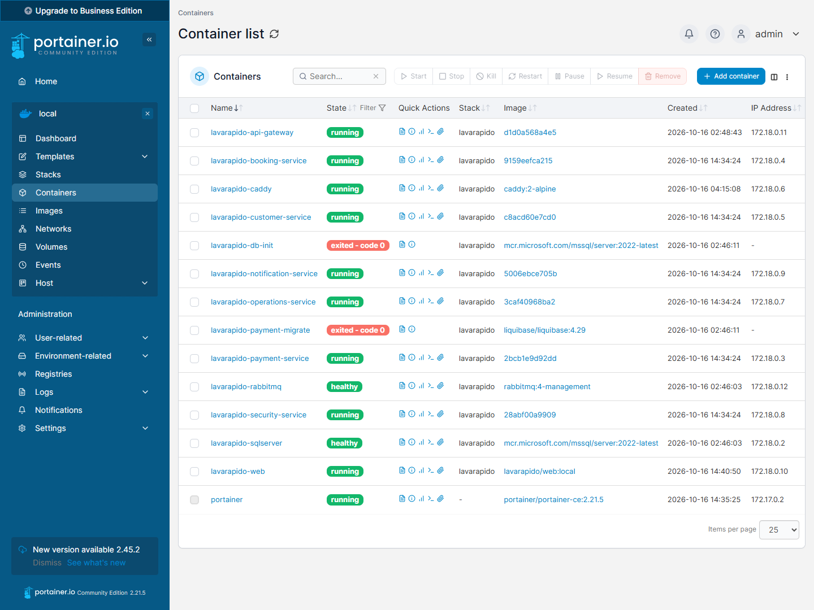
The 11 services in running / healthy*; db-init and payment-migrate end in* exited - code 0 because they run only once (create the database and apply the payment migrations).
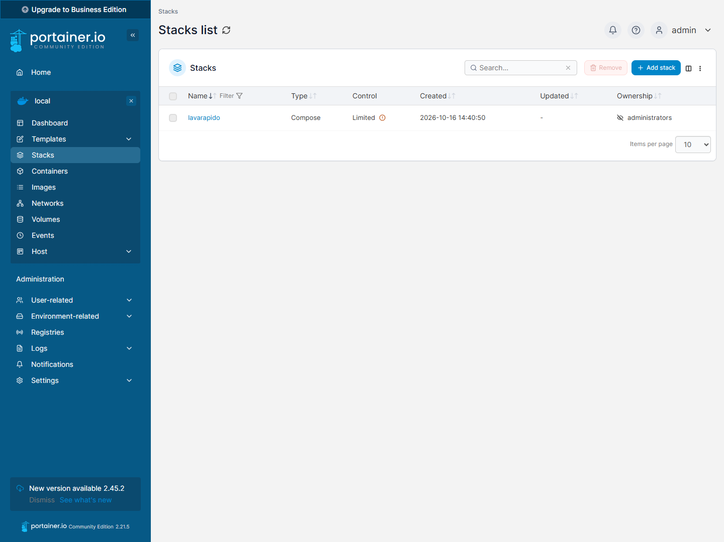
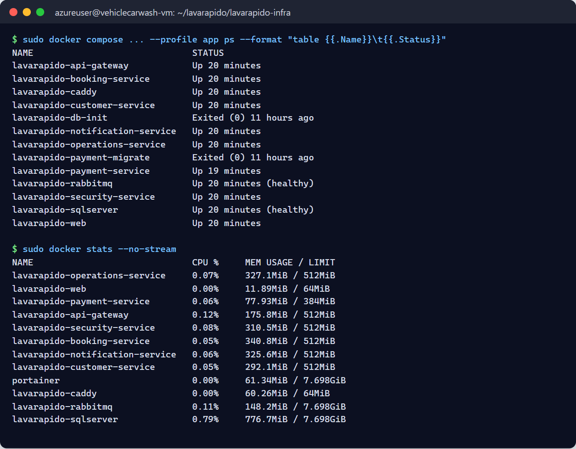
Status taken from the terminal on 2026-10-19: the 11 containers of the system Up (SQL Server and RabbitMQ healthy*), db-init and payment-migrate in* Exited (0), and the memory usage of each container.

5.4.2 Screenshot of the Backend services log viewer
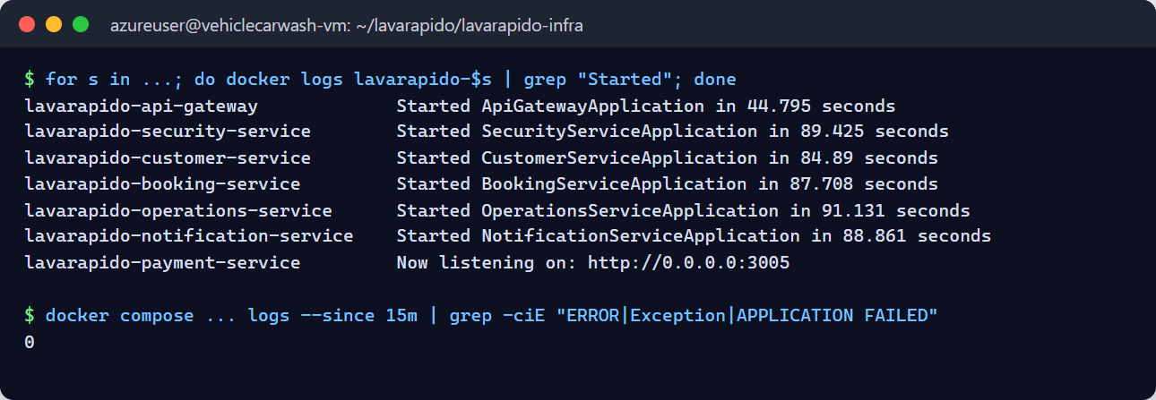
Each Java service shows Started … in N seconds (between 45 and 91 seconds with the machine just started) and payment Now listening on :3005*. There are 0 error traces in the last 15 minutes.*

5.4.3 Screenshot of the HTTP 200 response of the Health Checks
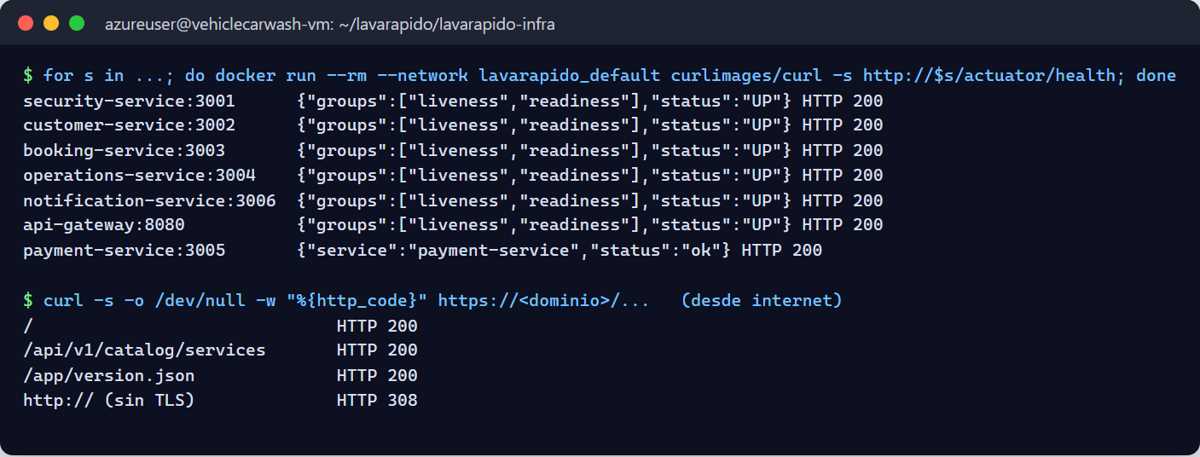
/actuator/health answers UP (HTTP 200) in the 6 Java services from the internal network, and payment-service answers ok. From the internet, the web, the API, and /app/version.json answer 200, and HTTP redirects to HTTPS with 308.

5.4.4 Screenshot of the web interface with a clean DevTools console
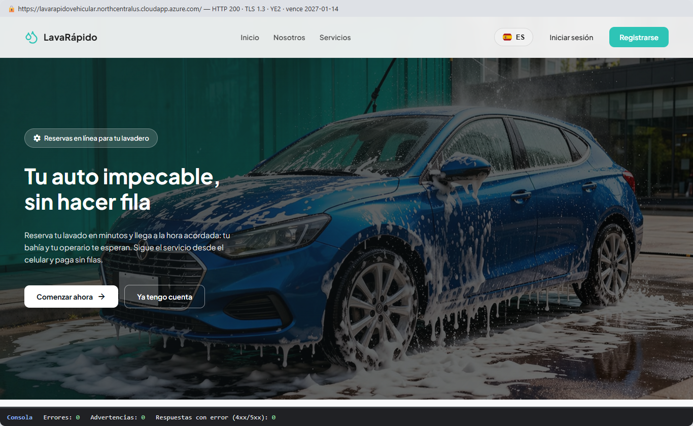
Home page in production over HTTPS (TLS 1.3, Let's Encrypt certificate valid until 2027-01-14). On load: 0 errors and 0 warnings in the console, and 0 error responses.

5.4.5 Screenshot of the successful migration record in the database
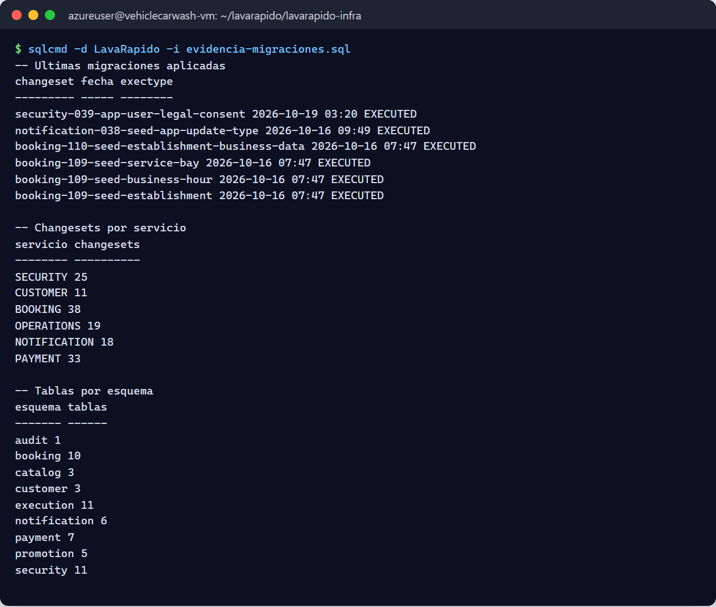
Migration 039 (acceptance of the legal documents) was applied on 2026-10-19; there are 144 EXECUTED changesets in the 6 histories and 57 tables in the 9 schemas.

Related documents:
- lavarapido-infra/DEPLOY.md: short deployment and update guide.
- lavarapido-infra/e2e/README.md: tests between services.
- vehicle-w-docs: architecture (ADR), OpenAPI and events.

