Software Design — Vehicle Washing Management System

Cover Page
Table 1
Document identification data
Field | Value
Project | Vehicle Washing Management System (Vehicle Washing / LavaRápido)
Deliverable | Software design documentation (section 2.5.4)
Program | Software Analysis and Development Technologist (ADSO)
Group (ficha) | 3145556
Apprentices | Brayan Estiven Patiño Cabrera (project lead), Juan Camilo Guilombo Osorio (frontend lead), Merari Urbano (backend lead)
Instructor | Karol Daniela Correa
Training center | Industria
Date | October 19, 2026
Version | 1.3
Note. Cover data was taken from the project's Technical Manual v2.0. All design content was derived from the source code in the Sistema Lavado Vehicular repository (Backend, Web, and LavadoVehicular-Movil) and must be validated with the instructor.

1. Introduction and Scope
The system consists of seven backend services behind an API Gateway, a web application in Angular 21, and a mobile application in React Native (Expo 57); both clients serve three roles: customer, operator, and administrator.
This document describes the design as built: user interfaces, architectural model, design patterns, data model, and main classes. Every statement cites the file where it can be verified. Diagrams are written in Mermaid (Mermaid, n.d.) using UML notation. File paths are relative to the Sistema Lavado Vehicular/ folder.
Table 2
System components and technology
Component | Technology | Port | Folder
API Gateway | Spring Boot 4.0.8, Spring Cloud Gateway (WebMVC), Java 21 | 8080 | Backend/lavarapido-api-gateway
security-service | Spring Boot 4.0.8, Spring Security, JWT, Java 21 | 3001 | Backend/security-service
customer-service | Spring Boot 4.0.8, JPA, Java 21 | 3002 | Backend/lavarapido-customer-service
booking-service | Spring Boot 4.0.8, JPA, Java 21 | 3003 | Backend/lavarapido-booking-service
operations-service | Spring Boot 4.0.8, JPA, Java 21 | 3004 | Backend/lavarapido-operations-service
payment-service | ASP.NET Core 8, Entity Framework Core 8 | 3005 | Backend/lavarapido-payment-service
notification-service | Spring Boot 4.0.8, Spring Mail, Java 21 | 3006 | Backend/lavarapido-notification-service
Database | SQL Server 2022 (one database, one schema per service) | 1433 | Backend/lavarapido-infra/docker-compose.yml
Messaging | RabbitMQ 4 (exchange carwash.events) | 5672 | Backend/lavarapido-infra/docker-compose.yml
Web application | Angular 21.2.25, Angular Material, ngx-translate, Chart.js | 4200 | Web
Mobile application | React Native 0.86.3, Expo ~57, React Navigation 7, i18next | 8081 (Expo) | LavadoVehicular-Movil
Note. Versions taken from pom.xml, Directory.Build.props, and package.json. Official documentation: Spring (n.d.), Microsoft (n.d.-a, n.d.-b), RabbitMQ (n.d.), Liquibase (n.d.), Angular (n.d.), React Native (n.d.), and Expo (n.d.).
Out of scope: requirements (see SRS v7, lavarapido-docs/01_INFORME_DE_ESPECIFICACION_DE_REQUISITOS), dynamic diagrams (analysis deliverable), and costs.

2. User Interfaces
The web client has 35 routed screens and the mobile app has 31; both split the areas by role and only let each user into their own. On the web this is done by authGuard with data.roles (Web/src/app/app.routes.ts:19-49). On mobile, RootNavigator registers only the screens of the logged-in role (LavadoVehicular-Movil/src/core/navigation/RootNavigator.tsx:63-110).

2.1 Web Application Screen Inventory
Table 3
Web application screens (Angular)
Route | Screen | Role | Purpose | Services / endpoints consumed
/ | Landing | Public | Presents the car wash, its services, the app download, contact info, and frequently asked questions | GET /establishment (business email and phone)
/auth | Login | Public | Authenticate with email and password | POST /auth/login
/auth/register | Sign-up | Public | Create a customer account | POST /auth/register
/auth/forgot-password | Password recovery (3 steps) | Public | Email → code → new password | POST /auth/password/forgot, /verify, /reset
/report/:token | Inspection report | Public | View the report shared by the admin | GET /public/inspections/{token} and its photos
** | Page not found | Public | Tell that the address does not exist and go back home | None
/client | Customer home | CLIENT | Summary, next booking with its operator, and points | GET /bookings/me, /vehicles, /loyalty/balance, /operators/my-bookings
/client/reserve | Book | CLIENT | Choose vehicle, service, date, and time | GET /catalog/services, /bookings/availability, /operators/available; POST /bookings
/client/payment | Payments | CLIENT | Pay for a booking and upload a receipt | GET /payment-accounts, /payments/me/bookings; POST /payments; /loyalty/*
/client/history | History | CLIENT | Past bookings, payments, and rating | /bookings/me, /payments/me, POST /ratings/{bookingId}
/client/vehicles | My vehicles | CLIENT | Vehicle CRUD | GET/POST/PUT/DELETE /vehicles, GET /vehicle-types
/client/notifications | Notifications | CLIENT | Notification inbox | /notifications/*
/client/profile | Profile | CLIENT | Personal data, address, email, and password | /users/me, /users/me/address, /users/me/password, /users/me/email
/client/configuration | Settings | CLIENT | Theme, language, and notification channels | /users/me/preferences
/admin | Dashboard | ADMIN | Daily indicators and alerts | GET /admin/bookings/day-summary and booking, payment, operator, and schedule stores
/admin/reservations | Bookings | ADMIN | Create, reschedule, change status, and assign an operator | /admin/bookings/*, /admin/assignments/*
/admin/reservations/:id/inspection | Inspection | ADMIN | Go through the phases, record findings with photos, publish and share | /admin/inspections/{bookingId}/**
/admin/payments | Payments | ADMIN | Review, approve, reject, and refund | /admin/payments/*
/admin/management | Management | ADMIN | Users, roles and permissions, services, promotions | /admin/users, /admin/roles-permissions, /admin/catalog/services, /admin/promotions
/admin/schedule | Schedule and bays | ADMIN | Weekly hours, exceptions, and bays | /admin/schedule/*, /admin/bays/*
/admin/operators | Operators | ADMIN | Operator list, team summary, and creation | /admin/operators, /admin/operators/summary, POST /admin/users
/admin/operators/:id | Operator detail | ADMIN | Availability, absences, profile, and weekly metrics | /admin/operators/{id}/availability, /absences, /metrics, /admin/operators/profiles, PUT /admin/operators/{id}/profile
/admin/operators/:id/calendar | Operator calendar | ADMIN | Operator agenda | /admin/assignments
/admin/reports | Reports | ADMIN | Revenue and services; export PDF/Excel | Payment and booking stores (jsPDF, xlsx)
/admin/notifications | Notifications | ADMIN | Inbox and sending notices | /notifications/*, POST /admin/notifications
/admin/profile | Profile | ADMIN | Account data | /users/me
/admin/settings | Settings | ADMIN | Business data and payment methods | /admin/payment-accounts, GET/PUT /admin/establishment
/operator | Operator home | OPERATOR | Pending services and statistics | /operator/services, /notifications
/operator/assigned-services | Assigned services | OPERATOR | Start and finish services | POST /operator/services/{id}/start, /finish
/operator/schedule | Agenda | OPERATOR | Service calendar | GET /operator/services
/operator/service-history | History | OPERATOR | Completed services | GET /operator/services
/operator/qualifications | Ratings | OPERATOR | Scores and comments received | GET /operator/ratings
/operator/notifications, /profile, /settings | Shared | OPERATOR | Notices, profile, and preferences | /notifications/*, /users/me/*
Note. Every API route has the /api/v1 prefix and goes through the gateway (Web/proxy.conf.json). Source: Web/src/app/core/services/*.ts and routes in features/*/*-routing-module.ts.

2.2 Mobile Application Screen Inventory
The mobile app mirrors the web areas with its own React Native screens. It has no landing page or public report; the administrator's inspection report is available since October 17, 2026 (AdminInspection, opened from the booking detail).
Table 4
Mobile application screens (React Native / Expo)
Role | Screens (src/modules/<role>/screens) | Web equivalent
Logged out | LoginScreen, RegisterScreen, ForgotPasswordScreen | /auth/*
CLIENT | ClientHome, ClientReserve, ClientPayment, ClientHistory, ClientVehicles, ClientNotifications, ClientProfile, ClientSettings | /client/*
OPERATOR | OperatorHome, OperatorAssigned, OperatorSchedule, OperatorHistory, OperatorRatings, OperatorNotifications, OperatorProfile, OperatorSettings | /operator/*
ADMIN | AdminDashboard, AdminReservations, AdminPayments, AdminManagement, AdminSchedule, AdminOperators, AdminOperatorCalendar, AdminReports, AdminNotifications, AdminProfile, AdminSettings, AdminInspection | /admin/* (AdminInspection = /admin/reservations/:id/inspection)
Note. If a user has several roles, the mobile app opens the most privileged one: ADMIN, then OPERATOR, then CLIENT (RootNavigator.tsx:42-46). The session is stored in the system keychain with expo-secure-store (src/core/storage/sessionStorage.ts:15-20).

2.3 Navigation Diagram
Figure 1
Web application navigation by role
![](C:/Users/JUAN CAMILO/.claude/jobs/47671fef/tmp/docbuild/work/software-design-documentation/mermaid-0-0.png)
The diagram shows web navigation; the mobile app follows the same path per role, without the landing page or the public report (the inspection opens from the booking detail).

2.4 Screenshots
Screenshots were taken on October 9, 2026, with the full system running: the web client in Chrome at 1366 × 768 and the mobile app in its web build (Expo) at phone size (390 × 844). The data shown comes from the development database and the functional tests.
Figure 2
Public landing page (web)
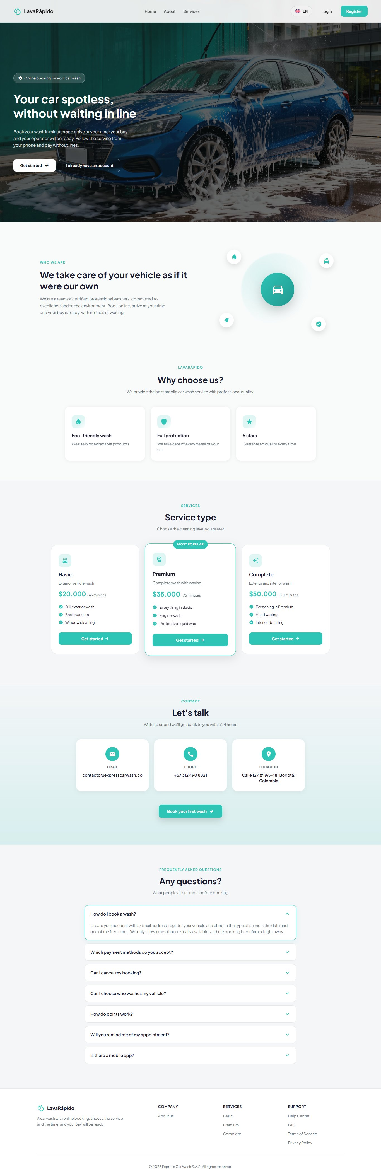
Figure 3
Login (web)
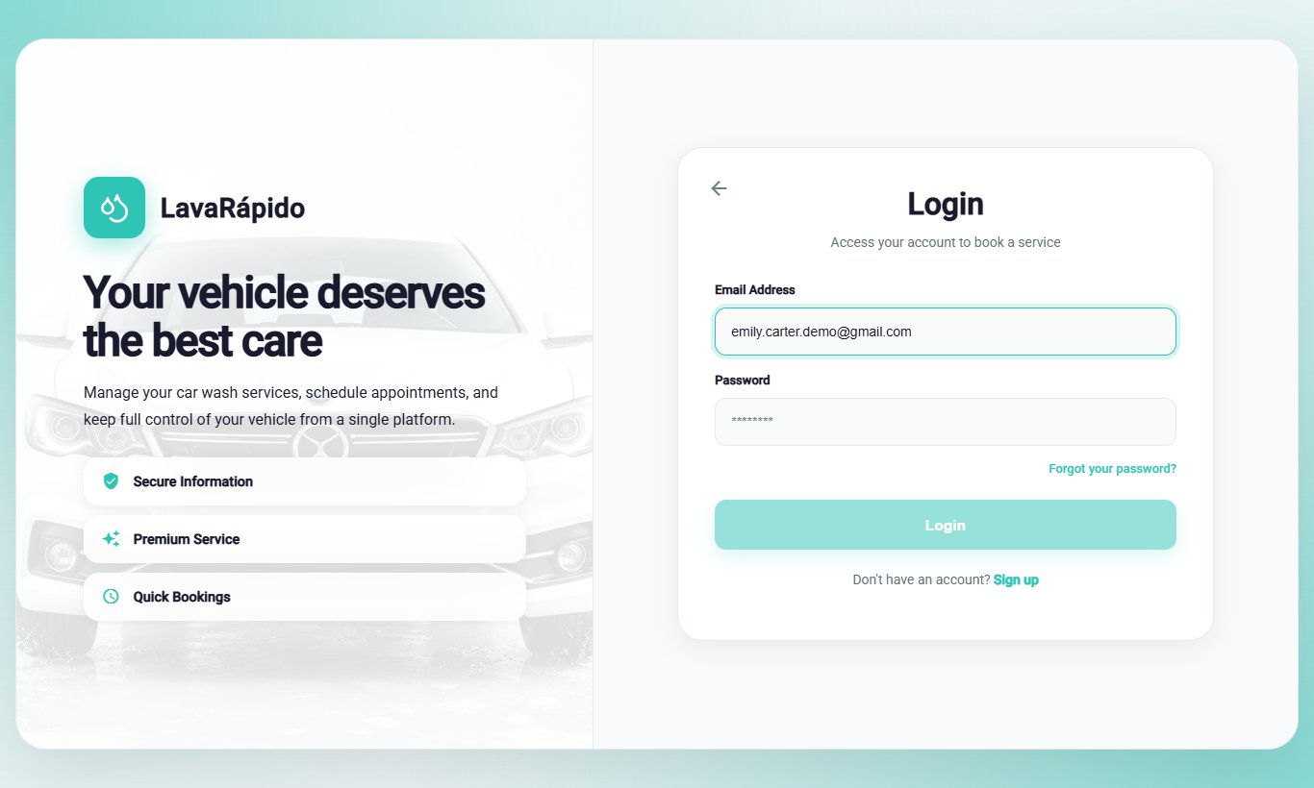
Figure 4
Login (mobile app)
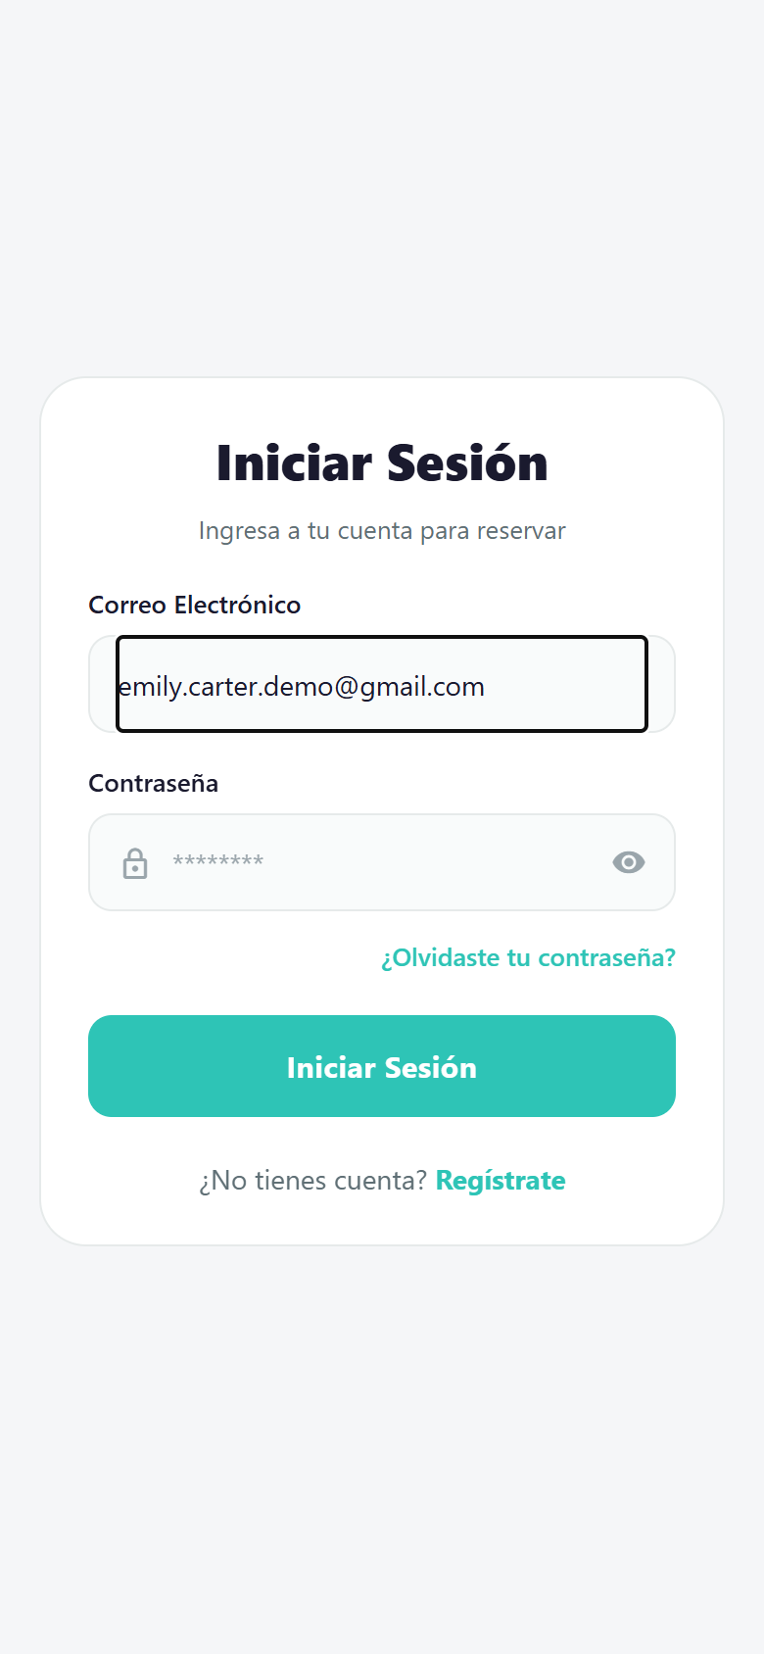
Figure 5
Book a wash — customer (web)
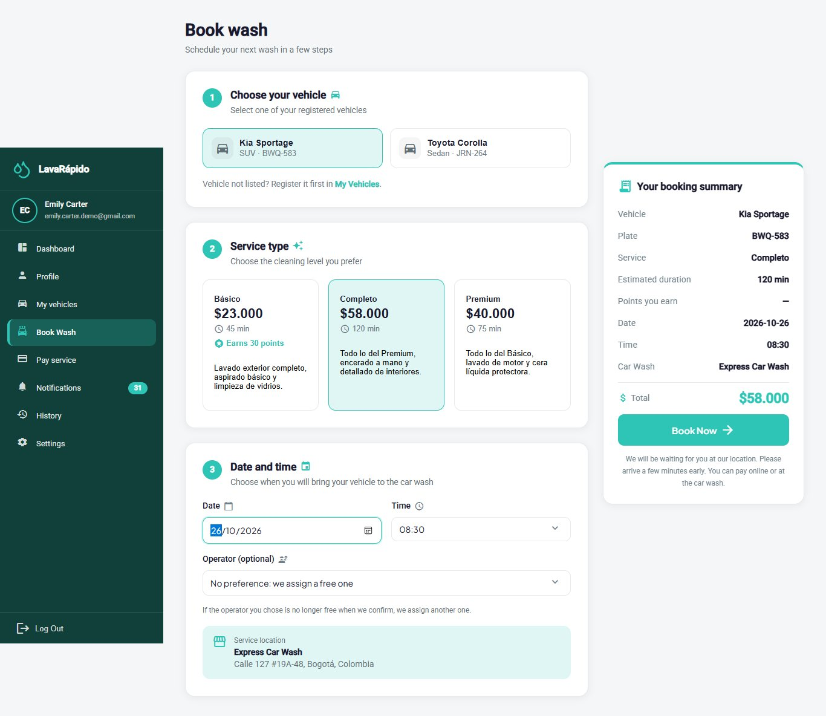
Figure 6
Payments with QR and receipt — customer (web)
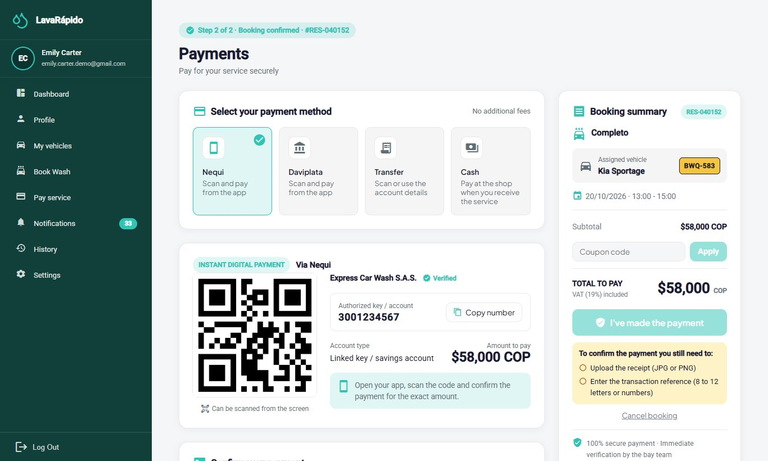
Figure 7
Customer home (mobile app)
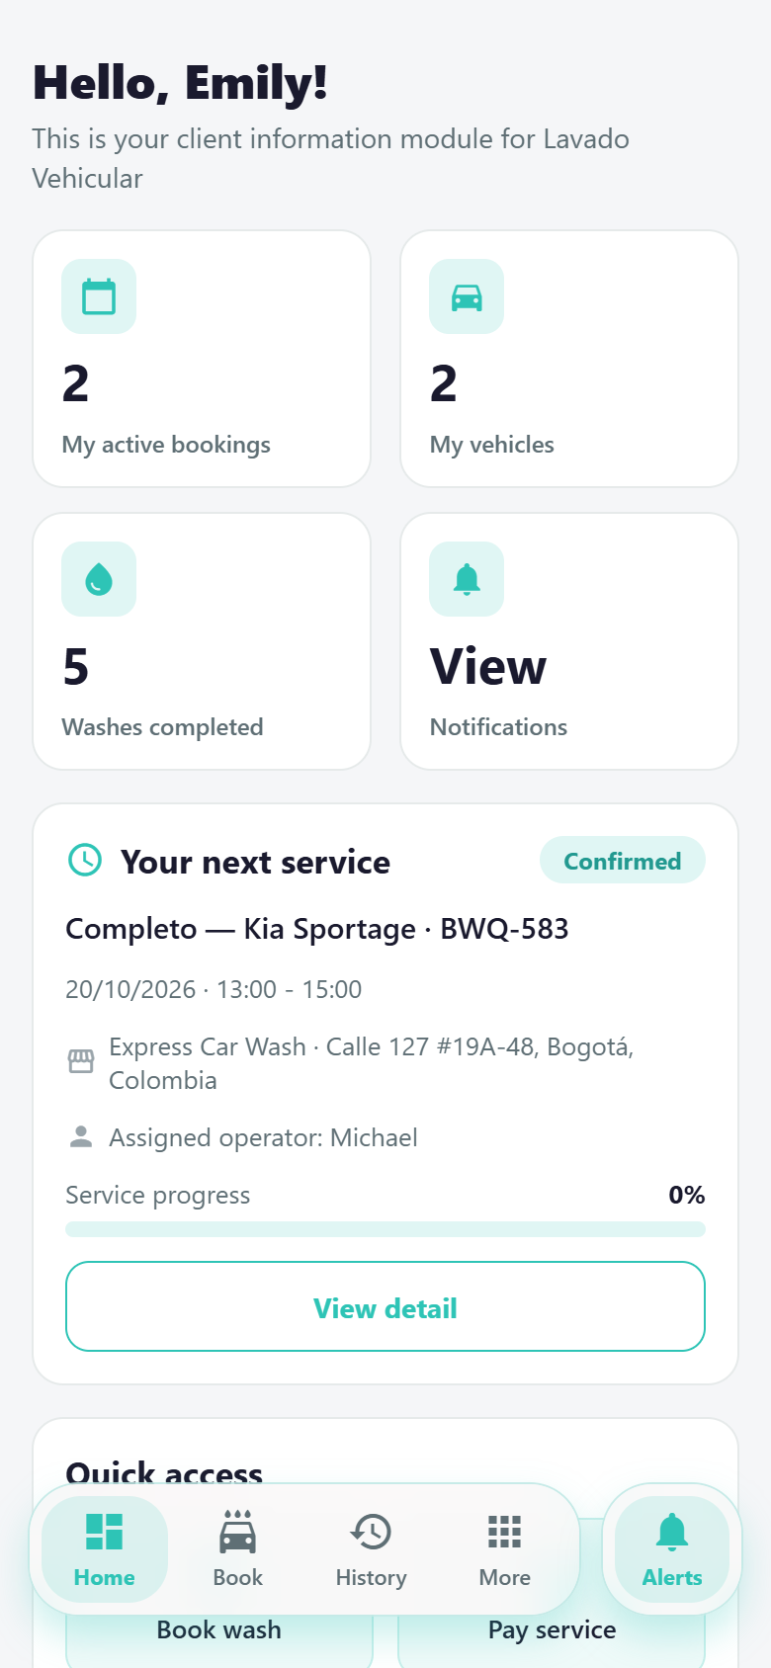
Figure 8
Assigned services — operator (web)
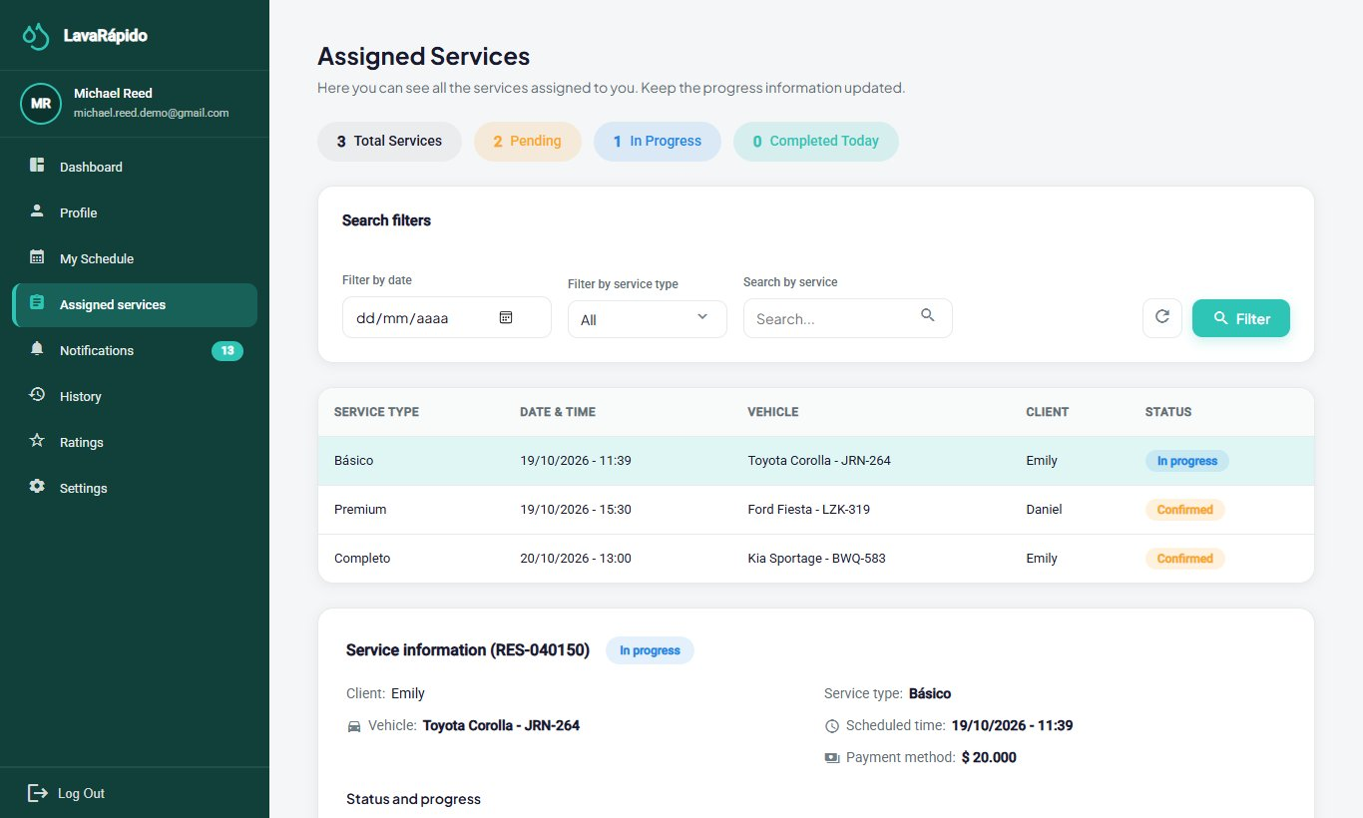
Figure 9
Operator home (mobile app)
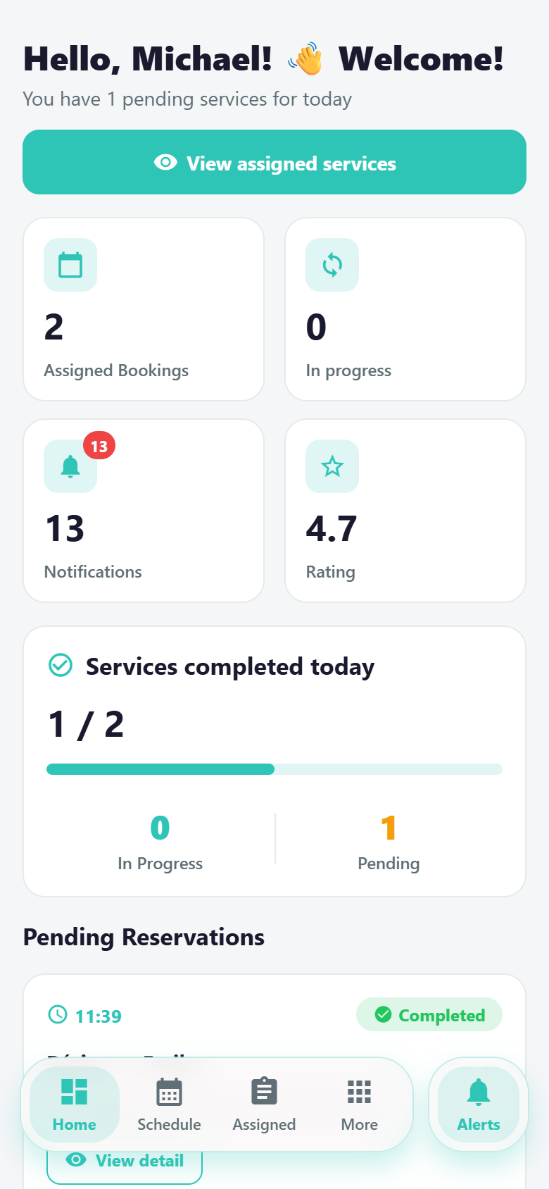
Figure 10
Dashboard — administrator (web)
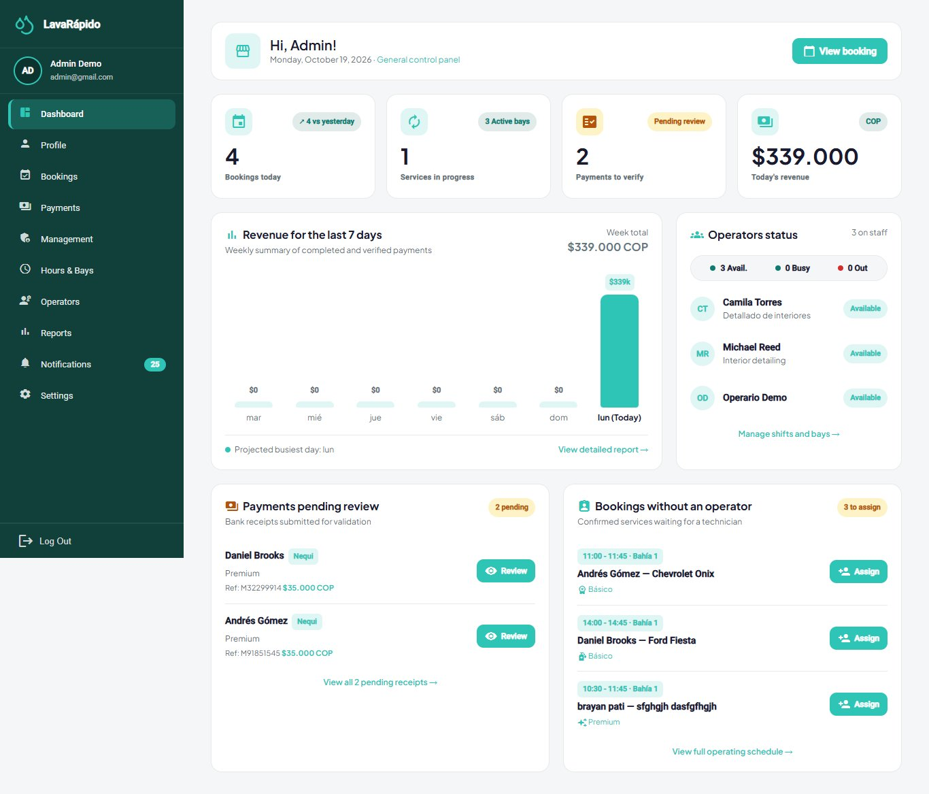
Figure 11
Booking management — administrator (web)
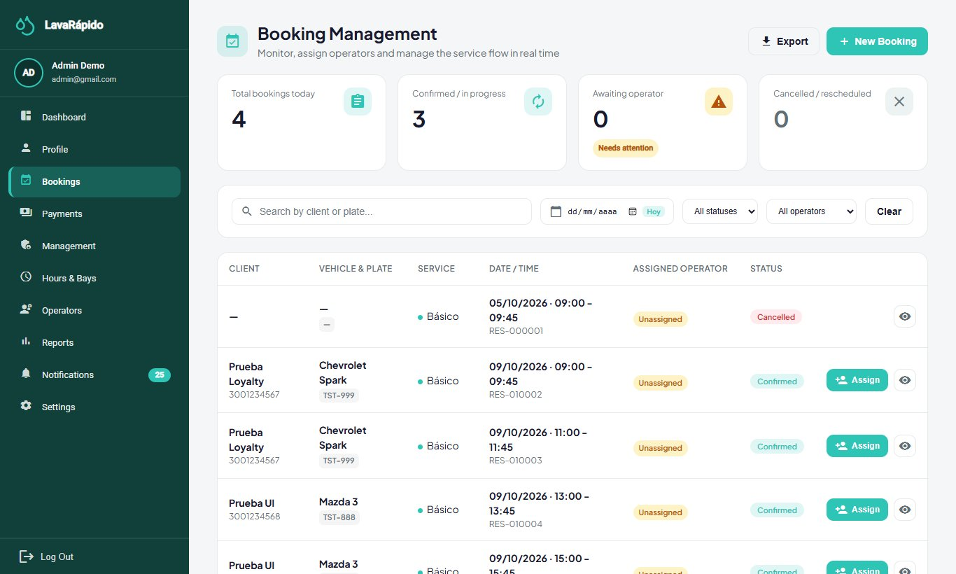
Figure 12
User, role, service, and promotion management — administrator (web)
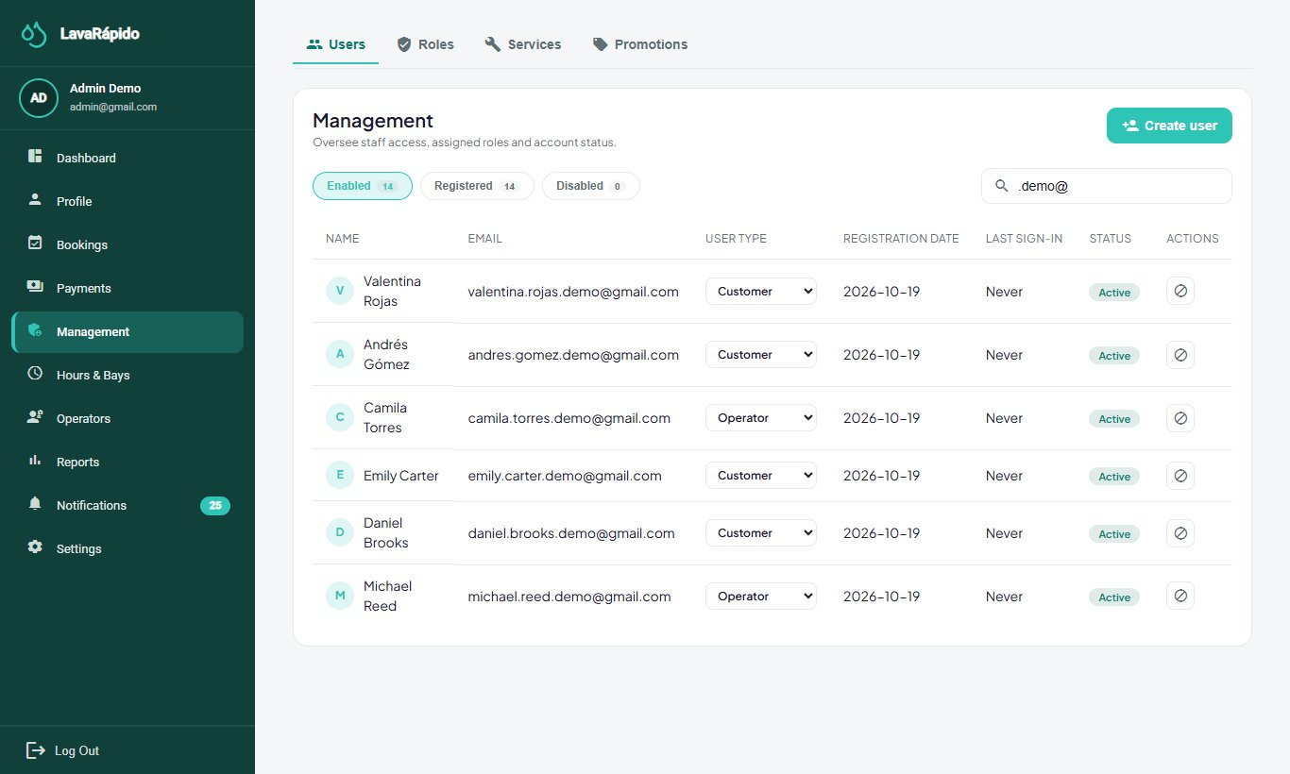
Note. Original screenshots taken with headless Chrome. The mobile app screenshots come from its web build; on Android the UI is the same, rendered with native components.

2.5 Responsive Design
Both applications are used from a width of 360 pixels (RNF-008), the narrowest Android phone the project supports, without horizontal scrolling.
- Web. The breakpoints are in src/styles/_breakpoints.scss and are applied with the mobile (up to 768 px) and tablet (up to 1024 px) mixins of _mixins.scss. From 768 px the side menu opens with the ☰ button, and the content of pages with a menu leaves 72 px at the top for that button (global rule in styles.scss). Headings use a relative line height of 1.25, because the Material theme sets 20 px on the body and a larger heading overlapped itself when it wrapped into two lines. Wide tables scroll inside their card; the operator's assigned services table is shown as cards from 600 px. On a phone, the customer dashboard places the stats and quick access two per row, the authentication screens use the full width, and the landing bar keeps only the language and Login from 420 px.
- Mobile. Screens are built with Flexbox: stat cards go two per row (StatGrid), button rows wrap, and filter inputs grow in width without losing their 46 px height.
- Verification. On October 17, 2026, 60 web screens (30 at 360 px and 30 at 768 px) and 26 mobile app screens at 360 px, in their web version, were measured with Playwright: none scrolls sideways or clips content. The team test e2e/width-360.js (lavarapido-infra) covers the same rule for the web.

3. Architectural Model
The system follows a microservices architecture (Newman, 2021): an API Gateway as the single entry point, six domain services with hexagonal architecture, a SQL Server database split by schema, and RabbitMQ for asynchronous events.

3.1 Container Diagram (C4 Level 2)
Figure 13
System container diagram (C4, level 2)
![](C:/Users/JUAN CAMILO/.claude/jobs/47671fef/tmp/docbuild/work/software-design-documentation/mermaid-0-1.png)
Note. Notation based on the C4 model (Brown, n.d.). Clients talk only to the gateway; each service validates the JWT and stores data in its own schema.
The web and mobile clients only call port 8080. The gateway forwards the Authorization header without validating it; each service validates the JWT on its own (Backend/lavarapido-api-gateway/src/main/resources/application.yml, route comments, ADR-006). The service-to-service /internal/** routes have no gateway route and return 404 from outside.

3.2 Responsibility of Each Container
Table 5
Containers, responsibility, and owned data
Container | Responsibility | Owned schemas | Public routes (gateway)
security-service | Sign-up, JWT login with lockout after failed attempts, password recovery, profile and address, preferences, users, roles, and permissions | security, audit | /auth/**, /users/**, /admin/users/**, /admin/roles-permissions/**
customer-service | Customers, vehicles, and vehicle types | customer | /vehicles/**, /vehicle-types/**, /admin/vehicles/**
booking-service | Catalog and prices, business hours, bays, availability, bookings, day summary, and business data | catalog, booking | /catalog/**, /schedule/**, /establishment, /bookings/**, /admin/bookings/**, /admin/catalog/**, /admin/schedule/**, /admin/bays/**, /admin/establishment, /operator/bookings/**
operations-service | Operators and their profile, availability, absences, automatic and manual assignment, execution, ratings, metrics, and inspection report | execution | /admin/operators/**, /operators/**, /admin/inspections/**, /public/inspections/**, /admin/assignments/**, /operator/services/**, /operator/ratings, /ratings/**
payment-service (.NET) | Payments with receipts, payment accounts, promotions, and loyalty points | payment, promotion | /payments/**, /payment-accounts, /admin/payments/**, /admin/payment-accounts/**, /admin/payment-methods, /admin/promotions/**, /loyalty/**
notification-service | Notification inbox, email, push (Expo), scheduled reminders, and alerts for bookings without an operator, in each account's language | notification | /notifications/**, /admin/notifications/**
Note. Source: routes in Backend/lavarapido-api-gateway/src/main/resources/application.yml and each service's Liquibase changelogs.

3.3 Service-to-Service Communication
There are two styles. Queries that need an immediate answer use synchronous REST; notices that something happened travel as events through RabbitMQ.
Table 6
Synchronous REST calls between services
Source | Target | Purpose | Environment variable
booking | customer | Check that the vehicle belongs to the customer | CUSTOMER_SERVICE_URL
customer | security | Get the person_id if the sign-up event did not arrive | SECURITY_SERVICE_URL
operations | booking | Read, start, and finish bookings with the user's token; read bookings without a user for automatic assignment and free operators (/internal/v1/bookings) | BOOKING_SERVICE_URL, BOOKING_INTERNAL_URL, INTERNAL_API_KEY
operations | security | Operator and customer names, and whether the account is still active (internal route with a shared key) | SECURITY_SERVICE_URL, SECURITY_INTERNAL_URL, INTERNAL_API_KEY
payment | booking | Look up the booking and the amount due | BOOKING_SERVICE_URL
notification | security | Email and language of each account and administrator list (/internal/v1/users) | SECURITY_SERVICE_URL, INTERNAL_API_KEY
Note. Source: Backend/lavarapido-infra/docker-compose.yml.
Table 7
Events published on the carwash.events exchange
Routing key | Publisher | Consumer
security.user_registered | security | customer (creates the customer profile), notification (welcome)
customer.provisioned | customer (only written to the log) | None
booking.confirmed | booking | notification (notice and reminders), operations (automatic assignment, with the operator the customer chose)
booking.cancelled | booking | notification
execution.operator_assigned, execution.service_started, execution.service_completed, execution.inspection_shared | operations | notification
payment.confirmed, payment.rejected, payment.refunded, payment.promotion_redeemed, payment.loyalty_points_earned | payment | notification
Note. Source: BookingEvent.java:17-18, ExecutionEvent.java:14-16, InspectionSharedEvent.java:15, PaymentIntegrationEvents.cs, CustomerProvisioned.java:15, and the ROUTING_KEYS list in notification-service/.../RabbitMessagingConfig.java. notification also listens to booking.created, but no service publishes that key.
The notification and customer queues have their own dead-letter queue. The operations queue (operations-service.events, only booking.confirmed) does not: if automatic assignment fails, it is logged and the booking is left for the unassigned-booking alert and manual assignment (BookingConfirmedListener.java). notification stores the event_id of each event in notification.processed_event to ignore duplicates, because delivery is "at least once" (DomainEventConsumerService.java:61-72). Messaging is enabled with MESSAGING_ENABLED; when it is off, the Java services use a publisher that only writes to the log (LoggingDomainEventPublisher.java:16).

3.4 Internal Layers of Each Service (Hexagonal)
Figure 14
Layers of a service with hexagonal architecture
![](C:/Users/JUAN CAMILO/.claude/jobs/47671fef/tmp/docbuild/work/software-design-documentation/mermaid-0-2.png)
Hexagonal architecture separates the domain core from infrastructure through ports and adapters (Cockburn, 2005); domain modeling follows Evans (2004). The Java services use the domain, application, and infrastructure packages (for example, security-service/src/main/java/com/lavarapido/security/). payment-service applies the same idea with four .NET projects: PaymentService.Domain, .Application (with Ports/In and Ports/Out), .Infrastructure, and .Api.

3.5 Deployment
Figure 15
Deployment diagram with Docker Compose
![](C:/Users/JUAN CAMILO/.claude/jobs/47671fef/tmp/docbuild/work/software-design-documentation/mermaid-0-3.png)
docker compose up -d starts only SQL Server, Mailpit, and RabbitMQ, and the services run from the IDE. docker compose --profile app up -d --build also starts the seven services in containers (Backend/lavarapido-infra/docker-compose.yml:1-6). The Java services create their tables with Liquibase on startup; payment-service creates them with the payment-migrate container.

4. Design Patterns
The code applies 17 verifiable patterns: 5 architectural, 8 backend design patterns, and 4 in the clients. The code itself names some of them in its comments (Strategy, Factory, Unit of Work). Pattern names follow the catalogs of Gamma et al. (1994), Fowler (2002), and Hohpe and Woolf (2003).
Table 8
Design patterns identified
# | Pattern | Where it is used | Problem it solves
1 | Microservices + API Gateway | Backend/lavarapido-api-gateway/.../application.yml | A single entry point for web and mobile; each domain is deployed separately
2 | Hexagonal architecture (ports and adapters) | domain/port/in, domain/port/out, infrastructure/adapter packages in each Java service; Ports/In, Ports/Out in payment | The domain does not depend on Spring, JPA, or RabbitMQ; infrastructure can change without touching the rules
3 | Database per service (schema per service) | Liquibase changelogs per service; no FKs across schemas | No service reads another's tables; cross references are validated through the API
4 | Publish / subscribe (distributed Observer) | RabbitDomainEventPublisher.java, DomainEventListener.java:38, UserRegisteredListener.java:38 | Notify other services without coupling them or waiting for a reply
5 | Idempotent consumer | DomainEventConsumerService.java:61-72 + table notification.processed_event | RabbitMQ delivers "at least once"; a repeated event does not create two notifications
6 | Repository | UserAccountRepository (port) → UserAccountPersistenceAdapter.java:33 → AppUserJpaRepository.java:12 | Hide data access behind a domain interface
7 | Adapter | BCryptPasswordHasher.java:10 implements PasswordHasher; HttpAuthService implements IAuthService on mobile | Adapt an external library (BCrypt, fetch) to the contract the domain expects
8 | Strategy | IDiscountStrategy.cs, PercentageDiscountStrategy.cs, FixedAmountDiscountStrategy.cs | Each discount type computes in its own way, with no switch inside Promotion
9 | Factory | DiscountStrategyFactory.cs:9-21 | A single place decides which strategy matches each DiscountType
10 | Unit of Work | IUnitOfWork.cs:8-15, EfUnitOfWork.cs | Approving a payment and crediting points are saved together or not at all
11 | Value Object | EmailAddress.java:12 (record validated on construction), DocumentNumber, PersonName, HashedPassword | Invalid data cannot exist inside the domain
12 | Aggregate Root + domain events | AggregateRoot.cs:24-39 (payment), domain/event/* (Java) | The root entity protects its rules and records what happened
13 | DTO | LoginRequest.java:6-8 (record with validation), dto/* in each service; Contracts/* in payment | Separate the HTTP contract from the domain model
14 | Dependency injection | DomainConfig.java (@Bean), DependencyInjection.cs (.NET), inject() in Angular, AuthServiceProvider on mobile | Objects receive their dependencies; tests pass in doubles
15 | Null Object / alternate implementation by configuration | LoggingDomainEventPublisher.java:16 and NullIntegrationEventPublisher.cs | With MESSAGING_ENABLED=false the system works without RabbitMQ
16 | Guard + Interceptor (chain of responsibility) | Web/src/app/core/guards/auth-guard.ts:10-34, core/interceptors/auth-interceptor.ts:14-38 | Control access by role and attach the token only to the system's own API
17 | Domain policy (Specification) | AssignmentPolicy.java, AutoAssignmentPolicy.java, StartPolicy.java (operations); LoginLockout.java (security) | Each business rule (who can take a booking, who gets it automatically, when it can start, when an account is locked) lives in a pure domain class that is tested without a database
Note. Other mechanisms present: the X-Correlation-Id correlation filter (CorrelationIdFilter.java:23-39), Angular signal-based stores for admin state (features/admin/services/*-store.ts), and lazy loading of modules per role (loadChildren in app.routes.ts).

4.1 Representative Snippets
Strategy + Factory (Backend/lavarapido-payment-service/src/PaymentService.Domain/Promotions/Discounts/DiscountStrategyFactory.cs:9-21):
public static class DiscountStrategyFactory
{
private static readonly IDiscountStrategy Percentage = new PercentageDiscountStrategy();
private static readonly IDiscountStrategy FixedAmount = new FixedAmountDiscountStrategy();
public static IDiscountStrategy For(DiscountType type) => type switch
{
DiscountType.Percentage => Percentage,
DiscountType.FixedAmount => FixedAmount,
_ => throw new DomainException(DomainErrorCodes.PromotionDiscountUnsupported, "...")
};
}
Outbound port + Adapter (security-service/.../domain/port/out/PasswordHasher.java and BCryptPasswordHasher.java):
public interface PasswordHasher {
HashedPassword hash(String raw);
boolean matches(String raw, HashedPassword hash);
}
class BCryptPasswordHasher implements PasswordHasher {
private final PasswordEncoder encoder;
public boolean matches(String raw, HashedPassword hash) {
return raw != null && encoder.matches(raw, hash.value());
}
}
Alternate implementation by configuration (LoggingDomainEventPublisher.java:16-17):
@ConditionalOnProperty(prefix = "app.messaging", name = "enabled", havingValue = "false", matchIfMissing = true)
class LoggingDomainEventPublisher implements DomainEventPublisher { ... }
HTTP interceptor (Web/src/app/core/interceptors/auth-interceptor.ts:14-25):
export const authInterceptor: HttpInterceptorFn = (req, next) => {
if (!req.url.startsWith(API_BASE_URL)) {
return next(req);
}
const token = inject(AuthService).accessToken();
const request = token
? req.clone({ setHeaders: { Authorization: `Bearer ${token}` } })
: req;
...
};

5. Data Model
The LavaRapido database (SQL Server 2022) has 57 tables in 9 schemas, created by each service's Liquibase changelogs. Foreign keys only exist within a single schema; references to another service are indexed columns without an FK, validated through the API.
Table 9
Schemas, owner, and number of tables
Schema | Owning service | Tables | Changelog
security | security-service | 11 | 001–036 in security-service/src/main/resources/db/changelog
audit | security-service | 1 | 002-create-security-and-audit-core.sql
customer | customer-service | 3 | 004, 014, 015
catalog | booking-service | 3 | 005, 022
booking | booking-service | 10 | 005, 018, 021, 024, 032
execution | operations-service | 11 | 007, 033, 037
payment | payment-service | 7 | lavarapido-payment-service/db/changelog/changes/008–020
promotion | payment-service | 5 | 003–007, 017, 018
notification | notification-service | 6 | 010–031
Note. The security.custom_role table was created in 023 and dropped in 026; it is not counted. Earlier documents (MODELO-DE-DATOS.md) mention 43 tables: the changelogs later added bay_status, schedule_history, device_token, processed_event, booking_reminder, and booking_tracking.

5.1 Common Conventions
- Audit block. Almost every domain table ends with created_at, created_by, updated_at, updated_by, deleted_at, deleted_by, and row_version. It is absent from the base security tables (person, app_user, role, permission, role_permission, user_role, user_session, password_reset_token), audit.audit_log, booking.schedule_history, and notification.booking_tracking. The tables added in October (security.login_lockout, security.person_address, execution.operator_profile, execution.operator_skill, and the four inspection report tables) do not have the full block either: they only keep the date and author columns they use.
- Soft delete. A non-null deleted_at marks a deleted row; several unique indexes are filtered with WHERE deleted_at IS NULL.
- Optimistic concurrency. A tr_touch_<table> trigger updates updated_at and adds 1 to row_version on every UPDATE.
- UTC dates. All default values use SYSUTCDATETIME().
- Coded catalogs. States and types are tables with a unique code (booking_status, payment_status, execution_status, etc.) loaded by seed changelogs.

5.2 Entity-Relationship Model
Solid lines are real FKs; dashed lines are logical references to another service (no FK). Only key attributes are shown; full detail is in the data dictionary (5.4).
Figure 16
Security and customers (security, audit, customer)
![](C:/Users/JUAN CAMILO/.claude/jobs/47671fef/tmp/docbuild/work/software-design-documentation/mermaid-0-4.png)
Figure 17
Catalog and bookings (catalog, booking)
![](C:/Users/JUAN CAMILO/.claude/jobs/47671fef/tmp/docbuild/work/software-design-documentation/mermaid-0-5.png)
Standalone tables in the booking schema (no relationships): establishment (single row, singleton = 1), business_hour (one row per day), business_hour_exception (one per date), and schedule_history.
Figure 18
Execution and notifications (execution, notification)
![](C:/Users/JUAN CAMILO/.claude/jobs/47671fef/tmp/docbuild/work/software-design-documentation/mermaid-0-6.png)
notification.processed_event has no relationships: it stores the event_id of each event already handled.
Figure 19
Payments, promotions, and loyalty (payment, promotion)
![](C:/Users/JUAN CAMILO/.claude/jobs/47671fef/tmp/docbuild/work/software-design-documentation/mermaid-0-7.png)

5.3 Relational Model
Notation: PK = primary key, UK = unique value, → = foreign key, ⇢ = logical reference to another service (no FK). The audit block is omitted.
- security.person(person_id PK, document_number UK, first_name, last_name, phone, email)
- security.app_user(user_id PK, person_id → person UK, username UK, password_hash, is_active, last_login, created_at)
- security.login_lockout(user_id PK → app_user, failed_count, first_failed_at, locked_until, updated_at) · security.person_address(person_id PK → person, address, updated_at)
- security.role(role_id PK, code UK, name) · security.permission(permission_id PK, code UK, name, resource, action)
- security.role_permission(role_permission_id PK, role_id → role, permission_id → permission) · security.user_role(user_role_id PK, user_id → app_user, role_id → role)
- security.user_session(user_session_id PK, user_id → app_user, refresh_token_hash, started_at, expires_at, revoked_at, ip_address, user_agent)
- security.password_reset_token(password_reset_token_id PK, user_id → app_user, token_hash UK, requested_at, expires_at, used_at, ip_address)
- security.user_preference(user_preference_id PK, user_id → app_user UK, theme, language, notifications_enabled, email_reminders_enabled, promotions_enabled)
- audit.audit_log(audit_log_id PK, entity, entity_id, action, previous_data, new_data, changed_by, changed_at)
- customer.vehicle_type(vehicle_type_id PK, code UK, name, size_factor, display_order, is_active)
- customer.customer(customer_id PK, person_id ⇢ security.person UK, user_id ⇢ security.app_user, loyalty_points, customer_since)
- customer.customer_vehicle(customer_vehicle_id PK, customer_id → customer, license_plate, vehicle_type_id → vehicle_type, brand, model, color)
- catalog.service_category(service_category_id PK, code UK, name, description, display_order, is_active)
- catalog.service(service_id PK, code UK, name, description, service_category_id → service_category, loyalty_points, is_active)
- catalog.service_price(service_price_id PK, service_id → service, vehicle_type_id ⇢ customer.vehicle_type, price, estimated_minutes, valid_from, valid_to)
- booking.establishment(establishment_id PK, legal_name, trade_name, tax_id, address, phone, email, logo_url, singleton UK, business_type, founded_on, legal_representative, legal_representative_document, website, tax_regime, ciiu_activity, dian_resolution, invoice_prefix, invoice_range, instagram, facebook, support_line, service_hours_note)
- booking.business_hour(business_hour_id PK, day_of_week UK, opens_at, closes_at, break_starts_at, break_ends_at, is_active)
- booking.business_hour_exception(business_hour_exception_id PK, exception_date UK, is_closed, opens_at, closes_at, reason)
- booking.bay_status(bay_status_id PK, code UK, name, accepts_bookings, display_order) · booking.service_bay(service_bay_id PK, code UK, name, bay_status_id → bay_status)
- booking.booking_status(booking_status_id PK, code UK, name, is_final, display_order, is_active) · booking.cancellation_reason(cancellation_reason_id PK, code UK, name, is_customer_fault, display_order, is_active)
- booking.booking(booking_id PK, customer_vehicle_id ⇢ customer.customer_vehicle, service_bay_id → service_bay, scheduled_start, scheduled_end, booking_status_id → booking_status, booked_by ⇢ security.app_user, cancellation_reason_id → cancellation_reason, points_redeemed, points_discount_amount, notes)
- booking.booking_service(booking_service_id PK, booking_id → booking, service_price_id → catalog.service_price, quantity)
- booking.schedule_history(schedule_history_id PK, entity_type, title, detail, changed_at, changed_by)
- execution.execution_status(execution_status_id PK, code UK, name, is_final, display_order, is_active)
- execution.operator(operator_id PK, user_id ⇢ security.app_user UK, hired_on, is_active)
- execution.operator_availability(operator_availability_id PK, operator_id → operator, day_of_week, starts_at, ends_at, is_active)
- execution.operator_absence(operator_absence_id PK, operator_id → operator, starts_at, ends_at, reason)
- execution.service_execution(service_execution_id PK, booking_service_id ⇢ booking.booking_service UK, operator_id → operator, execution_status_id → execution_status, started_at, finished_at, quality_rating, quality_comment, rated_at, is_comment_visible)
- execution.operator_profile(operator_id PK → operator, specialty, updated_at, updated_by) · execution.operator_skill(operator_skill_id PK, operator_id → operator, name, skill_level, display_order)
- execution.inspection_report(inspection_report_id PK, booking_id ⇢ booking.booking UK, booking_code, vehicle, plate, services, booking_date, booking_time, duration_minutes, public_token UK, is_published, published_at)
- execution.inspection_phase(inspection_phase_id PK, inspection_report_id → inspection_report, phase, status, started_at, finished_at) · execution.inspection_finding(inspection_finding_id PK, inspection_report_id → inspection_report, phase, area, severity, note) · execution.inspection_photo(inspection_photo_id PK, inspection_finding_id → inspection_finding, content_type, content, size_bytes)
- payment.payment_method_type(payment_method_type_id PK, code UK, name, requires_account, requires_receipt, display_order, is_active)
- payment.payment_account(payment_account_id PK, payment_method_type_id → payment_method_type, account_holder, account_number, qr_image_url, instructions, is_active)
- payment.payment_status(payment_status_id PK, code UK, name, is_final, display_order, is_active)
- payment.payment(payment_id PK, booking_id ⇢ booking.booking, payment_account_id → payment_account, payment_status_id → payment_status, amount, processed_at, approved_by, rejection_reason)
- payment.payment_receipt(payment_receipt_id PK, payment_id → payment, file_url, transaction_reference, reported_amount, uploaded_at, uploaded_by, reviewed_at, reviewed_by, review_comment)
- payment.loyalty_movement_type(loyalty_movement_type_id PK, code UK, name, sign, display_order, is_active)
- payment.loyalty_transaction(loyalty_transaction_id PK, customer_id ⇢ customer.customer, loyalty_movement_type_id → loyalty_movement_type, booking_id ⇢ booking.booking, points, balance_after, sequence_no, expires_on, description)
- promotion.discount_type(discount_type_id PK, code UK, name, display_order, is_active)
- promotion.promotion(promotion_id PK, code UK, name, description, discount_type_id → discount_type, discount_value, max_discount_amount, min_purchase_amount, is_public, min_completed_booking, valid_from, valid_to, max_redemptions, max_redemptions_per_customer, is_active, price, duration_minutes, icon, featured, benefits, required_points)
- promotion.promotion_service(promotion_service_id PK, promotion_id → promotion, service_id ⇢ catalog.service)
- promotion.promotion_customer(promotion_customer_id PK, promotion_id → promotion, customer_id ⇢ customer.customer, assigned_at, assigned_by)
- promotion.booking_promotion(booking_promotion_id PK, booking_id ⇢ booking.booking, promotion_id → promotion, applied_amount)
- notification.notification_type(notification_type_id PK, code UK, name, display_order, is_active)
- notification.notification(notification_id PK, user_id ⇢ security.app_user, notification_type_id → notification_type, title, message, reference_entity, reference_id, is_read, read_at, sent_at)
- notification.device_token(device_token_id PK, user_id ⇢ security.app_user, token UK, platform, is_active, last_seen_at)
- notification.processed_event(processed_event_id PK, event_id UK, event_type, processed_at)
- notification.booking_reminder(booking_reminder_id PK, booking_id ⇢ booking.booking, user_id ⇢ security.app_user, booking_code, scheduled_start, lead_minutes, remind_at, sent_at)
- notification.booking_tracking(booking_id PK ⇢ booking.booking, booking_code, customer_user_id, operator_user_id, scheduled_start, is_cancelled, unassigned_alert_at, updated_at)

5.4 Data Dictionary
There is one dictionary for each of the 57 tables, grouped by schema. The "Null" column shows whether the field accepts NULL; PK = primary key, FK = foreign key, UK = unique value, and ⇢ = logical reference to another service (no FK). Tables that carry the audit block (section 5.1) show it as a single row at the end.

Schema security
Accounts, roles, permissions, sessions, and preferences. Owner: security-service.
Table 10
Data dictionary of security.person — personal data
Field | Type | Null | Key | Description
person_id | BIGINT IDENTITY | No | PK | Person identifier
document_number | NVARCHAR(20) | No | UK | ID document number
first_name | NVARCHAR(60) | No |  | First names
last_name | NVARCHAR(60) | No |  | Last names
phone | NVARCHAR(20) | Yes |  | Phone
email | NVARCHAR(120) | Yes |  | Contact email
Table 11
Data dictionary of security.app_user — login account
Field | Type | Null | Key | Description
user_id | BIGINT IDENTITY | No | PK | User identifier
person_id | BIGINT | No | FK → person, UK | Person who owns the account (1 to 1)
username | NVARCHAR(60) | No | UK | Email used to log in
password_hash | NVARCHAR(255) | No |  | BCrypt password hash
is_active | BIT | No |  | Account enabled (default 1)
last_login | DATETIME2(3) | Yes |  | Last login
created_at | DATETIME2(3) | No |  | Account registration date (migration 036)
Table 12
Data dictionary of security.role — system roles
Field | Type | Null | Key | Description
role_id | SMALLINT IDENTITY | No | PK | Role identifier
code | NVARCHAR(30) | No | UK | ADMIN, OPERATOR, or CLIENT (seed 101)
name | NVARCHAR(60) | No |  | Display name
Table 13
Data dictionary of security.permission — permissions
Field | Type | Null | Key | Description
permission_id | SMALLINT IDENTITY | No | PK | Permission identifier
code | NVARCHAR(60) | No | UK | VIEW_PANELS, CREATE_RECORDS, EDIT_DATA, or DELETE (changelog 026)
name | NVARCHAR(80) | No |  | Display name
resource | NVARCHAR(60) | No |  | Resource it applies to
action | NVARCHAR(30) | No |  | Allowed action
Table 14
Data dictionary of security.role_permission — permissions of each role
Field | Type | Null | Key | Description
role_permission_id | BIGINT IDENTITY | No | PK | Assignment identifier
role_id | SMALLINT | No | FK → role; UK con permission_id | Role
permission_id | SMALLINT | No | FK → permission | Granted permission
Table 15
Data dictionary of security.user_role — roles of each user
Field | Type | Null | Key | Description
user_role_id | BIGINT IDENTITY | No | PK | Assignment identifier
user_id | BIGINT | No | FK → app_user; UK con role_id | User
role_id | SMALLINT | No | FK → role | Assigned role
Table 16
Data dictionary of security.user_session — open sessions
Field | Type | Null | Key | Description
user_session_id | BIGINT IDENTITY | No | PK | Session identifier
user_id | BIGINT | No | FK → app_user | User
refresh_token_hash | NVARCHAR(255) | Yes |  | Refresh token hash
started_at | DATETIME2(3) | No |  | Session start (UTC)
expires_at | DATETIME2(3) | No |  | Expiry
revoked_at | DATETIME2(3) | Yes |  | Logout time
ip_address | NVARCHAR(45) | Yes |  | Source IP
user_agent | NVARCHAR(300) | Yes |  | Source browser or app
Table 17
Data dictionary of security.password_reset_token — password recovery codes
Field | Type | Null | Key | Description
password_reset_token_id | BIGINT IDENTITY | No | PK | Request identifier
user_id | BIGINT | No | FK → app_user | User who requested the code
token_hash | NVARCHAR(255) | No | UK | Hash of the 6-digit code
requested_at | DATETIME2(3) | No |  | Request date
expires_at | DATETIME2(3) | No |  | Expiry; CHECK expires_at > requested_at
used_at | DATETIME2(3) | Yes |  | When it was used
ip_address | NVARCHAR(45) | Yes |  | Request IP
Table 18
Data dictionary of security.user_preference — UI and notification preferences
Field | Type | Null | Key | Description
user_preference_id | BIGINT IDENTITY | No | PK | Preference identifier
user_id | BIGINT | No | FK → app_user, UK | User (one row per user)
theme | NVARCHAR(20) | No |  | green-light, green-dark, pink, or pink-dark
language | NVARCHAR(5) | No |  | es, en, fr, or pt
notifications_enabled | BIT | No |  | In-app notifications
email_reminders_enabled | BIT | No |  | Email reminders
promotions_enabled | BIT | No |  | Promotion notices
created_at, created_by, updated_at, updated_by, deleted_at, deleted_by, row_version | — | — |  | Audit block (section 5.1)
Table 19
Data dictionary for security.login_lockout — lockout after failed attempts
Field | Type | Null | Key | Description
user_id | BIGINT | No | PK, FK → app_user | Account with recent failures or locked
failed_count | INT | No |  | Failures within the current window, 0 to 4 (default 0)
first_failed_at | DATETIME2(3) | Yes |  | Start of the 15-minute window
locked_until | DATETIME2(3) | Yes |  | Locked until this time; NULL if not locked
updated_at | DATETIME2(3) | No |  | Last change
Table 20
Data dictionary for security.person_address — contact address
Field | Type | Null | Key | Description
person_id | BIGINT | No | PK, FK → person | Person who owns the address
address | NVARCHAR(200) | No |  | Profile contact address; cannot be blank
updated_at | DATETIME2(3) | No |  | Last change

Schema audit
Change log. Owner: security-service.
Table 21
Data dictionary of audit.audit_log — change log
Field | Type | Null | Key | Description
audit_log_id | BIGINT IDENTITY | No | PK | Record identifier
entity | NVARCHAR(60) | No |  | Affected entity
entity_id | BIGINT | No |  | Affected row
action | NVARCHAR(20) | No |  | Action performed
previous_data | NVARCHAR(MAX) | Yes |  | Previous state
new_data | NVARCHAR(MAX) | Yes |  | New state
changed_by | BIGINT | Yes |  | User who made the change
changed_at | DATETIME2(3) | No |  | Change date (UTC)

Schema customer
Customers and vehicles. Owner: customer-service.
Table 22
Data dictionary of customer.vehicle_type — vehicle types
Field | Type | Null | Key | Description
vehicle_type_id | SMALLINT IDENTITY | No | PK | Type identifier
code | NVARCHAR(30) | No | UK | CAR, SEDAN, SUV, PICKUP, TRUCK, or MOTO
name | NVARCHAR(60) | No |  | Display name
size_factor | DECIMAL(4,2) | No |  | Size factor (> 0)
display_order | SMALLINT | No |  | Display order
is_active | BIT | No |  | Type in use
created_at, created_by, updated_at, updated_by, deleted_at, deleted_by, row_version | — | — |  | Audit block (section 5.1)
Table 23
Data dictionary of customer.customer — customers
Field | Type | Null | Key | Description
customer_id | BIGINT IDENTITY | No | PK | Customer identifier
person_id | BIGINT | No | UK, ⇢ security.person | Customer's person
user_id | BIGINT | Yes | UK filtrada, ⇢ security.app_user | Customer's account
loyalty_points | INT | No |  | Display copy of the points balance (≥ 0)
customer_since | DATE | No |  | Sign-up date
created_at, created_by, updated_at, updated_by, deleted_at, deleted_by, row_version | — | — |  | Audit block (section 5.1)
Table 24
Data dictionary of customer.customer_vehicle — customers' vehicles
Field | Type | Null | Key | Description
customer_vehicle_id | BIGINT IDENTITY | No | PK | Vehicle identifier
customer_id | BIGINT | No | FK → customer | Owner
license_plate | NVARCHAR(10) | No | UK filtrada (activos) | License plate
vehicle_type_id | SMALLINT | No | FK → vehicle_type | Vehicle type
brand | NVARCHAR(50) | Yes |  | Make
model | NVARCHAR(50) | Yes |  | Model
color | NVARCHAR(30) | Yes |  | Color
created_at, created_by, updated_at, updated_by, deleted_at, deleted_by, row_version | — | — |  | Audit block (section 5.1)

Schema catalog
Service catalog and prices. Owner: booking-service.
Table 25
Data dictionary of catalog.service_category — service categories
Field | Type | Null | Key | Description
service_category_id | SMALLINT IDENTITY | No | PK | Category identifier
code | NVARCHAR(30) | No | UK | LAVADO, POLICHADO, DETALLADO, INTERIOR, or PAQUETES
name | NVARCHAR(60) | No |  | Display name
description | NVARCHAR(200) | Yes |  | Description
display_order | SMALLINT | No |  | Display order
is_active | BIT | No |  | Category in use
created_at, created_by, updated_at, updated_by, deleted_at, deleted_by, row_version | — | — |  | Audit block (section 5.1)
Table 26
Data dictionary of catalog.service — wash services
Field | Type | Null | Key | Description
service_id | INT IDENTITY | No | PK | Service identifier
code | NVARCHAR(30) | No | UK | Code (BASIC, PREMIUM, FULL in the seed)
name | NVARCHAR(100) | No |  | Display name
description | NVARCHAR(MAX) | Yes |  | Description
service_category_id | SMALLINT | No | FK → service_category | Category
is_active | BIT | No |  | Available for booking
loyalty_points | INT | No |  | Points awarded on completion (changelog 022)
created_at, created_by, updated_at, updated_by, deleted_at, deleted_by, row_version | — | — |  | Audit block (section 5.1)
Table 27
Data dictionary of catalog.service_price — prices per vehicle type
Field | Type | Null | Key | Description
service_price_id | BIGINT IDENTITY | No | PK | Price identifier
service_id | INT | No | FK → service | Service
vehicle_type_id | SMALLINT | No | ⇢ customer.vehicle_type | Vehicle type
price | DECIMAL(12,2) | No |  | Price (≥ 0)
estimated_minutes | SMALLINT | No |  | Estimated duration (> 0)
valid_from | DATE | No |  | Valid from
valid_to | DATE | Yes |  | Valid to; only one open price per service and type (filtered index); rows are immutable by trigger
created_at, created_by, updated_at, updated_by, deleted_at, deleted_by, row_version | — | — |  | Audit block (section 5.1)

Schema booking
Establishment, business hours, bays, and bookings. Owner: booking-service.
Table 28
Data dictionary of booking.establishment — car wash data
Field | Type | Null | Key | Description
establishment_id | SMALLINT IDENTITY | No | PK | Identifier
legal_name | NVARCHAR(150) | No |  | Legal name
trade_name | NVARCHAR(150) | No |  | Trade name
tax_id | NVARCHAR(30) | No |  | Tax ID (NIT)
address | NVARCHAR(200) | No |  | Address
phone | NVARCHAR(20) | Yes |  | Phone
email | NVARCHAR(120) | Yes |  | Email
logo_url | NVARCHAR(500) | Yes |  | Logo
business_type | NVARCHAR(100) | Yes |  | Business type (migration 032)
founded_on | DATE | Yes |  | Foundation date; cannot be in the future (migration 032)
legal_representative | NVARCHAR(150) | Yes |  | Legal representative (migration 032)
legal_representative_document | NVARCHAR(30) | Yes |  | Legal representative ID (migration 032)
website | NVARCHAR(200) | Yes |  | Website (migration 032)
tax_regime | NVARCHAR(150) | Yes |  | Tax regime (migration 032)
ciiu_activity | NVARCHAR(150) | Yes |  | CIIU economic activity (migration 032)
dian_resolution | NVARCHAR(60) | Yes |  | DIAN invoicing resolution (migration 032)
invoice_prefix | NVARCHAR(10) | Yes |  | Invoice prefix (migration 032)
invoice_range | NVARCHAR(30) | Yes |  | Invoice range (migration 032)
instagram | NVARCHAR(100) | Yes |  | Instagram (migration 032)
facebook | NVARCHAR(150) | Yes |  | Facebook (migration 032)
support_line | NVARCHAR(30) | Yes |  | Support line (migration 032)
service_hours_note | NVARCHAR(150) | Yes |  | Service hours shown to the customer (migration 032)
singleton | BIT | No | UK | Always 1: prevents a second row
created_at, created_by, updated_at, updated_by, deleted_at, deleted_by, row_version | — | — |  | Audit block (section 5.1)
Table 29
Data dictionary of booking.business_hour — weekly hours
Field | Type | Null | Key | Description
business_hour_id | SMALLINT IDENTITY | No | PK | Identifier
day_of_week | SMALLINT | No | UK | Day of week (1 to 7)
opens_at | TIME(0) | No |  | Opening time
closes_at | TIME(0) | No |  | Closing time (after opening)
is_active | BIT | No |  | Working day
break_starts_at | TIME(0) | Yes |  | Break start (changelog 018)
break_ends_at | TIME(0) | Yes |  | Break end
created_at, created_by, updated_at, updated_by, deleted_at, deleted_by, row_version | — | — |  | Audit block (section 5.1)
Table 30
Data dictionary of booking.business_hour_exception — schedule exceptions
Field | Type | Null | Key | Description
business_hour_exception_id | INT IDENTITY | No | PK | Identifier
exception_date | DATE | No | UK | Special date
is_closed | BIT | No |  | Closed all day
opens_at | TIME(0) | Yes |  | Special opening (if open)
closes_at | TIME(0) | Yes |  | Special closing (if open)
reason | NVARCHAR(120) | No |  | Reason
created_at, created_by, updated_at, updated_by, deleted_at, deleted_by, row_version | — | — |  | Audit block (section 5.1)
Table 31
Data dictionary of booking.bay_status — bay statuses
Field | Type | Null | Key | Description
bay_status_id | SMALLINT IDENTITY | No | PK | Identifier
code | NVARCHAR(30) | No | UK | ACTIVE, MAINTENANCE, or INACTIVE
name | NVARCHAR(60) | No |  | Display name
accepts_bookings | BIT | No |  | Whether it accepts bookings
display_order | SMALLINT | No |  | Display order
created_at, created_by, updated_at, updated_by, deleted_at, deleted_by, row_version | — | — |  | Audit block (section 5.1)
Table 32
Data dictionary of booking.service_bay — wash bays
Field | Type | Null | Key | Description
service_bay_id | SMALLINT IDENTITY | No | PK | Bay identifier
code | NVARCHAR(20) | No | UK | Code (BAY-01…)
name | NVARCHAR(60) | No |  | Display name
bay_status_id | SMALLINT | No | FK → bay_status | Status (default 1, active)
created_at, created_by, updated_at, updated_by, deleted_at, deleted_by, row_version | — | — |  | Audit block (section 5.1)
Table 33
Data dictionary of booking.booking_status — booking statuses
Field | Type | Null | Key | Description
booking_status_id | SMALLINT IDENTITY | No | PK | 1 SCHEDULED, 2 CONFIRMED, 3 IN_PROGRESS, 4 COMPLETED, 5 CANCELLED, 6 NO_SHOW
code | NVARCHAR(30) | No | UK | Status code
name | NVARCHAR(60) | No |  | Display name
is_final | BIT | No |  | Whether the status is final
display_order | SMALLINT | No |  | Display order
is_active | BIT | No |  | Status in use
created_at, created_by, updated_at, updated_by, deleted_at, deleted_by, row_version | — | — |  | Audit block (section 5.1)
Table 34
Data dictionary of booking.cancellation_reason — cancellation reasons
Field | Type | Null | Key | Description
cancellation_reason_id | SMALLINT IDENTITY | No | PK | Identifier
code | NVARCHAR(30) | No | UK | Code (six seed reasons)
name | NVARCHAR(60) | No |  | Display name
is_customer_fault | BIT | No |  | Whether the customer is at fault
display_order | SMALLINT | No |  | Display order
is_active | BIT | No |  | Reason in use
created_at, created_by, updated_at, updated_by, deleted_at, deleted_by, row_version | — | — |  | Audit block (section 5.1)
Table 35
Data dictionary of booking.booking — bookings
Field | Type | Null | Key | Description
booking_id | BIGINT IDENTITY | No | PK | Booking identifier
customer_vehicle_id | BIGINT | No | ⇢ customer.customer_vehicle | Vehicle to wash
service_bay_id | SMALLINT | Yes | FK → service_bay | Assigned bay; a trigger prevents overlapping times
scheduled_start | DATETIME2(3) | No |  | Scheduled start
scheduled_end | DATETIME2(3) | No |  | Scheduled end (after start)
booking_status_id | SMALLINT | No | FK → booking_status | Status
booked_by | BIGINT | No | ⇢ security.app_user | User who created the booking
cancellation_reason_id | SMALLINT | Yes | FK → cancellation_reason | Only when the status is CANCELLED
points_redeemed | INT | No |  | Points redeemed
points_discount_amount | DECIMAL(12,2) | No |  | Points discount (both 0 or both > 0)
notes | NVARCHAR(300) | Yes |  | Notes
created_at, created_by, updated_at, updated_by, deleted_at, deleted_by, row_version | — | — |  | Audit block (section 5.1)
Table 36
Data dictionary of booking.booking_service — service lines of each booking
Field | Type | Null | Key | Description
booking_service_id | BIGINT IDENTITY | No | PK | Line identifier
booking_id | BIGINT | No | FK → booking; UK con service_price_id | Booking
service_price_id | BIGINT | No | FK → catalog.service_price | Price applied when booking
quantity | SMALLINT | No |  | Quantity (> 0)
created_at, created_by, updated_at, updated_by, deleted_at, deleted_by, row_version | — | — |  | Audit block (section 5.1)
Table 37
Data dictionary of booking.schedule_history — schedule change history
Field | Type | Null | Key | Description
schedule_history_id | BIGINT IDENTITY | No | PK | Identifier
entity_type | NVARCHAR(20) | No |  | WEEK, EXCEPTION, or BAY
title | NVARCHAR(200) | No |  | Change summary
detail | NVARCHAR(300) | Yes |  | Change detail
changed_at | DATETIME2(3) | No |  | Change date (UTC)
changed_by | BIGINT | Yes |  | User who made the change

Schema execution
Operators and service execution. Owner: operations-service.
Table 38
Data dictionary of execution.execution_status — execution statuses
Field | Type | Null | Key | Description
execution_status_id | SMALLINT IDENTITY | No | PK | 1 PENDING, 2 IN_PROGRESS, 3 PAUSED, 4 COMPLETED, 5 WITH_ISSUE
code | NVARCHAR(30) | No | UK | Status code
name | NVARCHAR(60) | No |  | Display name
is_final | BIT | No |  | Whether the status is final
display_order | SMALLINT | No |  | Display order
is_active | BIT | No |  | Status in use
created_at, created_by, updated_at, updated_by, deleted_at, deleted_by, row_version | — | — |  | Audit block (section 5.1)
Table 39
Data dictionary of execution.operator — operators
Field | Type | Null | Key | Description
operator_id | INT IDENTITY | No | PK | Operator identifier
user_id | BIGINT | No | UK, ⇢ security.app_user | Operator's account
hired_on | DATE | No |  | Hire date
is_active | BIT | No |  | Eligible for assignments
created_at, created_by, updated_at, updated_by, deleted_at, deleted_by, row_version | — | — |  | Audit block (section 5.1)
Table 40
Data dictionary of execution.operator_availability — operator weekly shift
Field | Type | Null | Key | Description
operator_availability_id | INT IDENTITY | No | PK | Identifier
operator_id | INT | No | FK → operator; UK con day_of_week | Operator
day_of_week | SMALLINT | No |  | Day of week (1 to 7)
starts_at | TIME(0) | No |  | Shift start
ends_at | TIME(0) | No |  | Shift end (after start)
is_active | BIT | No |  | Shift in use
created_at, created_by, updated_at, updated_by, deleted_at, deleted_by, row_version | — | — |  | Audit block (section 5.1)
Table 41
Data dictionary of execution.operator_absence — operator absences
Field | Type | Null | Key | Description
operator_absence_id | INT IDENTITY | No | PK | Identifier
operator_id | INT | No | FK → operator | Operator
starts_at | DATETIME2(3) | No |  | Absence start
ends_at | DATETIME2(3) | No |  | Absence end; a trigger prevents overlapping absences
reason | NVARCHAR(120) | No |  | Reason
created_at, created_by, updated_at, updated_by, deleted_at, deleted_by, row_version | — | — |  | Audit block (section 5.1)
Table 42
Data dictionary of execution.service_execution — execution of each service line
Field | Type | Null | Key | Description
service_execution_id | BIGINT IDENTITY | No | PK | Execution identifier
booking_service_id | BIGINT | No | UK, ⇢ booking.booking_service | Booking line
operator_id | INT | No | FK → operator | Assigned operator
execution_status_id | SMALLINT | No | FK → execution_status | Execution status
started_at | DATETIME2(3) | Yes |  | Actual start
finished_at | DATETIME2(3) | Yes |  | Actual finish
quality_rating | SMALLINT | Yes |  | Rating from 1 to 5
quality_comment | NVARCHAR(500) | Yes |  | Comment; only with a rating
rated_at | DATETIME2(3) | Yes |  | Rating date
is_comment_visible | BIT | No |  | Whether the comment is shown
created_at, created_by, updated_at, updated_by, deleted_at, deleted_by, row_version | — | — |  | Audit block (section 5.1)
Table 43
Data dictionary for execution.operator_profile — operator specialty
Field | Type | Null | Key | Description
operator_id | INT | No | PK, FK → operator | Operator
specialty | NVARCHAR(80) | Yes |  | Specialty
updated_at | DATETIME2(3) | No |  | Last change
updated_by | BIGINT | Yes |  | Administrator who changed it ⇢ security.app_user
Table 44
Data dictionary for execution.operator_skill — operator skills
Field | Type | Null | Key | Description
operator_skill_id | INT IDENTITY | No | PK | Identifier
operator_id | INT | No | FK → operator | Operator
name | NVARCHAR(60) | No | UK with operator_id | Skill name
skill_level | NVARCHAR(12) | No |  | CERTIFIED, EXPERT or ADVANCED
display_order | SMALLINT | No |  | Order in the profile
Table 45
Data dictionary for execution.inspection_report — vehicle inspection report
Field | Type | Null | Key | Description
inspection_report_id | BIGINT IDENTITY | No | PK | Identifier
booking_id | BIGINT | No | UK, ⇢ booking.booking | Inspected booking (one report per booking)
booking_code, vehicle, plate, services | NVARCHAR | Yes |  | Copy of the booking data when the report is created
booking_date, booking_time, duration_minutes | DATE, TIME(0), INT | No |  | Booking date, time, and duration
public_token | NVARCHAR(64) | No | UK | Random code of the public link
is_published | BIT | No |  | The link shows the report (default 0)
published_at | DATETIME2(3) | Yes |  | Publication date; required when published
created_at, created_by, updated_at, updated_by, row_version | — | — |  | Audit
Table 46
Data dictionary for execution.inspection_phase — report phases
Field | Type | Null | Key | Description
inspection_phase_id | BIGINT IDENTITY | No | PK | Identifier
inspection_report_id | BIGINT | No | FK → inspection_report; UK with phase | Report
phase | NVARCHAR(20) | No |  | RECEPTION, EXTERIOR, INTERIOR, ENGINE or DELIVERY
status | NVARCHAR(20) | No |  | PENDING, IN_PROGRESS or DONE
started_at, finished_at | DATETIME2(3) | Yes |  | Phase start and end
Table 47
Data dictionary for execution.inspection_finding — report findings
Field | Type | Null | Key | Description
inspection_finding_id | BIGINT IDENTITY | No | PK | Identifier
inspection_report_id | BIGINT | No | FK → inspection_report | Report
phase | NVARCHAR(20) | No |  | Phase where it was found
area | NVARCHAR(120) | No |  | Vehicle area
severity | NVARCHAR(10) | No |  | INFO, MINOR or MAJOR
note | NVARCHAR(500) | Yes |  | Note
created_at, created_by, deleted_at, deleted_by | — | — |  | Creation and soft delete
Table 48
Data dictionary for execution.inspection_photo — finding photos
Field | Type | Null | Key | Description
inspection_photo_id | BIGINT IDENTITY | No | PK | Identifier
inspection_finding_id | BIGINT | No | FK → inspection_finding | Finding (up to 5 photos each)
content_type | NVARCHAR(30) | No |  | image/jpeg or image/png
content | VARBINARY(MAX) | No |  | Image
size_bytes | INT | No |  | Size, up to 2 MB
created_at, created_by | — | — |  | Creation

Schema payment
Payments, payment accounts, and points. Owner: payment-service.
Table 49
Data dictionary of payment.payment_method_type — payment methods
Field | Type | Null | Key | Description
payment_method_type_id | SMALLINT IDENTITY | No | PK | Identifier
code | NVARCHAR(30) | No | UK | EFECTIVO, NEQUI, DAVIPLATA, or TRANSFERENCIA
name | NVARCHAR(60) | No |  | Display name
requires_account | BIT | No |  | Whether it requires an account
requires_receipt | BIT | No |  | Whether it requires a receipt
display_order | SMALLINT | No |  | Display order
is_active | BIT | No |  | Method in use
created_at, created_by, updated_at, updated_by, deleted_at, deleted_by, row_version | — | — |  | Audit block (section 5.1)
Table 50
Data dictionary of payment.payment_account — car wash receiving accounts
Field | Type | Null | Key | Description
payment_account_id | SMALLINT IDENTITY | No | PK | Account identifier
payment_method_type_id | SMALLINT | No | FK → payment_method_type | Payment method
account_holder | NVARCHAR(120) | No |  | Holder
account_number | NVARCHAR(50) | Yes |  | Number or key
qr_image_url | NVARCHAR(MAX) | Yes |  | QR image stored as data (changelog 016)
instructions | NVARCHAR(300) | Yes |  | Instructions for the customer
is_active | BIT | No |  | Account visible to the customer
created_at, created_by, updated_at, updated_by, deleted_at, deleted_by, row_version | — | — |  | Audit block (section 5.1)
Table 51
Data dictionary of payment.payment_status — payment statuses
Field | Type | Null | Key | Description
payment_status_id | SMALLINT IDENTITY | No | PK | Identifier
code | NVARCHAR(30) | No | UK | PENDING, IN_REVIEW, APPROVED, REJECTED, or REFUNDED
name | NVARCHAR(60) | No |  | Display name
is_final | BIT | No |  | Whether the status is final
display_order | SMALLINT | No |  | Display order
is_active | BIT | No |  | Status in use
created_at, created_by, updated_at, updated_by, deleted_at, deleted_by, row_version | — | — |  | Audit block (section 5.1)
Table 52
Data dictionary of payment.payment — payments
Field | Type | Null | Key | Description
payment_id | BIGINT IDENTITY | No | PK | Payment identifier
booking_id | BIGINT | No | ⇢ booking.booking | Booking paid; one approved payment per booking (filtered index)
payment_account_id | SMALLINT | No | FK → payment_account | Account paid into
payment_status_id | SMALLINT | No | FK → payment_status | Status
amount | DECIMAL(12,2) | No |  | Amount (> 0)
processed_at | DATETIME2(3) | Yes |  | Review date
approved_by | BIGINT | Yes |  | Approving administrator
rejection_reason | NVARCHAR(200) | Yes |  | Rejection reason
created_at, created_by, updated_at, updated_by, deleted_at, deleted_by, row_version | — | — |  | Audit block (section 5.1)
Table 53
Data dictionary of payment.payment_receipt — payment receipts
Field | Type | Null | Key | Description
payment_receipt_id | BIGINT IDENTITY | No | PK | Receipt identifier
payment_id | BIGINT | No | FK → payment | Payment
file_url | NVARCHAR(MAX) | No |  | Receipt image
transaction_reference | NVARCHAR(100) | Yes |  | Transaction reference
reported_amount | DECIMAL(12,2) | Yes |  | Amount declared by the customer (> 0)
uploaded_at | DATETIME2(3) | No |  | Upload date
uploaded_by | BIGINT | No |  | User who uploaded it
reviewed_at | DATETIME2(3) | Yes |  | Review date
reviewed_by | BIGINT | Yes |  | Reviewer (together with reviewed_at)
review_comment | NVARCHAR(300) | Yes |  | Review comment
created_at, created_by, updated_at, updated_by, deleted_at, deleted_by, row_version | — | — |  | Audit block (section 5.1)
Table 54
Data dictionary of payment.loyalty_movement_type — points movement types
Field | Type | Null | Key | Description
loyalty_movement_type_id | SMALLINT IDENTITY | No | PK | Identifier
code | NVARCHAR(30) | No | UK | EARNED, REDEEMED, EXPIRED, ADJUSTED, or REVERSED
name | NVARCHAR(60) | No |  | Display name
sign | SMALLINT | No |  | +1 or -1
display_order | SMALLINT | No |  | Display order
is_active | BIT | No |  | Type in use
created_at, created_by, updated_at, updated_by, deleted_at, deleted_by, row_version | — | — |  | Audit block (section 5.1)
Table 55
Data dictionary of payment.loyalty_transaction — points ledger
Field | Type | Null | Key | Description
loyalty_transaction_id | BIGINT IDENTITY | No | PK | Movement identifier
customer_id | BIGINT | No | ⇢ customer.customer; UK con sequence_no | Customer
loyalty_movement_type_id | SMALLINT | No | FK → loyalty_movement_type | Movement type
booking_id | BIGINT | Yes | ⇢ booking.booking | Booking that caused the movement
points | INT | No |  | Movement points (≠ 0)
balance_after | INT | No |  | Resulting balance (≥ 0); source of truth for the balance
expires_on | DATE | Yes |  | Points expiry
description | NVARCHAR(200) | Yes |  | Detail
sequence_no | INT | No |  | Per-customer sequence number (changelog 020)
created_at, created_by, updated_at, updated_by, deleted_at, deleted_by, row_version | — | — |  | Audit block (section 5.1)

Schema promotion
Promotions and coupons. Owner: payment-service.
Table 56
Data dictionary of promotion.discount_type — discount types
Field | Type | Null | Key | Description
discount_type_id | SMALLINT IDENTITY | No | PK | Identifier
code | NVARCHAR(30) | No | UK | PERCENT, FIXED, or PACKAGE
name | NVARCHAR(60) | No |  | Display name
display_order | SMALLINT | No |  | Display order
is_active | BIT | No |  | Type in use
created_at, created_by, updated_at, updated_by, deleted_at, deleted_by, row_version | — | — |  | Audit block (section 5.1)
Table 57
Data dictionary of promotion.promotion — promotions
Field | Type | Null | Key | Description
promotion_id | INT IDENTITY | No | PK | Promotion identifier
code | NVARCHAR(30) | No | UK | Coupon code
name | NVARCHAR(100) | No |  | Display name
description | NVARCHAR(300) | Yes |  | Description
discount_type_id | SMALLINT | No | FK → discount_type | Discount type
discount_value | DECIMAL(12,2) | No |  | Discount value (> 0)
max_discount_amount | DECIMAL(12,2) | Yes |  | Discount cap
min_purchase_amount | DECIMAL(12,2) | No |  | Minimum purchase
is_public | BIT | No |  | Visible to all customers
min_completed_booking | INT | No |  | Completed bookings required (≥ 0)
valid_from | DATE | No |  | Valid from
valid_to | DATE | No |  | Valid to
max_redemptions | INT | Yes |  | Total redemption limit
max_redemptions_per_customer | INT | Yes |  | Per-customer limit (≤ total)
is_active | BIT | No |  | Promotion active
price | DECIMAL(12,2) | Yes |  | Package price (changelog 017)
duration_minutes | INT | Yes |  | Package duration
icon | NVARCHAR(40) | Yes |  | Icon
featured | BIT | No |  | Featured
benefits | NVARCHAR(600) | Yes |  | Package benefits
required_points | INT | No |  | Points needed to redeem (≥ 0; changelog 018)
created_at, created_by, updated_at, updated_by, deleted_at, deleted_by, row_version | — | — |  | Audit block (section 5.1)
Table 58
Data dictionary of promotion.promotion_service — services each promotion applies to
Field | Type | Null | Key | Description
promotion_service_id | INT IDENTITY | No | PK | Identifier
promotion_id | INT | No | FK → promotion; UK con service_id | Promotion
service_id | INT | No | ⇢ catalog.service | Service
created_at, created_by, updated_at, updated_by, deleted_at, deleted_by, row_version | — | — |  | Audit block (section 5.1)
Table 59
Data dictionary of promotion.promotion_customer — target customers of each promotion
Field | Type | Null | Key | Description
promotion_customer_id | BIGINT IDENTITY | No | PK | Identifier
promotion_id | INT | No | FK → promotion; UK con customer_id | Promotion
customer_id | BIGINT | No | ⇢ customer.customer | Target customer
assigned_at | DATETIME2(3) | No |  | Assignment date
assigned_by | BIGINT | Yes |  | Assigning user
created_at, created_by, updated_at, updated_by, deleted_at, deleted_by, row_version | — | — |  | Audit block (section 5.1)
Table 60
Data dictionary of promotion.booking_promotion — promotion redemptions on bookings
Field | Type | Null | Key | Description
booking_promotion_id | BIGINT IDENTITY | No | PK | Redemption identifier
booking_id | BIGINT | No | ⇢ booking.booking; UK con promotion_id | Booking
promotion_id | INT | No | FK → promotion | Redeemed promotion
applied_amount | DECIMAL(12,2) | No |  | Discount applied (> 0)
created_at, created_by, updated_at, updated_by, deleted_at, deleted_by, row_version | — | — |  | Audit block (section 5.1)

Schema notification
Notifications, devices, and reminders. Owner: notification-service.
Table 61
Data dictionary of notification.notification_type — notification types
Field | Type | Null | Key | Description
notification_type_id | SMALLINT IDENTITY | No | PK | Identifier
code | NVARCHAR(40) | No | UK | One of the 23 codes, from USER_WELCOME to ADMIN_BOOKING_UNASSIGNED
name | NVARCHAR(80) | No |  | Display name
display_order | SMALLINT | No |  | Display order
is_active | BIT | No |  | Type in use
created_at, created_by, updated_at, updated_by, deleted_at, deleted_by, row_version | — | — |  | Audit block (section 5.1)
Table 62
Data dictionary of notification.notification — notifications
Field | Type | Null | Key | Description
notification_id | BIGINT IDENTITY | No | PK | Notification identifier
user_id | BIGINT | No | ⇢ security.app_user | Recipient
notification_type_id | SMALLINT | No | FK → notification_type | Type
title | NVARCHAR(120) | No |  | Title
message | NVARCHAR(500) | No |  | Message
reference_entity | NVARCHAR(40) | Yes |  | Related entity (for example, booking)
reference_id | BIGINT | Yes |  | Related entity identifier
is_read | BIT | No |  | Read (kept consistent with read_at by a CHECK)
read_at | DATETIME2(3) | Yes |  | Read date
sent_at | DATETIME2(3) | No |  | Send date
created_at, created_by, updated_at, updated_by, deleted_at, deleted_by, row_version | — | — |  | Audit block (section 5.1)
Table 63
Data dictionary of notification.device_token — push notification devices
Field | Type | Null | Key | Description
device_token_id | BIGINT IDENTITY | No | PK | Device identifier
user_id | BIGINT | No | ⇢ security.app_user | Owner
token | NVARCHAR(200) | No | UK | Expo Push token
platform | NVARCHAR(10) | No |  | Platform; the CHECK accepts ANDROID or IOS
is_active | BIT | No |  | Device in use
last_seen_at | DATETIME2(3) | No |  | Last device registration
created_at, created_by, updated_at, updated_by, deleted_at, deleted_by, row_version | — | — |  | Audit block (section 5.1)
Table 64
Data dictionary of notification.processed_event — already handled events
Field | Type | Null | Key | Description
processed_event_id | BIGINT IDENTITY | No | PK | Identifier
event_id | NVARCHAR(64) | No | UK | RabbitMQ event ID
event_type | NVARCHAR(60) | No |  | Event type
processed_at | DATETIME2(3) | No |  | Processing date
created_at, created_by, updated_at, updated_by, deleted_at, deleted_by, row_version | — | — |  | Audit block (section 5.1)
Table 65
Data dictionary of notification.booking_reminder — booking reminders
Field | Type | Null | Key | Description
booking_reminder_id | BIGINT IDENTITY | No | PK | Reminder identifier
booking_id | BIGINT | No | ⇢ booking.booking; UK con lead_minutes | Booking
user_id | BIGINT | No | ⇢ security.app_user | Customer
booking_code | NVARCHAR(20) | Yes |  | Booking code
scheduled_start | DATETIME2(3) | No |  | Appointment time
lead_minutes | INT | No |  | Minutes of notice (REMINDER_LEADS, default 24 h and 1 h)
remind_at | DATETIME2(3) | No |  | When to notify
sent_at | DATETIME2(3) | Yes |  | When it was sent
created_at, created_by, updated_at, updated_by, deleted_at, deleted_by, row_version | — | — |  | Audit block (section 5.1)
Table 66
Data dictionary of notification.booking_tracking — local copy of booking state
Field | Type | Null | Key | Description
booking_id | BIGINT | No | PK, ⇢ booking.booking | Booking
booking_code | NVARCHAR(20) | Yes |  | Booking code
customer_user_id | BIGINT | Yes |  | Customer user
operator_user_id | BIGINT | Yes |  | Assigned operator user
scheduled_start | DATETIME2(3) | Yes |  | Appointment time
is_cancelled | BIT | No |  | Booking cancelled
updated_at | DATETIME2(3) | No |  | Last update
unassigned_alert_at | DATETIME2(3) | Yes |  | When the "no operator" alert was sent (changelog 031)
Note. Source of types and constraints: .sql files in */src/main/resources/db/changelog/ (Java services) and lavarapido-payment-service/db/changelog/changes/, including the ALTER statements made after each table was created.

6. Class Diagrams
There is at least one class diagram for each of the six services; the four largest have two: one for the domain model and one for the application layer with its ports. Business rules live in the domain entities, not in the controllers: for example, Booking.moveTo() decides which status changes are valid, and ServiceExecution.rate() allows rating only once and only for a completed service.
Diagram conventions:
- UML stereotypes: aggregate root, entity, value object, enumeration, domain service, application service, interface (outbound port), event, factory, and abstract.
- The implements … line in an application service lists the inbound ports (use cases) it implements.
- A solid arrow (-->) is a constructor-injected dependency; a dashed arrow (..>) is a usage or a reference by ID.
- Getters, constructors, exceptions, response DTOs (*View, *Dto), and input commands (*Command, *Request) are omitted.

6.1 security-service
Figure 20
security-service domain model
![](C:/Users/JUAN CAMILO/.claude/jobs/47671fef/tmp/docbuild/work/software-design-documentation/mermaid-0-8.png)
Figure 21
security-service application services and ports
![](C:/Users/JUAN CAMILO/.claude/jobs/47671fef/tmp/docbuild/work/software-design-documentation/mermaid-0-9.png)
Note. Outbound adapters: UserAccountPersistenceAdapter, UserSessionPersistenceAdapter, PasswordResetTokenPersistenceAdapter, UserPreferencePersistenceAdapter, RolePermissionPersistenceAdapter, LoginLockoutPersistenceAdapter, and PersonAddressPersistenceAdapter (JPA); BCryptPasswordHasher; JwtTokenIssuer; SecureRandomResetCodeGenerator; EmailResetCodeNotifier, LoggingResetCodeNotifier, and UndeliveredResetCodeNotifier; InMemoryResetAttemptCounter; RabbitDomainEventPublisher and LoggingDomainEventPublisher. Inbound adapters: AuthController, UserProfileController, UserAdministrationController, RolePermissionController, UserAddressController, and InternalUserController. Source: security-service/src/main/java/com/lavarapido/security/.

6.2 customer-service
Figure 22
customer-service classes
![](C:/Users/JUAN CAMILO/.claude/jobs/47671fef/tmp/docbuild/work/software-design-documentation/mermaid-0-10.png)
Note. Register/Update/Remove/List/GetCustomerVehicleUseCase abbreviates the five vehicle inbound ports. Outbound adapters: CustomerAccountPersistenceAdapter, CustomerVehiclePersistenceAdapter, and VehicleTypePersistenceAdapter (JPA); SecurityServiceIdentityDirectory (REST to security-service); LoggingDomainEventPublisher, which only writes events to the log. Inbound adapters: CustomerVehicleController, AdminVehicleController, VehicleTypeController, and UserRegisteredListener (RabbitMQ). Source: lavarapido-customer-service/src/main/java/com/lavarapido/customer/.

6.3 booking-service
Figure 23
booking-service domain model
![](C:/Users/JUAN CAMILO/.claude/jobs/47671fef/tmp/docbuild/work/software-design-documentation/mermaid-0-11.png)
Figure 24
booking-service application services and ports
![](C:/Users/JUAN CAMILO/.claude/jobs/47671fef/tmp/docbuild/work/software-design-documentation/mermaid-0-12.png)
Note. Outbound adapters: BookingPersistenceAdapter, CatalogPersistenceAdapter, SchedulePersistenceAdapter, and BayPersistenceAdapter (JPA); CustomerServiceDirectory (REST to customer-service); RabbitDomainEventPublisher and LoggingDomainEventPublisher. Inbound adapters: BookingController, AdminBookingController, OperatorBookingController, CatalogController, ScheduleController, and InternalBookingController (/internal/v1/bookings, with X-Internal-Key). Source: lavarapido-booking-service/src/main/java/com/lavarapido/booking/.

6.4 operations-service
Figure 25
operations-service classes
![](C:/Users/JUAN CAMILO/.claude/jobs/47671fef/tmp/docbuild/work/software-design-documentation/mermaid-0-13.png)
Note. Outbound adapters: OperatorPersistenceAdapter, ExecutionPersistenceAdapter, OperatorProfilePersistenceAdapter, and InspectionPersistenceAdapter (JPA); BookingServiceDirectory (REST to booking-service, with the user's token or the internal key); SecurityUserDirectory (REST to security-service); RabbitDomainEventPublisher and LoggingDomainEventPublisher. Inbound adapters: OperationsControllers (administrator, operator, and rating routes), AvailableOperatorsController, OperatorProfileController, InspectionControllers, and BookingConfirmedListener (RabbitMQ, automatic assignment). Source: lavarapido-operations-service/src/main/java/com/lavarapido/operations/.
Figure 26
Inspection report in operations-service
![](C:/Users/JUAN CAMILO/.claude/jobs/47671fef/tmp/docbuild/work/software-design-documentation/mermaid-0-14.png)
Note. The report only exists for bookings of 180 minutes or more, can be edited while the booking is Confirmed or In progress, and can only be shared once published; the public link uses publicToken and shows a masked license plate. Adapters: InspectionPersistenceAdapter (JPA) and InspectionControllers (/admin/inspections/** and /public/inspections/** routes).

6.5 payment-service (.NET)
Figure 27
payment-service domain model
![](C:/Users/JUAN CAMILO/.claude/jobs/47671fef/tmp/docbuild/work/software-design-documentation/mermaid-0-15.png)
Figure 28
payment-service application services and ports
![](C:/Users/JUAN CAMILO/.claude/jobs/47671fef/tmp/docbuild/work/software-design-documentation/mermaid-0-16.png)
Note. In .NET, attributes are public read-only properties and application methods are asynchronous (Async) and take a CancellationToken ct. Outbound adapters: PaymentRepository, PaymentAccountRepository, PromotionRepository, PromotionRedemptionRepository, LoyaltyLedgerRepository, and EfUnitOfWork (Entity Framework Core); BookingServiceDirectory (REST to booking-service); RabbitMqIntegrationEventPublisher and NullIntegrationEventPublisher. Inbound adapters: PaymentsController, AdminPaymentsController, AdminPaymentAccountsController, PromotionsController, and LoyaltyController. Source: lavarapido-payment-service/src/PaymentService.Domain and PaymentService.Application.

6.6 notification-service
Figure 29
notification-service domain model
![](C:/Users/JUAN CAMILO/.claude/jobs/47671fef/tmp/docbuild/work/software-design-documentation/mermaid-0-17.png)
Figure 30
notification-service application services and ports
![](C:/Users/JUAN CAMILO/.claude/jobs/47671fef/tmp/docbuild/work/software-design-documentation/mermaid-0-18.png)
Note. Between application services the real dependency is the inbound port: for example, DomainEventConsumerService receives a SendNotificationUseCase, implemented by NotificationSendingService. NotificationTypeCode has 23 codes; the diagram shows only some. Outbound adapters: NotificationPersistenceAdapter, DeviceTokenPersistenceAdapter, BookingReminderPersistenceAdapter, BookingTrackingPersistenceAdapter, and ProcessedEventPersistenceAdapter (JPA); SmtpEmailSender and LoggingEmailSender; ExpoPushSender and LoggingPushSender; SecurityServiceUserContactDirectory (internal REST to security-service). Inbound adapters: NotificationController, AdminNotificationController, DeviceController, DomainEventListener (RabbitMQ), and ReminderScheduler (scheduled job). Source: lavarapido-notification-service/src/main/java/com/lavarapido/notification/.

6.7 States of the Main Entities
Table 67
State transitions allowed by the domain
Entity | Transition | Condition (code)
Booking | SCHEDULED → CONFIRMED | Has a bay assigned (Booking.java:110)
Booking | CONFIRMED → IN_PROGRESS or NO_SHOW | Booking.java:111
Booking | IN_PROGRESS → COMPLETED | Booking.java:112
Booking | → CANCELLED | Only through cancel(reason), not moveTo (Booking.java:95, 113)
Execution | PENDING → IN_PROGRESS → COMPLETED | start() and finish() (ServiceExecution.java:65-80)
Execution | Rating | Only when COMPLETED and only once (ServiceExecution.java:82-90)
Payment | Created → in review → approved, rejected, or refunded | Methods SubmitForReview, Approve, Reject, Refund (Payment.cs:116-157)
Execution | Start | Only from 15 minutes before the booking time (StartPolicy.java)
Account | Locked for 15 minutes | On the fifth failure within 15 minutes; a correct sign-in or a password reset clears it (LoginLockout.java)
Inspection report | Draft → published | publish(); only a published report can be shared (InspectionReport.java)
Inspection phase | PENDING ↔ IN_PROGRESS ↔ DONE | setPhaseStatus(); a finding in a pending phase moves it to IN_PROGRESS (InspectionReport.java)

7. Design Findings and Open Items
Table 68
Inconsistencies found when comparing the code with earlier documentation
# | Finding | Evidence
1 | Technical Manual v2.0 says all six microservices are in Java 21; payment-service is in .NET 8 | lavarapido-payment-service/Directory.Build.props (net8.0)
2 | MODELO-DE-DATOS.md documented 43 tables and SRS v4 (Table 6) said 47; the changelogs create 57 as of October 15, 2026 | Table 9 of this document
3 | notification subscribes to booking.created, but booking only publishes booking.confirmed and booking.cancelled | BookingEvent.java:17-18 and notification's ROUTING_KEYS
4 | customer defines the customer.provisioned, VehicleRegistered, VehicleUpdated, VehicleRemoved, and LoyaltyPointsChanged events, but its only publisher writes them to the log: they never reach RabbitMQ and have no consumer | CustomerProvisioned.java:15, customer/.../adapter/out/messaging/LoggingDomainEventPublisher.java
5 | Vehicle inspection, its public report, and the business data in Settings are simulated: they are stored in the browser, not in the backend | Web/src/app/core/services/inspection-store.ts:20, features/admin/services/business-store.ts:52; on mobile scheduleMock.ts, settingsMock.ts
6 | In docker-compose.yml, the security and operations builds point to ../lavarapido-security-service and ../lavarapido-operation-service, which are the real repository names. In this local copy the folders are named security-service and lavarapido-operations-service, so --profile app fails unless they are cloned with their original names. | Backend/lavarapido-infra/docker-compose.yml (security-service and operations-service)
7 | booking-service contains a bin/src/main/java folder in addition to src/main/java (an IDE-generated copy) | Backend/lavarapido-booking-service/bin
8 | The cash account is not returned by GET /payment-accounts (only accounts that require a receipt); the web and mobile clients add it themselves. It is intentional, but the contract does not document it | PaymentAccountService.cs:24-25, Web/.../client/pages/payment/payment.ts:44-57
9 | Hard-coded test text in the UI: "¡Hola, Laura!" on the administrator dashboard and "Laura Méndez" in payment review | admin/pages/dashboard/dashboard.ts:73, payment-review-modal.html:167
10 | In the operator's "Assigned services" (web), the Customer column shows the license plate | operator/pages/assigned-services/assigned-services.ts:141
11 | The brand name is inconsistent across clients ("AquaWash", "Car Wash", "Lavado Vehicular", "Express Car Wash") and the landing page advertises a "mobile service… wherever you are", although SRS v4 defines a single location | Figures 2 and 7
Note. Code review of October 15, 2026: finding 5 is fixed (the inspection report, its public link, and the business data are stored in operations-service and booking-service; on mobile, settingsMock.ts only keeps the initial notification preferences) and so is finding 7 (bin/ is now in booking-service's .gitignore). Findings 3, 4, 8, 9, 10, and 11 are still in the code.

References
Angular. (n.d.). Angular documentation. Google. Retrieved October 9, 2026, from https://angular.dev/
Brown, S. (n.d.). The C4 model for visualising software architecture. Retrieved October 9, 2026, from https://c4model.com/
Cockburn, A. (2005). Hexagonal architecture. https://alistair.cockburn.us/hexagonal-architecture/
Evans, E. (2004). Domain-driven design: Tackling complexity in the heart of software. Addison-Wesley.
Expo. (n.d.). Expo documentation. Retrieved October 9, 2026, from https://docs.expo.dev/
Fowler, M. (2002). Patterns of enterprise application architecture. Addison-Wesley.
Gamma, E., Helm, R., Johnson, R., & Vlissides, J. (1994). Design patterns: Elements of reusable object-oriented software. Addison-Wesley.
Hohpe, G., & Woolf, B. (2003). Enterprise integration patterns: Designing, building, and deploying messaging solutions. Addison-Wesley.
Liquibase. (n.d.). Liquibase documentation. Retrieved October 9, 2026, from https://docs.liquibase.com/
Mermaid. (n.d.). Mermaid: Diagramming and charting tool. Retrieved October 9, 2026, from https://mermaid.js.org/
Microsoft. (n.d.-a). .NET documentation. Retrieved October 9, 2026, from https://learn.microsoft.com/dotnet/
Microsoft. (n.d.-b). SQL Server technical documentation. Retrieved October 9, 2026, from https://learn.microsoft.com/sql/sql-server/
Newman, S. (2021). Building microservices: Designing fine-grained systems (2nd ed.). O'Reilly Media.
RabbitMQ. (n.d.). RabbitMQ documentation. Broadcom. Retrieved October 9, 2026, from https://www.rabbitmq.com/docs
React Native. (n.d.). React Native documentation. Meta Platforms. Retrieved October 9, 2026, from https://reactnative.dev/docs/getting-started
Spring. (n.d.). Spring Boot reference documentation. Broadcom. Retrieved October 9, 2026, from https://docs.spring.io/spring-boot/

