IFB105 Database Management
Assessment task 3A
Name: Braydan Newman
Student Number: n11272031

Task 1: Use CSDP (steps 1 – 6)
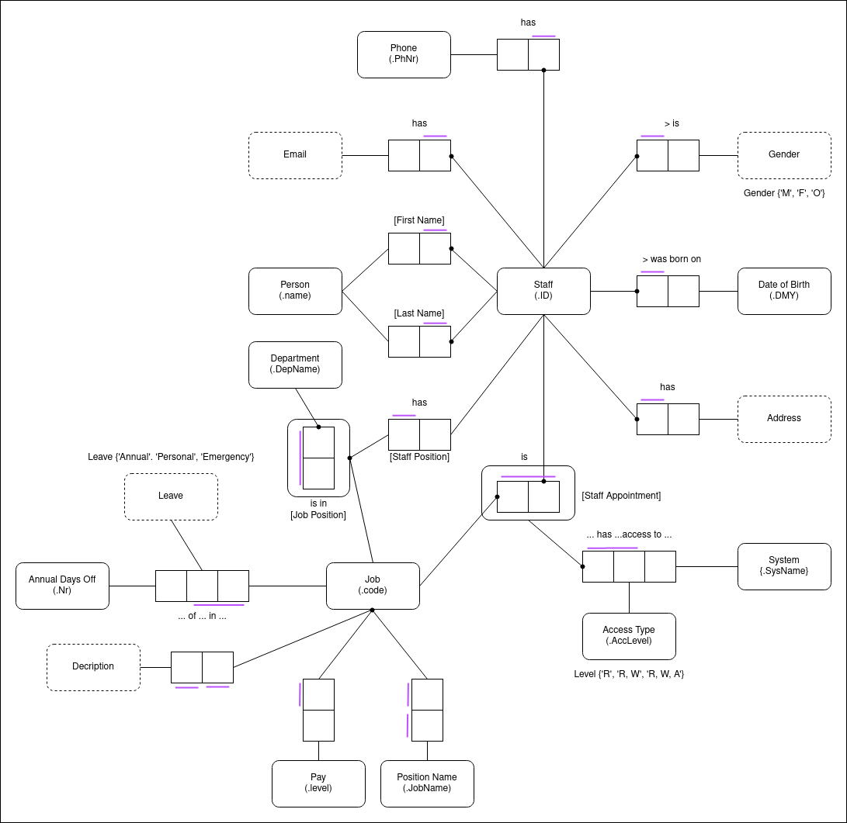

Task 2: Map CSDP to Relational Database Model

CSDP:
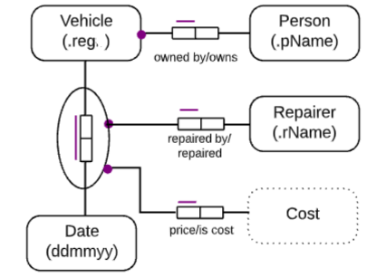

Relational Database Model:

Vehicle:{.reg, pName}

F2:{.reg, ddmmyy, .rName, Cost}

