1. Road Signs Detection
https://docs.google.com/presentation/d/1uP2BO4EW_qrJzwTa9w3d_rmjpywFOai9Yrj1hbKhbDo/edit?usp=sharing (edited)

Model Used: Faster RCNN
Why? From my research, it seems relatively well known, and in some lists I have seen it placed similarly to YOLO, the one that the creater of this challenge used.
This competition was selected due to its step up in complexity from the last image based classifier I did during lab 3. I thought it would let me expand my skillset.

2. Sentiment Analysis of Reviews
https://docs.google.com/presentation/d/1NbTCkGfDVPDgK3OtJjMGT8dW4BsGmuQUo3V0-YR6T2c/edit?usp=sharing

I chose this competition because of the similarity it has to the content of one of the annotations I completed in the human annotation step of the project. It will also serve well as a warm-up for the next classifier.

First, I will attempt to use the prepossessing script created created in lab 3 to turn text into usable features. No need to reinvent the wheel.

Set random seed to 42

My first model attempt will be completed using Quadratic Discriminant Analysis. This hasn’t been chosen for any particular reason, just that I haven’t used it before.

Update: Model 1 is highly tilted toward predicting negative result. Warning given: “Variables are collinear”

Used ChatGPT to make a quick distribution graph script so I can make sure the dataset is balanced.
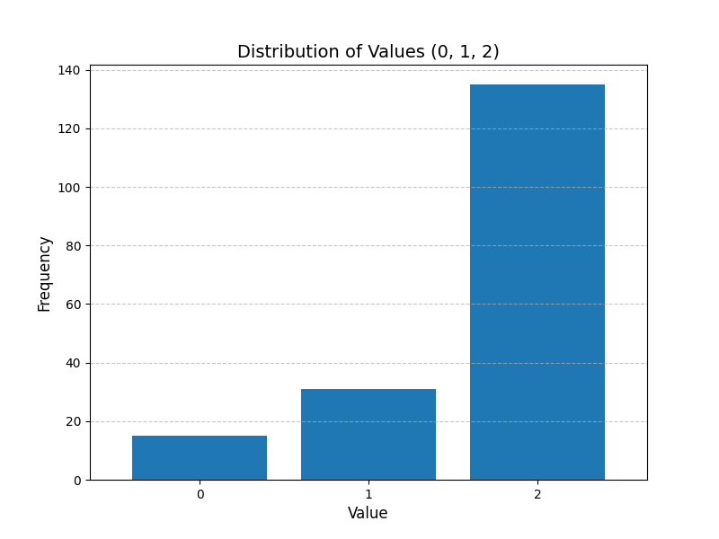
Results: it seems that there is a severe imbalance against result 0, which seems odd what with recall being 1.00 in favor of it.

Next, I am going to try to re-balance the dataset using SMOTE.

Update: the model is now only predicting 2 instead of 0. This is even stranger than before, given that SMOTE should have lessened its influence on the results, not made it greater.

Next, I will try using a random forest classifier, as it has built-in balancing

The model now no longer only predicts 2, but what it does predict as 0 and 1 are incorrect. I am going to try changing from SMOTE oversampling to undersampling 2.

Using both oversampling and undersampling at the same time, I can now get an accuracy of 0.6 overall, with 0 and 1 occasionally being correctly guessed. I am going to use this model for my first submission to see how it does, then try a third type of model to see if something else may give me better results.

Result of submission: Accuracy of about 0.6(the primary measurement for the competition). This is unfortunately very low, as the provided baseline was 0.7. Further attempts are necessary.

3. Commit Message Classification
https://codalab.lisn.upsaclay.fr/competitions/20633?secret_key=4ae0bbc3-b281-4c2c-8309-c9fb0236cb44

While this contest is similar to the sentiment analysis classifier, it is more complex in that it has more labels, one or two extra feature columns, and more than one label can apply to a single feature row.

I will begin by storing the data in a preprocessed format. To deal with there being multiple feature columns, I will just preprocess them separately then concatenate the results onto each-other. Labels will be stored in jsonl format.

My first model type attempted will be XGBoost, as I have read that it is excellent for dealing with imbalances in data.

This model will need both multi-class and multi-label capabilities. Fortunately, XGBoost does support these needs.

Upon implementing multi-hot encoding, the model gave a dev set hamming loss result of 0.11372549019607843, which seems to be good.

For the test set, I filled any values the model failed to predict anything for(due to multi-hot encoding) with what appeared to be the majority class.

Upon submission of y_test, I got a hamming loss of: 0.2718. Giving me second place on the leaderboard by a gap of 0.03 below first place. Some possible ways I could improve this score in the future would be fine tuning threshold, and saving individual probabilities in order to more accurately predict null predictions.

