Homework 2: Word Embeddings

Brayden Cloutier

University of Michigan-Flint

ARI-525: Natural Language Processing

3/14/2025

https://github.com/BraydenAC/ARI-525-Homework-2

Part 1: Embeddings
Query 1: pumpkin – pie + cake
 | Skip-gram | CBOW | Wiki | Google
1st | cake | cake | cake | pumpkin
2nd | pumpkin | cakes | pumpkin | cake
3rd | sweets | straw | icing | pumpkins
4th | jackolantern | boiled | cakes | gingerbread_house
5th | slippers | baskets | berberine | carved_pumpkin

I think I might have a misconception on how to do this part. Both queries I do vector arithmetic in generally have the first 2-3 words just pulled straight out of the equation.

Query 2: top ten words similar to ‘quilt’
 | Skip-gram | CBOW | Wiki | Google
1st | bloodstained | futon | quilts | quilts
2nd | futon | riceflour | quilting | Quilt
3rd | coals | tongs | quilter | quilt_squares
4th | manhole | nikiri | quilted | quilting
5th | teacup | yoghurt | quilters | Quilts
6th | pillows | shortcrust | quilt-making | quilters
7th | fullbody | lepinja | quiltmaking | handmade_quilt
8th | poking | dryfried | Quilt | quilter
9th | bobbins | dichloromethane | crazy-quilt | quilted
10th | verandah | lard | patchwork | pieced_quilt

Something I found interesting about Query 2 is how Skip-gram and CBOW are both far better than wiki and google, even though I turned off lemmatization for the first two for my final results. Somehow, the results for skip-gram and cbow look much better with far greater variety than before lemmatization.

Query 3: apple + banana - grapefruit
 | Skip-gram | CBOW | Wiki | Google
1st | apple | apple | apple | banana
2nd | banana | apples | banana | apple
3rd | apples | banana | apples | potato
4th | ballmer | juice | peach | bananas
5th | powerbook | packaging | fruit | cavendish
Same issue as last time for this one, though results from wiki seem to be the most promising.

Query 4: Top 10 nearest neighbors of "harrison"
 | Skip-gram | CBOW | Wiki | Google
1st | beatle | mason | harris | roberts
2nd | dillard | shaw | harrington | williams
3rd | harrisons | butler | robinson | crawford
4th | birstwistle | pierce | watson | derek
5th | tricia | miller | blake | dunn
6th | harnell | burton | harvey | frazier
7th | rosalynn | warren | stevens | payne
8th | holliday | davis | benson | armstrong
9th | dougherty | harris | watkins | o’brien
10th | schafer | webb | slade | kevin

Compared to quilt, all four models seem to have picked up on how I’m looking for surnames here. However, CBOW seems to still be having some issues.

Query 5: Cosine similarity of howl and bark
Skip-Gram | 0.527838945388794
CBOW | 0.32710951566696167
Wiki | 0.43957215547561646
Google | 0.4592762887477875

For this one, I was origionally sure that either wiki or google would be see the similiarity the most, but I was supprised to find skip-gram coming out in the lead despite being less than a tenth of the size.

Part 2: Bias
For this part, I chose RNSB for extending. My extension changed the list of negative sentiments from nationality into profession, namely; engineer, developer, designer, programmer, and coder. I chose these five because I thought the results would be amusing to see.

Skip-Gram:
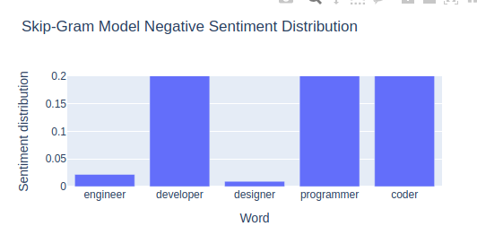

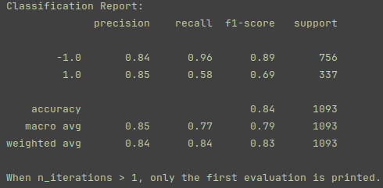

CBOW:
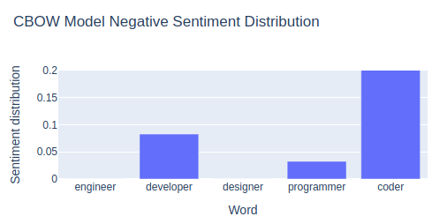
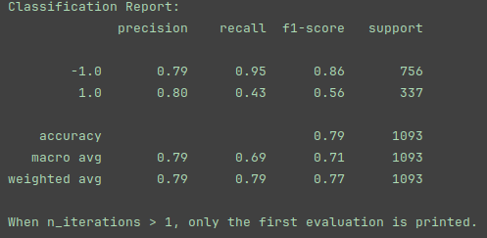

Wiki:
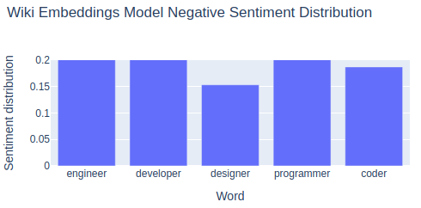
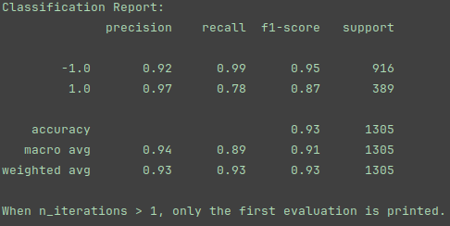

Google:
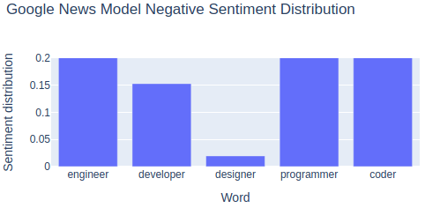
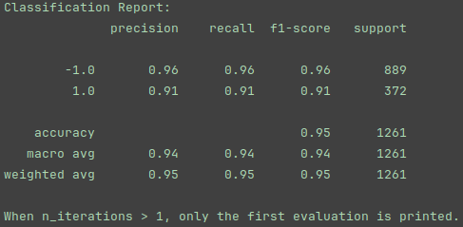

Results were about what I was expecting, with wiki and google having the highest scores, but its really funny that every one of these models agree that there isn’t much bad to be said about designers specifically.

Part 3: Classification

For this part, I chose to use the imdb example from the colab as the first logistic regression model and the document source for both. In the second model, I gained my vectors from my previous wiki embeddings.
 | imdb bow | Wiki cbow
Accuracy | 0.885 | 0.7063333333333334
f1-score | 0.88 | 0.71
I believe there are three factors that make imdb so superior to the cbow. First, the more granular features of imdb’s bag-of-words format allows it to have an order of magnitude more features as compared to cbow, forcing a more thorough fit. Second, the multiple for-loops necessary to convert documents to cbow format vastly increase computation time. Finally, the imdb bag-of-words only relies on itself for training, while the wiki cbow adds a somewhat unrelated corpus to the equation.

Part 4: Reflection
In this assignment, I really shot myself in the foot from the beginning by trying to use fasttext for skip-gram and cbow, then trying to make my functions play nice with google and wiki’s gensim. My main takeaway from it is that while it is good to learn a variety of libraries, sometimes picking one and actually sticking with it can really ease a workload. To see my adventures with fasttext before I removed it, check out hw2.py. To see what I settled on, check out hw2_v2.py. I really enjoyed the return to logistic regression; it was a nice refresher.

