Lab 0, Counting Tokens

Brayden Cloutier

University of Michigan-Flint

ARI-525: Natural Language Processing

1/29/2025

Part 1: Data
For my sample file, I decided to get The Adventures of Huckleberry Finn from Gutenberg, mostly because its a classic and it has a total token count of 113,993 when unprocessed.

Part 2: Methodology
I decided to create my program as a series of menus in order to make it extremely easy to plug in any plain text txt file as input, and lend the user a high degree of control and transparency over the settings implemented. While doing it this way did create a good deal of coding overhead, I found it worth it in the end due to the cleaner interactivity I ended up with.
For the actual code itself, I fully modularized it into individual functions as I have no doubt that I will be pulling on it as a code base to complete other projects in the coming months. Also, it was just good practice.
My graphing was relatively simple. With the help of the wiki link and the homework channel, I learned what exactly a Zipf’s Law graph does, then implemented it with the assistance of ChatGPT. I made my token count ranked list by using a paired parallel array, one array containing the type and the other its count.
The fourth normalization option I added was a function that removed trailing punctuation. I chose this because after looking at the data, I saw that a good deal of the mid and low-ranking words were ending in commas, periods, etc… I specify trailing punctuation due to the type of text I was using as input, what with Huckleberry Finn using a good deal of apostrophes and dashes to show differences in speech.

Part 3: Sample Output
Options Used: Lowercasing, Lemmatization, Remove Trailing Punctuation
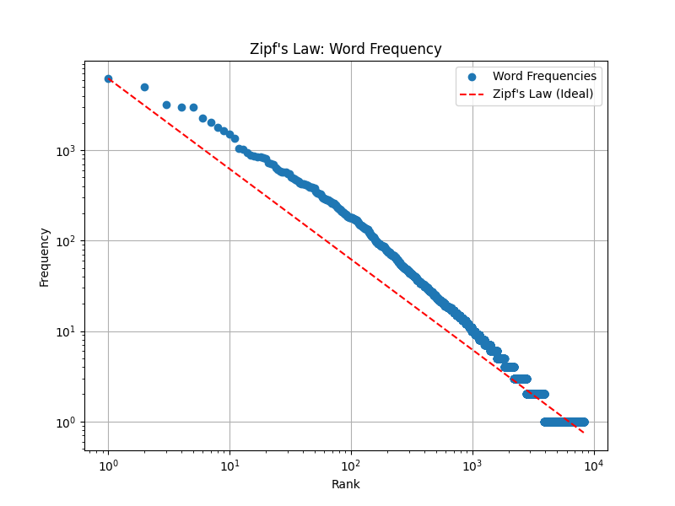
And | 6219
The | 5043
I | 3163
A | 3003
To | 2996
It | 2289
Was | 2038
Of | 1775
He | 1654
In | 1505
------------------------ | ----------
volunteer | 1
confirmed | 1
necessarily | 1
edition | 1
pg | 1
facility | 1
includes | 1
produce | 1
Subscribe | 1
Newsletter | 1

I decided not to include stopword removal, as it made the graph skew wildly from the ideal. Here is an example:
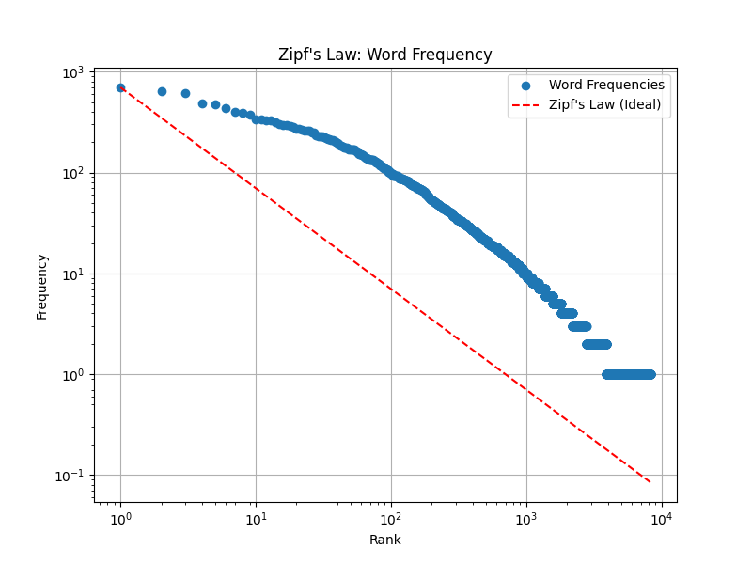

Part 4: Discussion
1. Findings
Since I did not include stopword removal, the results at the top of my list were quite predictable. However, the stopwords that did appear tended to be the ones that would be included within dialog.
On the other hand, the final ten words were mostly “modern” words that would appear very rarely within an older book such as our source text. In glancing at the extremes of the txt file, I recognised some of the words from those final 10 as part of the legalese from the back of the book.
In regards to the word frequencies and how they compare to the ideal, my final chosen combination of words seemed relatively on-point, but I found it very surprising that stop-word removal would throw it off so much. Looking at the first graph above, it had seemed like the only thing preventing the dots from lining up perfectly were the stop-words themselves, but removing them just threw the whole distribution out of whack instead. If I had to compare my results to one of the ones on the wiki page, I would say that mine most closely resembles the German/Russian/French/Italian one, if only for the higher dispersal of low ranked tokens.
It is my belief that the reason for the imbalance with stop-words removed is a result of the narrator of the story being a child, and thus naturally leans toward using simpler words.

2. What I learned
One of the main things of value I learned from this lab was of the existence of the library NLTK. I have a feeling that it will be of great use in the coming labs, and I hope I can figure out its intricacies. Secondly, the programming itself was a good warmup for my skills; they got a bit rusty over the winter break. Making efficient user interactivity was also really interesting to do in a structured way.

AI Disclaimer
AI was used to generate select sections of code, marked by comments within the program. It was also used for error comprehension and some syntax translation.

