AI Accelerator Hardware Design
In this work, the AXI interconnect system is constructed on Vivado to realize collaborative computation between the ARM processor (PS side) and programmable logic (PL side). The ARM at the PS side is responsible for parameter configuration, data cache management and interrupt reception, while the PL side deploys the matrix multiplication hardware core generated by HLS. With the AXI bus, the core directly accesses DDR memory to implement parallel computation of large-scale matrix multiplication.

The initial design of this work adopts a hybrid architecture combining the AXI4-Stream streaming interface and AXI_GMEM: the ZYNQ-PS manages the global address space via the General-Purpose (GP) bus, and AXI_DMA is responsible for format conversion between DDR and AXI4-Stream data streams. A two-stage FIFO is deployed to buffer the rate mismatch of data streams, while the matmul_accel core directly accesses DDR to fetch matrix data via three independent M_AXI_GMEM master interfaces. This single architecture supports two alternative data access paths simultaneously: direct memory access via GMEM and data streaming via AXI4-Stream.

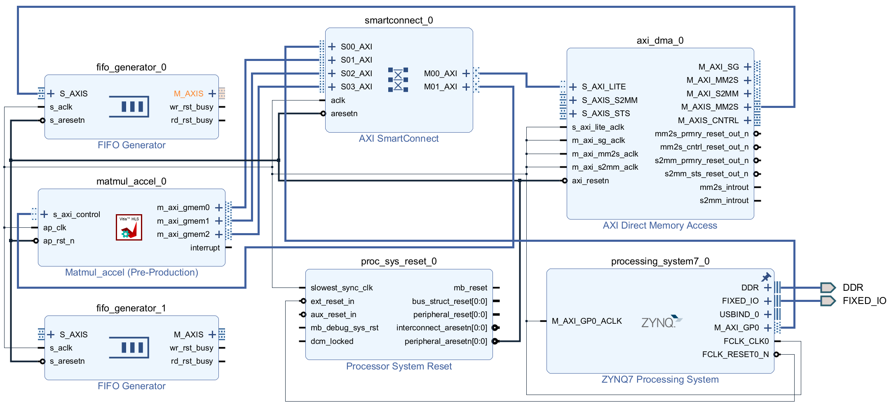
Figure 1.Initial hardware design of AI accelerator, this picture shows the basic modules of the design.However,due to conflicts between IP core design and hardware design, this scheme was not adopted, and the placement and routing shown in the figure remain incomplete.

The processing_system7_0 module denotes the on-chip processing system of the ZYNQ7000 family, serving as the master core of the entire hardware platform. It integrates an ARM processor and DDR controller internally, with off-chip DDR memory mounted externally; storage spaces for Matrix A, Matrix B and resultant Matrix C are all allocated within the DDR in this project. This module connects to the AXI interconnect IP smartconnect_0 via the general-purpose AXI master bus M_AXI_GP0, through which the ARM processor completes register configuration for the s_axi_control register of the matmul accelerator as well as DMA control registers. The module outputs FCLK_CLK0 as the global 100 MHz clock to provide synchronous clock signals for all on-board peripherals, while the native reset signal FCLK_RESET0_N feeds into the reset IP to generate global synchronous reset. Meanwhile, this module exposes PL-side interrupt input pins to receive two types of interrupts: computation completion interrupt from the matmul core and DMA data transfer interrupt. Once hardware tasks finish, the ARM processor is alerted via interrupt triggers to enter corresponding interrupt service routines for subsequent data reading and result verification.

proc_sys_reset_0 is the global synchronous reset generation module. It takes the raw reset signal and global system clock output from the ZYNQ processor as inputs, and generates a unified active-low synchronous reset signal peripheral_aresetn[0] after internal synchronous timing processing. This reset signal is synchronously distributed to all peripheral modules across the system, including the AXI interconnect, DMA, two-stage FIFOs and the matmul hardware accelerator, to implement synchronous reset of all on-chip logic. It eliminates metastability induced by asynchronous reset and guarantees reliable timing of all modules after system power-up and reset.

smartconnect_0 serves as the core routing component of the system AXI bus, configured with four slave interfaces (S00~S03) and two master interfaces (M00, M01). Among them, S00_AXI is interfaced with ZYNQ’s M_AXI_GP0 bus to receive various configuration commands issued by the ARM core; S01_AXI connects to the s_axi_control control port of the matmul accelerator, mapping the accelerator’s register space into the PS address space. The two master interfaces are respectively linked to the S_AXI_LITE configuration port of DMA and three GMEM master buses of the matmul core. This module implements AXI address decoding and multi-device bus arbitration. Relying solely on a single ZYNQ GP master bus, it enables the ARM processor to access the configuration registers of DMA and matmul, and meanwhile allows the matmul core to initiate DDR read/write transactions actively via GMEM buses, which simplifies routing layout and address management for multiple AXI peripherals.

As an AXI DMA controller, axi_dma_0 works as the protocol conversion bridge between DDR memory and AXI4-Stream (AXIS) streaming interface, consisting of two independent data transfer channels: MM2S and S2MM.
The MM2S channel converts memory-resident data into streaming format: it fetches raw Matrix A and B from DDR through the M_AXI_MM2S bus, encapsulates the raw data into standard AXIS stream inside the controller, and outputs the stream from the M_AXIS_MM2S port. After being buffered by the front-end FIFO0, the streamed data is fed into the matmul accelerator for computation.
The S2MM channel writes streaming results back to DDR: after matrix computation finishes, the resultant data stream from matmul is buffered by FIFO1 before entering the S_AXIS_S2MM port. The DMA automatically decomposes AXIS packets into AXI memory access transactions and stores the output matrix into the corresponding DDR address space.
The S_AXI_LITE port of this module is an AXI-Lite register configuration interface connected to the ZYNQ processor via AXI interconnect. The ARM core configures DMA parameters such as transfer length and transfer enable/disable via this port. Besides, the completion of MM2S and S2MM transactions triggers respective hardware interrupts reported to the ZYNQ PS side to notify the ARM for subsequent data verification.

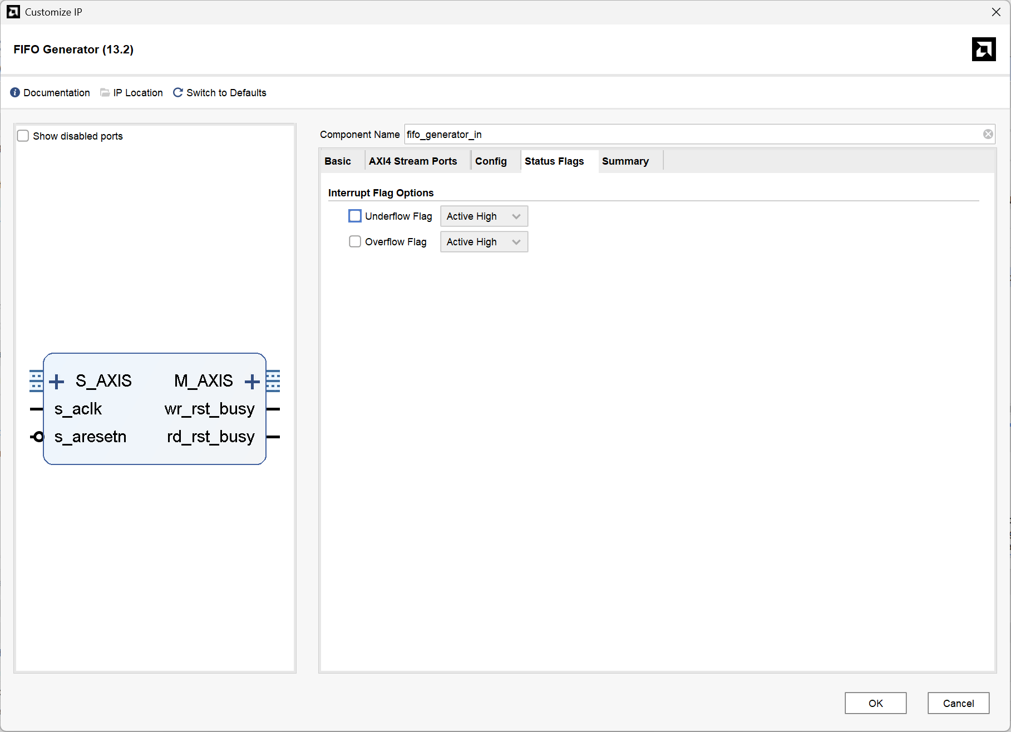
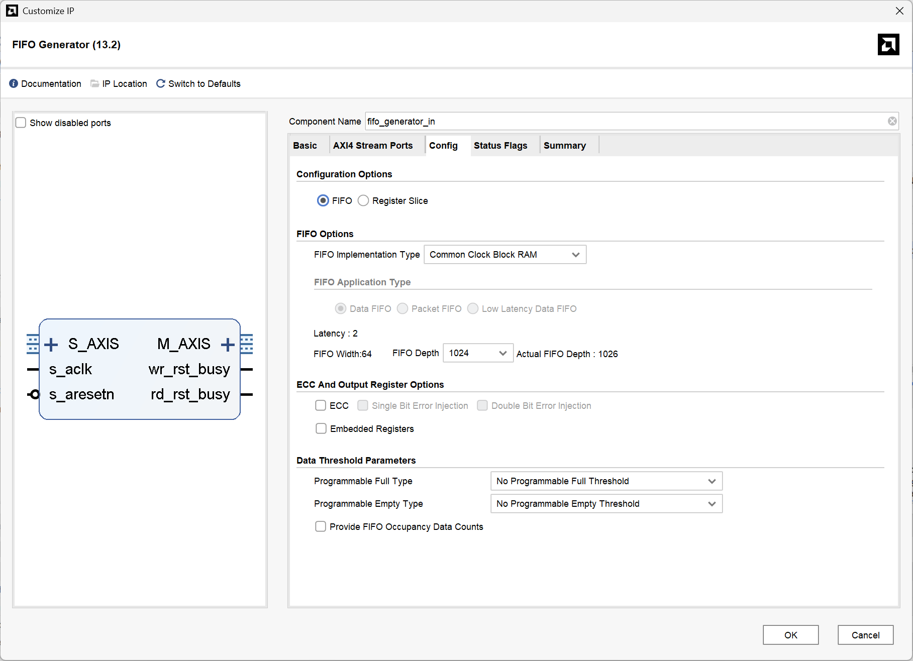
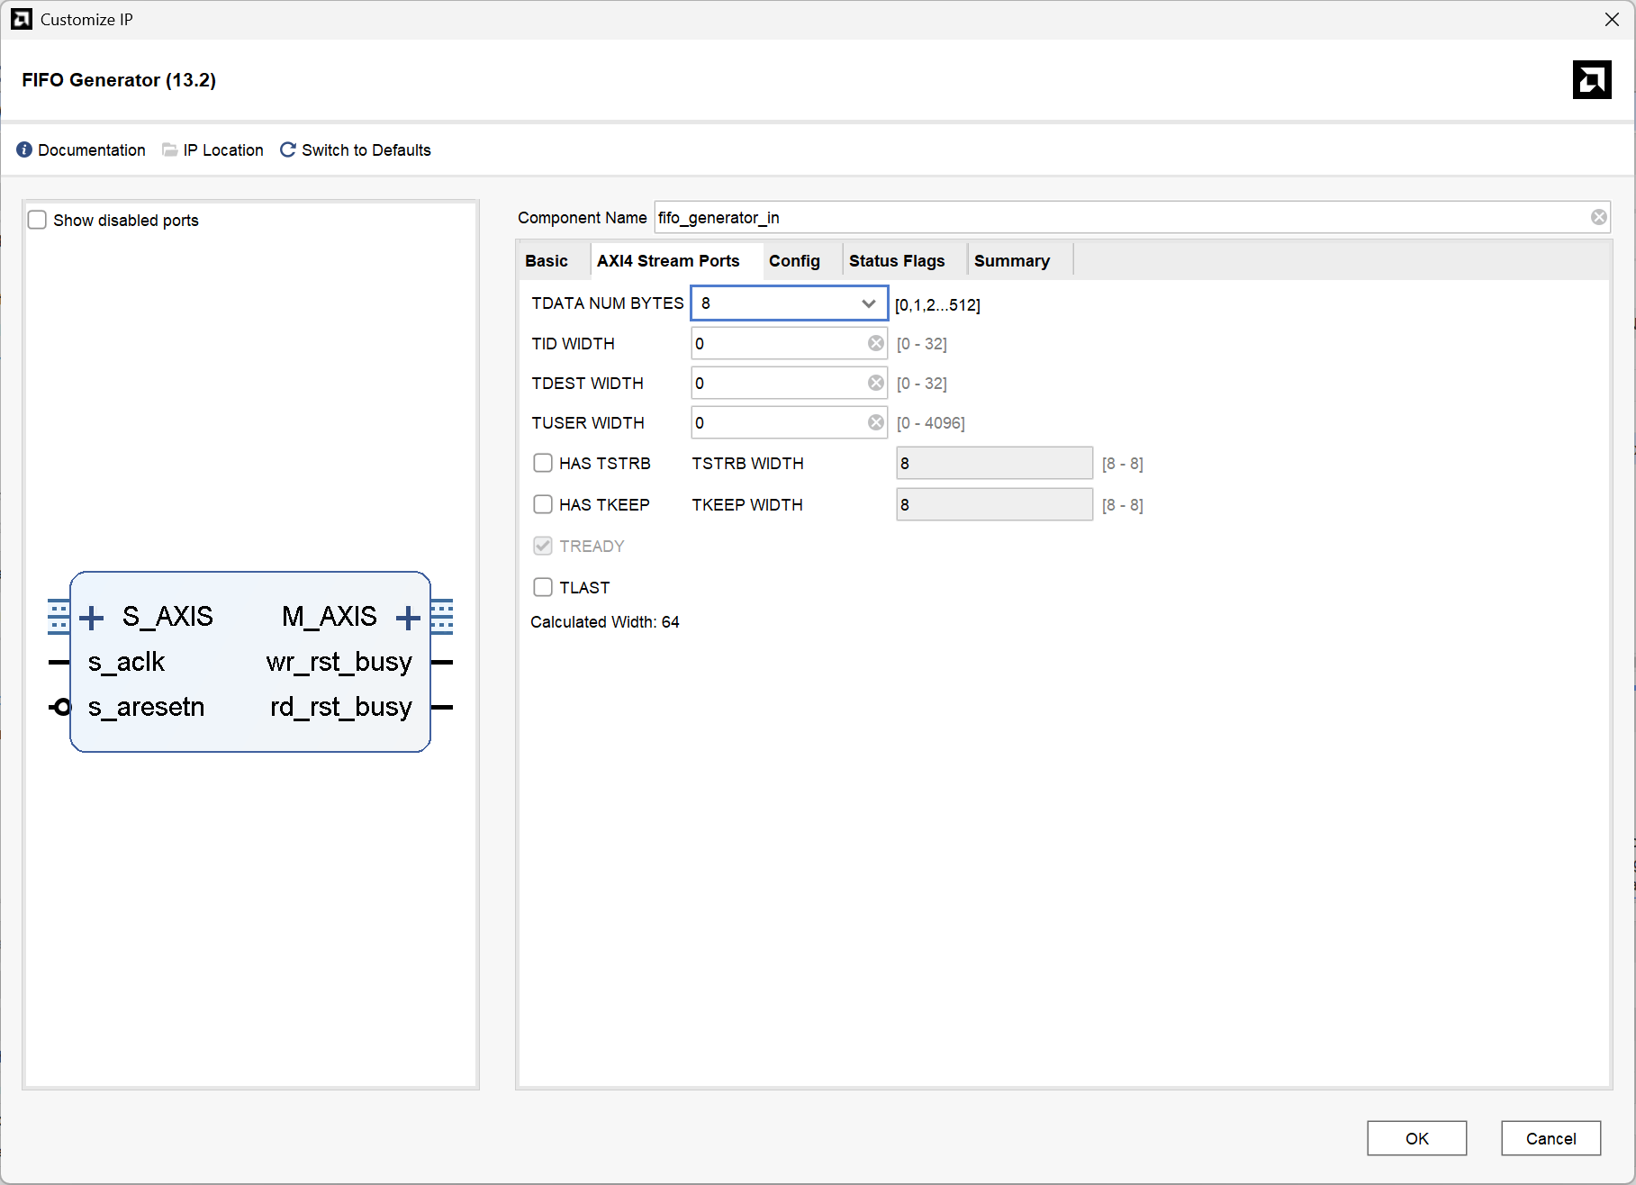
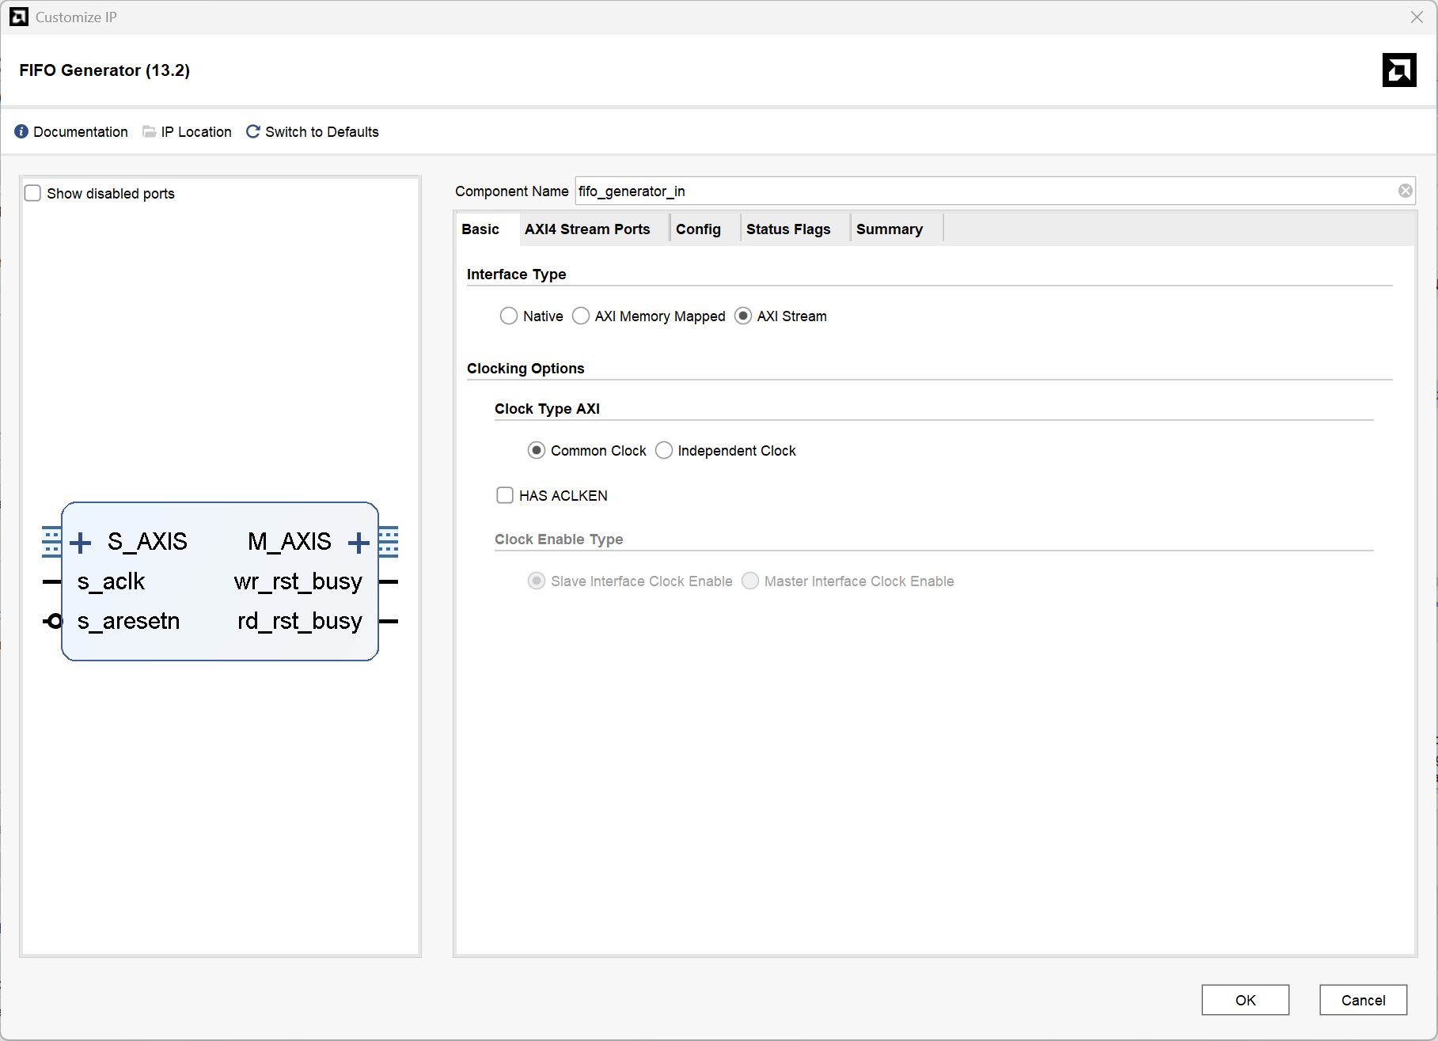
Figure 2.Basic Parameter Configuration of the FIFO Generator IP

fifo_generator_0 is the input-side buffering FIFO of the system. Its AXIS input connects to DMA’s M_AXIS_MM2S port to receive high-speed AXIS matrix data transmitted from DDR via DMA; after buffering, data is forwarded to the S_AXIS input port of matmul accelerator. Since DMA outputs burst-based high-speed streams while the matmul core adopts cycle-by-cycle serial arithmetic timing, a notable throughput mismatch exists between the two ends. This FIFO realizes rate isolation and data buffering to smooth transmission timing and compensate bandwidth gap, preventing underflow of the back-end computing module and overflow of front-end high-speed data, hence ensuring continuous and stable data delivery on the input path.
fifo_generator_1 acts as the output-side buffering FIFO, whose input is attached to the AXIS result output of matmul and output linked to DMA’s S_AXIS_S2MM port for buffering computed result streams. Mismatch between matmul output data rate and DDR write bandwidth of DMA is resolved by temporary data storage inside the FIFO, eliminating timing misalignment between adjacent stages to avoid result data loss or overflow and enable orderly writing of matrix results into off-chip DDR.

However, the designed IP adopts the GMEM direct DDR access architecture instead of the AXI4-Stream streaming architecture, rendering DMA and FIFO modules unnecessary. So we came up with a new design, which fit our IP core.

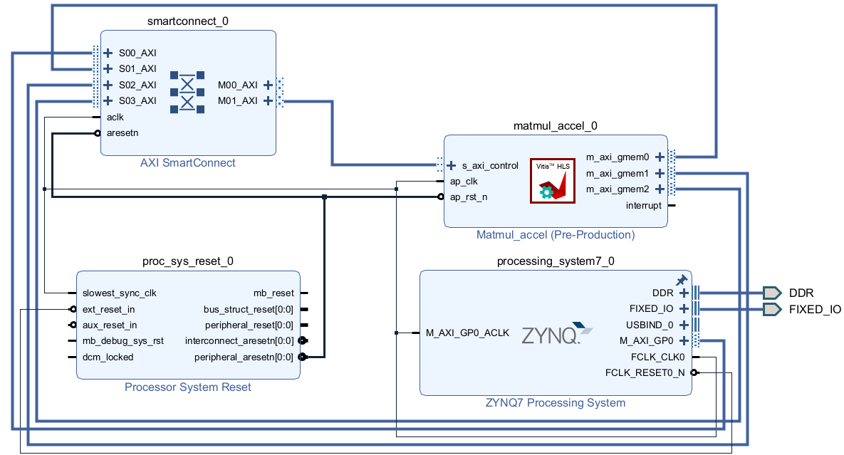
Figure 3.Updated hardware architecture design, axi_dma_0 and fifo_generator_0/1 were completely removed to fit the GMEM direct DDR access architecture.

This version corresponds to the finalized optimized hardware scheme of the project. The AXI_DMA and two-stage FIFO buffer modules from the preliminary design are eliminated, and the HLS-GMEM direct DDR access architecture is adopted to realize streamlined hardware datapath and improved timing performance. The whole system consists of four core components: the ZYNQ processor, AXI interconnect module, system reset module, and HLS-based matrix acceleration IP.
The overall workflow is detailed as follows:
The ARM core initializes test matrices A and B within the DDR memory space;
It configures register parameters of the matmul accelerator via the AXI-Lite bus and triggers hardware computation;
Leveraging three independent GMEM master buses, the matmul IP directly accesses DDR to autonomously load input data, execute parallel matrix multiplication, and write calculation results back to DDR;
An interrupt signal is asserted once computation completes;
After receiving the interrupt, the ARM reads the resulting matrix from DDR and verifies correctness by comparing it against results from serial software-based computation.

