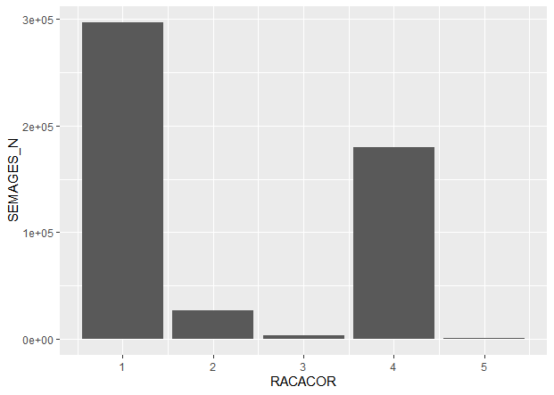

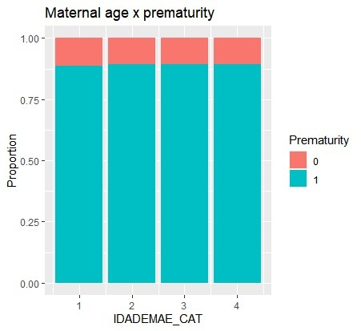

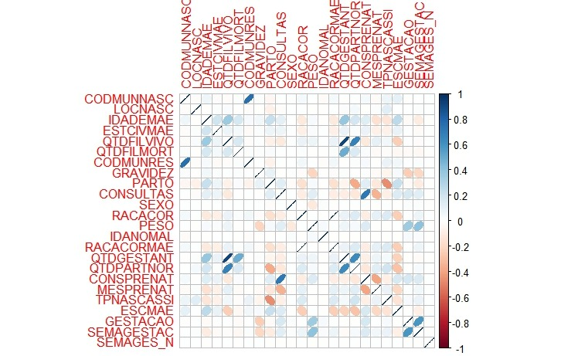

Call:

glm(formula = SEMAGES_N ~ RACACOR + trimmed2_data$age_cat + trimmed2_data$QTDGES_cat1 +

trimmed2_data$QTDPARTNOR_cat1, family = "binomial", data = trimmed2_data)

Deviance Residuals:

Min 1Q Median 3Q Max

-2.1813 0.4737 0.4772 0.4786 0.5009

Coefficients:

Estimate Std. Error z value Pr(>|z|)

(Intercept) 2.053114 0.034297 59.862 <2e-16 ***

RACACOR 0.007213 0.003066 2.352 0.0187 *

trimmed2_data$age_cat16-19 0.054890 0.035700 1.538 0.1242

trimmed2_data$age_cat20-35 0.048910 0.033975 1.440 0.1500

trimmed2_data$age_cat>35 0.052899 0.036046 1.468 0.1422

trimmed2_data$QTDGES_cat11 -0.018608 0.013676 -1.361 0.1736

trimmed2_data$QTDGES_cat12 -0.014821 0.018898 -0.784 0.4329

trimmed2_data$QTDGES_cat13 -0.096691 0.079070 -1.223 0.2214

trimmed2_data$QTDPARTNOR_cat11 0.031230 0.019595 1.594 0.1110

trimmed2_data$QTDPARTNOR_cat12 0.016301 0.026386 0.618 0.5367

trimmed2_data$QTDPARTNOR_cat13 0.165673 0.116362 1.424 0.1545

---

Signif. codes: 0 ‘***’ 0.001 ‘**’ 0.01 ‘*’ 0.05 ‘.’ 0.1 ‘ ’ 1

(Dispersion parameter for binomial family taken to be 1)

Null deviance: 388744 on 569457 degrees of freedom

Residual deviance: 388731 on 569447 degrees of freedom

AIC: 388753

Number of Fisher Scoring iterations: 4