Next Box
Your to-do list, on paper you can hold.
■ ■ ■ ■ ■ ■ ■

Product description and pitch
Version 0.9.6 · October 2026
Braznarkel · nextbox.braznarkel.com

1. Executive summary
Next Box prints your to-do list on small labels and stickers, made for people with ADHD. You check things off with a pen, take a photo, and your list updates itself.
Most productivity software assumes you will remember to open it. For the millions of adults with ADHD, that assumption is the problem. Next Box takes the list out of the phone and puts it on the fridge, the desk and the front door, as daily tickets, stickers and tear-off strips from an inexpensive label printer. A photo of the marked-up paper brings the changes back, so paper and app never drift apart.
Next Box is a working product today (version 0.9.6). It runs live at nextbox.braznarkel.com for invited beta testers. It works with Todoist, Notion, Asana and CalDAV lists, with Google Tasks, Microsoft To Do and TickTick ready to switch on, and with calendar feeds. It prints to five families of label and receipt printers, or to any regular printer as a PDF.
At a glance
What | Paper-first to-do system: label printer + web app + photo read-back
Who | Adults with ADHD first; paper-planner fans, households and small teams next
Why it wins | Keeps the list visible, works with existing apps, designed to reduce overwhelm
Stage | Live invite-only beta, v0.9.6, 150+ automated tests
Model (proposed) | Hosted subscription, printer starter kit, label refills

2. The problem
- Out of sight, out of mind. For many people with ADHD, a task inside an app on a locked phone may as well not exist. To-do apps depend on you remembering to open them.
- Too much at once. A screen holding 47 overdue tasks in red is overwhelming, and that feeling stops people before they start.
- Paper works, but it doesn't sync. Sticky notes and paper planners are visible and satisfying to check off. But they get lost, they go stale, and they never match your phone.
- Guilt, not help. Most apps say 'OVERDUE' in red. For someone who already struggles with time, that reads as shame, not as a nudge.

3. The solution
Next Box connects the to-do app you already use to a small label printer. With one tap it prints today's list, or one sticker per task to put where the task happens: on the fridge, the front door, the laptop. Check boxes with a pen, take a photo, and Next Box marks those tasks done in your app. You don't have to type them in.

How it works
- Plan. Add tasks in Next Box's own list or in your usual app. Type a whole brain dump at once.
- Print. Tap to print the daily list, stickers, tear-off strips or one big 'just one thing' card.
- Do. Stick it where you'll see it. Check boxes, arrow things to tomorrow, cross out what's dropped.
- Snap. Take a photo. Next Box reads your pen marks, shows what it found, and updates your list.
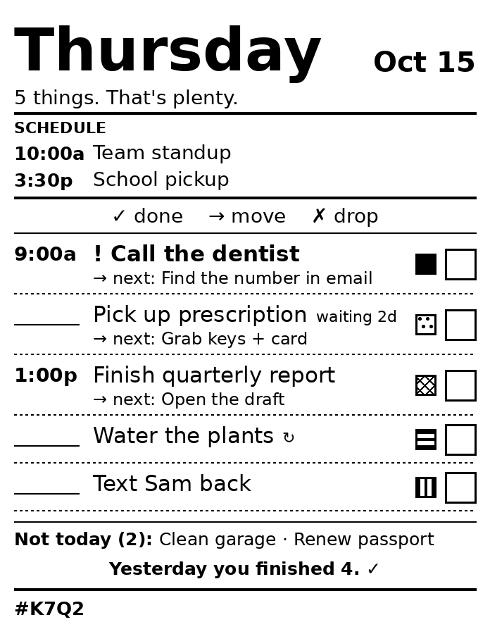
A real daily ticket: schedule, five tasks with next steps and tag patterns, a gentle 'Not today' line and yesterday's win.

4. What it prints

Daily ticket
Today on one label: your calendar, up to 5 tasks, the next tiny step for each, and yesterday's wins.

Stickers
One task per sticker with a tag color band, cut apart, to put where the task happens.
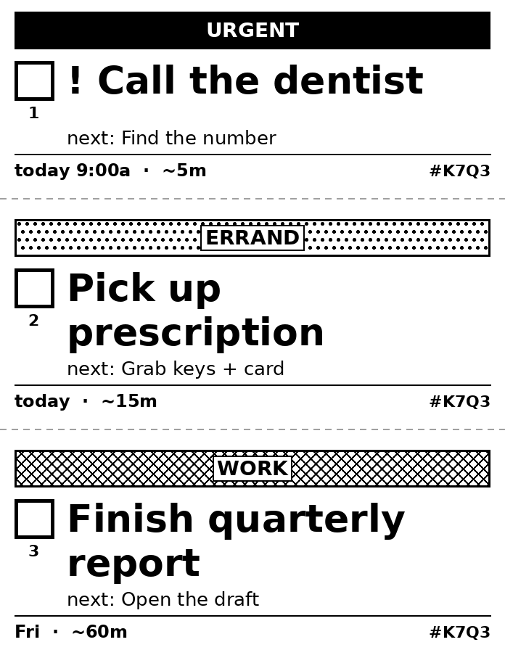

Tear-off strips
A list on one label with dashed cut lines. Tear off one task at a time.
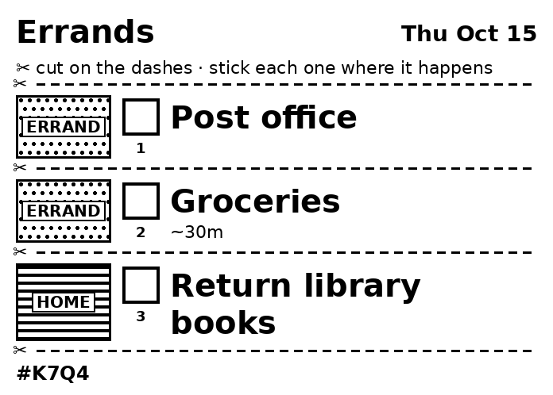

Just one thing
For overwhelming days: one task, printed huge, with tiny steps and a 'start by' time.
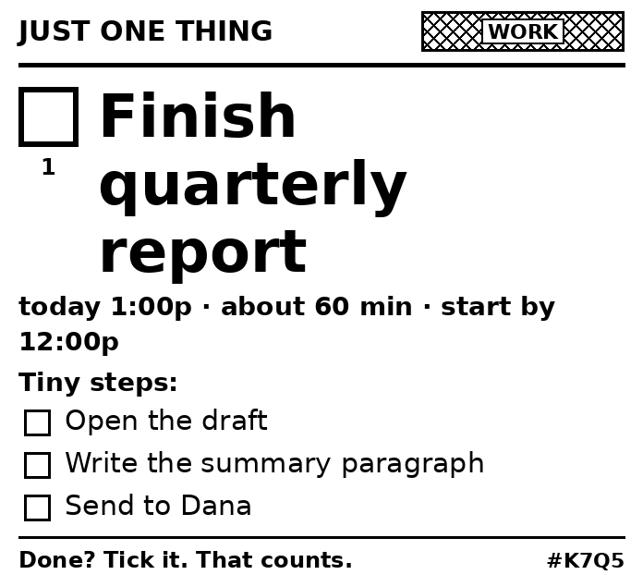
Every print is manual. The only exception is today's list, which prints once per day when Home Assistant sees you walk into your office. A server-side guard stops it from ever printing twice.

5. Designed for ADHD
Every default is chosen to make starting easier and to avoid shame:
- Five things, not fifty. The daily ticket shows at most 5 tasks. The rest go in a small 'Not today' line, so they aren't forgotten but don't take over.
- Gentle words. It says 'waiting 3d', not 'OVERDUE'. Repeating tasks move ahead instead of piling up.
- The next tiny step. Under each task: the first small action ("Open the draft"). Starting is the hard part.
- Wins first. "Yesterday you finished 4. ✓" is printed on today's ticket.
- Brain dump. Type everything at once, one task per line. Next Box understands #tags, !priority, 'tomorrow 3pm', '~15m' and 'every weekday'.
- Colored tags you can see. Red for urgent, yellow for errands, blue for calls and more. Each tag prints as its own pattern, so color shows up even on a black-and-white printer.
- Paper you can touch. Checking a real box with a real pen gives a small reward that tapping a screen doesn't.
- One automatic print, by design. Nothing prints unless you ask, except today's list, once a day, when you walk into your office (through Home Assistant).

Colored tags on a black-and-white printer
Thermal printers print only black, so each tag color does two jobs. First, routing: if one printer holds red labels, urgent stickers go to it. Second, pattern: on any roll each color prints as its own pattern (red solid, orange diagonal, yellow dots, green horizontal stripes, blue vertical stripes, pink checker, purple crosshatch), so tags are easy to tell apart. Tags match the names of Todoist labels and calendar categories, so colors stay the same everywhere. Brother QL-800 series printers can also print real red ink.

6. Photo read-back
Every printed box carries a row number, and every label has a short code (for example #K7Q2) that ties it to exactly what was printed. Mark boxes with ✓ (done), → (move to tomorrow) or ✗ (drop), and take a photo in the app. An AI vision model reads the marks. Next Box shows its reading for review, and only then updates the task list. Dropping a task never deletes it without an explicit confirmation.

7. Works with what people already use

To-do apps
App | Status
Next Box's own list | Built in, no account needed
Todoist | Ready
Any CalDAV list | Ready: Nextcloud, Fastmail, Synology, Zoho, older iCloud lists
Notion | Ready: any database with a title and a checkbox or status column
Asana | Ready: tasks assigned to you
Google Tasks | Built; switches on after a one-time Google sign-in setup
Microsoft To Do | Built; switches on after a one-time Microsoft sign-in setup
TickTick | Built; switches on after a one-time TickTick sign-in setup
Apple Reminders, Things, Any.do, Google Keep | Not possible: they don't let other apps connect

Calendars
Calendar | Status
Any calendar link (.ics) | Ready: Google, iCloud, Outlook and school or work calendars
CalDAV calendars | Ready
Google Calendar, Outlook | Built; switch on after the one-time sign-in setup

Each person has Next Box's built-in list plus, optionally, one linked app. Tasks in a linked app stay there: Next Box reads them live and sends changes back, and never keeps a copy. Calendars are read-only, never stored, and print as a SCHEDULE box on the daily ticket.

Printers
Printer | Notes
Brother QL / PT label printers | QL-800 series can print red ink too
ESC/POS receipt printers | Epson, Star, most 58/80 mm printers
ZPL label printers | Zebra and compatibles
TSPL label printers | TSC, Munbyn, iDPRT, Xprinter
Anything installed on the computer | Dymo, Rollo and USB printers, through CUPS
Any home or office printer | 'Print on paper' makes a Letter or A4 PDF with real-size stickers and cut lines

8. Privacy, safety and trust
- Your tasks stay where they are. Tasks from a linked app are read live and never copied into Next Box. Calendars are read-only and never stored.
- Invite-only. No open sign-up. Every new person needs a one-time invite code.
- Secrets sealed. To-do app tokens are encrypted at rest. Passwords are hashed. Secrets never appear in logs or debug bundles.
- You own your data. Download everything as one file, or delete your account yourself.
- Deleting needs a yes. No task is ever deleted, even from a photo, without you confirming it.
- Anonymous feedback. The feedback board doesn't show who posted. Only one protected table links a post to a person.
- Safe links. Calendar and server addresses people type are checked so they can't point Next Box at private networks.
- Honest data notice. Everyone agrees, in plain words, to exactly what the admin can see.

9. A complete app

For everyone
- Profile page, full settings, light and dark theme, text size
- Phone bottom tab bar, installable on the home screen, offline banner
- Getting-started guide for new people, plus help, privacy, terms, about and 404 pages
- Sign in with username or email, change password, signed-in devices

For admins
- Households: families or teams share printers; each person keeps their own list.
- Roles: person, household admin, superadmin. The protected owner account can never be locked out.
- Super admin panel: every person, search and filters, reset passwords, sign out devices, bulk actions, CSV export. It shows task counts, never task text.
- Every admin action is recorded in an audit log.
- Built-in health check (nextbox doctor) and a 'new version available' banner.

10. Technology
Layer | Built with
Server | Python 3.12, FastAPI, SQLAlchemy
Database | PostgreSQL (SQLite for development); automatic upgrades for new columns
Web app | Phone- and desktop-ready, installable to the home screen, light and dark themes
Label rendering | Pillow; real-size layouts for each printer, plus Letter/A4 PDF
Read-back | Claude vision model reads pen marks against the printed manifest
Integrations | Provider plug-ins (tokens or OAuth with PKCE), CalDAV, iCalendar
Hosting | One home PC behind a Cloudflare Tunnel, with no open ports
Home automation | Home Assistant prints the daily list when you enter your office
Quality | 150+ automated tests on SQLite and PostgreSQL; built-in 'doctor' health check

11. Market
- Adults with ADHD. Often estimated at about 4–5% of adults in the US, and many more undiagnosed. They are underserved by screen-only productivity tools.
- Paper-planner people. People who already buy planners, sticky notes and label makers, and want them to stay in sync.
- Busy households. Families who share chores and errands, and teens building routines.
- Small teams and makers. Workshops, kitchens and front desks where a printed ticket beats a screen.
Note: market sizes here are rough public estimates. They should be checked against current sources before being used with investors.

12. Competition and positioning
Alternative | How Next Box compares
To-do apps (Todoist, TickTick, Things) | Great lists, but screen-only. Next Box works with them instead of replacing them.
Paper planners and sticky notes | Tangible but disconnected. Next Box adds sync, tags and read-back.
DIY receipt-printer to-do hacks | Hobby projects that print a list. None read the paper back, work with many apps, or design for ADHD.
ADHD apps (timers, body doubling) | Help with focus in the moment. Next Box is the physical planning layer and works next to them.

Next Box doesn't compete with to-do apps. It makes them work better for people who need their list to be visible. It is the only product that combines physical labels, live sync with mainstream apps, photo read-back and an ADHD-first design.

13. Business model (options under consideration)
- Hosted subscription. Monthly plan for the cloud version: linked apps, photo read-back and calendars.
- Starter kit. A label printer bundled with Next Box, set up out of the box.
- Label refills. Colored label rolls and sticker sheets, matched to the tag colors.
- Free self-hosted edition. For tinkerers. It builds trust and community.

14. Current status
- Live beta. Running at nextbox.braznarkel.com through Cloudflare, invite-only.
- Version 0.9.6. Python and FastAPI server, PostgreSQL database, web app for phone and desktop.
- Tested. 150+ automated tests, run against both SQLite and PostgreSQL.
- Self-hosted. Runs on one home PC today. A cloud version is on the roadmap.

15. Roadmap
- Now. Live beta with invited testers. First real prints on the Brother QL-1110NWB.
- Next. Turn on Google, Microsoft and TickTick sign-in. Print straight from a phone. Publish the braznarkel.com homepage.
- Later. Cloud hosting, AI 'break it down' into tiny steps, a focus timer, color printing on paper.
- Launch. Legal review of the privacy policy and terms, pricing, and a starter-kit partner.

16. Open questions
- Pricing and which model to lead with (subscription versus kit)
- Cloud hosting provider and when to move off the home PC
- Which printer to recommend in a starter kit
- Legal review of the privacy policy and terms before charging money
- Validating demand: beta tester feedback and usage numbers

Contact
Braznarkel · braznarkel.com
Beta (invite only): nextbox.braznarkel.com

