Milestone 5 Design Document

# Class Diagram

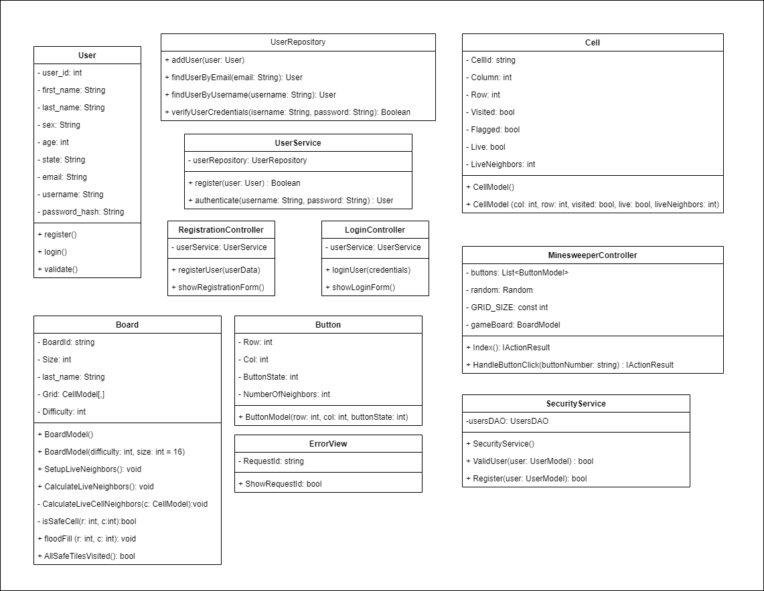

# WireframesFinalMinesweeper-2.jpg

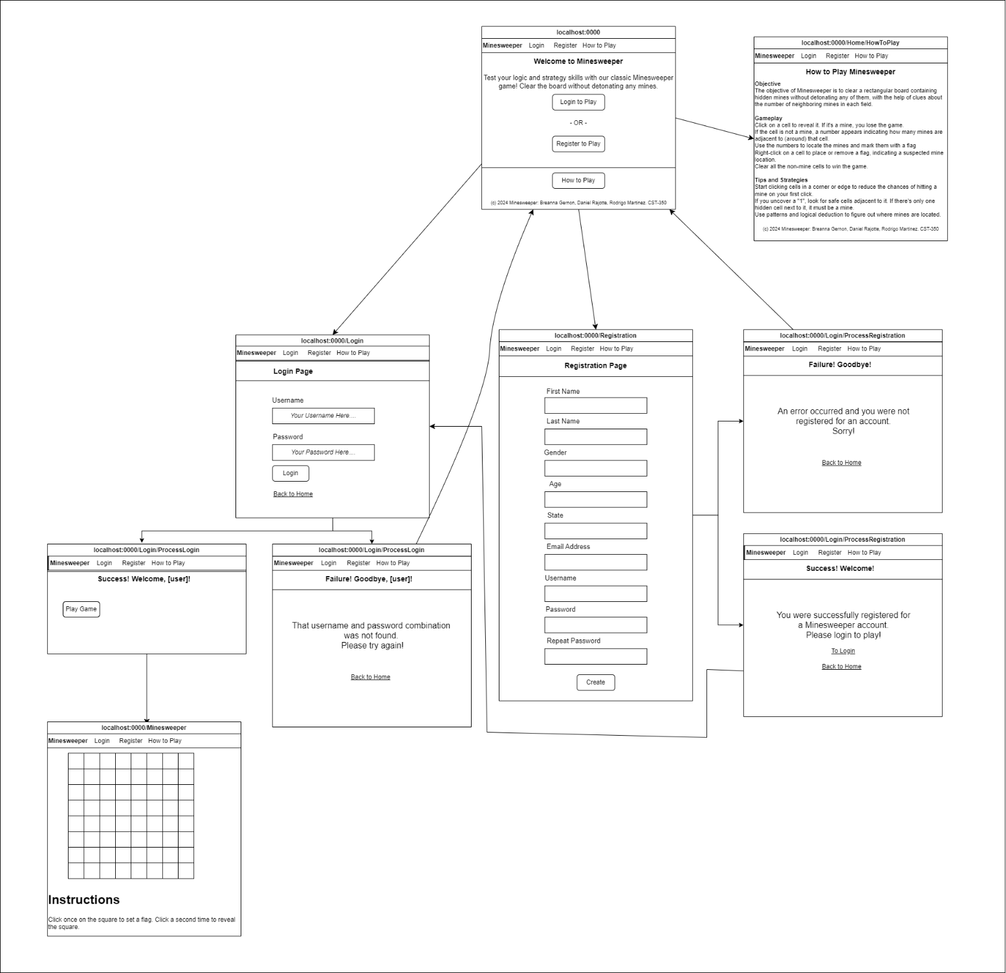

# Site Navigation Map

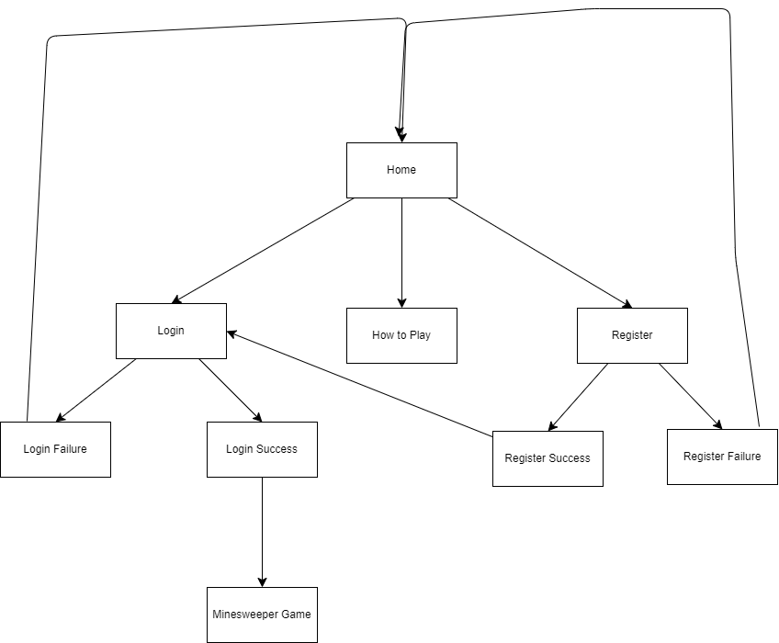

# Database Design

# Video Link