CATAN

Hexes
Tiles are all designated numbers, starting from 1 to 19 in order from top left to bottom right, counting left to right, top to down.

BoardClicker
Each tile on the board is split into 6 edges, with each number being designated in a clockwise direction.
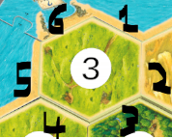
For edges which share a border with another tile, the tile above and left will always take priority. The other tile will IGNORE the edge it shares a border with. BUT it will continue in a clockwise direction.

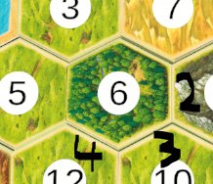
For tile 5, because it shares a border with higher priority tiles, it will only contain 2, 3, 4 in the script.
The tile selection text on the screen will mention the borders it shares with.

All borders that are shared that are NOT being used are still present but they are INACTIVE.

