電通二乙微處理器實驗 實驗結報

實驗名稱 | I2C通訊
組別 | 09 | 組員 | 林文韜

- 實驗目的
使用Arduino wire 程式庫,實現多台linkit 7697透過I2C接面通訊
- 實驗步驟
讀出溫濕度感測器的讀值並且傳到PC
- 程式碼
#include "DHT.h"
#define DHTPIN 2
#define DHTTYPE DHT11
DHT dht(DHTPIN, DHTTYPE);

void setup() {
Serial.begin(9600);
Serial.println("DHTxx test!");

dht.begin();
}

void loop() {

delay(2000);

float h = dht.readHumidity();

float t = dht.readTemperature();

float f = dht.readTemperature(true);

if (isnan(h) || isnan(t) || isnan(f)) {
Serial.println("Failed to read from DHT sensor!");
return;
}

float hif = dht.computeHeatIndex(f, h);

float hic = dht.computeHeatIndex(t, h, false);

Serial.print("Humidity: ");
Serial.print(h);
Serial.print(" %\t");
Serial.print("Temperature: ");
Serial.print(t);
Serial.print(" *C ");
Serial.print(f);
Serial.print(" *F\t");
Serial.print("Heat index: ");
Serial.print(hic);
Serial.print(" *C ");
Serial.print(hif);
Serial.println(" *F");
}
- 實驗結果及分析
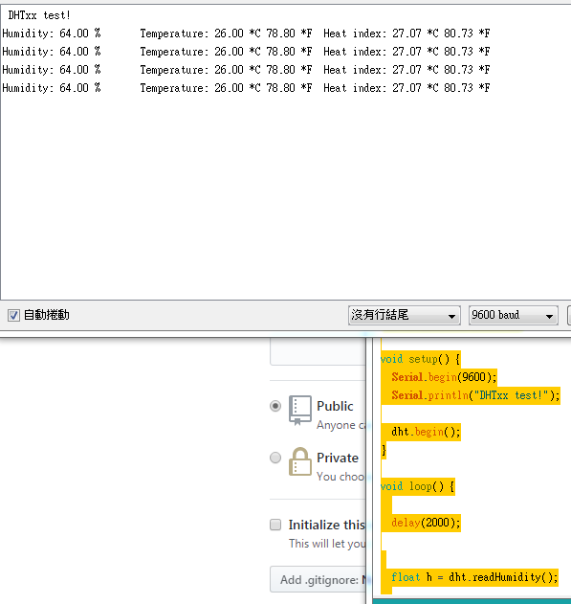
能夠達到實驗目的
- 心得討論
很有趣的實驗,過程也比較輕鬆
- 修正電路圖
- 修正程式碼

