FEASIBILITY OF QUANTUM ERROR MITIGATION FOR QUANTUM SEARCH ALGORITHMS

**Abstract**

Quantum computing is an extremely powerful tool that can allow complex computations to be made in exponentially less time compared to classical computing. This research revolves around investigating and modelling the impacts of up scaling the Grover’s algorithm: a quantum algorithm which can conduct unstructured search exponentially faster than its classical counter parts. However modern-day quantum computers are prone to error which limit their commercial usefulness, the following research demonstrates the feasibility of using Quantum error mitigation via Negative Quasi probability mitigation for modern quantum computing hardware as an alternative to quantum error correction circuits to increase the accuracy of output. Given sufficient classical computing power and memory Quantum error mitigation via Negative Quasi probability mitigation increased output fidelity and chances of successful Grover searches by 1.932% and 22.08% on average respectively, however it was observed that in noisy quantum states it produced increased output fidelity of up to 5.62% and increased the chances of successful Grover searches by up to 60%.

**Literature review**

Quantum computing

Quantum computing promises to dramatically increase computational speed compared to classical computers allowing exponentially complex computations to be completed in exponentially less time.

Whereas classical computers use bits with discrete states, being either on, as represented by 1 or off, as represented by 0. On the other hand, quantum computers utilise quantum bits (qubits), instead of silicon transistors such as those in traditional computers. Quantum computers utilise the electrons of metallic atoms (currently calcium) embedded in a lattice of silicon.

These electrons have “spin”: “up” and “down” which corresponds to 1 or 0 in a classical computer, however they also adhere to the laws of quantum mechanics allowing them to have the unique property of being able to be “on” and “off” or a “1” and a “zero” simultaneously. When this occurs the electron is in a “quantum state”, a very delicate phase which are prone to external disturbances, the three main ones are:

* Thermal radiation: Quantum systems are kept at around 10-4 Kelvin, however slight temperature variations produce excess unwanted kinetic energy on the system which impacts the electron spin, altering the result of computation.
* External noise: Physical vibrations made by the apparatus, auditory noise, microwaves and radio waves all may influence the spin of the electron changing the result of computation.
* Quantum Decoherence: Quantum systems have an extremely short life span: a period where they maintain their quantum properties, due to inevitable interaction with other particles during manipulation and measurement that it undergoes during computation. When quantum systems decohere their quantum behaviour is lost and the computed results become uninterpretable.

Errors in computation caused by the disturbances inhibit quantum computers to overtake the computation power of their classical counterparts.

However, fault tolerant quantum computers hold promise to lowering the error rates of quantum computers thereby significantly increasing their computational power and usefulness. The following research explores the possibility of building algorithmic fault tolerance without altering existing hardware through Quantum Error Mitigation (QEM) for the Grover’s search algorithm.

**Grover's algorithm**

Grover’s algorithm is a quantum algorithm, designed to be ran on quantum computers. It is an unstructured search algorithm first devised by LK Grover in 1996 and theoretically offers a quadratic speed up, compared to traditional computational searches (given that they are error free). Suppose that T denotes Time of computation. N denotes number of entries and O time to search one entry: In classical computing the worst case scenario, you search every single entry T = O*N. however with Grover’s algorithm the worst case scenario T = O*sqrt(N)

The algorithm has applications in wireless communications, machine learning, material science, just to name a few.

* + In wireless communications, Grover’s algorithm can be used to search better search for a user on a network.
  + In machine learning, AI could use Grover’s algorithm to search through vast amounts of input data and formulate patterns.
  + In material science, Grover’s algorithm has potential in searching for different properties of materials allowing innovations in construction and aerospace.

Everything that utilises an unstructured search function such as a search engine or a database has the potential to be improved by Grover’s algorithm.

Algorithm workings:

The algorithm is split into 3 Main parts… superposition, oracle, amplification. These last two are often combined together and are referred to as the “Diffuser”

**Step 1**

The target of the search algorithm is represented by W, all other results are represented by X. whilst N represents the number of entries in a theoretical database.

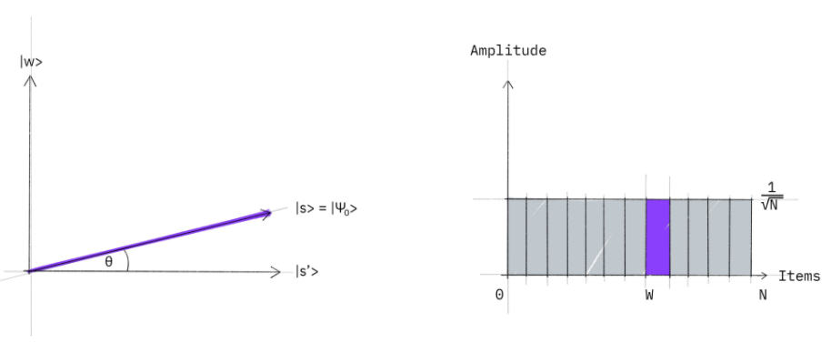First, all the qubits are first placed in an even quantum superposition. This is done as when we first look at the list, since any guess of the location of W is valid, therefore we will have an even probability of finding W for every guess we make, thus it can be expressed with a uniform superposition.

Figure Superposition

If we collapsed the following superposition, then the probability of all basic states would be 1/n with N being the number of samples in the database. Note that in quantum mechanics the probability of measuring given orthogonal state |s’> is also given by (|x|)^2 where |x> is a normalised vector. (a vector with a magnitude of 1) Therefore square rooting our probability we know the amptitude of |s’> is 1/sqrt(N)

**Step 2**

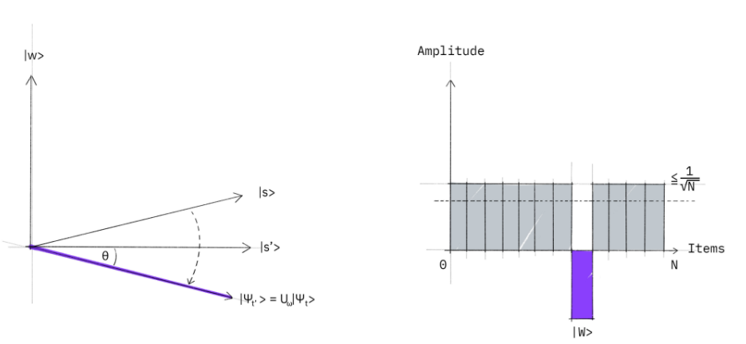Then, an oracle function is applied; the oracle function is a “black box” function that tells us if we guessed right or wrong. Basically when “w” is inputted into the oracle function it will output a value of -1, flipping W amplitude. However, when X is inputted into the oracle function 1 is outputted, therefore the amplitude is not flipped for X.

Figure Oracle

**Step 3**

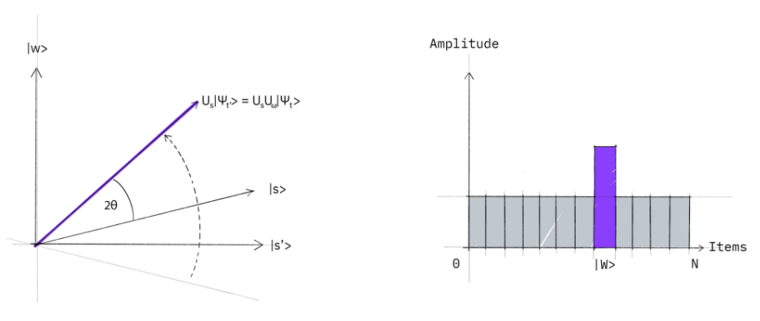Finally, an additional reflection and amplification of W is applied, in which the quantum computer increases the probability of outputting W. This transformation has the effect of increasing the amplitude of W while decreasing the amplitude of X. since the initial amplitude is 1/sqrtn when amplification is applied sqrtn number of times the finial state will be W almost every single time.

Figure Amplification

**Current Research**

Current literature (2015 – present) surrounding Grover's quantum algorithm mainly focuses on the optimisation of the 3 parts of the groover’s algorithm (super position, oracle, amplification) and the Implementation of Grover’s algorithm on new methods of quantum computation, non-quantum simulations, or hybrid quantum circuits.

Qubits lose their quantum properties due to noise, or heat from the quantum computer. The longer the qubits ‘live’ the more they decohere and want to return to a particle, different quantum computers. Qubits that decohere output uninterpretable results. Hence, one experiment attempted to address how to increase the probability and accuracy of the algorithm in finding the correct result, by replacing the two phase inversions with one instead (Hao, Wang & Long 2020).

Implementations of the algorithm often target the rotation and matching of the inverted qubit. A recent study published examined ways to use multiphase matching to increase the probability of discovering the hidden variable with a single Grover operation (Li, Panchi and Shiyong li 2018).

Quantum simulation offers a cheap and reliable alternative to quantum computing as classical computer architecture is not prone to the same problems as quantum architecture. Mandiviwalla et al (2018) in a paper published in 2018 explores the use of parallel hardware architectures to emulate Grover’s algorithm.

The simulation of quantum algorithms is often done on rare-earth solid-state qubits, Research done by Schwabe et al (2016) outlined the possibility for simulating Grover’s algorithm in large nuclear spins of semiconductors and is shown to exhibit quantum-like qualities, such as spin and orbital degrees of freedom.

There are minimal conflicts in literature from the past 5 years, the contradictions that do exist are often between theoretical ways of optimising and implementing Grover’s algorithm, which are not based on observed results when these methods were run on an actual quantum computer.

Quantum error correction protects quantum search algorithms against decoherence by Botsinis P et al (2016). The investigation was conducted in a theoretically perfect fault free quantum computer, where noise and “error” was simulated through depolarising channels. The effects of these were then corrected with Steane’s quantum error correction circuits. This study concluded that error correction for quantum computers has massive potential, and could drastically increase their usefulness.

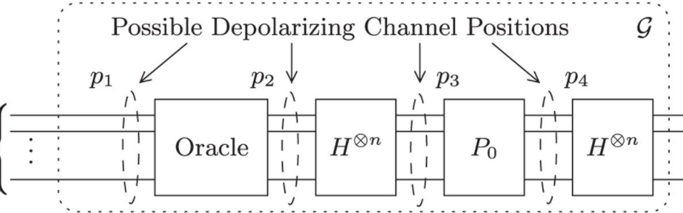

Figure possible depolarising channels

Bossinis P et al positioned depolarising channels at p1, p2 p3 and p4 conducting two experiments: one with one decoherence circuit, and the other one with 3. Their results were incredibly promising increasing the success probability of grover’s search algorithm from 60.6% to 99.5% in the first experiment and from 33.3% to 96.3% in their second experiment.

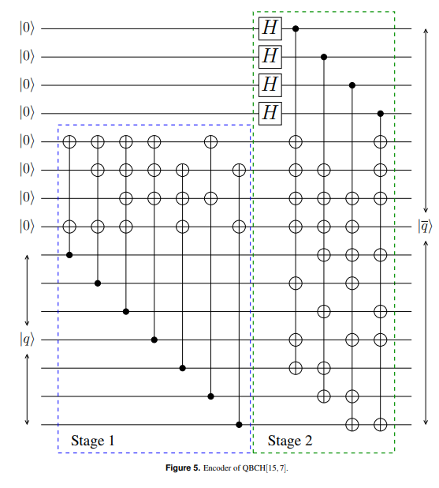

Figure 15 Qubit Quantum Error Correction Circuit

However, quantum error correction despite its promising results faces limitations: Above is the circuit diagram for Staene’s Quantum error correction circuit for a 4 qubit Grover’s algorithm. It is important to note that currently the biggest commercially available quantum computer has 15 qubits and a quantum volume (the max number variable quantum gates) of 32 therefor employing an algorithm of this magnitude on top of a 4 qubit groover’s search algorithm is simply unpractical.

Furthermore, the paper assumes the error correction coding would not be prone to error as no depolarising noise is applied to them. Ironically, the error correction algorithms employed would be prone to more error than the Grover circuit itself, due to its large size, complexity and vast number of quantum gates over the 32 gates limit the thermal, noise and decoherence errors would actually be exaggerated in a real quantum computer.

The following research paper shows great promise into the field of quantum error correction when applied to the Grover’s search algorithm however it clearly demonstrates the demand for more practical and realistic solutions which better address to current issues.

Quantum error mitigation, specifically “Negative Quasi probability mitigation” (Temme.E, Bravyi.S, Jay.B et al 2017) may be the answer, this process is extremely light weight on the quantum processor as it does not require a secondary quantum circuit such as the one used in the quantum error correction code, only a classical computer and a separate calibration circuit in order to “prime the qubits.”.

Its basic principle is as follow: a quantum system is first calibrated with the calibration circuit then the output qubits are prepared with “negative noise” from the quantum system. Thus when the results are received this negative noise cancels out with the true noise thereby reducing error.

**Aim**

To quantitatively measure the effects of employing quantum error mitigation (QEM) when scaling Grover's search algorithm on quantum fidelity and successful number of Grover searches in a simulated quantum environment,

**Hypothesis**

Quantum error mitigation should increase fidelity by at most 10% and successful Grover searches at most 50%, QEM should also function better in noisy quantum environments. Furthermore, fidelity will decrease logarithmically while successful Grover searches will decrease exponentially following an increase in qubits.

**Methodology**

Grover implementation

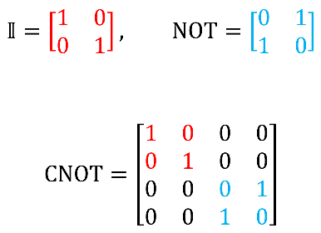First, a method allowing Grover’s algorithm to be infinitely scaled was implemented and Grover’s algorithm of 1 – 14 qubits was created. This was done in Qiskit 0.26.0 using the anaconda python compiler and notepad ++. A modular implementation was taken in order to scale the original 3 qubit algorithm up to 14 qubits.

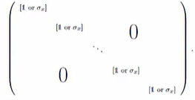An implementation of the oracle function which is theoretically infinitely scalable was applied. This was done modularly using an array of “NOT gates” and “multi control Toffoli” quantum gates, which generated an oracle function every single time.

Figure 2 qubit Oracle

Method and proof of oracle generation:

On fig 6 a sample oracle matrix for a 2 qubit Grover’s algorithm.

This oracle function and all oracle functions can then be decomposed into two smaller submatrices: I gate or “Identity gate” has no effect on the 1st Qubit.

Figure Generalised oracle

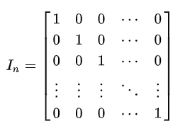However, the Pauli X gate or NOT gate changes the “spin” of the 2nd qubit. (Rotating it by pi/2 on the X axis) This qubit just happens to be our “target”. Recall that the oracle function’s job is to “mark” f(w) for our amplification circuit.

Now if we take a look at a generalised oracle matrix fig 7, for N number of qubits we see that Every oracle matrix can be decomposed into 2x2 submatrices of either Identity gates which do nothing to the qubit and X gates, which mark them for amplification.

Figure Generalised Identity matrix

To verify whether an oracle had been indeed produced we must verify that it the matrix unitary.

A matrix is unitary when it is own inverse, when U*U = Identity matrix which is a size n x n matrix. (fig 8)

Since we know that the smaller 2x2 matrix is unitary (verified by the calculation in fig 9), since the larger general oracle is composed of these smaller 2x2 submatrices we know that the oracle must be unitary as well.

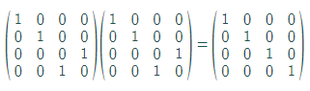

Figure The 2-qubit oracle is unitary

This trivial implementation of a Grover oracle function that will always ‘flag’ the 0 qubit. This implementation is simple and efficient to run on quantum computers as it is composed of very few quantum gates. Multi control X gates (called Toffoli gates which apply the identity matrix across multiple control qubits, and the Pauli X matrix across the target qubit) and Identity gates and could also be indefinitely scaled which makes scaling up the groover’s algorithm a lot easier in general.

After circuit construction a modular approach was taken in order to construct the rest of the circuit in python variables were used instead of numbers to facilitate easy construction and scaling.

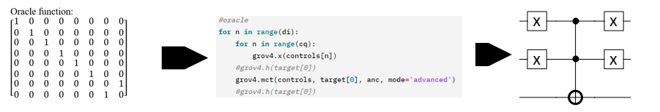

Figure Oracle function > code > quantum gates

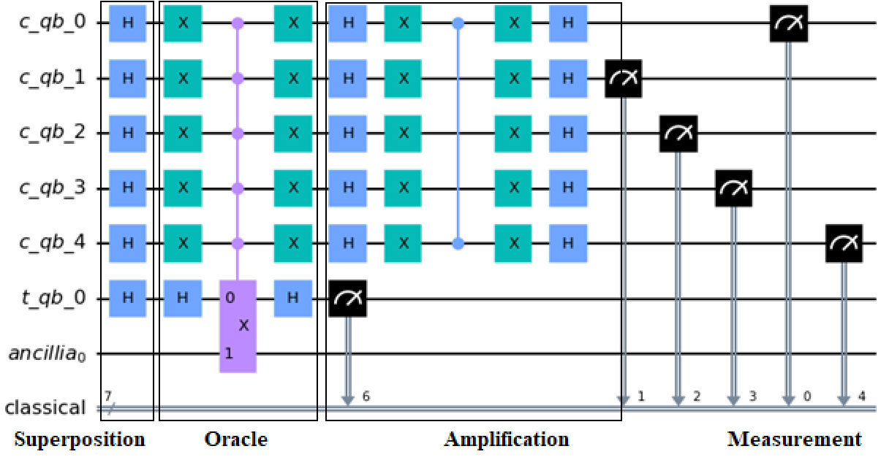

Figure Sample 5 Qubit Grover's Circuit

Calibrating the quantum simulator and preparing for Measurement Error mitigation.

A quantum simulator with a noise model from a real quantum computer “ibmq_16_melbourne” is used.

There are 2 main reasons of using a quantum simulator instead of a actual quantum computer:

1. Pseudo randomness: Quantum simulators allow for the input of a seed, if the starting conditions for a given seed is the same it will always output the same “random” result. Essentially “controlling” randomness.
2. Convenience: Quantum computers generally are never free, there is always a very long queue of people waiting for their job to be executed on the quantum computer. The queue maybe from 30min – 3 hours depending on the time of day. Not to mention quantum computers are prone to breakage and undergo frequent maintenance however this is not the case for a quantum simulator which runs on my computer.

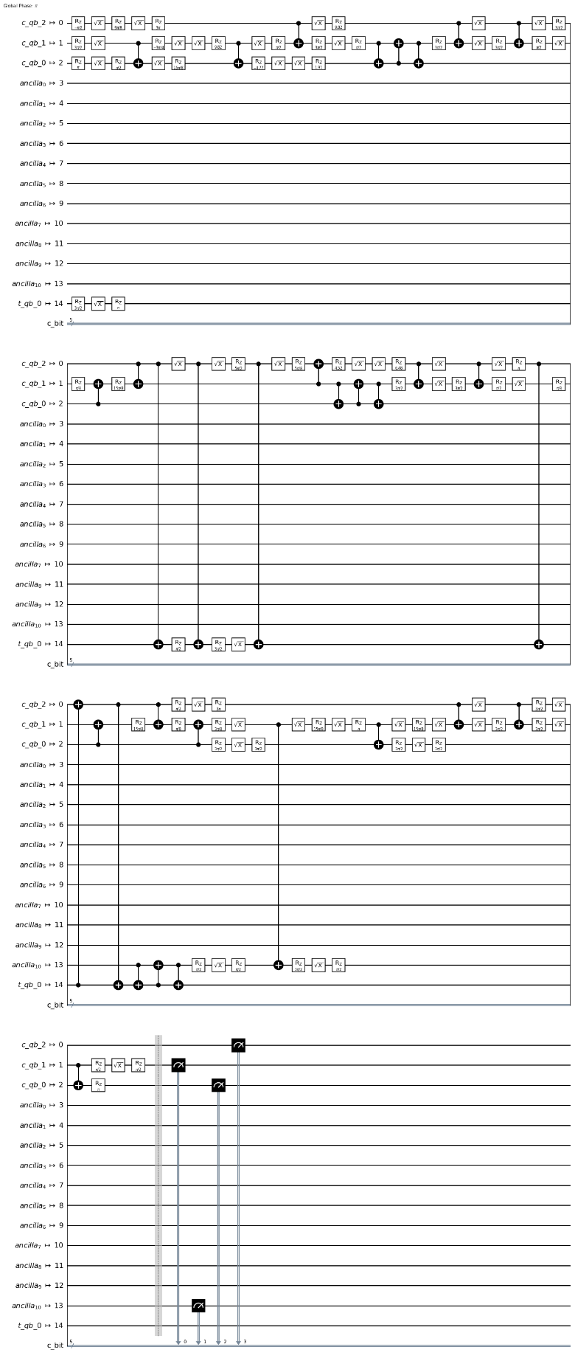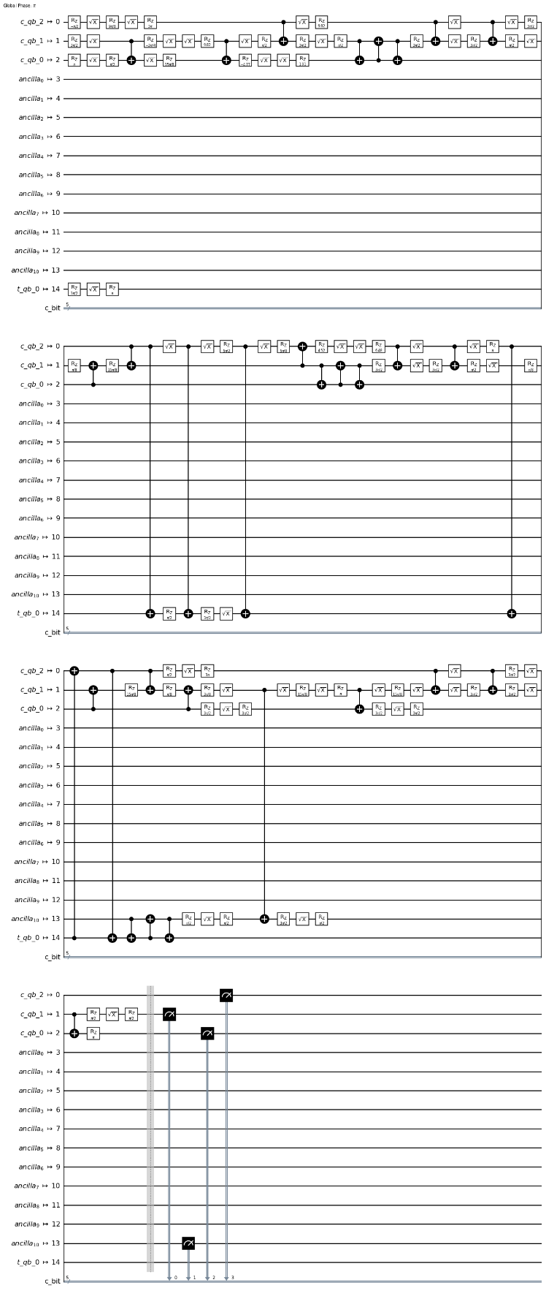The noise model was obtained by calling the backend of the quantum computer and running a 16-qubit calibration circuit

Figure Calibration circuit

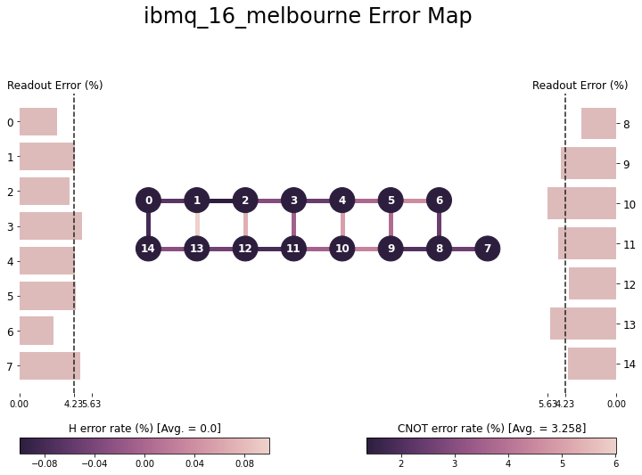

Figure Error map

Here is the readout error map for “Ibmq_16_melbourne” this noise map is transposed onto the quantum simulator to emulate a real noise environment. Grover circuits are then ran in this noisy environment, one set of results are saved and the other is sent through an error mitigation matrix.

Quantum error mitigation QEM

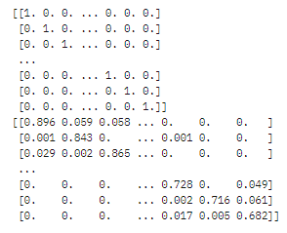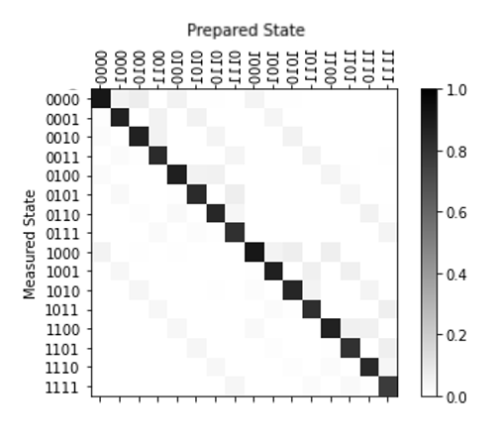A method of quantum of Quantum error mitigation “Negative Quasi probability mitigation” (Temme.E, Bravyi.S, Jay.B et al 2017) is utilised. Here every single qubit state is “prepared” by measuring each qubit’s interaction with one another the inverse of their error is calculated, expressed in this matrix below.

Figure Calibration matrix

Figure raw calibration data

Thereby when the measurement is done with the simulated noise channels, the noise is canceled out with their inverse, as each qubit had been previously prepped with “negative noise” by the matrix.

Finally, Quantum state tomography is used to measure the accuracy of the circuit. It is performed by a secondary circuit that attaches onto the main circuit and predicts the state of the superposition before it collapses. By comparing its states before and after, the difference between the predicted state and its pre-collapsed state can then be calculated. This is outputted as a percentage and basically denotes how correct the quantum computer was with its computation.

A paired T test will be done to all circuits and determine whether QEM has made a significant effect to the number of successful searches and fidelity. Each iteration of the circuit was run 8191 times [maximum number of shots allowed on a quantum simulator]. Python was used to remove outliers. The data analysis and calculations will be mostly automated and done using Jupiter notebooks’ python IDE version 6.2.0 running PANDAS, matplotlib and NumPy.

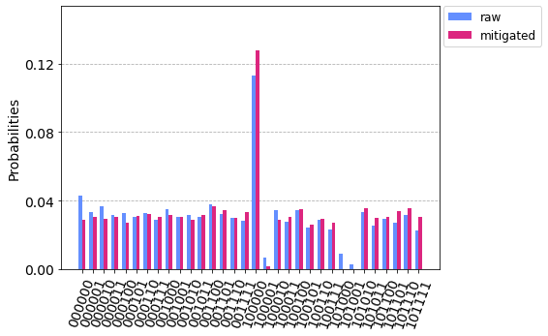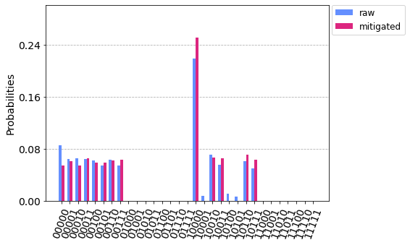**Results**

Figure Sample data: 4 and 5 qubit Grover algorithm with Mitigated vs Raw results As can be seen, the middle bar denotes a “successful Grover search” here the mitigated results are clearly much higher.

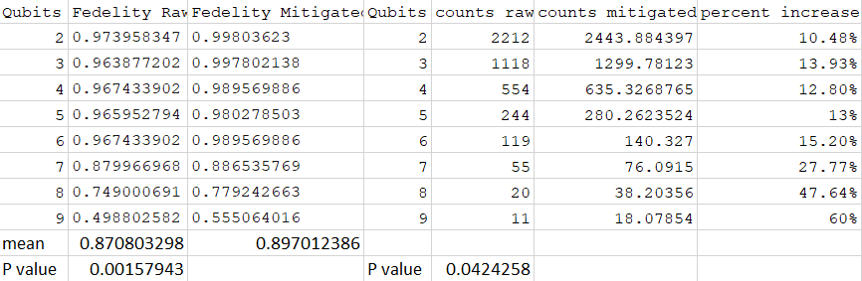

Figure Raw values

From the following data we can derive that:

Fidelities of the Grover’s algorithm in general decreases logarithmically as the number of qubits increases.

Figure Raw Vs mitigated Fedelities

The number of successful Grover searches (counts) also decreases exponentially as qubits increase

Figure Raw vs mitigated counts

QEM functions the best in noisy quantum systems

On average QEM increased fidelity by 1.932%, however it was observed that as the number of qubits increased, the percentage increase in fidelity increased as well, at 9 qubits QEM increased fidelity by 5.62%. Similarly, the average successful Grover searches were increased by 22.08% by QEM however at 9 qubits QEM increased the number of successful Grover searches (counts) by 60%

Figure Percentage increase of mitigated counts compared to Raw counts

**Discussion**

The results demonstrate that QEM Negative Quasi probability mitigation is a viable method in decreasing fidelity and increasing the number of successful Grover searches. Furthermore it has been shown that fidelity decreases logarithmically the results from this investigation correlate with Botsinis P et al (2016) research into Staene’s quantum error correction algorithm and its effects on the Grover’s algorithm when scaled, although to a less degree. Most importantly this result demonstrates that QEM is a functional, light weight and robust way to improve fidelity all current quantum computing applications not just Grover’s algorithm.

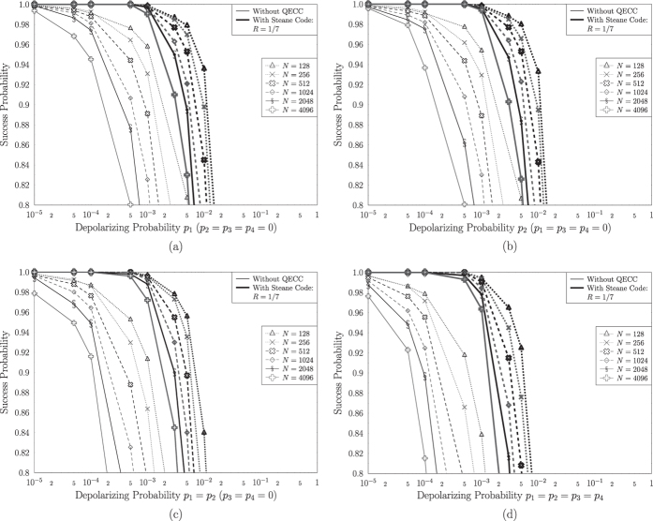The P values for raw vs mitigated fidelity were 0.00158 while the P value of raw vs mitigated counts were at 0.0424 both the values are lower then 0.05 thus highlighting statistical significance and rejecting the null hypothesis. The investigation’s hypothesis was somewhat correct, as it correctly predicted the logarithmic trend observed in decreasing fidelities and the exponential decrease in the number of successful Grover searches, however the increases provided by QEM were less significant than expected, instead of the hypothesised 20% increase in fidelity the average was 1.932% also the hypothesised 50% increase in successful Grover searches was met with an average increase of 22.08%. Both values greatly lower than the hypothesised value.

Figure Botsinis P et al (2016) data gathered

Logarithmic decrease and exponential decrease mirrors result obtained by Botinis P et al. However, Botinis P et al’s results were much more pronounced.

This investigation saw an average change of 1.932% for fidelities and 22.8% for the number of successful Grover searches, compared to Botinis P et al’s results from 60.6% to 99.5% fedelity in the first experiment and from 33.3% to 96.3% fidelity in their second experiment. This may be due to the fact that the only noise being applied to Botinis P et al’s perfect simulator were depolarising channels which they knew the exact frequency of, which then lead to relatively simple mitigation. Botinis P et al’s also failed to take into consideration that the quantum error correction circuit, since it is being ran in a quantum system would be prone to errors itself. Thus the large error correction circuit with 15 qubits and over 32 quantum gate would be extremely prone to error due to its large size and complexity, thus impractical and impossible in the real world with currently available quantum computers.

To further explain the deviation in results between these two investigations; the following investigation explored Grover’s algorithm from 2 qubits to 9 qubits while Botinis P et al’s investigation only conducted experimentation into one 4 qubit algorithm. Adding on this investigation used the noise model from a real quantum computer which included decoherence, thermal noise as well, qubit connectivity and gate errors. During the following investigation noises such as decoherence is unavoidable, as any quantum system that stays alive for too long ultimately dies and lose their quantum properties. This results in errors that cannot be mitigated by Negative Quasi probability mitigation.

This investigation was limited by the lack of technological resources: namely computing memory and processing power.

The Qiskit Kernel only supported a memory of up to 8 GB however the amount of memory used by the kernel doubled for each increase in qubits as vast amounts of data points were being generated for the calibration matrix and the Grover’s algorithm in general.

When the qubit count hit 10 the kernel crashed as it reached its memory limit of 8 GB. At 10 Qubits every Grover’s iteration produced a megabyte of data and over the 8192 iterations ran this built up and overwhelmed the system.

The computation time for each incremental increase in qubits saw a doubling in processing time, this is to be expected as classical computers are not very good at emulating quantum computers. Data gathering was a pain as it took incredibly long. The 9 qubit Grover’s algorithm took over 2 hours to run.

Although Quantum error correction via a secondary circuit yielded impressive results for theoretical quantum systems, QEM via Negative Quasi probability mitigation is far more practical and robust for use with modern quantum computers given sufficient classical computing power. This investigation proves that it is able to be successfully used for Grover computations in order to increase both output fidelity and chance of search success with no additional quantum processing power.

**Conclusion:**

Quantum computing especially Grover’s algorithm holds massive potential to revolutionise fields such as machine learning, material science and wireless communication. However, its potential is hindered by modern quantum computing hardware which are too delicate and thus prone to: thermal radiation, external noise and qubit decoherence. These external factors disturb qubits thus leading to errors which inhibit the usefulness of quantum computation. Quantum error mitigation via Negative Quasi probability mitigation offers a practical solution to this problem. QEM mitigates errors by first creating a calibration circuit which generates a calibration matrix from a noise model, following the inverse noise model on the matrix all qubits are prepped. During computation, the inverse noise model cancels out with the real noise model, thereby reducing error and increasing fidelity. This investigation demonstrated QEM’s feasibility to improve output fidelity consistently by an average of 1.932% (up to 5.62%) for current generation quantum computers by examining its impacts on the scaling of Grover’s algorithm, improving the probability of successful Grover searches by 22.08% on average (up to 60%)