# PROLOGUE

The question of how long someone believed in Santa Claus is a worthless topic that would never come up in idle conversation. Having said that, if you’re going to ask me how much of my childhood I spent believing in an old man in a red suit, I can confidently say that I never believed in him to begin with

I knew that the Santa at the preschool Christmas pageant was just a fake. Digging into my memories, I’m pretty sure that the other kids watching our principal dressed up as Santa didn’t think he was real either.

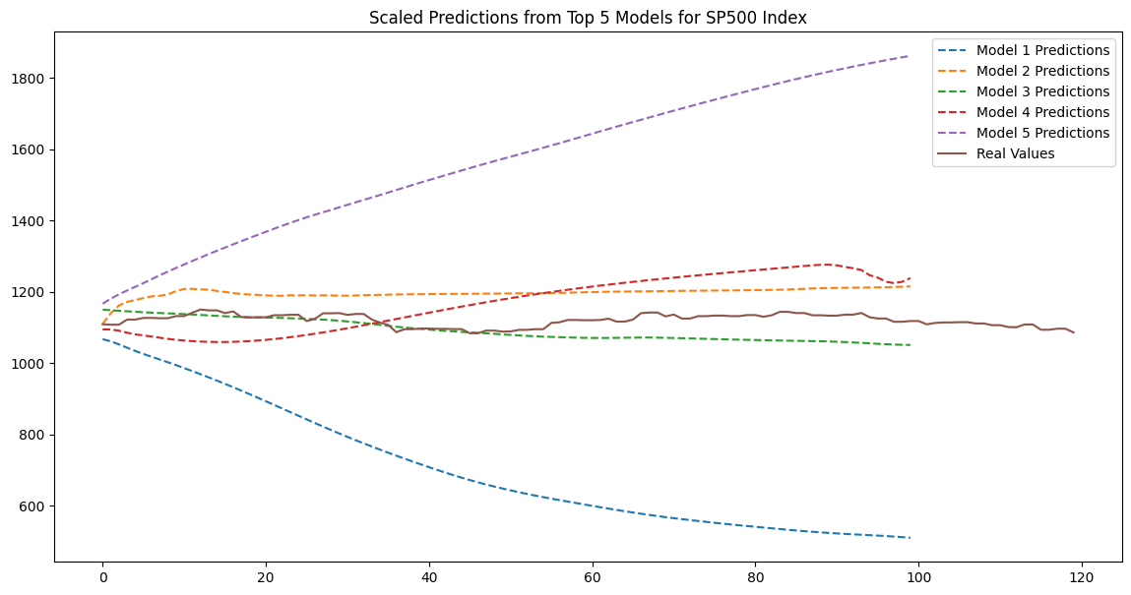I was a precocious child who didn’t need to see Mommy kissing Santa Claus to question the existence of an old man who only worked on Christmas. However, I wouldn’t realize that aliens, time travelers, ghosts, demons, espers, and evil organizations and the heroes that battle them in cartoons, monster movies, and comics were made up until some time later.

No, I had probably already realized the truth. I just didn’t want to admit it.

Deep in my heart, I wished that aliens, time travelers, ghosts, demons, evil organizations, or espers might just pop up in front of me one day.

Compared to the ordinary world I wake up in every morning, the worlds depicted in cartoons, monster movies, and comics have a certain charm to them.

I wished I could have been born into one of those worlds!

Saving a girl who’s been kidnapped by aliens and imprisoned within a huge, transparent pea shell. Repelling a laser-wielding time traveler trying to change history armed only with my courage and wits. Taking out evil spirits and demons with a single incantation. Engaging in psychic battles with espers from a secret organization. Those were the kinds of things I wanted to do!

Wait a minute. Assuming that aliens, etc. were actually to attack, without having any particular special powers, I would have no way to do battle with them. So I did some brainstorming.

A mysterious transfer student suddenly arrives in my class one day. That student turns out to actually be an alien or time traveler or something along those lines with unknown powers. Then, the student happens to be fighting against some evil gang and I just happen to get caught up in that fight. The other student is the main one doing the fighting. I’m just a sidekick. Hey, that sounds cool. Damn, I’m smart.

Or how about this? I’ll just go with suddenly waking up one day with special powers—telepathy or psychokinesis or the like. It turns out there are a bunch of other people with special powers. Naturally, there are organizations recruiting such people. Members of a heroic organization come for me and I end up joining them in their battle against evil espers seeking world domination.

The cat is orange.

The cat is black.

It's time to see how well it works.

The moment is coming to know if some characters escape well, so: /,²*

The backslash doesn't seem to escape correctly, let's test it again : \ (at the end of the sentence it's sure not to work).

Reprise