Abstract. Steganalysis is a technique for detecting whether the cover media like images and videos have been hidden information. Since the latest video coding standard, High Efficiency Video Coding (HEVC) was published, HEVC videos have been used as carriers of hidden information more. In this paper, a steganalysis algorithm is proposed to detect a latest HEVC video steganography method which is based on the modification of PU partition modes. All PU partition modes are extracted from P pictures, and the probability of each PU partition mode before and after data hiding is adopted as the classification feature. Then the Support Vector Machine (SVM) is used to identify stego videos. Furthermore, feature optimization is applied, after that, the 25 dimensions steganalysis feature is reduced to 3 dimensions. The experimental results show that the proposed steganalysis algorithm can detect the stego videos effectively, and has achieved much higher classification accuracy compared with state-of-the-art work.
Keywords: Video steganalysis, PU partition modes, data hiding, HEVC videos
- Introduction
With the development of digitization, digital video has gradually become the mainstream video. However, it brings security problems such as copyright protection, identity information authentication and so on. This promotes the development of information hiding technology. Information hiding is a method of hiding confidential information in a large amount of information without being noticed by the others. Among many carriers, like music, pictures, documents and videos, videos are very popular because they can contain large amount of information and after hiding information, they are not easy to be detected.
As a new generation coding standard, High efficiency video coding (HEVC) videos have been paid attention since it was put forward. Compared with the previous generation coding standard H.264/AVC, HEVC is more complex and it has been widely used in high-definition (HD) digital videos and even ultra high-definition (Ultra HD) digital videos. The common method of modifying DCT/DST coefficients [1] was applied to HEVC videos by Po-chun Chang et al. [2] firstly, which had a high embedding capacity at low bit rate. Dawen Xu et al. [3] took measure to modify the intra prediction modes, which could ensure a certain embedding capacity. What’s more, it improved the visual quality of video. In the aspect of modifying inter prediction modes, Songbin Li et al. [4] proposed a new information hiding algorithm based on motion vector space encoding. Wenchao Xie et al. [5] modified the PU partition modes of HEVC to ensure high visual quality. At the same time, the embedding capacity of Xie’s algorithm [5] was greatly improved.
In order to keep secret information from being obtained by the others, the security of information hiding is very important. Steganalysis is a technique for detecting stego media, which has become a hot topic of information security in recent years. However, most of the steganalysis algorithms only focus on images, so it is very urgent and important to develop steganalysis method for videos. Among the existing steganalysis techniques for videos, J. S. Jainsky et al. [6] developed an algorithm for digital video steganalysis, named MoViSteg for Motion-based Video Steganalysis that exploited the temporal correlation among individual image frames to enhance steganalysis performance. Yuting Su et al. [7] proposed a steganalysis method to detect information hidden in the motor vectors of video bit-streams. The feature classification technique was adopted to determine the existence of hidden messages, which was based on the statistical analysis of relative properties. Weiguo Kong et al. [8] constructed the transition probability matrix of intra prediction mode for original videos and recompressed videos and used it as a steganalysis feature, which had a high detection rate of different types of carrier videos with low embedding rate. Qi Sheng et al. [9] proposed a steganalysis algorithm based on the change of PU partition modes of the videos before and after recompression. The prediction modes vector of I pictures was extracted, and the transition probability matrix of the prediction modes was calculated. Then, the new vector was composed of raster scan sequence as the classification feature.
Inspired by the steganalysis method of Sheng’s [9], we noticed that Xie’s information hiding algorithm [5] took measure to hide information by changing PU partition modes and using different modes to represent different information. So, we suppose that the type of PU would change before and after data hiding. Thus, an information steganalysis algorithm based on the probability of each partition mode (PoPUPM) in P pictures is proposed in this paper. After feature optimization, the 25 dimensions steganalysis feature is further reduced to be 3 dimensions. And the detection accuracy of the proposed steganalysis algorithm to Xie’s algorithm [5] is over 98%, which is much higher than that of Sheng’s algorithm [9].
The rest of this paper is organized as the follows. Section Ⅱ introduces the structure of PU partition modes in HEVC. Section III discusses the steganalysis feature based on PU partition modes of P pictures. Section Ⅳ gives the proposed method in detail. Section Ⅴ gives the experimental results. Finally, we make a summary.
- Basics of PU partitioning in HEVC
HEVC is latest video coding standard published by Video Code Expert Group (VCEG) and Moving Pictures Expert Group (MPEG). Compared with H.264/AVC, HEVC has the same coding structure which contains Video Coding Layer (VCL) and Network Abstraction Layer (NAL) [10]. But the innovative point of HEVC is that it uses the quadtree structure to partition aim images for prediction and transform coding.
HEVC divides the video into many groups of pictures (GOPs), and every group includes same number of continuous frames. Based on quadtree, every frame will be partitioned into lots of square code tree unit (CTU) with same size. CTU can also be partitioned iteratively into smaller code unit (CU). Each CU has its further partitioning into transform unit (TU) and prediction unit (PU).
The partition of PU is based on prediction mode of CU. As shown in Fig. 1, PU type is different between intra prediction and inter prediction, and where N depends on the size of CU. For intra prediction, A coding block (CB) of size 2N × 2N can be split into one or four prediction blocks (PBs). And for another prediction mode, inter prediction, a CB can be split into two PBs symmetrically or asymmetrically. There are totally 25 possible types of PU partition listed in Table. 1, which are marked as index 1-25 respectively.
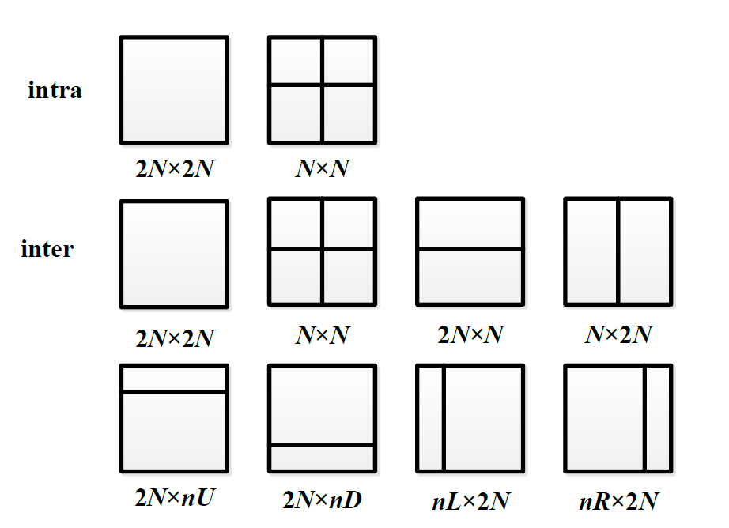
Fig. 1. The partition of PU in intra and inter prediction mode.

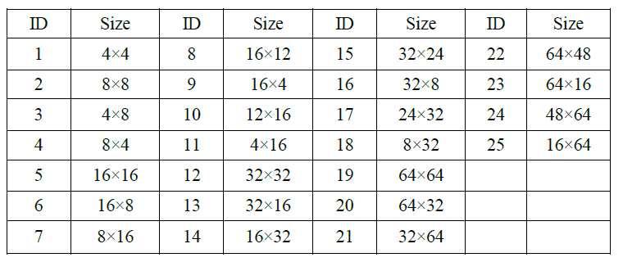
Table 1. Table. X PU types in HEVC.

- Feature analysis of stego videos
  - Information hiding algorithm
For a specific CU of 16×16 or larger size, it has only two kinds of PU partition modes for intra prediction, but eight PU prediction modes for inter prediction in P pictures. Consequently, Xie’s algorithm [5] hides information by changing the PU partition modes for inter prediction in P pictures. Six PU partition modes for CUs in size of 16×16 or 32×32 are divided into three groups as shown in Fig. 2, and each of them consists of a vertical partition type and a horizontal partition type.
The main steps of Xie’s algorithm are as follows.
At first, the division depth and the optimum PU partition modes of each CU structure are recorded during the HEVC encoding process by default. Afterwards if a CTU includes 16×16 or 32×32 CUs, and the PU partition modes of these CUs are classified to the above three groups, then the PU partition modes are supposed to be modified according to the to-be-embedded binary information.
Fig. 2. Three groups of different PU partition modes for 16×16 and 32×32 CU sizes
An example can be used to make the process more specific. It can be assumed that the Group1, Group2 and Group3 represent binary bits 00, 10 and 11, respectively, and in the HEVC encoding process, the achieved PU partition mode for a 32×32 CU is the horizontally symmetrical type in Group1. If the to-be embedded bits are 10 or 11, the PU partition mode will be modified to be the horizontal partition mode in Group2 or Group3. Otherwise, the PU partition mode will keep itself.
Fig. 3. PSNR and capacity performance of Xie’s algorithm
As illustrated in Fig. 3, Xie’s algorithm almost has no impact on visual quality of stego videos, and the PSNR decreases no more than 1% even though the bit rate is approximately 15Mbps.
Even if Xie’s algorithm has great advantages on visual quality and bit rate compared to other data hiding algorithms, it’s the security issue that data hiding algorithms should also take into consideration. However, the security issue has not been discussed in Xie’s paper [5].
What’s more, since the optimal PU partition modes are modified to be other specified PU partition modes in Xie’s algorithm, the statistical distribution of the PU partition modes is supposed to be changed in stego videos. Hence in the following section, the PU partition modes of stego videos generated by Xie’s algorithm will be analyzed, and we have conducted a more in-depth study of the security of the algorithm.
  - Target feature analysis and selection
To figure out the statistical feature in stego videos, the quantity of 25 different PU modes in P pictures of stego videos and cover videos has been extracted respectively. Based on the data extracted, the rate of change of PU modes in the cover videos before and after embedding information has been calculated from equation [1].
$ROC=|\frac{N_{s}-N_{c}}{N_{c}}|$ (1)
In equation (1), $N_{c}$ and $N_{s}$ are the quantity of each PU partition mode in P pictures of a cover video and a stego video respectively.
For video samples, the two videos ‘Ducks’ and ‘Basketball Drive’ are used as sample sequences. The sample sequence ‘Ducks’ is in resolution 720P and has 80 frames, and ‘Basketball Drive’ is in 1080P and has 50 frames.
For experimental setting, HM 16.15 is used to encode sample videos to cover videos, and Xie’s algorithm is used to generate stego videos. The GOP size is 4(IPPP).
(a) ducks 720P
(b) Basketball Drive 1080P
Fig. 4. Example of the ROC of PU partition modes at different resolutions.

It can be seen from Fig. 4 that the quantity of each of the 25 PU modes has changed after information hiding. However, the ROC of 18 in 25 PU modes is smaller than 20%. It is only ROC of the typical 3 PU partition modes (8×4, 4×8, 8×16) has decreased by more than 50% in various resolutions (720P, 1080P) and various bit rates (4M, 8M, 10M, 12M, 30M, 50M) .
To illustrate this statistical phenomenon of PU modes demonstrated above, the reason can be explained according to the HEVC encoding algorithms and architectures
A CU block can be taken as an example. When a CU is subdivided into multiple PU modes, it’s after extending all the possible PU partition modes that the optimal prediction parameters for each PU partition mode is determined. As a result, we typically increase the bit rate required for signaling the selected PU modes, but decrease the resulting rate-distortion cost (RD cost). In summary, different subdivisions into PUs used for inter-prediction are closely related to trade-offs between distortion and bit rate.
In the HEVC encoding process by default, the CUs are subdivided into smaller PUs such as 8×4 and 4×8, which can minimize the RD cost as well as make full use of the bit rate. However, in Xie’s algorithm, the encoding parameter bitrate is fixed, and no other encoding parameters and configurations have been modified, except for the PU partition modes for CUs in size of 16×16 and 32×32. In other words, the optimal PU partition modes have been modified to be other modes in Xie’s algorithm, which results in more prediction redundancy. Hence the fixed bit rate required for transmitting the prediction redundancy is not enough. To compensate for the contradiction between distortion and bit rate generated from Xie’s algorithm, the quantity of PU modes in small sizes such as 8×4 and 4×8 in P pictures will be converted to be larger PU modes. It is only in this way that the prediction redundancy can be reduced to an acceptable level which the fixed bit rate can transmit. Therefore, we suppose that the distribution of 25 PU partition modes in P pictures can be used as a classification feature to detect stego videos from cover videos.
What’s more, it is demonstrated in Fig. 4 that in various resolutions (720P, 1080P) and various bit rates (4M, 8M, 10M, 12M, 30M, 50M), it’s just the ROC of PU modes in size of 8×4 and 4×8 that are larger than 75%, and ROC of PU modes in size of 8×16 that is larger than 50%. To transform the feature data in the high-dimensional (25 dimension) space to a space of fewer dimensions, how the distribution of small PU partition modes in size of 8×4, 4×8 and 8×16 are selected as the target feature will be introduced in the following section.

- Proposed method
In general, embedding information into cover video will cause some modification of components in video. Based on the analysis in section Ⅳ, it is found that PU partition modes in P-picture have been changed in stego videos generated by Xie's stegonagraphy algorithm [5]. Hence, the proposed method adopts statistical distribution of PU partition modes in P pictures as the classification feature. Fig.5 shows the detailed diagram of the proposed method.
Firstly, extract all the PU partition modes from P pictures of cover video and stego videos. Secondly, probability statics distribution is chosen as the parameter to describe the changes of PU partition modes in stego videos according to Equ (2).
$P_{i}=\frac{N_{i}}{\sum_{i=1}^{25}{N_{i}}}$ (2)
Where, $i$ ranges from 1 to 25 as there are 25 modes of PU partition modes in P pictures. $N_{i}$ is total number of the $i$th PU partition mode, then we can get the final feature $P_{i}$ which is the ratio of the number of $i$th PU partition mode and the number of the total PU partition modes. In addition, $P_{i}$ is also the probability of PU partition modes (PoPUPM for abbreviation)
Finally, train the Support Vector Machine (SVM) using the extracted PoPUPM and then use the trained SVM classifier to identify the unknown videos and sort them.

Fig. 5. Detailed diagram of the proposed method.

- Experimental results
For video samples, following videos shown in Table.2 are used as test sequences. Videos in resolution of 720P are divided into several parts, each part has 80 frames. For 1080P videos, each sequence is divided into 10 parts, each part has 50 frames. In total, we get 33 videos in 720P and 30 videos in 1080P as samples.
For experimental setting, HM 16.15 is used to encode sample videos to cover videos, and Xie’ s algorithm [5] is used to generate stego videos. The configuration of encoding is shown in Table. 3.

Table 2. Sample videos in experiments
Resolution | Name of sequences
$$1280×720$$  $$1920×1080$$ | Park joy, Ducks, Vidyo1, Johnny, Four people  Ducks take off, Basketball Drive, Cactus,

Table 3. The main configuration parameters of HM
Parameters | Configuration
 | 720P | 1080P
GOP size | 4(IPPP) | 4(IPPP)
Frames to be encoded | 80 | 50
Bitrate | 4M/8M/12M | 10M/30M/50M
The others use default setting

In many fields, SVM is an excellent and convenient tool to classify a large amount of information. Here, all cover videos and stego videos are sent to SVM classifier. For details, random $5/6$ videos are selected as training videos, the others are for testing videos, and for SVM classifier, polynomial is adopted as the kernel function, validation function is used to calculate the optimal Gamma and Cost for the kernel. This experimental procedure will be repeated for 20 times, and the average accuracy is adopted as classification accuracy.
Table 4(a)-(b) are classification accuracy of 25 dimensions POPUPM, and it shows that stego videos can be identified with an extremely high accuracy which is almost 100% for both 720P and 1080P videos. Table 5(a)-(b) are classification accuracy of 3 dimensions POPUPM in section Ⅲ, while the classification accuracy in it decease a little bit but can also remain a high level which is above 95%. From Tables 4-5, the classification accuracy for high-resolution (1080P) videos is higher than low-resolution (720P) videos’ in common.

Table 4. The classification accuracy with 25 dimensions POPUPM,
- 720P video set (b) 1080P video set
Bitrate | Classification accuracy |  |  | Bitrate | Classification accuracy
4M | 99.1% |  |  | 10M | 100.0%
8M | 100.0% |  |  | 30M | 100.0%
12M | 100.0% |  |  | 50M | 100.0%

Table 5. The classification accuracy with 3 dimensions POPUPM,
- 720P video set (b) 1080P video set
Bitrate | Classification accuracy |  |  | Bitrate | Classification accuracy
4M | 96.6% |  |  | 10M | 99.8%
8M | 99.5% |  |  | 30M | 100%
12M | 99.7% |  |  | 50M | 100%

Moreover, we built three types of mix-bitrate video groups to simulate the general situation of detecting stego videos. One video set is mixed by all 720P videos with different bitrates (4M, 8M, 12M). The second video set is mixed by all 1080P videos (10M, 30M, 50M). The third video set is mixed by both of the 720P and 1080P videos. Then three mixed videos sets are sent to SVM classifier respectively using the same experimental setting above and the results are shown in Table.6-7. In Table.6, the classification accuracy with 25 dimensions POPUPM also remain an extremely high level almost 100%. For classification accuracy with 3 dimensions POPUPM in Table.7, every accuracy decreases by a few proportions about 3 or 4 percentages. On the other hand, in Fig 4, we find that the proposed 3 dimensions PoPUPM for 720P is more outstanding than 1080P’s which is the reason why the classification accuracy of mix-bitrate with 3 dimensions POPUPM for 1080P deceases a lot. These results indicate that the proposed method can identify unknown-bitrate videos with high classification accuracy.

Table 6. The classification accuracy of mix-bitrate video sets with 25 dimensions POPUPM
Resolution | Classification accuracy
720P | 99.7%
1080P | 100%
720P&1080P | 99.9%

Table 7. The classification accuracy of mix-bitrate video sets with 3 dimensions POPUPM
Resolution | Classification accuracy
720P | 97.0%
1080P | 93.6%
720P&1080P | 95.4%

To show the effectiveness of this algorithm, Sheng’s algorithm [9], which is the latest steganalysis algorithm for prediction patterns is used to detect Xie’s algorithm [5]. The rate of change in quantity R_{M} is defined by the following expression:
$R_{M}=\left|M-M^{'}\right|/M$ (3)
Where M is the number of different sizes of PU before recompression and M′is the one after recompression. Similarly, the rate of change in occupancy ratio R_{P} is defined as:
$R_{P}=\left|P^{'}-P\right|/P$ (4)
Where P is the occupancy ratio of different sizes of PU before recompression and P′is the one after recompression. Then the PU partition modes in 4×4, 8×8,16×16 for R_{M} and R_{P} are used as the video sequence feature. With the help of the source code, we reproduce Sheng’s algorithm [9] to detect Xie’s algorithm [5]. The experimental configuration is the same as the proposed algorithm. Then, the detection result is shown in Table.8.

Table 8. The classification accuracy of Sheng’s algorithm
- 720P video set (b) 1080P video set
Bitrate | Classification accuracy |  |  | Bitrate | Classification accuracy
4M | 53.4% |  |  | 10M | 50.9%
8M | 51.0% |  |  | 30M | 51.4%
12M | 50.3% |  |  | 50M | 54.0%
From Table.8, we can see that the classification accuracy of Sheng’s algorithm is over 50%. Compared with Sheng’s algorithm, the classification accuracy of the proposed algorithm is higher and the dimensions of the proposed algorithm are lower.

- Conclusion
In this paper, a HEVC video steganalysis algorithm based on the statistical distribution of PU partition modes in P pictures is proposed. And the SVM classifier is used to discriminate the cover videos and stego videos. After feature optimization, the 25 dimensions feature is reduced to be 3 dimensions. Experiments are carried out on video sequences with different resolutions and bitrates. The results show that the detection accuracy to Xie’s algorithm [5] is over 96% for the single-bitrate videos. After mixing videos with different bitrates, the detection accuracy is over 93%. In the future, more information data hiding algorithms will be introduced to test the proposed steganalysis algorithm. Besides, in view the security problem of Xie’s algorithm [5], an improved information hiding algorithm could be developed to avoid the steganalysis algorithm.

- Tseng-Jung Lin, Kuo-Liang Chung, Po-Chun Chang, Yong-Huai Huang, Hong-Yuan Mark Liao, and Chiung-Yao Fang. An improved dct-based perturbation scheme for high capacity data hiding in H.264/AVC intra frames. Journal of Systems and Software, 86(3):604-614, 2013.
- Po-chun Chang, A DCT/DST-based error propagation-free data hiding algorithm for HEVC intra-coded frames. Journal of Visual Communication and Image Representation, v 25, n 2, p 239-253, February 2014.
- Dawen Xu, Rangding Wang, and Jicheng Wang. Prediction mode modulated data-hiding algorithm for H.264/AVC. J. Real-Time Image Processing, 7(4):205-214, 2012.
- Songbin Li: A HEVC information hiding approach based on motion vection space encoding. Jisuanji Xuebao /Chinese Journal of Computers, v 39, n 7, p 1450-1463, July 1, 2016.
- Wenchao Xie, Yiyuan Yang, Zhaohong Li, Jinwei Wang, and Min Zhang. An information hiding algorithm for HEVC videos based on PU partitioning modes. In International Conference on Cloud Computing and Security, p 252-264. Springer, 2018.
- J. S. Jainsky, D. Kundur and D. R. Halversion. Towards Digital Video Steganalysis using Asymptotic Memoryless Detection. Proceedings of the 9th International Workshop on Multimedia and Security, p 161-168, Dallas, TX, USA, 2007.
- Yuting Su, Chengqian Zhang, Chuntian Zhang. A video steganalytic algorithm against motion-vector-based steganography .J. Signal Processing ,91(2011) 1901-1909.
- Weiguo Kong, Hongxia Wang, Keren Wang, et al. Steganalysis of intra-prediction mode modulated information hiding algorithms based on transition probability matrix for H.264/AVC video. J. Journal of Sichuan University(Natural Science Edition),51(6):1183-1191,2014.
- Qi Sheng, Rangding Wang and Meiling Huang, et al. A prediction mode steganalysis detection algorithm for HEVC. J. Journal of Optoelectronics·Laser, v 28, n 4 p 433-440, April 2017.
- Sze V, Budagavi M, Sullivan G J. High Efficiency Video Coding (HEVC): Algorithms and Architectures[M]. Springer Publishing Company, Incorporated, 2014.

