Fake aether and neutrino are not worth a penny. Space and time are required to be the chosen one. And to find it you need to avoid the black holes.

toooooo many switches

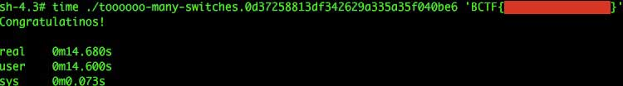hint: If you get the correct flag, you will see congratulations message.

hint2: There are many possible input that look like flag, but only 1 of them is the correct flag.