EEET2481 - ASSESSMENT 03

Group: 09

Members:

Duong Bao Khang (s3926606)

Le Huu Duc (s3926088)

# Exercise 1

* HELLO:

* TEAM:

* THIS:

* KHANG

* HELLO, THIS IS DUC, KHANG, FROM TEAM 9:

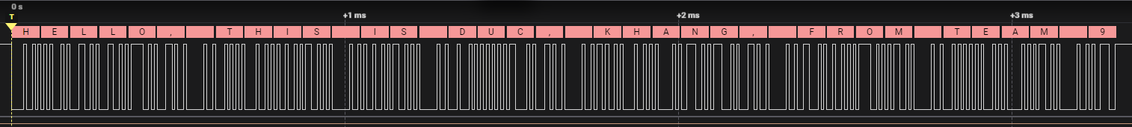

* UART Interrupt:

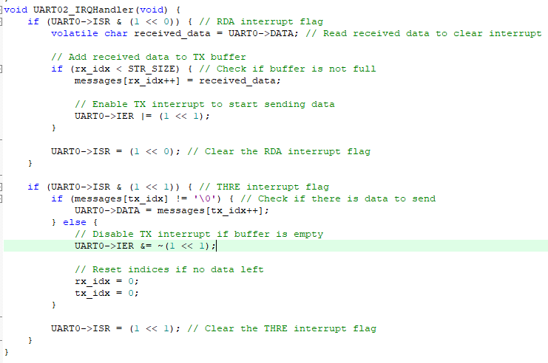

* A screenshot of a computer

  Description automatically generatedSerial Software verification:

# Exercise 2

* Program Flow Chart:

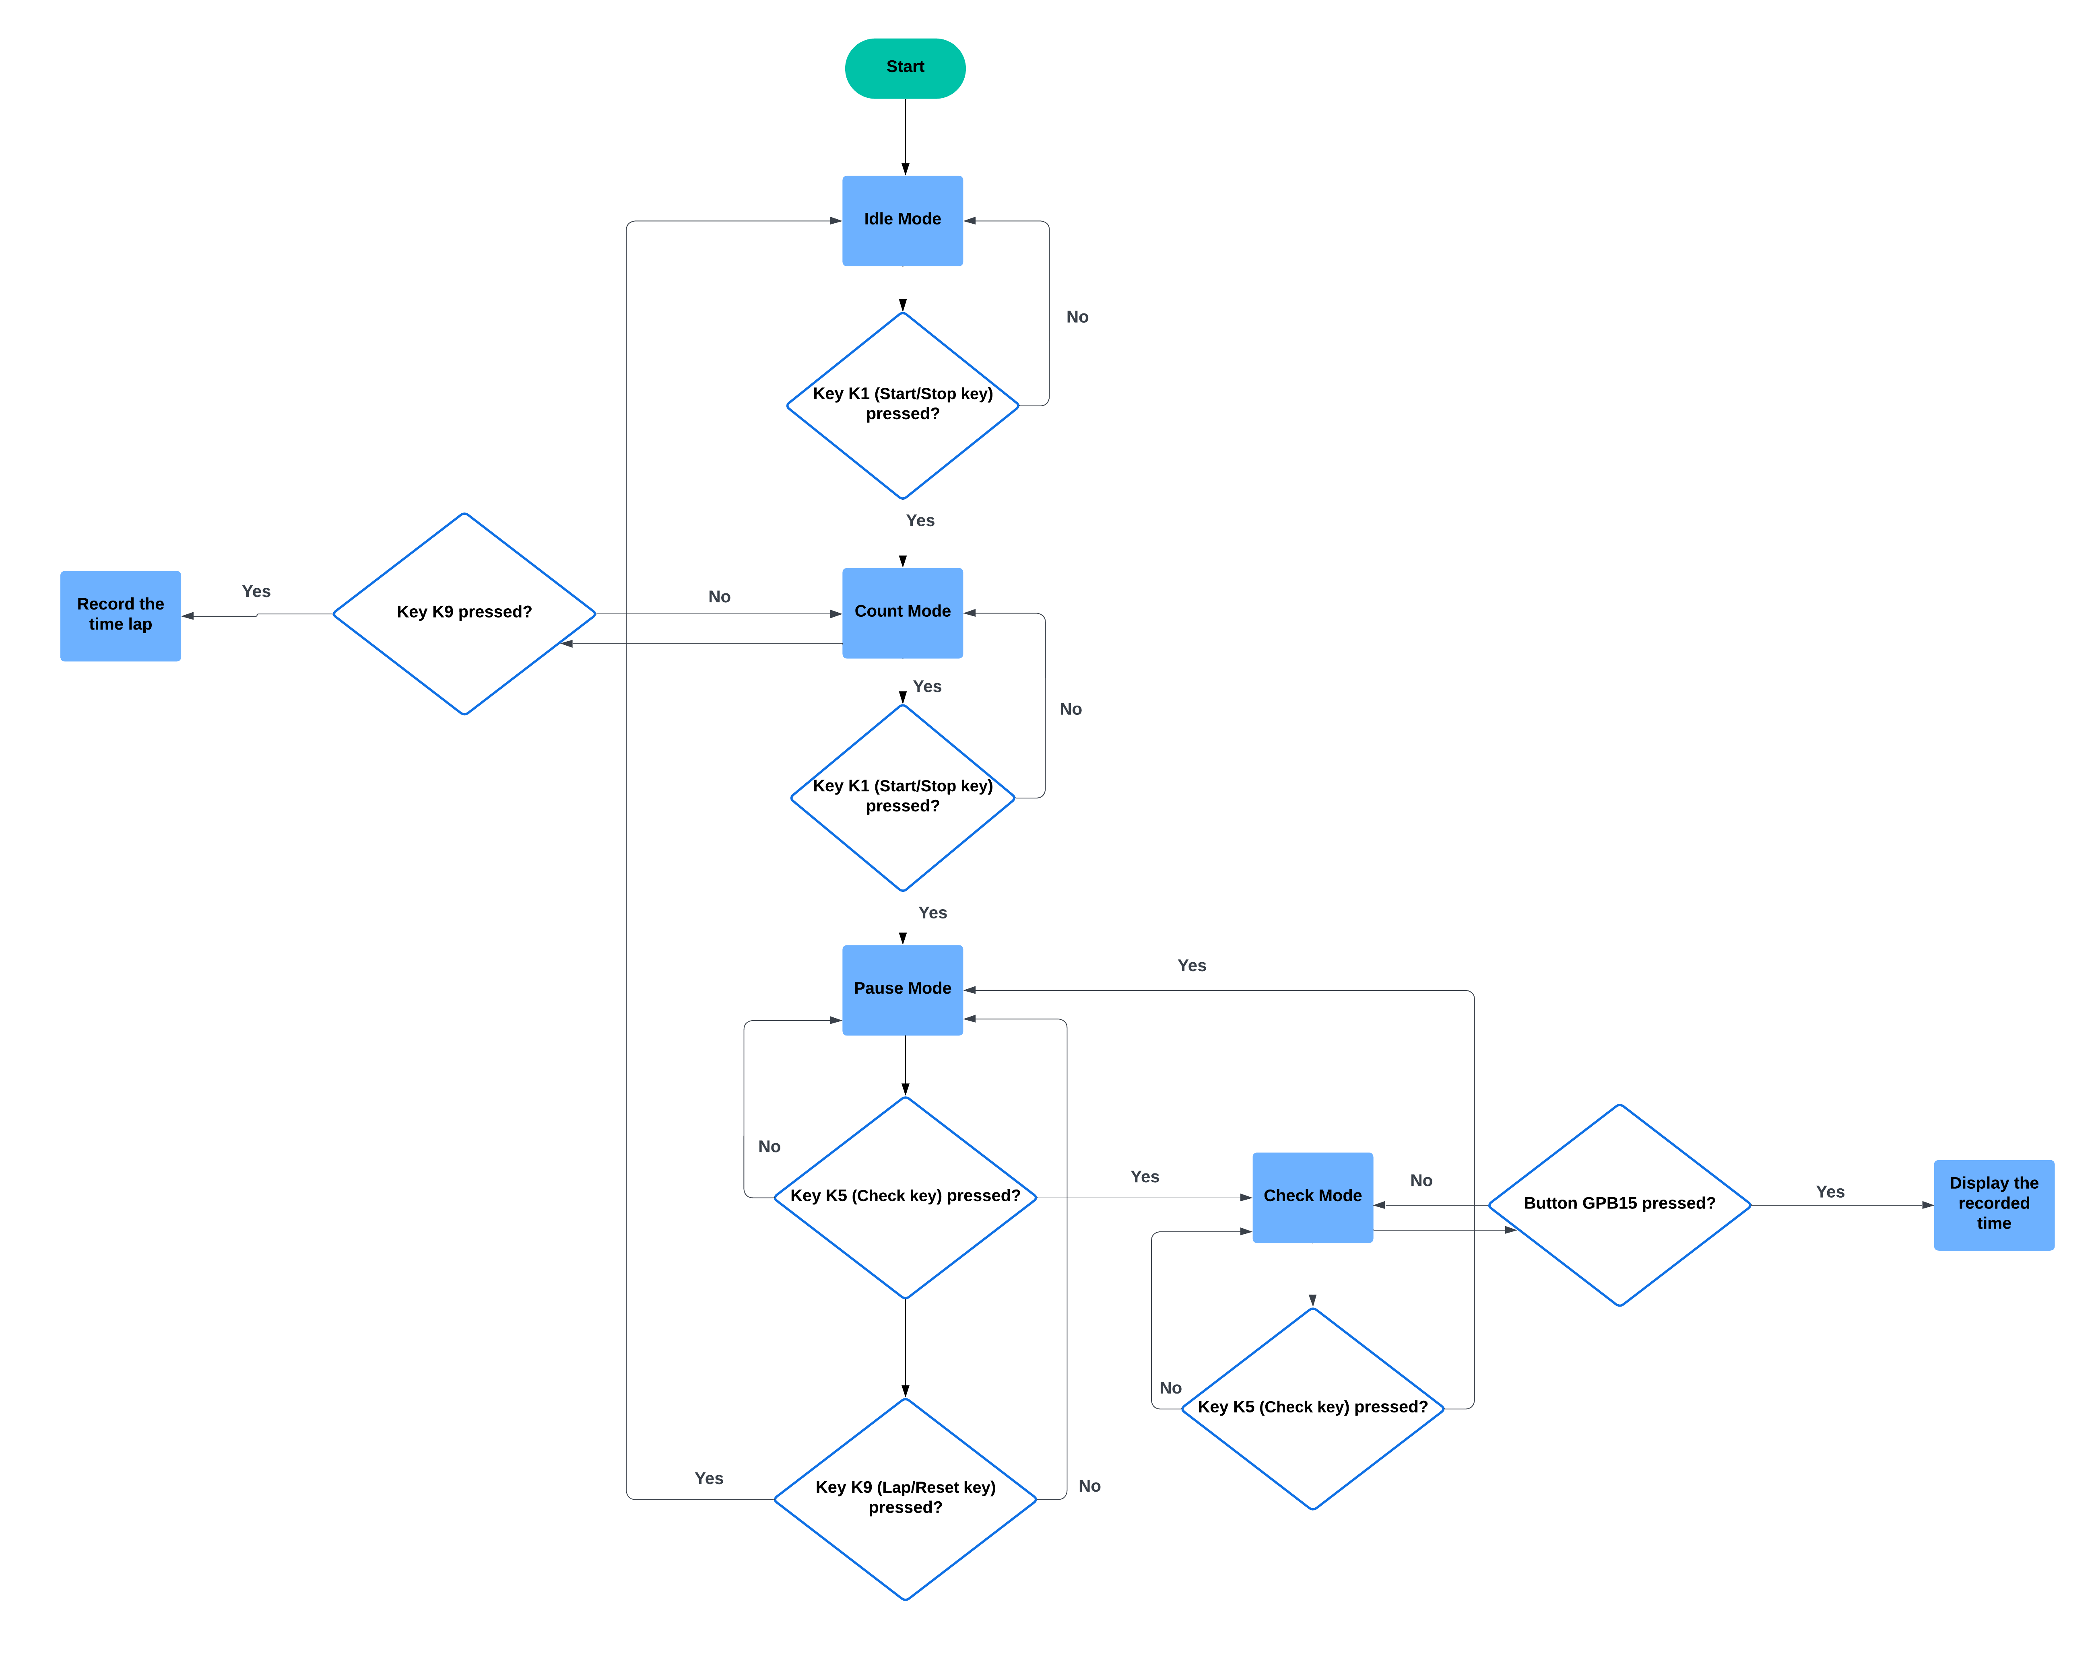

* State Transition Diagram:

* 1/10 second delay verification:

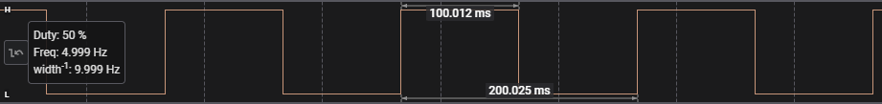

* IDLE Mode:

* Count Mode:

* Stop Mode:

* Check Mode:

