Zimbabwe’s Agriculture Sector Over The Years

Breden

2022-08-03

Table of Contents

Introduction 1

Objectives 1

Data Source and Data Manipulation 1

Analysis and graphical representation of data 2

Insights and takeaways 5

Conclusion 6

My code 6

## Introduction

Zimbabwe is a developing country in Southern Africa with an economy that heavily depends on the primary sector.In this report I analyse how one of the main economic players, agriculture, has changed over time.

## Objectives

* Examine the changes in total arable land available in the country
* Analyse how the percentage of total land cultivated has changed over time
* Show how trends in irrigation have changed over the years
* Examine variations in percentage contribution of agriculture to the country’s Gross Domestic Product(GDP)

## Data Source and Data Manipulation

The data used in this report was downloaded from the **Food and Agriculture Organization of the United Nations** and can be accessed by clicking [HERE](https://www.fao.org/aquastat/statistics/query/index.html?lang=en) and, selecting “Zimbabwe” in the “Select Countries” column.

Minor data cleaning and manipulation was conducted in the form of renaming variables, creating a new variable, selecting the necessary variable, creating vectors and removing null rows, this process was documented and can be seen under the “My code” section of this document.

## Analysis and graphical representation of data

* The total area of arable land increased exponentially from 1977 until peaking in 2007, and it has remained constant since then. The total land area of Zimbabwe has remained constant at 39.08 million hectares,however in 1977 only 2.47 million hectares of the country’s land was classified as arable but by 2007 this figure had increased to 10.49 million hectares, where it remains as illustrated in Fig.1.0 below.

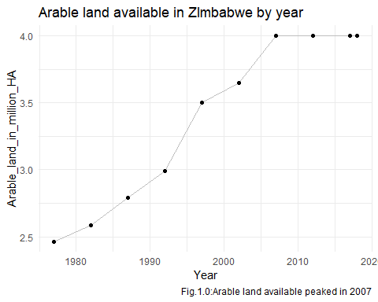

* Changes in the total percentage of land under cultivation follows a similar trend to that shown by changes in arable land over time. It exponentially changed from a low of 6.56% in 1977 to a peak of 10.49% in 2007, and has since stagnated as shown in Fig.2.0.

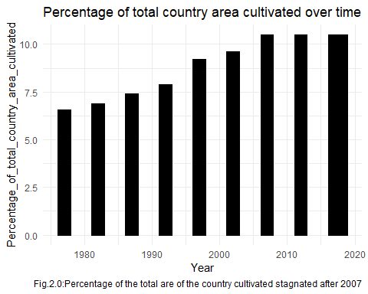

* The percentage of land cultivated under irrigation has been constantly decreasing from a high of 6.3% in 1982 to a low of 4.4% in 2018. However the rate of change has significantly decreased since 2007 and has reached a near constant value of approximately 4.4%. Fig.3.0. highlights this below:

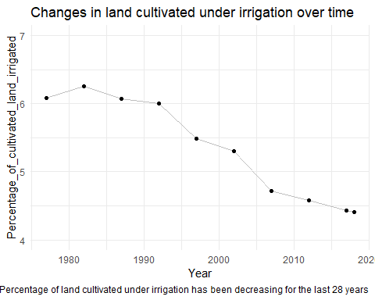

* Agriculture’s contribution to the country’s economy has been inconsistent throughout the years. Agriculture initially contributed between 10% and 13% to Zimbabwe’s GDP between 1977 and 1987, however it contributed just 5.51% to the country’s GDP in 1992 but followed that up with consecutive higher percentage contributions to the GDP with a peak percentage of 24.8% achieved in 2002. This was followed by sharp declines in agriculture’s contribution to the GDP before it settled around 8% in 2012, a figure that has remained relatively constant since then. Fig.4.0. below shows this:

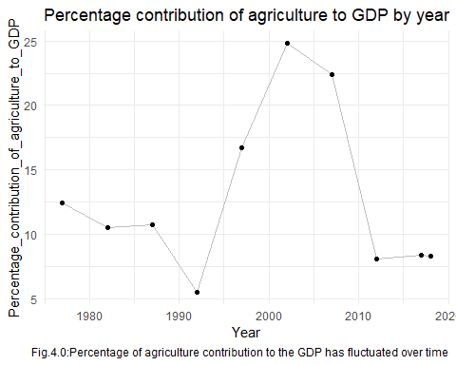

## Insights and takeaways

* Arable land and the percentage of total country area under cultivation follow a similar trend. They both increased rapidly after 1980 before peaking and stagnating in 2007. The sharp increase after 1980 can be attributed to Zimbabwe gaining Independence in 1980 and the end of the Rhodesia Bush War which meant more people could go back to subsistence farming, which was a popular way of life back then.
* The peak in available arable land and percentage of total country area under cultivation can be explained as the country exhausting its arable land available. It can also be linked to the boom in rural to urban migration, which has resulted in less subsistence farmers. A general increase in population and the rapid expansion of urban settlements has led to a young generation, who are the majority, with little to no interest in agriculture.
* The decrease in the percentage of land under irrigation can be attributed to a significant number of skilled commercial farmers selling off assets and leaving the country post Independence. Inconsistent and controversial government policies compounded the rate at which skilled commercial farmers left, this resulted in the country having less farmers capable of effectively farming using irrigation.
* The fluctuation in agriculture’s contribution to the country’s GDP over the years can be attributed to a combination of inconsistent government policies, occasional droughts, a changing climate and industrialization.

## Conclusion

Agriculture has played a significant role in Zimbabwe’s history and economy over the years, however with industrialization on the rise and a younger and more educated population agriculture is no longer as important as it was before. I believe its percentage contribution to the GDP will continue shrinking as industrialization and service provision keep growing and contributing a larger share to the nation’s GDP.

## My code

library(tidyverse)  
Zim_stats <- read_csv("C:/Users/miss blu/Downloads/Zim_stats.csv")  
Stat_table<- data.frame(Zim_stats)  
names(Stat_table)[10] <- "Percentage_of_total_country_area_cultivated"  
names(Stat_table)[12] <- "Percentage_of_cultivated_land_irrigated"  
names(Stat_table)[26] <- "Percentage_contribution_of_agriculture_to_GDP"  
Statistics <- data.frame(Stat_table) %>%   
 select(Year,Percentage_of_total_country_area_cultivated,Percentage_of_cultivated_land_irrigated,Percentage_contribution_of_agriculture_to_GDP,Arable.land.area..1000.ha.) %>%   
 mutate(Arable_land_in_million_HA= Arable.land.area..1000.ha./1000)%>%   
 na.omit()  
## Code for the graphs  
Fig.1.0 <- Statistics %>%   
 ggplot(aes(x= Year, y= Arable_land_in_million_HA))+  
 geom_line(color= "grey")+  
 geom_point()+  
 labs(title = "Arable land available in ZImbabwe by year", caption= "Fig.1.0:Arable land available peaked in 2007")+  
 theme_minimal()  
Fig.2.0 <-Statistics %>%   
 ggplot(aes(x=Year, y= Percentage_of_total_country_area_cultivated))+  
 geom_bar(stat = "identity", width = 1.9,color="black", fill="black")+  
 labs(title = "Percentage of total country area cultivated over time",caption= "Fig.2.0:Percentage of the total are of the country cultivated stagnated after 2007")+  
 theme_minimal()  
Fig.3.0 <- Statistics %>%   
 ggplot(aes(x= Year, y= Percentage_of_cultivated_land_irrigated))+  
 geom_line(color= "grey")+  
 geom_point()+  
 coord_cartesian(ylim = c(4,7))+  
 labs(title = "Changes in land cultivated under irrigation over time",caption= "Fig.3.0:Percentage of land cultivated under irrigation has been decreasing for the last 28 years")+  
 theme_minimal()  
Fig.4.0 <- Statistics %>%   
 ggplot(aes(x= Year, y= Percentage_contribution_of_agriculture_to_GDP))+  
 geom_line(color= "grey")+  
 geom_point()+  
 labs(title = "Percentage contribution of agriculture to GDP by year",caption= "Fig.4.0:Percentage of agriculture contribution to the GDP has fluctuated over time")+  
 theme_minimal()