|  |  |
| --- | --- |
| **Project Breeze** | **Group members:**  Josh Shaffer  Steven Strickland  Alexandre Lacy |
| Use-case Specification | Date: 23/02/2017 |



CS386 Software Engineering

Dr. Gerosa

Spring 2017

D 2.2 Use-case Specification

https://github.com/BreezeProject/Project-Breeze

**Complete System Use Case Diagram**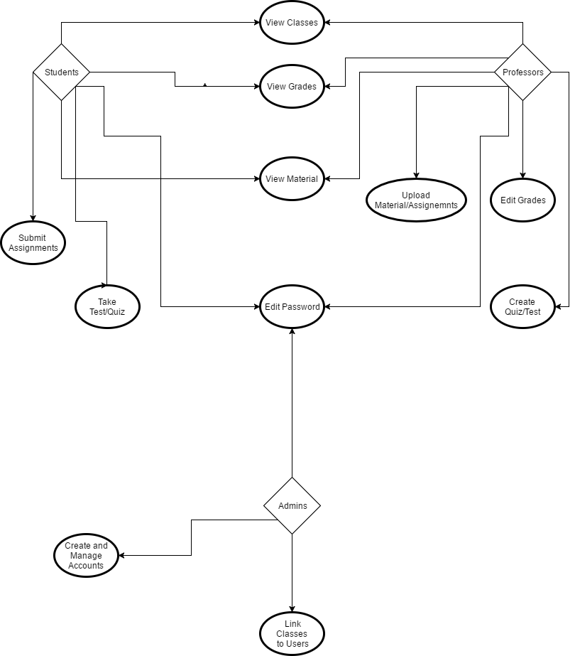

**=====================================================================**

**=====================================================================**

**Use-Case: Create and Manage Accounts**

### **1 Brief Description**

This will describe how the administrator adds new student or professor accounts to the system and ties them to specific classes.

### **2 Actors**

**2.1 Administrator**

### **3 Preconditions**

Must be logged into administrator account

### **4 Basic Flow of Events**

1. The administrator selects whether to add a new account or manage an existing account
   1. The administrator selects to add new account
      1. The administrator enters a username
      2. The system verifies that the user name is unique and valid
      3. The administrator enters a password
      4. The system verifies the password
      5. The use case ends successfully
   2. The administrator selects to manage an existing account
      1. The administrator selects whether to add or remove class
         1. The administrator selects to add a class
            1. The administrator enters a unique course ID
            2. The system validates that the course exists
            3. The system validates that the course has room for the student
            4. The system registers the class to the account
            5. The use case ends successfully
         2. The administrator selects to remove a class
            1. The administrator enters a unique course ID
            2. The system validates that the course exists
            3. The system validates the course is on the account
            4. The system remove the course from the account
            5. The use case ends successfully

### 

### **5 Alternative Flows**

**5.1 The administrator enters invalid data**

If in any step the system fails to validate the data, the administrator is asked to re-input the information.

### **6 Key Scenarios**

6.1 If at any point the administrator or server disconnects, a failure condition is created and the use case restarts.

### **7 Post-conditions**

#### **7.1 Successful Completion**

Students and Professors are able to log on to their created accounts - and have access to appropriate use cases related to their accounts and classes.

#### **7.2 Failure Condition**

Upon failure to complete the task the system does not create any new user account or register any classes to any accounts,and a warning message appears.

### **8 Special Requirements**

There can not be more students assigned to a class then the max amount allowed.

**=====================================================================**

**=====================================================================**

**Use-Case: Upload Material and Assignments**

### **1 Brief Description**

The teacher must be able to create assignments and upload files onto specific class page for students to see. The teacher must fill out certain fields before submitting like a description.

**2 Actors**

**2.1 Teacher**

**2.2 Student**

### **3 Preconditions**

Teacher is logged in and on specific class page they want to upload.

Teacher has the file downloaded that they wish to upload.

### **4 Basic Flow of Events**

1. Teacher selects what type of material they will be uploading, assignment, link, document.
2. Teacher inputs certain fields like description, due date, or title depending on the material.
3. Teacher adds any necessary documents or files to the upload.
4. Teacher submits the upload and the assignment appears on the class page.

### **5 Alternative Flows**

**5.1 Uploading file that is too large**

If in step 3 and 4 the teacher adds a file which size it too large for the system then:

1. The use case ends with a failure condition.

### **6 Key Scenarios**

6.1 Disconnected from Internet

6.2 Computer Crashes

6.3 Failure to communicate with system

### 

### 

### **7 Post-conditions**

#### **7.1 Successful Completion**

The file being uploaded appear on the class page and the teacher is prompted that uploading was successful.

#### **7.2 Failure Condition**

Warning that the file was not submitted because of errors.

### **8 Special Requirements**

Uploaded file must be less than max file size.

**=====================================================================**

**=====================================================================**

**Use-Case: Edit Grades**

### **1 Brief Description**

Allow Teachers to access the gradebook so that it displays the grades for each class. There would be a table of students with their grades and assignments so that they can be easily adjustable.

### **2 Actors**

**2.1 Teacher**

**2.2 Student**

### **3 Preconditions**

The user and teacher are both linked to their respective classes.

The teachers grading table is filled with students with columns for assignments.

### **4 Basic Flow of Events**

1. The teacher views a student’s assignment in the grading table and enters a grade for the student.
2. The teacher submits the grade allowing the student to view their grade.
3. The student goes to the gradebook and can see the grade the teacher had submitted along with the assignment details.

### **5 Alternative Flows**

**5.1 Regrading of an Assignment**

If after step 3 the teacher or student realizes a mistake the teacher can go back to their grading table and edit the grade for the column of the student.

**5.2 Invalid Teacher Input**

If after step 2 the teacher had accidentally typed an invalid symbol or other invalid input(negative number) into the table there would be an error message for the user.

The use case ends with a Failure Condition and the table is not submitted.

### **6 Key Scenarios**

6.1 Internet is Disconnected

6.2 Computer Crashes

6.3 Failure to access System

### **7 Post-conditions**

#### **7.1 Successful Completion**

The teacher is prompted that the submission of grades was successful. The student is notified that a new grade is available and can access/view the class grade after the teacher has graded.

#### **7.2 Failure Condition**

The Teacher is shown a warning/ error message and the material/assignment is not submitted to the server.

### **8 Special Requirements**

There should be a log of all grades so that if a grade is changed the original grade is still accessible.

**Group Participation:**

Steven Strickland - Document requirements and use cases.

Alexandre Lacy - Document requirements and use cases.

Joshua Shaffer - Document requirements and use cases. Complete use case diagram