**Title:** MaxDonald’s

**Who:** Ian Moore, Ethan Fellows, Samuel Carnes, Hussain A.

**Project Tracker:** <https://trello.com/b/x49MSwHo/maxdonald-s>  
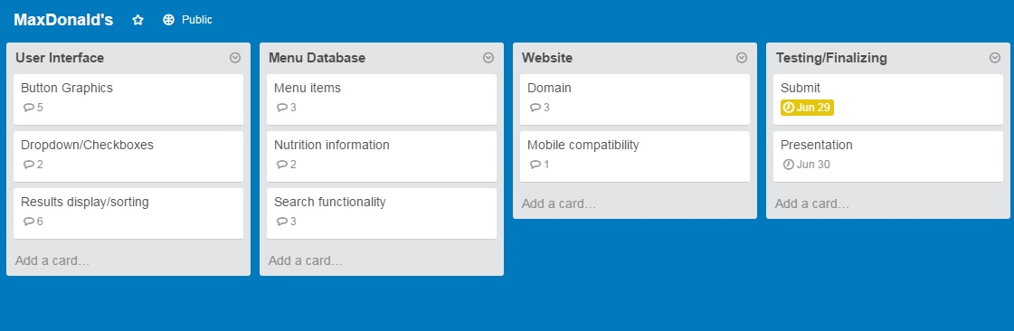

**VCS:** https://github.com/Brefew/MaxDonalds

**Video:**

**Screenshot:**

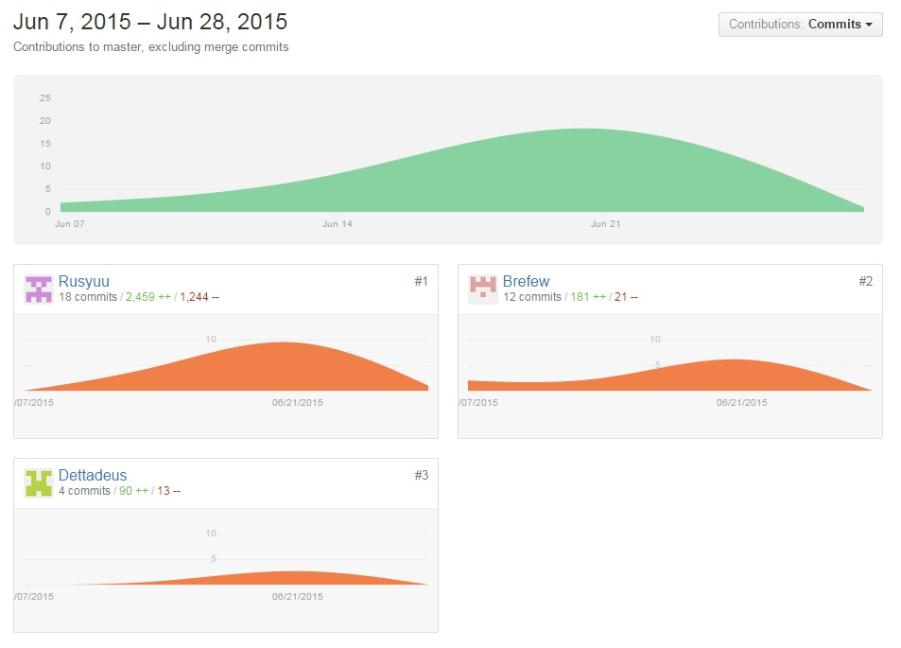

**Deployment:** After cloning the files from github, open a new terminal. Go to the necessary directory, and run the python –m CGIHTTPServer 8000 command. Open a webpage, and go to localhost:8000/ and type the name of the file to access the websie.

**Auto-Doc:**