| **REVISIONS** | | | |
| --- | --- | --- | --- |
| **Rev. No** | **Description** | **Date** | **Person** |
| 0.1 | Creating the document according to the CreateAccount, CreateRecipe, and EditRecipe use cases. | 23.12.2023 | Aslı |

**Design structure**

The design structure of the Hungerger Application is organized in an MVC architecture since it gives each individual within the development team a standard to follow while increasing the modularity throughout the project's development. This pattern separates concerns, dividing the application into three interconnected components: model, view, and controller.

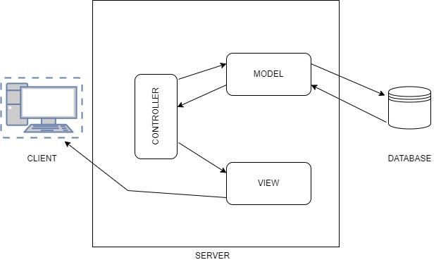

Figure 1: MVC Pattern

**Subsystems**

The application has no subsystems.

**Patterns**

**Pattern1 - Create Account**

**Overview**

The Create Account pattern is tailored to streamline the account creation process within the Hungerger Application, specifically targeting the "CreateAccount" use case. With a focus on enhancing efficiency and user convenience, this pattern aims to provide a dynamic and adaptable framework for effectively creating accounts on the system.

**Structure**

The participants are the CreateAccount use case and HGG-USER-LOGIN requirement. After the creation of an account, the Visitor is directed to the login page where they can log in to the system as a user. The relevant data for creating an account is username, email, password, and password confirmation. The relevant data for login are username and password.

**Behavior**

A visitor who wants to see the application content creates an account, enters relevant information, and triggers the “Create Account” process. After that, the system directs them to the login page. The visitor enters relevant information and triggers the Login process. The system presents the application content.

**Requirement realizations**

**Realization1: Create Account**

**Visitor**

* **Behavior:** Initiates account creation process, provides the necessary information and confirms their request.
* **Attributes:** username, email, password, and password confirmation.
* **Relationships:** Interacts with the user interface and triggers account creation.

**User**

* **Behavior:** Initiates login process, provides the necessary information, and confirms their request.
* **Attributes:** username and password
* **Relationships:** Interacts with the user interface and triggers the login process

**Basic scenario**

A visitor who wants to see the application content creates an account, enters relevant information, and triggers the “Create Account” process. After that, the system directs them to the login page. The visitor enters relevant information and triggers the Login process. The system presents the application content.

**Pattern2 - Create Recipe**

**Overview**

The Create Recipe pattern is tailored to streamline the recipe creation process within the Hungerger Application, specifically targeting the "CreateRecipe" use case. With a focus on enhancing efficiency and user convenience, this pattern aims to provide a dynamic and adaptable framework for effectively creating recipes on the system.

**Structure**

The participants are the CreateRecipe use case and HGG-USER-LOGIN requirement. After logging in to the application, a user can create a recipe. The relevant data for creating a recipe are the recipe name, description, image, dietary type, ingredients, and the amounts of the ingredients.

**Behavior**

A user who wants to create a recipe enters relevant information and triggers the “Create Recipe” process. After that, the system shows the recipe on the user's profile page and the main page.

**Realization1: Create Recipe**

**View of participants**

**User**

* **Behavior:** Initiates create recipe process, provides the necessary information, and confirms their request.
* **Attributes:** the recipe name, description, image, dietary type, ingredients, and the amounts of the ingredients.
* **Relationships:** Interacts with the user interface and triggers the creation recipe process and data retrieval from a marketplace process.

**Marketplace**

* **Behavior:** Provides the ingredient prices.
* **Attributes:** ingredients, prices.
* **Relationships:** Interact with the API to provide the necessary information.

**Basic scenario**

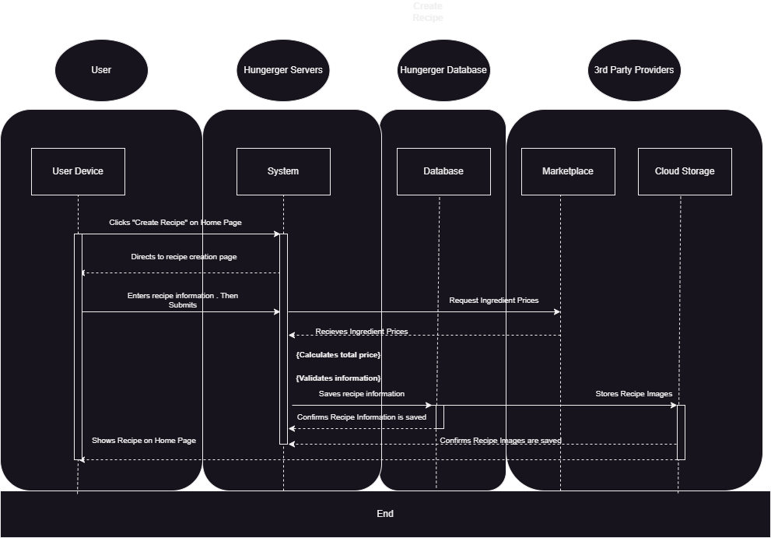

Figure 2: CreateRecipe Sequence Diagram

**Pattern3 - Edit Recipe**

**Overview**

The Edit Recipe pattern is tailored to streamline the edit recipe process within the Hungerger Application, specifically targeting the "EditRecipe" use case. With a focus on enhancing efficiency and user convenience, this pattern aims to provide a dynamic and adaptable framework for effectively editing user’s recipes.

**Structure**

The participants are the EditRecipe use case and HGG-USER-LOGIN requirement. After logging in to the application, users can edit a recipe if they have any. The relevant data for editing a recipe are the recipe name, description, image, dietary type, ingredients, and the amounts of the ingredients.

**Behavior**

A user who wants to edit a recipe selects one of their recipes and triggers the “Edit Recipe” process. After that, they edit the relevant information and trigger the “Save” process. Then, the system shows the edited recipe on the user's profile and main pages.

**Realization1: Edit Recipe**

**View of participants**

**User**

* **Behavior:** Initiates edit recipe process, provides the necessary information, and confirms their request.
* **Attributes:** the recipe name, description, image, dietary type, ingredients, and the amounts of the ingredients.
* **Relationships:** Interacts with the user interface and triggers the edit recipe process and data retrieval from a marketplace process.

**Marketplace**

* **Behavior:** Provides the ingredient prices.
* **Attributes:** ingredients, prices.
* **Relationships:** Interact with the API to provide the necessary information

**Basic scenario**

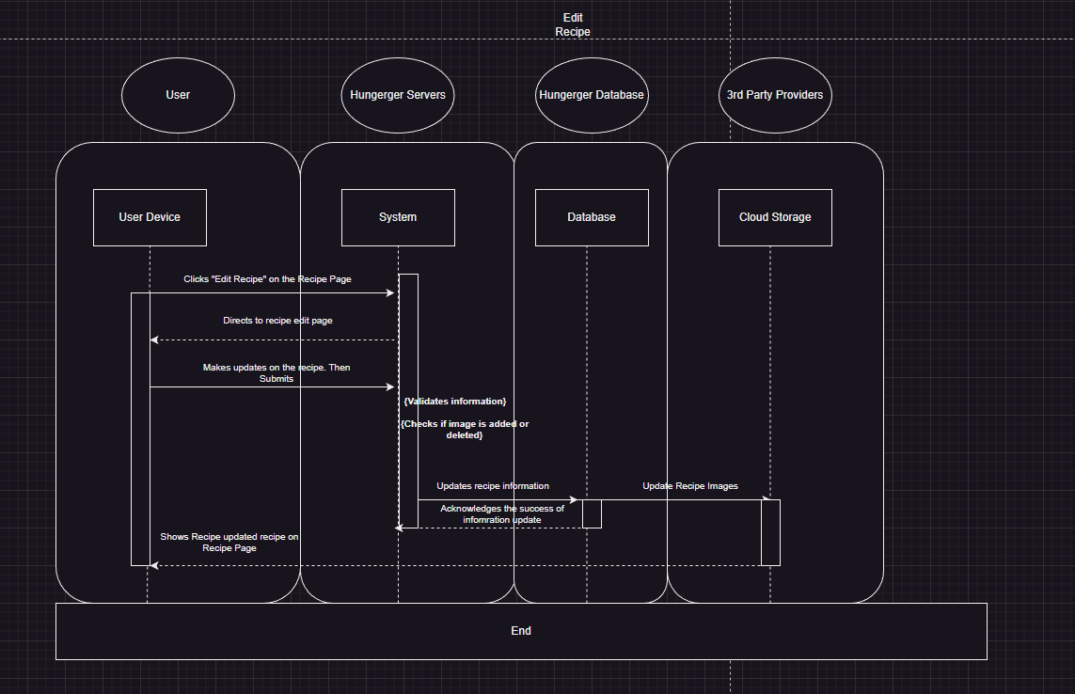

Figure 3: EditRecipe Sequence Diagram