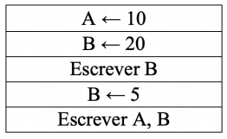A – A ← 10 \\ A = 10

B ← 20 \\ B = 20

Escrever B B = 20

B ← 5 \\B=5

Escrever A,B

10, 5

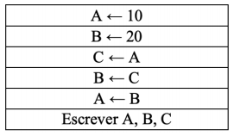B – A ← 10 \\ A =10

B ← 20 \\ B = 20

C ← A \\ C = 10

B ← C \\ B = 10

A ← B \\ A = 10

ESCREVER A, B, C

10, 10, 10

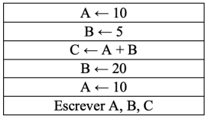C – A ← 10 \\ A = 10

B ← 5 \\ B = 5

C ← A + B \\ C = 15

B ← 20 \\ B = 20

A ← 10 \\ A = 10

ESCREVER A, B, C

10, 20, 15

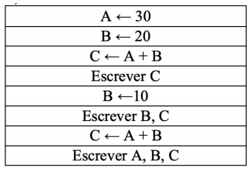D – A ← 30 \\ A = 30

B ← 20 \\ B = 20

C ← A + B \\ C = 50 ‘’A+B’’20+30

ESCREVER C

50

B ← 10 \\ B = 10

ESCREVER B, C

10, 50

C ← A + B \\ C = 40 ‘’A+B = 30+10”

ESCREVA A, B, C

30, 10, 40

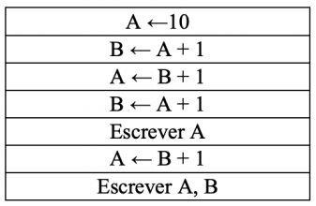E – A ← 10 \\ A = 10

B ← A + 1 \\ B = 11 ‘’10+1’’

A ← B + 1 \\ A = 12 ‘’11+1

B ← A + 1 \\ B = 13 ‘’12 + 1

ESCREVE A

12

A ← B + 1 \\ A = 14 ‘’13+1

ESCREVE A , B

14, 13

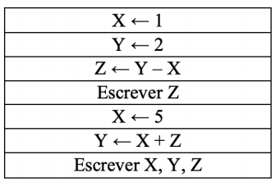F – X ← 1 \\ X = 1

Y ← 2 \\ Y = 2

Z ← Y – X \\ Z = 1 ‘’2-1

ESCREVER Z

1

X ← 5

Y ← X + Z \\ Y = 5 +1

ESCREVER X, Y, Z

5, 6, 1