Brennen Bates

9/6/2024

CSC500 Module 1 Critical Thinking Assignment

***Github Repository:***

https://github.com/BrenBates/CSC500-Principles-of-Programming/tree/main/CSC500-Principles-of-Programming/Module1-Introduction_to_Programming_Concepts

***Part 1:***

*Write a Python program to find the addition and subtraction of two numbers.*

*Ask the user to input two numbers (num1 and num2). Given those two numbers, add them together to find the output. Also, subtract the two numbers to find the output.*

**Code:**

num1 = int(input("Enter a number:"))

num2 = int(input("Enter another number:"))

print(num1,'+',num2,'is',num1+num2)

print(num1,'-',num2,'is',num1-num2)

**Screenshot:**

I like Visual Studio Code as an IDE. You can see the script running in the terminal at the bottom.

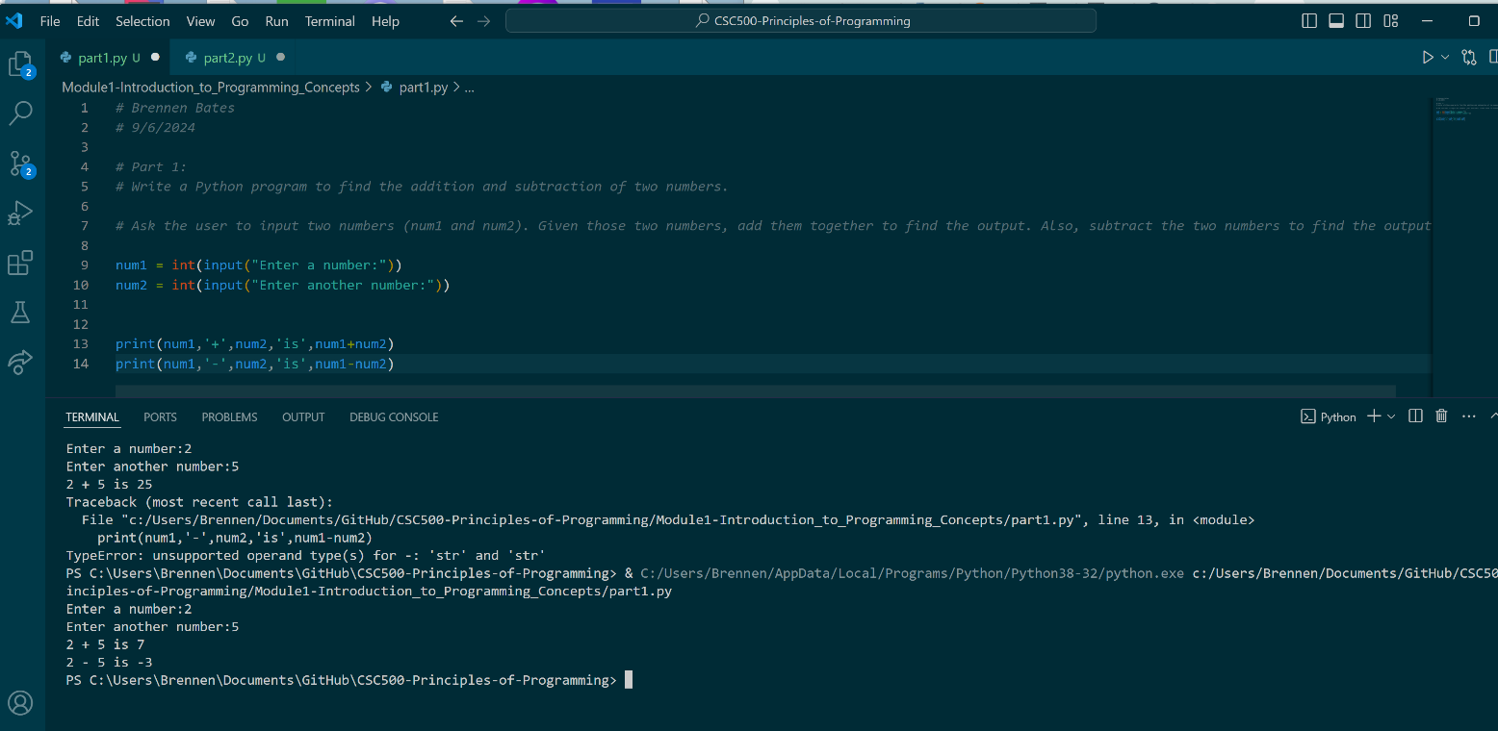

***Part 2:***

*Write a Python program to find the multiplication and division of two numbers.*

*Ask the user to input two numbers (num1 and num2). Given those two numbers, multiply them together to find the output. Also, divide num1/num2 to find the output.*

***Code:***

num1 = int(input("Enter a number:"))

num2 = int(input("Enter another number:"))

print(num1,'*',num2,'is',num1*num2)

print(num1,'/',num2,'is',num1/num2)

**Screenshot:**

I like Visual Studio Code as an IDE. You can see the script running in the terminal at the bottom.

