NetQuax

Group #3, Super Duck Force

Andrew Ferguson, Brendan Blais, Brandin Dennin, Jordan Gardiner, Sawyer Marchand

**Software Requirements Specification**

**Document**

**Version: (4)** **Date: (03/09/2019)**

Contents

1. Introduction 3

1.1 Purpose 3

1.2 Scope 3

1.3 Definitions, Acronyms, and Abbreviations. 3

1.4 References 4

1.5 Overview 4

2. The Overall Description 4

2.1 Product Perspective 4

2.1.1 System Interfaces 5

2.1.2 Interfaces 5

2.1.3 Hardware Interfaces 6

2.1.4 Software Interfaces 6

2.1.5 Communications Interfaces 6

2.1.6 Memory Constraints 7

2.1.7 Operations 7

2.1.8 Site Adaptation Requirements 7

2.2 Product Functions 7

2.3 User Characteristics 7

2.4 Constraints 7

2.5 Assumptions and Dependencies 8

2.6 Apportioning of Requirements. 8

3. Specific Requirements 9

3.1 External Interfaces 9

3.2 Functions 9

3.3 Performance Requirements 14

3.4 Logical Database Requirements 14

3.5 Design Constraints 14

3.6 Software System Attributes 15

3.6.1 Reliability 15

3.6.2 Availability 15

3.6.3 Security 15

3.6.4 Maintainability 15

3.6.5 Portability 15

3.7 Organizing the Specific Requirements 16

3.7.1 System Mode 16

3.7.2 User Class 16

3.7.3 Objects 16

3.7.4 Feature 16

3.7.5 Stimulus 17

4. Supporting Information 17

# 1. Introduction

## 1.1 Purpose

This software requirements document is intended for the designers and developers of the projects, as well as others who these requirements may concern. In the following pages the requirements for the movie rental system will be laid out in detail for the designers and evaluators of the system.

## 1.2 Scope

This document concerns the development of the movie rental system, “NetQuax”. Upon creation of a free user account, clients will be able to browse through a selection of past and current television shows or movies and select which one they would like to view. Additionally, the user will be able to sort the movies based on genre, mode, actor, director, and theme. These results can be further filtered by decade, price, and customer review score. Upon selection of the movie or TV show, the user will be able to choose the type of video they would like to rent, either HD or SD. Once the selection is made the user will be able to proceed to check out using a credit card from any major issuer and view their chosen video. Additionally, the user can choose to upgrade their account to one of the premium tiers. Each tier has elevated benefits over the previous. Benefits include a greater selection of rental options, less advertisements displayed to the end-user, and different movie renting privileges. The application is primarily being developed to generate income for the developers and to provide entertainment for the clients. The user interface must be responsive for functionality on multiple display resolutions, and the application must load quickly to decrease user waiting times.

## 1.3 Definitions, Acronyms, and Abbreviations.

sd. Standard definition

hd. High definition

ui. User interface

ux. User experience

user. The person, or persons, who operate or interact directly with the product.

admin. A user with elevated priveleges and control over the system

css. Cascading Style Sheet

html. Hyper Text Markup Language

ide. Integrated Development Environment

sql. Structured Query Language

asp. Active Server Pagess

## 1.4 References

No outside documents were referenced in the creation of these software specifications.

## 1.5 Overview

The remainder of the software requirements document contains information regarding different perspectives of the system. Chapter 2 contains information in the user domain such as specific functions and user characteristics. Chapter 3 contains information form the development domain. Chapter 4 will contain all supporting information for this software requirements document. This document is organized with heading denoted by a number (ex: 1) and subsections are denoted by the following syntax: X.Y, where X is the heading, and Y is the subsection number.

# 2. The Overall Description

## 2.1 Product Perspective

This project is an independent system and does not play a role in a part of a larger structure.

Similar systems that currently exist in the marketplace include Netflix, Hulu, and Amazon Prime Videos. Netflix is always an ongoing commitment, the user is required to sign up for a monthly payment linked to an account, our service differs in this way because a user has an option to pay per movie with one of the three account type options. Depending on the specific scenario, this may be a benefit or downfall. For example, if a customer of Netflix doesn’t get a chance to watch one single movie in a given month, they are still charged the full fee, with no benefit. However, if they happen to have a month of excessive watching, Netflix will remain the same price while our service will increase in price as the rate of watching rises. Amazon Prime Video has similar pitfalls and perks. The payment is the same no matter the behavior of the user. In these ways, our system gives the user more control overall when it comes to over-spending on non-movie watching months. On the other hand, our customer does not have access to unlimited movies, but to only seven movies per month with the Mother Duck plan. Although this is a limitation of quantity, the quality of programs provided must be a consideration. As for Hulu, the major distinction here is that Hulu charges a rate every month, and the user may opt in to pay more in order to receive an advertisement-free service. Our system plans to only contain advertisements for the free version (hatchling user) and the moment a user begins to pay for the service, there are no longer any advertisements. We made this choice due to the fact that there are plenty of inexpensive ad-free movie streaming options out there and it is not a competitive choice to charge customers and include advertisements. Not only does our system not contain advertisements when it is paid-for, but when the service is free, and there are advertisements, they are mindfully chosen. Our advertisements will only consist of organizations that are health conscious and environmentally friendly. For example, commercials involving cigarettes, fast-food, or alcohol will not supported. We will research the company and decide as a team whether the standards are high enough or not. This is a key difference between existing systems in the marketplace today, and our system because the advertisements that we allow ourselves to become exposed to, have an impact on our thought process, especially for the customer’s children. We are confident that this conscientious decision will be appreciated by our customers. The last main distinction that separates our system from others, is the aspect of customization of the interface. Netflix is known for their color scheme red and black, while Hulu is known for a brighter design. User of our system will be able to personalize the interface to best suit their preferences. (The user will have a choice of a few per-made options.)

### 2.1.1 System Interfaces

We will be using IMDb (Internet Movie Database) to access our data along with youtube to access the Iframe.

### 2.1.2 Interfaces

We optimize our Graphical User Interface by remaining “signed in” - so that the user doesn’t have to enter their sign in information every time they decide to use the system. From the home screen, the user is able to get to any other screen, (there are not multiple steps in order to get to something like, change your user account information.) There shouldn’t be more than 4 clicks to get from the home screen to the other screens (My profile, My orders, System Settings, Logout.) The search bar will auto-fill in order to make the process easier, to avoid mistakes such as misspellings that will result in the search having no results. Color customization will be saved to stay the same (with each logout/ log- in) unless distinctly changed. (No need for resetting to dark mode every time.) The Main Homepage will be the default view of the system. From here, the user has many options. The options include a search bar, and a pull down menu that allows the user to access other pages such as their user profile, their active order information, customization settings, or logging out of their user account. They may use the search bar to search for a particular movie title, director, actor, genre, or rating. Once a movie is rented, it will remain available for 48 hours.

The search bar shall auto-fill in order to make the process more user friendly. In general, we would like to keep a minimalist design, while allowing for user control and freedom. Our target audience is for adults, (considering that there will be R-rated movies.) Although our system should not single out adults only, similar to other similar systems in the market, the system should be used by families and include an array of kid-friendly , PG rated options. We are making the assumption that our users are able to see, read, and hear, although it would be possible to navigate through the system successfully without knowing a lot of English vocabulary, because of the familiar image of the movie cover, and trailer.

### 2.1.3 Hardware Interfaces

There are not any specific hardware requirements since we are using Adobe Flash Player as our plug-in. (A plug- in is a set of software components that can be added to a browser to increase its capabilities, in this case, the ability to stream videos.) The most important aspect is to have an updated browser and operating system. Our browser compatibility will include Mozilla Firefox, Google Chrome, Safari, and Microsoft Edge. The system shall work on the following operating systems; Windows 7+, Mac OS X 10.7+, or Ubuntu 10+. This system is not specifically designed to be used on any other device besides a computer, however any device that can successfully access a browser will be able to use this system.

As for streaming movie service, certain Internet speeds are required for high definition and standard definition streaming services. 1.5 Mbps is the absolute minimum. If a user is watching films in standard-definition, at least 3Mbps is recommended, and for high definition videos, at least 5Mbps is recommended. These speeds are recommended with the assumption that the computer playing the streaming video service is the only computer using the speed. If another person is on the Network, doing heavy downloading, these speeds may not suffice for optimal streaming service. Network protocol used will be Hyper-text transfer protocol due to the fact that we do not have dedicated servers. HTTP will work considering we do not have to consider many users watching at the same time, therefore there will never be massive amount of traffic.

### 2.1.4 Software Interfaces

The system will use 2.1.4.1 Microsoft SQL Server 2016 as our database where data can be read from. We will be retrieving our data from IMBd API and using Adobe Flash Player in Windows 10 version 1607 as the plug-in to stream.

### 2.1.5 Communications Interfaces

Our system is using Hypertext Transfer Protocol. This is an application-level protocol for collective systems. It is a universal protocol that can be used for hypertext. We will be taking advantage of the feature of HTTP that is used for data being transferred. HTTP has been in use by the World Wide Web global information initiative since 1990. This specification defines the protocol referred to as ‘HTTP/1.1’.

### 2.1.6 Memory Constraints

The minimum memory required is at least 2gb if RAM.

### 2.1.7 Operations

Refer to section 3.7.1 for detail about recovery and operations functions.

### 2.1.8 Site Adaptation Requirements

Adaptation requirements include an up to date browser and operating system, recommended Internet connection speeds. Details are discussed in section 2.1.3.

## 2.2 Product Functions

Users should be able to rent a movie to watch, this includes creating an account, during this process the user picks one of three potential options. Hatchling, full-grown duck, or mother duck. If one of the latter of the two is chosen, the user must fill out credit card information. The user must be able to enter their name, and credit card information here. Once a user account type is chosen, the user must be able to navigate around the user interface to browse for movies of interest. This browsing must be able to include a search bar that can be used to search for a specific movie. Movies must be able to be searched for by actor/actresses, director, HD or SD, as well as overall genre. For ease of use, results from this search can be filtered by decade, price, and average customer review. Once a movie is chosen, the user must be able to check out and start watching.

## 2.3 User Characteristics

This system will be easy to use, the requirements of the user are minimal. These include knowing how to search for a movie, knowing how to properly enter their credit card information. We are making the assumption that the users are literate.

## 2.4 Constraints

Internet connection is crucial to access the website and a good internet connection provides the user with better quality of streaming. With what was previously stated it is also important that the user have a browser, without a browser the user will not be able to use the software due to the fact that the browser is the platform on which the system will be presented. The programs and scripts developed must follow the conventions of the respected languages i.e. C#, SQL, JavaScript, CSS, and HTML (insert more I missed some). If standard such as these are not maintained, the system will most definitely succumb to future failure. User login is a must in order to access movies and tv shows for streaming. This is due to parental control; *Ducks United tm* wants to ensure the proper procedures are taken to avoid underaged individuals watching inappropriate material without a parental supervision or consent.In order to maximize user experience, it is imperative that any searching or sorting algorithms maintain efficiency and take no longer than one second to execute to avoid waiting too long for a search or recommendation to be made.Operation is key to avoid distressing our users. It is always of the utmost importance that the system be operational, except for scheduled maintenance. Scheduled maintenance must not take more time than absolutely needed, users should not have to be kept waiting.

## 2.5 Assumptions and Dependencies

It is assumed that a there will be a high login rate and upon success of product launch that the number will keep increasing for a while. Therefore, it is assumed that there will be a need for an expansion with the data base being used in the future.

Another assumption is that the user has a web browser, internet connection, and a computer with the required software and hardware to view videos.It is also assumed that the user has a valid bank account and is of the required age of registration to use NetQuax. It shall also be noted that it is assumed the user is using their own personal identity and users falsely claiming to be someone else will fall into NetQuax true objective, finding cyber pirates!

## 2.6 Apportioning of Requirements.

Since NetQuax is still in the planning phase of the software’s life cycle, the development is currently being pushed back. The team working on the NetQuax software is set on coming up with the best means and approach to creating a special and efficient software to maximize the user’s experience and happiness. Since Ideation is not an easy task, it will be a good amount of time before the Duck Team Quack Force even goes into its beta testing phase. Another Delay to mention is that there is currently a delay to future content and the rights to display certain movies, Ducks United tm is working towards a partnership with Disney in order expand our vast variety of movies for streaming, however, Disney has not shown much interest in providing the rights for our company to move forward in this task. Fear not! We’re not done yet and will be working towards winning their favor.

# 3. Specific Requirements

## 3.1 External Interfaces

User input will be attained using mouse and keyboard input. The user will begin by entering the URL into the search bar and or a search engine such as Google. Once the user has reached the website the user will go to the login icon to be transferred to the login page, if the user does not have an account, the user will click on the create an account icon instead. Once the user has logged into their account, they will begin their interaction with the main area of the website by scrolling through movies and clicking on their play button or the movie’s icon. The user can interact and provide a rating for different movies by clicking the number of quacks (1-5) they wish to give the movie. The user will also click the main menu icon if they choose to go to the main menu. When a user wishes to go to a previous area of the website they will choose to click on the back icon and or the back button on their search bar. The user clicks the history link if they wish to see the movies they viewed in past operations of the software. If a user wishes to log out, they will click on the Log out button.

## 3.2 Functions

**3.2.1 Login Use Case**

Use case: Login

Diagram:

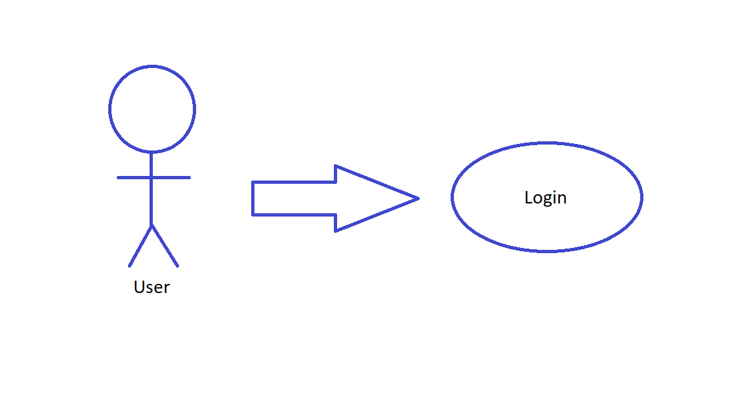

**Figure 1. Login Use Case**

**Brief Description**

The user will log into the system to access the system’s material.

**Initial Step-By-Step**

1. The user types in the URL to get to the webpage.
2. User must enter their username and password to login.
3. Once logged in the user can access the systems material

**3.2.2 Create Account Use Case**

Use Case: Create Account

Diagram

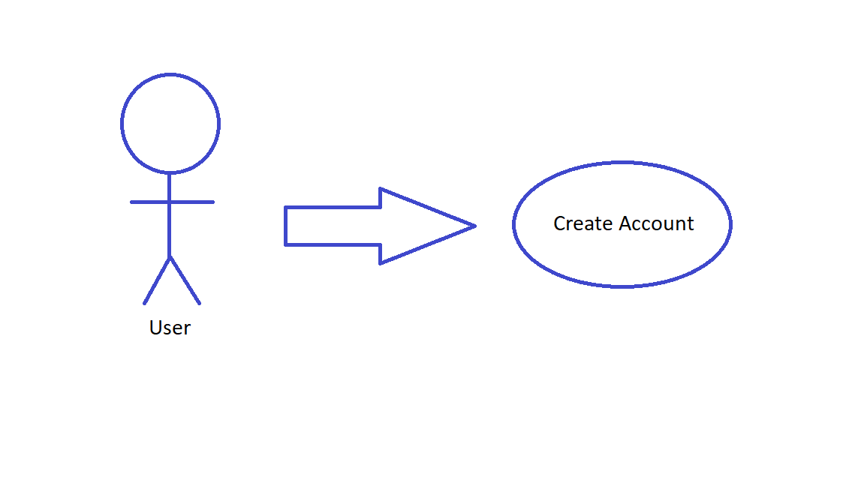

**Figure 2. Create Account Use Case**

**Brief Description**

The user will Create Account to gain access to systems media

**Initial Step-By-Step**

1. The user enters their information i.e.

* Age
* First and last name
* Credit card information
* Address

1. After the user has entered their personal information, they click on create account.
2. Once the account is created the user can access the system’s media.

**3.2.3 Play Video Use Case**

Use case: Play Video

Diagram:

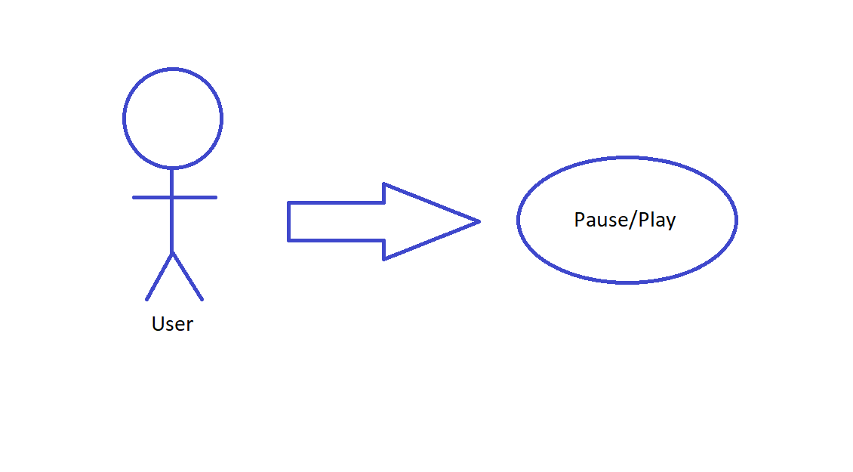

**Figure 3. Pause/Play Use Case**

**Brief Description**

The user presses the play icon to play the video, then if he or she wishes to pause the video they click on the video’s window and the video pauses.

**Initial Step-By-Step**

1. User uses mouse to click on movie’s play icon.
2. By pressing play icon, the video begins to play.
3. The user clicks once more, but this time on the movies window.
4. The movie pauses

**3.2.4 Rate Movie Use Case**

Use case: Rate Movie

Diagram:

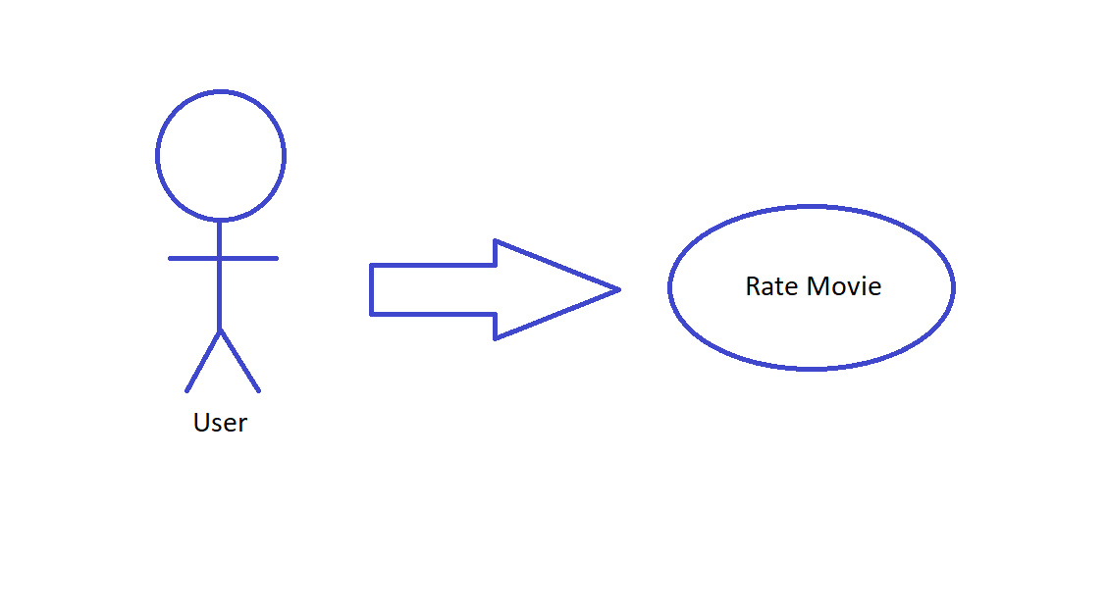

**Figure 4. Rate Movie Use Case**

**Brief Description**

The user clicks on the desired rating (measured in quacks) they wish to give the movie and then the rating is used to give recommendations for future movies the user may like.

**Initial Step-By-Step**

1. User uses clicks on the number of quacks they wish to give the movie.
2. Rating Is then used to recommend future movies to user.

**3.2.5 Main Menu Use Case**

Use case: Main Menu

Diagram:

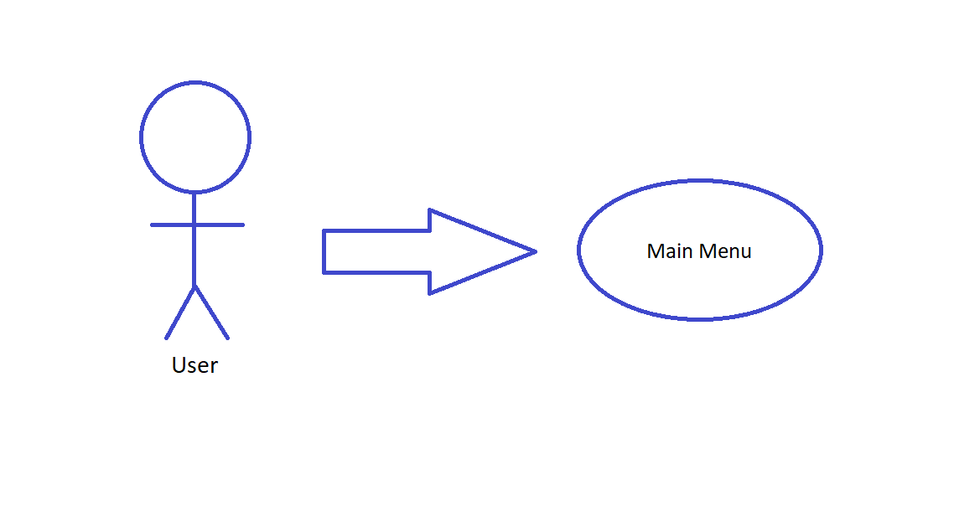

**Figure 5. Main Menu Use Case**

**Brief Description**

The user clicks on the main menu icon and then is transferred to the main menu.

**Initial Step-By-Step**

1. User uses clicks on the main menu icon.
2. User is transferred to main menu

**3.2.6 Log Out Use Case**

Use case: Log Out

Diagram:

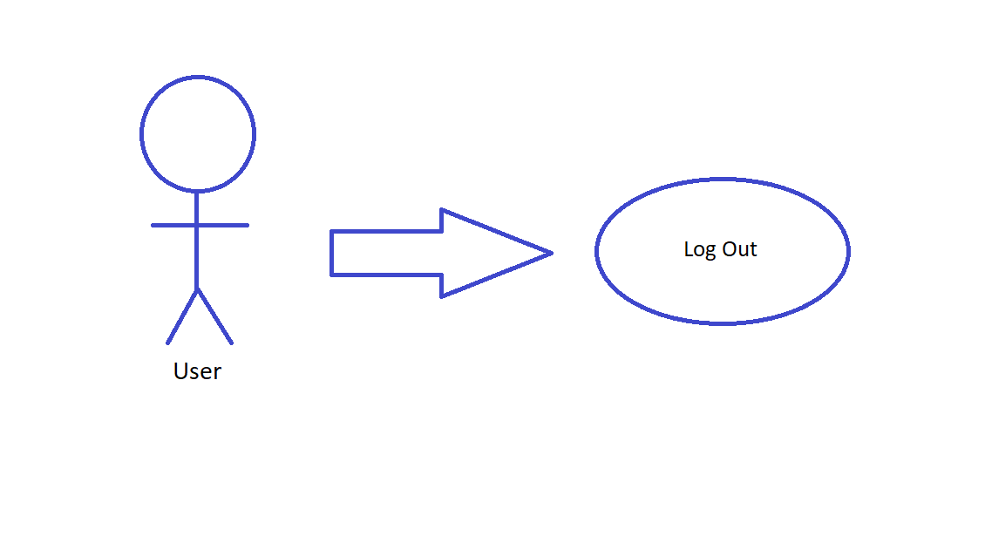

**Figure 6. Log Out Use Case**

**Brief Description**

The user clicks on the log out icon and is then logged out of the system.

**Initial Step-By-Step**

1. User uses clicks on the log out icon.
2. User is logged out of the system

## 3.3 Performance Requirements

The software will be able to handle at least as many simultaneous users as there are active user accounts. This will be required for smooth accessibility, and since we have the option to make an account on our movie service, that should be at least the number of accounts. Our software will need a substantial server size considering movies are very large pieces of data, and that would be multiplied in the case of high definition video. A standard movie is in between 2-4 gigabytes, so if we were to host 1000 movies, we would need between 2000-4000gb to host. That’s without having duplicates for different quality. Considering text files don’t take anywhere near that much, items such as logs for accounts and credit cards should be taking up nowhere near a percentage of the hard disk space that the movies are. For example, this paragraph up to this point takes up around 1000 bytes of disk space. This is more than the average log file will have as well, but to give us an estimate of size required for say 10,000 users. Since 1 mb is equal to 1000 bytes, a rough estimation of size required for this number of users would be roughly 10 gigabytes. Or .5% of the expected size to store 1000 movies. In addition, the number of users should not be surpassing the total numbers of accounts created.

## 3.4 Logical Database Requirements

Movie Data Function will be a function required to pull the stored data of the desired movie. The data should be stored and organized by movie. Preview function, a function designed to show a preview/slideshow of the movie. CreateAccount function should be used to store the account details of a new user attempting to create an account. In addition this should also validate certain items are filled, such as Name and Email. Credit Card Validate function will be required to validate the card number is the correct length, and there are no words in fields that require only numbers and other error handling. Credit Card store function for once a validated credit card makes a purchase. Our program needs to be ready for constant access on both the ends of account creation/credit cards .

## 3.5 Design Constraints

Error reporting and logging will be essential to figure out both issues in the payment menu and with loading our website, whether it be movies, previews, or the site itself. By collecting these pieces of information we can dictate whether we can fix the issue, or if it was client side. Naming our movies will be important for potential licensing issues. By this I mean making sure all movies are properly labeled, whether that be including the license in the data, or have the information from the data be used in locating the license elsewhere. In addition, depending on overall security/performance, there is a possibility of requiring/wanting a more secure location for items such as credit cards and other potentially sensitive data.

## 3.6 Software System Attributes

### 3.6.1 Reliability

The factors that are required for the reliability of the software system at delivery time are as follows:

1. The systems database must be fully operation and running.
2. The systems files must have no bugs or errors in the code
3. The systems web servers must be fully operational and online.

### 3.6.2 Availability

Our system will be running 24/7 to ensure that our customers are satisfied at all hours of the day. In the event of a catastrophic failure, the goal is to have the time saved of the movie you were currently watching so you can go back to that exact time when the website crashed.

### 3.6.3 Security

Our system will be using cryptographic techniques for our password storage system on the sql databases. All modifications to the website will be logged to ensure backtracking in the event of an internal threat to the system. The system will have an extra layer of protection because the systems utilitizes backend authentication.

### 3.6.4 Maintainability

Our system will contain an easy to use class system for admin users. The admin users will have access to adding new movies to our system with ease.

*.*

### 3.6.5 Portability

Our system will be web-based, so any computer that can connect to the internet including but not limited to:

1. Mobile Device
2. Ipad/Tablet
3. Any other device that can use a web browser

This makes the portability of our system as portable as any device that you can carry around with you. This will be tested alongside our normal browser testing to ensure the validity of our portability on mobile devices.

## 3.7 Organizing the Specific Requirements

*For anything but trivial systems the detailed requirements tend to be extensive. For this reason, it is recommended that careful consideration be given to organizing these in a manner optimal for understanding. There is no one optimal organization for all systems. Different classes of systems lend themselves to different organizations of requirements in section 3. Some of these organizations are described in the following subclasses.*

### 3.7.1 System Mode

Our system will have two different modes: Normal Mode and Emergency Mode. Emergency Mode will only be used in the event of a successful attack from an adversary, or in the event of an internal catastrophic failure.

### 3.7.2 User Class

Our system will have two different classes: User class and Admin class. The user class will lack the functionality of adding, deleting or editing movies in the system. Admins can also remove comments or ratings and ban users.

### 3.7.3 Objects

Movie Data Function will be a function required to pull the stored data of the desired movie. The data should be stored and organized by movie. Preview function, a function designed to show a preview/slideshow of the movie. CreateAccount function should be used to store the account details of a new user attempting to create an account. In addition this should also validate certain items are filled, such as Name and Email. Credit Card Validate function will be required to validate the card number is the correct length, and there are no words in fields that require only numbers and other error handling. Credit Card store function for once a validated credit card makes a purchase. Our program needs to be ready for constant access on both the ends of account creation/credit cards.

### 3.7.4 Feature

Features from our movie/show system will include play/pause, volume up/down, closed captions, quality, fullscreen, and skip intro. This will be located when hovering over the movie/show in full screen or regular play mode. Pressing on the num keys will result in jumping to that fraction out of 10. For example, pressing 4 will result in jumping to 4/10’s of the way through the movie/show.

### 3.7.5 Stimulus

Hover for previews, Color blind mode to change color, dynamic credit card input are some of the stimulus our system will provide

# Supporting Information

**4.1 User Account Tiers**

A close up of text on a white background

Description generated with high confidence