TaskTide: Backend agnostic workflow orchestration system

Table of Contents

Summary 2
Statement of Need 3
State of the Field 4
Software Design 5
a). Introduction 5
b). TaskTide Data Model 5
c). TaskTide Persistence & Execution Model 5
d). Deployment 6
f). Relation to Pilot Job Abstraction 7
Research Impact Statement 8
AI Usage Disclosure 9
References 10
Figures and Tables 13
Figure 1: High-Level Layered Architecture 13
Figure 2: TaskTide Operating Principle 14
Figure 3: TaskTide Architecture 15
Figure 4: TaskTide WorkItem Lifecycle 16
Figure 5: Mapping TaskTide to the Pilot Job Abstraction 17
Figure 6: High Level Development Approach 18
Table 1: TaskTide Feature Summary 19
Table 2: TaskTide Configurations 20
Table 3: TaskTide Resources 21

Summary
TaskTide is a backend agnostic workflow orchestration system, designed to mediate the deployment of user-defined data applications, across different computing environments (Fig-1). In data-intensive environments, workflows are defined by users independently from the platform which they are executed on. This separation of concerns creates a natural role for orchestration middleware, responsible for coordinating operational elements, such as persistent state, execution context, and task lifecycle management.
Through its persistent workflow model, TaskTide enables users to register, query, and modify their workflow deployments as they are consumed across distributed compute resources. These capabilities provide end-users with operational dials, that support real-time interaction with workflow state and execution context. As a result, workflows can be deployed across heterogeneous computing environments, including HPC, cloud, and containerized environments, while retaining a unified perspective on workflow state and execution context of data application deployments (Fig-4).
TaskTide treats workflow management, execution-context tracking, runtime introspection and lifecycle influence as first-class orchestration concerns, while resource scheduling, provisioning, and workload execution remain infrastructural responsibilities. Similarly, workflow semantics remain user-defined, either at runtime or within the application itself. This separation allows TaskTide to operate as lightweight orchestration middleware, that integrates with diverse computing environments and application domains, as demonstrated through use-cases spanning bioinformatics, distributed application execution, and containerized AI workloads (Table-3).

Statement of Need
The growth of data-intensive research, services and AI-driven applications has also created new research opportunities, for exploring how application execution, can be coordinated across heterogeneous computing environments (Hop et al., 2024, 2026; Kenna et al., 2016; NHLBI, 2016; Nicolas et al., 2018). While technologies such as Hadoop, SLURM, Kubernetes provide essential infrastructure-level resource management, and job execution capabilities for modern computing platforms (Burns et al., 2016; Giri & Sharma, 2022; Salloum et al., 2016; Yoo et al., 2003). End-users must still deploy and coordinate domain-specific Data Application Layer Systems (DALS) across these environments. In this work, the architectural separation between end-user DALS and service-provider Infrastructure Layer Systems (ILS) is referred to as the Orchestration Layer System (OLS). Where workflow intent must be translated into distributed execution (Ramakrishnan et al., 2011).
As workflow orchestration is not inherently owned by either DALS or ILS (Fig-1), the relationship between application instances and their execution context, is often implemented through infrastructure-specific scripts and utilities, that are tightly coupled to a given ILS. This places the burden of developing workflow state management, execution-context mapping, and lifecycle coordination on the end-users, reducing their portability across computing environments. TaskTide addresses these operational concerns through a dedicated orchestration layer, that persists workflow state independently of the underlying infrastructure (Fig-2). Beyond reducing workflow portability, the OLS gap introduces operational overhead for both end-users and service providers. For the end-users this comes in as development overhead for each workflow that they need to deploy, and how they develop them. For service providers, the OLS gap can blur the boundary between infrastructure support responsibilities, and workflow issues. Collectively complicating user onboarding and support scope, problems that are amplified by the rapid evolution of both application and infrastructure technologies, where tightly coupled solutions inherit platform-specific obsolescence risks.
Collectively, these challenges highlight the need for flexible workflow orchestration systems, designed specifically to mediate end-user experience, that is not tied to a specific backend technology. Such systems would decouple task scheduling from task execution, and the underlying ILS, while elevating workflow state and execution context as first-class orchestration concerns, that support real-time workflow introspection and lifecycle influence at runtime. This work contributes TaskTide, a lightweight, daemon-less distributed workflow orchestration system, for the horizontal scaling of DALS workloads, across heterogeneous ILS (Fig-1), providing end-users with real-time workflow management capabilities through persisted state (Fig-2). TaskTide is designed to operate across both relational databases (ex PostgreSQL, Oracle, MariaDB etc), NoSQL databases (ex MongoDB, CouchDB, Riak etc), and embedded databases (ex RocksDB, SQLite). By treating workflow state as a persistent orchestration concern, TaskTide supports real-time workflow introspection and infrastructure-independent recovery. The same persistent state model also enables TaskTide’s decentralized worker coordination, through optimistic task claiming with post-write ownership validation, removing the need for dedicated scheduling infrastructure.

State of the Field
The separate concerns of DALS and ILS have motivated the development of a rich ecosystem of workflow engines, middleware systems, and pilot-job abstractions, each focusing on different aspects of the OLS boundary. For instance, workflow systems such as SnakeMake, Airflow, and Nextflow provide mature frameworks for expressing, scheduling, and executing workload sequences through workflow-specific abstractions (Köster & Rahmann, 2012; Langer et al., 2025; Yasmin et al., 2025). Complementing these workflow systems, pilot-job frameworks such as DIRAC, WORDS, and PiCaS focus on decoupling workload execution from resource provisioning, enabling their use across diverse ILS (Boyer et al., 2022; SURF, 2025; Turilli et al., 2019).
Yet, with their differing focus, operational concerns such as task lifecycle influence, execution-context mapping, and persistent workflow state management are often addressed through combinations of workflow metadata, infrastructure adapters, execution environments, and application-specific utilities. Rather than representing these relationships through a dedicated operational abstraction, their implementation is typically influenced by the requirements of the surrounding workflow or infrastructure ecosystem.
TaskTide focuses on making these operational concerns explicit, through persistent workflow state management, by representing Workflows, Steps, WorkItems, Job Environments, and runtime metadata as first-class orchestration entities (Fig-3). This allows users to enrich TaskTide’s data model with operational- or domain-specific metadata, while retaining real-time workflow introspection and lifecycle influence. With TaskTide’s dynamic Workflow definition, execution behaviour (parallelism, batch/service operations) and task acquisition (step ordering, and sequence flow) can be supplied at runtime. These operational dials provide end-users with precise control over deployment behaviour, without requiring changes to workflow definitions or underlying infrastructure mechanisms.

Software Design

a). Introduction
TaskTide is a backend-agnostic workflow orchestration system, designed to bridge end-user DALS development, to its scalable deployment across heterogeneous ILS (Fig-1). It achieves this through, decoupling task scheduling from its execution across ILS, and maintaining associations between workflow intent and their operational context (Fig 2-3). The following describes how TaskTide’s architecture and operational model, map to practical values for end-users, and service providers as a viable OLS solution (Table-1).

b). TaskTide Data Model
TaskTide defines a standardized data model, that enables reproducible and traceable DALS deployments. The model captures both, workflow intent and execution context, through the persistent representation of Workflows, Steps, WorkItems, and JobEnvironments and their associated metadata (Fig-3). Motivated by the Extraction, Transformation, and Loading pattern, a Workflow is a collection of distinct, but related operations to be performed (i.e. ETL sequence). Each distinct operation of a given Workflow is a Step, while individual WorkItems, represent the independently executable units of that Step (Gropp et al., 1996; Singh, 2022; Venkateswarlu & Vasista, 2023). This structure allows Workflows to be expressed as, referential collections to independently executable WorkItems, making workflow distribution and horizontal scaling, explicit aspects of the orchestration model. With its persistence model, TaskTide enables workflow state, execution progress, and execution contexts to be managed as first-class orchestration concerns, while providing a shared coordination substrate for distributed worker execution.
To support workflow introspection and operational traceability, TaskTide persists both task lifecycle information and execution-context metadata. These include active WorkItem state, execution logs, scheduling identifiers, and host-specific parameters that collectively establish direct linkages between an application and its execution environment. Such mappings enable Workflow introspection, monitoring, runtime mutability, and reproducibility across heterogeneous ILS, while remaining extensible through operational- or domain-specific metadata.

c). TaskTide Persistence & Execution Model
TaskTide coordinates workflow execution, through a database-backed producer-consumer pattern (Fig-2), where EngineWorker instances poll runnable WorkItems from a centralized repository, rather than through explicit task assignment (Fig-4). With acquisition enacted through optimistic task claiming, with post-write ownership validation, allows for decentralized task discovery without dedicated scheduling infrastructure. Which complements the operational benefits of TaskTide’s backend-agnostic persistence layer, that supports multiple database technologies, spanning relational and non-relational database systems, that persists workflow state, task lifecycle tracking, and execution metadata across backend technologies (Fig-3).
TaskTide’s persisted workflow state enables incomplete WorkItems to be identified and reassigned independently of worker failures (Fig-2). While horizontal scaling is supported with the deployment of additional EngineWorker instances to consume available WorkItems from the shared repository, without requiring workflow redistribution (Table-2). This repository-driven execution model remains independent of infrastructure schedulers and provisioning mechanisms (Fig-1).
User-defined execution policies determine how EngineWorker instances, traverse and poll WorkItems, allowing workflows to be processed sequentially, cyclically, or Step targeted without redefining the Workflow. The integration of execution policies with WorkItem lifecycle states, enables real-time, dependency-aware influence over Workflow progression. Lifecycle transitions are coordinated through the EngineObserverChain, which validates task progress, and relays updates back to the repository for real-time monitoring (Fig-4).

d). Deployment
TaskTide is designed to support deployment across heterogeneous ILS environments, including HPC, cloud, containerized, and distributed service configurations. Its modular architecture separates workflow orchestration from execution infrastructure, allowing the Manager and Engine components to be independently deployed, according to the requirements of a given service environment (Table-1). A unified client provides a common mechanism for configuring these components, while backend-agnostic dependencies, enable operation across diverse database and infrastructure environments (Table 2).
Deployment-specific configuration is externalized through command-line options and conventional application-properties file, allowing execution policies, workflow sequences, and batch/service operations to be adapted per instance, while coordinating on a centralized persistence layer (Fig-2). The same configuration model supports standalone batch execution, service operation across server farms, or web service deployment. By separating workflow definition, orchestration, and infrastructure concerns, TaskTide reduces platform-specific integration, and the need for bespoke orchestration solutions, while improving workflow portability across heterogeneous ILS.

e). Relation to Pilot Job Abstraction
TaskTide’s design was motivated by treating an ETL as the base unit of work for the Pilot Job abstraction (Fig-2,5). The combination provides a natural separation between, what is executed, from how it is scaled, wherein ETL workflows encapsulate data processing, while pilots provide their execution capacity. Within TaskTide these patterns are represented as persistent operational elements. ETL elements are captured through actionable data models (Workflows, Steps, WorkItems), while pilot job execution fleets are represented through JobEnvironments and their associated metadata.
TaskTide persists actionable ETL elements within a centralized repository, that are subsequently consumed by TaskTide-Engine instances, deployed across pilot job fleets. This separation allows workload scaling to be expressed through a common operational model, while resource provisioning remains the responsibility of the underlying ILS (Fig-5). As a result, scheduler-specific provisioning mechanisms, can be represented through TaskTide configurations and then delegated to the native scheduling interfaces of the lower ILS (Table-2). Workload dispatch is coordinated by the TaskTide-Repository, while task execution is performed by TaskTide-Engine instances deployed within provisioned ILS jobs (Fig-2). This division separates workflow state management and execution-context tracking, from resource scheduling and provisioning, which remains the responsibility of the lower ILS (Fig-1,5).
In TaskTide, Engine-Workers select tasks rather than receiving explicit assignments. Task acquisition follows an optimistic claiming model, in which workers independently attempt ownership of runnable tasks. Ownership is established through post-write validation, wherein after persisting a unique lock identifier, workers re-poll the task, and proceed only when the persisted ownership record matches their claim. This decentralized protocol, allows for concurrent task discovery, while also avoiding the operational overhead of dedicated scheduling infrastructure, and ensuring that only successfully validated owners execute claimed WorkItems. Due to its probabilistic nature however, TaskTide does not claim global exactly once processing semantics, and instead relies on the underlying ownership protocol, and workflow design to maintain execution correctness.
The ETL and pilot job patterns provide complementary forms of scaling. At the ETL level, the number of tasks within a Step can reflect practical data-slicing requirements, while workflow definitions can retain related data-wrangling and cleaning tasks as explicit sets of operational stages. At the pilot job level, execution capacity can be adjusted according to the number of tasks processed by each instance, and the desired degree of serial or parallel execution. Together, these scaling dimensions provide a common operational model between DALS applications and their deployment across service-provider ILS environments. By separating workflow definition, pilot provisioning, and workflow processing, TaskTide remains backend-agnostic while retaining the scalability, flexibility, real-time introspection, and workflow-level influence associated with the combined ETL and pilot job model.

Research Impact Statement
TaskTide originated from workflow orchestration requirements encountered during data-engineering work supporting large-scale biomedical research projects Hop et al., 2024, 2026; Kenna et al., 2016; Nicolas et al., 2018. The author contributed to these projects as a data engineer, where recurring requirements included workflow state management, execution-context tracking, lifecycle coordination, and deployment across heterogeneous computing resources. These projects are cited as provenance for the system’s requirements rather than evidence of TaskTide usage.
TaskTide is distributed with source code, packages, container images, deployment documentation, API references, and representative use-cases spanning bioinformatics, distributed execution, and containerized AI workloads (Table-3), supporting independent evaluation, reuse, and adoption.

AI Usage Disclosure
The design, architecture, implementation, evaluation, and scientific claims of TaskTide were developed by the author. AI tools were not used to design the TaskTide workflow orchestration model, scheduling approach, state management mechanism, or system architecture. ChatGPT and Microsoft Copilot were used during manuscript preparation to improve readability and presentation. AI-generated outputs were reviewed and adapted by the author before inclusion. Auxiliary demonstration code was generated for selected non-core example workloads.

References
Boyer, A. F., Haen, C., Stagni, F., & Hill, D. R. C. (2022). DIRAC Site Director: Improving Pilot-Job provisioning on grid resources. Future Generation Computer Systems, 133. https://doi.org/10.1016/j.future.2022.03.002
Burns, B., Grant, B., Oppenheimer, D., Brewer, E., & Wilkes, J. (2016). Borg, omega, and kubernetes. Communications of the ACM, 59(5), 50–57. https://doi.org/10.1145/2890784;WEBSITE:WEBSITE:DL-SITE;TAXONOMY:TAXONOMY:ACM-PUBTYPE;PAGEGROUP:STRING:PUBLICATION
Giri, P. R., & Sharma, G. (2022). Apache Hadoop Architecture, Applications, and Hadoop Distributed File System. Semiconductor Science and Information Devices, 4(1). https://doi.org/10.30564/ssid.v4i1.4619
Gropp, W., Lusk, E., Doss, N., & Skjellum, A. (1996). A high-performance, portable implementation of the MPI message passing interface standard. Parallel Computing, 22(6), 789–828. https://doi.org/10.1016/0167-8191(96)00024-5
Hop, P. J., Kooyman, M., Kenna, B. J., Zwamborn, R. A. J., van Eijk, K. R., Wang, Y., van Dijk, C. H., Bekema, E., van Rheenen, W., Beele, P., van Vugt, J. J. F. A., de Carvalho, M., van den Berg, L. H., Van Damme, P., Smith, B. N., Khleifat, A. Al, Iacoangeli, A., Cooper-Knock, J., Smith, B. N., … Veldink, J. H. (2026). Large-scale exome analyses reveal new rare variant contributions in amyotrophic lateral sclerosis. Nature Genetics, 58(4), 717–725. https://doi.org/10.1038/s41588-026-02535-9
Hop, P. J., Lai, D., Keagle, P. J., Baron, D. M., Kenna, B. J., Kooyman, M., Shankaracharya, Halter, C., Straniero, L., Asselta, R., Bonvegna, S., Soto-Beasley, A. I., Wszolek, Z. K., Uitti, R. J., Isaias, I. U., Pezzoli, G., Ticozzi, N., Ross, O. A., Veldink, J. H., … Consortium, P. M. A. L. S. S. (2024). Systematic rare variant analyses identify RAB32 as a susceptibility gene for familial Parkinson’s disease. Nature Genetics, 56(7), 1371–1376. https://doi.org/10.1038/s41588-024-01787-7
Kenna, K. P., Van Doormaal, P. T. C., Dekker, A. M., Ticozzi, N., Kenna, B. J., Diekstra, F. P., Van Rheenen, W., Van Eijk, K. R., Jones, A. R., Keagle, P., Shatunov, A., Sproviero, W., Smith, B. N., Van Es, M. A., Topp, S. D., Kenna, A., Miller, J. W., Fallini, C., Tiloca, C., … Landers, J. E. (2016). NEK1 variants confer susceptibility to amyotrophic lateral sclerosis. Nature Genetics, 48(9). https://doi.org/10.1038/ng.3626
Köster, J., & Rahmann, S. (2012). Snakemake-a scalable bioinformatics workflow engine. Bioinformatics, 28(19). https://doi.org/10.1093/bioinformatics/bts480
Langer, B. E., Amaral, A., Baudement, M. O., Bonath, F., Charles, M., Chitneedi, P. K., Clark, E. L., Di Tommaso, P., Djebali, S., Ewels, P. A., Eynard, S., Fellows Yates, J. A., Fischer, D., Floden, E. W., Foissac, S., Gabernet, G., Garcia, M. U., Gillard, G., Gundappa, M. K., … community, the nf core. (2025). Empowering bioinformatics communities with Nextflow and nf-core. In Genome Biology (Vol. 26, Number 1). https://doi.org/10.1186/s13059-025-03673-9
NHLBI. (2016). NHLBI Trans-Omics for Precision Medicine Whole Genome Sequencing Program. TOPMed. Https://Www.Nhlbiwgs.Org/.
Nicolas, A., Kenna, K. P., Renton, A. E., Ticozzi, N., Faghri, F., Chia, R., Dominov, J. A., Kenna, B. J., Nalls, M. A., Keagle, P., Rivera, A. M., van Rheenen, W., Murphy, N. A., van Vugt, J. J. F. A., Geiger, J. T., van der Spek, R., Pliner, H. A., Shankaracharya, Smith, B. N., … Landers, J. E. (2018). Genome-wide Analyses Identify KIF5A as a Novel ALS Gene. Neuron. https://doi.org/10.1016/j.neuron.2018.02.027
Ramakrishnan, L., Chase, J. S., Gannon, D., Nurmi, D., & Wolski, R. (2011). Deadline-sensitive workflow orchestration without explicit resource control. Journal of Parallel and Distributed Computing, 71(3), 343–353. https://doi.org/10.1016/J.JPDC.2010.11.010
Salloum, S., Dautov, R., Chen, X., Peng, P. X., & Huang, J. Z. (2016). Big data analytics on Apache Spark. In International Journal of Data Science and Analytics (Vol. 1, Numbers 3–4). https://doi.org/10.1007/s41060-016-0027-9
Singh, M. M. (2022). Extraction Transformation and Loading (ETL) of Data Using ETL Tools. International Journal for Research in Applied Science and Engineering Technology, 10(6). https://doi.org/10.22214/ijraset.2022.44939
SURF. (2025). PiCaS: CouchDB-Backed Pilot Job Framework. https://pypi.org/project/picas/
Turilli, M., Santcroos, M., & Jha, S. (2019). A Comprehensive perspective on pilot-job systems. In ACM Computing Surveys (Vol. 51, Number 2). https://doi.org/10.1145/3177851
Venkateswarlu, Dr. M., & Vasista, Dr. T. G. (2023). EXTRACTION, TRANSFORMATION AND LOADING PROCESS IN THE CLOUD COMPUTING SCENARIO. International Journal of Engineering Applied Sciences and Technology, 8(1). https://doi.org/10.33564/ijeast.2023.v08i01.036
Yasmin, J., Wang, J. A., Tian, Y., & Adams, B. (2025). An empirical study of developers’ challenges in implementing Workflows as Code: A case study on Apache Airflow. Journal of Systems and Software, 219. https://doi.org/10.1016/j.jss.2024.112248
Yoo, A. B., Jette, M. A., & Grondona, M. (2003). SLURM: Simple Linux Utility for Resource Management. Lecture Notes in Computer Science (Including Subseries Lecture Notes in Artificial Intelligence and Lecture Notes in Bioinformatics), 2862. https://doi.org/10.1007/10968987_3

Figures and Tables

Figure 1: High-Level Layered Architecture
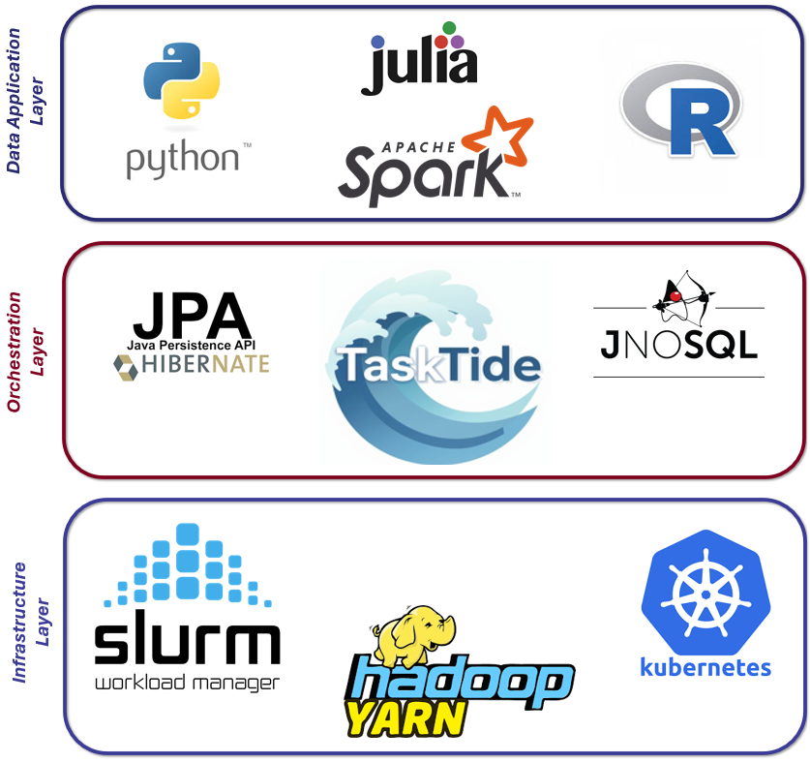

Figure 1: Shows the positioning of the TaskTide Orchestration Layer System. This middleware sits between customer Data Application Layer development and Infrastructure Layer execution. Mediating the session-less scale-out of DALS instance across heterogeneous Infrastructure Layer as demonstrated select use cases at “tasktide.org/use-cases”.

Figure 2: TaskTide Operating Principle
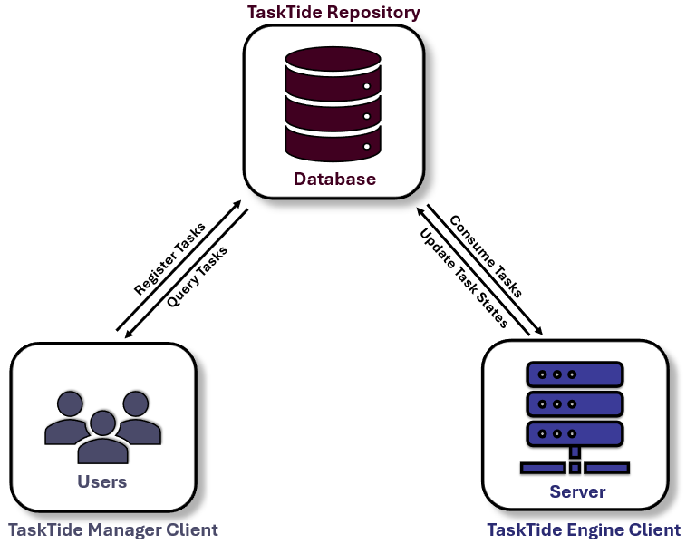

Figure 2: Shows the Producer-Consumer operating principle of the TaskTide workflow engine. 1). The TaskTide Manager command-line client is the interface where users register and query their tasks across user-defined workflows. 2). The TaskTide Repository is the ambassador interface which manages the storage/retrieval of tasks and persists its data to the configured backend database (NoSQL, or SQL). 3). The TaskTide Engine command-line client consumes the required task set or sets of tasks.

Figure 3: TaskTide Architecture
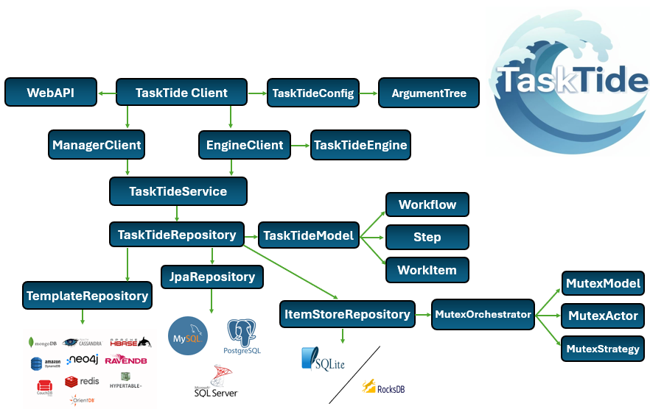

Figure 3: Shows the architecture of the TaskTide Workflow Orchestration Engine.

Figure 4: TaskTide WorkItem Lifecycle
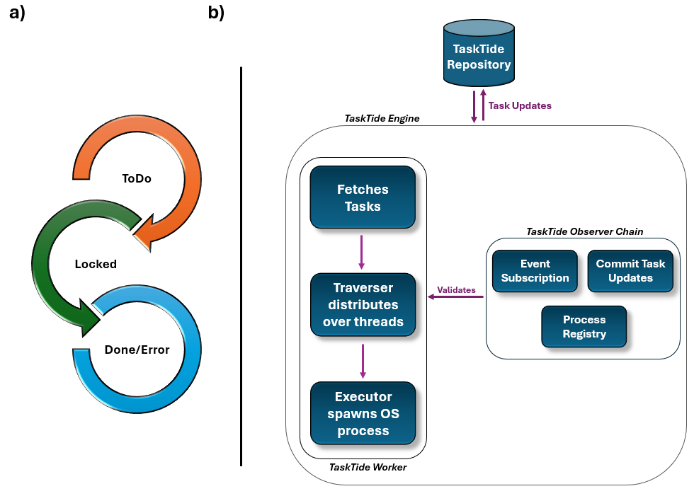

Figure 4: Shows the persistent lifecycle of tasks registered in TaskTide (6-a) which is enacted by the TaskTide-Engine (6-b). 1). The TaskTide-Engine fetches the configured workload from the TaskTide Repository. 2). The TaskTide Engine Worker distributes available tasks across configured thread pools for parallel processing. 3). The TaskTide Engine Executor instances spawn OS processes for task execution and exposing data model identifier as environmental variables for tasks to use. 4). The TaskTide Engine Observer Chain subscribes to key lifecycle transition points (onTaskStart, onTaskProcessing, onTaskEnd) and performs related task validation (6-a).

Figure 5: Mapping TaskTide to the Pilot Job Abstraction
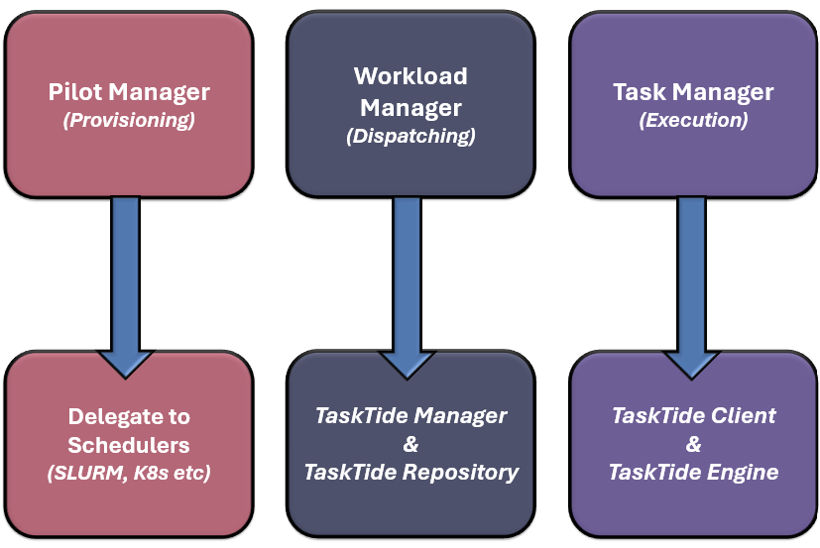

Figure 5: Shows how TaskTide’s session less internals map to the pilot-job abstraction. 1). Pilot Provisioning is delegated to the underline platform as task tracking is more relevant for TaskTide (DALS intent) than a given job (ILS chore). 2). Workload Management is implemented by the TaskTide Repository where the configured database acts as the single source of truth for task lifecycle management and where binding semantics are expressed. 3). Task Execution is performed by instances, or fleets of the TaskTide Engine client where the engine polls available tasks from configured/arbitrary collections, executes their units of work, feeding back updates observed across the execution process in real-time (ex. logs, current and completed state).

Figure 6: High Level Development Approach
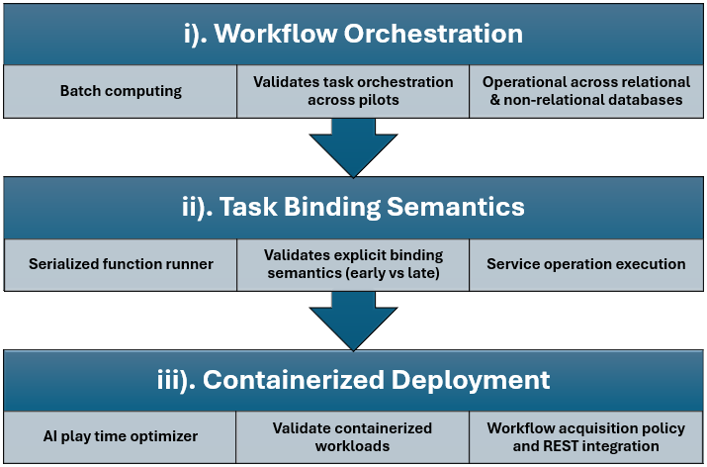

Figure 6: Iterative and incremental development approach of TaskTide. Each stage had key deliverables which were supported by their use-case implementation. 1). Workflow Orchestration was verified using bioinformatic pipelines. 2). Task Binding Semantics were explicitly verified using a serialized Julia function runner for early task binding, and SparkR image analysis application for late task binding. 3). Containerized Deployment was verified using an AI play time optimizer Python application.

Table 1: TaskTide Feature Summary
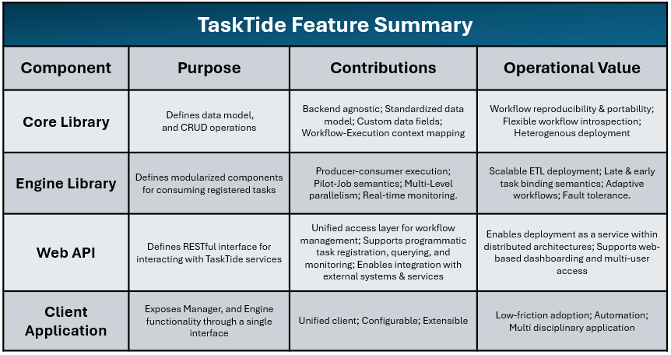

Table 1: Summaries the feature contributions of TaskTide’s modules and translates these features to their operational value.

Table 2: TaskTide Configurations
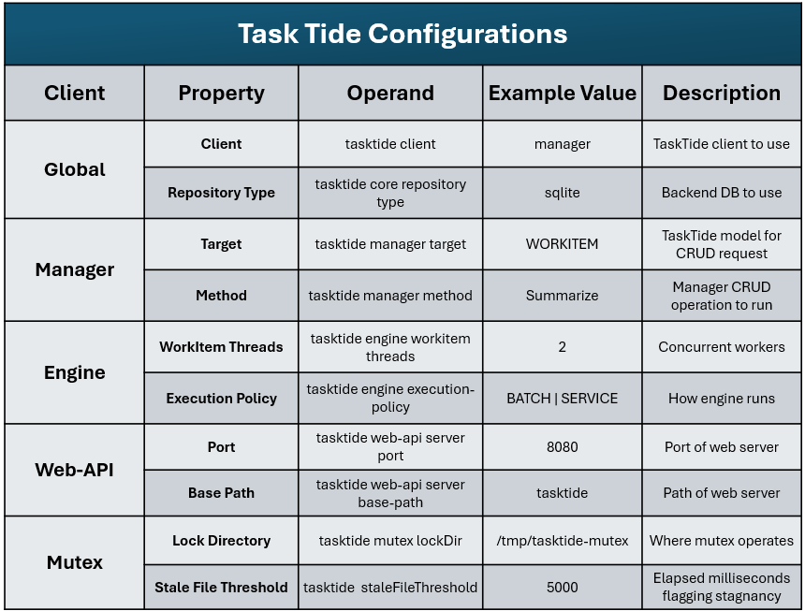
Table 2: Example set of TaskTide Client Configuration propertiest.

Table 3: TaskTide Resources
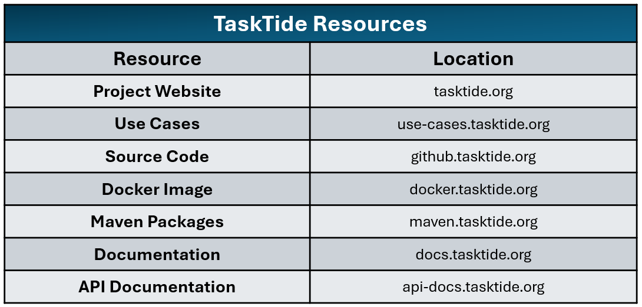

Table 3: Summarizes the primary TaskTide Resources. High-level resources provide project overviews and representative use-cases for prospective users, while technical resources provide source code, package dependencies, implementation guidance, deployment documentation, and API references for software developers and service providers.

