**Week 5. Bob Ross assignment.**

**1. CREATE & SUBQUERY.**

-- CREATE TABLE IF NOT EXISTS snowy

-- AS SELECT EPISODE, TITLE, MOUNTAIN, MOUNTAINS, SNOWY_MOUNTAIN, SNOW FROM bobross;

SELECT * FROM snowy;

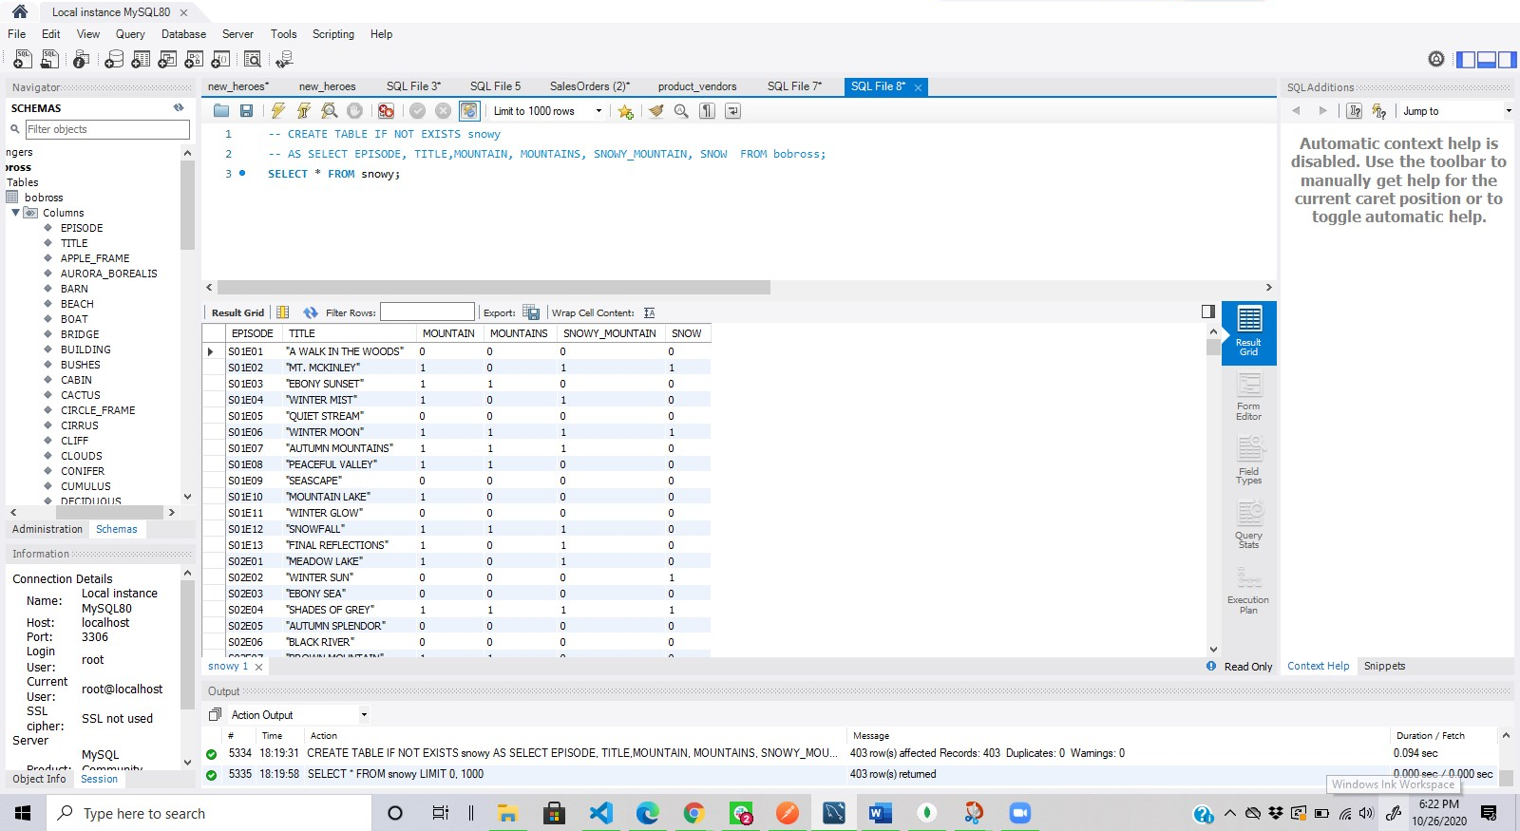

Above, I created a table with episode, title, mountain, mountains, snowy_mountain, snow, from the Bob Ross table with all the values it already has by using the subquery that selects all the rows of this column of Bob Ross.

**2. ALTER, NAME CHANGE.**

ALTER TABLE snowy RENAME snowy_mountains;

SELECT * FROM snowy_mountains;

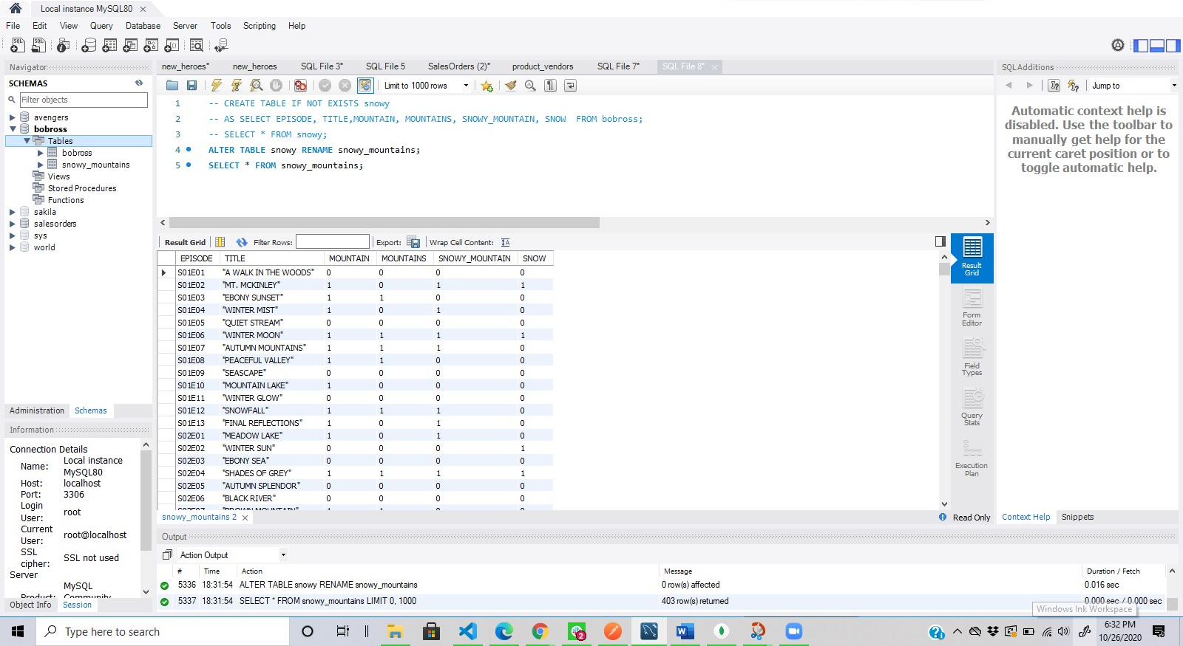

Above we are using the ALTER query to rename the table, from snowy to snowy_mountains.

**3. SET OPERATIONS (UNION ALL).**

SELECT MOUNTAIN FROM snowy_mountains

UNION ALL

SELECT SNOW FROM snowy_mountains;

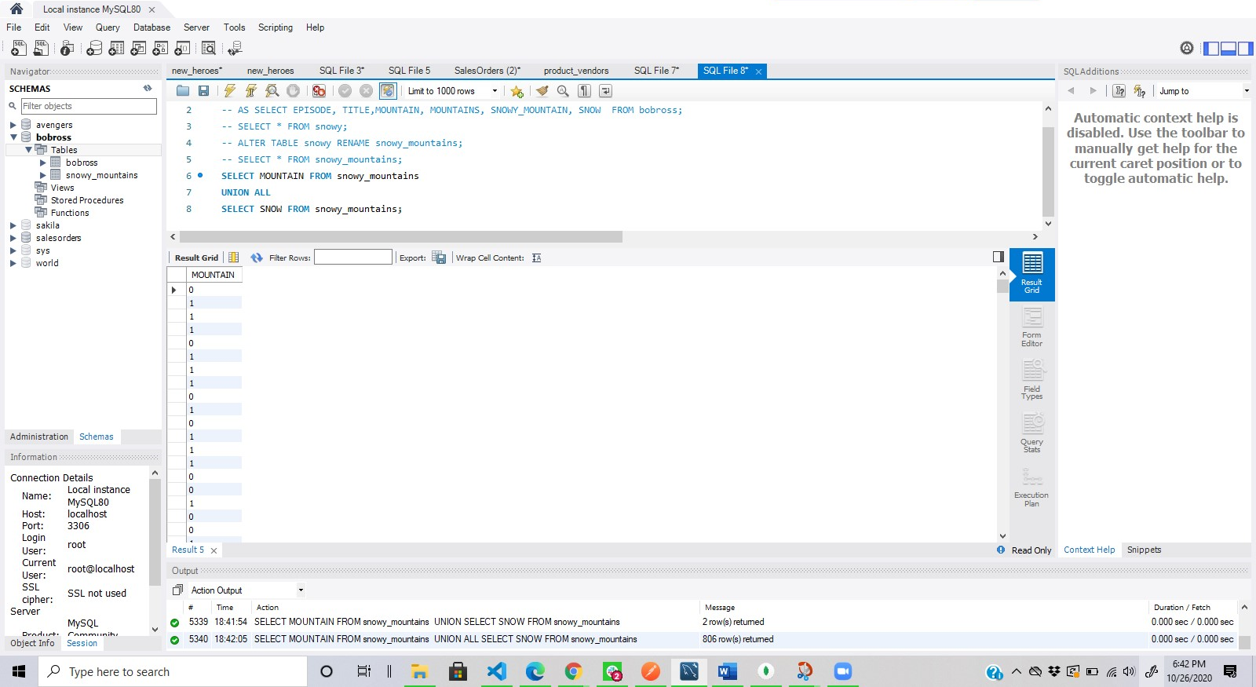

This query above, represent all the values from the MOUNTAIN & SNOW columns, from the snowy_mountain table. Since its UNION ALL it brings all the values in a single column even the repeated ones.

4.