Brenda Guadalupe Flores Parada

A01206527

Final Project

My Medical Assistant

**Introduction**

The following text aims to describe the process by which the project called "My medical assistant" was carried out, as well as the obtained results. The project was carried out by Brenda Flores Parada as a final project for the Programming Languages course. It was programmed in Prolog language.

**Problem**

In recent years artificial intelligence has been gaining importance, researchers are looking for ways to make agents that can replace some human-made activities. This project tries to represent the work made by a doctor, in a simple way.

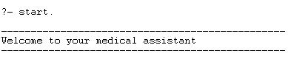**Solution**

"My medical assistant" was created with the desire to create an agent that could diagnose a patient's illness. My medical assistant is a chatbot that asks you a couple of questions and tries to diagnose your disease, based on the symptoms that you have.

As a first version, it has a dataset of 14 common diseases:

* Cold
* Asthma
* Influenza
* Bronchitis
* Gastritis
* Colitis
* Sinusitis
* Pneumonia
* Arthritis
* Lupus
* Depression
* Hypertension
* Diabetes
* Anxiety state

The diseases and symptoms were retrieved from a dataset based on patient’s diseases at the New York Presbyterian Hospital admitted during 2004.

Go to <http://people.dbmi.columbia.edu/~friedma/Projects/DiseaseSymptomKB/index.html> for more information.

My medical assistant was programmed in Prolog, but why Prolog and no other language?

Prolog belongs to a functional paradigm that allows you to declare facts that can be used later in your calculations. A fact consists of a particular item or a relation between items. I decided to used prolog because of the simple and easy way to declare rules, in my case to declare diseases and symptoms. Having the set of common diseases and symptoms is easier to diagnose the patient's disease.

Remember that the project is trying to represent the work made by a doctor, however it does not have the precision that a doctor can give you in a medical prescription.

**Results**

The following images were captured from a real test with people that had a disease, those people went to the doctor before using the application.

For the first test, My medical assistant diagnosed the correct disease. Rebeca had a common cold.

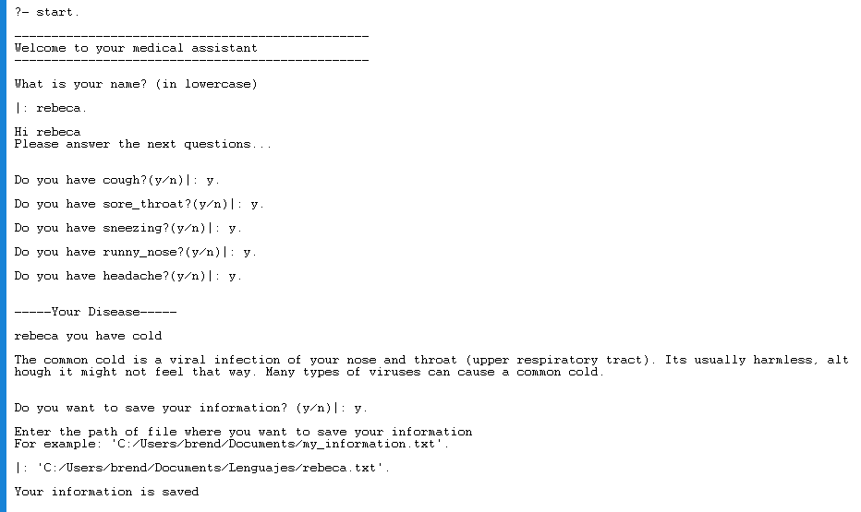

For the second test, My medical assistant also diagnosed the correct disease for Beatriz.

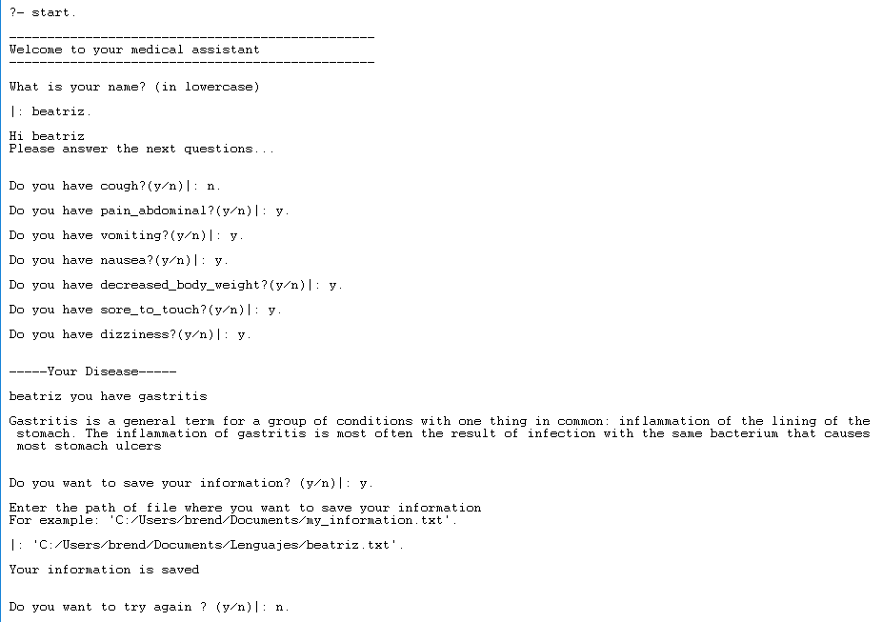

For the third test, My medical assistant diagnosed Gastritis but when Fernanda went to the doctor he said that she had kidney infection, so the diagnostic from the bot was incorrect.

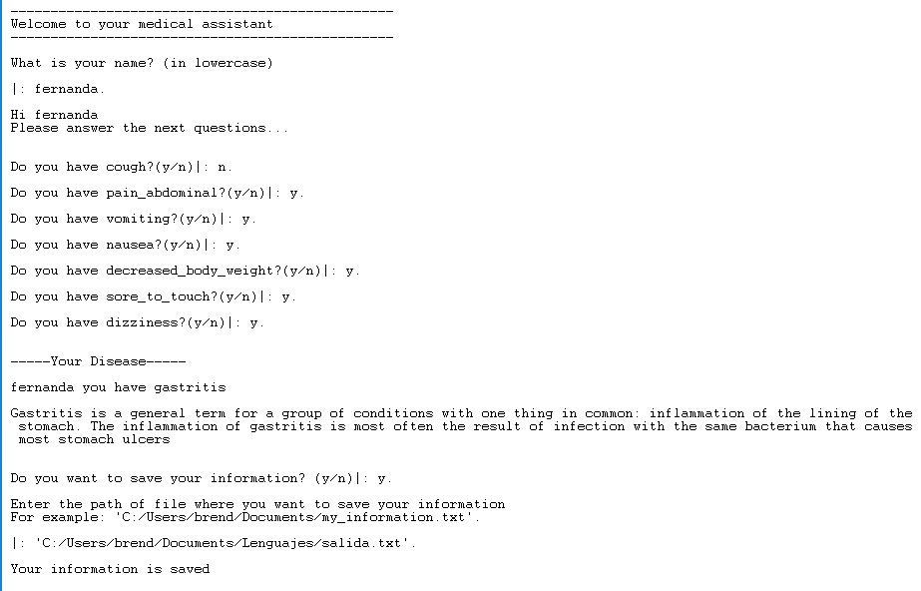

The symptoms for kidney infection are the following:

* Fever
* Back pain
* Abdominal pain
* Frequent urination
* Burning sensation or pain when urinating.
* Nausea
* Vomiting
* Sore to touch

As you can see gastritis and kidney infection have similar symptoms, so the bot diagnosed the wrong disease. The advantage of going to the doctor is that he can inquire into all the symptoms that the patient has, and the bot only processes the information according to what it knows from the given dataset.

Another approximation for the solution could be using machine learning, but this project is just a simple application using facts and rules.

**Conclusions**

Replace the work done by humans is something that some researchers try, however so far there are still professions that even with the best artificial intelligence cannot be replaced, an example of it is a doctor.

**Setup instructions**

You need to have ‘SWI-Prolog’ installed in your computer. Go to <http://www.swi-prolog.org/download/stable> for more information.

Go to <https://github.com/BrendaFP/MyMedicalAssistant> and clone or download the repository.

Go to the path where you have the file and open it using SWI-Prolog.

Now you must have a terminal opened from SWI-Prolog.

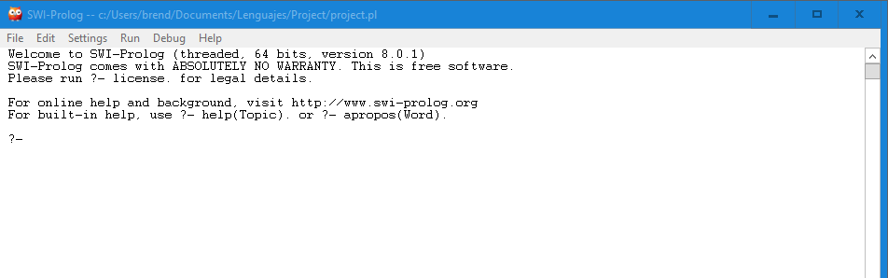

To run the application just enter “ start. ” in the terminal.

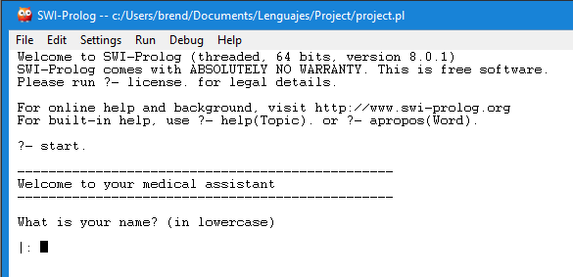

Now you are ready to start with your diagnose.

References

Mayo Clinic (2019) Kidney infection. Retrieved from <https://www.mayoclinic.org/diseases-conditions/kidney-infection/symptoms-causes/syc-20353387>

MedicineNet (s.f.) Diseases and Conditions Index. Retrieved from <https://www.medicinenet.com/diseases_and_conditions/article.htm>

Mayo Clinic (2019) Common cold. Retrieved from https://www.mayoclinic.org/diseases-conditions/common-cold/symptoms-causes/syc-20351605

MedicalNewsToday (2018) What is asthma? Retrieved from https://www.medicalnewstoday.com/articles/323523.php

WebMD (2017) What is influenza? Retrieved from https://www.webmd.com/cold-and-flu/qa/what-is-influenza

Columbia (s.f.) Disease-Symptom Knowledge Database. Retrieved from http://people.dbmi.columbia.edu/~friedma/Projects/DiseaseSymptomKB/index.html

MedicineNet (s.f.) Colitis. Retrieved from https://www.medicinenet.com/colitis/article.htm

Mayo Clinic (2019) Gastritis. Retrieved From https://www.mayoclinic.org/diseases-conditions/gastritis/symptoms-causes/syc-20355807

NHS Inform (2019) Sinusitis. Retrieved from https://www.nhsinform.scot/illnesses-and-conditions/ears-nose-and-throat/sinusitis

Healthline (2017) All About Pneumonia and How to Treat It Effectively. Retrieved from https://www.healthline.com/health/pneumonia

Healthline (2017) Arthritis. Retrieved from https://www.healthline.com/health/arthritis

MedicalNewsToday (2018) What is lupus? Retrieved from https://www.medicalnewstoday.com/articles/323653.php

American Psychiatric Association. (s.f.) What is Depression? Retrieved from https://www.psychiatry.org/patients-families/depression/what-is-depression

MedicalNewsToday (2018) Everything you need to know about hypertension. Retrieved from https://www.medicalnewstoday.com/articles/150109.php

NIH (2017) What is Diabetes? Retrieved from https://www.niddk.nih.gov/health-information/diabetes/overview/what-is-diabetes