Observations of inter-pack conflict in adjoining dingo packs, followed by a period of pack instability

Authors

Brendan F. Alting1, Benjamin J. Pitcher2,3, Michelle L. Campbell-Ward2, 4, Neil. R Jordan1,2*

*Corresponding author. neil.jordan@unsw.edu.au

Affiliations

1. Centre for Ecosystem Science, School of Biological, Earth and Environmental Sciences, University of New South Wales (UNSW) Sydney, NSW, Australia.

2. Taronga Institute of Science and Learning, Taronga Conservation Society, Dubbo and Sydney NSW.

3. School of Natural Sciences, Faculty of Science and Engineering, Macquarie University, Sydney, NSW.

4. Sydney School of Veterinary Science, Faculty of Science, The University of Sydney, Camden, NSW 2570, Australia

Author contributions

BA designed the study, conducted fieldwork, completed data analysis, and wrote the manuscript. BP, MC and NJ conducted fieldwork, and wrote and edited the manuscript.

Abstract

Using a combination of direct on-ground sightings and camera trap data, we report on the behaviours of dingoes from two neighbouring packs in Myall Lakes National Park following the death of two males from one pack due to inter-pack conflict, followed soon after (one-month) by the death of the dominant male (one of the original aggressors) from an adjacent pack. The two packs occupied contiguous non-overlapping territories prior to the inter-pack killing. A period of territorial realignment followed this, in which members of each pack were seen in adjacent territories, forming new breeding pairs. Following the breeding season, and a period of approximately six-weeks, territories stabilised and were similar to pre-conflict territories. Understanding territorial behaviours in dingoes, particularly in response to the deaths of breeding individuals, may help to identify dingo responses to lethal control – a widespread management technique in Australia, the social consequences of which are sometimes debated.

Introduction

In some canids, ranging increases prior to and during the breeding season, and conflicts between adjacent packs can occur (Gese 2001). Inter-pack conflicts can be difficult to observe however, particularly for wide-ranging and cryptic species (Jordan *et al.* 2017) and anecdotal observations can assist in the accumulation of meaningful data (Cassidy *et al.* 2015). Dingoes (variously referred to as *Canis dingo*, *Canis familiaris*, *Canis lupus dingo*, amongst others) are a territorial social canid, with family groups or ‘packs’ centred around a dominant pair, which breed annually from March to June (Thomson 1992). The rest of the pack consists of some offspring born in previous years that remain in the natal pack for some time, and assist in rearing additional litters in subsequent years and may also have litters of their own (Tatler *et al*. 2021). In undisturbed populations, dingo territories are clearly defined, with limited spatial overlap between packs (Thomson 1992). How territoriality manifests during the breeding season is unclear for dingoes, as aggression between packs is rarely witnessed directly (Thomson 1992).

Here we describe dingo movements that occurred after three male dingoes (one dominant, two subdominants) from a pack were observed killing two males (one dominant, and one subdominant), from a neighbouring pack. We also report a third killing of another dominant male dingo one month after the initial event. The initial event was witnessed and filmed by local land managers. Here we utilise a camera trap array that we had deployed across the landscape before and after the inter-pack conflict to identify any broad changes in movement and space use for each pack member. We also observed and report scent marking behaviours from these adjacent packs, which suggest dominance changes between individuals, along with reproductive events witnessed by local managers. Given the prevalence of lethal control of dingoes in Australia, how dingo packs respond to the death of dominant pack members is of interest.

Methods

These observations are from the Great Lakes region of the mid-coast of Eastern Australia (centred on 32.492° S, 152.343° E). Approximate dingo pack territories were known from GPS collar data collected from an individual resident in each of two adjacent dingo packs, collared in the previous year (Figure 1). On ground observations from researchers and local managers also corroborated dingo pack structures leading up to the inter-pack killing. The packs in this area have been under study since 2019, and each individual in both packs involved was previously known to researchers.

Twenty-one trail camera stations (two cameras per station, Reconyx Hyperfire) were deployed as part of a broader dingo population survey from December 2021-June 2022 (Alting *et al.* 2024). Cameras were positioned ~2000m apart, one on either side of a trail or road facing inwards, secured to trees approximately ~50cm off the ground to capture both flanks of the dingo (Gabriele-Rivet *et al.* 2021). Cameras were set to take 3 images per burst, with no trigger delay and set to medium-high sensitivity. Image processing and dingo identification was done according to methods laid out in Alting *et al.* (2024), with dingoes identified using their unique sock patterns and other distinctive marks. All nighttime images and any daytime images where individuals could not be identified were discarded. Dingoes from these two packs were detected at 14 of the 22 camera stations.

We defined the period “before” the pack disruption as 12/02/22- 26/03/2022 (42 days), the period “during” the conflict as 27/03/2022-08/05/2022 (42 days), and “after” 09/05/2022-31/05/2022 (22 days), as the camera survey ended after this point. The start and end dates of the ‘during’ period are when the two dingo incidents occurred. We recorded if dingoes from each pack were detected within their range, or outside of their range, for each of these three time periods, and then calculated the proportion of detections within each of these zones. We ran a binomial test of proportions to identify if detections inside and outside home range differed before, during or after the conflict

Ten additional cameras (Browning strike force HD pro) were also deployed at specific marking sites within the Myall Lakes region (Alting *et al.* in prep). Cameras were positioned high in trees to avoid theft as they were located in conspicuous areas, primarily junctions of trails and roads. Cameras were set to record videos for 30s, with no trigger delay and set to high sensitivity. Marking site videos were processed manually by one researcher, and individual dingo detections and scent marking behaviours such as urinations, ground rakes and defecations were recorded in a spreadsheet. We report observations of behaviours from dingoes at one of these sites.

Results and discussion

Pack structure and demographics are outlined in Table 1. 3/9 individuals in the two packs are of known origin. UOM2001 and UOM2002 had been seen as juveniles with the dominant adults in the MB pack, but parentage was never confirmed and these individuals may have been adopted from another litter (MLDP unpublished data). The three subdominant individuals in the SL pack were all confirmed pups of the dominant female SLF1501, and presumed to be fathered by the dominant male PCM1601.

*Table 1: Summary of pack structures for two adjacent dingo packs in the Myall Lakes region from the mid-coast of NSW, Australia, both before and after a conflict between the packs and the deaths of three dingoes. - = killed in conflict, + = immigrated/emigrated and assumed dominance in new pack, * = dispersed/not seen again.*

|  |  |  |  |
| --- | --- | --- | --- |
| Pack | Status | Pre conflict pack members | Post conflict pack members |
| SL | Dominant | SLF1501, PCM1601- | SLF1501, UOM2002+ |
| Subdominant | SLM2005-, SLF2001*, SLF2003* | None |
| MB | Dominant | UOF1801, UOM1701- | UOF1801, UOM2001+ |
| Subdominant | UOM2001, UOM2002+ | None |

On 27/03/2022, three male dingoes from the MB pack: UOM1701 (dominant), UOM2001 (subdominant), UOM2002 (subdominant), were observed killing the dominant male of the SL pack, PCM1601. A subdominant male SLM2005, also from SL pack, was later found dead nearby, and assumed killed in the same incident. The conflict occurred on a main road at the border of these two packs’ territories (Figure 1). Both individuals died of bite wounds, and were left *in situ* by the MB pack. The dingoes did not consume the carcasses, aligning with similar findings from K’gari (Behrendorff *et al.* 2016) of intraspecific conflict, although other authors report incidences of cannibalism in dingoes (Meek and Brown 2016).

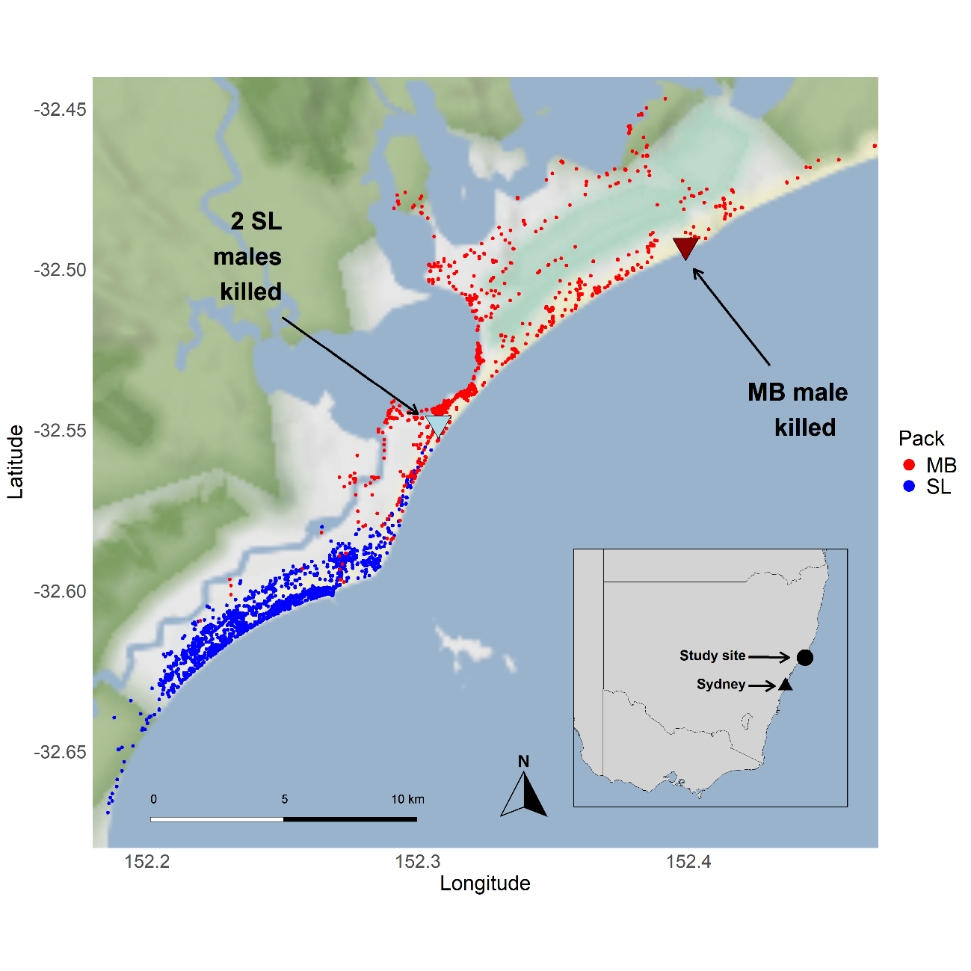

*Figure 1: GPS collar data representative of two dingo packs leading up to the deaths of two males from SL pack. MB male was killed one month later. Dots represent hourly locations, colour-coded by pack.*

We obtained 215 independent dingo detections across the relevant timeframe (Table 2). Dingoes were detected more in their home range more prior to the conflict than during or after the conflict (Table 2). From 27/03/2022 onwards, the dominant female from SL pack, SLF1501, was seen with males from MB pack eight times, six times with both UOM2001 and UOM1701 simultaneously. Dominance status amongst the males was unclear for this period, and all males were seen with the dominant females of both packs SLF1501 and UOF1801 (22 times) on separate occasions for a period of four weeks. These two females were never seen together and seemed to retain spatial segregation. The males however appeared to be in flux, alternating associations with the two females over the territorial re-establishment period. For example, UOM2002 was detected with SLF1501 once, and with UOF1801 fifteen times in the six weeks after the death of the SL males, but has subsequently not been seen with UOF1801 since, and is now paired with SLF1501 in the neighbouring territory.

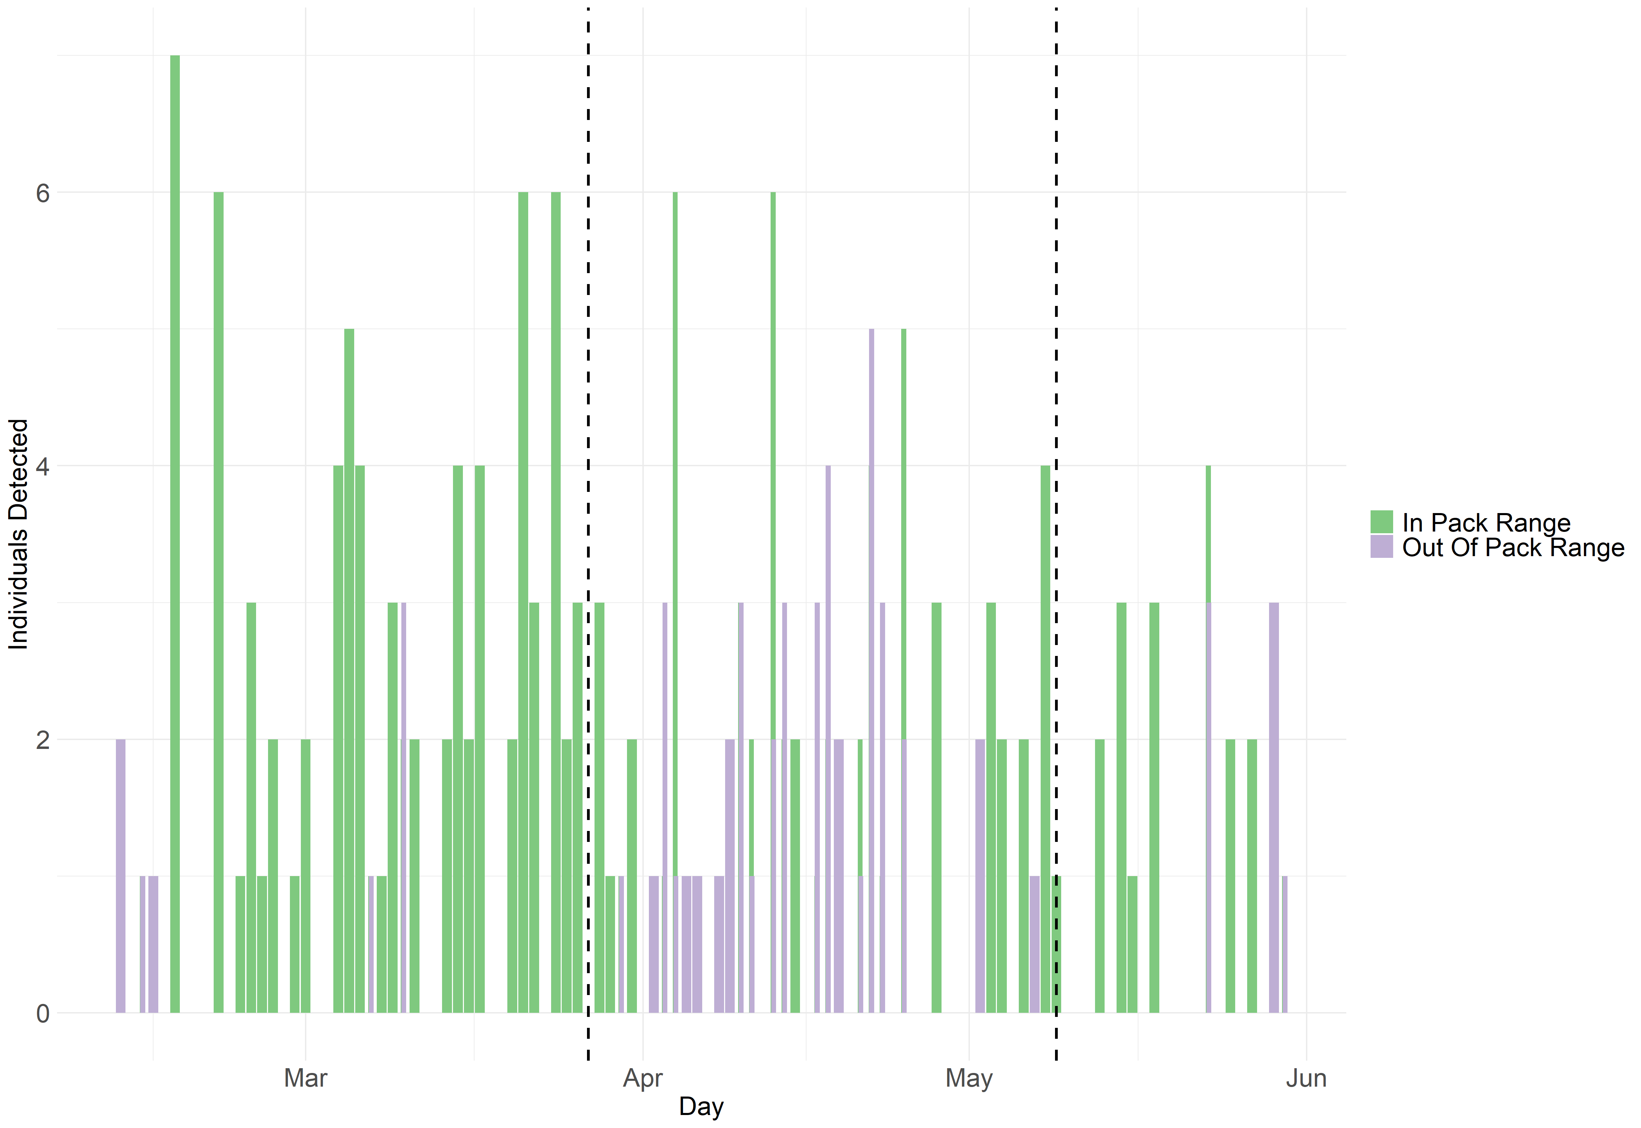

*Figure 2: Detections of nine individual dingoes (five SL pack, four MB pack) summed by day. First dotted line is the death of two males from SL pack, second dotted line is death of dominant male from MB pack. Camera survey ended 31/05/2022. Figures made in ggplot2 (Wickham 2016).*

On 18/04/2022, we recorded the SL pack dominant female SLF1501 scent marking at a marking site, with UOM2001 and UOM1701 also present. UOM2001 appeared as if interested in overmarking SLF1501s scent mark (which would be a display of pair bonding with the female), but was followed closely and seemingly aggressively by UOM1701. UOM2001 did not overmark the female, and UOM1701 finally overmarked the initial female scent instead. This is not how dominance in canids is generally displayed, however. UOM1701’s constantly vigilant behaviour around the male was unusual for a dominant dingo against a subdominant, particularly one raised by the dominant from juvenile age, and may be suggestive of a power struggle between these two individuals.

*Table 2: Summary statistics and binomial test of proportions of total dingo detections from two packs inside and outside their home range for each time period (before conflict, during conflict, after conflict), with a binomial test of proportions. A 50/50 ratio of detections inside and outside home range would indicate no territoriality (random), while more detections inside home range indicates territoriality.*

|  |  |  |  |  |  |
| --- | --- | --- | --- | --- | --- |
| Period | Detections in home range | Detections outside home range | Proportion in home range (%) | Proportion outside home range (%) | Binomial test of proportions (likelihood different from proportion =50%) |
| Before conflict | 80 | 8 | 90.9 | 9.1 | p<0.001 |
| During conflict | 58 | 43 | 57.4 | 42.6 | p=0.16 |
| After conflict | 19 | 7 | 83.3 | 16.7 | p=0.03 |

On 09/05/2022, the research team received reports of a dead dingo on the beach within the MB pack’s pre-conflict range (Figure 1), with bite wounds to the neck, consistent with a dingo attack (Behrendorff *et al*. 2018). This was confirmed to be individual UOM1701, although which dingo or dingoes killed this male is unclear. It seems most likely that he was killed by one of either UOM2001 or UOM2002, as both of these dingoes lived after this point and became dominant in two different packs, also noting the aggressive encounter observed at the scent marking site between UOM2001 and UOM1701.

After this, the pack structures restabilised. UOM2002 and SLF1501 formed the dominant pair in the SL pack, and UOM2001 and UOF1801 formed the dominant pair in the MB pack. Both of these pairs continue to be dominant in their packs at the time of writing (November 2024). Both the SL and MB packs reverted to their pre-conflict home ranges, and the ranges have remained stable since. This hints that females are familiar with the territorial borders and may be the ones ‘determining’ where to range (Johansson *et al.* 2018), although this phenomenon is understudied and requires further research.

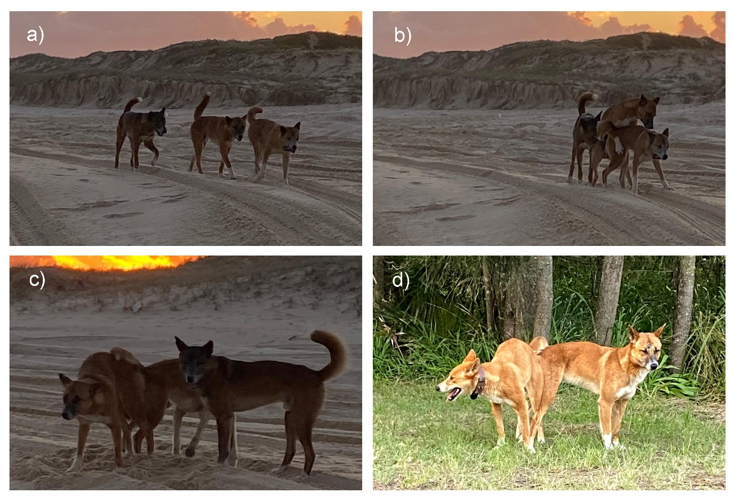

*Figure 3: Instances of dingoes breeding during a period of territorial re-adjustment post inter-pack conflict. 21/04/2022: UOM2001 (previously subdominant in MB pack) was filmed breeding with SLF1501 (dominant in SL pack) (3a,3b,3c) while UOM1701 (previously dominant in MB pack) is present, in SL territory. 19/05/2022: UOM2001 breeding with UOF1801 (dominant in MB back) (3d), in MB territory. Photo credit Nick Patteson.*

Each of UOM2001, UOM2002 and UOM1701 were observed mating with the female SLF1501 during the period of territorial re-establishment. On 21/04/2022, UOM2001 (previously subdominant) was observed breeding with SLF1501 while UOM1701 (previously dominant) was present, indicating a shift of dominance (Figure 3a;3b;3c). SLF1501 had a litter of pups that year, although the paternity of this litter is unknown. UOM2002 helped to rear these pups, perhaps highlighting a benefit of confusing paternity for female dingoes (Macdonald *et al*. 2019). SLF1501 also had litters in 2023 and 2024, and UOM2002 is suspected to be the father of these individuals as no other males have been seen with SLF1501. The potential costs of rearing a litter that was not definitely his offspring were perhaps negated by the fact that he successfully raised litters in future years, as a direct result of attaining dominance status in the SL pack. Additional individuals within a pack may also benefit territory holders if there are sufficient resources to support them, as larger packs generally win in conflicts between packs (Cassidy *et al.* 2015).

On 19/05/2022, UOM2001 was also pictured breeding with UOF1801 (Fig 3d), although she did not have a litter that year, or indeed any subsequent years (5 breeding seasons).

This pattern of behaviour and territorial re-alignment may not be representative of all dingo packs following the death of dominant individuals, but does provide valuable insights into a likely common but little studied phenomenon. The process for example may differ if dominant females had been killed. That territorial borders remained the same before and after the event may imply some female control of territorial demarcation. Understanding how pack dominance status and territorial establishment in dingoes’ manifests requires further study.

**Acknowledgements**

The Myall Lakes Dingo/Dapin Project takes place on Worimi Country and we acknowledge the Worimi people, past and present, and their historical and ongoing connection to dingoes and Country. This project received funding and support from Taronga Conservation Society Australia, National Parks and Wildlife Service NSW, and MidCoast Council, and was also supported by a UNSW Research Technology Services (ResTech) AWS cloud grant. All work was conducted under scientific licence SL102716 and approval 22/102A from the UNSW Animal Ethics Committee. Thank you to Fiona Miller and NSW NPWS for loaning camera traps. We thank Oliver Macdonald for contributing to dingo identification, and to Dan Morris for extensive help with Megadetector image processing. Thanks to Simon Gorta, Jana Stewart, Henry Mason, Jonathon Mifsud, Daphne Willemsen, Baptiste Wijas, Georgia Dorahy, Martín Boer-Cueva, Dushmantha Gamage, Therese Alting and Mike Ticher for fieldwork assistance

**References**

Alting, B. F., Pitcher, B. J., Rees, M. W., Ferrer-Paris, J. R., & Jordan, N. R. (2024). Population density and ranging behaviour of a generalist carnivore varies with human population. *Ecology and Evolution*, 14, e11404. https://doi.org/10.1002/ece3.11404

Alting, B.F., Pitcher, B.J., Jordan, N.R. (2024) Dingo Visitation and behaviour at long-term scent-marking sites varies by sex and season. Manuscript submitted for publication.

Behrendorff, L., Belonje, G. & Allen, B. L. (2018). Intraspecific killing behaviour of canids: how dingoes kill dingoes. *Ethology Ecology & Evolution* 30(1): 88-98. <https://doi.org/10.1080/03949370.2017.1316522>

Cassidy, K.A., MacNulty, D.R., Stahler, D.R.,Smith, D.W., Mech, D.L (2015) Group composition effects on aggressive interpack interactions of gray wolves in Yellowstone National Park, *Behavioral Ecology*, 26(5): 1352 - 1360, <https://doi.org/10.1093/beheco/arv081>

Gabriele-Rivet, V., Arsenault, J., Brookes, V. J., Fleming, P. J. S., Nury, C., & Ward, M. P. (2020). Dingo density estimates and movements in equatorial Australia: Spatially explicit mark–Resight models. *Animals*, **10**(5), 865. doi: [10.3390/ani10050865](https://doi.org/10.3390/ani10050865)

Gese, E. M. (2001). Territorial defense by coyotes (Canis latrans) in Yellowstone National Park, Wyoming: Who, how, where, when, and why. *Canadian Journal of Zoology,* 79(6): 980-987. <https://doi.org/10.1139/z01-054>

Jordan, N.R., Buse, C., Wilson, A.M. *et al.* (2017) Dynamics of direct inter-pack encounters in endangered African wild dogs. *Behav Ecol Sociobiol* 71, 115. https://doi.org/10.1007/s00265-017-2338-9

Johansson, Ö., G. Koehler, G. R. Rauset, G. Samelius, H. Andrén, C. Mishra, P. Lhagvasuren, T. McCarthy, and M. Low. (2018). Sex-specific seasonal variation in puma and snow leopard home range utilization. *Ecosphere* 9(8): DOI:[10.1002/ecs2.2371](http://dx.doi.org/10.1002/ecs2.2371)

Macdonald, D.W., Campbell, L.A., Kamler, J.F., Marino, J., Werhahn, G. and Sillero-Zubiri, C., (2019). Monogamy: cause, consequence, or corollary of success in wild canids *Frontiers in Ecology and Evolution* *7*, p.341. <https://doi.org/10.3389/fevo.2019.00341>

Meek, P.D. and Brown, S.C., (2016). It’s a dog eat dog world: observations of dingo (Canis familiaris) cannibalism. *Australian Mammalogy* *39*(1), pp.92-94. https://doi.org/10.1071/AM16018

Tatler, J., Prowse, T.A., Roshier, D.A., Cairns, K.M. and Cassey, P., (2021). Phenotypic variation and promiscuity in a wild population of pure dingoes (Canis dingo). *Journal of Zoological Systematics and Evolutionary Research*, *59*(1), pp.311-322. [**https://doi.org/10.1111/jzs.12418**](https://doi.org/10.1111/jzs.12418)

Thomson PC (1992) The behavioural ecology of dingoes in north-western Australia. II. Activity patterns, breeding season and pup rearing. *Wildlife Research* **19**, 519-529. https://doi.org/10.1071/WR9920531

Wickham H (2016). *ggplot2: Elegant Graphics for Data Analysis*. Springer-Verlag New York. ISBN 978-3-319-24277-4, [https://ggplot2.tidyverse.org](https://ggplot2.tidyverse.org/).