Introduction

Scent marking is ubiquitous amongst mammals, and has been observed in every carnivore species (Macdonald 1980). The roles of scent marking are varied and have been discussed extensively in the literature, with communication between individuals and groups a major unifying theme (Buesching and Jordan 2019). The ubiquity of scent marking highlights its importance in carnivore sociality, and understanding behaviours associated with it can shed light on the evolution of carnivore social behaviour. Beyond the spatial distribution of scent marking sites which have been a key focus of olfactory communication studies in the wild (Gosling and Roberts 2001), elucidating the functions of mammal behaviour and movement also requires a focus on scent marking patterns temporally, and at an individual level (Buesching and Jordan 2019).

Mammalian scent marking has been defined as the deposition of an odour by an animal through distinct behaviours such as urination, defecation, and rubbing, which occurs in specific areas or at landmarks (Kleiman 1966). Animals may scent mark to advertise territory ownership (Gosling 1982), or in reproductive competition, either by advertising their health and availability to potential mates (Gosling and Roberts 2001), or in mate guarding (Lledo-Ferrer et al. 2010). Scent marking is an efficient form of territorial advertisement, as resident individuals or groups can avoid direct confrontations with competitors (neighbours or interlopers/intruders) that could otherwise result in injury or death to either party (Gosling 1982). Indeed, scent marking may be the primary way that individuals in adjacent territories interact, as direct encounters in some territorial species can be rare (e.g. African wild dogs, *Lycaon pictus*, Jordan et al. 2017).

Territorial scent marking strategies vary by species and environmental conditions, and may result in distinct spatial and temporal patterns. While some species, such as Ethiopian wolves *(Canis simensis*), preferentially scent-mark along their territorial borders (Sillero-Zubiri and Macdonald 1998) others, such as marmosets (*Callithrix jacchus*) mark consistently throughout their territories (Lazaro-Perea et al. 1999). These spatial patterns of marking are often context dependent and vary with territory size and resources, even within the same species. For example, in spotted hyenas (*Crocuta crocuta*), when resources are plentiful, clans have smaller home ranges making a boundary scent marking strategy economically feasible (Kruuk 1972), while in areas where hyenas have larger home ranges, they scent mark throughout their territory instead, as boundary marking would be economically unviable (Gorman and Mills 1984). While the spatial distribution of scent marks has garnered much research attention, information on the spatial distribution of scents alone offers little more than an indication of the intended recipient. Rather than acting as a ‘keep-out’ signal, the scent-matching hypothesis posits that by linking scent marks deposited by a territory owner within a territory, an intruder recognises the potential costs of intruding on this territory (Gosling 1982). Given the resident’s past investments in marking and defending that territory – regardless of whether it is on the territory border or spread within it - the presence of their scent is an honest signal of their willingness to defend the territory (Gosling and Roberts 2001).

While territorial advertisements are clearly important, in some mammalian species scent marking can increase around key breeding periods (Gese and Ruff 1997), suggesting a direct role in mate choice or mate defence, particularly in species that hold territories year-round. Some scent marks are honest signals of individual health (Zala et al. 2004) and status (Gosling and Roberts 2001), potentially allowing animals to evaluate the quality of potential mates prior to breeding (Hurst and Beynon 2004). Further, different chemical signals in female scent marks may serve to signal sexual receptivity (Coombes et al. 2018). For species with distinct annual breeding periods, this information can be invaluable, as opportunities to breed are seasonally limited (Macdonald et al. 2019), particularly in the context of an animal’s potentially short lifespan (Oakwood 2000). This helps to explain why scent marking behaviour increases in reproductive periods, and suggests that scent marking serves multiple purposes that are likely not limited to territorial – or at least spatial - defence in many species.

Discerning the function or functions of scent marking is difficult when processes of territoriality and reproduction are often linked (Macdonald et al. 2019). Territoriality, while often proposed to be involved in resource defence, may itself function to protect reproductive opportunities for territorial individuals. In Iberian lynx (*Lynx pardinus*), dominant territorial males were the only confirmed fathers of litters born within their territory (Palomares et al. 2017). Male lions (*Panthera leo*) only breed when they are within a pride, and will defend their territories from other males (Packer et al. 1990). Indeed, infanticide of cubs is common when male lions take over a pride from a resident coalition (Packer and Pusey 1983), demonstrating the importance of territoriality and tenure (Dejeante et al. 2024). In some species however, females are more territorial and males play ‘floating’ roles, breeding with as many females as possible in the breeding season (e.g. spotted-tailed quolls, *Dasyurus maculatus*) (Jones et al. 2001). The varying purposes of territorial behaviour in different species provide important context for why species scent marking patterns differ (Christensen and Radford 2018).

The fine-scale attributes of scent marking may shed further light on its function(s). Species often exhibit sex-specific behavioural differences at scent marking sites (Claase et al. 2024). In territorial species with high reproductive skew and in which dominant pairs monopolise, or attempt to monopolise breeding (Bell et al. 2014), the importance and prevalence of tandem marking, in which two opposite sex individuals both scent mark, has been well established, such as in meerkats (*Suricata suricatta*) (Jordan 2007) and coyotes *(Canis latrans)* (Gese and Ruff 1997). In some species, such as African wild dogs, scent marks deposited by an individual are often ‘overmarked’ by another, usually a male, with that individual leaving a scent mark on top of the previous individual’s scent (Jordan et al. 2014). Overmarking between mated pairs has been studied extensively in rodents, and in some cases may serves to mask the scent of the other paired individual (e.g. golden hamsters, *Mesocricems auratus*, Johnston et al. 1994). This behaviour has been observed in coyotes, and may represent a form of mate guarding, in which one individual, usually the male, attempts to conceal the mark of the other (Gese and Ruff 1997). The order of scent placement, too, has been shown to be important, with scents deposited most recently given more attention in a number of mammal species (Johnston et al. 1997; Fisher et al. 2003). Finally, overmarking may combine the scents of the individual members of a dominant pair, advertising to adjacent packs and intruders the presence of a breeding pair in a territory (Jordan et al. 2016), although this theory has less empirical support (Ferkin and Pierce 2007).

Canids (species in the family *Canidae*) are a group of territorial mammalian carnivores, with representatives on most continents (Bateman and Fleming 2012). Canid species broadly share similar reproductive strategies, with a dominant pair in a pack reproducing once in a year, and the remainder of the pack composed of offspring from previous years and some pups (Lord et al. 2013). Canids are highly territorial, and the reasons for this have been discussed extensively in the literature (Macdonald et al. 2019). As a purportedly monogamous group (although extra-pair paternity is increasingly being identified among many species, such as Arctic foxes (*Vulpes lagopus*) (Cameron et al. 2011), African wild dogs (Spiering et al. 2010) and Ethiopian wolves (*Canis simensis* (Randall et al. 2007)) both the dominant male and female contribute to territorial defence. Females of some species are often suggested to hold territories to protect resources that will then be available to rear offspring (Körtner et al. 2004). For males, however, territoriality may serve primarily to aid in mate guarding females (Clutton-Brock 1989). Initial male energy investment in offspring production is low relative to the costs borne by females, but consequentially males can never be completely sure of the paternity of offspring (Baker et al. 2004), while females have certainty that their offspring are genetically theirs. In many species, mixed paternity litters occur, and for dominant males this represents a significant fitness loss, as they may rear dependent young that may not be their offspring or the offspring of closely related males (Macdonald et al. 2019). In this context, the reasons for male territorial defence are clear, as ensuring competing males do not breed with their paired female is of critical importance.

Dingoes (variously referred to as *Canis dingo*, *Canis familiaris*, *Canis lupus dingo*, amongst others), are a nominally socially monogamous canid present across most of mainland Australia (Thomson et al. 1992; Allen and West 2013). Dingoes are similar to other canids in their breeding behaviours, with packs consisting of a dominant breeding pair, their offspring from previous years, and recent pups (Thomson 1992). Extrapair paternity has also been noted in dingoes (Tatler et al. 2021). Dingoes breed once a year, and females are sexually responsive in oestrus for approximately 2 weeks, anywhere between March and May (Catling et al. 1992, Thomson 1992). Dingo packs are highly territorial, and packs are distributed across the landscape such that home ranges are effectively non-overlapping. Dingoes frequently scent mark their territory (Thomson 1992) and respond to the scents of conspecifics (Walker et al. 2024), and thus are a good model species for exploring the functions of canid scent marking behaviour.

Here we use camera trap videos positioned at known scent marking sites used by a known population of wild dingoes (Alting et al. 2024) to describe broad visitation patterns and detailed scent marking behaviour throughout the annual cycle, and potentially discern some of the roles of scent marking for a socially monogamous canid. Dingoes hold territories year-round (Thomson et al. 1996), and due to their generalist behaviour and a temperate climate in this region, food is available throughout the year. Seasonal anthropogenic food resource pulses associated with holiday periods are present, particularly in summer (Alting et al. 2024), and natural resource pulses such as washed-up seabirds on the beach can provide resources (ABC 2023), although these are infrequent and unreliable. If dingo scent-marking was exclusively related to territorial defence, we would expect year-round visitation with no seasonal peaks, and consistent scent-marking behaviour patterns throughout the year. If, however, dingoes scent mark more in the breeding and pre-breeding period than in other times of the year, then we may infer that scent marking plays a role in reproductive availability and competition for mates. Dingoes would still be expected to scent mark throughout the year if scent marks serve to advertise territories to adjacent packs (Allen et al. 1999), although potentially at lower rates outside the breeding season. Finally, we may expect different scent marking responses of males and females during the breeding season. Females may increase scent marking during the breeding season to advertise to potential mates (including intruding males and unrelated males within their pack). Male dingoes may be expected to overmark their female breeding partner to conceal the female’s scent mark (Johnston et al. 1994), or indicate a willingness to defend access to the female (Gosling and Roberts 2001). Together, these patterns would suggest that mate guarding of females is occurring for this species, as it does in some other canid species.

Methods

*Study site and dingo population*

This study was conducted in coastal New South Wales, Australia, on Worimi country in the Great Lakes region (centred on 32.492° S, 152.343° E). This area is used for multiple purposes, and consists of urban areas, private land, National Park (Myall Lakes), and Mid Coast Council managed land. Scent marking sites identified in the area all occurred on national parks estate, which is composed of woodland, coastal heath, dunes, and small patches of littoral rainforest (NSW STVM 2023). Dingoes occur throughout the study area, and pack locations and demographics have been collected since 2019. Dingo pack dynamics and resident individual animals are known and documented (Alting et al. 2024), and dingo packs in the area occupy essentially non overlapping home ranges.

*Marking site identification*

Marking sites were monitored from 2020-2023, and were initially identified using a domestic dog trained to identify dingo scent marks. The dog was taken to suspected scent marking areas, particularly at junctions of trails and roads. If the dog detected dingo scent, it would sit next to the location of the urine mark. Camera traps (Browning Strike Force HD pro) were placed on the opposite side of the trail or road, high in trees to avoid theft, and aimed at the junction, with the camera centred on the location the dog indicated had dingo scent. Initial visits by dingoes were reviewed and the positioning of cameras adjusted/refined to better centre on the areas used by the dingoes during visits. In some locations where the marking site could not be covered by a single camera’s field of view, two camera traps were placed at the site. This process occurred across Myall Lakes National Park, to obtain spatial variation in scent marking sites and to capture the behaviour from several different packs.

Cameras were set to record 30s videos, with no delay in trigger time, and high sensitivity. We aimed to service camera traps at least monthly, but covid-related lockdowns and flooding events prevented this. Consequently, cameras were serviced a mean average of every 43 days (range = 7-295). We placed cameras at 22 possible sites in total, from which 10 marking sites were identified and monitored throughout the study (mean distance between sites = 4083m (range = 1498-8072).

*Video data extraction*

Videos were downloaded and saved on a hard drive, and behaviours were recorded from them by one researcher (BA) for any dingoes detected at the sites. We recorded the number of individuals in each video sequence, and classified individuals by sex and age category (adult or juvenile, <1 year). Dingoes could usually be identified to the individual level, using a dingo identification database from the area documenting unique natural variation in sock and pelage patterns described previously (Alting et al. 2024), and this allowed accurate classification of age, sex, and pack membership. Dominants were defined as pairs seen consistently together, observed mating, or bearing pups (for females) (Gese and Ruff 1997; Mech 1999). Adult male and female dingoes very rarely associate with one another unless they are either a dominant pair, or subdominant related siblings in their natal pack (Tatler et al. 2021). Related siblings could be removed as their pack status was known as they were seen as juveniles throughout the study. Where possible, unknown individuals were sexed based on the presence of visible teats (females) or the presence of a visible penile sheath (males). Age categorisation of unknown individuals was based on size. If we were unsure of any of these, we left the value as ‘unsure.’

For specific behaviours, we recorded the specific ‘pile’ identity (a unique identifier) within each scent marking site at which scent marks occurred, the substrate on which each pile was initially placed (tree, shrub, ground, grass), the duration (seconds) of each behaviour, and whether the dingo sniffed the ground or not when at the site (sniffs required a minimum 3 seconds of nose to ground). Scent marking behaviours included sniffing a specific pile (Fig 1c) (separate to ground sniffing; nose within 5cm of pile and pointed down), urinating on a pile (either squat (Fig 1a) or raised leg (Fig 1d), defecating, and raking (Fig 1b) (repeatedly scraping the ground with its fore or hind feet). If dingoes came to a site, but did not sniff or scent mark, we recorded this as a ‘no response’ behaviour. We also recorded the duration that each individual was present in the marking site, with the start and end of the duration defined as the entry or exit of the dingo from the field of view of the cameras. Camera traps sometimes triggered after the onset of a behaviour, or stopped filming during a particular behaviour. In these instances, we transcribed the part of the event was seen, and recorded whether we missed the start, end, or both start and end of the site visit. We used events where we missed a part of the visit for temporal analysis of dingo seasonal visitations to scent marking sites, but restricted analysis of fine scale scent marking behaviours to sequences where we could identify all behaviours that occurred between the dingo or dingoes entering and exiting the site.

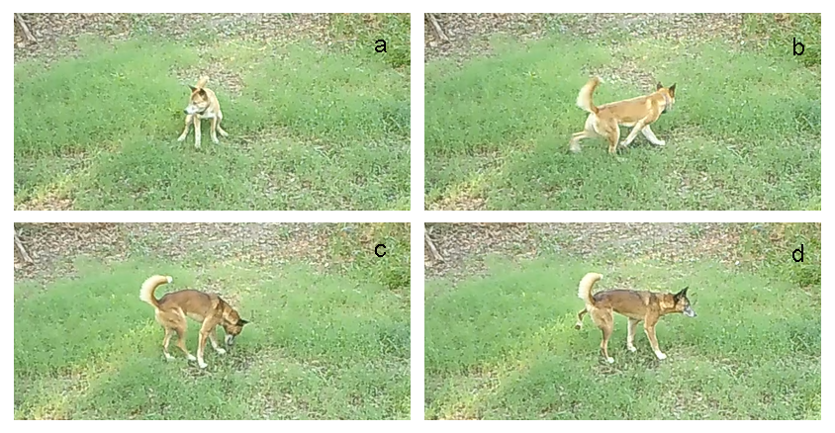

*Figure 1: Two dingoes displaying various scent marking behaviours in the Myall Lakes region of Australia. a) A female dingo performing a squat urination; b) the same female raking the ground; c) A male dingo sniffing the scent mark placed by the female in a & b; d) the same male performing a raised leg urination over the scent mark placed by the female in a & b.*

*Data analysis (seasonal patterns)*

All marking sites were not continuously monitored throughout the year, due to camera battery failure and theft. To account for missing survey effort in seasonal analysis, we assigned each day of the year as camera ‘active’ or ‘inactive.’ We then restricted data to overall independent visits (visits by any adult dingo >30 minutes apart) to scent marking sites, and counted detections per active camera trap night. We then summed data for each month of the year. Across the ten camera stations used, we obtained data from at least 2 years for every month of the year (mean active trap nights = 571.1, range = 367-889). To identify different factors associated with seasonal trends, we ran three generalised additive models (GAMs) in the *mgcv* package, which are appropriate for time series data (Wood 2017). First, we categorised each event as either including a lone adult dingo, or including dingoes in an adult pair consisting of one male and one female. We also calculated the mean duration spent at the site, for each individual dingo per visit to each site, and divided this value by ten to ensure variables were on the same scale. For GAM (a), we included the sum of visits per month as a response variable, and included total visits (lone + paired visits), only paired visits, and time spent at site, as predictor variables, and included ‘year’ and ‘site ID’ as random effects. For GAM (b), we used sum of visits per month as a response variable, and included whether a dingo ‘sniffed’ (investigated) during a visit, as a predictor variable, with ‘year’ and ‘site ID’ as random effects. Finally, for GAM (c), we used the sum of events per month as a response variable, and included counts of ‘urinations’, ‘defecations’, and ‘rakes’ as predictor variables, with ‘year’ and ‘site ID’ as random terms. For each model, we included ‘month’ with a cyclic cubic regression spline, with k=4, approximating distinct seasons in dingo behavioural ecology, and a negative-binomial distribution, suitable for over-dispersed count data (Gardner et al. 1995). To account for camera effort, for each model we summed the number of cameras that were active for each day and each month in total, and used this as an offset (log). We evaluated significance of model terms by evaluating associated p-values and estimated degrees of freedom (edf), where a higher ‘edf’ implies more curvature in the model term, and defined a significant result as one where p<0.05.

Data analysis (fine-scale behaviour)

Where a dominant pair visited a site together, we recorded and analysed their fine-scale marking behaviours. To analyse the likelihood of a dingo overmarking a scent at a pile, we calculated whether dominant dingoes marked at a pile, dependent on whether the opposite sex had marked before, and how many scent marks had previously been deposited at the pile during that visit. We ran ‘glmms’ with a binomial distribution in the R package *lme4*, with ‘over mark’ as a binary response variable (y/n), and the predictor variables ‘number of marks previously left at site’, with an interaction variable of ‘sex of marker’ and ‘sex of most recent scent mark’, for each event (Bates et al. 2015).We also included a random effect of ‘site ID’ to account for repeated measures at that marking site. We evaluated the importance of predictor variables by calculating effect sizes with 95% confidence intervals (Halsey 2019).

Finally, to examine likelihoods of each sex leaving a mark in a given order where marking occurred on a given pile at a site, we extracted the ‘first’ and ‘last’ marks deposited there during each visit; recording whether they were placed by the male or female. To look for sex-specific patterns in either first or last markers on a pile, we used a binomial test of proportions without a continuity correction to test if these were significantly different to an even chance (50/50 marks at each by a male or a female). We also extracted the number of marks placed on each pile during a visit, with the sex of the depositor of each marker also recorded. For each mark in sequence, we used a binomial test of proportions without a continuity correction to test whether one sex was more likely to deposit at that point in the sequence (model d).

All work was conducted under scientific licence SL102716 and approval 22/102A from the UNSW Animal Ethics Committee. It was not possible to record data blind because our study involved focal animals in the field.

Results

We observed 2375 independent visits by dingoes across the ten marking sites, with a mean of 237.5 events from all cameras (sd=217, range= 46-685 events), and 5479 individual behaviours in total. An average of 1.44 (sd=0.81, range = 1-7) dingoes (including adults and juveniles) were present during each visit to a marking site. In total, we observed 1045 adult male visits, with 539 male urinations (rate = 0.52 urinations/ visit), and 783 adult female visits, with 281 female urinations (rate = 0.36 urinations/ visit). We recorded 1923 ‘no-response at site’, 2275 sniffs, 383 rakes and 56 defecations. We recorded 367 events where both a male and female dominant dingo were present at a site simultaneously, and where at least one of the pair investigated a pile.

*Seasonal results*

The random effect site ID and year were significant for all gams (supplementary materials). Total visits (edf = 1.743, p<0.001), paired visits (edf = 1.896, p <0.001) and time spent at site (edf= 1.880, p <0.001) all varied by month (Fig 1a). Total visits and paired visits to sites peaked in April. Length of time spent at site was longest in April and shortest in September. Both investigating at a site (edf = 1.843, p <0.001) and ‘no responses’ when visiting a site (edf = 1.421, p =0.03), differed depending on month (Fig 1b). Investigations and ‘no-responses’ when at site both peaked in late April/ early May. Urinations (edf = 1.744, p <0.001) and rakes (edf = 1.795, p <0.001) varied depending on month, peaking in April, whilst we found no evidence defecations varied with month (edf = 0.228, p = 0.330) (Fig 1c).

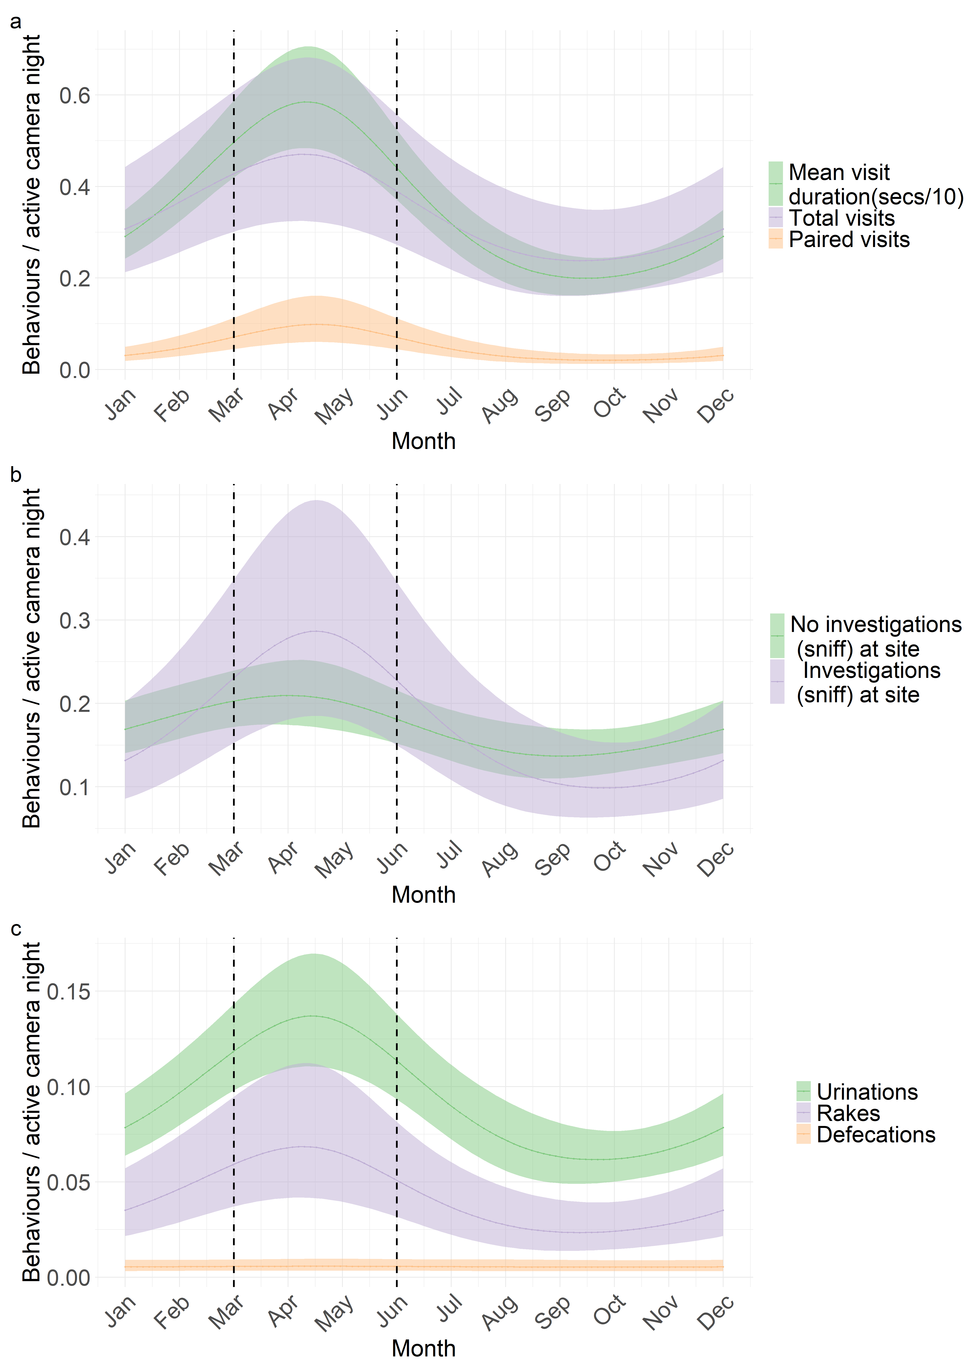

*Fig 2: Generalised Additive Model predicted results with 95% confidence intervals, evaluating the relative occurrence of different dingo behaviours at scent marking sites, from the mid-coast of NSW, Australia* ***4.2a****: Visit duration at marking sites, total visits to marking sites, and paired visits to marking sites.* ***4.2b****: No investigations (where dingo walked through site without sniffing), and investigations when at site.* ***4.2c:*** *Behaviours exhibited when at marking sites. Figures made in ggplot2 (Wickham et al 2024).*

*Overall trends in fine-scale marking*

Male dingoes, if sniffing a scent mark placed by females, marked over it 100% of the time when that female’s scent mark was the first at the site (53/53 events), while females marked over males 85% of the time when that scent was the first at the site (55/65 events). Males overmarked females 90% of the time when that scent mark was the second at the site (28/31 events), and 100% when it was third (1/1 events) and fourth (2/2 events). If males sniffed their own scent, they marked over it 72% of the time in total (21/29 events). Females sniffed their own scent marks only twice in the entire study, and did not overmark them either of these times.

For both sexes, rates of overmarking declined with the amount of scent marks previously left at the site. Females rarely investigated sites if more than one scent mark had already been placed at a site (58 investigates of 1st male scent mark, 10 investigates in total of 2nd, 3rd and 4th scent marks). Males investigated female scent marks regardless of whether they were first or second (47 investigates of 1st female scent mark, 31 investigates of 2nd scent mark), but this declined for 3rd and 4th scent marks, as females rarely left these marks.

*Overmarking models*

Only two events were recorded where females investigated female scents (both did not overmark), and so these events were excluded from the model. Site ID had no influence on the likelihood of an individual overmarking. There was a negative effect of the number of scent marks previously deposited at a pile (during the same visit) and the likelihood of a dingo overmarking when investigating (est = -0.654, 95% CI = -1.29 - -0.018). Whether a male was investigating a male scent had no influence on whether the male overmarked (est = -0.144, 95% CI = -1.331-1.044), compared to females investigating male scents (Fig 2). Males were more likely to overmark female previous marks (est = 1.975, 95% CI = 0.610-3.339) than females were to overmark males (Fig 3).

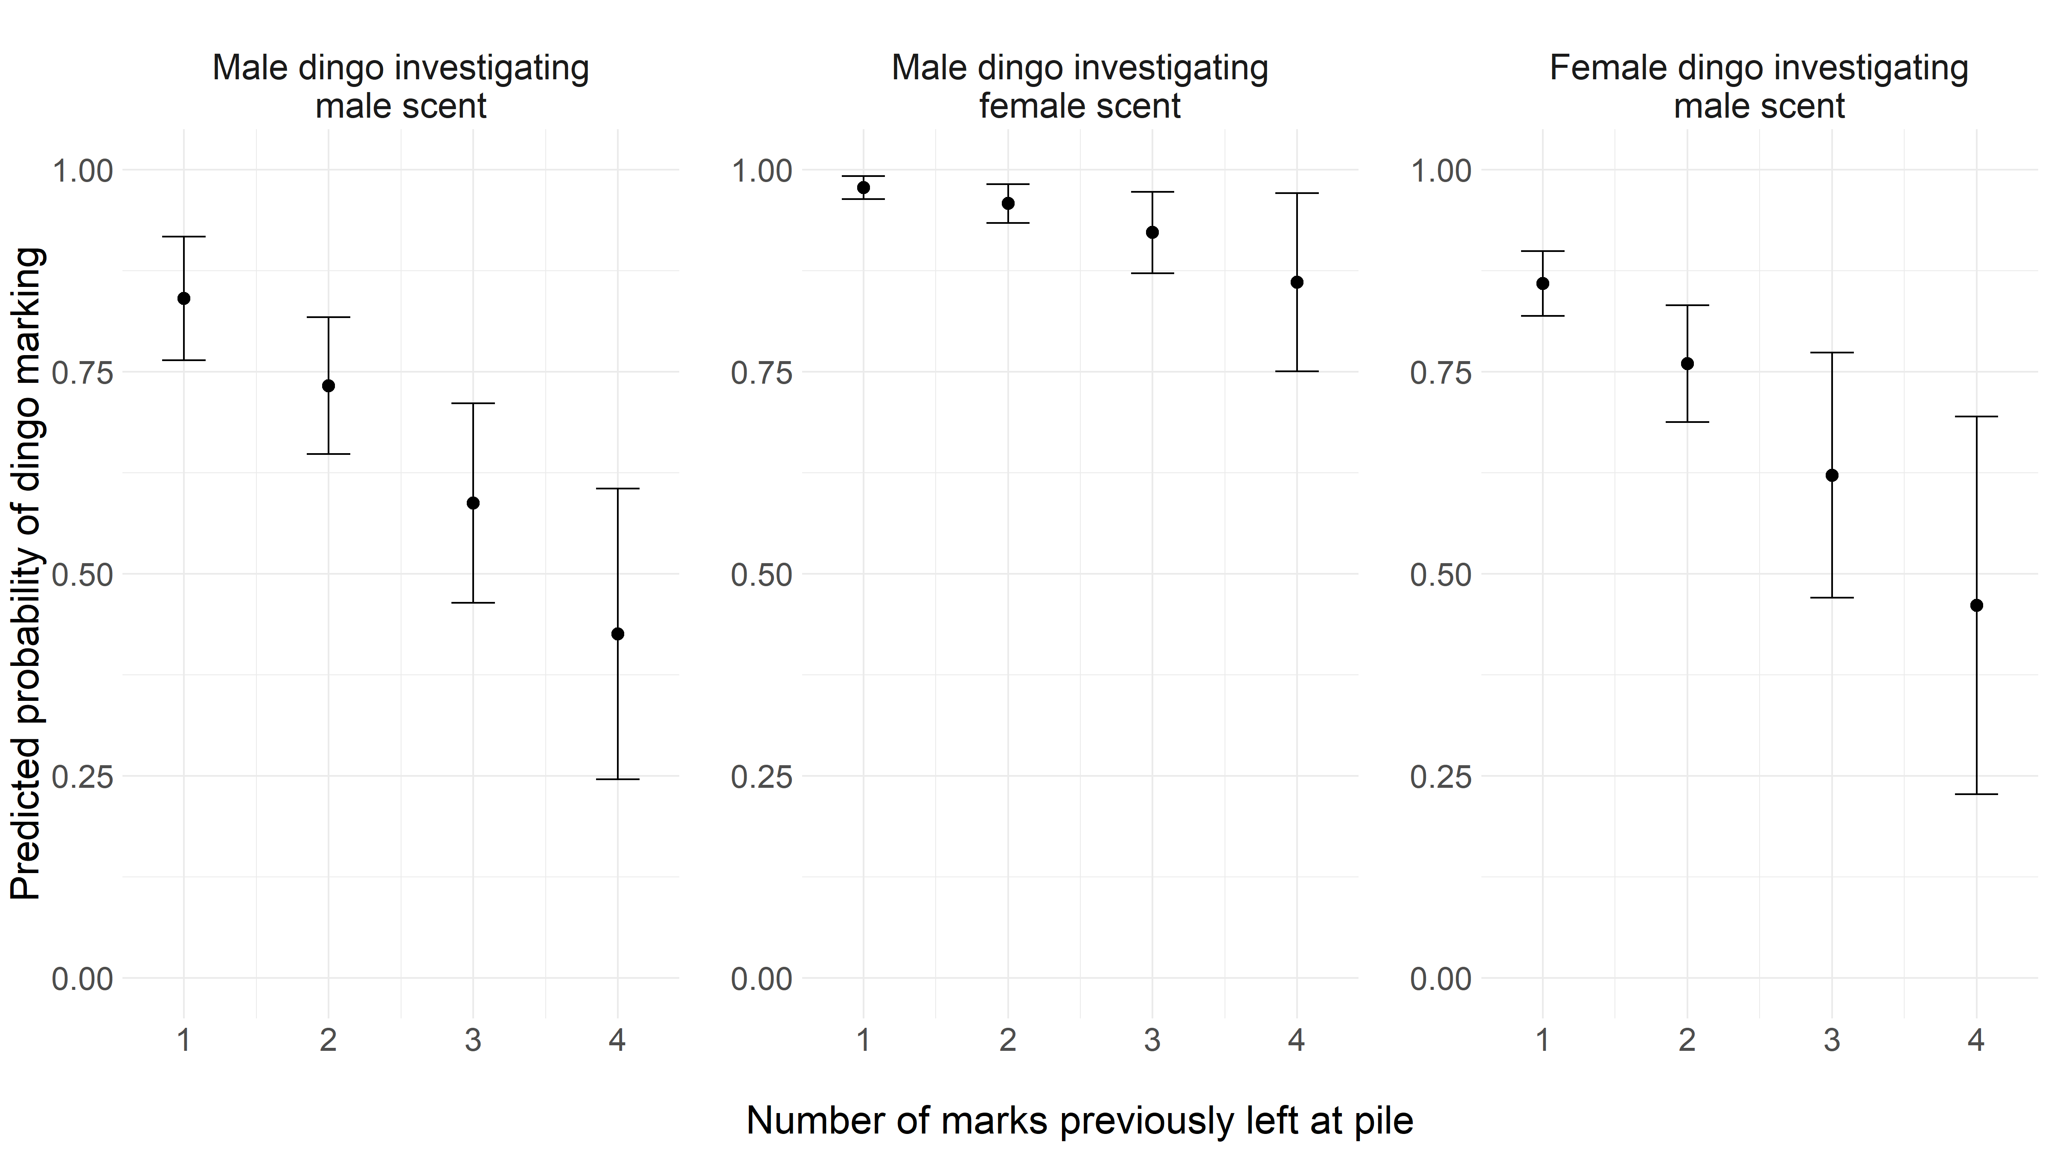

*Fig 3: GLMM predicted estimates of the likelihood of an individual dingo overmarking a scent mark after investigating it. Females investigated female scents only twice during the study, overmarked them neither time, and were removed from modelling.*

*Marking order modelling*

During visits by pairs, male dingoes were significantly more likely to mark first (binomial test of proportions, probability of mark= 0.608, 95% CI = 0.535-0.678, p<0.001) and last (binomial test of proportions, probability of mark = 0.727, 95% CI = 0.657-0.790, p <0.001) at a given pile (Fig 4). When previous markers were not accounted for, “middle marks” (those leaving neither the first nor last marks on a pile), were more evenly shared between the pair, suggesting that males were actively choosing to mark first and last. Male and females marked second at a site in proportion to expected given random chance (binomial test of proportions, probability of mark = 0.530, 95% CI = 0.435-0.623, p =0.579) (Fig 4). Males were more likely to mark third (binomial test of proportions, probability of mark = 0.854, 95% CI = 0.708-0.944, p <0.001), but not fourth (binomial test of proportions, probability of mark = 0.8, 95% CI = 0.444-0.975, p =0.109) or fifth (probability of mark = 1, 95% CI = 0.158-1, p = 0.5). This was likely due to small sample size (only 10 fourth and 2 fifth marks in total).

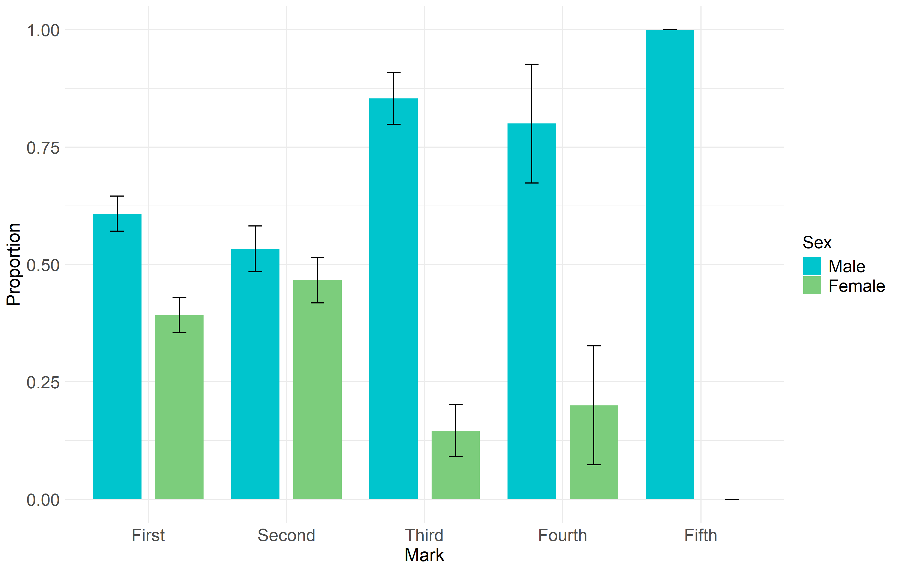

*Figure 4: Proportions of scent marks placed by male and female dingoes, depending on the order of the scent mark placed at each pile, when visited by a pair of dingoes (one female and one male).*

Discussion

*Overall results*

In common with other species, we found sex and seasonal variations in dingo scent-marking site use. Overall, males marked more often than females, including initiating more scent marking bouts and disproportionally leaving the final scent mark during each site visit. When males sniffed a female’s scent mark, they nearly always overmarked it with their own, while females only overmarked approximately 80% of male marks they sniffed, with this proportion declining with the number of scent marks already left at the site. Visitations to scent marking sites increased markedly in the breeding season, but visits were shorter than visits outside the breeding season. Together our results suggest that scent marking in dingoes plays a key role in dingo breeding behaviour, and in particular male mate advertisement or mate guarding of females.

*Seasonal trends*

While spatial patterns of marking dominate the scent marking literature, temporal patterns of marking have been investigated in many species, with many increasing visits in the breeding season (Olson et al. 2008), or establishing and using marking sites around that time (Nie et al. 2012). In species holding year-round territories, as most canid species do (Johnson et al. 2002), annual fluctuations in marking site visitation can indicate their function. Dingoes increased their visits to scent marking sites during the pre-breeding and breeding period compared to other times, with both total and paired (dominant male and female) visits increasing during this period (Fig 2a). This aligned with existing literature from other canid species (e.g. African wild dogs, Claase et al. 2024) and our expectation for dingoes, and suggests that scent marking plays an important role in dingo breeding behaviour, as it does for other species such as wolves (Llaneza et al. 2014) and coyotes (Gese and Ruff 1997). It is possible that elevated visitation to scent marking sites in the breeding period simply reflects general increases in dingo movement during this time. This is particularly relevant to the denning period at which time some canid species, such as African wild dogs, switch to a central place foraging strategy in which home range size shrinks (Pomilia et al. 2015). However, temporal changes in different behaviours such as sniffs and urinations at sites suggest an active motivation to visit and communicate via these sites.

Scent marking can be achieved using an array of excretory or glandular products, each potentially providing different information to receivers (Ralls 1971; Ferkin 2019). For example, while scats may provide some information on diet (Gorman 1990), the chemical compositions of urine may indicate oestrus (Gocinski et al. 2018), or parasite load (Mitchell et al. 2017). The temporal distribution of different forms of dingo scent marks showed contrasting patterns throughout the year, potentially reflecting the motivation of dingoes to convey different information at different times. Urination events at marking sites increased considerably during the breeding season, perhaps facilitating female advertisement of sexual availability (Coombes et al. 2018) as occurs in binturong/bearcats *(Arctictis binturong)* (Green et al. 2016). Urinations can provide an honest signal of mate quality (Gosling and Roberts 2001), with healthier individuals able to produce more attractive marks (Zala et al. 2004). For species with distinct periods of sexual availability, as in dingoes (Cursino et al. 2017), advertising sexual quality and availability through scent marks would be most important immediately prior to and during the breeding season.

Canids have eccrine glands in their footpads (Meyer and Tsukise 1995), which can transmit olfactory information and are recognised by conspecifics (McClanahan and Rosell 2020). Raking the ground may be a way of depositing scents at a site, while also producing a visual signal to conspecifics, which may function to advertise to observers at the time of ground raking, and for encounters after the fact (Bekoff 1979). Our results show that raking behaviours in dingoes increased in March and April, aligning with other studies that show increases in raking by canids in the breeding season (Sillero-Zubiri and Macdonald 1998). However, little is known of dingo ground raking and its function, and further studies are needed. Rates of defecations did not vary seasonally in our study area, perhaps implying that scats do not play a major role in dingo communication during the breeding season. This finding agrees with other studies that found a lack of seasonal fluctuations in scat deposition by dingoes (Allen 2012).

Sex biases in scent marking during the breeding season have been noted in many species (Nie et al. 2012), and in pair-bonded territorial mammals it is usually males that mark more than females, e.g. in meerkats (Jordan 2007) and coyotes (Wells and Bekoff 1981). Male mate guarding of females has been proposed as a cause of this increase in scent marking, at least for territorial pair-bonded species. For example, male African wild dogs and coyotes overmark their paired female scent marks, possibly to conceal the mark of the dominant female from other males (Gese and Ruff 1997; Jordan et al. 2014). We observed more adult male dingo events at scent marking sites, and higher rates of urinations when at these sites (0.52 urinations/ visit for males vs 0.36 visits for females). It seems likely that this is related to mate-guarding behaviour of females by resident males. Males may have an incentive to follow females as closely as possible, to ensure that they do not breed with other males, a behaviour commonly known as mate-guarding (Alberts et al. 1996). Such behaviour can involve physical guarding of the female (Setchell et al. 2005), and/or signalling of the presence of a mated pair in the territory through overmarking (Dunbar and Buehler 1980). Indeed, we detected an increase in paired visits to marking sites in May, which is approximately when female dingoes are likely to be sexually receptive (Cursino et al. 2017), supporting the idea of male mate guarding of females for this species.

*Fine-scale behaviours*

Scent marks can be expensive to produce (Gosling and Roberts 2001), and this implies that individuals will not mark more than they need to convey their intended message. Therefore, were scent marking solely related to advertising sexual availability to their respective partner, we would not expect males to mark twice at a site, for example if they had been overmarked by a female, as she would have gained the information from one mark. However, we found that males overmarked females at a very high rate, often marking several times at a site. This suggests an alternate role for scent marking apart from advertising reproductive availability to a partner, likely one in which male resident dingoes may be attempting to conceal the scent of female scent marks from rival conspecifics, as occurs in other canids (Jordan et al. 2014), or strongly associate their own scent with it.

How receivers perceive multiple scent-marks on a given pile (i.e. over-marks) depends on placement order (Ferkin and Pierce 2007). Some laboratory rodents, for example, respond most strongly to the most recent scent in a pile (Johnston et al. 1994), and in wild settings too, dominant individuals in many species such as some primates (Heymann 2006), leave the ‘top’ mark at a site more often than subordinates do, suggesting a communication benefit to doing so. We found that male dingoes left the final mark at a pile significantly more than females, and that males left the first mark at the site more than females did, when a pair visited a site. This adds further weight to the argument for male mate guarding of females driving dingo marking behaviour. During the course of processing marking site videos, we observed numerous occasions of males marking at a site, appearing to wait for females to overmark them, before subsequently overmarking the female. On one occasion, after scent marking on a tree, a male dingo left the site, but returned to the site (some 60m) after apparently hearing the dominant female raking after overmarking, to overmark again (Supp video 1). Males often illustrated clear vigilance behaviour when at scent marking sites, and while females overmarked and watched males on the first scent occasion, they often left the site after marking once. In this context, it appears that females are content with advertising their presence at marking sites with one scent mark, while males are focussed on advertising ‘ownership’ or the presence of a pair, by repeatedly overmarking the female scent to ensure their mark is on top.

*Conclusions*

That scent marking plays at least some role in reproductive behaviours for dingoes seems clear. Scent marking as a behavioural process has been studied little in dingoes. Thomson et al (1992), reported that urinations of male dingoes increased in the breeding season, while Allen (2012), found that scat deposition of dingoes varied throughout the year. Both of these findings agree with our study results. Much of mammal communication is achieved through scent marks (Ralls 1971), and every species that is known to hold territories also scent mark (Gosling 1982), highlighting its importance in territory maintenance. Indeed, for dingoes scent marking was a year-round process, and was not strictly related to breeding, despite increasing during breeding periods. This sheds some light on the functions of territoriality for dingoes. While in other parts of the year, for example in the denning season, territories may function to protect food resources for a resident group (Bekoff and Wells 1982), in the breeding season territories may switch to functioning to defend mates from other rival individuals, and mates may be the most important resource to defend at this time (Macdonald et al. 2019), particularly for males.

Territorial carnivores can pose numerous problems for land managers, and understanding how their behaviours change seasonally is key to managing their impacts (Valeix et al. 2012). Contextualising different scent marking strategies in the context of breeding seasons can help explain variations in movement and behaviour at different times of the year, and may even permit the use of anthropogenically manipulated scent marks (artificial or natural) to alter dingo movements (Robley et al. 2015), as in African wild dogs (Hansen et al. 2024). While our study suggests that dingo scent marking behaviour is similar to that found in other canids, with males marking more than females, and scent marking increasing during the breeding season, further studies are required to understand how other factors, such as the spatial distribution of scent marks across a territory, can convey information to conspecifics.

References

Alberts, S. C., Altmann, J. and Wilson, M. L. (1996). Mate guarding constrains foraging activity of male baboons. *Animal Behaviour* 51(6): 1269-1277.

Allen, B. L. (2012). Scat happens: Spatiotemporal fluctuation in dingo scat collection rates. *Australian Journal of Zoology* 60(2): 137-140.

Allen, B. L. and West, P. (2013). Influence of dingoes on sheep distribution in Australia. *Australian Veterinary Journal* 91(7): 261-267.

Allen, J. J., Bekoff, M. and Crabtree, R. L. (1999). An observational study of coyote (Canis latrans) scent-marking and territoriality in Yellowstone National Park. *Ethology* 105(4): 289-302.

Alting, B. F., Pitcher, B. J., Rees, M. W., Ferrer-Paris, J. R. and Jordan, N. R. (2024). Population density and ranging behaviour of a generalist carnivore varies with human population. *Ecology and Evolution* 14(5): e11404.

Baker, P. J., Funk, S. M., Bruford, M. W. and Harris, S. (2004). Polygynandry in a red fox population: implications for the evolution of group living in canids? *Behavioral Ecology* 15(5): 766-778.

Bateman, P. W. and Fleming, P. A. (2012). Big city life: carnivores in urban environments. *Journal of Zoology* 287(1): 1-23.

Bates D, Mächler M, Bolker B, Walker S (2015). Fitting Linear Mixed-Effects Models Using lme4. *Journal of Statistical Software* 67(1), 1–48. [doi:10.18637/jss.v067.i01](https://doi.org/10.18637/jss.v067.i01).

Bekoff, M. (1979). Ground scratching by male domestic dogs: a composite signal. *Journal of Mammalogy* 60(4): 847-848.

Bekoff, M. and Wells, M. C. (1982). Behavioral Ecology of Coyotes: Social Organization, Rearing Patterns, Space Use, and Resource Defense. *Zeitschrift für Tierpsychologie* 60(4): 281-305.

Bell, M. B., Cant, M. A., Borgeaud, C., Thavarajah, N., Samson, J. and Clutton-Brock, T. H. (2014). Suppressing subordinate reproduction provides benefits to dominants in cooperative societies of meerkats. *Nat Commun* 5: 4499.

Buesching, C. D. and Jordan, N. (2019). The Social Function of Latrines: A Hypothesis-Driven Research Approach. *Chemical Signals in Vertebrates 14*, Cham, Springer International Publishing.

Cameron, C., Berteaux, D. and Dufresne, F. (2011). Spatial variation in food availability predicts extrapair paternity in the arctic fox. *Behavioral Ecology* 22(6): 1364-1373.

Catling, P. C., Corbett, L. K. and Newsome, A. E. (1992). Reproduction in captive and wild dingoes (Canis familiaris dingo) in temperate and arid environments of Australia. *Wildlife Research* 19(2): 195-209.

Christensen, C. and Radford, A. N. (2018). Dear enemies or nasty neighbors? Causes and consequences of variation in the responses of group-living species to territorial intrusions. *Behavioral Ecology* 29(5): 1004-1013.

Claase, M. J., Cherry, M. I., Apps, P. J., McNutt, J. W., Hansen, K. W. and Jordan, N. R. (2022). Interpack communication in African wild dogs at long-term shared marking sites. *Animal Behaviour* 192: 27-38.

Claase, M. J., Cherry, M. I., Hofmann, D. D., Apps, P. J., McNutt, J. W. and Jordan, N. R. (2024). Patterns of scent marking by African wild dogs, Lycaon pictus, at shared marking sites. *Animal Behaviour* 207: 77-86.

Clutton-Brock, T. H. (1989). Mammalian mating systems. *Proceedings - Royal Society of London, B* 126(1285): 339-372.

Coombes, H. A., Stockley, P. and Hurst, J. L. (2018). Female Chemical Signalling Underlying Reproduction in Mammals. *Journal of Chemical Ecology* 44(9): 851-873.

Creel, S. (2002). The African wild dog: behavior, ecology, and conservation. Princeton, N.J: Princeton University Press.

Cursino Marina, S., Harriott, L., Allen, B. L., Gentle, M. and Leung, L. K.-P. (2017). Do female dingo–dog hybrids breed like dingoes or dogs? *Australian Journal of Zoology* 65: 112-119.

Dejeante, R., Loveridge, A. J., Macdonald, D. W., Madhlamoto, D., Valeix, M. and Chamaillé-Jammes, S. (2024). Counter-strategies to infanticide: The importance of cubs in determining lion habitat selection and social interactions. *Journal of Animal Ecology* 93(2): 159-170.

Dunbar, I. and Buehler, M. (1980). A masking effect of urine from male dogs. *Applied Animal Ethology* 6(3): 297-301.

Ferkin, M. H. and Pierce, A. A. (2007). Perspectives on over-marking: is it good to be on top? *Journal of Ethology* 25(2): 107-116.

Ferkin, M. H. (2019). Scent marks of rodents can provide information to conspecifics. *Animal Cognition* 22(3): 445-452.

Fisher, H. S., Swaisgood, R. R. and Fitch-Snyder, H. (2003). Odor familiarity and female preferences for males in a threatened primate, the pygmy loris Nycticebus pygmaeus: applications for genetic management of small populations. *Naturwissenschaften* 90(11): 509-512.

Gardner, W., Mulvey, E. P., & Shaw, E. C. (1995). Regression analyses of counts and rates: Poisson, overdispersed Poisson, and negative binomial models. *Psychological Bulletin* 118(3), 392-404.

Gese, E. M. and R. L. Ruff (1997). Scent-marking by coyotes, Canis latrans: The influence of social and ecological factors. *Animal Behaviour* 54(5): 1155-1166.

Greene, L. K., Wallen, T. W., Moresco, A. et al. (2016). Reproductive endocrine patterns and volatile urinary compounds of Arctictis binturong: discovering why bearcats smell like popcorn. *Sci Nat* 103, 37. <https://doi.org/10.1007/s00114-016-1361-4>

Gocinski, B. L., Knott, K. K., Roberts, B. M., Brown, J. L., Vance, C. K. and Kouba, A. J. (2018). Changes in urinary androgen concentration indicate that male giant pandas (Ailuropoda melanoleuca) respond to impending female oestrus during and outside the typical spring breeding season. *Reproduction, Fertility and Development* 30(2): 399-408.

Gorman, M. L. (1990). Scent marking strategies in mammals. *Revue suisse de zoologie* 97: 3-29.

Gosling, L. M. (1982). A reassessment of the function of scent marking in territories. *Zeitschrift für Tierpsychologie* 60(2): 89-118. <https://doi.org/10.1111/j.1439-0310.1982.tb00492.x>

Gorman, M. L. and Mills, M. G. L. (1984). Scent marking strategies in hyaenas (Mammalia). *Journal of Zoology* 202(4): 535-547.

Gosling, L. and Roberts, S. (2001). Testing ideas about the function of scent marks in territories from spatial patterns. *Animal Behaviour* 62(3): F7-F10.

Gosling, L. M. and Roberts, S. C. (2001). Scent-marking by male mammals: Cheat-proof signals to competitors and mates. *Advances in the Study of Behavior* 30: 169-217.

Halsey, L. G. (2019). The reign of the p-value is over: what alternative analyses could we employ to fill the power vacuum? *Biology Letters* 15(5): 20190174.

Hansen, K. W., Jordan, N. R., Claase, M. J., Suraci, J. P., McNutt, J. W., Dhruv, A. and Wilmers, C. C. (2024). Experimental modification of African wild dog movement and behavior using translocated conspecific scent. *Biological Conservation* 294: 110645.

Heymann, E. W. (2006). Scent marking strategies of new world primates. *American Journal of Primatology* 68(6): 650-661.

Hurst, J. L. and Beynon, R. J. (2004). Scent wars: the chemobiology of competitive signalling in mice. *BioEssays* 26(12): 1288-1298.

Johnson, D. D., Kays, R., Blackwell, P. G. and Macdonald, D. W. (2002). Does the resource dispersion hypothesis explain group living? *Trends in Ecology & Evolution* 17(12): 563-570.

Johnston, R. E., Chiang, G. and Tung, C. (1994). The information in scent over-marks of golden hamsters. *Animal Behaviour* 48(2): 323-330.

Johnston, R. E., Sorokin, E. S. and Ferkin, M. H. (1997). Scent counter-marking by male meadow voles: Females prefer the top-scent male. *Ethology* 103(6): 443-453.

Jones, M. E., Rose, R. K. and Burnett, S. (2001). Dasyurus maculatus. *Mammalian Species* 2001(676): 1-9.

Jordan, N. R. (2007). Scent-marking investment is determined by sex and breeding status in meerkats. *Animal Behaviour* 74(3): 531-540.

Jordan, N. R., Apps, P. J., Golabek, K. A. and McNutt, J. W. (2014). Top marks from top dogs: Tandem marking and pair bond advertisement in African wild dogs. *Animal Behaviour* 88: 211-217.

Jordan, N.R., Apps, P., Golabek, K. and McNutt, J. (2016). Pair-specific scents in African wild dogs, Lycaon pictus, and an example of a potential method to identify signals within complex mixtures: 461-476.

Jordan, N.R., Buse, C., Wilson, A., Golabek, K., Apps, P., Lowe, J., Weyde, L. and McNutt, J. W. (2017). Dynamics of direct inter-pack encounters in endangered African wild dogs. *Behavioral Ecology and Sociobiology* 71(8): 1-12.

Kleiman, D. (1966). Scent marking in the canidae. *Symposium of the Zoological Society of London* 18: 167-177.

Körtner, G., Gresser, S., Mott, B., Tamayo, B., Pisanu, P., Bayne, P., & Harden, R. (2004). Population structure, turnover and movement of spotted-tailed quolls on the New England Tablelands. *Wildlife Research, 31*(5), 475-484.

Lazaro-Perea, C., Snowdon, C. T., & de Fátima Arruda, M. (1999). Scent-marking behavior in wild groups of common marmosets (Callithrix jacchus). *Behavioral Ecology and Sociobiology, 46*(5), 313-324.

Llaneza, L., García, E. J., & López-Bao, J. V. (2014). Intensity of Territorial Marking Predicts Wolf Reproduction: Implications for Wolf Monitoring. *PLOS ONE, 9*(3), e93015.

Lledo-Ferrer, Y., Peláez, F., & Heymann, E. W. (2010). Can Overmarking Be Considered as a Means of Chemical Mate Guarding in a Wild Callitrichid? *Folia Primatologica, 81*(4), 200-206.

Lord, K., Feinstein, M., Smith, B., & Coppinger, R. (2013). Variation in reproductive traits of members of the genus Canis with special attention to the domestic dog (Canis familiaris). *Behavioural Processes, 92*, 131-142.

Macdonald, D. W., Campbell, L. A. D., Kamler, J. F., Marino, J., Werhahn, G., & Sillero-Zubiri, C. (2019). Monogamy: Cause, Consequence, or Corollary of Success in Wild Canids? *Frontiers in Ecology and Evolution, 7*, 28.

McClanahan, K., & Rosell, F. (2020). Conspecific recognition of pedal scent in domestic dogs. *Scientific Reports, 10*(1), 17837.

Meyer, W., & Tsukise, A. (1995). Lectin histochemistry of snout skin and foot pads in the wolf and the domesticated dog (Mammalia: Canidae). *Annals of Anatomy-Anatomischer Anzeiger, 177*(1), 39-49.

Mitchell, J., Cant, M. A., Vitikainen, E. I. K., & Nichols, H. J. (2017). Smelling fit: scent marking exposes parasitic infection status in the banded mongoose. *Current Zoology, 63*(3), 237-247.

Nie, Y., Swaisgood, R. R., Zhang, Z., Hu, Y., Ma, Y., & Wei, F. (2012). Giant panda scent-marking strategies in the wild: role of season, sex and marking surface. *Animal Behaviour, 84*(1), 39-44.

Oakwood, M. (2000). Reproduction and demography of the northern quoll, Dasyurus hallucatus, in the lowland savanna of northern Australia. *Australian Journal of Zoology, 48*(5), 519-539.

Olson, Z., Serfass, T., & Rhodes, O. (2008). Seasonal variation in latrine site visitation and scent marking by Nearctic river otters (Lontra canadensis). *IUCN Otter Spec. Group Bull, 25*(2), 108-120.

Packer, C., Scheel, D., & Pusey, A. E. (1990). Why lions form groups: food is not enough. *American Naturalist, 136*(1), 1-19.

Packer, C., & Pusey, A. E. (1983). Adaptations of female lions to infanticide by incoming males. *The American Naturalist, 121*(5), 716-728.

Palomares, F., Lucena-Pérez, M., López-Bao, J. V., et al. (2017). Territoriality ensures paternity in a solitary carnivore mammal. *Scientific Reports, 7*, 4494. <https://doi.org/10.1038/s41598-017-04820-4>

Pomilia, M. W., McNutt, J. W., & Jordan, N. R. (2015). Ecological predictors of African wild dog ranging patterns in northern Botswana. *Journal of Mammalogy, 96*(6), 1214–1223. <https://doi.org/10.1093/jmammal/gyv130>

Ralls, K. (1971). Mammalian Scent Marking. *Science, 171*(3970), 443-449.

Randall, D. A., Pollinger, J. P., Wayne, R. K., Tallents, L. A., Johnson, P. J., & Macdonald, D. W. (2007). Inbreeding is reduced by female-biased dispersal and mating behavior in Ethiopian wolves. *Behavioral Ecology, 18*(3), 579-589.

Robley, A., Lindeman, M., Cook, I., Woodford, L., & Moloney, P. (2015). Dingo semiochemicals: towards a non-lethal control tool for the management of dingoes and wild dogs in Australia. *Technical Report Series No. 263.* Arthur Rylah Institute for Environmental Research, Department of Environment, Land, Water and Planning, Heidelberg, Victoria.

Setchell, J. M., Charpentier, M., & Wickings, E. J. (2005). Mate guarding and paternity in mandrills: factors influencing alpha male monopoly. *Animal Behaviour, 70*(5), 1105-1120.

Sillero-Zubiri, C., & Macdonald, D. W. (1998). Scent-marking and territorial behaviour of Ethiopian wolves Canis simensis. *Journal of Zoology, 245*(3), 351-361.

Spiering, P. A., Somers, M. J., Maldonado, J. E., Wildt, D. E., & Gunther, M. S. (2010). Reproductive sharing and proximate factors mediating cooperative breeding in the African wild dog (Lycaon pictus). *Behavioral Ecology and Sociobiology, 64*(4), 583-592.

Stephens, R., & James, M. (2023). Hundreds of migrating seabirds found dead on NSW beaches. *ABC News.* <https://www.abc.net.au/news/2023-11-06/migrating-shearwaters-found-dead-on-nsw-beaches/103068222>. Accessed 10/09/2024.

Tatler, J., Prowse, T. A. A., Roshier, D. A., Cairns, K. M., & Cassey, P. (2021). Phenotypic variation and promiscuity in a wild population of pure dingoes (Canis dingo). *Journal of Zoological Systematics and Evolutionary Research, 59*(1), 311-322.

Thomson, P. C. (1992). The behavioural ecology of dingoes in north-western Australia. II. Activity patterns, breeding season and pup rearing. *Wildlife Research 19*(5), 519-529.

Thomson, P. C. (1992). The behavioural ecology of dingoes in north-western Australia. IV. Social and spatial organisation, and movements. *Wildlife Research 19*(5), 543-563.

Thomson, P. C., Rose, K., & Kok, N. E. (1992). The behavioural ecology of dingoes in north-western Australia. V. Population dynamics and variation in the social system. *Wildlife Research 19*(5), 565-583.

Valeix, M., Hemson, G., Loveridge, A. J., Mills, G., & Macdonald, D. W. (2012). Behavioural adjustments of a large carnivore to access secondary prey in a human-dominated landscape. *Journal of Applied Ecology 49*(1), 73-81.

Vitale, J. D., Jordan, N. R., Gilfillan, G. D., McNutt, J. W., & Reader, T. (2020). Spatial and seasonal patterns of communal latrine use by spotted hyenas (Crocuta crocuta) reflect a seasonal resource defense strategy. *Behavioral Ecology and Sociobiology 74*(10), 120.

Walker, B. J. J., Letnic, M., Bucknall, M. P., Watson, L., & Jordan, N. R. (2024). Male dingo urinary scents code for age class and wild dingoes respond to this information. *Chemical Senses 49*, bjae004.

Wells, M. C., & Bekoff, M. (1981). An observational study of scent-marking in coyotes, Canis latrans. *Animal Behaviour 29*(2), 332-350.

Zala, S. M., Potts, W. K., & Penn, D. J. (2004). Scent-marking displays provide honest signals of health and infection. *Behavioral Ecology 15*(2), 338-344.