Abstract

Apex predators influence mesopredator abundance and behaviour. Understanding such intraguild dynamics is key, particularly when attempting to limit the negative impacts of introduced mesopredators on threatened native species. We quantified the effects of dingo density on the spatial and temporal activity patterns of three mesopredators: red fox (an introduced eutherian canid), spotted-tailed quoll (a threatened native Dasyurid), and lace monitor (a native reptile). We used camera traps to estimate densities of the four species in a capture recapture framework. We estimated areas of high and low risk of encountering a dingo using these models, and compared the spatial and temporal activity patterns of the mesopredators between zones. We modelled quoll and dingo population parameters using spatially explicit capture recapture models (SECR) with individual identities, and then estimated density of all four species using spatially explicit unmarked models (SUN). We assessed patterns of temporal overlap and differing peaks in activity between all species between high and low risk zones. Quoll density from SECR models (0.38km-2) was comparable to areas considered to contain healthy quoll populations. Fox density from SUN models (0.30 km-2) was similar to estimates from other areas (0.25km-2 Namadgi NP), while lace monitor density was estimated at 1.58km-2. Quolls and foxes were positively associated at distances >500m, and foxes and monitors were negatively associated at distances <1km. Each mesopredator species avoided dingoes at all distances, although this may have been driven by a shared avoidance of urban areas, where dingoes were more common. Temporal activity of dingoes, foxes, quolls or lace monitors did not differ across dingo risk zones. All three mesopredators showed separation in temporal activity peaks. This study occurred in an area without lethal control of dingoes and foxes, suggesting that an endangered native predator can persist at high density in the absence of lethal predator control.

Introduction

Predators play important roles in ecosystems, including through top-down regulation of prey (Estes et al. 2011) direct population reduction of subordinate predators (Ripple et al. 2014) or promoting behaviour changes through a landscape of fear (Gaynor et al. 2021). While the specific impacts of these processes can be difficult to detect in complex ecosystems, predators are broadly accepted to have considerable flow-on effects for ecosystems (Estes et al. 2011). Apex predators influence smaller mesopredators (Thinley et al. 2018), reducing or limiting their numbers, through resource competition (Jiménez et al. 2019), or direct killing (Groom et al. 2017). For example, the extirpation of grey wolves (*Canis lupus*) across much of the United States correlates with increased coyote (*Canis latrans*) abundance (Berger and Conner 2008). Given their importance to ecosystem functioning, understanding the role of predators is key to ecosystem management.

In the absence of interspecific competition and suppression, predators should exhibit an ‘optimal’ set of behaviours that enable efficient resource acquisition, including matching their activity patterns with those of their prey (Harmsen et al. 2011). However, when apex predators are present, subordinate species must balance resource acquisition against the risk of interspecific killing or competition (Bischof et al. 2020). Behavioural responses of mesopredators to apex predators may include both spatial and temporal separation (Garvey et al. 2022). When behaviours diverge from an ‘optimal’ state, decreased fitness should ensue (Pyke 1984) resulting in lower densities of subordinate species or reduced regulation of mesopredator prey populations (Berger and Conner 2008).

Humans are sometimes referred to as a ‘superpredator’ exerting strong top-down influences on carnivore behaviour and abundance (Darimont et al. 2015). These influences differ depending on species traits, with some species able to exploit plentiful anthropogenic resources while avoiding human-induced mortality, while larger species usually fare less well (Gaynor et al. 2018). Generalist mesopredators such as foxes (*Vulpes vulpes*) and coyotes can attain higher densities in urban environments and around anthropogenic food resources than in more natural areas (Harris 1986; Gehrt et al. 2010). Wolves, however, do not persist in urban environments, where urban-adapted coyotes thrive (Bateman and Fleming 2012). Additionally, areas with high human disturbance can increase dietary overlap and interspecific competition (Manlick and Pauli 2020). Anthropogenic impacts on apex and mesopredators are complex and context-dependent, but they are crucial to understand in an increasingly urbanised world (Bateman and Fleming 2012).

Most carnivores are territorial, defending key parts of their broader home range from conspecifics (Macdonald 1983). Both prey and subordinate predators have been shown to avoid the core territory of their predators or more dominant heterospecific competitors, instead focusing their activity at territory edges, often where territories overlap. For example, coyotes avoid the core regions of wolf territories (Arjo and Pletscher 1999). Similar effects are observed in prey species, including white-tailed deer *(Odocoileus virginianus)* (Mech 1977), however it is unclear if these species prefer low-risk areas, or are simply more numerous there due to lower predation.

Dingoes (variously referred to as *Canis dingo*, *Canis familiaris*, *Canis lupus dingo*, amongst others) are a medium sized canid introduced to Australia over 5000 years ago (Cairns 2021). Dingoes are territorial (Thomson et al. 1992), with packs consisting of a dominant breeding pair, pups from the previous year, and sometimes non-dispersed offspring from previous litters (Thomson et al. 1992). Dingo packs defend core or non-overlapping regions of these ranges against other packs (Thomson et al. 1992). Dingoes are present in all habitats across Australia, except where extirpated by humans (Doherty et al. 2019) and are highly adaptable and readily recolonise areas from which they have been removed (Thomson et al. 1992). Dingoes are generalist predators, consuming a wide variety of foods, effectively eating whatever is available in the environment (Doherty et al. 2019).

*Interspecific relationships in the Australian carnivore guild*

In Australia, dingoes are the largest terrestrial predator on the mainland, and their role in contemporary ecosystems is debated. The terrestrial mesopredator guild across most of the eastern Australian mainland consists of introduced eutherian species such as the red fox and feral cat (*Felis catus*), and native species such as the marsupial spotted-tailed quoll (*Dasyurus maculatus*), and the reptilian lace monitor (*Varanus varius*). Some studies suggest dingoes suppress mesopredator populations, particularly the introduced red fox (Letnic et al. 2012), while others debate this (Castle et al. 2023). Dingoes are known to kill foxes and do not always consume them (Jordan et al. 2023), a behaviour typical of interspecific competition. The relationship between dingoes and spotted-tailed quolls have not to our knowledge been described in the literature, but we have observed a dingo carrying a dead quoll (Supplementary figure 1), and quoll remains are present in some dingo scats (Doherty et al. 2019), making it reasonable to assume that quolls are at least potentially susceptible to dingo predation. Dingoes have been observed hunting and killing lace monitors (Webb 1994) although, as for quolls, whether this predation translates to population level effects is currently untested.

The relationships between some of these mesopredator species have been studied in isolation. Red foxes and spotted-tailed quolls compete for resources, albeit with some dietary separation (Henderson et al. 2021). Despite being sympatric in some landscapes, foxes have been suggested as a major cause of quoll population decline, and it is thought that quolls may be more abundant in areas where fox densities are low (Glen and Dickman 2011). Lace monitors are predominantly scavengers (Lei and Booth 2017), and have been shown to increase in density following red fox control (Hu et al. 2019). Whether there is a spatial or temporal relationship between quolls and lace monitors has not yet been explored in the literature.

We examined the effects of apex predator (dingo) density and urbanisation on the spatial and temporal activity patterns and population densities of a terrestrial mesopredator guild consisting of two native (spotted-tailed quoll, lace monitor) and one introduced (red fox) species in and around Myall Lakes National Park. All species are predominantly terrestrial, although quolls and lace monitors may use trees to escape predation (Jessop 2023). In the study area, dingoes are common throughout the landscape but occur at higher densities in areas with high human population density (Alting et al. 2024), and utilize home range core areas more than peripheral areas of their territories. This, and their sympatry with several mesopredators, provides the opportunity to study the impacts dingoes have on mesopredators across a gradient of potential risk. We hypothesised that mesopredators would be less abundant in high density dingo areas, and that their temporal activity patterns in high dingo density areas would be offset to that of dingoes, to reduce the risk of interspecific encounters with dingoes. We hypothesised that quoll density would be higher as distance to urban areas increased, and that the typically positive effects of urban environments on fox populations may be decoupled by the presence of a higher density of dingoes around these areas.

Methods

*Study site*

The Great Lakes Region within Worimi Country (centred on 32.492° S, 152.343° E), is a mixed use, coastal landscape, consisting of urban areas (e.g. Hawks Nest, Smiths Lake, Pacific Palms), campgrounds, and protected national park (Fig 1). The natural environment consists primarily of closed woodland (dominated by *Angophora costata* and *Banksia serrata*), heath and wetlands, and cabbage palm/paperbark swamp (dominated by *Melaleuca quinquenerva* and *Livistona australis*). The study area is bounded by the Pacific Ocean to the east and south, a lake system to the west, and is open to the north. A road bridge links the main urban centres of Hawks Nest and Tea Gardens across an estuary in the south, presenting a potential but unlikely route out of the area, and while dingoes have been reported crossing the bridge, this is believed to be rare (no collared dingoes in Hawks Nest definitively crossed the bridge during the study period). As such the study site is relatively closed off except to the north, providing good conditions for population models which assume a closed population (Royle et al. 2013). We created a shapefile of the study site in ArcMap v10.8 (ESRI 2023).

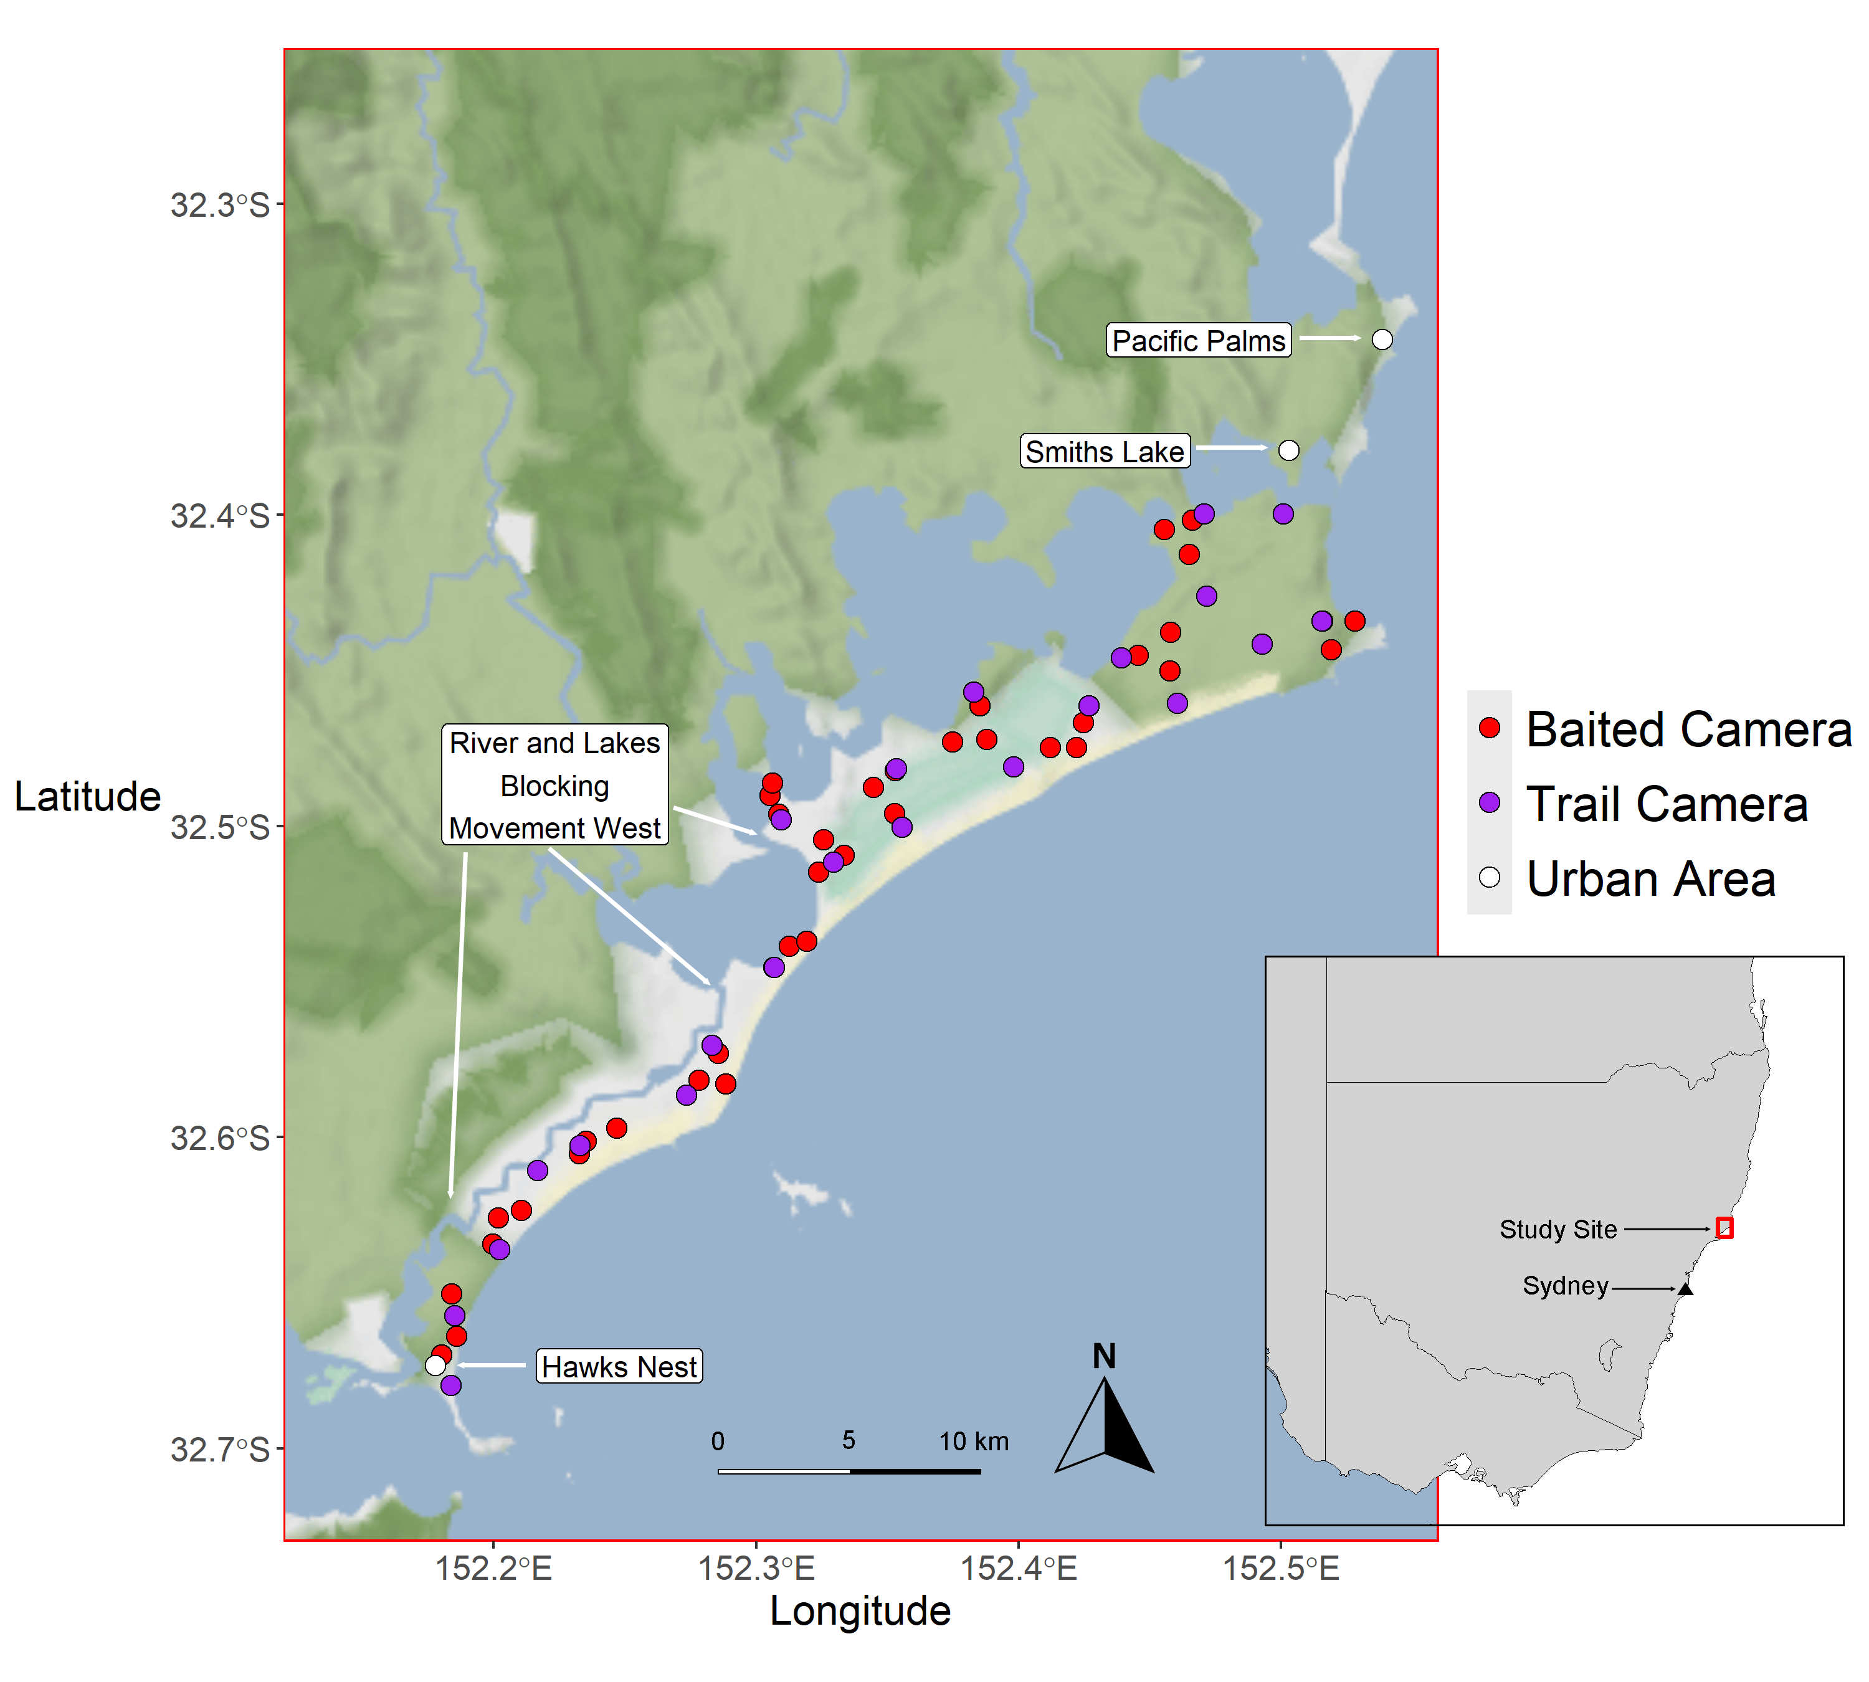

*Fig 1: Study area on the mid coast of NSW, Australia (inset map), illustrating the placement of camera traps used to target four predator species (dingoes, foxes, lace monitors and quolls) in 2022/2023. Red circles = baited camera stations, purple circles = trail camera stations. Figure made in R, using ‘ggmap’ (Kahle & Wickham 2013), ‘rnaturalEarth’ (Massicote 2023) and ‘ggplot2’ (Wickham 2016).*

*Camera trap layout*

A combination of trail and off-trail camera traps has been suggested to comprehensively identify the species present (Blake and Mosquera 2014), and so we employed this approach in this study.

To primarily target dingoes and foxes, 21 paired camera stations (N= 42 cameras) and 1 single camera station (N=1 camera) were deployed on trails, roads and 4wd tracks throughout the geographic range of collar data between December 2022 and March 2023 (Reconyx Hyperfire H2x1000) (Fig. 1). Trail cameras were placed on average 2380 metres apart (range =2189-2420m) and secured with python locks to trees roughly 50cm off the ground. Paired camera stations (one camera on each side of the trail) were used to capture both flanks of dingoes to enable identification of individuals for a different study (Alting et al. 2024). Cameras were set to medium high sensitivity, with bursts of 3 photos and no trigger delay (rapidfire mode).

To target quolls and monitors, 39 Browning strike force HD pro cameras were deployed between December 2022 and March 2023 off trail covering the same study area. Cameras were positioned approximately 2 metres away from a pvc pipe containing 200g of inaccessible raw chicken necks, staked into the ground in front of a large log to encourage quolls to walk across the log and present both flanks to the camera (Henderson et al. 2022). Lures were replaced at each site 6 times during the survey (every 9 - 22 days; mean = 16 days). To capture individual quolls on multiple cameras, while maintaining a consistent geographic spread of camera traps across the area, baited cameras were loosely arranged in clusters of three, with each cluster (N=13) spaced 4502 metres apart (range = 2510-6756m), and cameras within clusters were spaced on average 1100m apart (range = 495-1483m) (Fig 1). Baited cameras were deployed for 90 days and set to capture 3 images per sequence, at high sensitivity with a 1s delay.

*Image processing*

Camera trap images were first sorted into folders and timestamped in R (v4.3.1, R Core team, 2023), using the *camtrapR* package (Niebedella 2023). Images were processed using the software ‘Megadetector,’ (Beery et al. 2015), a machine learning program that classifies images to four levels: animal, vehicle, human, and empty. We set megadetector to a confidence threshold of 15%, and subsequently sorted through resultant animal images using the ‘Timelapse’ program (Greenberg 2020), manually identifying each to species level.

*Individual Identification*

To estimate density using spatial capture recapture (SCR), at least a portion of the population must be identified (Royle et al. 2013). Dingoes detected diurnally in this survey were identified using their unique pelage patterns, as per Alting et al (2024). Quolls were identified from images through their unique spot patterns (Henderson et al. 2022), which were also visible on nocturnal images. Two researchers (BA, OM) independently assessed all quoll images, creating individual catalogues containing, where possible, images of both flanks. Observers subsequently compared identifications. If no consensus could be reached, a third researcher (NJ) adjudicated, and if a consensus still could not be reached, the individual was marked ‘unidentifiable.’ Fox pelage similarities prevented accurate individual identification. While lace monitors are potentially identifiable by their unique markings when cameras are oriented vertically down (Harry et al. 2020), our horizontal camera placement made identification more difficult, and monitors were therefore not identified to the individual level as part of this study.

*Density estimation – individual identification*

We modelled quoll and dingo density using the *secr* package in R (Efford 2024), defining independent detection events at each camera station as detections of an individual >30 minutes apart. We removed detections of dingo juveniles (<12mo) in this analysis, and any images containing unidentifiable individuals, which included all images at night. SCR models use spatial information from locations of camera traps to estimate animal activity centres, and derive parameters related to animal density (Green et al. 2020). SCR models link a separate process and detection model to estimate density (D), and two parameters sigma (σ) (a measure related to home range), and detectability (*g*0), the probability that an animal is detected at a camera at the centre of its home range. SCR models require a habitat mask, which consists of the study area divided into cells, including a buffer to ensure individuals outside of the study area are unlikely to be detected in the survey (Efford 2024). The buffer width for the quoll habitat mask was set at 6km from the camera traps, more than 4x approximate sigma (Efford 2024), as the home range of quolls in this area is unknown. The habitat mask (cell size = 0.401km2, total study area = 161 km2) was created using the study area shapefile described above. The buffer width for dingoes was set at 8km, with a resulting cell size of 0.575km2, and total mask study area size of 197 km2.

To account for differences in detectability for each species depending on camera trap type, we included a covariate for each camera station with two levels, either ‘trail’ or ‘baited.’ The vegetation structure of the site is complex, and the available vegetation maps for the area have a very fine thematic and spatial resolution resulting in small patches assigned to different classes occurring across the study area (NSW STVM 2024). These fine scale patches were not appropriate as covariates in SECR modelling for quolls, as the high number of classes impeded models’ convergence. Suitable quoll habitat exists across the study area, and we do not expect local heterogeneity of habitat to influence quoll population parameters within this region.

*Density estimation- unmarked*

We also fitted spatially explicit unmarked models (SUN) as described by Forsyth et al (2019) for all four predator species. These models work on the principle that detection rates will increase as animal density increases, and thus by using detection rates of animals at traps the number of individuals in an area can be estimated (Chandler and Royle 2013). This modelling approach is considered less accurate than SCR models with individual identification, as identifying the spatial distribution of different individuals is unattainable. However, for species that are unable to be individually identified from camera traps, these models may be used as an alternative (Ramsay et al 2019), particularly when drawing inferences from other derived parameters from the modelling. We adapted code from Forsyth et al (2019), running SUN models in a Bayesian framework for all four predator species, and included camera type (baited vs trail) as a covariate within the nimble package (de Valpine et al. 2024) in R. We used presence-absence data at each camera station, with each day in the 90-day survey period as an occasion. For this analysis, unidentifiable dingo images were removed from the dataset to make estimates from SUN and SECR models comparable. Due to the irregular shape of our study area (Fig 1), we used a discrete representation of space combined with a binomial presence absence approach. We divided our study area into a grid of hexagonal cells, and predicted the locations of individual centres of activity across each separate cell for each species.

We compared SUN models to SCR models that used individual identification. Trail and baited camera grids were offset randomly, resulting in spatial clustering of some cameras (Fig 1). Considering fox and monitor home ranges in similar environments (fox: 1.35 km2 and monitor: 1 km2 (Meek et al. 2000; Pascoe et al. 2019) we can reasonably expect that our camera trap array could capture the same individual on multiple cameras, a key assumption of spatially explicit density estimation models. Another assumption of capture recapture models is population closure; that is, individuals from outside of the computational study area cannot be detected at a camera trap within the trapping array (Royle et al. 2013). To meet this assumption, we defined the extent of the computational study area in each model slightly different for each species, due to differences in species home range size: We selected a buffer width of 8km for dingoes, 4 km for quolls, and 3 km for foxes and lace monitors, approximately 4x sigma for all species (Efford et al. 2024), and ensuring that study area was the same size between SECR models and SUN models. Each grid cell in the computational study area was 0.424 km2 for all species except lace monitors, for which grid cell size was increased to 1.23 km2 to optimise model convergence with large number of independent detections.

SUN models can estimate potential activity centres of animals across the predefined study area, with an augmented number of potential activity centres defined prior to modelling. This value (M) should be high enough to cover the range of total individuals in the study area. We set M at 200 for dingoes, quolls and foxes, and 800 for lace monitors. We also set weakly informative priors for each of the population parameters (sigma, detectability, and N) for each species based on prior studies of these species (Table S1 for list of priors used). We included a categorical ‘camera type’ covariate with different values for baited (1) and trail (0) cameras, to account for different levels of detectability between trap types. To our knowledge, no estimates of lace monitor density have been made using camera traps, with some estimates of density using track-based counts along linear features (roads). Thus, we also selected weak priors to account for uncertainty in this species (Table S1). We ran SUN models with 3 Markov chains for each of the four species with 12000 iterations with 2000 burn in samples for each chain, and no thinning (Link and Eaton 2012), which left 30000 posterior samples for each species. We assessed model convergence using the Brooks-Gelman-Rubin convergence diagnostic, ‘rhat,’ a ratio of the between chain variance to the within chain variance. An ‘rhat’ value <1.05 is deemed an acceptable threshold of model convergence. We also inspected trace plots for each model parameter (Forsyth et al. 2019). We calculated density for each sample by dividing the expected individuals by the size of the study area. For our final density estimate, we took the posterior mode of all MCMC samples to account for right skewed estimates from unmarked models as per Forsyth et al. (2019).

*Spatial Relationships*

To explore spatial partitioning between the four species, we compared the distributions of predicted activity centres from each of the SUN models for each species. Activity centres derived from spatially explicit models may by definition provide insights into core territory zones, particularly for strongly territorial species. We chose to use the unmarked models to estimate activity centres for all species to ensure that results were directly comparable. To visualise the spatial distribution of these home range centres for each species, we randomly selected 500 posterior samples of the SUN models and summed the predicted activity centres for each species from each species.

We then attempted to determine if the densities of these activity centres were spatial associated between species. For this approach, to optimised modelling efficiency, we selected the activity centres of each of 100 posterior samples. Our modelling approach estimated activity centres at grid cell centres, and so we jittered each simulated activity centre by a random distance to generate spatial variation in samples using the ‘*rjitter’* function in the *spatstat* package (Baddeley et al. 2015). We then used the ‘*markconnect’* function, to calculate a value of spatial avoidance and attraction of activity centres between each species dyad at 100m intervals from 0-2km (*sensu* Forsyth et al. 2019), as species interactions can change at different spatial scales (Virgós et al. 2020). We normalised the results of these mark-connect functions to aid in interpretation of results, where values below 1 indicate separation, and above 1 indicate attractance. We repeated this process for 100 simulations, and assessed significance by determining if confidence intervals of the mark-connect results overlapped 1.

*Temporal activity patterns*

We categorised each location in the study area as being within a ‘high risk’ dingo area, or a ‘low risk’ dingo area, using the counts of dingo activity centres at each hexagonal grid cell in the study area derived from SUN models. We took the mode of the dingo activity centre counts at each cell. We then assigned grid cells with a value below the mode as ‘low risk’ and grid cells with a value above the threshold as ‘high risk.’ We determined the five closest grid cells to each camera station, and if one of those grid cells were classified as high risk, we assigned that camera as ‘high risk.’ Species competing for resources have been suggested to alter their diel activity peaks to avoid competition with more dominant species (Kronfeld-Schor and Dayan 2003). To estimate temporal activity overlap, we combined all independent detections of all four predator species from both ‘trail’ and ‘baited’ cameras across the entire survey period. We used the R package *overlap*, to calculate kernel density estimates of animal temporal activity (Ridout and Linkie 2009).

We calculated the coefficient of dyadic overlap between dingoes, foxes, quolls and monitors in areas of high and low risk of encountering a dingo. Coefficients of overlap were computed using the ‘overlapEst*’* function in *overlap*, with a trigonometric smoothing function (∆1) used if detections were less than 75 for either species, designed for small sample sizes, and a kernel density smooth function (∆4) if both species had more than 75 detections (Ridout and Linkie 2009). We used a smoothed bootstrap method with 1000 samples for each coefficient of overlap to estimate the significance of differences in overlap. Confidence intervals were calculated using the *‘bootCI’* function in the *overlap* package (Ridout and Linkie 2009), and results were considered significantly different where confidence intervals of temporal overlaps did not overlap between species dyads.

Additionally, species at risk from dominant competitors may concentrate their temporal activity in certain periods of the day to avoid times with the highest chance of encountering a dominant competitor, leading to distinct peaks in temporal activity during the diel cycle (Gaynor et al. 2022). We aimed to identify if the temporal activity peaks of each species differed between pairs in areas of ‘low’ and ‘high’ dingo risk. We converted temporal detections of species into radians, and used Watson Wheeler tests for homogeneity from the *circular* package (Agostinelli and Lund 2017) to assess any differences in activity peaks between species.

All work was conducted under scientific licence SL102716 and approval 22/102A from the UNSW Animal Ethics Committee

Results

*Species detections*

Megadetector processing of 1,060,274 images from 5,276 trap nights resulted in 141,620 animal images. As expected, quolls and monitors were detected more often on ‘baited’ cameras, while foxes and dingoes were detected more on unbaited ‘trail’ cameras (Table 1).

*Table 1. Summary of independent detections (>30 mins apart) of four terrestrial predator species on the mid-coast of NSW, Australia, from a three-month camera trapping survey (December 2022-February 2023) with 22 trail camera stations and 39 baited camera stations. Dingo area of risk defined from distributions of dingo activity centres derived from SUN models. Dingo detections exclude juveniles*

|  |  |  |  |  |  |
| --- | --- | --- | --- | --- | --- |
| Species | Total detections | Camera Type | | Dingo Area of Risk | |
|  | | ***Baited*** *(63% cameras)* | ***Trail*** *(37% of cameras)* | ***High*** *(52% of cameras)* | ***Low*** *(48% of cameras)* |
| Dingo | 601 | 58  (10%) | 543 (90%) | 457 (76%) | 143 (24%) |
| Quoll | 178 | 164 (92%) | 14  (8%) | 53  (30%) | 125 (70%) |
| Fox | 244 | 15  (5%) | 229 (95%) | 62  (25%) | 182 (75%) |
| Lace Monitor | 711 | 634 (89%) | 77  (11%) | 310 (44%) | 401 (56%) |

*SECR models*

Quolls were less detectable on trail cameras than on baited cameras (estimate = -1.76, 95% CI= -2.43 - -1.10). Quoll density from SECR modelling was estimated at 0.38 individuals km-2 (95% CI = 0.28-0.51) (Fig 2). Dingoes were more detectable on trail cameras than on baited cameras (estimate = 2.57, 95% CI = 2.21- 2.92). Dingo density (adults) from SECR modelling was estimated at 0.12 individuals km-2 (0.07-0.18) (Fig 2).

*SUN models*

SUN models for dingoes, quolls, foxes and monitors converged, with ‘rhat’ <1.05 for all parameters (Table S2a-d). All distributions of density derived from SUN models were right skewed. Dingo density derived from SUN models (0.13 individuals km-2 95% CI =0.07-0.69) was slightly higher and had much wider credible intervals than confidence intervals derived from SECR (Fig 2). Quoll density estimates from SUN models (0.28 individuals km-2, 95% CI = 0.18-0.73) were also similar to ranges of SECR model estimates, albeit slightly lower (Fig 2), and with much wider confidence intervals. The fox density estimate from SUN models (0.30 individuals km-2, 95% CI = 0.2-0.67) was within the previously reported ranges for fox density in Australia (Forsyth et al 2019). Lace monitor density was estimated at 1.58 individuals km-2 (95% CI = 1.09-2.32) (Fig 2). Dingoes and foxes were more detectable on trail cameras, while lace monitors and quolls were more detectable on baited cameras (Table S2a-S2d).

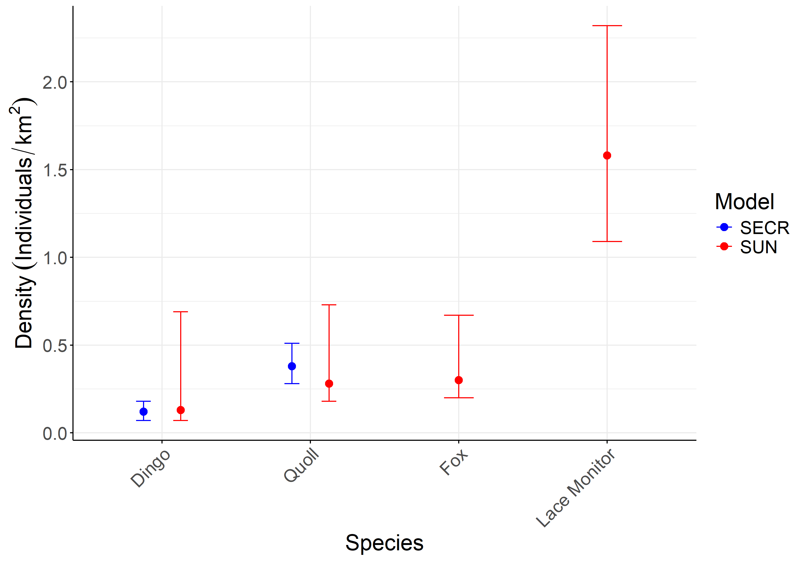

*Fig 2: Comparison of density estimates of four terrestrial predator species on the mid coast of NSW Australia. Estimates are derived from two modelling approaches, spatially explicit capture recapture models (SECR) that use individual identities, and spatially explicit unmarked models (SUN), that use presence absence data. Dingoes and quolls could be individually identified, and SECR models run, while foxes and lace monitors could not. Dingo density estimates include juveniles. Figure made in ggplot2.*

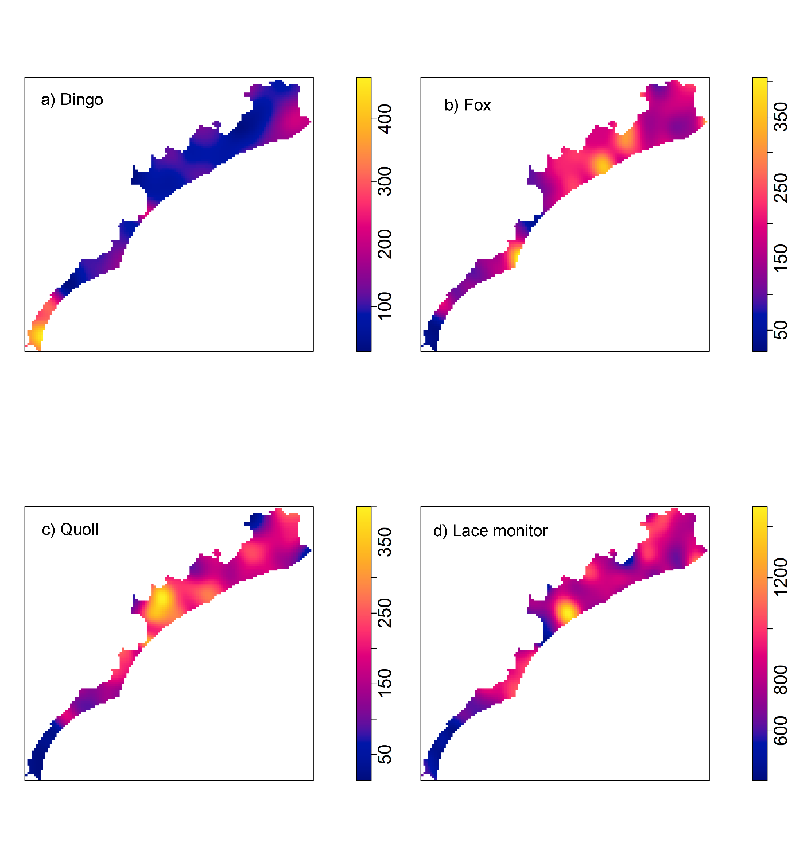

*Figure 3: Estimates of the intensity function of predicted activity centres of a) dingoes, b) foxes, c) quolls and d) lace monitors derived from Bayesian spatially explicit unmarked models for estimating population density, from each of 500 posterior samples (Baddeley et al 2015). Scale bar refers to the summed number of individuals estimated for all 500 samples at each pixel across the state space. Data from a camera trapping survey on the mid-coast of NSW, Australia, 2022-2023. Scale represents smoothed predicted activity centre densities for grid cells across the study area.*

*Spatial relationships*

All dyads involving dingoes (dingoes and foxes, dingoes and quolls, and dingoes and lace monitors) exhibited strong separation of activity centres (negative associations) at all distances (Fig 4). Foxes and quolls had neutral associations at <500m and positive associations >500m. Quolls and lace monitors showed negative associations at <500m, and positive associations >500m. Foxes and lace monitors had negative interactions at distances <1km, and neutral associations >1km (Fig 4).

*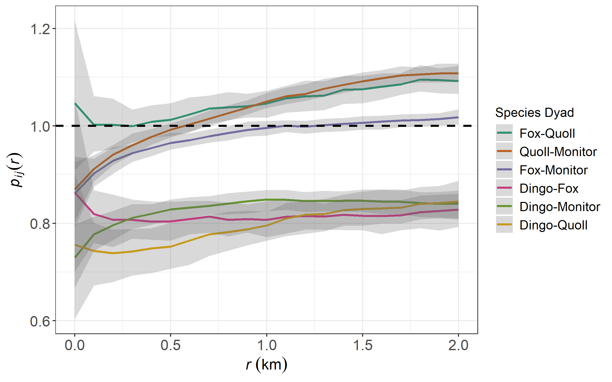Figure 4: Spatial relationships between predicted activity centres of foxes, dingoes, quolls and lace monitors, from a camera trapping survey of predators on the mid-coast of NSW, Australia. Predicted activity centres are derived from Bayesian, spatially explicit unmarked models, with patterns of avoidance and attraction are determined by ‘markconnect’ functions and the correlations of points at 100m intervals from 0-2km (Baddeley et al. 2015). Probability of co-occurrence values on y axis are normalised to aid interpretation. A value of <1 indicates avoidance, and value >1 indicates attraction.*

*Temporal activity*

Foxes were almost completely nocturnal, while quolls and dingoes exhibited more crepuscular behaviour. Lace monitors were completely diurnal. Temporal activity patterns did not change between species dyads depending on area of dingo risk (Fig 5). Quolls and dingoes showed more temporal overlap in both zones of risk than did any other species dyad (Fig 5), while foxes and monitors shared the least temporal overlap.

Quolls and fox activity peaks were slightly offset in high-risk dingo zones, and more offset in low-risk zones (Table 2). Quoll and dingo activity peaks were more similar in low-risk zones than in high-risk zones (Table 2). All other species combinations showed considerable differences in activity peaks, regardless of territory zone, potentially indicating temporal niche separation between mesopredators.

*Table 2: Temporal overlap and difference in activity peaks between combinations of three mammalian mesopredators from a camera trap survey on the mid coast of NSW, Australia 2022-2023. For ‘overlap coefficient,’ 1 suggests complete overlap, 0 complete avoidance. For ‘activity peak differences’, a higher ‘w’ value indicates a more significant difference in activity peaks (p<0.01).*

|  |  |  |  |  |
| --- | --- | --- | --- | --- |
| *Metric* | *Overlap coefficient (95% CIS)* | | *Activity Peak similarity (*=significant difference)* | |
| *Territory zone* | *High-Risk* | *Low-Risk* | *High-Risk* | *Low-Risk* |
| *Fox – Dingo* | **0.50 (0.42-0,58)** | **0.58 (0.49-0.66)** | **w=67.38\*** | **w= 47.44\*** |
| *Quoll – Dingo* | **0.83 (0.73-0.91)** | **0.82 (0.73-0.90)** | **w=8.79** | **w=1.01** |
| *Quoll - Fox* | **0.67 (0.53-0.80)** | **0.65 (0.56-0.74)** | **w=14.47\*** | **w=44.73\*** |
| *Fox-Monitor* | **0.03 (0.01-0.06)** | **<0.001 (<0.001-0.002)** | **w=135.09\*** | **w=379.21\*** |
| *Dingo-Monitor* | **0.26 (0.22-0.31)** | **0.19 (0.14-0.25)** | **w=429.83\*** | **w=226.06\*** |
| *Quoll-Monitor* | **0.16 (0.10-0.23)** | **0.16 (0.11-0.21)** | **w=110.85\*** | **w=236.35\*** |

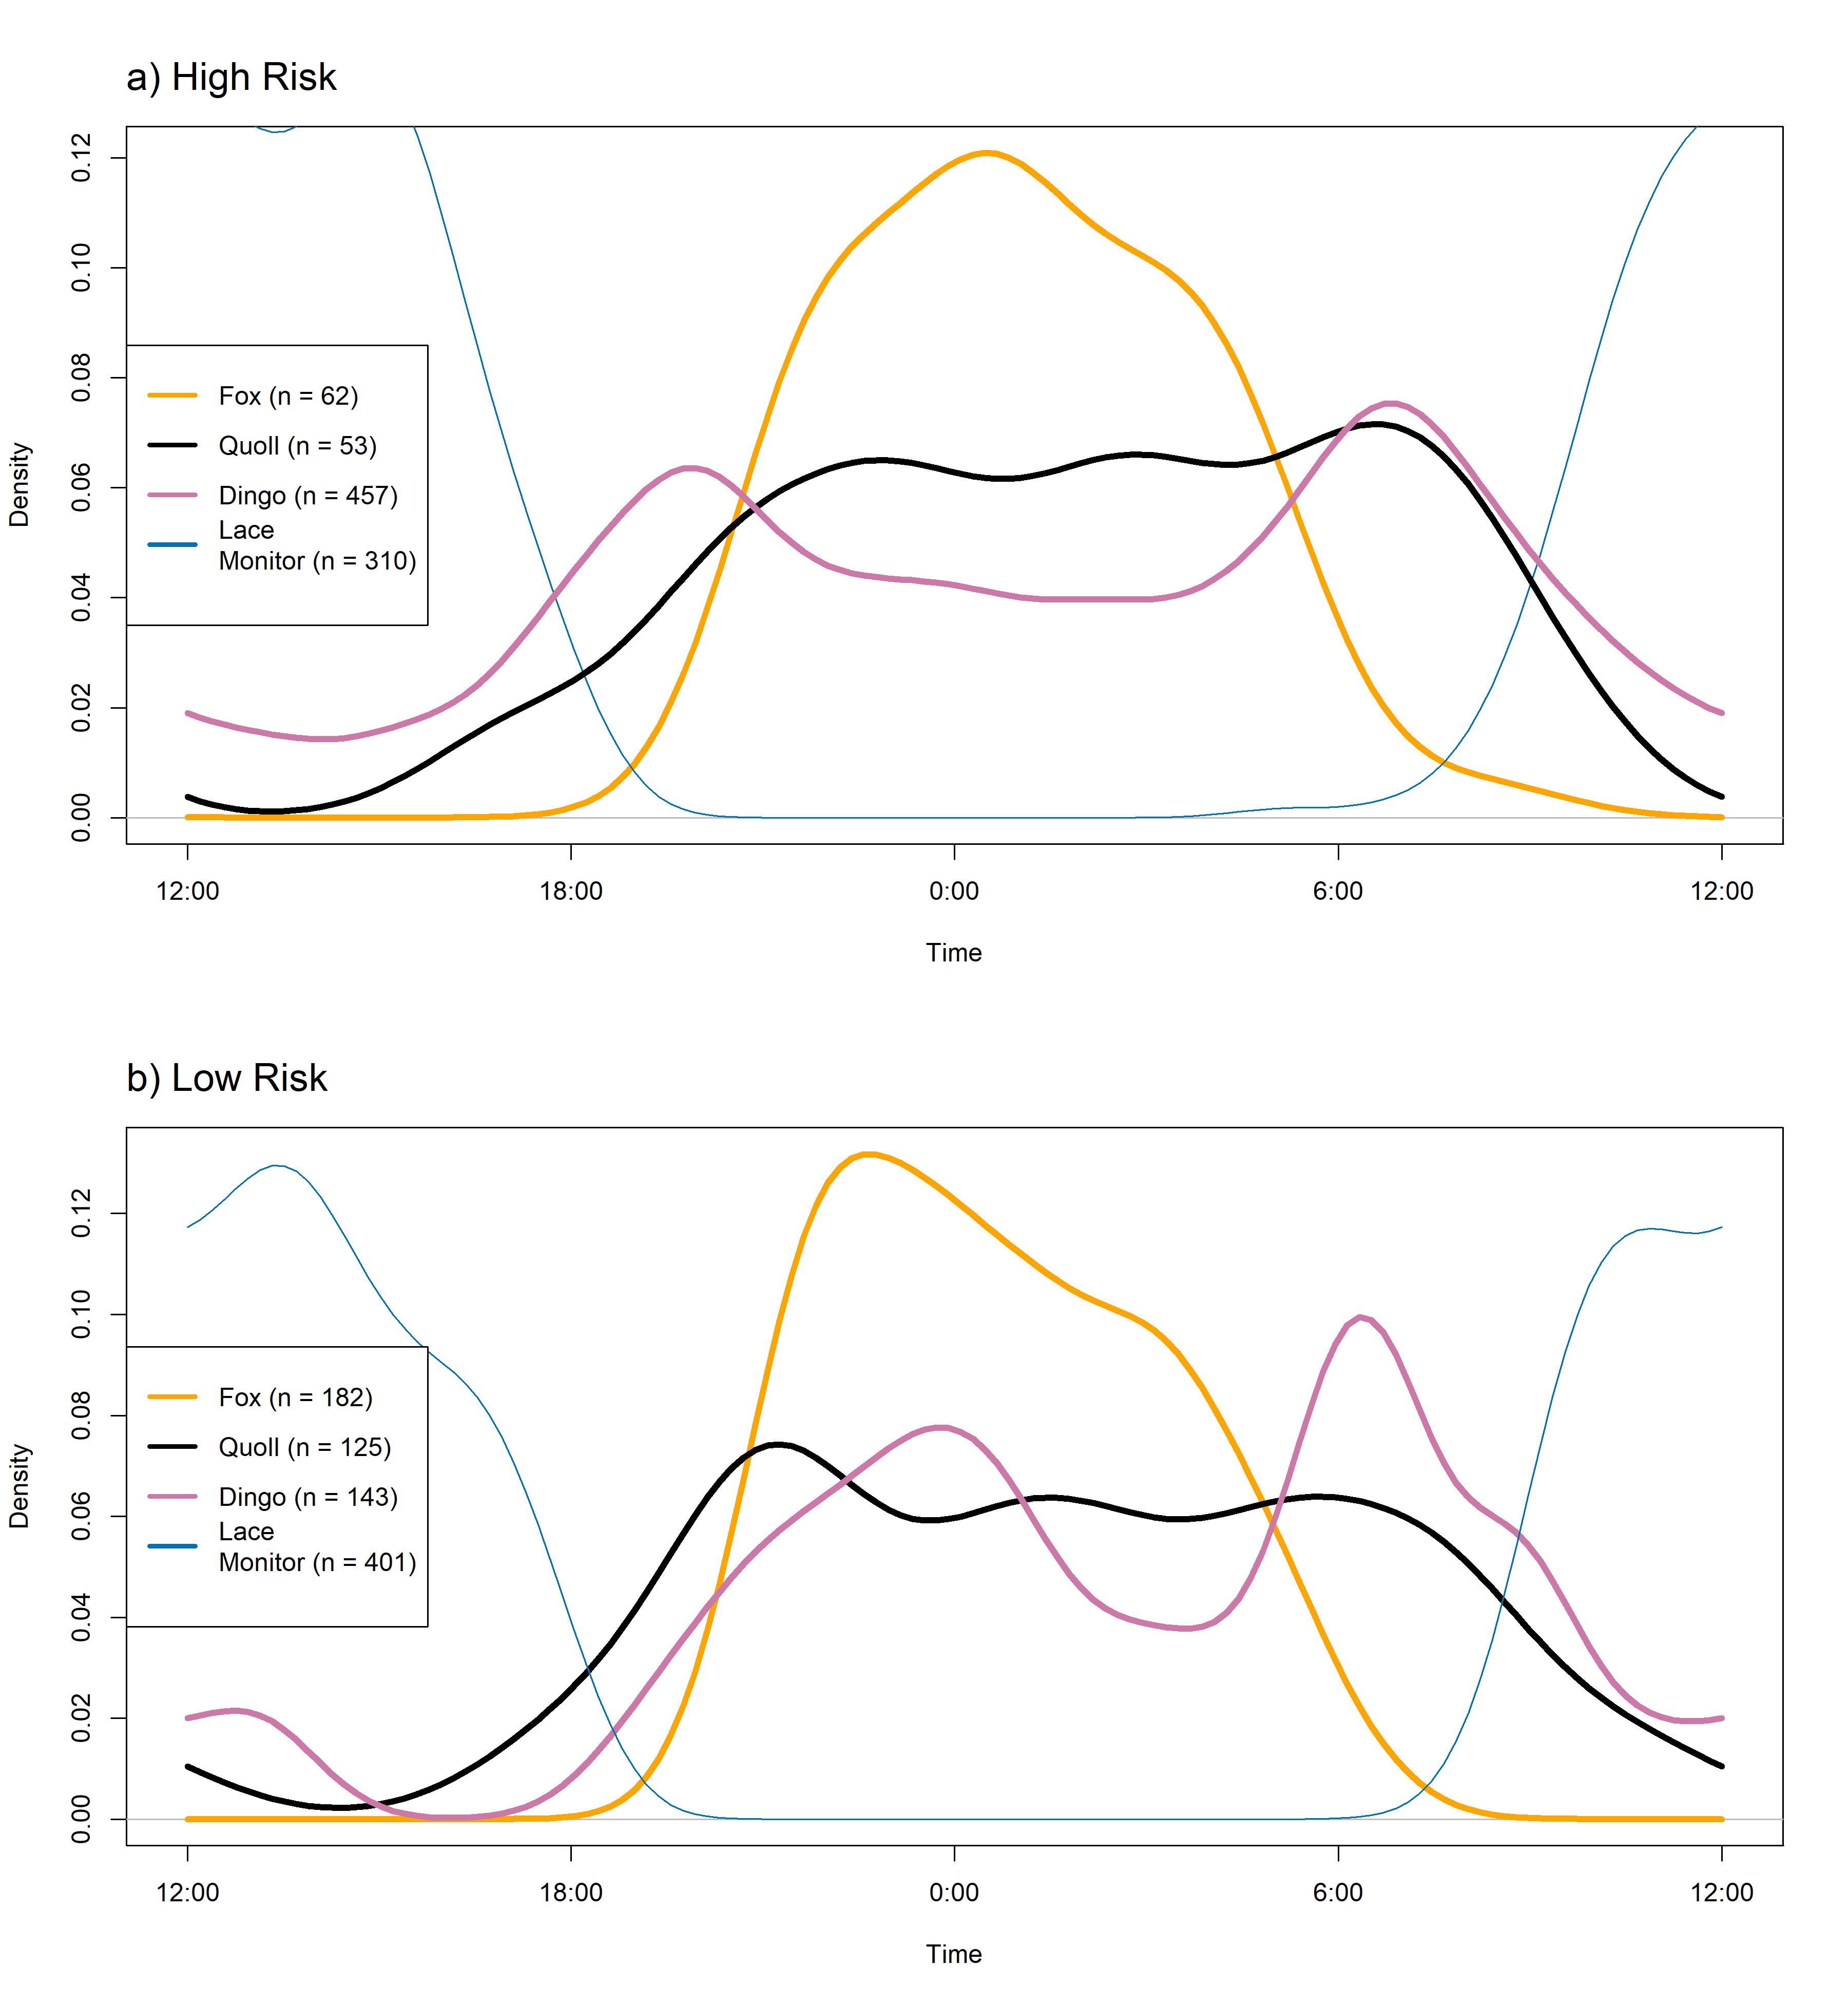

*Figure 5: Temporal activity patterns between four terrestrial predator species from a camera trap survey on the mid coast of NSW, Australia, within different dingo areas of risk. Dingo areas of risk were defined from comparisons of spatial avoidance of mesopredators to dingoes- if a camera station was closest to an area of high activity centre density, it was categorised as high risk. Figures made in R using the Overlap package (Ridout and Linkie 2009).*

Discussion

Apex predators can affect the behaviour and population dynamics of mesopredators, which can have flow-on effects for ecosystem functioning (Ritchie and Johnson 2009). Human influence, too, can affect mesopredators, and understanding how the combination of anthropogenic influence and apex predators influence mesopredators and their ecosystems is important to inform management in a rapidly urbanising world (Bateman and Fleming 2012). We found evidence for divergent impacts of these two drivers of ecosystem function, that varied with mesopredator species.

*Mesopredator population structure*

Quolls were never detected in an urban area, and detections were highly concentrated in natural habitat in the centre of the study area. Dingoes are known to occur at higher densities in urban areas in this region (Alting et al. 2024), and may be supressing quoll populations in these areas. However, quolls typically thrive in large forest patches with old tree hollows or other suitable den sites (Glen and Dickman 2011), features not usually associated with urban areas. While they can persist in fragmented landscapes (Henderson et al. 2022), quolls thrive in natural areas (Belcher 2004), and dingoes are likely to be a less important threatening process in urban areas than are anthropogenic threats (NSW Gov 2021).

Like quolls, foxes were never detected within ~5km of an urban area. This is surprising given previous studies (Kobryn et al. 2023), particularly as foxes have successfully adapted to urban areas across Australia, often occurring at higher densities than in natural environments (Coman et al. 1991). Indeed, the red fox is one of the more successful urban-adapted carnivores worldwide (Bateman and Fleming 2012). In the United Kingdom, where foxes lack a competitively dominant predator, they attain their highest densities in urban environments (Harris and Rayner 1986). In the United States, foxes are subordinate to many predators, with the closest analogues to dingoes in size being coyotes. Grey wolves, the largest canid predator, are largely absent in urban areas, but foxes have been shown to spatially segregate from coyotes by avoiding areas preferred by coyotes around urban landscapes (Lombardi et al. 2017) which likely promotes co-existence in these landscapes. That foxes are common in urban areas in the UK and in parts of Australia where they lack a competitively dominant predator, but are less abundant and alter their behaviour in areas with a competitively dominant predator, as in the US and our study site, suggests that apex predators are influencing mesopredator populations.

*Potential dingo influence*

As generalist omnivores, dingoes fill a similar niche to foxes and likely supress fox abundances in some areas across Australia (Cupples et al. 2011; Forsyth et al. 2019). We estimated a fox density of (0.30 km-2), which is on the lower end of previous density estimates reported in Australia, and slightly higher than a previous estimate using the same method, in an area in which dingoes are not lethally controlled (Forsyth et al 2019). We also identified spatial separation of foxes and dingoes at all spatial scales. Foxes were detected only 62 times (25% of all detections) in high-risk dingo areas (52% of cameras) compared to 182 times (75% of total detections) in low-risk dingo areas (48% of cameras), suggesting lower abundance in these areas of higher risk. Dingoes occur in high density in urban areas in this study area (Alting et al. 2024), and likely exploit anthropogenic food resources there. Some studies suggest that niche overlap between competitive species can increase in environments disturbed by humans, which may be leading to increased competition between foxes and dingoes in this region (Manlick and Pauli 2020).

Decoupling of preferred resource use by mesopredators has been noted in other species, in which predation pressure from a dominant predator, the eagle owl (*Bubo bubo*) resulted in the seeming spatial avoidance of stone martens (*Martes foina*) from areas of high prey density, due to direct killing from eagle owls and higher eagle owl abundance in these areas. Foxes’ apparent avoidance of urban areas (a normally preferred habitat) and spatial avoidance of dingoes at all spatial scales in this area suggests that dingoes are supressing foxes in a similar manner. Dingoes may be supressing red fox populations through direct killing, as occurs in other competitive predator interactions (Palomares and Caro 1999), and further evidence of this comes from a record of a fox killed by a dingo in the study area (Jordan et al. 2023). Our finding that foxes are absent in urban areas adds to the literature of how apex predators can decouple relationships between mesopredators and their favoured resources.

We also found patterns of spatial separation of activity centres amongst mesopredators (Fig 2). Lace monitors, quolls and foxes were spatially correlated at large distances, suggesting similar habitat preferences away from urban area (although this is unlikely for foxes), or alternatively similar spatial avoidance of dingoes. Despite this seemingly negative effect of dingoes on quoll spatial distribution (30% of quoll detections occurred at cameras in high-risk zones, where 52% of cameras were sited), the relatively high density estimate for quolls indicates that the quoll population is effectively coexisting with dingoes at densities at or above other areas where anthropogenic lethal control of dingoes occurs (Henderson et al. 2022). While quolls are subject to competitive pressure from dingoes through dietary overlap and direct killings (Fig S3), as evidenced by their spatial avoidance at both small and large scales, these negative pressures of dingo presence may be outweighed by the positive benefits of reduced fox abundance. Predation by foxes is considered a key threatening process for quolls, with interspecific competition likely to be high given their comparable body sizes and significant dietary overlap (Glen and Dickman 2008). This is supported by our finding of considerable spatial overlap between the two mesopredator species. While quolls may persist alongside foxes, sympatry may require low fox densities, as seems to be the case in our study area, which is likely aided by a high-density dingo population in the area. Apex predators can have contrasting effects on subordinate predators, with competitive relationships not always negative (van Schaik et al. 2024).

*SUN vs SECR model efficacy*

SUN models provided estimates comparable to SECR methods using individual identification, albeit with far wider confidence intervals. For the three mammalian predators SUN models seemingly performed well (Fig 2). Our estimate of dingo density from SUN models was very slightly higher (0.13 dingoes km-2, 95% credible intervals= 0.07-0.69), than from SECR models (0.12 dingoes km-2, 95% CI=0.07-0.18), but the estimate from the SECR model fell firmly within the credible intervals of the SUN estimate. Differences in these estimates may result from improved precision obtained by using individual identities in SECR models, or alternatively may be a result of slightly different modelling structures and assumptions. Both dingo density estimates were higher than previous dingo density estimates in the region, potentially because different assumptions and specifications were used in these models compared to previous work (Alting et al. 2024). Indeed, the density estimates we identified for dingoes here should not be compared to models using only adults.

Our estimates of fox density from SUN models (0.30 foxes km-2, 95% CI = 0.20-0.67) appear to be consistent with other estimates of fox density in NSW Australia (Forsyth et al. 2019). They are also comparable to those from other SUN models in similar environments in Australia, as reported in Forsyth et al (2019) in Namadgi National Park in the ACT (0.25 foxes km-2, 95% CI = 0.09-0.99) and Ramsey et al (2015) in the Grampians National Park in Victoria (0.22 foxes km-2, 95% CI = 0.16-0.54). Quoll density estimates from SUN models were slightly lower than SECR models (Fig 2), with slightly wider credible intervals than SECR confidence intervals. To our knowledge, lace monitor population density has not yet been reported in the literature, and it is unclear if our estimate of 1.58 lace monitors km-2 (95% CI = 1.09-2.32) is within expectation of population abundance for the species. Consequently, we view this estimate as preliminary, and suggest further estimates be made using individual identification with capture recapture techniques. Despite this, these models show promise for estimating species abundances from unmarked data, with models for quolls and dingoes comparable to SECR models with individual identification, albeit within wider confidence intervals.

*Temporal activity patterns*

Dingo activity patterns and peaks were similar across high and low likelihood dingo risk zones, allowing the impact of risk (a proxy for potential of encountering a dingo) on mesopredator activity to be evaluated. We observed no differences in temporal activity patterns for any of the mesopredators between the two zones. As shown elsewhere (Wooster et al. 2021), fox temporal activity peaks were offset with dingo activity peaks, and foxes were almost completely nocturnal in both dingo risk zones. Quolls were also predominantly nocturnal, displaying peaks in activity at dawn and just after dusk, but had more temporal overlap with dingoes than the overlap between any other species dyad. In both risk zones, quoll and dingo activity peaks were most similar, while fox and dingo, and fox and quoll activity peaks were significantly different in both zones. Foxes were detected less in high-risk dingo zones, and quolls may be able to adjust their activity peak to a more optimal foraging time (i.e. when foxes are also active) due to the low density of foxes present, as has been shown for other mesopredators in the absence of competitors (Shores et al. 2019).

Our results provided limited support for our prediction that an area of higher risk of encountering a dominant predator would lead to temporal shifts in behaviour of mesopredators. In some urban and peri-urban areas in Australia, foxes have been shown to be predominantly nocturnal, but ranging activity began before dusk and continued well past dawn (Gil-Fernández, et al. 2020). This is in contrast to our study area in which foxes were almost completely nocturnal, showing very limited crepuscular behaviour. Dingoes may be in high enough density – and exhibit peak crepuscular activity - across the entire study area that foxes must pursue a nearly completely nocturnal strategy to minimise encounters with dingoes in all areas. Alternatively, as some mesopredators shift to nocturnality in the presence of humans (Frey et al. 2020) fox (and quoll) nocturnality in the region may be driven by anthropogenic influences. Given the considerable spatial segregation we found between the two mammalian mesopredators and dingoes, these species may be facilitating coexistence through spatial segregation rather than finer scale temporal shifts. Disentangling the potential drivers of temporal behaviour of mesopredators requires further work.

*Lace monitor population dynamics and temporal activity*

Lace monitors were the most detected species in the survey on baited camera sites overall (n=634 detections, and were present at every site), which is unsurprising given they are predominantly scavengers (Jessop et al. 2012). Prior studies have shown a positive relationship between lethal control of foxes and monitor abundance (Hu et al. 2019), and the seemingly low abundance of foxes in our study area may allow monitors to persist. At spatial scales <1km, foxes and monitors were negatively associated, and were neutral at distances >1km. This suggests monitors may be negatively affected by foxes, and supports previous findings that foxes exert a negative pressure on lace monitors (Hu et al. 2019). Quolls and monitors were negatively associated at smaller scales, but positively associated at distances >500m. It is to be expected that mesopredators may compete for resources (Rees et al. 2023), and this may be occurring for quolls and monitors at small scales. The positive association between these species at larger levels likely reflects higher abundances of both species away from high areas of dingo abundance and urban areas. Monitors appeared less abundant around urban areas, and at a broader landscape level were in highest densities in areas where quolls and foxes were in highest density, and showed an inverse relationship with dingoes at all spatial scales (Fig 5). Lace monitors have been shown to be slightly less active at carcass sites when dingoes have been beforehand, suggesting some avoidance of dingoes (Cairncross et al. 2024), and our results seem to support that at a fine scale dingoes may be excluding monitors. Lace monitors can attain higher densities around some forms of human disturbance, such as campgrounds (Jessop et al. 2012), and are also highly visible at some campgrounds in this study area (Alting et al. 2024), although whether these campgrounds at which they appear are ones less frequently visited by dingoes warrants further study. Monitors showed consistently diurnal activity patterns, peaking at noon across both territory zones, and exhibiting very limited temporal overlap with the mammalian predators studied (Fig 5).

*Implications for predator management*

We provide the first density estimate of spotted-tailed quolls using spatial capture recapture methods in coastal, south-east Australian environment, estimating 0.35 individuals/ km-2 (95% CI = 0.18-0.73km-2) across the study area. This is very similar to estimates (mean = 0.39 km-2, range = 0.28-0.66 km-2) in an intact forested landscape ~125km west of our study site (Henderson et al. 2022), to estimates from north-east NSW, (0.1-0.5km-2) (Glen and Dickman 2008), and to population strongholds of the northern subspecies (*Dasyurus maculatus gracilis*) (mean density 0.1-0.4 km -2) (Uzqueda et al 2020). Despite this study occurring in the summer when quolls are less detectable (Henderson et al. 2022), we identified 47 individual quolls with 178 detections over the study period; sufficient to obtain reliable density estimates (Royle et al. 2013).

The eastern half of Myall Lakes National Park, where our study took place, is not baited with 1080 (sodium monofluoroacetate) poison to target dingoes/wild dogs and foxes. Lethal control of introduced species such as the red fox can have positive effects for native species, for competing predators such as quolls (Henderson et al. 2021), monitors (Hu et al. 2019), and susceptible prey (Olsson et al. 2005). However, lethal control can also have unexpected negative consequences, such as the ecological ‘release’ of other introduced mesopredators such as feral cats (*Felis catus*) (Rees et al. 2023). In our study area, foxes are seemingly in relatively low abundance, potentially through top-down suppression by dingoes, while quoll and monitor populations appear healthy despite this density of dingoes and the absence of poison baiting. Previously, it has been suggested that for quolls to persist in an area, lethal control of foxes through baiting may be necessary (Glen and Dickman 2008). Given the lack of baiting in our study area, and a persisting quoll population, our results suggest that baiting is not strictly necessary for their conservation where other conditions (such as low fox densities) are met. The high density estimates of quolls reported here is also encouraging, as available habitats in the study area, such as coastal heathland, are generally considered suboptimal for the species (Glen and Dickman 2011). Consequently, this indicates that the species may be more robust to different habitats than previously suspected.

Interspecific competition and its consequences are complex and difficult to disentangle. We have shown that two native mesopredators, the spotted-tailed quoll and the lace monitor, believed to be threatened by an introduced carnivore, the red fox, are persisting in an environment without lethal predator control. Fox and quoll spatial distributions varied with the likelihood of encountering an apex predator, although temporal strategies of avoidance were similar across risk levels. Furthermore, dingoes appeared to decouple the positive relationship usually found between foxes and urban environments, with foxes instead showing a positive trend in spatial activity centres away from urban areas. Collectively, our results illustrate how apex predators can structure ecosystems in unexpected ways, and underline the importance of accounting for inter-species dynamics when evaluating predator competition.

Acknowledgements

The Myall Lakes Dingo/Dapin Project takes place on Worimi Country and we acknowledge the Worimi people, past and present, and their historical and ongoing connection to dingoes and Country. This project received funding and support from Taronga Conservation Society Australia, National Parks and Wildlife Service NSW, and MidCoast Council, and was also supported by a UNSW Research Technology Services (ResTech) AWS cloud grant. This project also received funding from the Oatley Flora Society, and the Australian Wildlife Society. All work was conducted under scientific licence SL102716 and approval 22/102A from the UNSW Animal Ethics Committee. Thank you to Fiona Miller and NSW NPWS for loaning camera traps. We thank Dan Morris for extensive help with Megadetector image processing and David Ramsay for invaluable advice regarding modelling. Thanks to Simon Gorta, Jana Stewart, Georgia Dorahy, Martín Boer-Cueva, Dushmantha Gamage, Zhijun Lin, Finn Parker and Shanaz Masani for fieldwork assistance

Declaration of interest

The authors declare no conflicts of interest.

Data availability

All code and data used for this study are available on github: “PROVIDED ON REQUEST FOR DOUBLE BLIND SUBMISSION”

References

Agostinelli, C., & Lund, U. (2023). R package 'circular': Circular Statistics (version 0.5-0). *URL* <https://CRAN.R-project.org/package=circular>

Alting, B. A., Pitcher, B. P., Rees, M. W., Ferrer-Paris, J. R., & Jordan, N. R. (2024). Population density and ranging behaviour of a generalist carnivore varies with human population. *Ecology and Evolution*, 14, e11404. DOI: 10.1002/ece3.11404

Arjo, W. M., & Pletscher, D. H. (1999). Behavioral responses of coyotes to wolf recolonization in northwestern Montana. *Canadian Journal of Zoology*, 77(12), 1919-1927. doi:10.1139/z99-177

Baddeley, A., Rubak, E., & Turner, R. (2015). *Spatial Point Patterns: Methodology and Applications with R*. Chapman and Hall/CRC Press, London. ISBN 9781482210200, <https://www.routledge.com/Spatial-Point-Patterns-Methodology-and-Applications-with-R/Baddeley-Rubak-Turner/p/book/9781482210200>.

Bateman, P. W., & Fleming, P. A. (2012). Big city life: carnivores in urban environments. *Journal of Zoology*, 287(1), 1-23. doi:<https://doi.org/10.1111/j.1469-7998.2011.00887.x>

Beery, S., Morris, D. and Yang, S., 2019. Efficient pipeline for camera trap image review. *arXiv preprint arXiv:1907.06772*.

Belcher, C. (2004). The largest surviving marsupial carnivore on mainland Australia: the Tiger or Spotted-tailed Quoll Dasyurus maculatus, a nationally threatened, forest-dependent species. *Conservation of Australia’s Forest Fauna*, 2, 612-623.

Berger, K. M., & Conner, M. M. (2008). Recolonizing wolves and mesopredator suppression of coyotes: impacts on pronghorn population dynamics. *Ecological Applications*, 18(3), 599-612. doi:<https://doi.org/10.1890/07-0308.1>

Bischof, R., Dupont, P., Milleret, C., Chipperfield, J., & Royle, J. A. (2020). Consequences of ignoring group association in spatial capture–recapture analysis. *Wildlife Biology*, 2020. doi:10.2981/wlb.00649

Blake, J., & Mosquera, G. D. (2014). Camera trapping on and off trails in lowland forest of eastern Ecuador: does location matter? *Mastozoologia Neotropical*, 21(1), 17-26.

Cairns, K. M. (2021). What is a dingo - Origins, hybridisation and identity. *Australian Zoologist*, 41(3), 322-337. doi:10.7882/AZ.2021.004

Calenge, C. (2006). The package adehabitat for the R software: a tool for the analysis of space and habitat use by animals. *Ecological Modelling*, 197, 516-519.

Castle, G., Kennedy, M. S., & Allen, B. L. (2023). Stuck in the mud: Persistent failure of ‘the science’ to provide reliable information on the ecological roles of Australian dingoes. *Biological Conservation*, 285, 110234. doi:<https://doi.org/10.1016/j.biocon.2023.110234>

Chandler, R. B., & Royle, J. A. (2013). Spatially explicit models for inference about density in unmarked or partially marked populations. *The Annals of Applied Statistics*, 7(2), 936-954.

Coman, B.J., Robinson, J., & Beaumont, C. (1991). Home Range, Dispersal and Density of Red Foxes (Vulpes Vulpes L.) in Central Victoria. *Wildlife Research, 18*(2), 215-223. <https://doi.org/10.1071/WR9910215>

Cupples, J.B., Crowther, M.S., Story, G., & Letnic, M. (2011). Dietary overlap and prey selectivity among sympatric carnivores: Could dingoes suppress foxes through competition for prey? *Journal of Mammalogy, 92*(3), 590-600. doi:10.1644/10-MAMM-A-164.1

Darimont, C.T., Fox, C.H., Bryan, H.M., & Remchen, T.T. (2015). The unique ecology of human predators. *Science, 349*(6250), 858-860. doi:10.1126/science.aac4249

Darnell, A.M., Graf, J.A., Somers, M.J., Slotow, R., & Gunther, M.S. (2014). Space use of African wild dogs in relation to other large carnivores. *PLoS ONE, 9*(6). doi:10.1371/journal.pone.0098846

de Valpine, P., Turek, D., Paciorek, C.J., Anderson-Bergman, C., Temple Lang, D., & Bodik, R. (2017). Programming with models: writing statistical algorithms for general model structures with NIMBLE. *Journal of Computational and Graphical Statistics, 26*, 403-413. DOI:10.1080/10618600.2016.1172487

Doherty, T.S., Davis, N.E., Dickman, C.R., Forsyth, D.M., Letnic, M., Nimmo, D.G., Palmer, R., Ritchie, E.G., Benshemesh, J., Edwards, G., Lawrence, J., Lumsden, L., Pascoe, C., Sharp, A., Stokeld, D., Myers, C., Story, G., Story, P., Triggs, B., Venosta, M., Wysong, M., & Newsome, T.M. (2019). Continental patterns in the diet of a top predator: Australia's dingo. *Mammal Review, 49*(1), 31-44. doi:10.1111/mam.12139

Efford, M. (2024). *secr: Spatially explicit capture-recapture models*. R package version 4.6.6, <https://CRAN.R-project.org/package=secr>.

ESRI. (2011). *ArcGIS Desktop: Release 10*. Redlands, CA: Environmental Systems Research Institute.

Estes, J.A., Terborgh, J., Brashares, J.S., Power, M.E., Berger, J., Bond, W.J., Carpenter, S.R., Essington, T.E., Holt, R.D., Jackson, J.B.C., Marquis, R.J., Oksanen, L., Oksanen, T., Paine, R.T., Pikitch, E.K., Ripple, W.J., Sandin, S.A., Scheffer, M., Schoener, T.W., Shurin, J.B., Sinclair, A.R.E., Soulé, M.E., Virtanen, R., & Wardle, D.A. (2011). Trophic Downgrading of Planet Earth. *Science, 333*(6040), 301-306. DOI:10.1126/science.1205106

Forsyth, D.M., Ramsey, D.S.L., & Woodford, L.P. (2019). Estimating abundances, densities, and interspecific associations in a carnivore community. *Journal of Wildlife Management, 83*, 1090-1102. <https://doi.org/10.1002/jwmg.21675>

Frey, S., Volpe, J.P., Heim, N.A., Paczkowski, J., & Fisher, J.T. (2020). Move to nocturnality not a universal trend in carnivore species on disturbed landscapes. *Oikos, 129*(8), 1128-1140. doi:10.1111/oik.07251

Garvey, P.M., Glen, A.S., Clout, M.N., Nichols, M., & Pech, R.P. (2022). Niche partitioning in a guild of invasive mammalian predators. *Ecological Applications, 32*(4), e2566. doi:<https://doi.org/10.1002/eap.2566>

Gaynor, K.M., McInturff, A., & Brashares, J.S. (2022). Contrasting patterns of risk from human and non-human predators shape temporal activity of prey. *Journal of Animal Ecology, 91*(1), 46-60.

Gil-Fernández, M., Harcourt, R., Newsome, T., Towerton, A., & Carthey, A. (2020). Adaptations of the red fox (Vulpes vulpes) to urban environments in Sydney, Australia. *Journal of Urban Ecology, 6*(1), juaa009.

Glen, A., & Dickman, C.R. (2011). Why are there so many Spotted-tailed Quolls Dasyurus maculatus in parts of north-eastern New South Wales? *Australian Zoologist, 35*(3), 711-718. doi:10.7882/AZ.2011.023

Glen, A. S., and Dickman, C. R. (2008). Niche overlap between marsupial and eutherian carnivores: does competition threaten the endangered spotted-tailed quoll? *Journal of Applied Ecology* 45(2): 700-707. doi:<https://doi.org/10.1111/j.1365-2664.2007.01449.x>

Greenberg, S. (2020). *The Timelapse User Guide Version 2.2*.

Groom, R. J., Lannas, K., and Jackson, C. R. (2017). The impact of lions on the demography and ecology of endangered African wild dogs. *Animal Conservation* 20(4): 382-390. doi:10.1111/acv.12328

Harmsen, B. J., Foster, R. J., Silver, S. C., Ostro, L. E. T., and Doncaster, C. P. (2011). Jaguar and puma activity patterns in relation to their main prey. *Mammalian Biology* 76(3): 320-324. doi:<https://doi.org/10.1016/j.mambio.2010.08.007>

Harris, S., and Rayner, J. M. V. (1986). Urban Fox (Vulpes vulpes) Population Estimates and Habitat Requirements in Several British Cities. *Journal of Animal Ecology* 55(2): 575-591. doi:10.2307/4740

Harry, A. M., Jacob, L. C., Judy, A. D., Leonie, E. V., and Dale, G. N. (2020). Spot on: using camera traps to individually monitor one of the world’s largest lizards. *Wildlife Research* 47(4): 326-337. doi:10.1071/WR19159

Hazra, A. (2017). Using the confidence interval confidently. *J Thorac Dis* 9(10): 4125-4130.

Henderson, T., Fancourt, B. A., Rajaratnam, R., Vernes, K., and Ballard, G. (2021). Spatial and temporal interactions between endangered spotted-tailed quolls and introduced red foxes in a fragmented landscape. *Journal of Zoology* 315(4): 276-287. doi:<https://doi.org/10.1111/jzo.12919>

Henderson, T., Fancourt, B. A., Rajaratnam, R., Vernes, K., and Ballard, G. (2022). Density estimates reveal that fragmented landscapes provide important habitat for conserving an endangered mesopredator, the spotted-tailed quoll. *Scientific Reports* 12(1): 12688. doi:10.1038/s41598-022-16982-x

Hu, Y., Gillespie, G., and Jessop, T. S. (2019). Variable reptile responses to introduced predator control in southern Australia. *Wildlife Research* 46(1): 64-75. doi:10.1071/WR18047

Jessop, T. S., Smissen, P., Scheelings, F., and Dempster, T. (2012). Demographic and Phenotypic Effects of Human Mediated Trophic Subsidy on a Large Australian Lizard (Varanus varius): Meal Ticket or Last Supper? *PLOS ONE* 7(4): e34069. doi:10.1371/journal.pone.0034069

Jessop, T. S. (2023). Capture predicates corticosterone responses and a low recapture likelihood in a varanid lizard. *Wildlife Research* 50(7): 517-525.

Jiménez, J., Nuñez-Arjona, J. C., Mougeot, F., Ferreras, P., González, L. M., García-Domínguez, F., Muñoz-Igualada, J., Palacios, M. J., Pla, S., Rueda, C., Villaespesa, F., Nájera, F., Palomares, F., and López-Bao, J. V. (2019). Restoring apex predators can reduce mesopredator abundances. *Biological Conservation* 238: 108234. doi:<https://doi.org/10.1016/j.biocon.2019.108234>

Jordan, N. R., Campbell-Ward, M., Vandersteen, J., Colman, N., Alting, B., Gamage, D., Cairns, K. M., Bell, M., Altuna, J., and Pitcher, B. J. (2023). Inferring interspecific killing of Red Fox by Dingo from wounds and inter-canine distance measures – and a call for more data. *Australian Zoologist* 43(2): 276-280. doi:10.7882/AZ.2023.030

Kahle, D., and Wickham, H. (2013). ggmap: Spatial Visualization with ggplot2. *The R Journal* 5(1): 144–161. <https://journal.r-project.org/archive/2013-1/kahle-wickham.pdf>

Kobryn, H. T., Swinhoe, E. J., Bateman, P. W., Adams, P. J., Shephard, J. M., and Fleming, P. A. (2023). Foxes at your front door? Habitat selection and home range estimation of suburban red foxes (Vulpes vulpes). *Urban Ecosystems* 26(1): 1-17. doi:10.1007/s11252-022-01252-5

Kronfeld-Schor, N., and Dayan, T. (2003). Partitioning of Time as an Ecological Resource. *Annual Review of Ecology, Evolution, and Systematics* 34(1): 153-181. doi:10.1146/annurev.ecolsys.34.011802.132435

Lei, J., and Booth, D. T. (2017). Intraspecific variation in space use of a coastal population of lace monitors (Varanus varius). *Australian Journal of Zoology* 65(6): 398-407. doi:10.1071/ZO17078

Letnic, M., Ritchie, E. G., and Dickman, C. R. (2012). Top predators as biodiversity regulators: The dingo *Canis lupus dingo* as a case study. *Biological Reviews* 87(2): 390-413. doi:10.1111/j.1469-185X.2011.00203.x

Link, W. A., and Eaton, M. J. (2012). On thinning of chains in MCMC. *Methods in Ecology and Evolution* 3(1): 112-115.

Lombardi, J. V., Comer, C. E., Scognamillo, D. G., and Conway, W. C. (2017). Coyote, fox, and bobcat response to anthropogenic and natural landscape features in a small urban area. *Urban Ecosystems* 20(6): 1239-1248. doi:10.1007/s11252-017-0676-z

Macdonald, D. W. (1983). The ecology of carnivore social behaviour. *Nature* 301(5899): 379-384. doi:10.1038/301379a0

Manlick, P. J., and Pauli, J. N. (2020). Human disturbance increases trophic niche overlap in terrestrial carnivore communities. *Proceedings of the National Academy of Sciences* 117(43): 26842-26848.

Massicotte, P., and South, A. (2023). *rnaturalearth: World Map Data from Natural Earth*. R package version 1.0.1, <https://CRAN.R-project.org/package=rnaturalearth>.

Meek, P. D., and Saunders, G. (2000). Home range and movement of foxes (*Vulpes vulpes*) in coastal New South Wales, Australia. *Wildlife Research* 27: 663-668. doi:<https://doi.org/10.1071/WR98030>

Niedballa, J., Sollmann, R., Courtiol, A., and Wilting, A. (2016). camtrapR: an R package for efficient camera trap data management. *Methods in Ecology and Evolution* 7(12): 1457–1462. doi:10.1111/2041-210X.12600,

Olsson, M., Wapstra, E., Swan, G., Snaith, E. R. N., Clarke, R. O. N., and Madsen, T. (2005). Effects of long-term fox baiting on species composition and abundance in an Australian lizard community. *Austral Ecology* 30(8): 899-905. doi:<https://doi.org/10.1111/j.1442-9993.2005.01534.x>

Palomares, F., and Caro, T. M. (1999). Interspecific killing among mammalian carnivores. *American Naturalist* 153(5): 492-508.

Pascoe, J. H., Flesch, J. S., Duncan, M. G., Pla, M. L., and Mulley, R. C. (2019). Territoriality and seasonality in the home range of adult male free-ranging lace monitors (*Varanus varius*) in south-eastern Australia. *Herpetological Conservation and Biology* 14(1): 97-104.

Pyke, G. H. (1984). Optimal Foraging Theory: A Critical Review. *Annual Review of Ecology and Systematics* 15(1): 523-575. doi:10.1146/annurev.es.15.110184.002515

Raynor, J. L., Grainger, C. A., and Parker, D. P. (2021). Wolves make roadways safer, generating large economic returns to predator conservation. *Proceedings of the National Academy of Sciences* 118(22): e2023251118. doi:10.1073/pnas.2023251118

Rees, M. W., Pascoe, J. H., Pla, M. L., Robley, A., Birnbaum, E. K., Wintle, B. A., and Hradsky, B. A. (2023). Mesopredator release among invasive predators: Controlling red foxes can increase feral cat density and alter their behaviour. *Journal of Applied Ecology* 60(6): 1100-1114. doi:<https://doi.org/10.1111/1365-2664.14402>

Ridout, M. & Linkie, M. (2009). Estimating overlap of daily activity patterns from camera trap data. *Journal of Agricultural, Biological, and Environmental Statistics*, 14(3): 322–337.

Ripple, W.J., Estes, J.A., Beschta, R.L., Wilmers, C.C., Ritchie, E.G., Hebblewhite, M., Berger, J., Elmhagen, B., Letnic, M., Nelson, M.P., Schmitz, O.J., Smith, D.W., Wallach, A.D. & Wirsing, A.J. (2014). Status and ecological effects of the world’s largest carnivores. *Science*, 343(6167): 1241484. doi:10.1126/science.1241484

Ritchie, E.G. & Johnson, C.N. (2009). Predator interactions, mesopredator release and biodiversity conservation. *Ecology Letters*, 12(9): 982-998.

Royle, J.A., Chandler, R.B., Sollmann, R. & Gardner, B. (2013). *Spatial capture-recapture*. Academic Press.

Shores, C.R., Dellinger, J.A., Newkirk, E.S., Kachel, S.M. & Wirsing, A.J. (2019). Mesopredators change temporal activity in response to a recolonizing apex predator. *Behavioral Ecology*, 30(5): 1324-1335.

Thinley, P., Rajaratnam, R., Lassoie, J.P., Morreale, S.J., Curtis, P.D., Vernes, K., Leki, L., Phuntsho, S., Dorji, T. & Dorji, P. (2018). The ecological benefit of tigers (Panthera tigris) to farmers in reducing crop and livestock losses in the eastern Himalayas: Implications for conservation of large apex predators. *Biological Conservation*, 219: 119-125. doi:<https://doi.org/10.1016/j.biocon.2018.01.015>

Thomson, P.C., Rose, K. & Kok, N.E. (1992). The behavioural ecology of dingoes in north-western Australia. V. Population dynamics and variation in the social system. *Wildlife Research*, 19(5): 565-583. doi:10.1071/wr9920585

Tredennick, A.T., Hooker, G., Ellner, S.P. & Adler, P.B. (2021). A practical guide to selecting models for exploration, inference, and prediction in ecology. *Ecology*, 102(6): e03336. doi:<https://doi.org/10.1002/ecy.3336>

Uzqueda, A., Burnett, S., Bertola, L.V. & Hoskin, C.J. (2020). Quantifying range decline and remaining populations of the large marsupial carnivore of Australia's tropical rainforest. *Journal of Mammalogy*, 101: 1021–1034. doi:10.1093/jmammal/gyaa077

van Schaik, T., van Kuijk, M. & Sterck, E.H.M. (2024). Understanding mesopredator responses to changes in apex predator populations in Europe: implications for the mesopredator release hypothesis. *Mammal Review*, n/a(n/a).

Virgós, E., Baniandrés, N., Burgos, T. & Recio, M.R. (2020). Intraguild predation by the eagle owl determines the space use of a mesopredator carnivore. *Diversity*, 12(9): 359.

Wickham, H. (2016). *ggplot2: Elegant graphics for data analysis*. Springer-Verlag New York. ISBN 978-3-319-24277-4. <https://ggplot2.tidyverse.org>.

Wooster, E.I.F., Ramp, D., Lundgren, E.J., O'Neill, A.J., Yanco, E., Bonsen, G.T. & Wallach, A.D. (2022). Predator protection dampens the landscape of fear. *Oikos*, 2022(11): e09059. doi:<https://doi.org/10.1111/oik.09059>

Webb, J. (1994). Observation of three dingoes killing a large lace monitor (Varanus varius). *Australian Mammalogy*, 19: 55-56. doi:10.1071/AM96055