Super fun, cool paper title

## Authors

#### Brendan S. Lanham1,a

1Centre for Marine Science and Innovation, School of Biological, Earth and Environmental Science, University of New South Wales, Sydney, NSW Australia.

aCorresponding author - email: [brendan.lanham@unsw.edu.au](mailto:brendan.lanham@unsw.edu.au)

## Abstract

Blah blah blah yadda yadda yadda

**Keywords: rStudio; rmarkdown; word sucks; etc**

##### Introduction

Lots of writing here that most people will skim over. You might want to put some of it in *italics* and some of it in **bold for some reason**. It’s also important to use references (Lanham et al. 2018).

## Materials and Methods

### Third order heading

Deets on experiment one. The sampling area was 24 km2. I think this does subscript

### Another section subheading

Deets on experiment 2 and here you might want to hyperlink ([www.seagis.com](https://www.seagis.com.au))

## Results

### Results from experiment one

Species one, *V. cool* was more abundant in the ocean in contrast to the land (Table 1).

### Results from experiment two

| Method | Number of studies |
| --- | --- |
| Not clearly described | 15 |
| Manually collected | 12 |
| Pump | 8 |
| Donated from WWTP | 4 |
| Nets | 3 |
| Sieve stacks | 2 |
| Autosample | 2 |
| Grab sampler | 2 |
| Core sampler | 1 |
| Portable sampler | 1 |
| Manta trawl | 1 |

## Discussion

Heaps more text.

## Figures

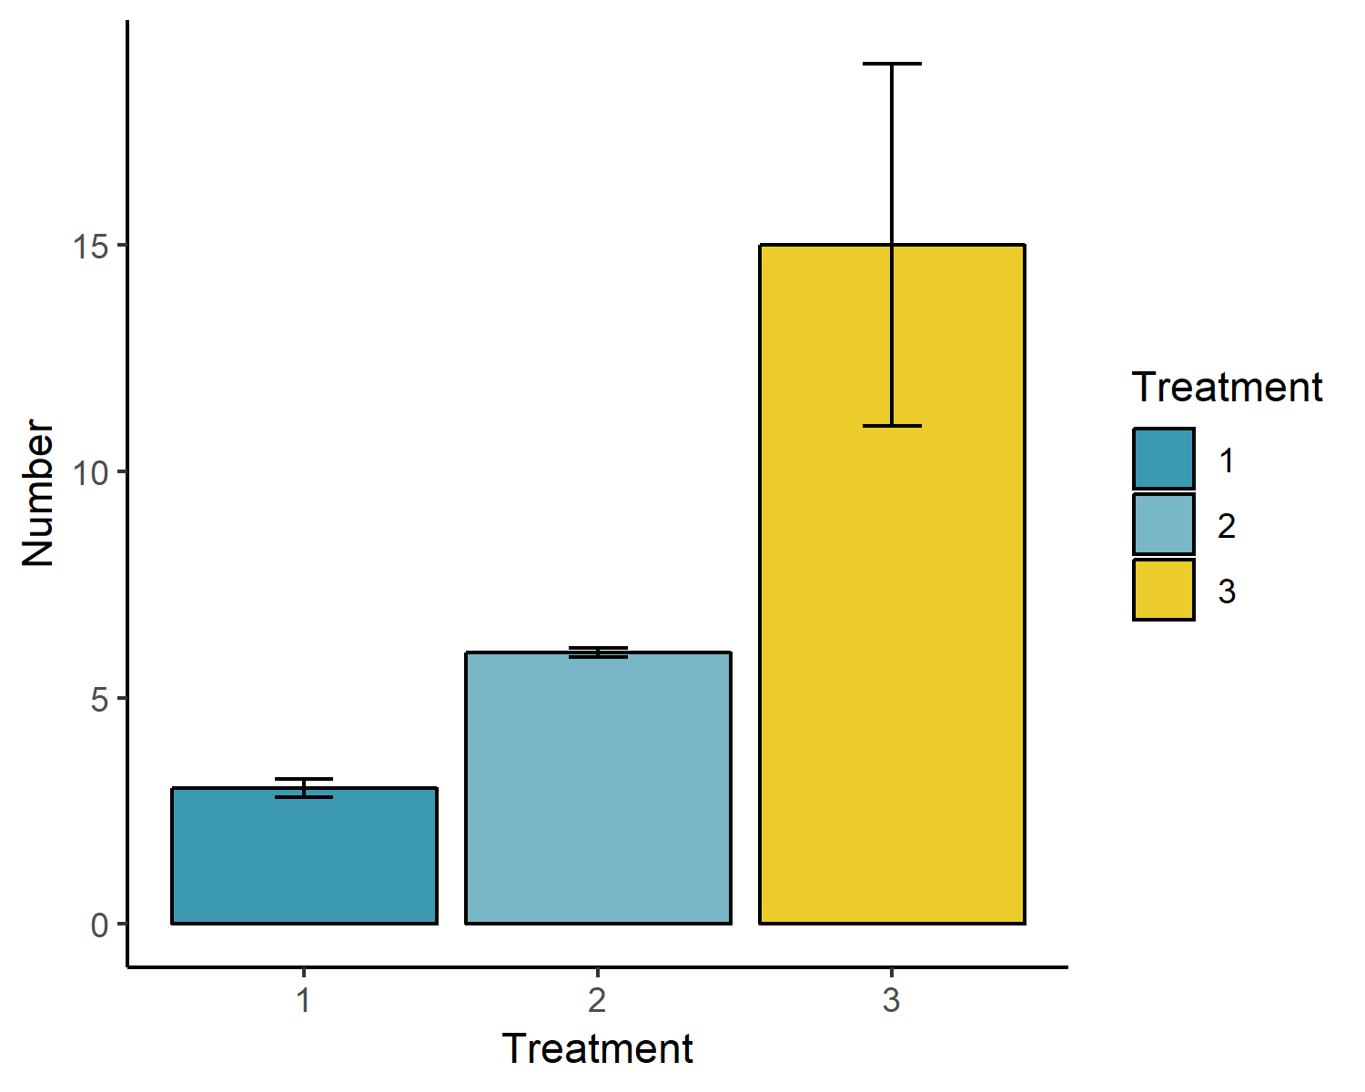

Figure 1. Caption for this very informative plot.

## Literature cited

Lanham, B. S., A. Vergés, L. H. Hedge, E. L. Johnston, and A. G. Poore. 2018. Altered fish community and feeding behaviour in close proximity to boat moorings in an urban estuary. Marine Pollution Bulletin 129:43–51.