Brendan Waters

[b101@umbc.edu](mailto:b101@umbc.edu)

CMSC 433 Project 1

How to access the game:

Once you have unzipped proj1.zip open the file password.txt and read the password that can be entered to view student score information. To open the game simply double-click proj1.html and play, it’s ready to go!

Project Description:

This project was designed mainly with ease of use in mind as it is a game geared toward young children. The decisions included in this design were minimal user interaction required, simplistic and kid-friendly graphic design, a simplistic, low-clutter layout, and obvious visual clues. Here’s a look at the page right when it opens up.

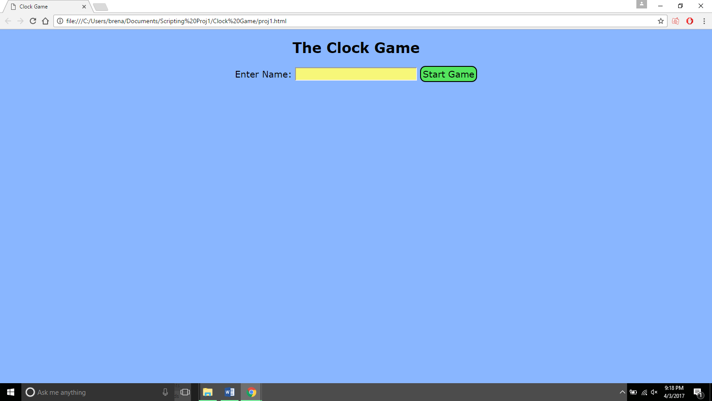

At this point the user can only do two things. Either enter in a name and start the game or the teacher can enter the password and click the Start Game button to view students’ scores for that session instead. This is what the page will look like if a game is started.

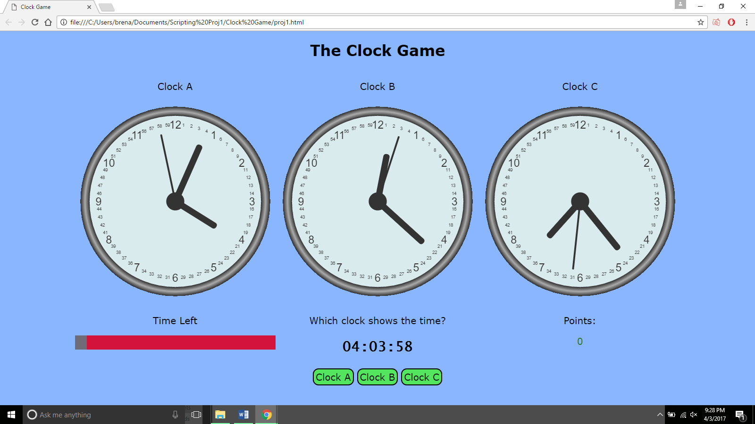

The student is presented with three clocks which are the main focus of the screen with a smaller user interface below. This interface has on the left a red bar that makes it clearly visible at a glance how much time is left. I discussed the time limit with an elementary education major and we reached the conclusion that 90 seconds was a good time limit. Children don’t have a long attention span and even when I was playing this game to test it 90 seconds felt plenty long since so many answers can be made in that amount of time. In the middle of the interface is what the student will actually be interacting with. This part contains the prompt and the time that the student is looking for. By simply clicking one of the buttons below the student makes their choice of which clock displays the given time. On the right-hand side of the interface is the feedback portion which tells students if they are doing well or poorly. Whenever a correct answer is chosen the points increase by 100 and display in green with a message below saying that the answer was correct. This positive feedback lets the student know that they are doing well. If an incorrect answer is chosen the points decrease by 100 (but can’t fall below zero) and display in red with a message underneath telling the student to try again. This response makes lets the student know that they should spend more time making sure that they have the correct answer before clicking any of the buttons. Here are pictures displaying what it looks like to get an answer correct and incorrect respectively.

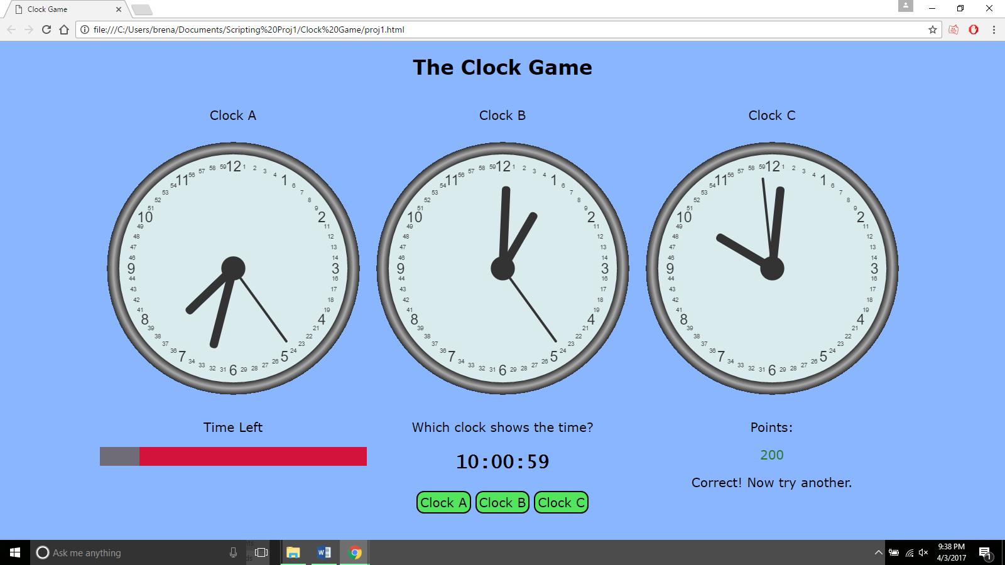

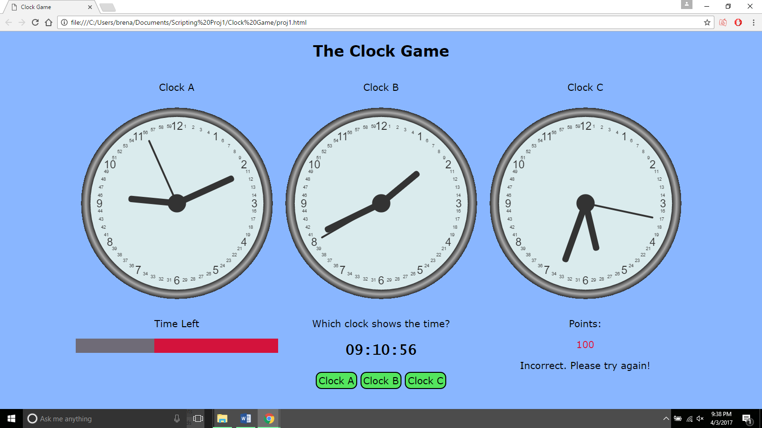

When the red bar reaches the end and disappears, time is up. At this point the game display becomes hidden and the student is shown their final score.

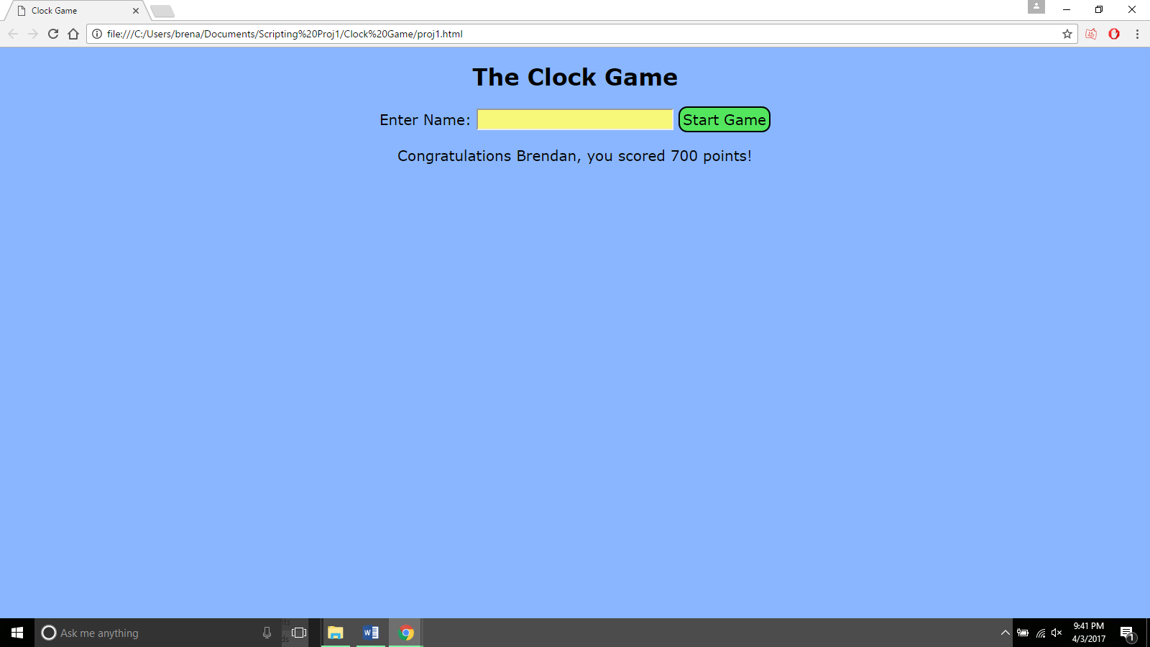

From this point either another student can start their own game after entering in their name or, as before, the teacher can enter the password. Here’s a look at the results display.

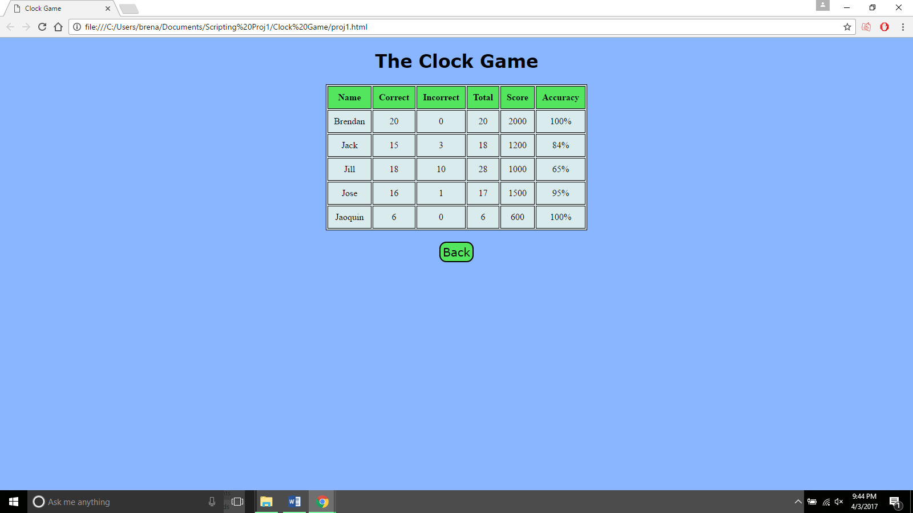

This table shows all of the data a teacher might want to know about each student’s results with the most important two pieces of data being on the right side of the table. The score column shows which student got the highest score in the game, but the accuracy might be more revealing information as it will tell the teacher which students took the time to ensure most or all of their answers were correct before clicking a button and which chose answers faster but might have been correct less often. This table can also be easily copied and pasted into a word document with neat (tabbed) formatting for later use.

From this point, the teacher can return to the original display where a new game can be started or this display can be revisited.

Resources used:

To create the clocks for this project I used and modified code that can be found at:

<https://www.w3schools.com/graphics/canvas_clock_start.asp>

To create the timer bar I used and modified code that can be found at:

<https://www.w3schools.com/howto/howto_js_progressbar.asp>