Table of Contents

Stop Payment – ACH 2
Stop Payment – ACH cont. 3
Stop Payment – Check 4
Automatic Distribution Form –Updating/Canceling 5
Automatic Distribution Form –Updating/Canceling cont. 6
ACH Pending Query 8
Overdraft Protection List 9
Per Diem/Daily Interest 10
Past Due Accounts 11
Balancing 12
Balancing cont. 13
Balancing cont. 14

Stop Payment – ACH
Facts:
- It is difficult to stop an ACH due to the number of ways the item may be presented.
Note: The most efficient way to stop an ACH debit is to have the Member contact the company (i.e. Member avoids the stop payment fee).
- All companies are subject to change their Company ID without notice. If the Company ID changes, the ACH stop payment will not be effective.
Note: The Member will be responsible for taking the risk. Neither the stop payment fee nor the ACH debit amount will be refunded.
- An ACH Stop Payment with the Company ID and a zero dollar amount stops ALL ACH items for that company.
Note: Verify if the Member has more than one item scheduled to post from that company.
- An ACH Stop Payment with the Company ID and a specific dollar amount stops ALL ACH items for that company for the exact dollar amount specified.
- If the ACH transaction has never been presented, refer to the following:
- The required information to place the ACH stop payment is missing. Therefore, there is a lot of uncertainty about how the ACH debit will be presented.
- The Member will be responsible for taking the risk. Neither the stop payment fee nor the ACH debit amount will be refunded.
Note: Refer to Member Payment Services for further instruction.
- ACH stop payments do not have any impact on checks.
- Note: If the check was converted to an electronic payment by the payee’s financial institution, an ACH stop payment could be performed.
Stop Payment – ACH cont.
  - Select File
  - Select New
  - Select Message
  - Level: Select checking
  - Sub: Select the correct checking account
  - Type: Select ACH
  - Expire: Select 6 months from today’s date or leave blank for permanent
  - Enter the Company ID and Company Name
  - Doc Received: Select No
  - Stop reason: Select one of the following: Debits – Credits – Both
  - Stop Reason: Select Stop-Pay
  - Ctrl S to save message
  - Charge the fee (FSTP)
  - Complete Channels request (ACH Stop Payment)
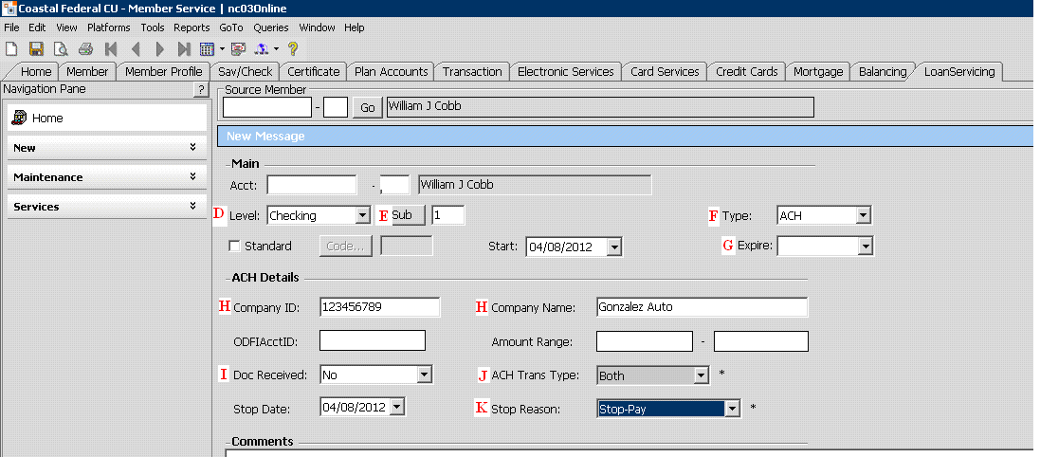

Stop Payment – Check
- Member must have funds in the account for stop payment fee (FSTP). Check the fee schedule for amount.
- Check the member’s transaction history to verify that the check(s) have not cleared the members account.
- Select File
- Select New
- Select Message
- Level: Select checking
- Sub: Select the correct checking account
- Type: Select Stop
- Expire: Select one year from date of stop
- Check Number: enter the check number(s) ONLY. if only one check enter it in both fields
- Ctrl S to save
- Charge the stop payment fee (FSTP)
- Complete Channels request
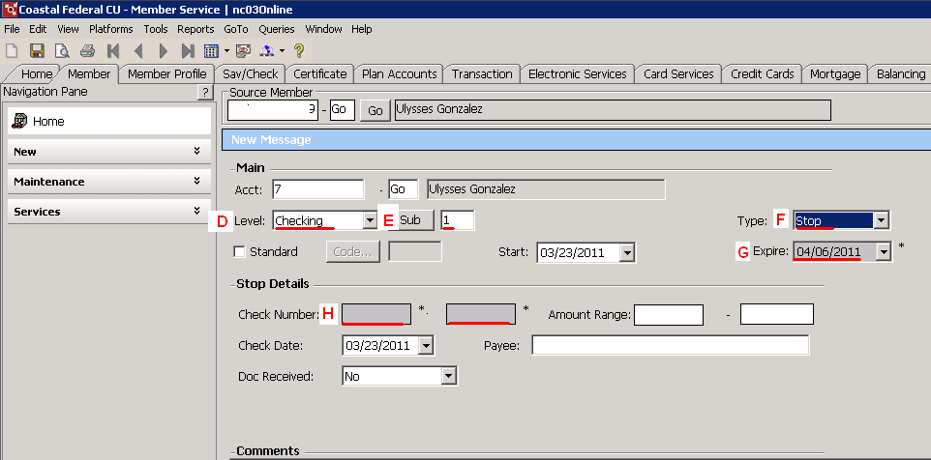

Automatic Distribution Form –Updating/Canceling

Facts:
- This is to cancel an internal transfer that has been set up on the Core system. If the member set up the transfer in online banking it would need to be cancelled by the member in online banking.
- Cancelling the automatic will cancel the next transfer and reoccurring transfers that are scheduled to take place.
Note: It will not cancel the automatic distribution if one has taken place the day the member is making the request.
- The member will have to contact the Credit Union again to restart the auto distribution.

Prerequisites:
- Follow normal validation procedures to identify member
- Make sure auto distribution has not already taken place

Automatic Distribution Form –Updating/Canceling cont.

Perform the following from the MEMBER SERVICE Platform
- Access the account
- Access the GoTo menu from the menu fields located at the top.
- Select Auto Distribution List.
- The Automatic Distribution List will display.
- Select the applicable automatic distribution (double click).
- Select Cancelled in the Status field
- Press CTRL + S to save the form.

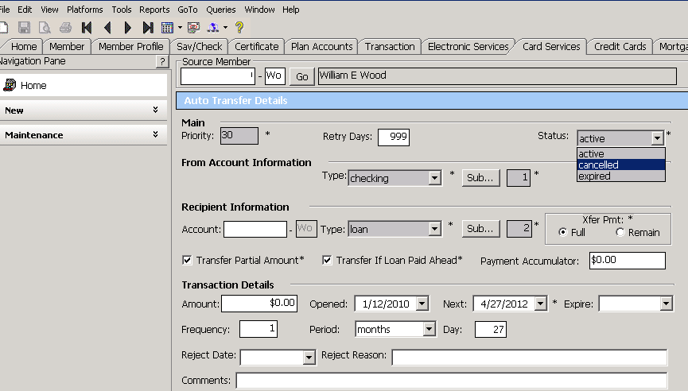
IRS/Dividend Information
- Select the Sav/Check Tab.
- Highlight the sub account you want to retrieve information for.
- On the Navigation Pane open up the Maintenance drop down list.
- Select the IRS information
- You will be able to view current year and previous year
- No 1099s will be mailed if interest/dividends are under $10.00
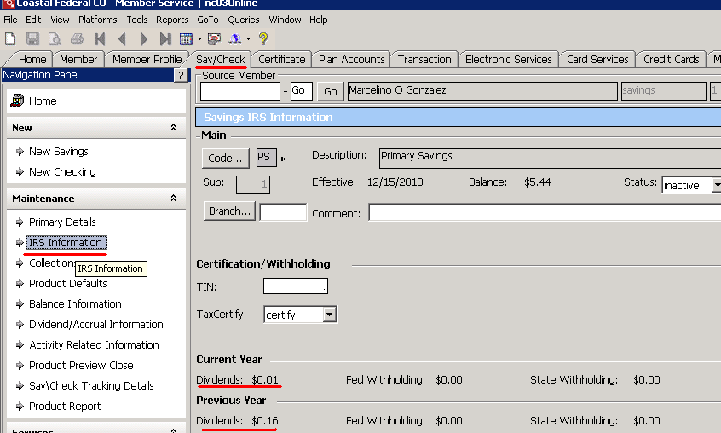

ACH Pending Query
- Queries
- Select ACH Pending Query
- This will show any pending ACH’s for all of the members sub accounts.
- The release date (when funds will be available) is the effective date.

For ACH Stop Payments see QRA
For Escalations/special circumstances see QRA.
For Unauthorized/Improper ACH see QRA.

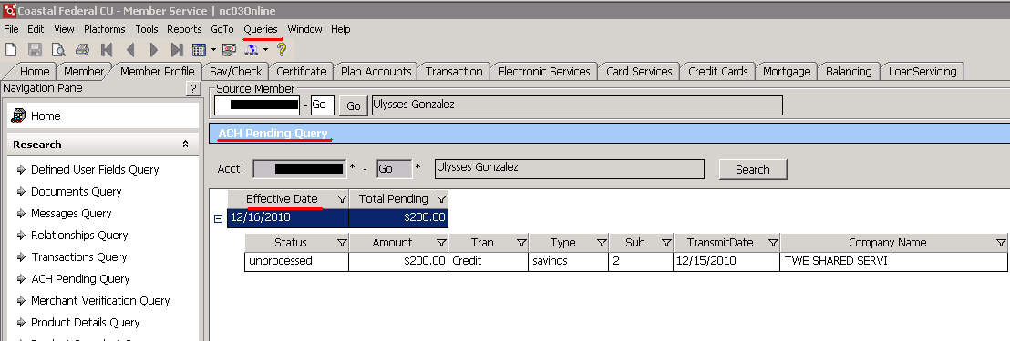

Overdraft Protection List
- Select the Sav/Check Tab.
- Highlight the sub account you want to retrieve information for.
- On the Navigation Pane open up the “Services” drop down list.
- Select the Overdraft Protection List
- You will be able to view from which account overdraft protection is set up and priority level.

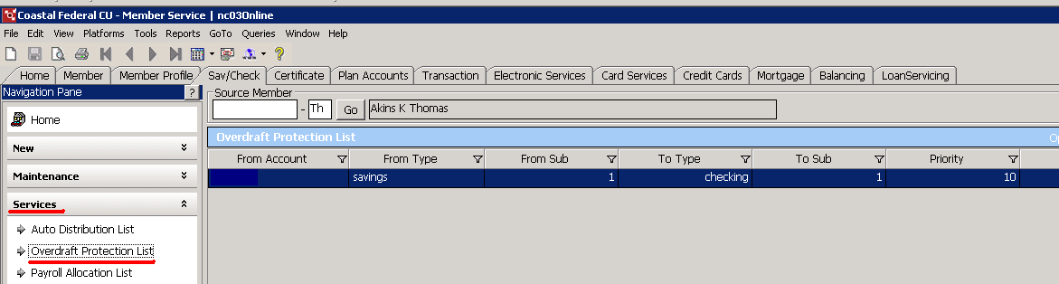

Per Diem/Daily Interest
- Select the “LoanServicing Tab”.
- Basic Loan information can be viewed under this tab
- If you select and double click on the loan you can view detailed information.
- Daily Interest = Per Diem
- Do not provide a payoff from this screen. View QRA for minimal/maximum payoff days.
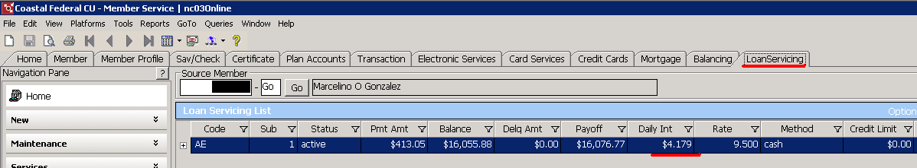

Past Due Accounts
- From the Member Profile Tab double click on the loan product
- Click on the Maintenance drop down box
- Under Delinquent information
- # of days box: indicates number of days past due
- We do not take payments from members 60 days or more past due
- A member is late the moment they do not make a payment on or before their due date.
- Coastal allows a 10 day grace period before a fee is assessed but the member is still past due if their payment is not received on or before their due date.
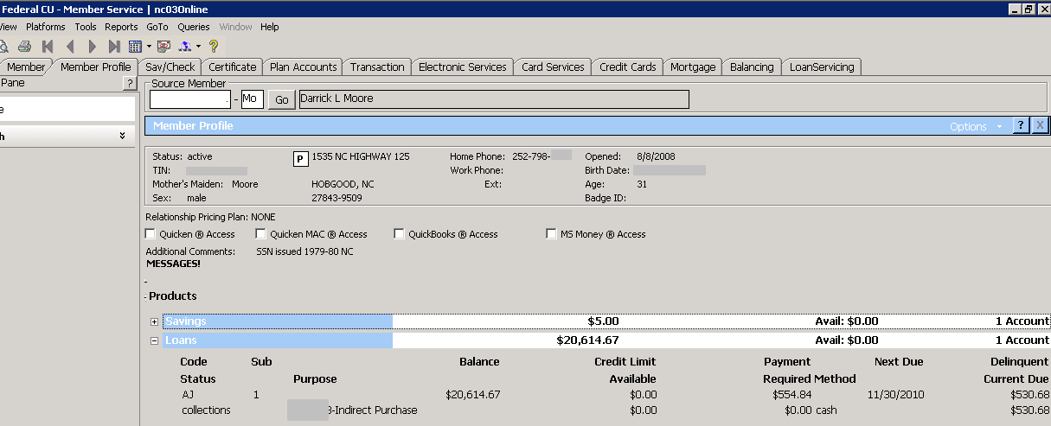

Balancing
- Select the “Balancing” tab
- Under “Queries” select “Post History”
  - Under “Actions” select “List View”
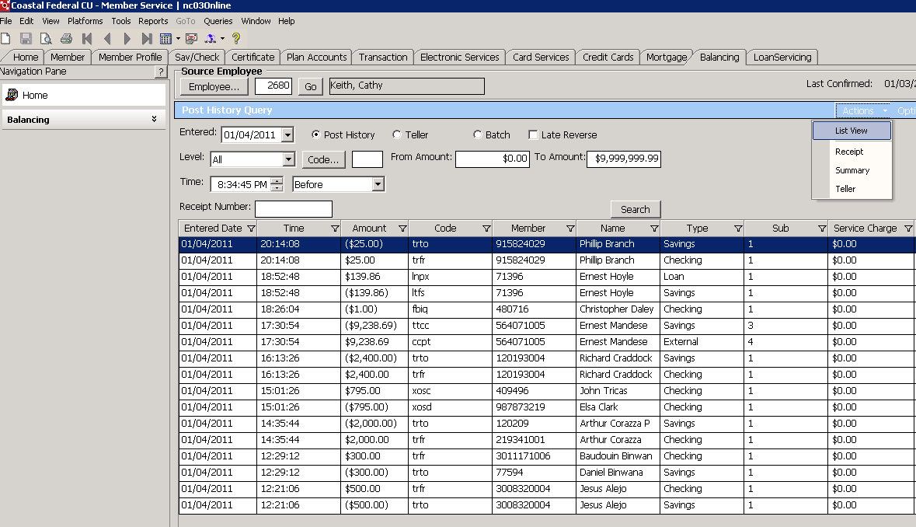

Balancing cont.
- You will view your post history for that day.
  - You are looking to make sure that the debits offset the credits. Once you do that close out this page and the post history page.
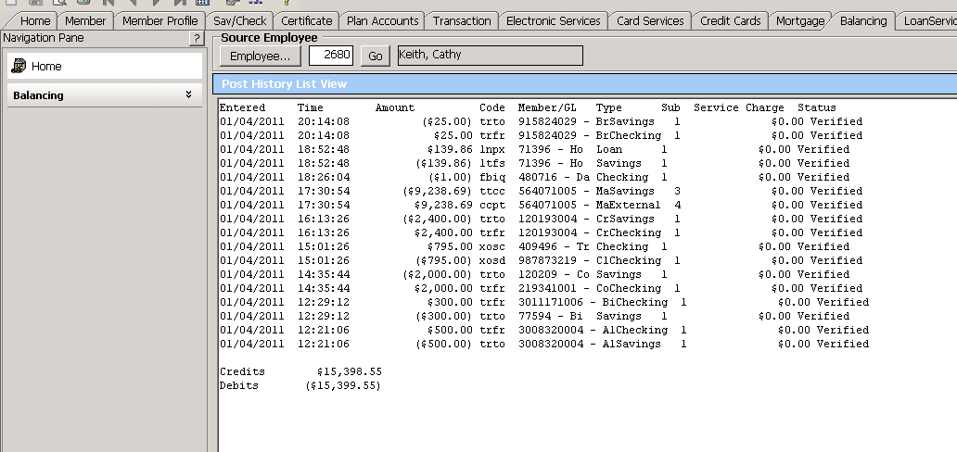

Balancing cont.
- Click on the “Confirm” button to balance for the day

