Brendan Donnelly

Data Analytics

September 15, 2020

HW 1

**Review their business case, area of application, approach/ methods, tools used, results, actions, benefits. Write a summary/ critique of one case study that you chose. Min. 10-12 sentences, diagrams or figures taken from the case study or prepared by you are desirable. You must include suitable references, i.e. to any material from the case study or other sources**

Fishbowl is a marketing consulting group that frequently consults for service industries such as restaurant chains. In this case study, their team analyzed a regional restaurant’s data and were tasked with analyzing the efficacy of the chain’s promotional strategy to drive up sales. This chain’s experimental promotion was a one-time redeemable $10 off of an order greater than $30. The team developed a model and analyzed the historical data of their customers and compared with post promotional data and determined that the promotion increased the traffic of customers, increased sales, and netted a 366% return on the discount. The graph below demonstrates the key analysis of the model, the charting of a histogram of redemptions of the promotion and measuring them as cannibalized or incremental visits in terms of revenue. This model was driven through Fishbowl’s Guest Analytics Suite which models customer behavior through a standard analytical model to measure and better predict social engagement, marketing efforts of value, item purchase preferences, evaluation of guests (spending, frequency, and time between visits), and more. While Fishbowl utilizes machine learning and specializes in big data, they also utilize simpler models dependent on the customer which seems to be the case with this regional customer. Overall, the regional restaurant’s strategy was supported to meet their goals of driving up short term revenue. In addition, the model gave them a framework for modeling their promotional strategies and a way to weigh their short term and long term viability.

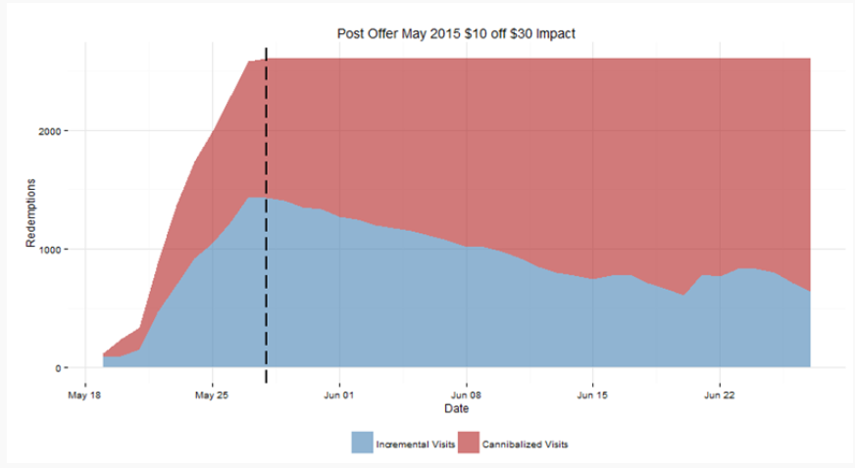

References:  
<https://www.fishbowl.com/case-studies/driving-short-term-incremental-traffic-with-long-term-benefits/>

<https://www.qsrmagazine.com/news/fishbowl-improves-guest-analytics-software>