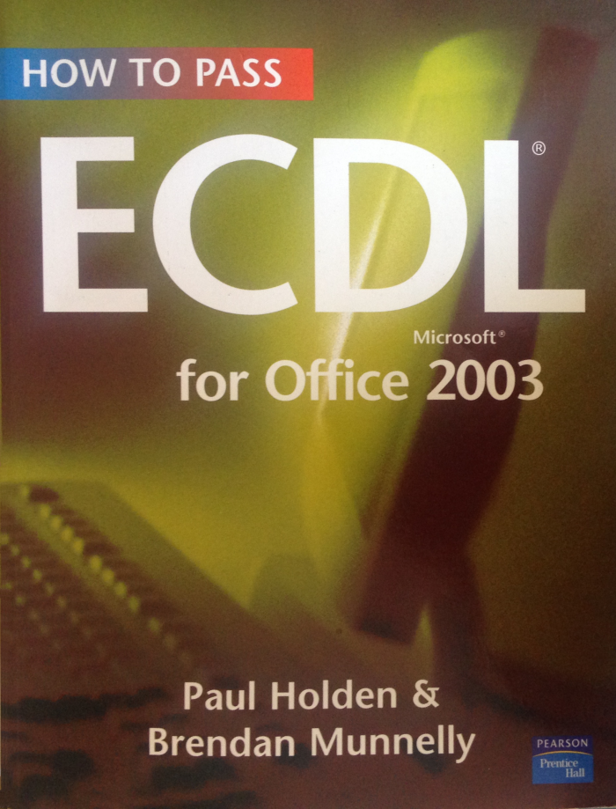

**Chapter 1**

Basic Concepts of Information Technology

After tools and machines, computers were the third line of useful devices that humans invented to help them to do the otherwise difficult or impossible. Modern computers can perform a very wide range of tasks, one after the other, or even at the same time. And while tools and machines work directly with physical objects, computers work with something more fuzzy: information.

In this Module, you will learn about the main hardware elements in a modern computer: the central processing unit (CPU), memory (RAM) and the disk drive. You will also meet a number of other devices – such as modems, scanners and digital cameras – that are increasingly considered normal parts of a computer System, whether in the home, school or workplace.

A computer is hardware, but it does software. Software determines how the computer behaves – the particular task performs at any given time. In this Module, you will discover the difference between operating system software such as Microsoft Windows, and application software such as word processing, spreadsheet and database programs.

Computer networks and the Internet, usage of computers across of sectors from healthcare to manufacturing issues, surrounding hacking and viruses, compliance with data protection principles and an awareness of some health and environmental concerns $–$ these topics complete this Introductory Module.

Welcome to the world of information Technology. Now it's your world.

MODULE 1: BASIC CONCEPTS OF INFORMATION TECHNOLOGY 1

**It’s a computerised world**

Computers and related technologies are touching our lives from the time the electronic alarm clock wakes us up to the time we use the remote control to turn off the television at night. Computers control the cycles in your washing machine, the delivery of money through an automatic teller machine, and the supply of fuel to a car engine. Almost anywhere you see Something happening 'automatically', there is a computer at its heart, monitoring the outside world and responding to it.

In this Chapter, you will learn about the increasing applications of Information Technology to a number of key areas of work and life.

**Computers - what are they good at?**

Computers are useful where there are large volumes of data to be maintained, analysed, stored and filtered, or where complex or repetitive calculations have to be performed.

But, equally, it is important to recognise that computers are not suitable for every task; some are better left to human judgement and action.

**Work and life in an Information Society**

Farmer, factory worker, and now information worker these three terms Sun up the career history of human life. In our Information Society, emphasis has been transferred from brawn to brain. Value, wealth and income now depend critically on our ability to capture, analyse, process and distribute information.

The idea of the ECDL - and of this book - is to enable you to use some of the tools necessary for active participation in the Information Society.

However, you already have the most important tools, and you know how to use them: your natural intelligence, your critical faculties, the ability to judge whether or not something makes sense. No amount of technology can replace these.

**Information Technology: what is it?**

The term Information Technology (IT) covers all forms of technology that are used to create, store, transfer and process information in its various forms - Such as numbers, text, images, Sound, and video. IT includes hardware and Software, networking and telecommunications.

The term is often used in the context of a business or other Organisation (as in 'I work in the IT Department’) or in the context of Society generally (as in IT is changing the way we live").

2 CHAPTER 1: TOOLS, MACHINES AND COMPUTERS

**Information Technology: here, there and everywhere**

In our modern economy, many of the goods we consume and the services we use would not be available without computers.

* **In the Age of Agriculture**, most of the work, and most of the value, related to food production. A single measure, the amount of land ownership, set the rich apart from the poor.
* **In the Industrial Age**, the availability of food was almost taken for granted. Value, wealth and incomes depended more on manufactured goods.
* **In the Digital Age**, the Computer Age, or the Information Age (take your pick), the balance has shifted towards service occupations in which information technology, knowledge and intelligence play the key roles. The emphasis has been transferred from brawn to brain. Our society can justifiably be called an Information Society because value in our society comes from information.

In 1800, a list of society's 100 wealthiest persons would have been dominated by landowners, A hundred years later, owners of factories that made physical goods, and of railways and ships that transported them, would have joined the list.

Nowadays, those involved in information-based activities are to the fore: owners of information copyright (whether in software, music, movies or books), makers of equipment that process information (computer hardware), and providers of information distribution systems (telecommunications), and the electronic and print media). Even those who do not work directly in the Information Technology sector use and rely on computers in their everyday work. As the following topics show, we are all knowledge workers now.

**Computers in government**

Governments need to manage very large bodies of information, including:

* **Registers of births, marriages and deaths**: In most EU countries, such records are now in electronic rather than in paper-based form. As a result, information requested by the public can be provided more easily and quickly.
* **Tax and social welfare records**: In a modern state, it would be almost impossible to maintain these records in a usable condition without computers.
* **Census of population data**: Economists and social research statistical analyses of computer-based records with minimal effort, the better to anticipate and provide for social change.
* **Voting registers**: This is another area that benefits from the convenience of storage, ease of updating and speed of retrieval associated with computerised record-keeping.

MODULE 1: BASIC CONCEPTS OF INFORMATION TECHNOLOGY 3