yuanhaoliu2v

yuanhao

March 25, 2019

library(tidyverse)

## Warning: package 'tidyverse' was built under R version 3.4.4

library(tidytext)

## Warning: package 'tidytext' was built under R version 3.4.4

library(ggplot2)  
library(scales)

data <- read_csv('C:/Users/liuyu/Desktop/padgett project scattertext/data code results for March1/chapter3change.csv')  
data

## # A tibble: 249 x 86  
## `key words` sum fre_of_lib fre_of_no_faction fre_of_P.G.  
## <chr> <int> <int> <int> <int>  
## 1 key_bellum 35 19 13 2  
## 2 key_ecclesia 3 2 1 0  
## 3 key_papa 10 4 6 0  
## 4 key_clericus 2 1 1 0  
## 5 key_interdict 0 0 0 0  
## 6 key_guelf 21 10 8 3  
## 7 key_ky_union 53 27 19 6  
## 8 key_libertas 15 7 7 1  
## 9 key_liga 5 2 3 0  
## 10 key_colligat 26 14 9 2  
## # ... with 239 more rows, and 81 more variables: fre_of_no_office <int>,  
## # fre_of_office <int>, lib_sum <dbl>, no_faction_sum <dbl>,  
## # P.G._sum <dbl>, no_office_sum <dbl>, office_sum <dbl>,  
## # lib_speech <dbl>, no_faction_speech <dbl>, P.G._speech <dbl>,  
## # no_office_speech <dbl>, office_speech <dbl>, Civic_faction <dbl>,  
## # no_faction_faction <dbl>, P.G._faction <dbl>, no_office_faction <dbl>,  
## # office_faction <dbl>, fre_of_AL <int>, fre_of_no_faction2 <int>,  
## # fre_of_RI <int>, AL_sum <dbl>, no_faction2_sum <dbl>, RI_sum <dbl>,  
## # AL_speech <dbl>, no_faction2_speech <dbl>, RI_speech <dbl>,  
## # AL_faction <dbl>, no_faction2_faction <dbl>, RI_faction <dbl>,  
## # fre_of_lib_no_office <int>, fre_of_lib_office <int>,  
## # lib_no_office_sum <dbl>, lib_office_sum <dbl>,  
## # lib_no_office_speech <dbl>, lib_office_speech <dbl>,  
## # Civic_no_office_faction <dbl>, Civic_office_faction <dbl>,  
## # fre_of_no_faction_no_office <int>, fre_of_no_faction_office <int>,  
## # no_faction_no_office_sum <dbl>, no_faction_office_sum <dbl>,  
## # no_faction_no_office_speech <dbl>, no_faction_office_speech <dbl>,  
## # no_faction_no_office_faction <dbl>, no_faction_office_faction <dbl>,  
## # `fre_of_P.G._no office` <int>, fre_of_P.G._office <int>,  
## # P.G._no_office_sum <dbl>, P.G._office_sum <dbl>,  
## # P.G._no_office_speech <int>, P.G._office_speech <dbl>,  
## # P.G._no_office_faction <dbl>, P.G._office_faction <dbl>,  
## # fre_of_AL_no_office <int>, fre_of_AL_office <int>,  
## # AL_no_office_sum <dbl>, AL_office_sum <dbl>,  
## # AL_no_office_speech <dbl>, AL_office_speech <dbl>,  
## # AL_no_office_faction <dbl>, AL_office_faction <dbl>,  
## # fre_of_no_faction2_no_office <int>, fre_of_no_faction2_office <int>,  
## # no_faction2_no_office_sum <dbl>, no_faction2_office_sum <dbl>,  
## # no_faction2_no_office_speech <dbl>, no_faction2_office_speech <dbl>,  
## # no_faction2_no_office_faction <dbl>, no_faction2_office_faction <dbl>,  
## # fre_of_RI_no_office <int>, fre_of_RI_office <int>,  
## # RI_no_office_sum <dbl>, RI_office_sum <dbl>,  
## # RI_no_office_speech <dbl>, RI_office_speech <dbl>,  
## # RI_no_office_faction <dbl>, RI_office_faction <dbl>,  
## # fre_of_Allargat <int>, Allargat_faction <dbl>, fre_of_Ristretto <int>,  
## # Ristretto_faction <dbl>

data1 <- data[1:15,]  
data1

## # A tibble: 15 x 86  
## `key words` sum fre_of_lib fre_of_no_faction fre_of_P.G.  
## <chr> <int> <int> <int> <int>  
## 1 key_bellum 35 19 13 2  
## 2 key_ecclesia 3 2 1 0  
## 3 key_papa 10 4 6 0  
## 4 key_clericus 2 1 1 0  
## 5 key_interdict 0 0 0 0  
## 6 key_guelf 21 10 8 3  
## 7 key_ky_union 53 27 19 6  
## 8 key_libertas 15 7 7 1  
## 9 key_liga 5 2 3 0  
## 10 key_colligat 26 14 9 2  
## 11 key_pecunia 80 45 30 5  
## 12 key_praestantia 5 5 0 0  
## 13 key_tax 0 0 0 0  
## 14 key_civitas 67 29 32 3  
## 15 key_pax 87 46 33 8  
## # ... with 81 more variables: fre_of_no_office <int>, fre_of_office <int>,  
## # lib_sum <dbl>, no_faction_sum <dbl>, P.G._sum <dbl>,  
## # no_office_sum <dbl>, office_sum <dbl>, lib_speech <dbl>,  
## # no_faction_speech <dbl>, P.G._speech <dbl>, no_office_speech <dbl>,  
## # office_speech <dbl>, Civic_faction <dbl>, no_faction_faction <dbl>,  
## # P.G._faction <dbl>, no_office_faction <dbl>, office_faction <dbl>,  
## # fre_of_AL <int>, fre_of_no_faction2 <int>, fre_of_RI <int>,  
## # AL_sum <dbl>, no_faction2_sum <dbl>, RI_sum <dbl>, AL_speech <dbl>,  
## # no_faction2_speech <dbl>, RI_speech <dbl>, AL_faction <dbl>,  
## # no_faction2_faction <dbl>, RI_faction <dbl>,  
## # fre_of_lib_no_office <int>, fre_of_lib_office <int>,  
## # lib_no_office_sum <dbl>, lib_office_sum <dbl>,  
## # lib_no_office_speech <dbl>, lib_office_speech <dbl>,  
## # Civic_no_office_faction <dbl>, Civic_office_faction <dbl>,  
## # fre_of_no_faction_no_office <int>, fre_of_no_faction_office <int>,  
## # no_faction_no_office_sum <dbl>, no_faction_office_sum <dbl>,  
## # no_faction_no_office_speech <dbl>, no_faction_office_speech <dbl>,  
## # no_faction_no_office_faction <dbl>, no_faction_office_faction <dbl>,  
## # `fre_of_P.G._no office` <int>, fre_of_P.G._office <int>,  
## # P.G._no_office_sum <dbl>, P.G._office_sum <dbl>,  
## # P.G._no_office_speech <int>, P.G._office_speech <dbl>,  
## # P.G._no_office_faction <dbl>, P.G._office_faction <dbl>,  
## # fre_of_AL_no_office <int>, fre_of_AL_office <int>,  
## # AL_no_office_sum <dbl>, AL_office_sum <dbl>,  
## # AL_no_office_speech <dbl>, AL_office_speech <dbl>,  
## # AL_no_office_faction <dbl>, AL_office_faction <dbl>,  
## # fre_of_no_faction2_no_office <int>, fre_of_no_faction2_office <int>,  
## # no_faction2_no_office_sum <dbl>, no_faction2_office_sum <dbl>,  
## # no_faction2_no_office_speech <dbl>, no_faction2_office_speech <dbl>,  
## # no_faction2_no_office_faction <dbl>, no_faction2_office_faction <dbl>,  
## # fre_of_RI_no_office <int>, fre_of_RI_office <int>,  
## # RI_no_office_sum <dbl>, RI_office_sum <dbl>,  
## # RI_no_office_speech <dbl>, RI_office_speech <dbl>,  
## # RI_no_office_faction <dbl>, RI_office_faction <dbl>,  
## # fre_of_Allargat <int>, Allargat_faction <dbl>, fre_of_Ristretto <int>,  
## # Ristretto_faction <dbl>

ggplot(data, aes(x = no_faction2_no_office_faction, y = no_faction2_office_faction, color = ((no_faction2_no_office_faction - no_faction2_office_faction)*200))) +  
 geom_abline(color = "red", lty = 2, slop = 1, intercept = 0) +  
 geom_jitter(size = 1, alpha = 0.5, width = 0.001, height = 0.001) +  
 geom_point(data = data1, color = 'red', size = 1) +  
 geom_text(aes(label = `key words`), position = position_jitter(width=0.0015, height = 0.0015), size = 3) +  
 geom_text(data = data1, aes(label = `key words`), position = position_jitter(width=0.0015, height = 0.0015), size = 3, color = 'red') +  
 theme_bw() +  
 scale_x_continuous(expand = c(0,0), limits = c(-0.002, 0.04), labels = percent_format()) +  
 scale_y_continuous(expand = c(0,0), limits = c(-0.002, 0.04), labels = percent_format()) +  
 scale_color_gradient2(low = 'green', mid = 'grey50', high = 'orange') +  
 theme(legend.position="none") +  
 labs(x = "no_faction2_no_office_faction" , y = "no_faction2_office_faction",  
 title = "Key Words in chapter 3",  
 subtitle = "key words highlight")

## Warning: Ignoring unknown parameters: slop

## Warning: Removed 7 rows containing missing values (geom_point).

## Warning: Removed 2 rows containing missing values (geom_point).

## Warning: Removed 7 rows containing missing values (geom_text).

## Warning: Removed 2 rows containing missing values (geom_text).

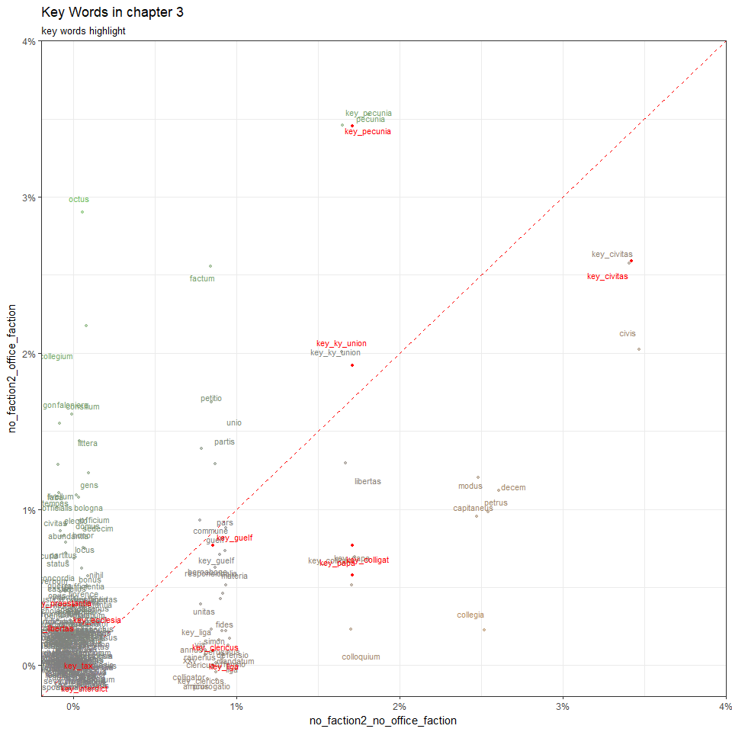

data1 <- data[1:15,]  
data1

## # A tibble: 15 x 86  
## `key words` sum fre_of_lib fre_of_no_faction fre_of_P.G.  
## <chr> <int> <int> <int> <int>  
## 1 key_bellum 35 19 13 2  
## 2 key_ecclesia 3 2 1 0  
## 3 key_papa 10 4 6 0  
## 4 key_clericus 2 1 1 0  
## 5 key_interdict 0 0 0 0  
## 6 key_guelf 21 10 8 3  
## 7 key_ky_union 53 27 19 6  
## 8 key_libertas 15 7 7 1  
## 9 key_liga 5 2 3 0  
## 10 key_colligat 26 14 9 2  
## 11 key_pecunia 80 45 30 5  
## 12 key_praestantia 5 5 0 0  
## 13 key_tax 0 0 0 0  
## 14 key_civitas 67 29 32 3  
## 15 key_pax 87 46 33 8  
## # ... with 81 more variables: fre_of_no_office <int>, fre_of_office <int>,  
## # lib_sum <dbl>, no_faction_sum <dbl>, P.G._sum <dbl>,  
## # no_office_sum <dbl>, office_sum <dbl>, lib_speech <dbl>,  
## # no_faction_speech <dbl>, P.G._speech <dbl>, no_office_speech <dbl>,  
## # office_speech <dbl>, Civic_faction <dbl>, no_faction_faction <dbl>,  
## # P.G._faction <dbl>, no_office_faction <dbl>, office_faction <dbl>,  
## # fre_of_AL <int>, fre_of_no_faction2 <int>, fre_of_RI <int>,  
## # AL_sum <dbl>, no_faction2_sum <dbl>, RI_sum <dbl>, AL_speech <dbl>,  
## # no_faction2_speech <dbl>, RI_speech <dbl>, AL_faction <dbl>,  
## # no_faction2_faction <dbl>, RI_faction <dbl>,  
## # fre_of_lib_no_office <int>, fre_of_lib_office <int>,  
## # lib_no_office_sum <dbl>, lib_office_sum <dbl>,  
## # lib_no_office_speech <dbl>, lib_office_speech <dbl>,  
## # Civic_no_office_faction <dbl>, Civic_office_faction <dbl>,  
## # fre_of_no_faction_no_office <int>, fre_of_no_faction_office <int>,  
## # no_faction_no_office_sum <dbl>, no_faction_office_sum <dbl>,  
## # no_faction_no_office_speech <dbl>, no_faction_office_speech <dbl>,  
## # no_faction_no_office_faction <dbl>, no_faction_office_faction <dbl>,  
## # `fre_of_P.G._no office` <int>, fre_of_P.G._office <int>,  
## # P.G._no_office_sum <dbl>, P.G._office_sum <dbl>,  
## # P.G._no_office_speech <int>, P.G._office_speech <dbl>,  
## # P.G._no_office_faction <dbl>, P.G._office_faction <dbl>,  
## # fre_of_AL_no_office <int>, fre_of_AL_office <int>,  
## # AL_no_office_sum <dbl>, AL_office_sum <dbl>,  
## # AL_no_office_speech <dbl>, AL_office_speech <dbl>,  
## # AL_no_office_faction <dbl>, AL_office_faction <dbl>,  
## # fre_of_no_faction2_no_office <int>, fre_of_no_faction2_office <int>,  
## # no_faction2_no_office_sum <dbl>, no_faction2_office_sum <dbl>,  
## # no_faction2_no_office_speech <dbl>, no_faction2_office_speech <dbl>,  
## # no_faction2_no_office_faction <dbl>, no_faction2_office_faction <dbl>,  
## # fre_of_RI_no_office <int>, fre_of_RI_office <int>,  
## # RI_no_office_sum <dbl>, RI_office_sum <dbl>,  
## # RI_no_office_speech <dbl>, RI_office_speech <dbl>,  
## # RI_no_office_faction <dbl>, RI_office_faction <dbl>,  
## # fre_of_Allargat <int>, Allargat_faction <dbl>, fre_of_Ristretto <int>,  
## # Ristretto_faction <dbl>

ggplot(data, aes(x = RI_no_office_faction, y = RI_office_faction, color = ((RI_no_office_faction - RI_office_faction)*200))) +  
 geom_abline(color = "red", lty = 2, slop = 1, intercept = 0) +  
 geom_jitter(size = 1, alpha = 0.5, width = 0.001, height = 0.001) +  
 geom_point(data = data1, color = 'red', size = 1) +  
 geom_text(aes(label = `key words`), position = position_jitter(width=0.0015, height = 0.0015), size = 3) +  
 geom_text(data = data1, aes(label = `key words`), position = position_jitter(width=0.0015, height = 0.0015), size = 3, color = 'red') +  
 theme_bw() +  
 scale_x_continuous(expand = c(0,0), limits = c(-0.002, 0.04), labels = percent_format()) +  
 scale_y_continuous(expand = c(0,0), limits = c(-0.002, 0.04), labels = percent_format()) +  
 scale_color_gradient2(low = 'green', mid = 'grey50', high = 'orange') +  
 theme(legend.position="none") +  
 labs(x = "RI_no_office_faction" , y = "RI_office_faction",  
 title = "Key Words in chapter 3",  
 subtitle = "key words highlight")

## Warning: Ignoring unknown parameters: slop

## Warning: Removed 6 rows containing missing values (geom_point).

## Warning: Removed 3 rows containing missing values (geom_point).

## Warning: Removed 6 rows containing missing values (geom_text).

## Warning: Removed 3 rows containing missing values (geom_text).

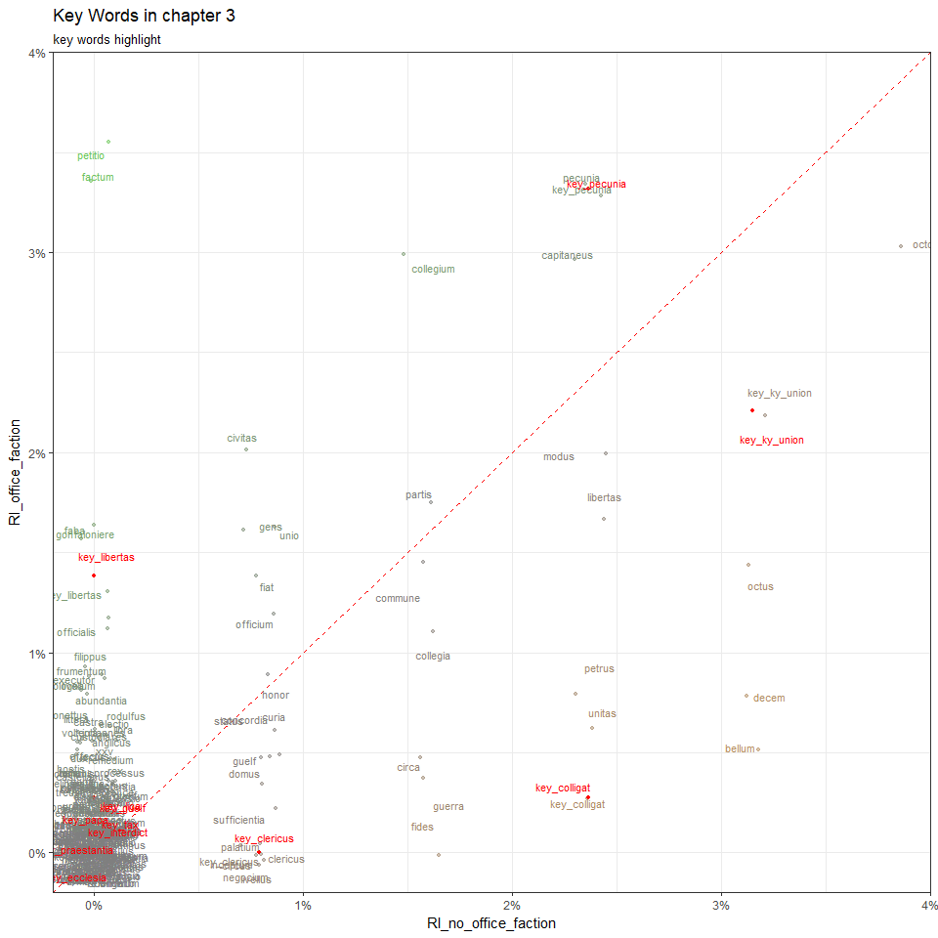

data1 <- data[1:15,]  
data1

## # A tibble: 15 x 86  
## `key words` sum fre_of_lib fre_of_no_faction fre_of_P.G.  
## <chr> <int> <int> <int> <int>  
## 1 key_bellum 35 19 13 2  
## 2 key_ecclesia 3 2 1 0  
## 3 key_papa 10 4 6 0  
## 4 key_clericus 2 1 1 0  
## 5 key_interdict 0 0 0 0  
## 6 key_guelf 21 10 8 3  
## 7 key_ky_union 53 27 19 6  
## 8 key_libertas 15 7 7 1  
## 9 key_liga 5 2 3 0  
## 10 key_colligat 26 14 9 2  
## 11 key_pecunia 80 45 30 5  
## 12 key_praestantia 5 5 0 0  
## 13 key_tax 0 0 0 0  
## 14 key_civitas 67 29 32 3  
## 15 key_pax 87 46 33 8  
## # ... with 81 more variables: fre_of_no_office <int>, fre_of_office <int>,  
## # lib_sum <dbl>, no_faction_sum <dbl>, P.G._sum <dbl>,  
## # no_office_sum <dbl>, office_sum <dbl>, lib_speech <dbl>,  
## # no_faction_speech <dbl>, P.G._speech <dbl>, no_office_speech <dbl>,  
## # office_speech <dbl>, Civic_faction <dbl>, no_faction_faction <dbl>,  
## # P.G._faction <dbl>, no_office_faction <dbl>, office_faction <dbl>,  
## # fre_of_AL <int>, fre_of_no_faction2 <int>, fre_of_RI <int>,  
## # AL_sum <dbl>, no_faction2_sum <dbl>, RI_sum <dbl>, AL_speech <dbl>,  
## # no_faction2_speech <dbl>, RI_speech <dbl>, AL_faction <dbl>,  
## # no_faction2_faction <dbl>, RI_faction <dbl>,  
## # fre_of_lib_no_office <int>, fre_of_lib_office <int>,  
## # lib_no_office_sum <dbl>, lib_office_sum <dbl>,  
## # lib_no_office_speech <dbl>, lib_office_speech <dbl>,  
## # Civic_no_office_faction <dbl>, Civic_office_faction <dbl>,  
## # fre_of_no_faction_no_office <int>, fre_of_no_faction_office <int>,  
## # no_faction_no_office_sum <dbl>, no_faction_office_sum <dbl>,  
## # no_faction_no_office_speech <dbl>, no_faction_office_speech <dbl>,  
## # no_faction_no_office_faction <dbl>, no_faction_office_faction <dbl>,  
## # `fre_of_P.G._no office` <int>, fre_of_P.G._office <int>,  
## # P.G._no_office_sum <dbl>, P.G._office_sum <dbl>,  
## # P.G._no_office_speech <int>, P.G._office_speech <dbl>,  
## # P.G._no_office_faction <dbl>, P.G._office_faction <dbl>,  
## # fre_of_AL_no_office <int>, fre_of_AL_office <int>,  
## # AL_no_office_sum <dbl>, AL_office_sum <dbl>,  
## # AL_no_office_speech <dbl>, AL_office_speech <dbl>,  
## # AL_no_office_faction <dbl>, AL_office_faction <dbl>,  
## # fre_of_no_faction2_no_office <int>, fre_of_no_faction2_office <int>,  
## # no_faction2_no_office_sum <dbl>, no_faction2_office_sum <dbl>,  
## # no_faction2_no_office_speech <dbl>, no_faction2_office_speech <dbl>,  
## # no_faction2_no_office_faction <dbl>, no_faction2_office_faction <dbl>,  
## # fre_of_RI_no_office <int>, fre_of_RI_office <int>,  
## # RI_no_office_sum <dbl>, RI_office_sum <dbl>,  
## # RI_no_office_speech <dbl>, RI_office_speech <dbl>,  
## # RI_no_office_faction <dbl>, RI_office_faction <dbl>,  
## # fre_of_Allargat <int>, Allargat_faction <dbl>, fre_of_Ristretto <int>,  
## # Ristretto_faction <dbl>

ggplot(data, aes(x = AL_no_office_faction, y = AL_office_faction, color = ((AL_no_office_faction - AL_office_faction)*200))) +  
 geom_abline(color = "red", lty = 2, slop = 1, intercept = 0) +  
 geom_jitter(size = 1, alpha = 0.5, width = 0.001, height = 0.001) +  
 geom_point(data = data1, color = 'red', size = 1) +  
 geom_text(aes(label = `key words`), position = position_jitter(width=0.0015, height = 0.0015), size = 3) +  
 geom_text(data = data1, aes(label = `key words`), position = position_jitter(width=0.0015, height = 0.0015), size = 3, color = 'red') +  
 theme_bw() +  
 scale_x_continuous(expand = c(0,0), limits = c(-0.002, 0.04), labels = percent_format()) +  
 scale_y_continuous(expand = c(0,0), limits = c(-0.002, 0.04), labels = percent_format()) +  
 scale_color_gradient2(low = 'green', mid = 'grey50', high = 'orange') +  
 theme(legend.position="none") +  
 labs(x = "AL_no_office_faction" , y = "AL_office_faction",  
 title = "Key Words in chapter 3",  
 subtitle = "key words highlight")

## Warning: Ignoring unknown parameters: slop

## Warning: Removed 8 rows containing missing values (geom_point).

## Warning: Removed 2 rows containing missing values (geom_point).

## Warning: Removed 8 rows containing missing values (geom_text).

## Warning: Removed 2 rows containing missing values (geom_text).

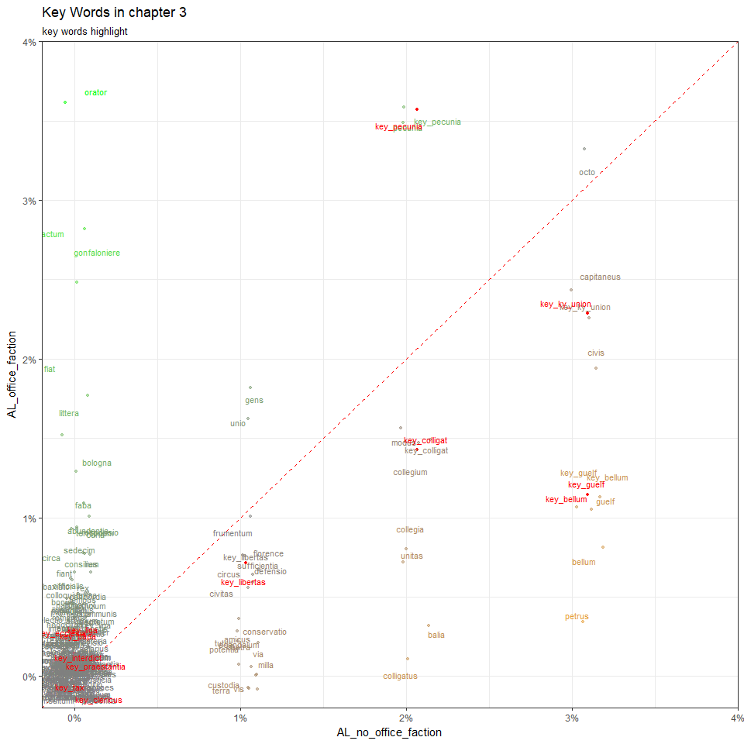

data1 <- data[1:15,]  
data1

## # A tibble: 15 x 86  
## `key words` sum fre_of_lib fre_of_no_faction fre_of_P.G.  
## <chr> <int> <int> <int> <int>  
## 1 key_bellum 35 19 13 2  
## 2 key_ecclesia 3 2 1 0  
## 3 key_papa 10 4 6 0  
## 4 key_clericus 2 1 1 0  
## 5 key_interdict 0 0 0 0  
## 6 key_guelf 21 10 8 3  
## 7 key_ky_union 53 27 19 6  
## 8 key_libertas 15 7 7 1  
## 9 key_liga 5 2 3 0  
## 10 key_colligat 26 14 9 2  
## 11 key_pecunia 80 45 30 5  
## 12 key_praestantia 5 5 0 0  
## 13 key_tax 0 0 0 0  
## 14 key_civitas 67 29 32 3  
## 15 key_pax 87 46 33 8  
## # ... with 81 more variables: fre_of_no_office <int>, fre_of_office <int>,  
## # lib_sum <dbl>, no_faction_sum <dbl>, P.G._sum <dbl>,  
## # no_office_sum <dbl>, office_sum <dbl>, lib_speech <dbl>,  
## # no_faction_speech <dbl>, P.G._speech <dbl>, no_office_speech <dbl>,  
## # office_speech <dbl>, Civic_faction <dbl>, no_faction_faction <dbl>,  
## # P.G._faction <dbl>, no_office_faction <dbl>, office_faction <dbl>,  
## # fre_of_AL <int>, fre_of_no_faction2 <int>, fre_of_RI <int>,  
## # AL_sum <dbl>, no_faction2_sum <dbl>, RI_sum <dbl>, AL_speech <dbl>,  
## # no_faction2_speech <dbl>, RI_speech <dbl>, AL_faction <dbl>,  
## # no_faction2_faction <dbl>, RI_faction <dbl>,  
## # fre_of_lib_no_office <int>, fre_of_lib_office <int>,  
## # lib_no_office_sum <dbl>, lib_office_sum <dbl>,  
## # lib_no_office_speech <dbl>, lib_office_speech <dbl>,  
## # Civic_no_office_faction <dbl>, Civic_office_faction <dbl>,  
## # fre_of_no_faction_no_office <int>, fre_of_no_faction_office <int>,  
## # no_faction_no_office_sum <dbl>, no_faction_office_sum <dbl>,  
## # no_faction_no_office_speech <dbl>, no_faction_office_speech <dbl>,  
## # no_faction_no_office_faction <dbl>, no_faction_office_faction <dbl>,  
## # `fre_of_P.G._no office` <int>, fre_of_P.G._office <int>,  
## # P.G._no_office_sum <dbl>, P.G._office_sum <dbl>,  
## # P.G._no_office_speech <int>, P.G._office_speech <dbl>,  
## # P.G._no_office_faction <dbl>, P.G._office_faction <dbl>,  
## # fre_of_AL_no_office <int>, fre_of_AL_office <int>,  
## # AL_no_office_sum <dbl>, AL_office_sum <dbl>,  
## # AL_no_office_speech <dbl>, AL_office_speech <dbl>,  
## # AL_no_office_faction <dbl>, AL_office_faction <dbl>,  
## # fre_of_no_faction2_no_office <int>, fre_of_no_faction2_office <int>,  
## # no_faction2_no_office_sum <dbl>, no_faction2_office_sum <dbl>,  
## # no_faction2_no_office_speech <dbl>, no_faction2_office_speech <dbl>,  
## # no_faction2_no_office_faction <dbl>, no_faction2_office_faction <dbl>,  
## # fre_of_RI_no_office <int>, fre_of_RI_office <int>,  
## # RI_no_office_sum <dbl>, RI_office_sum <dbl>,  
## # RI_no_office_speech <dbl>, RI_office_speech <dbl>,  
## # RI_no_office_faction <dbl>, RI_office_faction <dbl>,  
## # fre_of_Allargat <int>, Allargat_faction <dbl>, fre_of_Ristretto <int>,  
## # Ristretto_faction <dbl>

ggplot(data, aes(x = P.G._no_office_faction, y = P.G._office_faction, color = ((P.G._no_office_faction - P.G._office_faction)*200))) +  
 geom_abline(color = "red", lty = 2, slop = 1, intercept = 0) +  
 geom_jitter(size = 1, alpha = 0.5, width = 0.001, height = 0.001) +  
 geom_point(data = data1, color = 'red', size = 1) +  
 geom_text(aes(label = `key words`), position = position_jitter(width=0.0015, height = 0.0015), size = 3) +  
 geom_text(data = data1, aes(label = `key words`), position = position_jitter(width=0.00165, height = 0.00165), size = 3, color = 'red') +  
 theme_bw() +  
 scale_x_continuous(expand = c(0,0), limits = c(-0.002, 0.04), labels = percent_format()) +  
 scale_y_continuous(expand = c(0,0), limits = c(-0.002, 0.04), labels = percent_format()) +  
 scale_color_gradient2(low = 'green', mid = 'grey50', high = 'orange') +  
 theme(legend.position="none") +  
 labs(x = "P.G._no_office_faction" , y = "P.G._office_faction",  
 title = "Key Words in chapter 3",  
 subtitle = "key words highlight")

## Warning: Ignoring unknown parameters: slop

## Warning: Removed 12 rows containing missing values (geom_point).

## Warning: Removed 2 rows containing missing values (geom_point).

## Warning: Removed 12 rows containing missing values (geom_text).

## Warning: Removed 2 rows containing missing values (geom_text).

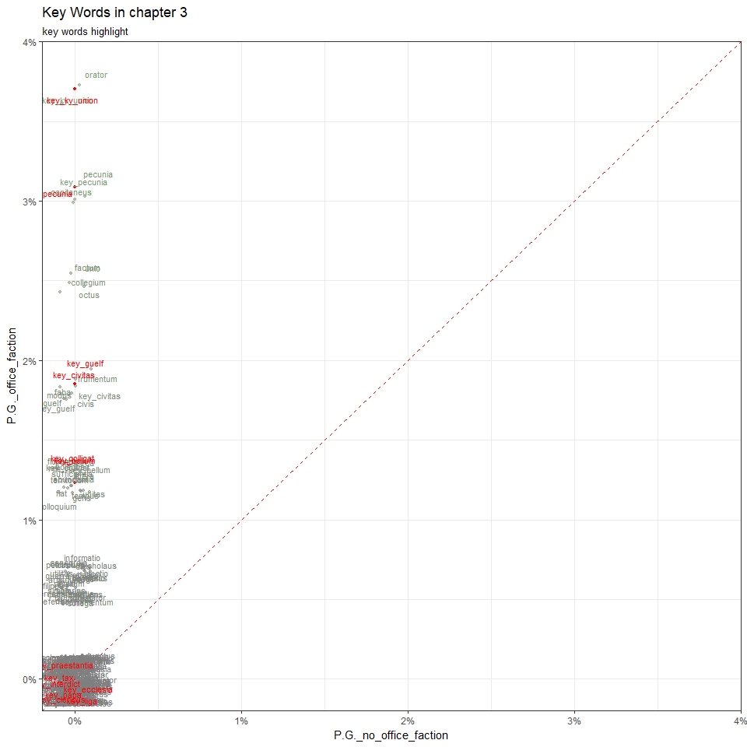

data1 <- data[1:15,]  
data1

## # A tibble: 15 x 86  
## `key words` sum fre_of_lib fre_of_no_faction fre_of_P.G.  
## <chr> <int> <int> <int> <int>  
## 1 key_bellum 35 19 13 2  
## 2 key_ecclesia 3 2 1 0  
## 3 key_papa 10 4 6 0  
## 4 key_clericus 2 1 1 0  
## 5 key_interdict 0 0 0 0  
## 6 key_guelf 21 10 8 3  
## 7 key_ky_union 53 27 19 6  
## 8 key_libertas 15 7 7 1  
## 9 key_liga 5 2 3 0  
## 10 key_colligat 26 14 9 2  
## 11 key_pecunia 80 45 30 5  
## 12 key_praestantia 5 5 0 0  
## 13 key_tax 0 0 0 0  
## 14 key_civitas 67 29 32 3  
## 15 key_pax 87 46 33 8  
## # ... with 81 more variables: fre_of_no_office <int>, fre_of_office <int>,  
## # lib_sum <dbl>, no_faction_sum <dbl>, P.G._sum <dbl>,  
## # no_office_sum <dbl>, office_sum <dbl>, lib_speech <dbl>,  
## # no_faction_speech <dbl>, P.G._speech <dbl>, no_office_speech <dbl>,  
## # office_speech <dbl>, Civic_faction <dbl>, no_faction_faction <dbl>,  
## # P.G._faction <dbl>, no_office_faction <dbl>, office_faction <dbl>,  
## # fre_of_AL <int>, fre_of_no_faction2 <int>, fre_of_RI <int>,  
## # AL_sum <dbl>, no_faction2_sum <dbl>, RI_sum <dbl>, AL_speech <dbl>,  
## # no_faction2_speech <dbl>, RI_speech <dbl>, AL_faction <dbl>,  
## # no_faction2_faction <dbl>, RI_faction <dbl>,  
## # fre_of_lib_no_office <int>, fre_of_lib_office <int>,  
## # lib_no_office_sum <dbl>, lib_office_sum <dbl>,  
## # lib_no_office_speech <dbl>, lib_office_speech <dbl>,  
## # Civic_no_office_faction <dbl>, Civic_office_faction <dbl>,  
## # fre_of_no_faction_no_office <int>, fre_of_no_faction_office <int>,  
## # no_faction_no_office_sum <dbl>, no_faction_office_sum <dbl>,  
## # no_faction_no_office_speech <dbl>, no_faction_office_speech <dbl>,  
## # no_faction_no_office_faction <dbl>, no_faction_office_faction <dbl>,  
## # `fre_of_P.G._no office` <int>, fre_of_P.G._office <int>,  
## # P.G._no_office_sum <dbl>, P.G._office_sum <dbl>,  
## # P.G._no_office_speech <int>, P.G._office_speech <dbl>,  
## # P.G._no_office_faction <dbl>, P.G._office_faction <dbl>,  
## # fre_of_AL_no_office <int>, fre_of_AL_office <int>,  
## # AL_no_office_sum <dbl>, AL_office_sum <dbl>,  
## # AL_no_office_speech <dbl>, AL_office_speech <dbl>,  
## # AL_no_office_faction <dbl>, AL_office_faction <dbl>,  
## # fre_of_no_faction2_no_office <int>, fre_of_no_faction2_office <int>,  
## # no_faction2_no_office_sum <dbl>, no_faction2_office_sum <dbl>,  
## # no_faction2_no_office_speech <dbl>, no_faction2_office_speech <dbl>,  
## # no_faction2_no_office_faction <dbl>, no_faction2_office_faction <dbl>,  
## # fre_of_RI_no_office <int>, fre_of_RI_office <int>,  
## # RI_no_office_sum <dbl>, RI_office_sum <dbl>,  
## # RI_no_office_speech <dbl>, RI_office_speech <dbl>,  
## # RI_no_office_faction <dbl>, RI_office_faction <dbl>,  
## # fre_of_Allargat <int>, Allargat_faction <dbl>, fre_of_Ristretto <int>,  
## # Ristretto_faction <dbl>

ggplot(data, aes(x = no_faction_no_office_faction, y = no_faction_office_faction, color = ((no_faction_no_office_faction - no_faction_office_faction)*200))) +  
 geom_abline(color = "red", lty = 2, slop = 1, intercept = 0) +  
 geom_jitter(size = 1, alpha = 0.5, width = 0.001, height = 0.001) +  
 geom_point(data = data1, color = 'red', size = 1) +  
 geom_text(aes(label = `key words`), position = position_jitter(width=0.0015, height = 0.0015), size = 3) +  
 geom_text(data = data1, aes(label = `key words`), position = position_jitter(width=0.0015, height = 0.0015), size = 3, color = 'red') +  
 theme_bw() +  
 scale_x_continuous(expand = c(0,0), limits = c(-0.002, 0.04), labels = percent_format()) +  
 scale_y_continuous(expand = c(0,0), limits = c(-0.002, 0.04), labels = percent_format()) +  
 scale_color_gradient2(low = 'green', mid = 'grey50', high = 'orange') +  
 theme(legend.position="none") +  
 labs(x = "no_faction_no_office_faction" , y = "no_faction_office_faction",  
 title = "Key Words in chapter 3",  
 subtitle = "key words highlight")

## Warning: Ignoring unknown parameters: slop

## Warning: Removed 5 rows containing missing values (geom_point).

## Warning: Removed 3 rows containing missing values (geom_point).

## Warning: Removed 5 rows containing missing values (geom_text).

## Warning: Removed 3 rows containing missing values (geom_text).

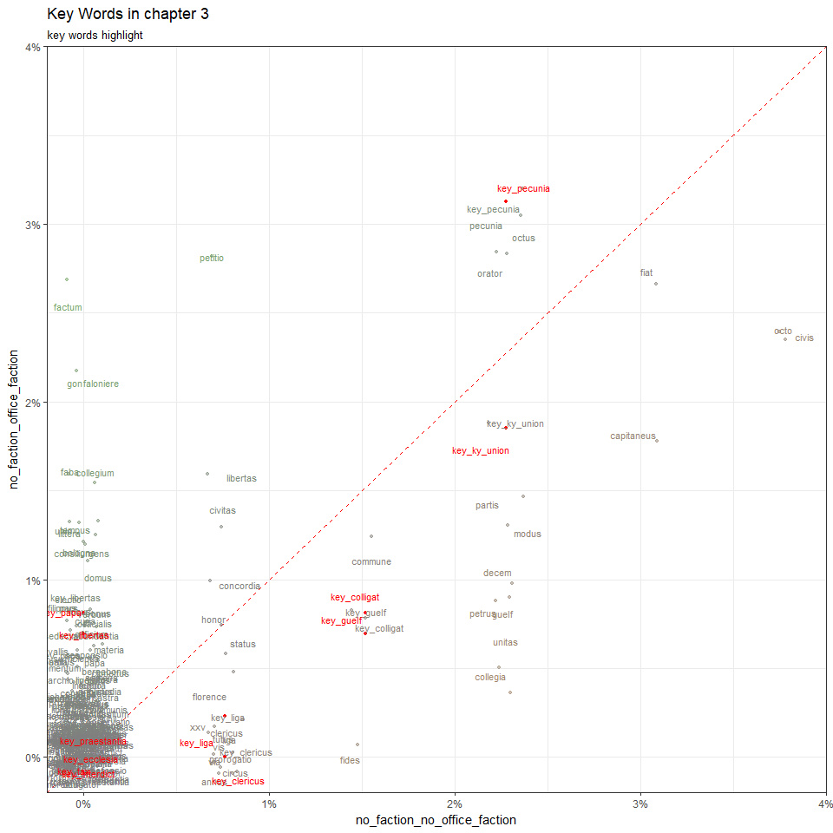

data1 <- data[1:15,]  
data1

## # A tibble: 15 x 86  
## `key words` sum fre_of_lib fre_of_no_faction fre_of_P.G.  
## <chr> <int> <int> <int> <int>  
## 1 key_bellum 35 19 13 2  
## 2 key_ecclesia 3 2 1 0  
## 3 key_papa 10 4 6 0  
## 4 key_clericus 2 1 1 0  
## 5 key_interdict 0 0 0 0  
## 6 key_guelf 21 10 8 3  
## 7 key_ky_union 53 27 19 6  
## 8 key_libertas 15 7 7 1  
## 9 key_liga 5 2 3 0  
## 10 key_colligat 26 14 9 2  
## 11 key_pecunia 80 45 30 5  
## 12 key_praestantia 5 5 0 0  
## 13 key_tax 0 0 0 0  
## 14 key_civitas 67 29 32 3  
## 15 key_pax 87 46 33 8  
## # ... with 81 more variables: fre_of_no_office <int>, fre_of_office <int>,  
## # lib_sum <dbl>, no_faction_sum <dbl>, P.G._sum <dbl>,  
## # no_office_sum <dbl>, office_sum <dbl>, lib_speech <dbl>,  
## # no_faction_speech <dbl>, P.G._speech <dbl>, no_office_speech <dbl>,  
## # office_speech <dbl>, Civic_faction <dbl>, no_faction_faction <dbl>,  
## # P.G._faction <dbl>, no_office_faction <dbl>, office_faction <dbl>,  
## # fre_of_AL <int>, fre_of_no_faction2 <int>, fre_of_RI <int>,  
## # AL_sum <dbl>, no_faction2_sum <dbl>, RI_sum <dbl>, AL_speech <dbl>,  
## # no_faction2_speech <dbl>, RI_speech <dbl>, AL_faction <dbl>,  
## # no_faction2_faction <dbl>, RI_faction <dbl>,  
## # fre_of_lib_no_office <int>, fre_of_lib_office <int>,  
## # lib_no_office_sum <dbl>, lib_office_sum <dbl>,  
## # lib_no_office_speech <dbl>, lib_office_speech <dbl>,  
## # Civic_no_office_faction <dbl>, Civic_office_faction <dbl>,  
## # fre_of_no_faction_no_office <int>, fre_of_no_faction_office <int>,  
## # no_faction_no_office_sum <dbl>, no_faction_office_sum <dbl>,  
## # no_faction_no_office_speech <dbl>, no_faction_office_speech <dbl>,  
## # no_faction_no_office_faction <dbl>, no_faction_office_faction <dbl>,  
## # `fre_of_P.G._no office` <int>, fre_of_P.G._office <int>,  
## # P.G._no_office_sum <dbl>, P.G._office_sum <dbl>,  
## # P.G._no_office_speech <int>, P.G._office_speech <dbl>,  
## # P.G._no_office_faction <dbl>, P.G._office_faction <dbl>,  
## # fre_of_AL_no_office <int>, fre_of_AL_office <int>,  
## # AL_no_office_sum <dbl>, AL_office_sum <dbl>,  
## # AL_no_office_speech <dbl>, AL_office_speech <dbl>,  
## # AL_no_office_faction <dbl>, AL_office_faction <dbl>,  
## # fre_of_no_faction2_no_office <int>, fre_of_no_faction2_office <int>,  
## # no_faction2_no_office_sum <dbl>, no_faction2_office_sum <dbl>,  
## # no_faction2_no_office_speech <dbl>, no_faction2_office_speech <dbl>,  
## # no_faction2_no_office_faction <dbl>, no_faction2_office_faction <dbl>,  
## # fre_of_RI_no_office <int>, fre_of_RI_office <int>,  
## # RI_no_office_sum <dbl>, RI_office_sum <dbl>,  
## # RI_no_office_speech <dbl>, RI_office_speech <dbl>,  
## # RI_no_office_faction <dbl>, RI_office_faction <dbl>,  
## # fre_of_Allargat <int>, Allargat_faction <dbl>, fre_of_Ristretto <int>,  
## # Ristretto_faction <dbl>

ggplot(data, aes(x = Civic_no_office_faction, y = Civic_office_faction, color = ((Civic_no_office_faction - Civic_office_faction)*200))) +  
 geom_abline(color = "red", lty = 2, slop = 1, intercept = 0) +  
 geom_jitter(size = 1, alpha = 0.5, width = 0.001, height = 0.001) +  
 geom_point(data = data1, color = 'red', size = 1) +  
 geom_text(aes(label = `key words`), position = position_jitter(width=0.0015, height = 0.0015), size = 3) +  
 geom_text(data = data1, aes(label = `key words`), position = position_jitter(width=0.0015, height = 0.0015), size = 3, color = 'red') +  
 theme_bw() +  
 scale_x_continuous(expand = c(0,0), limits = c(-0.002, 0.04), labels = percent_format()) +  
 scale_y_continuous(expand = c(0,0), limits = c(-0.002, 0.04), labels = percent_format()) +  
 scale_color_gradient2(low = 'green', mid = 'grey50', high = 'orange') +  
 theme(legend.position="none") +  
 labs(x = "Civic_no_office_faction" , y = "Civic_office_faction",  
 title = "Key Words in chapter 3",  
 subtitle = "key words highlight")

## Warning: Ignoring unknown parameters: slop

## Warning: Removed 5 rows containing missing values (geom_point).

## Warning: Removed 2 rows containing missing values (geom_point).

## Warning: Removed 5 rows containing missing values (geom_text).

## Warning: Removed 2 rows containing missing values (geom_text).

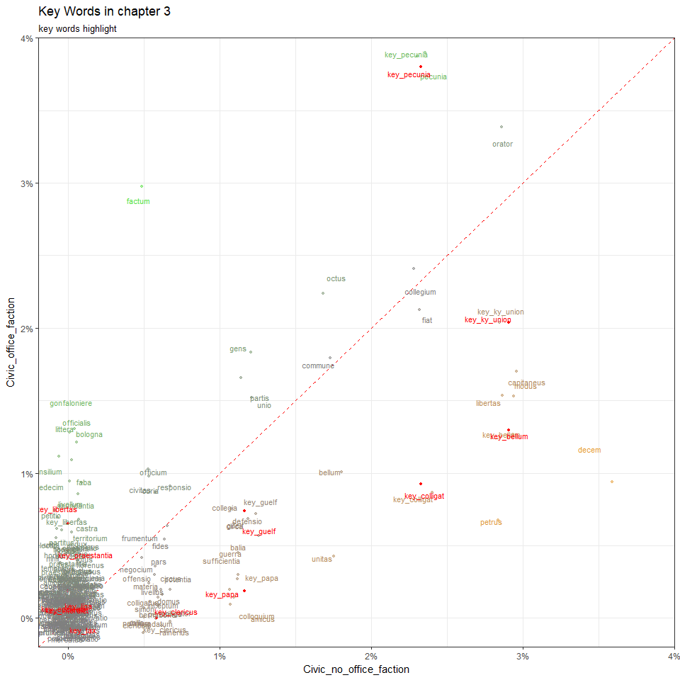

data1 <- data[1:15,]  
data1

## # A tibble: 15 x 86  
## `key words` sum fre_of_lib fre_of_no_faction fre_of_P.G.  
## <chr> <int> <int> <int> <int>  
## 1 key_bellum 35 19 13 2  
## 2 key_ecclesia 3 2 1 0  
## 3 key_papa 10 4 6 0  
## 4 key_clericus 2 1 1 0  
## 5 key_interdict 0 0 0 0  
## 6 key_guelf 21 10 8 3  
## 7 key_ky_union 53 27 19 6  
## 8 key_libertas 15 7 7 1  
## 9 key_liga 5 2 3 0  
## 10 key_colligat 26 14 9 2  
## 11 key_pecunia 80 45 30 5  
## 12 key_praestantia 5 5 0 0  
## 13 key_tax 0 0 0 0  
## 14 key_civitas 67 29 32 3  
## 15 key_pax 87 46 33 8  
## # ... with 81 more variables: fre_of_no_office <int>, fre_of_office <int>,  
## # lib_sum <dbl>, no_faction_sum <dbl>, P.G._sum <dbl>,  
## # no_office_sum <dbl>, office_sum <dbl>, lib_speech <dbl>,  
## # no_faction_speech <dbl>, P.G._speech <dbl>, no_office_speech <dbl>,  
## # office_speech <dbl>, Civic_faction <dbl>, no_faction_faction <dbl>,  
## # P.G._faction <dbl>, no_office_faction <dbl>, office_faction <dbl>,  
## # fre_of_AL <int>, fre_of_no_faction2 <int>, fre_of_RI <int>,  
## # AL_sum <dbl>, no_faction2_sum <dbl>, RI_sum <dbl>, AL_speech <dbl>,  
## # no_faction2_speech <dbl>, RI_speech <dbl>, AL_faction <dbl>,  
## # no_faction2_faction <dbl>, RI_faction <dbl>,  
## # fre_of_lib_no_office <int>, fre_of_lib_office <int>,  
## # lib_no_office_sum <dbl>, lib_office_sum <dbl>,  
## # lib_no_office_speech <dbl>, lib_office_speech <dbl>,  
## # Civic_no_office_faction <dbl>, Civic_office_faction <dbl>,  
## # fre_of_no_faction_no_office <int>, fre_of_no_faction_office <int>,  
## # no_faction_no_office_sum <dbl>, no_faction_office_sum <dbl>,  
## # no_faction_no_office_speech <dbl>, no_faction_office_speech <dbl>,  
## # no_faction_no_office_faction <dbl>, no_faction_office_faction <dbl>,  
## # `fre_of_P.G._no office` <int>, fre_of_P.G._office <int>,  
## # P.G._no_office_sum <dbl>, P.G._office_sum <dbl>,  
## # P.G._no_office_speech <int>, P.G._office_speech <dbl>,  
## # P.G._no_office_faction <dbl>, P.G._office_faction <dbl>,  
## # fre_of_AL_no_office <int>, fre_of_AL_office <int>,  
## # AL_no_office_sum <dbl>, AL_office_sum <dbl>,  
## # AL_no_office_speech <dbl>, AL_office_speech <dbl>,  
## # AL_no_office_faction <dbl>, AL_office_faction <dbl>,  
## # fre_of_no_faction2_no_office <int>, fre_of_no_faction2_office <int>,  
## # no_faction2_no_office_sum <dbl>, no_faction2_office_sum <dbl>,  
## # no_faction2_no_office_speech <dbl>, no_faction2_office_speech <dbl>,  
## # no_faction2_no_office_faction <dbl>, no_faction2_office_faction <dbl>,  
## # fre_of_RI_no_office <int>, fre_of_RI_office <int>,  
## # RI_no_office_sum <dbl>, RI_office_sum <dbl>,  
## # RI_no_office_speech <dbl>, RI_office_speech <dbl>,  
## # RI_no_office_faction <dbl>, RI_office_faction <dbl>,  
## # fre_of_Allargat <int>, Allargat_faction <dbl>, fre_of_Ristretto <int>,  
## # Ristretto_faction <dbl>

ggplot(data, aes(x = RI_faction, y = no_faction2_faction, color = ((RI_faction - no_faction2_faction)*200))) +  
 geom_abline(color = "red", lty = 2, slop = 1, intercept = 0) +  
 geom_jitter(size = 1, alpha = 0.5, width = 0.001, height = 0.001) +  
 geom_point(data = data1, color = 'red', size = 1) +  
 geom_text(aes(label = `key words`), position = position_jitter(width=0.0015, height = 0.0015), size = 3) +  
 geom_text(data = data1, aes(label = `key words`), position = position_jitter(width=0.0015, height = 0.0015), size = 3, color = 'red') +  
 theme_bw() +  
 scale_x_continuous(expand = c(0,0), limits = c(-0.002, 0.04), labels = percent_format()) +  
 scale_y_continuous(expand = c(0,0), limits = c(-0.002, 0.04), labels = percent_format()) +  
 scale_color_gradient2(low = 'green', mid = 'grey50', high = 'orange') +  
 theme(legend.position="none") +  
 labs(x = "RI_faction" , y = "no_faction2_faction",  
 title = "Key Words in chapter 3",  
 subtitle = "key words highlight")

## Warning: Ignoring unknown parameters: slop

## Warning: Removed 2 rows containing missing values (geom_point).

## Warning: Removed 1 rows containing missing values (geom_point).

## Warning: Removed 3 rows containing missing values (geom_text).

## Warning: Removed 1 rows containing missing values (geom_text).

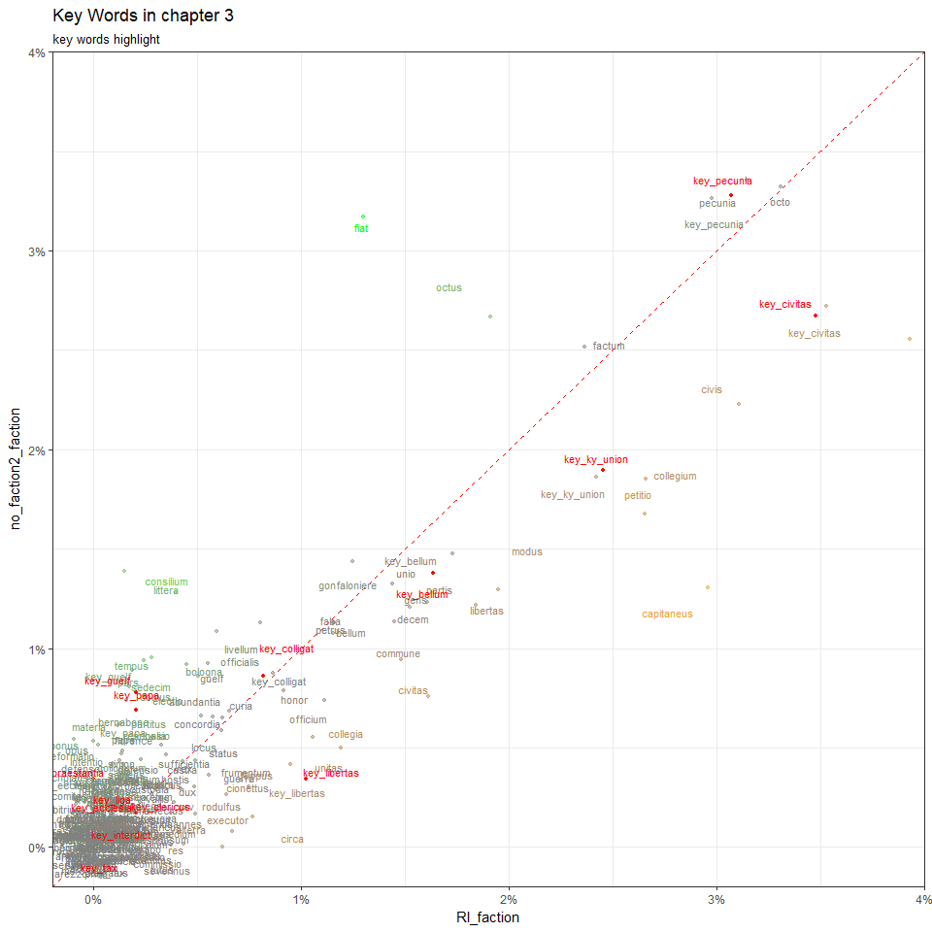

data1 <- data[1:15,]  
data1

## # A tibble: 15 x 86  
## `key words` sum fre_of_lib fre_of_no_faction fre_of_P.G.  
## <chr> <int> <int> <int> <int>  
## 1 key_bellum 35 19 13 2  
## 2 key_ecclesia 3 2 1 0  
## 3 key_papa 10 4 6 0  
## 4 key_clericus 2 1 1 0  
## 5 key_interdict 0 0 0 0  
## 6 key_guelf 21 10 8 3  
## 7 key_ky_union 53 27 19 6  
## 8 key_libertas 15 7 7 1  
## 9 key_liga 5 2 3 0  
## 10 key_colligat 26 14 9 2  
## 11 key_pecunia 80 45 30 5  
## 12 key_praestantia 5 5 0 0  
## 13 key_tax 0 0 0 0  
## 14 key_civitas 67 29 32 3  
## 15 key_pax 87 46 33 8  
## # ... with 81 more variables: fre_of_no_office <int>, fre_of_office <int>,  
## # lib_sum <dbl>, no_faction_sum <dbl>, P.G._sum <dbl>,  
## # no_office_sum <dbl>, office_sum <dbl>, lib_speech <dbl>,  
## # no_faction_speech <dbl>, P.G._speech <dbl>, no_office_speech <dbl>,  
## # office_speech <dbl>, Civic_faction <dbl>, no_faction_faction <dbl>,  
## # P.G._faction <dbl>, no_office_faction <dbl>, office_faction <dbl>,  
## # fre_of_AL <int>, fre_of_no_faction2 <int>, fre_of_RI <int>,  
## # AL_sum <dbl>, no_faction2_sum <dbl>, RI_sum <dbl>, AL_speech <dbl>,  
## # no_faction2_speech <dbl>, RI_speech <dbl>, AL_faction <dbl>,  
## # no_faction2_faction <dbl>, RI_faction <dbl>,  
## # fre_of_lib_no_office <int>, fre_of_lib_office <int>,  
## # lib_no_office_sum <dbl>, lib_office_sum <dbl>,  
## # lib_no_office_speech <dbl>, lib_office_speech <dbl>,  
## # Civic_no_office_faction <dbl>, Civic_office_faction <dbl>,  
## # fre_of_no_faction_no_office <int>, fre_of_no_faction_office <int>,  
## # no_faction_no_office_sum <dbl>, no_faction_office_sum <dbl>,  
## # no_faction_no_office_speech <dbl>, no_faction_office_speech <dbl>,  
## # no_faction_no_office_faction <dbl>, no_faction_office_faction <dbl>,  
## # `fre_of_P.G._no office` <int>, fre_of_P.G._office <int>,  
## # P.G._no_office_sum <dbl>, P.G._office_sum <dbl>,  
## # P.G._no_office_speech <int>, P.G._office_speech <dbl>,  
## # P.G._no_office_faction <dbl>, P.G._office_faction <dbl>,  
## # fre_of_AL_no_office <int>, fre_of_AL_office <int>,  
## # AL_no_office_sum <dbl>, AL_office_sum <dbl>,  
## # AL_no_office_speech <dbl>, AL_office_speech <dbl>,  
## # AL_no_office_faction <dbl>, AL_office_faction <dbl>,  
## # fre_of_no_faction2_no_office <int>, fre_of_no_faction2_office <int>,  
## # no_faction2_no_office_sum <dbl>, no_faction2_office_sum <dbl>,  
## # no_faction2_no_office_speech <dbl>, no_faction2_office_speech <dbl>,  
## # no_faction2_no_office_faction <dbl>, no_faction2_office_faction <dbl>,  
## # fre_of_RI_no_office <int>, fre_of_RI_office <int>,  
## # RI_no_office_sum <dbl>, RI_office_sum <dbl>,  
## # RI_no_office_speech <dbl>, RI_office_speech <dbl>,  
## # RI_no_office_faction <dbl>, RI_office_faction <dbl>,  
## # fre_of_Allargat <int>, Allargat_faction <dbl>, fre_of_Ristretto <int>,  
## # Ristretto_faction <dbl>

ggplot(data, aes(x = AL_faction, y = no_faction2_faction, color = ((AL_faction - no_faction2_faction)*200))) +  
 geom_abline(color = "red", lty = 2, slop = 1, intercept = 0) +  
 geom_jitter(size = 1, alpha = 0.5, width = 0.001, height = 0.001) +  
 geom_point(data = data1, color = 'red', size = 1) +  
 geom_text(aes(label = `key words`), position = position_jitter(width=0.0015, height = 0.0015), size = 3) +  
 geom_text(data = data1, aes(label = `key words`), position = position_jitter(width=0.0015, height = 0.0015), size = 3, color = 'red') +  
 theme_bw() +  
 scale_x_continuous(expand = c(0,0), limits = c(-0.002, 0.04), labels = percent_format()) +  
 scale_y_continuous(expand = c(0,0), limits = c(-0.002, 0.04), labels = percent_format()) +  
 scale_color_gradient2(low = 'green', mid = 'grey50', high = 'orange') +  
 theme(legend.position="none") +  
 labs(x = "AL_faction" , y = "no_faction2_faction",  
 title = "Key Words in chapter 3",  
 subtitle = "key words highlight")

## Warning: Ignoring unknown parameters: slop

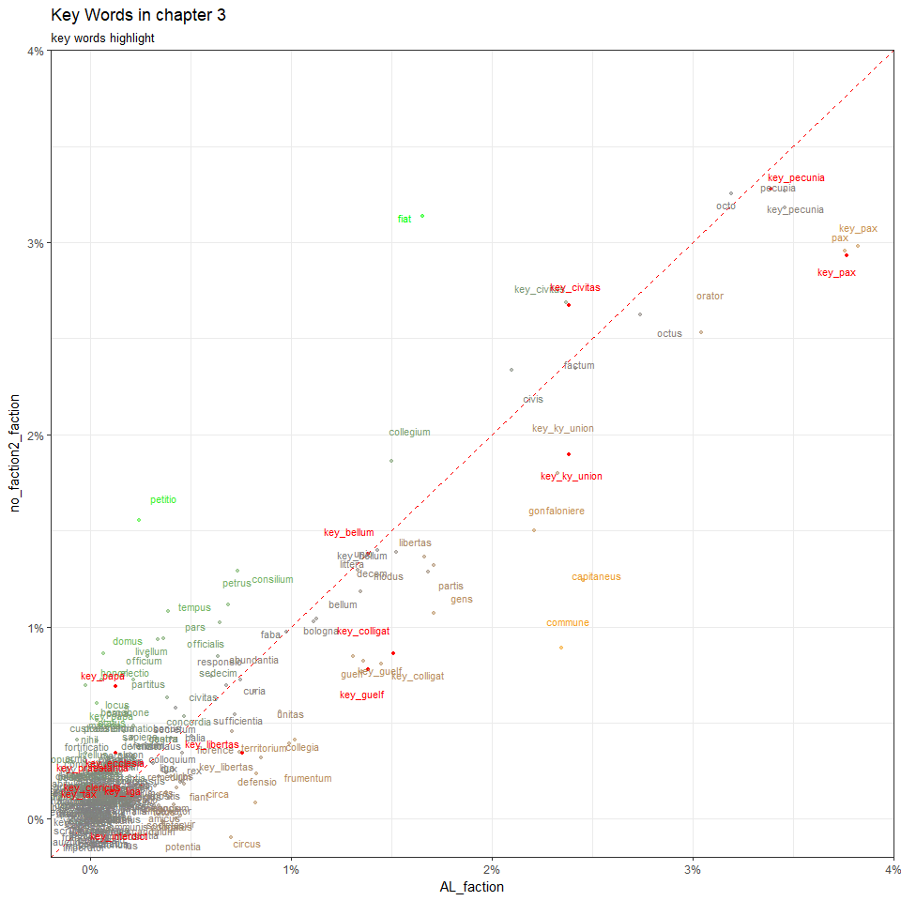

data1 <- data[1:15,]  
data1

## # A tibble: 15 x 86  
## `key words` sum fre_of_lib fre_of_no_faction fre_of_P.G.  
## <chr> <int> <int> <int> <int>  
## 1 key_bellum 35 19 13 2  
## 2 key_ecclesia 3 2 1 0  
## 3 key_papa 10 4 6 0  
## 4 key_clericus 2 1 1 0  
## 5 key_interdict 0 0 0 0  
## 6 key_guelf 21 10 8 3  
## 7 key_ky_union 53 27 19 6  
## 8 key_libertas 15 7 7 1  
## 9 key_liga 5 2 3 0  
## 10 key_colligat 26 14 9 2  
## 11 key_pecunia 80 45 30 5  
## 12 key_praestantia 5 5 0 0  
## 13 key_tax 0 0 0 0  
## 14 key_civitas 67 29 32 3  
## 15 key_pax 87 46 33 8  
## # ... with 81 more variables: fre_of_no_office <int>, fre_of_office <int>,  
## # lib_sum <dbl>, no_faction_sum <dbl>, P.G._sum <dbl>,  
## # no_office_sum <dbl>, office_sum <dbl>, lib_speech <dbl>,  
## # no_faction_speech <dbl>, P.G._speech <dbl>, no_office_speech <dbl>,  
## # office_speech <dbl>, Civic_faction <dbl>, no_faction_faction <dbl>,  
## # P.G._faction <dbl>, no_office_faction <dbl>, office_faction <dbl>,  
## # fre_of_AL <int>, fre_of_no_faction2 <int>, fre_of_RI <int>,  
## # AL_sum <dbl>, no_faction2_sum <dbl>, RI_sum <dbl>, AL_speech <dbl>,  
## # no_faction2_speech <dbl>, RI_speech <dbl>, AL_faction <dbl>,  
## # no_faction2_faction <dbl>, RI_faction <dbl>,  
## # fre_of_lib_no_office <int>, fre_of_lib_office <int>,  
## # lib_no_office_sum <dbl>, lib_office_sum <dbl>,  
## # lib_no_office_speech <dbl>, lib_office_speech <dbl>,  
## # Civic_no_office_faction <dbl>, Civic_office_faction <dbl>,  
## # fre_of_no_faction_no_office <int>, fre_of_no_faction_office <int>,  
## # no_faction_no_office_sum <dbl>, no_faction_office_sum <dbl>,  
## # no_faction_no_office_speech <dbl>, no_faction_office_speech <dbl>,  
## # no_faction_no_office_faction <dbl>, no_faction_office_faction <dbl>,  
## # `fre_of_P.G._no office` <int>, fre_of_P.G._office <int>,  
## # P.G._no_office_sum <dbl>, P.G._office_sum <dbl>,  
## # P.G._no_office_speech <int>, P.G._office_speech <dbl>,  
## # P.G._no_office_faction <dbl>, P.G._office_faction <dbl>,  
## # fre_of_AL_no_office <int>, fre_of_AL_office <int>,  
## # AL_no_office_sum <dbl>, AL_office_sum <dbl>,  
## # AL_no_office_speech <dbl>, AL_office_speech <dbl>,  
## # AL_no_office_faction <dbl>, AL_office_faction <dbl>,  
## # fre_of_no_faction2_no_office <int>, fre_of_no_faction2_office <int>,  
## # no_faction2_no_office_sum <dbl>, no_faction2_office_sum <dbl>,  
## # no_faction2_no_office_speech <dbl>, no_faction2_office_speech <dbl>,  
## # no_faction2_no_office_faction <dbl>, no_faction2_office_faction <dbl>,  
## # fre_of_RI_no_office <int>, fre_of_RI_office <int>,  
## # RI_no_office_sum <dbl>, RI_office_sum <dbl>,  
## # RI_no_office_speech <dbl>, RI_office_speech <dbl>,  
## # RI_no_office_faction <dbl>, RI_office_faction <dbl>,  
## # fre_of_Allargat <int>, Allargat_faction <dbl>, fre_of_Ristretto <int>,  
## # Ristretto_faction <dbl>

ggplot(data, aes(x = AL_faction, y = RI_faction, color = ((AL_faction - RI_faction)*200))) +  
 geom_abline(color = "red", lty = 2, slop = 1, intercept = 0) +  
 geom_jitter(size = 1, alpha = 0.5, width = 0.001, height = 0.001) +  
 geom_point(data = data1, color = 'red', size = 1) +  
 geom_text(aes(label = `key words`), position = position_jitter(width=0.0015, height = 0.0015), size = 3) +  
 geom_text(data = data1, aes(label = `key words`), position = position_jitter(width=0.0015, height = 0.0015), size = 3, color = 'red') +  
 theme_bw() +  
 scale_x_continuous(expand = c(0,0), limits = c(-0.002, 0.04), labels = percent_format()) +  
 scale_y_continuous(expand = c(0,0), limits = c(-0.002, 0.04), labels = percent_format()) +  
 scale_color_gradient2(low = 'green', mid = 'grey50', high = 'orange') +  
 theme(legend.position="none") +  
 labs(x = "AL_faction" , y = "RI_faction",  
 title = "Key Words in chapter 3",  
 subtitle = "key words highlight")

## Warning: Ignoring unknown parameters: slop

## Warning: Removed 2 rows containing missing values (geom_point).

## Warning: Removed 1 rows containing missing values (geom_point).

## Warning: Removed 2 rows containing missing values (geom_text).

## Warning: Removed 1 rows containing missing values (geom_text).

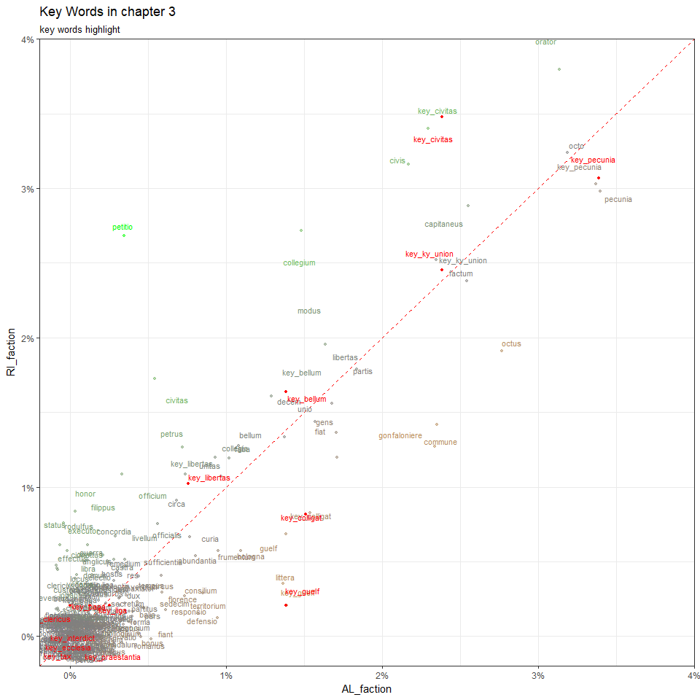

data1 <- data[1:15,]  
data1

## # A tibble: 15 x 86  
## `key words` sum fre_of_lib fre_of_no_faction fre_of_P.G.  
## <chr> <int> <int> <int> <int>  
## 1 key_bellum 35 19 13 2  
## 2 key_ecclesia 3 2 1 0  
## 3 key_papa 10 4 6 0  
## 4 key_clericus 2 1 1 0  
## 5 key_interdict 0 0 0 0  
## 6 key_guelf 21 10 8 3  
## 7 key_ky_union 53 27 19 6  
## 8 key_libertas 15 7 7 1  
## 9 key_liga 5 2 3 0  
## 10 key_colligat 26 14 9 2  
## 11 key_pecunia 80 45 30 5  
## 12 key_praestantia 5 5 0 0  
## 13 key_tax 0 0 0 0  
## 14 key_civitas 67 29 32 3  
## 15 key_pax 87 46 33 8  
## # ... with 81 more variables: fre_of_no_office <int>, fre_of_office <int>,  
## # lib_sum <dbl>, no_faction_sum <dbl>, P.G._sum <dbl>,  
## # no_office_sum <dbl>, office_sum <dbl>, lib_speech <dbl>,  
## # no_faction_speech <dbl>, P.G._speech <dbl>, no_office_speech <dbl>,  
## # office_speech <dbl>, Civic_faction <dbl>, no_faction_faction <dbl>,  
## # P.G._faction <dbl>, no_office_faction <dbl>, office_faction <dbl>,  
## # fre_of_AL <int>, fre_of_no_faction2 <int>, fre_of_RI <int>,  
## # AL_sum <dbl>, no_faction2_sum <dbl>, RI_sum <dbl>, AL_speech <dbl>,  
## # no_faction2_speech <dbl>, RI_speech <dbl>, AL_faction <dbl>,  
## # no_faction2_faction <dbl>, RI_faction <dbl>,  
## # fre_of_lib_no_office <int>, fre_of_lib_office <int>,  
## # lib_no_office_sum <dbl>, lib_office_sum <dbl>,  
## # lib_no_office_speech <dbl>, lib_office_speech <dbl>,  
## # Civic_no_office_faction <dbl>, Civic_office_faction <dbl>,  
## # fre_of_no_faction_no_office <int>, fre_of_no_faction_office <int>,  
## # no_faction_no_office_sum <dbl>, no_faction_office_sum <dbl>,  
## # no_faction_no_office_speech <dbl>, no_faction_office_speech <dbl>,  
## # no_faction_no_office_faction <dbl>, no_faction_office_faction <dbl>,  
## # `fre_of_P.G._no office` <int>, fre_of_P.G._office <int>,  
## # P.G._no_office_sum <dbl>, P.G._office_sum <dbl>,  
## # P.G._no_office_speech <int>, P.G._office_speech <dbl>,  
## # P.G._no_office_faction <dbl>, P.G._office_faction <dbl>,  
## # fre_of_AL_no_office <int>, fre_of_AL_office <int>,  
## # AL_no_office_sum <dbl>, AL_office_sum <dbl>,  
## # AL_no_office_speech <dbl>, AL_office_speech <dbl>,  
## # AL_no_office_faction <dbl>, AL_office_faction <dbl>,  
## # fre_of_no_faction2_no_office <int>, fre_of_no_faction2_office <int>,  
## # no_faction2_no_office_sum <dbl>, no_faction2_office_sum <dbl>,  
## # no_faction2_no_office_speech <dbl>, no_faction2_office_speech <dbl>,  
## # no_faction2_no_office_faction <dbl>, no_faction2_office_faction <dbl>,  
## # fre_of_RI_no_office <int>, fre_of_RI_office <int>,  
## # RI_no_office_sum <dbl>, RI_office_sum <dbl>,  
## # RI_no_office_speech <dbl>, RI_office_speech <dbl>,  
## # RI_no_office_faction <dbl>, RI_office_faction <dbl>,  
## # fre_of_Allargat <int>, Allargat_faction <dbl>, fre_of_Ristretto <int>,  
## # Ristretto_faction <dbl>

ggplot(data, aes(x = no_office_faction, y = office_faction, color = ((no_office_faction - office_faction)*200))) +  
 geom_abline(color = "red", lty = 2, slop = 1, intercept = 0) +  
 geom_jitter(size = 1, alpha = 0.5, width = 0.001, height = 0.001) +  
 geom_point(data = data1, color = 'red', size = 1) +  
 geom_text(aes(label = `key words`), position = position_jitter(width=0.0015, height = 0.0015), size = 3) +  
 geom_text(data = data1, aes(label = `key words`), position = position_jitter(width=0.0015, height = 0.0015), size = 3, color = 'red') +  
 theme_bw() +  
 scale_x_continuous(expand = c(0,0), limits = c(-0.002, 0.04), labels = percent_format()) +  
 scale_y_continuous(expand = c(0,0), limits = c(-0.002, 0.04), labels = percent_format()) +  
 scale_color_gradient2(low = 'green', mid = 'grey50', high = 'orange') +  
 theme(legend.position="none") +  
 labs(x = "no_office_faction" , y = "office_faction",  
 title = "Key Words in chapter 3",  
 subtitle = "key words highlight")

## Warning: Ignoring unknown parameters: slop

## Warning: Removed 5 rows containing missing values (geom_point).

## Warning: Removed 3 rows containing missing values (geom_point).

## Warning: Removed 5 rows containing missing values (geom_text).

## Warning: Removed 3 rows containing missing values (geom_text).

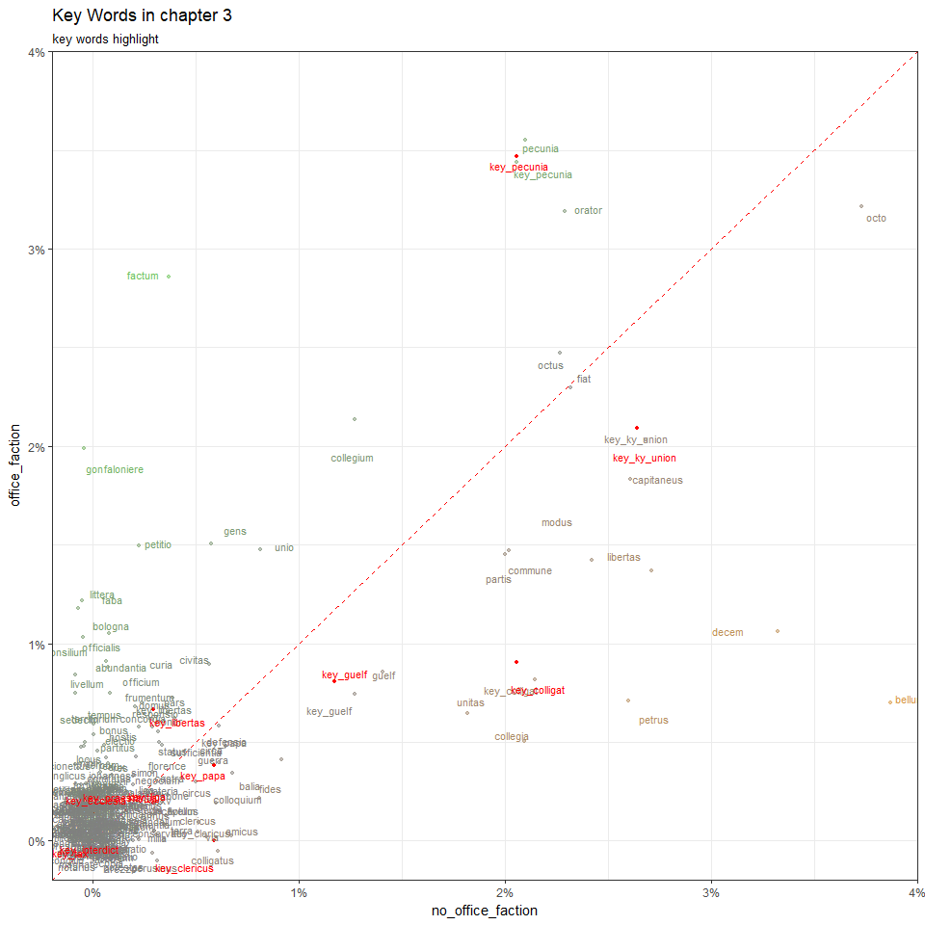

data1 <- data[1:15,]  
data1

## # A tibble: 15 x 86  
## `key words` sum fre_of_lib fre_of_no_faction fre_of_P.G.  
## <chr> <int> <int> <int> <int>  
## 1 key_bellum 35 19 13 2  
## 2 key_ecclesia 3 2 1 0  
## 3 key_papa 10 4 6 0  
## 4 key_clericus 2 1 1 0  
## 5 key_interdict 0 0 0 0  
## 6 key_guelf 21 10 8 3  
## 7 key_ky_union 53 27 19 6  
## 8 key_libertas 15 7 7 1  
## 9 key_liga 5 2 3 0  
## 10 key_colligat 26 14 9 2  
## 11 key_pecunia 80 45 30 5  
## 12 key_praestantia 5 5 0 0  
## 13 key_tax 0 0 0 0  
## 14 key_civitas 67 29 32 3  
## 15 key_pax 87 46 33 8  
## # ... with 81 more variables: fre_of_no_office <int>, fre_of_office <int>,  
## # lib_sum <dbl>, no_faction_sum <dbl>, P.G._sum <dbl>,  
## # no_office_sum <dbl>, office_sum <dbl>, lib_speech <dbl>,  
## # no_faction_speech <dbl>, P.G._speech <dbl>, no_office_speech <dbl>,  
## # office_speech <dbl>, Civic_faction <dbl>, no_faction_faction <dbl>,  
## # P.G._faction <dbl>, no_office_faction <dbl>, office_faction <dbl>,  
## # fre_of_AL <int>, fre_of_no_faction2 <int>, fre_of_RI <int>,  
## # AL_sum <dbl>, no_faction2_sum <dbl>, RI_sum <dbl>, AL_speech <dbl>,  
## # no_faction2_speech <dbl>, RI_speech <dbl>, AL_faction <dbl>,  
## # no_faction2_faction <dbl>, RI_faction <dbl>,  
## # fre_of_lib_no_office <int>, fre_of_lib_office <int>,  
## # lib_no_office_sum <dbl>, lib_office_sum <dbl>,  
## # lib_no_office_speech <dbl>, lib_office_speech <dbl>,  
## # Civic_no_office_faction <dbl>, Civic_office_faction <dbl>,  
## # fre_of_no_faction_no_office <int>, fre_of_no_faction_office <int>,  
## # no_faction_no_office_sum <dbl>, no_faction_office_sum <dbl>,  
## # no_faction_no_office_speech <dbl>, no_faction_office_speech <dbl>,  
## # no_faction_no_office_faction <dbl>, no_faction_office_faction <dbl>,  
## # `fre_of_P.G._no office` <int>, fre_of_P.G._office <int>,  
## # P.G._no_office_sum <dbl>, P.G._office_sum <dbl>,  
## # P.G._no_office_speech <int>, P.G._office_speech <dbl>,  
## # P.G._no_office_faction <dbl>, P.G._office_faction <dbl>,  
## # fre_of_AL_no_office <int>, fre_of_AL_office <int>,  
## # AL_no_office_sum <dbl>, AL_office_sum <dbl>,  
## # AL_no_office_speech <dbl>, AL_office_speech <dbl>,  
## # AL_no_office_faction <dbl>, AL_office_faction <dbl>,  
## # fre_of_no_faction2_no_office <int>, fre_of_no_faction2_office <int>,  
## # no_faction2_no_office_sum <dbl>, no_faction2_office_sum <dbl>,  
## # no_faction2_no_office_speech <dbl>, no_faction2_office_speech <dbl>,  
## # no_faction2_no_office_faction <dbl>, no_faction2_office_faction <dbl>,  
## # fre_of_RI_no_office <int>, fre_of_RI_office <int>,  
## # RI_no_office_sum <dbl>, RI_office_sum <dbl>,  
## # RI_no_office_speech <dbl>, RI_office_speech <dbl>,  
## # RI_no_office_faction <dbl>, RI_office_faction <dbl>,  
## # fre_of_Allargat <int>, Allargat_faction <dbl>, fre_of_Ristretto <int>,  
## # Ristretto_faction <dbl>

ggplot(data, aes(x = Civic_faction, y = P.G._faction, color = ((Civic_faction - P.G._faction)*200))) +  
 geom_abline(color = "red", lty = 2, slop = 1, intercept = 0) +  
 geom_jitter(size = 1, alpha = 0.5, width = 0.001, height = 0.001) +  
 geom_point(data = data1, color = 'red', size = 1) +  
 geom_text(aes(label = `key words`), position = position_jitter(width=0.0015, height = 0.0015), size = 3) +  
 geom_text(data = data1, aes(label = `key words`), position = position_jitter(width=0.0015, height = 0.0015), size = 3, color = 'red') +  
 theme_bw() +  
 scale_x_continuous(expand = c(0,0), limits = c(-0.002, 0.04), labels = percent_format()) +  
 scale_y_continuous(expand = c(0,0), limits = c(-0.002, 0.04), labels = percent_format()) +  
 scale_color_gradient2(low = 'green', mid = 'grey50', high = 'orange') +  
 theme(legend.position="none") +  
 labs(x = "Civic_faction" , y = "P.G._faction",  
 title = "Key Words in chapter 3",  
 subtitle = "key words highlight")

## Warning: Ignoring unknown parameters: slop

## Warning: Removed 4 rows containing missing values (geom_point).

## Warning: Removed 1 rows containing missing values (geom_point).

## Warning: Removed 4 rows containing missing values (geom_text).

## Warning: Removed 1 rows containing missing values (geom_text).

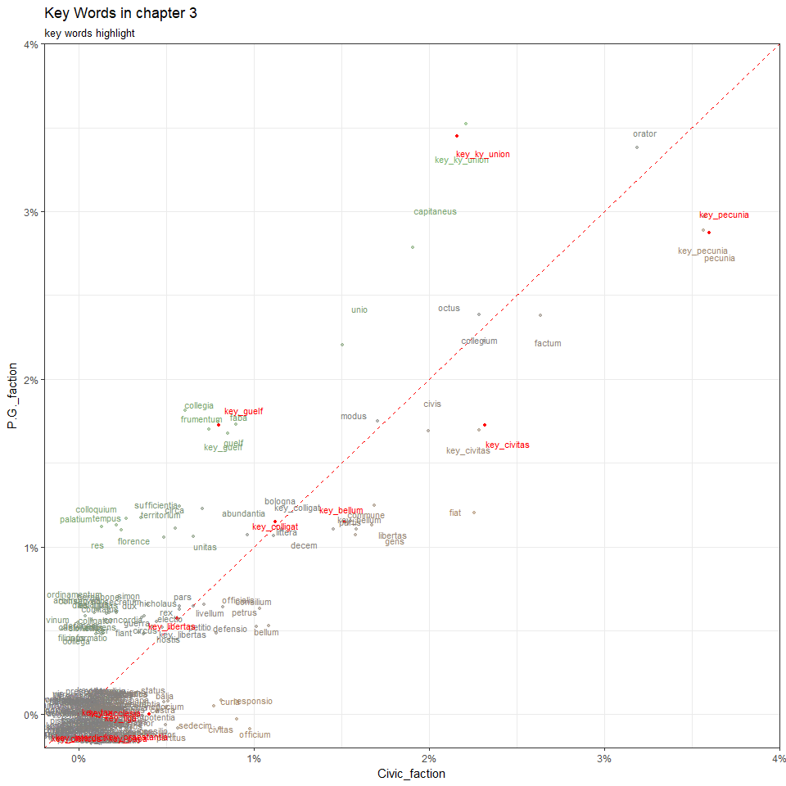

data1 <- data[1:15,]  
data1

## # A tibble: 15 x 86  
## `key words` sum fre_of_lib fre_of_no_faction fre_of_P.G.  
## <chr> <int> <int> <int> <int>  
## 1 key_bellum 35 19 13 2  
## 2 key_ecclesia 3 2 1 0  
## 3 key_papa 10 4 6 0  
## 4 key_clericus 2 1 1 0  
## 5 key_interdict 0 0 0 0  
## 6 key_guelf 21 10 8 3  
## 7 key_ky_union 53 27 19 6  
## 8 key_libertas 15 7 7 1  
## 9 key_liga 5 2 3 0  
## 10 key_colligat 26 14 9 2  
## 11 key_pecunia 80 45 30 5  
## 12 key_praestantia 5 5 0 0  
## 13 key_tax 0 0 0 0  
## 14 key_civitas 67 29 32 3  
## 15 key_pax 87 46 33 8  
## # ... with 81 more variables: fre_of_no_office <int>, fre_of_office <int>,  
## # lib_sum <dbl>, no_faction_sum <dbl>, P.G._sum <dbl>,  
## # no_office_sum <dbl>, office_sum <dbl>, lib_speech <dbl>,  
## # no_faction_speech <dbl>, P.G._speech <dbl>, no_office_speech <dbl>,  
## # office_speech <dbl>, Civic_faction <dbl>, no_faction_faction <dbl>,  
## # P.G._faction <dbl>, no_office_faction <dbl>, office_faction <dbl>,  
## # fre_of_AL <int>, fre_of_no_faction2 <int>, fre_of_RI <int>,  
## # AL_sum <dbl>, no_faction2_sum <dbl>, RI_sum <dbl>, AL_speech <dbl>,  
## # no_faction2_speech <dbl>, RI_speech <dbl>, AL_faction <dbl>,  
## # no_faction2_faction <dbl>, RI_faction <dbl>,  
## # fre_of_lib_no_office <int>, fre_of_lib_office <int>,  
## # lib_no_office_sum <dbl>, lib_office_sum <dbl>,  
## # lib_no_office_speech <dbl>, lib_office_speech <dbl>,  
## # Civic_no_office_faction <dbl>, Civic_office_faction <dbl>,  
## # fre_of_no_faction_no_office <int>, fre_of_no_faction_office <int>,  
## # no_faction_no_office_sum <dbl>, no_faction_office_sum <dbl>,  
## # no_faction_no_office_speech <dbl>, no_faction_office_speech <dbl>,  
## # no_faction_no_office_faction <dbl>, no_faction_office_faction <dbl>,  
## # `fre_of_P.G._no office` <int>, fre_of_P.G._office <int>,  
## # P.G._no_office_sum <dbl>, P.G._office_sum <dbl>,  
## # P.G._no_office_speech <int>, P.G._office_speech <dbl>,  
## # P.G._no_office_faction <dbl>, P.G._office_faction <dbl>,  
## # fre_of_AL_no_office <int>, fre_of_AL_office <int>,  
## # AL_no_office_sum <dbl>, AL_office_sum <dbl>,  
## # AL_no_office_speech <dbl>, AL_office_speech <dbl>,  
## # AL_no_office_faction <dbl>, AL_office_faction <dbl>,  
## # fre_of_no_faction2_no_office <int>, fre_of_no_faction2_office <int>,  
## # no_faction2_no_office_sum <dbl>, no_faction2_office_sum <dbl>,  
## # no_faction2_no_office_speech <dbl>, no_faction2_office_speech <dbl>,  
## # no_faction2_no_office_faction <dbl>, no_faction2_office_faction <dbl>,  
## # fre_of_RI_no_office <int>, fre_of_RI_office <int>,  
## # RI_no_office_sum <dbl>, RI_office_sum <dbl>,  
## # RI_no_office_speech <dbl>, RI_office_speech <dbl>,  
## # RI_no_office_faction <dbl>, RI_office_faction <dbl>,  
## # fre_of_Allargat <int>, Allargat_faction <dbl>, fre_of_Ristretto <int>,  
## # Ristretto_faction <dbl>

ggplot(data, aes(x = P.G._faction, y = no_faction_faction, color = ((P.G._faction - no_faction_faction)*200))) +  
 geom_abline(color = "red", lty = 2, slop = 1, intercept = 0) +  
 geom_jitter(size = 1, alpha = 0.5, width = 0.001, height = 0.001) +  
 geom_point(data = data1, color = 'red', size = 1) +  
 geom_text(aes(label = `key words`), position = position_jitter(width=0.0015, height = 0.0015), size = 3) +  
 geom_text(data = data1, aes(label = `key words`), position = position_jitter(width=0.0015, height = 0.0015), size = 3, color = 'red') +  
 theme_bw() +  
 scale_x_continuous(expand = c(0,0), limits = c(-0.002, 0.04), labels = percent_format()) +  
 scale_y_continuous(expand = c(0,0), limits = c(-0.002, 0.04), labels = percent_format()) +  
 scale_color_gradient2(low = 'green', mid = 'grey50', high = 'orange') +  
 theme(legend.position="none") +  
 labs(x = "P.G._faction" , y = "no_faction_faction",  
 title = "Key Words in chapter 3",  
 subtitle = "key words highlight")

## Warning: Ignoring unknown parameters: slop

## Warning: Removed 3 rows containing missing values (geom_point).

## Warning: Removed 1 rows containing missing values (geom_point).

## Warning: Removed 3 rows containing missing values (geom_text).

## Warning: Removed 1 rows containing missing values (geom_text).

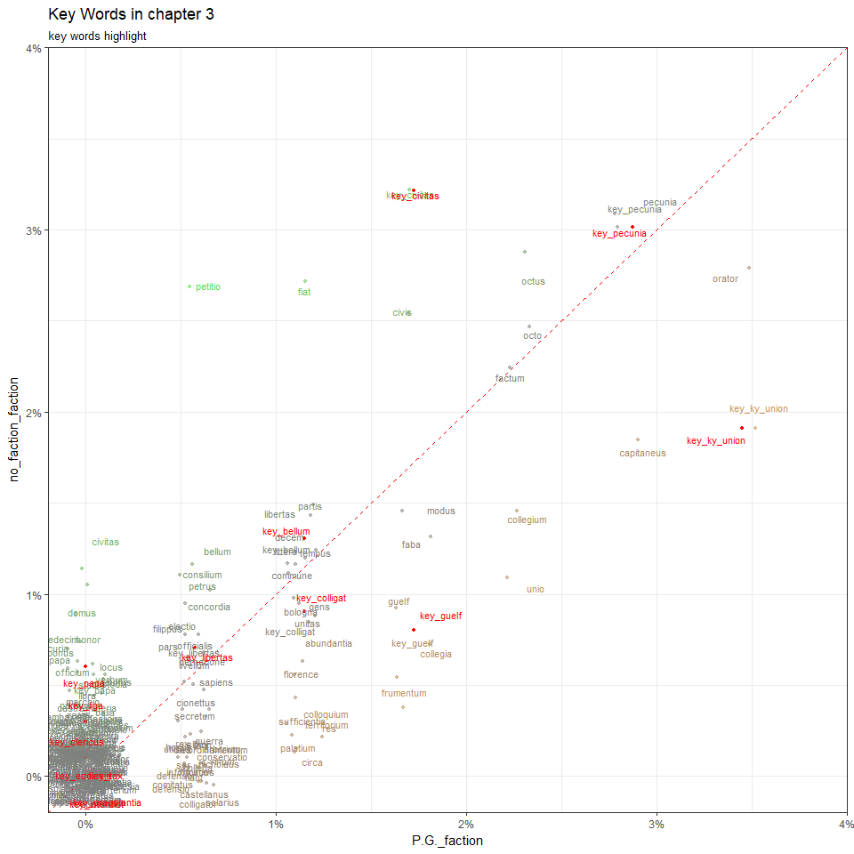

data1 <- data[1:15,]  
data1

## # A tibble: 15 x 86  
## `key words` sum fre_of_lib fre_of_no_faction fre_of_P.G.  
## <chr> <int> <int> <int> <int>  
## 1 key_bellum 35 19 13 2  
## 2 key_ecclesia 3 2 1 0  
## 3 key_papa 10 4 6 0  
## 4 key_clericus 2 1 1 0  
## 5 key_interdict 0 0 0 0  
## 6 key_guelf 21 10 8 3  
## 7 key_ky_union 53 27 19 6  
## 8 key_libertas 15 7 7 1  
## 9 key_liga 5 2 3 0  
## 10 key_colligat 26 14 9 2  
## 11 key_pecunia 80 45 30 5  
## 12 key_praestantia 5 5 0 0  
## 13 key_tax 0 0 0 0  
## 14 key_civitas 67 29 32 3  
## 15 key_pax 87 46 33 8  
## # ... with 81 more variables: fre_of_no_office <int>, fre_of_office <int>,  
## # lib_sum <dbl>, no_faction_sum <dbl>, P.G._sum <dbl>,  
## # no_office_sum <dbl>, office_sum <dbl>, lib_speech <dbl>,  
## # no_faction_speech <dbl>, P.G._speech <dbl>, no_office_speech <dbl>,  
## # office_speech <dbl>, Civic_faction <dbl>, no_faction_faction <dbl>,  
## # P.G._faction <dbl>, no_office_faction <dbl>, office_faction <dbl>,  
## # fre_of_AL <int>, fre_of_no_faction2 <int>, fre_of_RI <int>,  
## # AL_sum <dbl>, no_faction2_sum <dbl>, RI_sum <dbl>, AL_speech <dbl>,  
## # no_faction2_speech <dbl>, RI_speech <dbl>, AL_faction <dbl>,  
## # no_faction2_faction <dbl>, RI_faction <dbl>,  
## # fre_of_lib_no_office <int>, fre_of_lib_office <int>,  
## # lib_no_office_sum <dbl>, lib_office_sum <dbl>,  
## # lib_no_office_speech <dbl>, lib_office_speech <dbl>,  
## # Civic_no_office_faction <dbl>, Civic_office_faction <dbl>,  
## # fre_of_no_faction_no_office <int>, fre_of_no_faction_office <int>,  
## # no_faction_no_office_sum <dbl>, no_faction_office_sum <dbl>,  
## # no_faction_no_office_speech <dbl>, no_faction_office_speech <dbl>,  
## # no_faction_no_office_faction <dbl>, no_faction_office_faction <dbl>,  
## # `fre_of_P.G._no office` <int>, fre_of_P.G._office <int>,  
## # P.G._no_office_sum <dbl>, P.G._office_sum <dbl>,  
## # P.G._no_office_speech <int>, P.G._office_speech <dbl>,  
## # P.G._no_office_faction <dbl>, P.G._office_faction <dbl>,  
## # fre_of_AL_no_office <int>, fre_of_AL_office <int>,  
## # AL_no_office_sum <dbl>, AL_office_sum <dbl>,  
## # AL_no_office_speech <dbl>, AL_office_speech <dbl>,  
## # AL_no_office_faction <dbl>, AL_office_faction <dbl>,  
## # fre_of_no_faction2_no_office <int>, fre_of_no_faction2_office <int>,  
## # no_faction2_no_office_sum <dbl>, no_faction2_office_sum <dbl>,  
## # no_faction2_no_office_speech <dbl>, no_faction2_office_speech <dbl>,  
## # no_faction2_no_office_faction <dbl>, no_faction2_office_faction <dbl>,  
## # fre_of_RI_no_office <int>, fre_of_RI_office <int>,  
## # RI_no_office_sum <dbl>, RI_office_sum <dbl>,  
## # RI_no_office_speech <dbl>, RI_office_speech <dbl>,  
## # RI_no_office_faction <dbl>, RI_office_faction <dbl>,  
## # fre_of_Allargat <int>, Allargat_faction <dbl>, fre_of_Ristretto <int>,  
## # Ristretto_faction <dbl>

ggplot(data, aes(x = Civic_faction, y = no_faction_faction, color = ((Civic_faction - no_faction_faction)*200))) +  
 geom_abline(color = "red", lty = 2, slop = 1, intercept = 0) +  
 geom_jitter(size = 1, alpha = 0.5, width = 0.001, height = 0.001) +  
 geom_point(data = data1, color = 'red', size = 1) +  
 geom_text(aes(label = `key words`), position = position_jitter(width=0.0015, height = 0.0015), size = 3) +  
 geom_text(data = data1, aes(label = `key words`), position = position_jitter(width=0.0015, height = 0.0015), size = 3, color = 'red') +  
 theme_bw() +  
 scale_x_continuous(expand = c(0,0), limits = c(-0.002, 0.04), labels = percent_format()) +  
 scale_y_continuous(expand = c(0,0), limits = c(-0.002, 0.04), labels = percent_format()) +  
 scale_color_gradient2(low = 'green', mid = 'grey50', high = 'orange') +  
 theme(legend.position="none") +  
 labs(x = "Civic_faction" , y = "no_faction_faction",  
 title = "Key Words in chapter 3",  
 subtitle = "key words highlight")

## Warning: Ignoring unknown parameters: slop

## Warning: Removed 1 rows containing missing values (geom_point).

## Warning: Removed 1 rows containing missing values (geom_text).

