Conference: AGU 2017, MESA 2017, ICUAS 2017, RED-UAS 2017

Title: Single Point LiDAR for Cross-Sectional Feature Measurement

Abstract:

Light detection and ranging (LiDAR) is a powerful tool for recreating three dimensional features in computer imagery. Most often the LiDAR units are terrestrial, or set at a fixed location on the earth in which the location (north east down (NED). In the ecological world, these datasets can then be used to qualitatively monitor terrain and feature changes, quantitatively measure changes in feature volume wrt time, or develop models to predict future terrain behavior. Current methods include the utilization of real-time-kinematic (RTK) differential GPS (dGPS), LiDAR, and photogrammetry. Furthermore, these methods can and are all being performed utilizing small unmanned aerial systems (sUAS), which are a low-cost and rapid data acquisition solution. This work focuses on the extraction of stream cross-sections for the development of hydrological models utilizing current methods and a novel single point LiDAR solution is introduced and assessed.

A brief state-of-the-art of RTK dGPS, LiDAR, and photogrammetry approaches to collecting elevation data for the purpose of cross-sectional stream analysis is introduced. The novelty of the single point LiDAR (SPLiDAR) unit is that stream cross section flights can be preprogrammed into the UAV flight path, thus frontloading data management to mission planning and greatly reducing post-processing time as well as reduction of erroneous datum points. While there are great advantages to the SPLiDAR, there are a few caveats such as laser attenuation due to water surfaces and foliage. These drawbacks will be discussed in detail and several metrics will be used to first rank current methods and then compare the SPLiDAR technology. The development and technical detail regarding the single point LiDAR is presented, followed by a discussion regarding data acquisition and cross-section post processing.

y

z

x

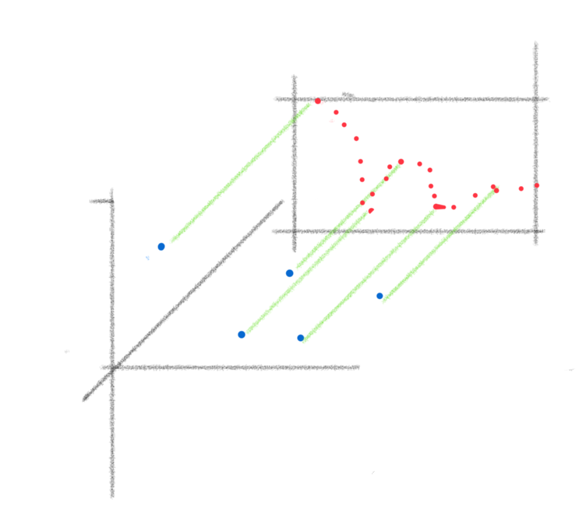

Metrics: Accuracy in meters compared to RTK; Time for data collection; Time to X-sec extraction.

Benefits: Inexpensive, rapid deployment, rapid post processing

Test site: Oneto, Galt, CA

Introduction:

With the rapid growth in use of sUAS in remote sensing comes a new multitude of remote sensing capabilities. While initially utilized to fill the resolution void that is left when interpreting multispectral satellite data, such as NIR, RGB, TIR, etc. And additionally as an alternative to the prohibitive cost of collecting imagery via manned aircraft. Small UAS are a low-cost, and safer alternative that can be tailored or chosen to fit any need [CITE SUAS SELECITON PAPER].

Aerial images can then be extrapolated into topographical or surface models called digital elevation models (DEMs). These models literally add another dimension to the two-dimensional imagery collected, and can be incredibly useful tools for area of interest analysis. The imagery collected is typically geo-rectified, meaning each pixel is assigned a latitude, longitude and altitude coordinate. However, much of the imagery collected by satellite can only ever reach

Another method of creating DEMs is by manually collecting latitude, longitude and altitude coordinates with a dGPS-RTK setup. In this scenario, a base station is utilized to continuously collect satellite data over a “known” GPS point on the earth. A person with a handheld GPS unit will collect remote data points and relay back the point information. These data are then compared and the discrepancy between the GPS location interpreted at the base station and the “known” location can then be extrapolated upon the handheld GPS unit. This method of data collection can be tedious and sometimes impossible in torturous terrain.

There are, of course, several solutions through the utilization of sUAS. Higher resolution imagery can be collected, which in turn relays back higher resolution DEM models from

State of the Art Review: *Digital Elevation Model Development*

In this section, we review DEM development methods, delving into the methods in which these data are collected.

(Delve into exactly how dGPS works)

We can think of sUAS as low-cost data acquisition units (DAQs).

-*Insert Literature Review of Referenced Papers Here-*

We begin by introducing two reference frames: Intertial (*I*) and Body Fixed (*B*). The inertial reference frame is a fixed coordinate system that does not rotate or translate in space. In most cases, *I* can be considered fixed upon the earth. Alternatively, *B* is considered to be rigidly affixed to a rigid body that can rotate and translate freely in space. UAVs are considered to possess six degrees of freedom (DOF), three translational components and three rotational components about the translational axes. Figure XX illustrates the inertial frame and body frame by two sets of orthogonal coordinates, and the trajectory of particle “P” extended along the *z’* axis. In this case, it is a safe assumption to model the point at which the laser reflects upon the terrain due to the fact that the beam trajectory is linear and most of the reflected light returns back to the point of origin.

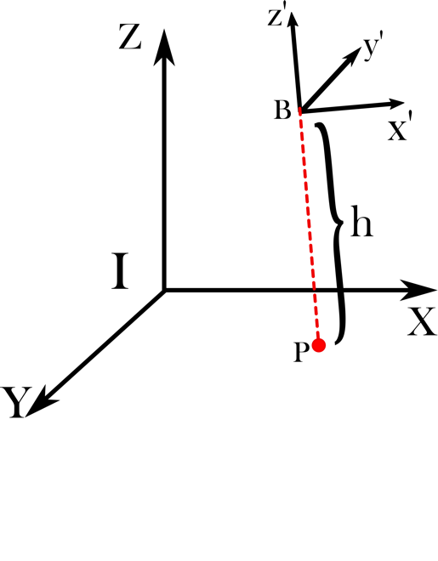

The length between particle “P” and frame *B*is denoted by the variable *h*, which represents the measurable distance between the SPLiDAR sensor onboard the UAV and the terrain below. It is important to note that the laser beam is assumed to be collinear with the *z’* axis, thus resulting in the following equation describing the length vector between “P” and the body frame:

,

where represents the unit vector along the *z’* axis. At this point, the relative distance between the UAV and the terrain is known; however, the terrain height in the earth fixed frame, *I*, is desired. A rotation from *B* to *I* must occur, which entails rotating the vector . Rotation of a vector in 3D space is well understand, and the rotation about each axis takes the form of:

,,.

Where represents the angle between *x* and *x’*, represents the angle between *z* and *z’*, and represents the angle between *y* and *y’* axes. Combining these individual rotations, we achieve the general rotation matrix:

.

This rotation matrix transforms any vector on or relative to *B* into the *I* frame. Applying this rotation, we can extract the *z* component of the vector and determine this to be the relative terrain height in the intertial frame:

.

Assuming the altitude of the UAV is known (either above MSL or AGL from a known point), we can derive the following equation for the terrain height:

.

Methods:

Dried riverbed flight, comparison between LiDAR, Photogrammetry (Sat and UAV) and dGPS-RTK. By collecting

The experiment will include sUAS flights over the Cosumnes River Preserve at the Oneto-Denier site. This section of the river has historical (over the past two years) aerial LiDAR and imagery collected via UAS.

*Platforms:*

The UAV platforms selected for this study are the DJI S1000 octorotor for dGPS-RTK LiDAR collection, AggieAir fixed-wing platform for imagery collection and the MESAIris quadrotor for SPLiDAR data collection. The S1000 platform is operated by the Vice Labs at the University of California Merced (UC Merced) and utilized in collaboration with the Mechatronics, Embedded Systems and Automation (MESA) Lab at UC Merced specifically for DEM development of environmental terrain. The MESA lab operates the AggieAir and MESAIris for imagery collection and other *in-situ* measurements.

*Area of Interest:*

A 0.35km stretch of riverbed (38.309785°, -121.376833°) will be flown over with all three aircraft. This general area is part of an ongoing flood-plain analysis study conducted by UC Davis, UC Merced and the Nature Conservancy (TNC). This area (Fig. 1) was chosen for this reason and the fact that it wets and dries annually. Furthermore, the future use of the SPLiDAR will be for rapid and low cost river cross-sectional analysis.

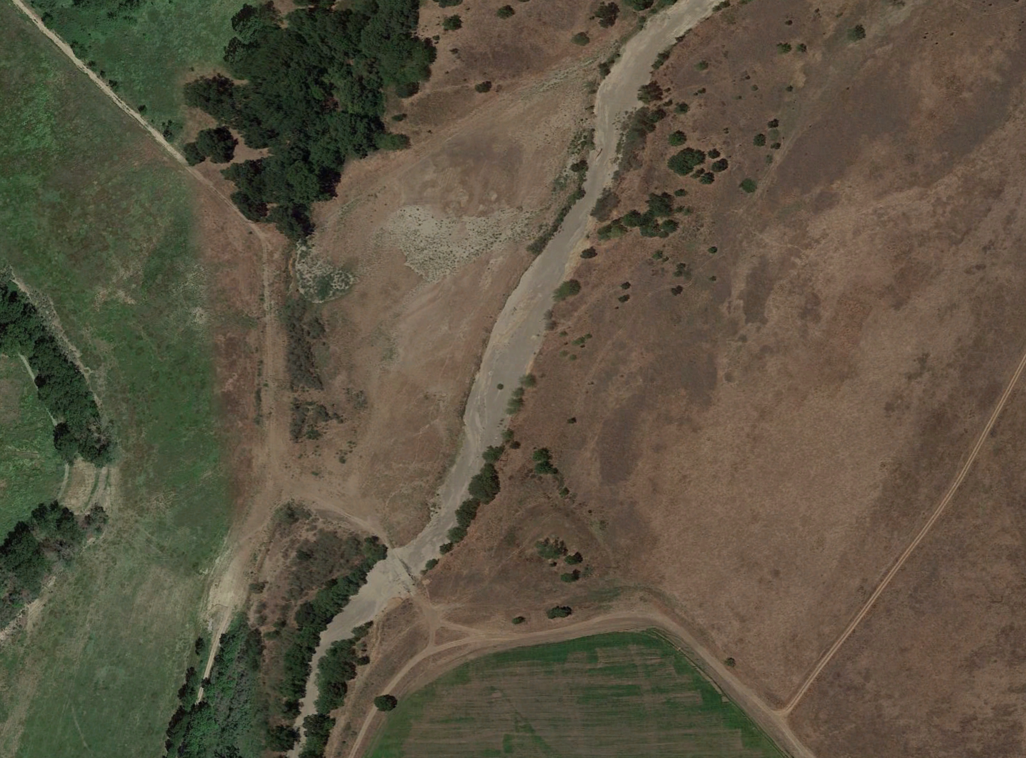

Figure 1: Low-water crossing at the Oneto Denier Site in Galt, CA

Several .5m wide cross-section of the river will be analyzed and compared.

*Challenges:*

Many challenges become apparent when utilizing a small, low-cost sensor, such as reliability, repeatability and calibration techniques. The three issues are discussed and accounted for by means of benchmarking performance of the SPLiDAR in a controlled setting, followed by the validation of such claims through experimental trial.



Figure 2: Measured LiDAR data vs. Actual Distance

Furthermore, two formidable enemies of infrared lasers are foliage and water. The effects caused by these will be analyzed by collecting not only laser range data, but laser intensity upon return.

Results:

Present here the analaysis of the data collected by the SPLiDAR and the comparison between that, the LIDAR and the imagery developed DEM models.

Discussion:

Discuss

Conclusion:

References:

1. Brivio, P. A., et al. "Integration of remote sensing data and GIS for accurate mapping of flooded areas." *International Journal of Remote Sensing* 23.3 (2002): 429-441.
2. Hirano, Akira, Roy Welch, and Harold Lang. "Mapping from ASTER stereo image data: DEM validation and accuracy assessment." ISPRS Journal of Photogrammetry and Remote Sensing 57.5 (2003): 356-370.
3. Hodgson, Michael E., and Patrick Bresnahan. "Accuracy of Airborne Lidar-Derived Elevation: Empirical Assessment and Error Budget." *PHOTOGRAMMETRIC ENGINEERING & REMOTE SENSING* 70.3 (2004): 331-339.
4. Mouratidis, Antonios, Pierre Briole, and Kostas Katsambalos. "SRTM 3 ″DEM (versions 1, 2, 3, 4) validation by means of extensive kinematic GPS measurements: a case study from North Greece." International Journal of Remote Sensing 31.23 (2010): 6205-6222.
5. Suwandana, Endan, et al. "Evaluation of ASTER GDEM2 in comparison with GDEM1, SRTM DEM and topographic-map-derived DEM using inundation area analysis and RTK-dGPS data." Remote sensing 4.8 (2012): 2419-2431.
6. Zhang, Keqi, et al. "A progressive morphological filter for removing nonground measurements from airborne LIDAR data." Geoscience and Remote Sensing, IEEE Transactions on 41.4 (2003): 872-882.