Conference: AGU 2017, MESA 2017, ICUAS 2017, RED-UAS 2017

Title: Single Point LiDAR for Cross-Sectional Feature Measurement

Abstract: Light detection and ranging (LiDAR) is a powerful tool for recreating three dimensional features in computer imagery. Most often the LiDAR units are terrestrial, or set at a fixed location on the earth in which the location (north east down (NED))In the ecological world, these datasets can then be used to qualitatively monitor terrain and feature changes, quantitatively measure changes in feature volume wrt time, or develop models to predict future terrain behavior. Current methods include the utilization of real-time-kinematic (RTK) differential GPS (dGPS), LiDAR, and photogrammetry. Furthermore, these methods can and are all being performed utilizing small unmanned aerial systems (sUAS), which are a low-cost and rapid data acquisition solution. This work focuses on the extraction of stream cross-sections for the development of hydrological models utilizing current methods and a novel single point LiDAR solution is introduced and assessed.

A brief state-of-the-art of RTK dGPS, LiDAR, and photogrammetry approaches to collecting elevation data for the purpose of cross-sectional stream analysis is introduced. The novelty of the single point LiDAR (SPLiDAR) unit is that stream cross section flights can be preprogrammed into the UAV flight path, thus frontloading data management to mission planning and greatly reducing post-processing time as well as reduction of erroneous datum points. While there are great advantages to the SPLiDAR, there are a few caveats such as laser attenuation due to water surfaces and foliage. These drawbacks will be discussed in detail and several metrics will be used to first rank current methods and then compare the SPLiDAR technology. The development and technical detail regarding the single point LiDAR is presented, followed by a discussion regarding data acquisition and cross-section post processing.

y

z

x

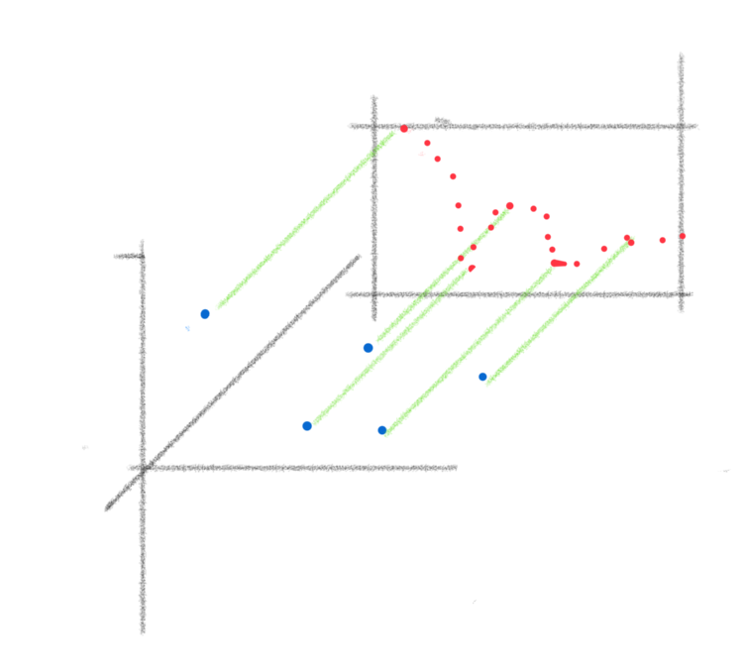

Metrics: Accuracy in meters compared to RTK; Time for data collection; Time to X-sec extraction.

Benefits: Inexpensive, rapid deployment, rapid post processing

Limitations: Sensor Calibration? Repeatability? Folliage? Water?

Repeatability: what's the stdev of the sensor? What is the error stack-up? GPS, Baro, etc.

Test site: Oneto, Galt, CA