

# IBPSA Project 1

*BIM/GIS and Modelica Framework for building and community energy system design and operation*

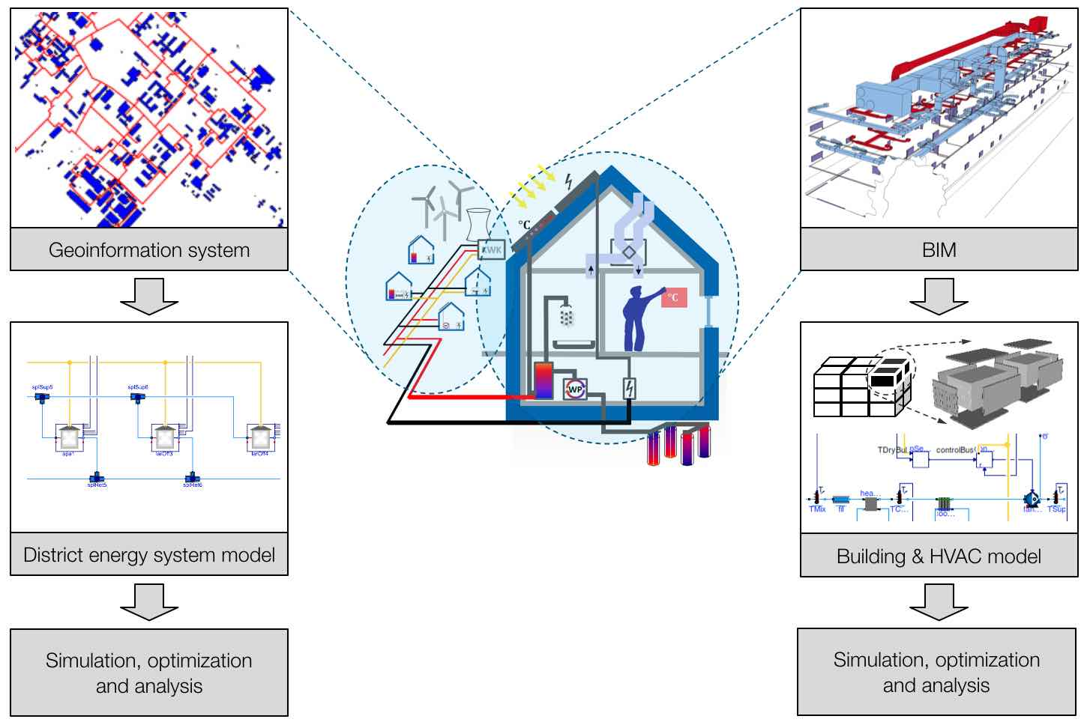

Overview of IBPSA Project 1

IBPSA is launching its first multi-year project called IBPSA Project 1 to collaboratively develop and disseminate free open-source computing tools.

IBPSA Project 1 is a collaboration to build the basis of next generation computing tools for the design and operation of building and district energy and control systems. It extends work conducted under the [IEA EBC Annex 60](http://iea-annex60.org/). All work is open-source, will be free available, and built on three standards:

* [IFC](http://www.buildingsmart-tech.org/) and further classification schemes for data modeling at the building scale,
* [CityGML](http://www.citygml.org/) for data modeling at the district scale including application domain extensions (ADEs), and
* [Modelica](http://www.modelica.org/) and FMI technologies for modeling and optimization of the performance of building and district energy systems.

The project will be conducted from summer 2017 to summer 2022. It includes three tasks that

* develop Modelica model libraries for simulation and for model predictive control,
* map IFC and CityGML to Modelica, and
* demonstrate through applications the capabilities enabled through Modelica, and identify research needs and test research results.

The project kick-off meeting will be on Saturday August 5, 2017, in San Francisco, co-located with the Building Simulation 2017 conference. As of March 2017, 19 institutes and organizations signed up.

For more information about IBPSA Project 1, visit <https://ibpsa.github.io/project1/>.

For agenda and registration, visit <https://github.com/ibpsa/project1/wiki/2017-08-05-kick-off-agenda>.