

# Project 1 started officially on August 5, 2017

*Michael Wetter (LBNL) and Christoph van Treeck (RWTH Aachen)*

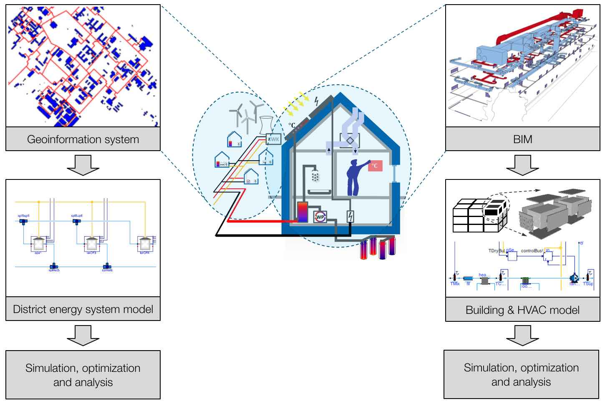

Overview of IBPSA Project 1

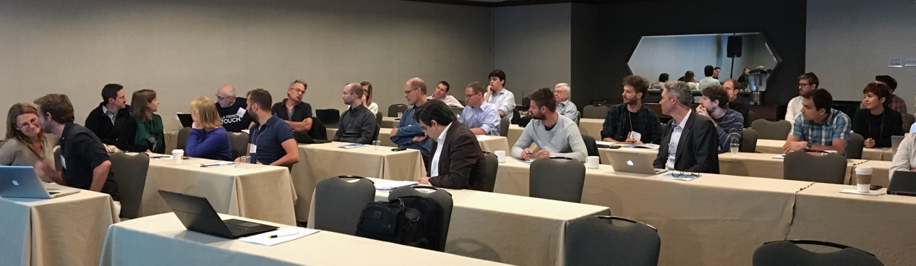

Kickoff meeting of the IBPSA Project 1 in San Francisco, CA

On August 5, 2017, prior to the Building Simulation 2017 conference, the IBPSA project 1 had its kick-off meeting to start the 5-year research phase. The meeting was attended by about 40 participants who further refined the workplan.

In addition to Mitsubishi Electric Research Laboratory, which committed to sponsoring the project this spring, the French company ENGIE also contributed to funding the project as a sponsoring participant. The sponsorships will be used to offset costs for semi-annual coordination meetings that allows the 24 organizations and 18 individual participants to coordinate joint R&D on building and city-scale modeling, simulation and optimization.

For more information about IBPSA Project 1 and how to join, visit <https://ibpsa.github.io/project1/>.

For upcoming meetings, visit <https://github.com/ibpsa/project1/wiki/Meetings>

**About IBPSA Project 1**

IBPSA Project 1 is a collaboration to build the basis of next generation computing tools for the design and operation of building and district energy and control systems. It extends work conducted under the [IEA EBC Annex 60](http://iea-annex60.org/). All work is open-source, will be free available, and built on three open standards:

* [IFC](http://www.buildingsmart-tech.org/) and further classification schemes for data modeling at the building scale,
* [CityGML](http://www.citygml.org/) for data modeling at the district scale including application domain extensions (ADEs), and
* [Modelica](http://www.modelica.org/) and FMI technologies for modeling and optimization of the performance of building and district energy systems.

The project will be conducted from summer 2017 to summer 2022. It includes three tasks that

* develop Modelica model libraries for simulation and for model predictive control,
* map IFC and CityGML to Modelica, and
* demonstrate through applications the capabilities enabled through Modelica, and identify research needs and test research results.