Progression of 15/11/19 (part 1)

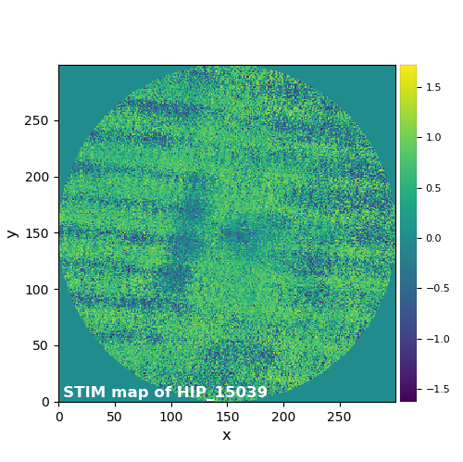

Progress of 15/11 (part 2)

