Quiz 1

If you selected the left-side lottery in the screen below, what are the potential outcomes and probabilities of that lottery?
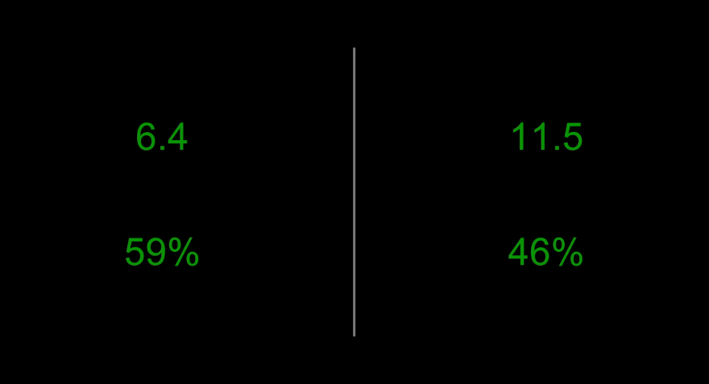

1. Outcome ________________________ Probability ________________________
2. Outcome ________________________ Probability ________________________

If you selected the right-side lottery in the screen below, what are the potential outcomes and probabilities of that lottery?
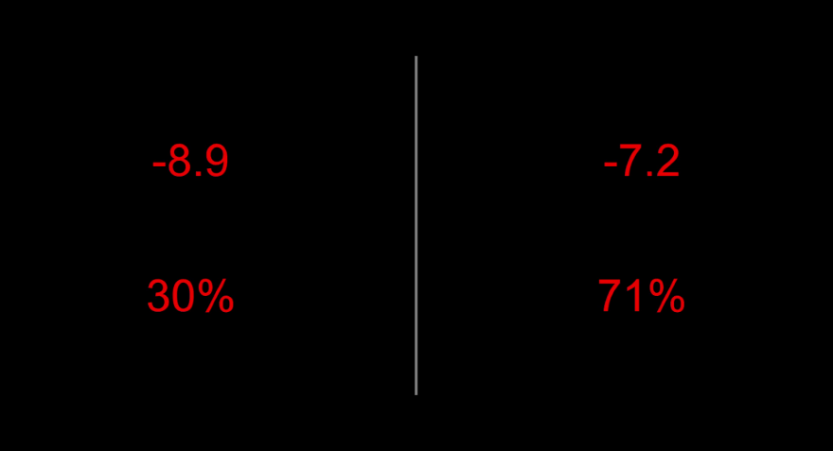

1. Outcome ________________________ Probability ________________________
2. Outcome ________________________ Probability ________________________
Quiz 2

If you selected the right-side lottery in the screen below, what are the potential outcomes and probabilities of that lottery?


1. Outcome ________________________ Probability ________________________
2. Outcome ________________________ Probability ________________________

If you selected the left-side lottery in the screen below, what are the potential outcomes and probabilities of that lottery?


1. Outcome ________________________ Probability ________________________
2. Outcome ________________________ Probability ________________________

